Question 1 – Functional Requirements
Functional Requirements describe the specific behaviors, functions, and operations a system must perform to meet business needs. These are directly linked to what the system should do.
Req ID | Functional Requirement Name | Functional Requirement Description
FR001 | User Registration – Farmer | The system shall allow new farmers to register by providing email, creating a secure password, and personal details.
FR002 | User Registration – Manufacturer | The system shall allow manufacturers to register by providing business details, email, and password.
FR003 | User Login | The system shall authenticate users (farmers/manufacturers) with registered credentials before granting access.
FR004 | Product Catalog Browsing | The system shall display a categorized list of products (fertilizers, seeds, pesticides) for farmers to browse.
FR005 | Product Search | The system shall allow farmers to search for products using keywords, categories, or filters.
FR006 | Add to Cart | The system shall allow farmers to add selected products to the shopping cart for purchase.
FR007 | Buy Later List | The system shall allow farmers to save products in a 'Buy Later' list for future purchases.
FR008 | Product Upload – Manufacturer | The system shall allow manufacturers to upload product details, pricing, and images.
FR009 | Product Editing – Manufacturer | The system shall allow manufacturers to edit or update product details after upload.
FR010 | Payment – COD | The system shall allow farmers to make payments via Cash on Delivery (COD) option.
FR011 | Payment – Credit/Debit Card | The system shall allow farmers to make payments using credit/debit cards securely.
FR012 | Payment – UPI | The system shall allow farmers to pay using UPI payment methods.
FR013 | Order Placement | The system shall allow farmers to confirm the cart items and place an order.
FR014 | Order Confirmation Email | The system shall send an email confirmation to farmers upon successful order placement.
FR015 | Delivery Tracking | The system shall allow farmers to track the status and location of their order.
FR016 | User Profile Management | The system shall allow farmers and manufacturers to view and update their profile details.
FR017 | Password Reset | The system shall allow users to reset their password via email verification.
FR018 | Product Reviews & Ratings | The system shall allow farmers to submit reviews and ratings for purchased products.
FR019 | Order History | The system shall allow farmers to view their previous orders and re-order if needed.
FR020 | Admin Dashboard | The system shall provide an admin dashboard to manage users, products, and orders.

Question 2 – Wireframes / Page Designs
Below are the low-fidelity wireframes for five key pages of the Online Agriculture Products Store.
- SIGNUP:

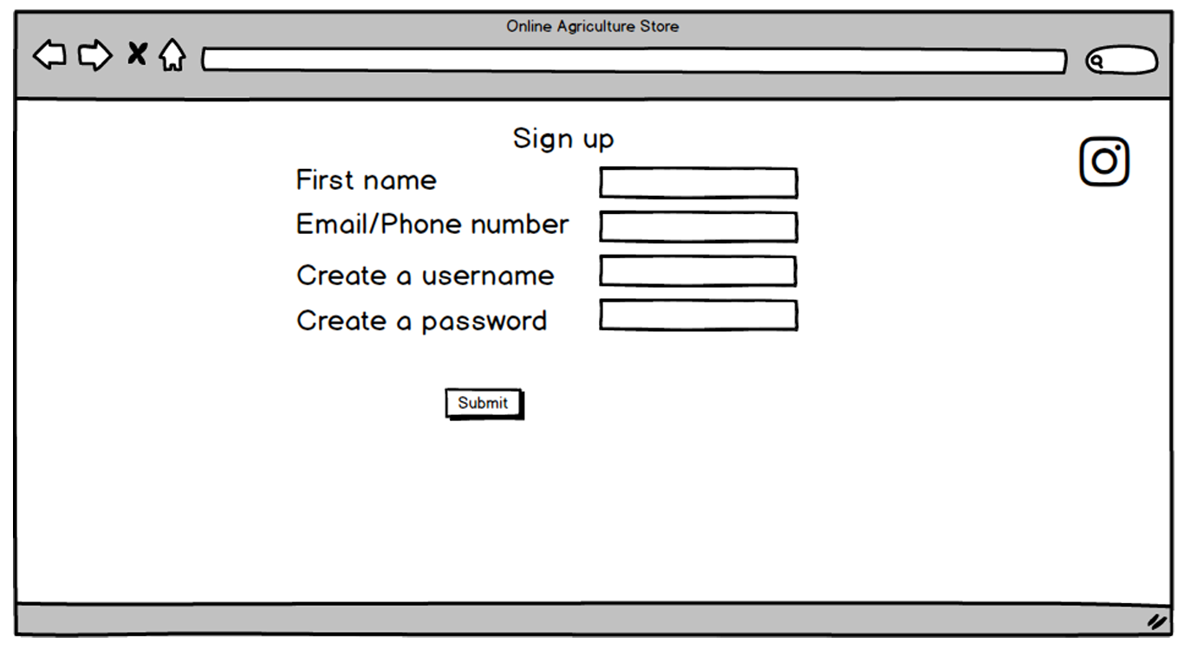

- LOGIN:

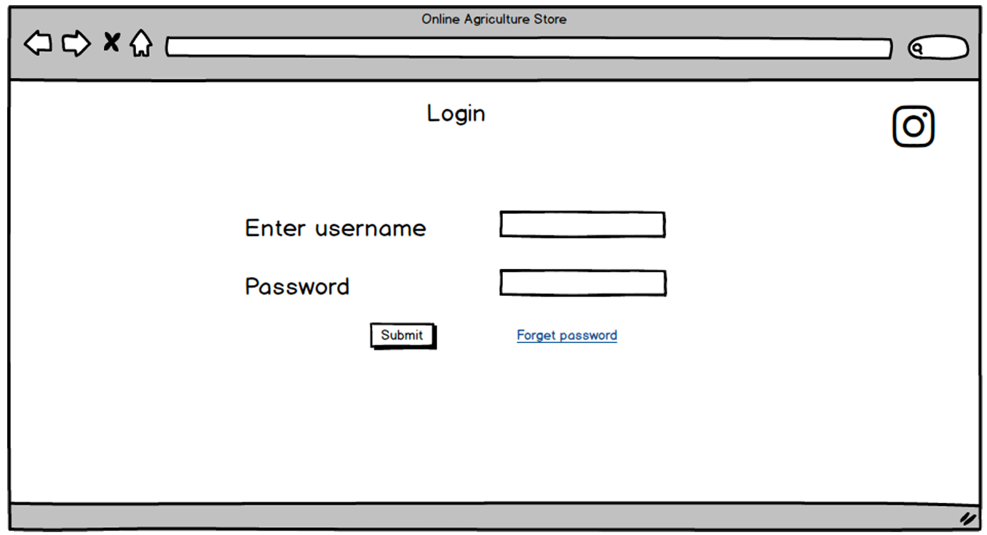

- CATEGORY SEARCH:

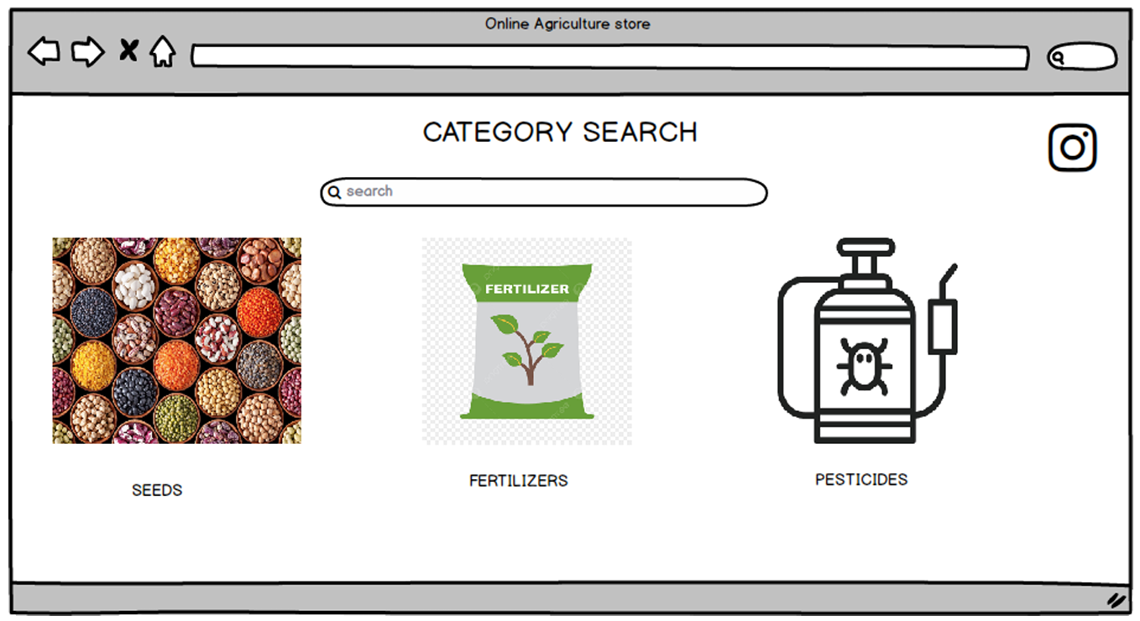

- CART:

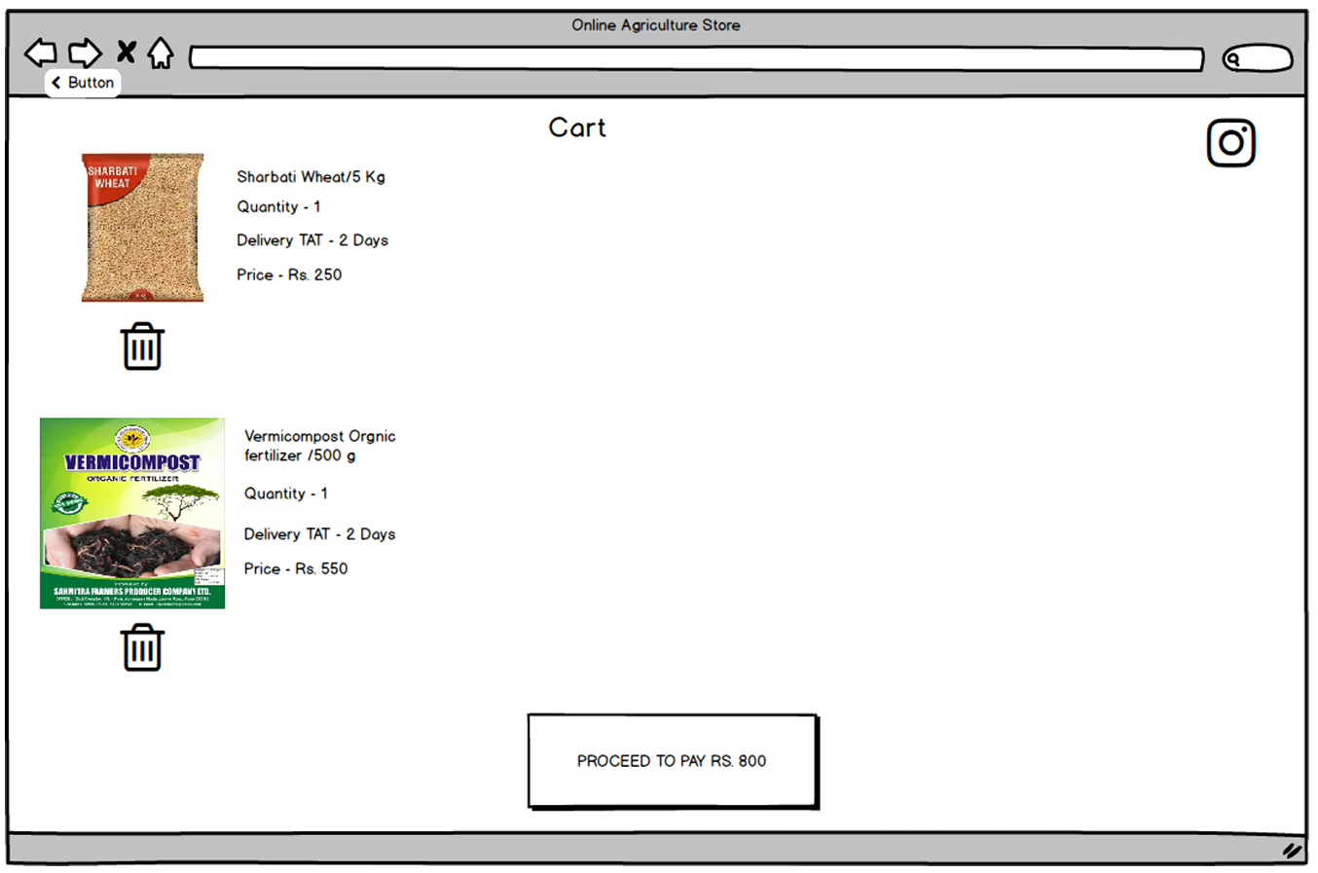

- PAYMENT:

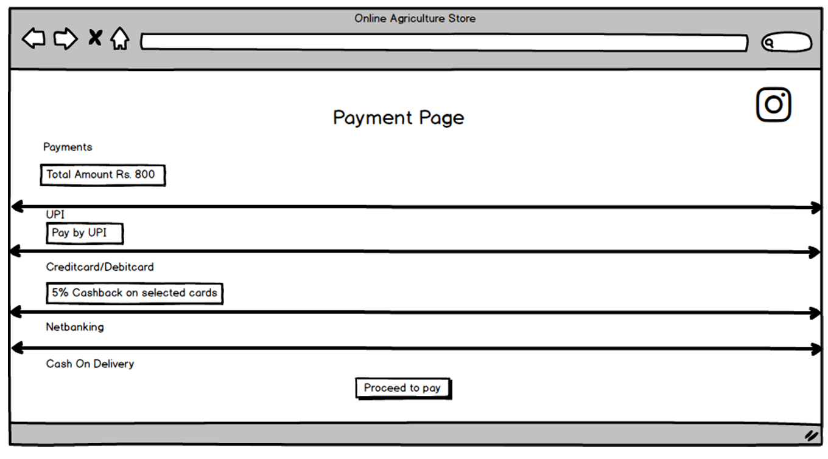

Question 3 – Tools (Visio, Balsamiq)

Tool Name | Purpose / Usage
Microsoft Visio | Used to create UML diagrams such as Use Case Diagrams, Activity Diagrams, and Data Flow Diagrams.
Balsamiq | Used for designing low-fidelity wireframes for system pages (e.g., Home Page, Login, Registration).
Axure | Used to create high fidelity, interactive wireframes & prototypes for web & mobile applications.

Question 4 – RTM

Definition:
A Requirements Traceability Matrix is a document that links requirements throughout the project lifecycle to ensure that all requirements defined for a system are tested in the test protocols. It helps track the progress of each requirement from definition to delivery.
Purpose:
- To ensure that no requirement is missed during design, development, or testing.
- To provide clear mapping between business requirements, functional requirements, design documents, test cases, and UAT.
- To facilitate status tracking for stakeholders like Mr. Henry and Peter.

Requirements Traceability Matrix:

Req ID | Req Name | Req Description | Design | D1 | T1 | T2 | T3 | T4 | UAT
FR001 | Farmer Registration | Farmers should be able to register with the application | Done | Done | Pass | Pass | Pass | Pass | Pending
FR002 | Farmer Search for Products | Farmers should be able to search for available products | Done | Done | Pass | Pass | Pass | Pass | Pending
FR003 | Product Upload | Manufacturers should be able to upload products | Done | Done | Pass | Pass | Pass | Pass | Pending
FR004 | Payment Gateway | Multiple payment options | Done | Done | Pass | Pass | Pass | Pass | Pending
FR005 | Order Tracking | Track delivery status | Done | Done | Pass | Pass | Pass | Pass | Pending
NFR001 | Page Loading Time | Pages load within 2 seconds | Done | Done | Pass | Pass | Pass | Pass | Pending
NFR002 | WCAG 2.1 | Accessibility compliance | Done | Done | Pass | Pass | Pass | Pass | Pending

Question 5 – 10 Test Case Documents

Definition:
A Test Case Document is a set of conditions or variables used to determine whether a system meets its requirements and works as expected. Each test case describes Test scenarios, Test steps, and Expected results for verifying a particular functionality.

Test Case ID | Test Scenario | Test Steps | Expected Result
TC001 | Verify farmer registration | 1. Navigate to Registration page.  2. Enter required details.  3. Click Register. | User account is created, success message shown, and confirmation email sent.
TC002 | Verify manufacturer registration | 1. Navigate to Registration page.  2. Select role as Manufacturer.  3. Fill in details.  4. Submit. | Manufacturer account is created and confirmation email sent.
TC003 | Verify user login | 1. Go to Login page.  2. Enter valid credentials.  3. Click Login. | User successfully logs in and is redirected to the dashboard.
TC004 | Search for a product | 1. Login as Farmer.  2. Enter product name in search bar.  3. Click Search. | Search results display relevant products matching the keyword.
TC005 | Add product to cart | 1. Browse catalog.  2. Select product.  3. Click Add to Cart. | Product is added to the shopping cart with correct price and quantity.
TC006 | Add product to Buy Later list | 1. Select product.  2. Click Add to Buy Later.  3. Verify in Buy Later list. | Product appears in the Buy Later list.
TC007 | Place order with COD | 1. Add product to cart.  2. Proceed to checkout.  3. Select COD payment.  4. Confirm order. | Order is placed successfully, and confirmation email is sent.
TC008 | Make payment via UPI | 1. Add product to cart.  2. Select UPI payment method.  3. Enter valid UPI ID.  4. Confirm. | Payment is processed and order is confirmed.
TC009 | Track order delivery | 1. Login.  2. Navigate to My Orders.  3. Select an order.  4. Click Track Delivery. | System displays real-time delivery status.
TC010 | Submit product review | 1. Login.  2. Go to My Orders.  3. Select delivered order.  4. Submit review. | Review is saved and displayed on product page.

Question 6 – DB Design

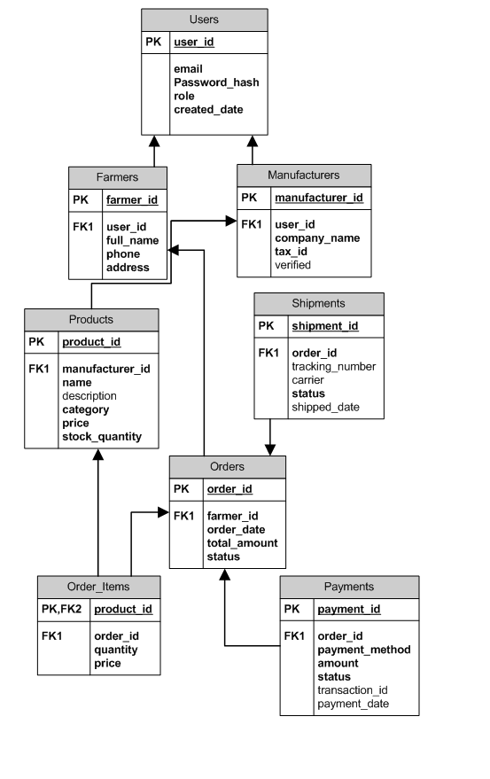

Question 7 – Data Flow Diagram

A Data Flow Diagram (DFD) is a graphical representation of the flow of data through an information system. It shows how data is input, processed, stored, and output, highlighting the logical movement of data without focusing on technical implementation details.
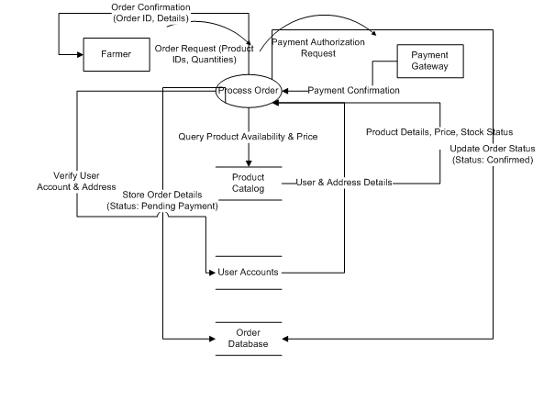

Question 8 – Change Request

As a Business Analyst, I would handle the change request using a structured Change Management Process:
1. Identify the Change – Government taxation structure has changed, requiring updates in the system.
2. Log the Change Request – Record in Change Request Log with details (ID, description, impacted modules).
3. Impact Analysis – Analyze effect on functional requirements (tax calculations, invoices), database, UI/UX, reports, and timeline.
4. Approval from Change Control Board (CCB) – Present analysis to stakeholders for review and approval.
5. Update Documentation – Modify BRD, SRS, RTM, and design documents with revised tax structure.
6. Implementation – Developers update tax logic; DB admins update tax tables.
7. Testing – QA team prepares test cases and conducts regression testing.
8. Deployment & Communication – Deploy changes and notify users about updated taxation.
Conclusion: This is a Change Request because it modifies an existing feature (taxation logic) rather than introducing new functionality

Question 9 – Change Request Vs an Enhancement

My initial response would be to thank Ben and Kevin for their valuable feedback and to schedule a meeting to discuss it in detail.
This is a fundamental change in the project's scope and business model. The original purpose was a B2B2C platform (Manufacturers -> Platform -> Farmers). This new idea transforms it into a multi-vendor marketplace (Manufacturers & Farmers -> Platform -> Consumers/Other Farmers) and introduces an entirely new "Auction" functionality.
- This is a Change Request, and a significant one. It is not a minor improvement or tweak to an existing feature (which would be an enhancement). It introduces new user roles (consumers/public), new core workflows (farmers selling, auction bidding), and new complex functionality (auction engine).
I would explain that while this is an excellent idea for future phases, incorporating it now would require a major re-evaluation of the project's scope, timeline, and budget. I would propose completing the current project as defined and then initiating a Phase 2 Project specifically focused on this marketplace and auction functionality.

Question 10 – Estimations

Estimating based on a team size of ~10 members (PM, BA, 4 Devs, 2 Testers, 2 Admins) for 18 months.
- Total Project Duration: 18 months = ~78 weeks.
- Assuming a 5-day workweek: 78 weeks * 5 days = 390 man-days per resource.
- Total Man-Days (Theoretical Max): 10 resources * 390 days = 3,900 man-days.
- Adjusting for Realities (Utilization Rate): Not all time is spent on development (meetings, admin tasks, holidays, sick leave). Assuming a 70% utilization rate:
  - Effective Total Man-Hours: 3,900 man-days * 8 hours/day * 0.70 = 21,840 man-hours.

Question 11 – UAT

The following table explains the UAT Acceptance Process and Project Closure Steps:
Stage | Description
Preparation | Create UAT plan (scope, entry/exit criteria, schedule). Identify UAT testers (farmers, manufacturers, committee). Prepare UAT test cases and arrange UAT environment.
Execution | Conduct UAT kick-off meeting. Execute UAT test cases. Record results in defect log. Developers fix issues and retesting is performed.
Acceptance & Sign-off | Stakeholders validate that the system meets requirements. Obtain formal sign-off from Mr. Henry and key stakeholders confirming readiness for production.
Project Closure | Prepare Project Closure Document (objectives achieved, deliverables, lessons learned). Conduct closure meeting. Handover deliverables, manuals, and documents. Release resources and archive project files.

Summary:
As a BA, my role in UAT is to coordinate test preparation, ensure requirements coverage, manage defect reporting, and obtain stakeholder approval. Once UAT is signed off, I initiate formal project closure with proper documentation and handover.

Question 12 – Project Closure Document

A Project Closure Document (PCD) is a formal report prepared at the end of a project to confirm that all deliverables have been completed, requirements have been met, and the project is officially closed. It serves as a reference for future projects and ensures smooth handover.
Key Components of a Project Closure Document:
Section | Description
Project Overview | Summarizes the project scope, objectives, timelines, and budget.
Deliverables | Lists final deliverables (web/mobile application, documentation, training manuals, test reports). Confirms that all requirements have been met.
Performance Analysis | Compares planned vs. actual effort, cost, and schedule. Highlights variances and reasons.
UAT Sign-off | Contains client’s formal approval that the system meets business needs.
Lessons Learned | Documents successes, challenges, risks handled, and improvements for future projects.
Stakeholder Feedback | Records feedback from Mr. Henry, SOONY Committee, and Farmers/Manufacturers.
Open Issues / Pending Items | Lists unresolved issues (if any) and defines responsibility for future handling.
Handover Details | Includes delivery of source code, user manuals, admin guides, training sessions, and maintenance support plan.
Resource Release | Confirms release of project team members and closure of contracts.
Formal Closure Approval | Signed by sponsor (Mr. Henry) and project manager (Mr. Vandanam), confirming project completion.

