Document 1: Definition of Done (DoD)

- Introduction
The Definition of Done (DoD) is a shared understanding within the Scrum team that defines what it means for a task, user story, or sprint deliverable to be considered complete.
It ensures that the increment delivered at the end of each sprint is of high quality, tested, documented, and ready for release without further modifications.
In the Student Management System (SMS) project, the DoD serves as a quality gate to confirm that each increment adheres to the expected standards of functionality, performance, usability, and compliance. It promotes transparency and accountability among the team, reduces rework, and provides a measurable way to track progress and completeness.

- Purpose of the Definition of Done
The purpose of defining a DoD in the SMS project is to:
- Create a clear and common understanding among the Product Owner, Scrum Master, Developers, Testers, and Business Analyst on when a backlog item is “done.”
- Maintain quality consistency across sprints and releases.
- Ensure incremental value delivery through potentially shippable product increments at the end of each sprint.
- Support continuous integration, continuous testing, and continuous improvement practices.
- Facilitate smoother sprint reviews and release planning, since the team has clear criteria for completion.

- DoD Guidelines
The Definition of Done applies to three levels of project work:
Level | Scope | Purpose
User Story Level | Applied to each individual feature or user story. | Confirms that functionality meets its acceptance criteria and can be demonstrated to stakeholders.
Sprint Level | Applied to the collection of completed user stories within a sprint. | Ensures that the integrated increment is working, stable, and ready for review.
Release Level | Applied to all sprints leading up to a release. | Guarantees that the product increment is fully tested, documented, and deployable to the live environment.

- Checklist for Definition of Done

# | Criteria | Elaboration / Description
1 | Code Developed and Committed | All functionalities (e.g., Student Registration, Attendance Tracking, Grades, Timetable, Reports) are coded, reviewed, and committed to the repository. No partial or commented-out code remains.
2 | Build Successful | The latest build compiles and executes successfully in development and staging environments without dependency or configuration issues.
3 | Unit Testing Completed | Unit tests are created for all logical components. Test coverage should reach ≥90%, ensuring reliability at the smallest level of functionality.
4 | Integration Testing Completed | Inter-module data flow (Student ↔ Faculty ↔ Admin) is verified. API calls and database transactions operate as expected.
5 | Functional Testing Passed | Each user story meets its defined acceptance criteria. Test cases are documented in the QA tracker, and all are marked “Pass.”
6 | Assumptions of User Story Met | All story-specific conditions (e.g., access level, input validation, data mapping) are verified by the Product Owner.
7 | UI/UX Validation | The feature meets layout standards, responsive design rules, and accessibility norms (contrast, readability, mobile friendliness). Feedback from UX designer incorporated.
8 | Data Validation and Integrity | Data captured in the system is accurate, non-redundant, and follows referential integrity. CRUD operations behave as expected.
9 | Security Verification | Authentication, role-based access, and encryption (for passwords and sensitive information) are tested. SQL injection and input vulnerabilities checked.
10 | Performance Verification | Response time for key operations (e.g., attendance submission, report generation) does not exceed 3 seconds under normal load.
11 | Deployment to Test/Staging Environment | The developed increment is deployed in an environment identical to production and accessible for UAT.
12 | Regression Testing Completed | After each sprint integration, regression testing ensures that previous functionalities are intact. Automated scripts are run using Selenium or similar tools.
13 | Defects Resolved and Verified | All high- and medium-priority bugs are fixed. Low-priority ones are documented in the backlog for future sprints.
14 | Code Review Conducted | Code reviewed by at least one peer developer. Review findings tracked and resolved before merge. Review checklist includes readability, naming, comments, and logic.
15 | Documentation Updated | Functional and technical documentation, API endpoints, and user manuals are updated. Each sprint increment adds to the master documentation repository.
16 | Release Notes Prepared | Key changes, new features, bug fixes, and known issues are documented in sprint release notes for stakeholder communication.
17 | Acceptance Sign-off | The Product Owner verifies that the story meets business value and acceptance criteria, then formally approves it as “Done.”

- Quality Criteria Embedded in DoD
- Functionality: Each feature performs the intended business function.
- Usability: The interface is intuitive and aligned with educational usability standards.
- Reliability: System uptime and data accuracy are ensured across modules.
- Performance: The system handles concurrent users (students and faculty) without lag.
- Security: Compliance with institutional data protection policies.
- Maintainability: Codebase is modular, readable, and version-controlled.
- Portability: The solution is compatible with web and mobile interfaces.

- Benefits of Applying DoD
- Promotes transparency and shared ownership within the Scrum team.
- Prevents scope creep and incomplete deliveries by setting clear boundaries.
- Enables predictable delivery velocity through repeatable, measurable quality gates.
- Builds stakeholder confidence through consistency and traceable progress.
- Reduces rework costs by ensuring issues are caught early in the cycle.

- DoD Review and Continuous Improvement
The Definition of Done is not static. It is reviewed at the end of each release during the Sprint Retrospective.
Feedback from QA, developers, and stakeholders is used to refine criteria — for example, incorporating new automation tools or tightening quality standards for future sprints.

- Agreement and Sign-Off
Role | Name | Organization
Product Owner | Mr. Karthik | COEPD
Scrum Master | Mr. Vandanam | COEPD
Business Analyst | Ms. Varshini Thoudishetty | COEPD
Developers | Ms. Juhi, Mr. Tyson, Ms. Lucie, Mr. Tucker, Mr. Bravo | COEPD
Testers | Mr. Jason, Ms. Alekya | COEPD
Date of Agreement | October 2025 | —

Document 2 – Product Vision

- Vision
To empower educational institutions through a centralized digital platform that seamlessly manages student information, attendance, grades, and communication in real time.
The vision is to eliminate manual record-keeping, enhance transparency, and enable data-driven decision-making using dashboards and analytics — creating a modern, efficient, and collaborative academic environment.

- Target Group
Category | Description
Market Segment | Educational Institutions – schools, colleges, and universities looking to automate administrative processes.
Primary Users | Faculty members, administrative staff, students, and department heads.
Secondary Users | Parents, IT support team, and institutional management.

- Needs
Problem / Need | Description
Manual Processes | Institutions currently rely on paper-based or fragmented systems, leading to delays and errors.
Inefficient Communication | No structured medium exists for faculty-student communication or notifications.
Data Redundancy | Multiple spreadsheets cause inconsistency in student data and reports.
Limited Transparency | Lack of centralized dashboards restricts visibility for management and faculty.
Error-Prone Reporting | Manual attendance and grading lead to inaccuracies and performance delays.

- Benefits
Benefit | Explanation
Centralized Information Access | Unified portal for all academic data — accessible to students, teachers, and administrators.
Real-Time Analytics | Dashboards powered by Power BI/Tableau provide instant insights on attendance, grades, and student performance.
Automation of Workflows | Reduces manual workload for teachers and staff by 70%.
Improved Accuracy | Validations and controlled access minimize human errors in student records.
Enhanced Communication | In-app messaging and notifications bridge gaps between faculty, students, and admin.
Scalability | Architecture supports future modules like Hostel, Library, and Examination Management.
- Product Description
Aspect | Details
Product Type | Web and Mobile Application
Core Modules | Student Registration, Attendance Tracking, Grading, Reports & Analytics, Role-Based Access, Notifications
Technology Stack | ReactJS (Frontend), Java Spring Boot (Backend), MySQL (Database), Jira (Sprint Tracking), Power BI/Tableau (Analytics)
Integration | Compatible with institutional ERP and third-party communication APIs (email/SMS).
Special Features | Real-time dashboards, audit trails, and secure data storage compliant with academic standards.
Feasibility | Technically and economically viable — aligns with COEPD’s infrastructure and 18-month timeline.

- Value to the Organization
Value Dimension | Description
Operational Efficiency | Reduces redundant administrative effort by automating daily academic tasks.
Strategic Decision Making | Provides reliable, real-time insights for academic planning and performance tracking.
Compliance and Governance | Ensures accuracy, accountability, and security in student data management.
Sustainability | Supports paperless operations, reducing administrative costs and promoting eco-friendly practices.

- Business Goals
- Digitize 100% of student records within the first 3 months of system rollout.
- Achieve 96% accuracy in attendance and grading processes.
- Deliver incremental releases every sprint to continuously enhance system usability.
- Achieve 85% user satisfaction during UAT and first-term usage.
- Integrate analytics dashboards for instant performance reporting (within 1 minute).

- Business Model
- Implementation Type: SaaS or On-premise solution adaptable for educational institutions.
- Revenue Model: One-time implementation cost + annual maintenance (for licensing and updates).
- Operational Model: Agile-based continuous delivery ensuring quick adaptability to new academic needs.
- Stakeholder Benefits: Improved operational transparency, better academic monitoring, and reduced manual overhead.

Document 3 – User Stories
Core Functional Stories
No. | Title | User | Goal
1 | Student Registration | Admin | Register and manage student details
2 | Faculty Registration | Admin | Register and assign faculty
3 | Course and Subject Management | Admin | Manage courses and subjects
4 | Student Login | Student | Secure system access
5 | Faculty Login | Faculty | Access teaching modules
6 | Attendance Management | Faculty | Mark and track attendance
7 | Grading & Assessment | Faculty | Manage grades and performance
8 | Time Table Management | Admin | Plan and publish timetables
9 | Exam Scheduling | Admin | Schedule and manage exams
10 | Notification System | Admin | Send messages and alerts
11 | Library Module | Librarian | Manage books and transactions
12 | Hostel Management | Warden | Allocate and monitor rooms
13 | Fee Management | Accountant | Track and process student fees
14 | Report Generation | Head of Dept | Generate academic reports
15 | Dashboard & Analytics | Management | View analytics and KPIs
16 | Feedback & Suggestions | Student | Provide feedback
17 | Role-Based Access Control | Admin | Manage access and roles
18 | Audit and Backup | Admin | Maintain system logs and backups
19 | Helpdesk / Ticketing | User | Raise and track issues
20 | Data Migration | Admin | Migrate legacy student data

User Story No: 1 | Task: Design student registration form | Priority: High
Value Statement:
AS A UI/UX DESIGNER,
I WANT TO DESIGN A STRUCTURED REGISTRATION FORM WITH VALIDATION RULES,
SO THAT I CAN ENSURE ACCURATE AND USER-FRIENDLY STUDENT DATA ENTRY,
BV: 9 | CP: 8
Acceptance Criteria:

- Form includes all mandatory fields (Name, DOB, Course, ID).
- Client-side validation prevents empty or invalid data.
- Layout responsive across devices

User Story No: 2 | Task: Validate Input Fields and Prevent Duplicates | Priority: Medium
Value Statement:
AS A DEVELOPER,
I WANT TO IMPLEMENT DATA VALIDATION AND DUPLICATE CHECKS,
SO THAT I CAN ENSURE DATA ACCURACY AND UNIQUENESS IN STUDENT RECORDS.
BV: 8 | CP: 5
Acceptance Criteria:

- Duplicate student IDs prevented.
- Input validated for format (email, mobile number, DOB).
- Error messages displayed clearly.

User Story No: 3 | Task: Faculty-Subject Mapping | Priority: Low
Value Statement:
AS AN ADMINISTRATOR,
I WANT TO MAP EACH FACULTY TO THEIR RESPECTIVE SUBJECTS AND CLASSES,
SO THAT I CAN AUTOMATE ATTENDANCE AND GRADING WORKFLOWS
BV: 7 | CP: 3
Acceptance Criteria:

- Faculty mapped per subject and semester.
- Updates auto-reflect in attendance module

User Story No: 4 | Task: Student Dashboard Design | Priority: High
Value Statement:
AS A UI DEVELOPER,
I WANT TO CREATE AN INTUITIVE STUDENT DASHBOARD,
SO THAT I CAN PROVIDE ACCESS TO ATTENDANCE, GRADES, AND MESSAGES AT ONE PLACE.
BV: 9 | CP: 8
Acceptance Criteria:

- Dashboard shows attendance %, grade summary, and announcements.
- Modules link properly with backend data

User Story No: 5 | Task: Faculty Dashboard Creation | Priority: Medium
Value Statement:
AS A FRONTEND DEVELOPER,
I WANT TO DESIGN THE FACULTY DASHBOARD,
SO THAT I CAN ENABLE QUICK ACCESS TO ATTENDANCE MARKING AND GRADING TOOLS.
BV: 8 | CP: 5
Acceptance Criteria:

- Faculty see assigned subjects.
- Attendance and marks input accessible via quick links

User Story No: 6 | Task: Attendance Entry Screen | Priority: Low
Value Statement:
AS A FACULTY MEMBER,
I WANT TO RECORD DAILY ATTENDANCE DIGITALLY,
SO THAT I CAN REDUCE MANUAL WORK AND ERRORS.
BV: 7 | CP: 3
Acceptance Criteria:

- Faculty can mark present/absent in real time.
- Attendance stored per date and subject

User Story No: 7 | Task: Attendance Summary Report | Priority: Medium
Value Statement:
AS A FACULTY MEMBER,
I WANT TO VIEW SUMMARIZED ATTENDANCE PER STUDENT AND CLASS,
SO THAT I CAN MONITOR PATTERNS AND IDENTIFY IRREGULAR STUDENTS.
BV: 8 | CP: 5
Acceptance Criteria:

- Attendance reports filterable by course/date.
- Low-attendance alerts visible

User Story No: 8 | Task: Grade Entry Interface | Priority: High
Value Statement:
AS A FACULTY MEMBER,
I WANT TO ENTER MARKS SECURELY,
SO THAT I CAN CALCULATE RESULTS AUTOMATICALLY.
BV: 9 | CP: 8
Acceptance Criteria:

- Only authorized faculty can enter grades.
- Formula applied automatically for GPA

User Story No: 9 | Task: GPA Auto Calculation | Priority: High
Value Statement:
AS A SYSTEM DEVELOPER,
I WANT TO AUTOMATE GPA CALCULATION,
SO THAT I CAN ENSURE GRADING CONSISTENCY AND ELIMINATE MANUAL ERRORS
BV: 9 | CP: 8
Acceptance Criteria:

- GPA calculated per student and subject.
- Formula configurable for updates

User Story No: 10 | Task: Time Table Creation Interface | Priority: Low
Value Statement:
AS AN ADMINISTRATOR,
I WANT TO DESIGN AND ASSIGN CLASS SCHEDULES DIGITALLY,
SO THAT I CAN AVOID OVERLAPPING SESSIONS AND MAINTAIN CONSISTENCY
BV: 7 | CP: 3
Acceptance Criteria:

- Conflict detection enabled.
- Time table viewable by faculty and students

User Story No: 11 | Task: Exam Notification Generation | Priority: Medium
Value Statement:
AS AN ADMIN,
I WANT TO GENERATE AUTOMATED EXAM NOTIFICATIONS,
SO THAT I CAN INFORM ALL STAKEHOLDERS ON SCHEDULES INSTANTLY
BV: 8 | CP: 5
Acceptance Criteria:

- Notifications sent to students and faculty via email/SMS.
- Confirmations logged.

User Story No: 12 | Task: Notification Delivery Tracking | Priority: Low
Value Statement:
AS A SYSTEM ADMIN,
I WANT TO TRACK NOTIFICATION DELIVERY STATUS,
SO THAT I CAN ENSURE COMMUNICATION RELIABILITY
BV: 7 | CP: 3
Acceptance Criteria:

- Delivery receipts logged per recipient.
- Failed deliveries retried automatically

User Story No: 13 | Task: Library Book Entry | Priority: Medium
Value Statement:
AS A LIBRARIAN,
I WANT TO ADD AND MANAGE BOOK DETAILS,
SO THAT I CAN MAINTAIN AN UPDATED DIGITAL CATALOG
BV: 8 | CP: 5
Acceptance Criteria:

- ISBN, author, and copies mandatory.
- Duplicates prevented

User Story No: 14 | Task: Library Issue and Return Tracking | Priority: Medium
Value Statement:
AS A LIBRARIAN,
I WANT TO TRACK BOOK ISSUES AND RETURNS DIGITALLY,
SO THAT I CAN CALCULATE FINES AND MANAGE INVENTORY EFFICIENTLY
BV: 8 | CP: 5
Acceptance Criteria:

- Transactions logged with due dates.
- Fines auto-calculated for delays

User Story No: 15 | Task: Fee Payment and Receipt Generation | Priority: Medium
Value Statement:
AS AN ACCOUNTANT,
I WANT TO PROCESS STUDENT FEE PAYMENTS AND ISSUE RECEIPTS,
SO THAT I CAN MAINTAIN TRANSPARENT FINANCIAL RECORDS.
BV: 8 | CP: 5
Acceptance Criteria:

- Payment gateway integrated.
- Auto-generated receipts emailed

User Story No: 16 | Task: Power BI Dashboard Setup | Priority:High
Value Statement:
AS A BI ANALYST,
I WANT TO CONFIGURE POWER BI DASHBOARDS,
SO THAT I CAN PROVIDE REAL-TIME INSIGHTS TO MANAGEMENT.
BV: 9 | CP: 8
Acceptance Criteria:

- Dashboard displays attendance, grades, and fees metrics.
- Refresh interval configurable

User Story No: 17 | Task: Feedback Report Generation | Priority: Medium
Value Statement:
AS AN ADMINISTRATOR,
I WANT TO COMPILE AND ANALYZE STUDENT FEEDBACK,
SO THAT I CAN IDENTIFY AREAS FOR ACADEMIC IMPROVEMENT
BV: 8 | CP: 5
Acceptance Criteria:

- Feedback reports grouped by course/faculty.
- Ratings displayed in charts.

User Story No: 18 | Task: Backup Scheduler Configuration | Priority: High
Value Statement:
AS A SYSTEM ADMINISTRATOR,
I WANT TO AUTOMATE DAILY DATA BACKUPS,
SO THAT I CAN PREVENT DATA LOSS AND ENSURE RECOVERY READINESS.
BV: 9 | CP: 8
Acceptance Criteria:

- Backups run automatically.
- Verification logs maintained.

User Story No: 19 | Task: Audit Log Generation | Priority:Medium
Value Statement:
AS A SYSTEM AUDITOR,
I WANT TO MAINTAIN LOGS FOR ALL CRUD ACTIVITIES,
SO THAT I CAN TRACK USER ACTIONS AND ENSURE ACCOUNTABILITY
BV: 8 | CP: 5
Acceptance Criteria:

- Each record change logged with timestamp.
- Reports exportable for audits.

User Story No: 20 | Task: Data Validation Post Migration | Priority: Medium
Value Statement:
AS A DATABASE ENGINEER,
I WANT TO VALIDATE ALL MIGRATED STUDENT DATA,
SO THAT I CAN CONFIRM COMPLETENESS AND DATA INTEGRITY
BV: 8 | CP: 5
Acceptance Criteria:

- 100% record match between legacy and new database.
- Duplicates or missing data flagged.

Document 4 – Agile Product Owner (PO) Experience
- Overview
In this project, the Product Owner (PO) role is represented by Mr. Karthik (COEPD) with the Business Analyst (Ms. Varshini Thoudishetty) working closely as the PO liaison. The PO is the single voice of the customer, accountable for maximizing product value by managing the product backlog, prioritizing features, and ensuring the Scrum team delivers increments aligned to stakeholder needs.
This document describes the PO responsibilities, activities performed during the SMS implementation, interactions with stakeholders and the Scrum team, sprint artifacts managed, and lessons learned.

- Key Responsibilities of the Product Owner (PO)
- Product Vision & Roadmap
  - Define and maintain a clear product vision for SMS (centralized student records, attendance automation, analytics dashboards).
  - Create a high-level roadmap mapping major releases and key milestones (MVP → Attendance & Registration, Release 2 → Grades & Reporting, Release 3 → Finance/Hostel/Library).
- Backlog Ownership
  - Create and maintain the Product Backlog with prioritized Epics, Features, and User Stories.
  - Ensure backlog items are INVEST-compliant (Independent, Negotiable, Valuable, Estimable, Small, Testable).
  - Refine and groom backlog continuously with the BA and Scrum Master.
- Prioritization & Value Trade-offs
  - Prioritize backlog using BV (Business Value) and CP (Complexity Points), MoSCoW and MVP approaches.
  - Balance stakeholder requests against technical risks and delivery capacity.
- Stakeholder Engagement
  - Act as the primary liaison between COEPD stakeholders (faculty, admin, management) and the Scrum Team.
  - Conduct JAD sessions, requirement workshops, and UAT sessions.
  - Manage stakeholder expectations and gather acceptance/sign-off.
- Acceptance Criteria & Sign-off
  - Define clear acceptance criteria for each user story and sign off stories when DoD met.
  - Validate increments during Sprint Reviews and approve releases for UAT/production.
- Release Planning & ROI
  - Plan releases that deliver business value early (e.g., student registration & attendance in early sprints).
  - Monitor metrics (UAT satisfaction, defect trends, velocity) to guide future prioritization.

- PO Activities Specific to the SMS Project
A. Vision Workshops & Discovery
- Conducted initial discovery workshops with stakeholders to capture pain points: paper-based records, fragmented systems, slow reporting.
- Established success criteria: digitize student data within 3 months, 96% attendance accuracy, 85% UAT satisfaction.
B. Backlog Creation & Prioritization
- Created the initial product backlog with 40 user stories (core + task-level). Each story included BV and CP to support data-driven prioritization.
- Prioritization principle: implement core student lifecycle flows first (Register → Login → Attendance → Grades → Reports).
C. Story Elaboration & Acceptance Criteria
- Collaborated with subject-matter users (faculty, admin) to write acceptance criteria for complex flows (attendance exceptions, grade calculation edge cases).
- Used mockups and acceptance tests to reduce ambiguity.
D. Sprint Planning & Release Strategy
- Adopted 2-week sprints; planned MVP in the first 3 sprints to deliver registration, login, dashboards, and attendance.
- Defined release criteria based on DoD and business acceptance to enable staged UAT.
E. UAT & Rollout Support
- Coordinated UAT cycles with faculty and admin; captured feedback and moved high-priority defects to the backlog for the next sprint.
- Organized training sessions and prepared release notes and user manuals for the first rollout.
- PO Tools, Artifacts & Techniques Used
- Tools: Jira (backlog & sprint tracking), Confluence (documentation), Figma (UI mockups), Power BI (dashboards), Git (code repo).
- Artifacts: Product Vision, Product Backlog, Release Plan, Sprint Backlog, Burndown Charts, Release Notes, UAT Sign-off forms.
- Techniques: User story mapping, MoSCoW prioritization, Planning Poker (for CP estimation), Acceptance Test-Driven Development (ATDD) for key stories.
- Sprint Meeting Involvement (How PO Participated)
- Sprint Planning:
  - Presented top-priority backlog items, clarified acceptance criteria, answered technical & business queries.
  - Negotiated scope to match team capacity (velocity) for sprint commitments.
- Daily Stand-ups:
  - Not required daily, attended selectively to clarify story questions or remove blockers.
  - Ensured quick decisions on scope and acceptance criteria.
- Backlog Refinement:
  - Weekly grooming sessions with BA and dev leads to break down epics into stories, assign BV/CP, and prepare for the next sprint.
- Sprint Review:
  - Demonstrated completed features to stakeholders, collected feedback, and either accepted stories or moved issues to the backlog.
- Sprint Retrospective:
  - Participated to evaluate process improvements (e.g., increase automated test coverage, reduce story size, improve DevOps pipeline).

- Sample PO Decisions & Rationale in SMS Context
- Decision: Prioritize Attendance & Registration in Sprint 1-2.
Rationale: These are core workflow enablers — all other modules depend on accurate student records and authentication.
- Decision: Defer advanced analytics (Power BI drill-downs) to after core flows.
Rationale: Deliver operational value early; analytics require stable data and are lower priority for immediate operations.
- Decision: Automate fee receipts only after testing payment gateway on a sandbox.
Rationale: Minimize financial risk and ensure security/compliance before rolling out payment live.
- Metrics the PO Monitored
- Delivery Metrics: Sprint velocity, sprint burndown, cycle time (story to done), release burnup.
- Quality Metrics: Number of defects (by severity), regression pass rate, automated test coverage.
- Business Metrics: UAT satisfaction score, attendance accuracy rate, % of student data digitized.
- Adoption Metrics: Login/active-user counts, number of support tickets during early rollout.

- Challenges Faced & PO Learnings
Challenges
- Conflicting stakeholder priorities across departments (faculty vs admin).
- Data quality issues during migration (inconsistent legacy records).
- Need to balance fast delivery with security and compliance (payment & PII).
PO Learnings
- Early engagement and sample data validation during discovery significantly reduced migration defects.
- Breaking large features into small, testable stories improved velocity and reduced rework.
- Embedding acceptance test examples early reduced UAT rejections.
Improvements Implemented
- Instituted a small “data quality” spike before migration sprints.
- Increased focus on automated regression for core flows to speed up releases.
- Formalized stakeholder review cadence (weekly demos for critical sponsors).

- Example PO Inputs & Artifacts (attached/included as part of work)
- Product Vision statement (Document 2).
- Prioritized Product Backlog (40 user stories with BV & CP).
- Acceptance criteria templates and sample test cases for Attendance and Grading stories.
- Release plan (MVP → incremental releases) and sprint schedule (2-week sprints).

- Conclusion
The Product Owner role for the SMS project was pivotal in aligning COEPD stakeholders, prioritizing work to deliver maximum value early, and ensuring each increment met quality standards. Close collaboration between the PO, BA (Varshini), Scrum Master, and developers allowed the team to:
- Deliver core student lifecycle features early,
- Maintain a clear backlog and release plan, and
- Iterate rapidly based on stakeholder feedback.
This PO experience demonstrates practical application of Agile principles, stakeholder management, and delivery-focused decision making — all aligned to the SMS project goals and COEPD evaluation criteria.

Agreed By
Role | Name | Organization
Product Owner | Mr. Karthik | COEPD
Business Analyst / PO Liaison | Ms. Varshini Thoudishetty | COEPD
Scrum Master | Mr. Vandanam | COEPD
Date | October 2025 | —

Document 5: Product and sprint backlog and product and sprint burndown charts

Sprint | Story Points
1 | 23
2 | 29
3 | 24
4 | 29

Sprint 1 Burndown Initial

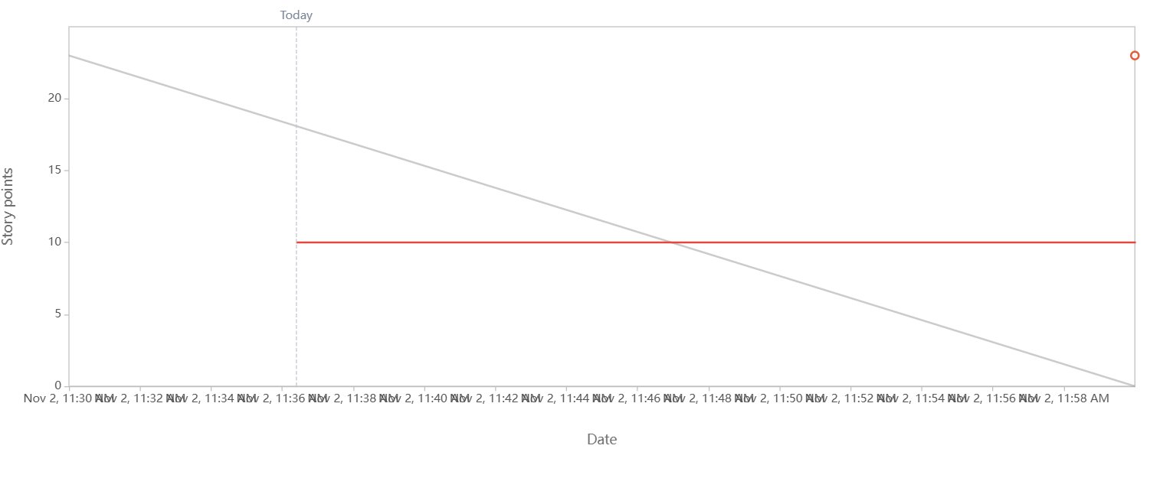
Sprint 1 Burndown (Later stage)
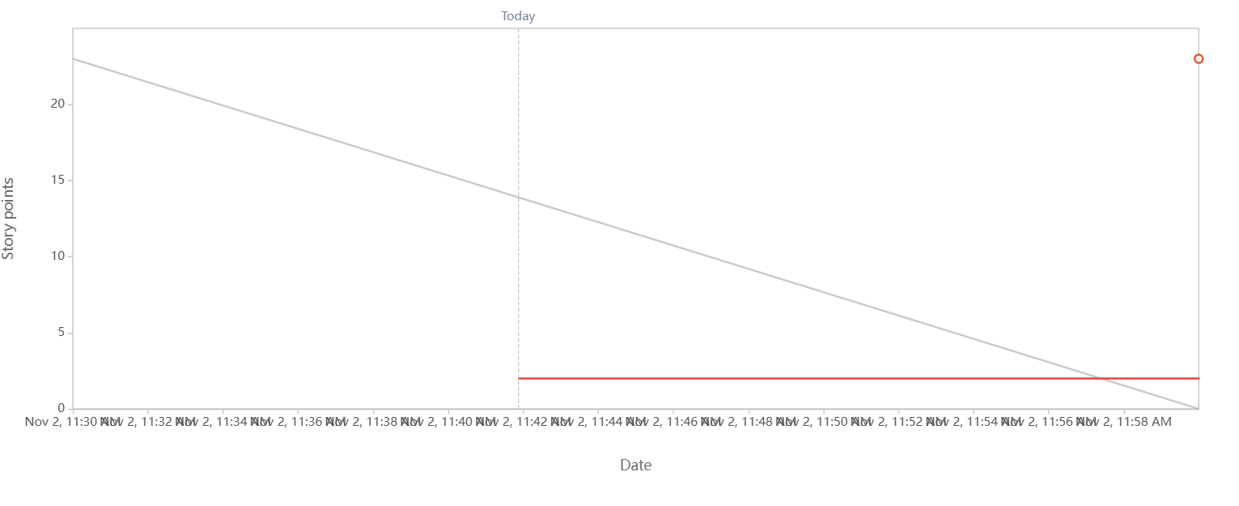

Product 1 Burn-up (Initial and mid way)
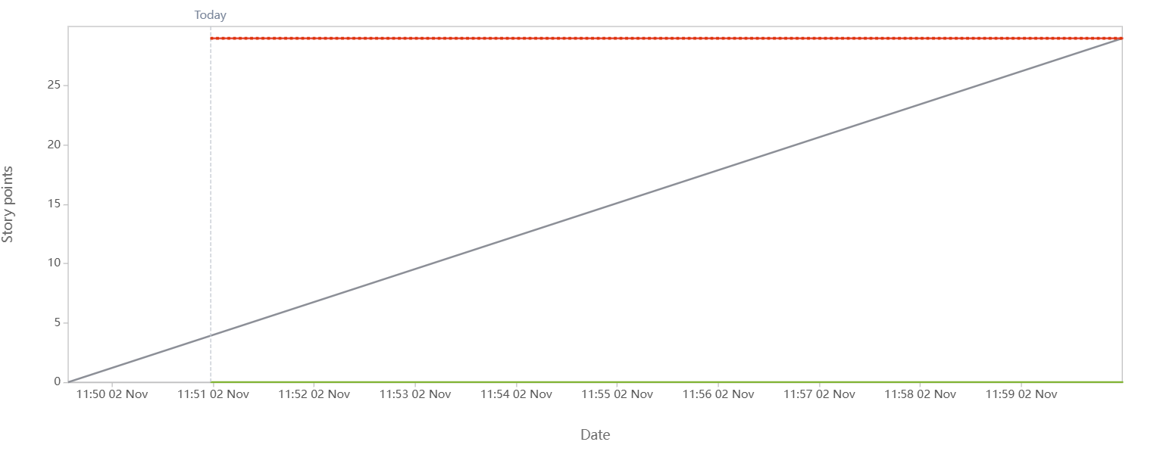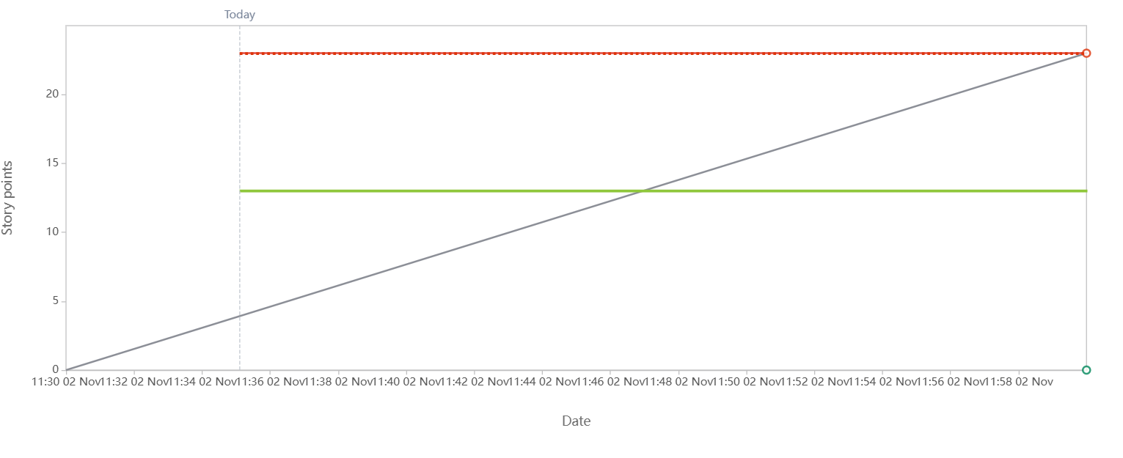

Sprint 2 Burndown

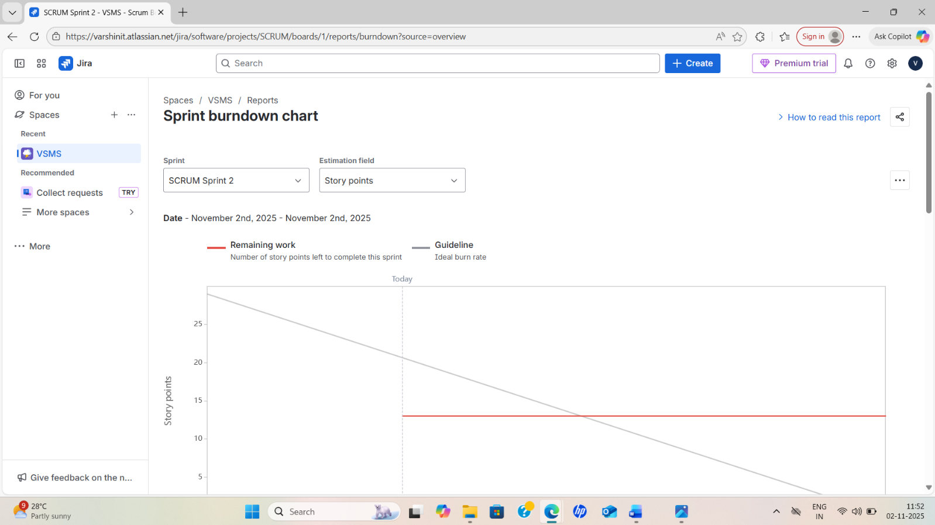

Product 2 Burn-up

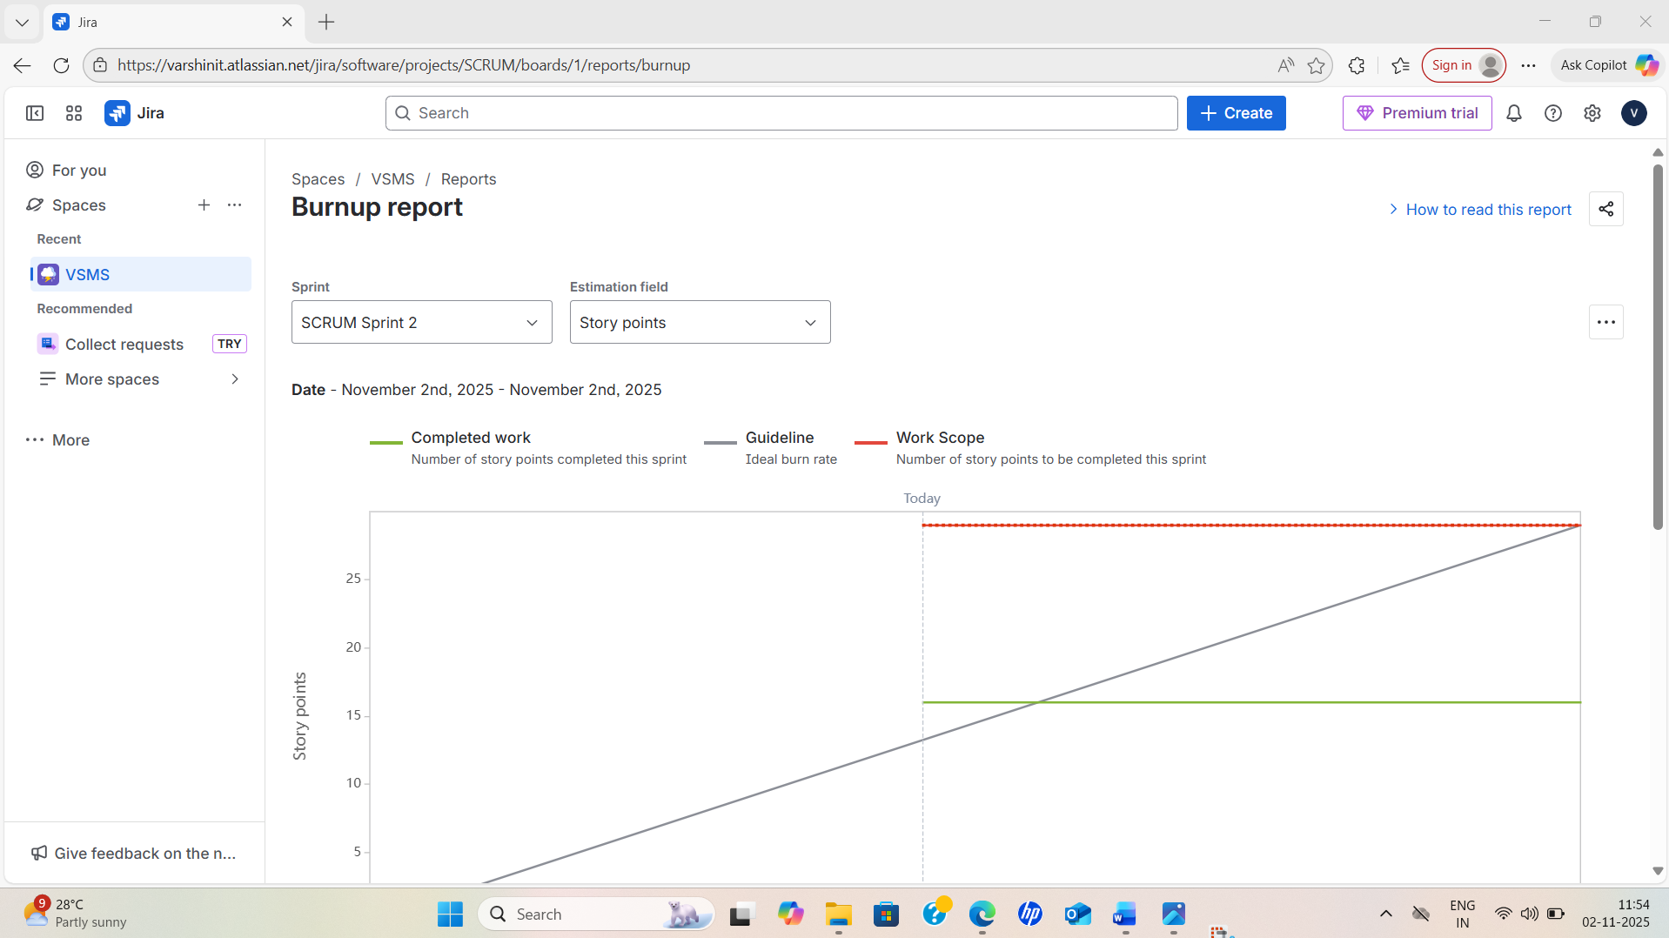

Sprint 3 Burndown

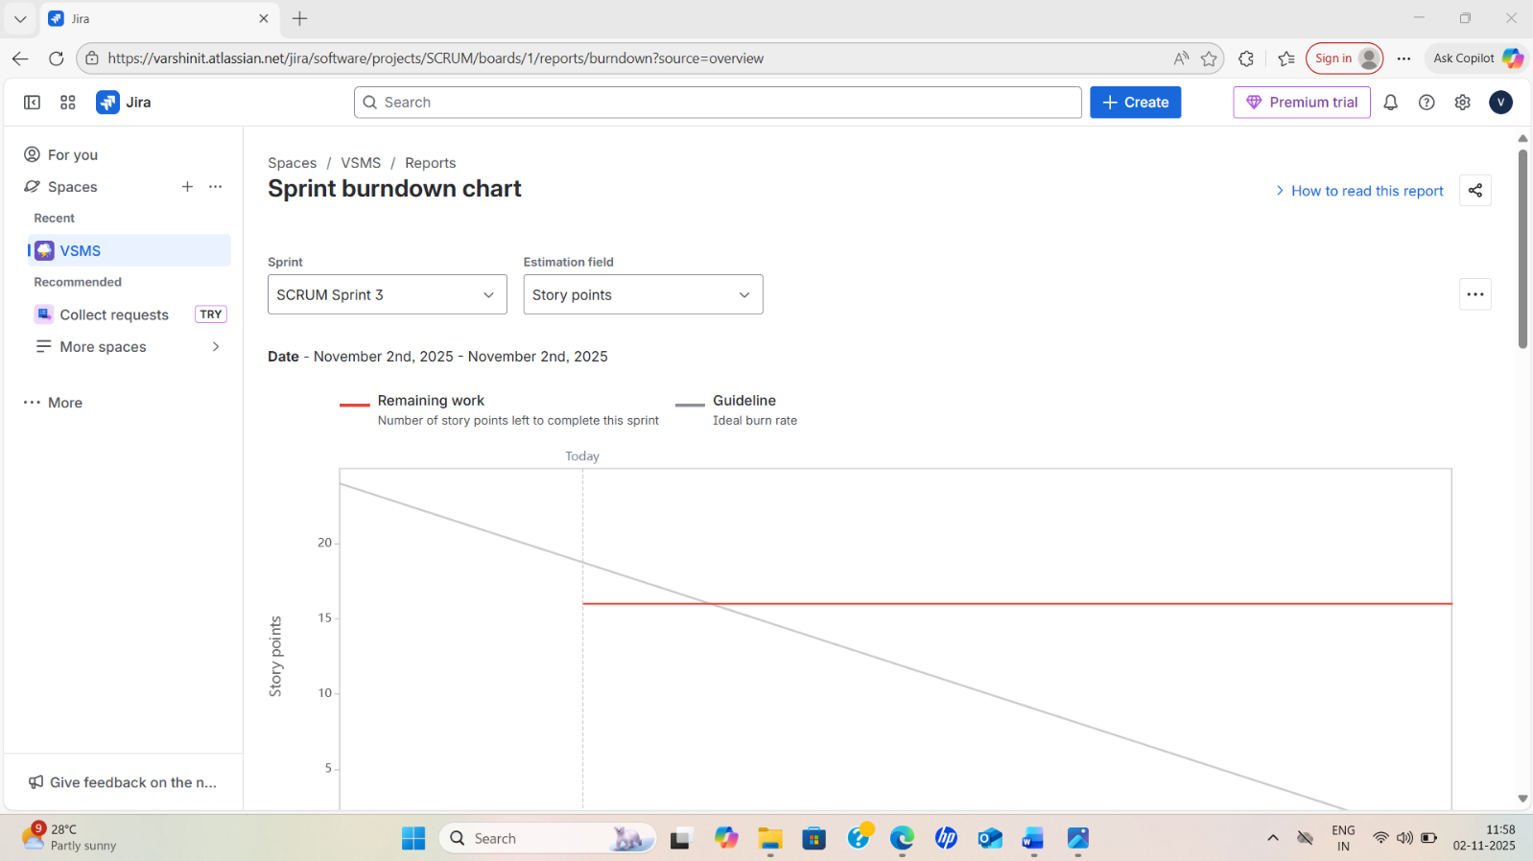

Product 3 Burn-up
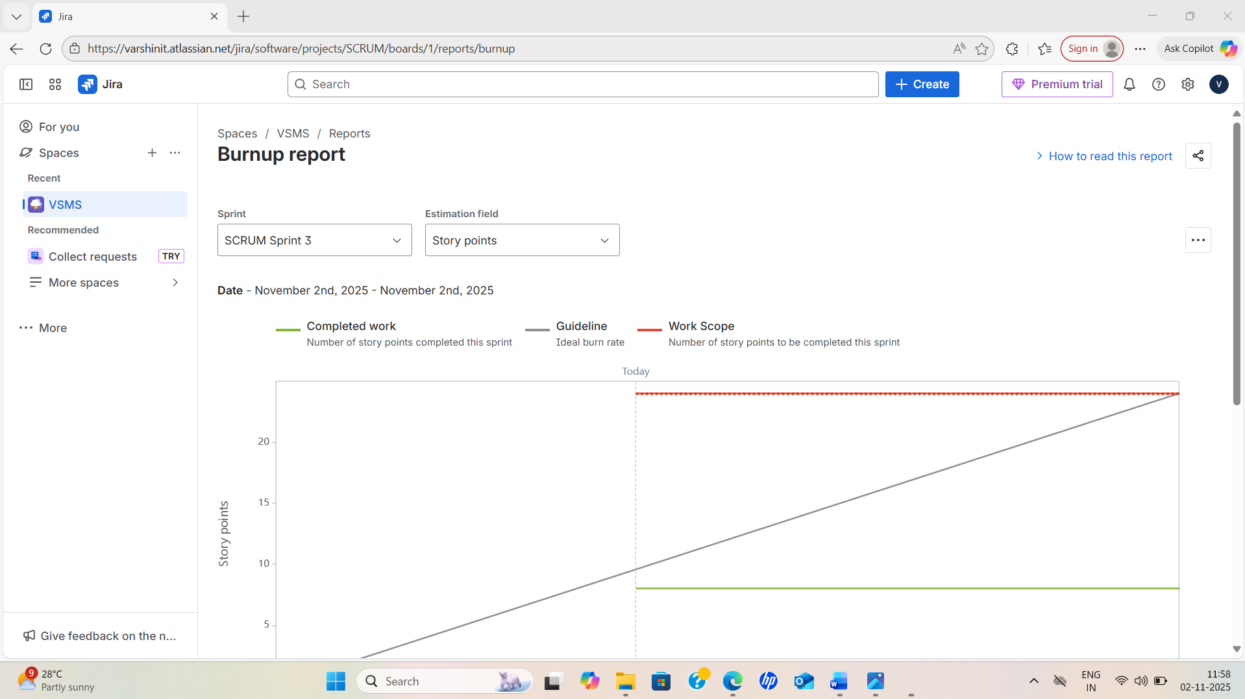

Sprint 4 Burndown

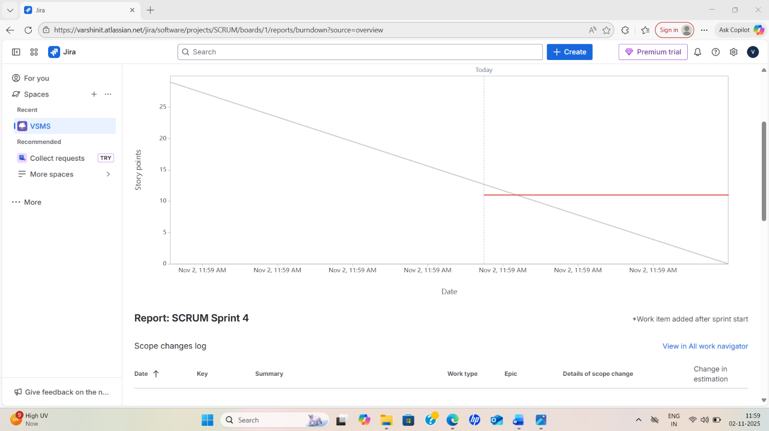

Product 4 Burn-up

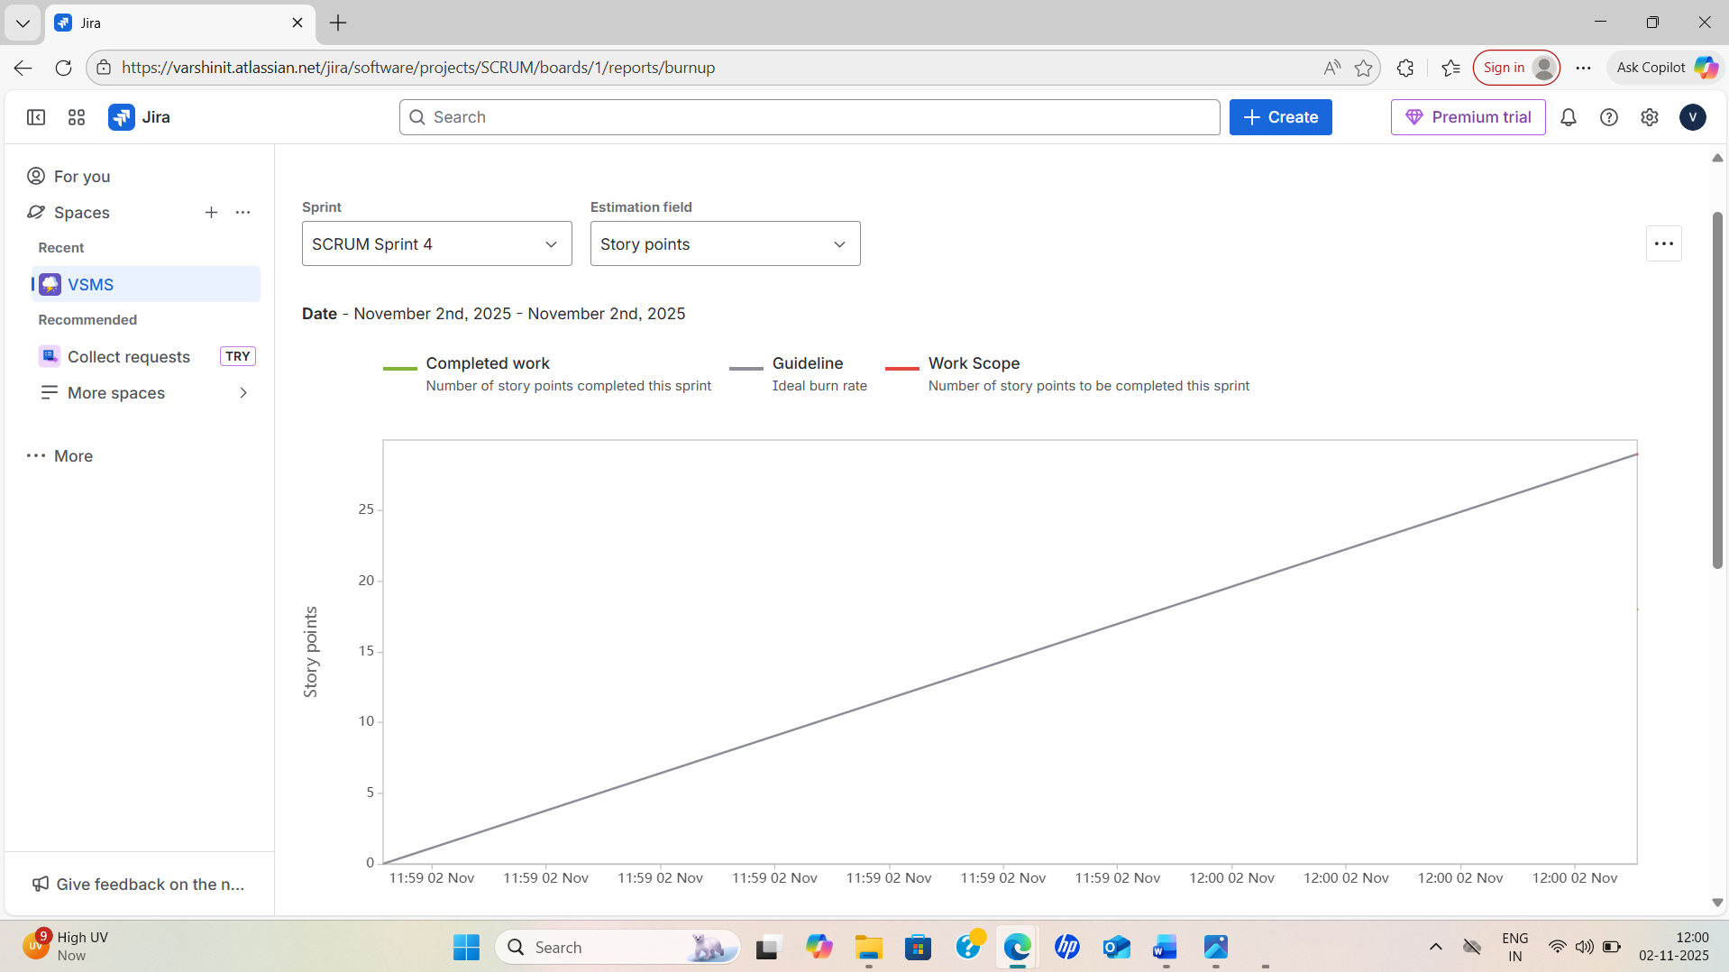
Document 6 – Sprint Meetings
- Sprint Planning Meeting
Objective:
To define the sprint goal, select backlog items, and plan how the team will deliver them within the sprint timeline.
Key Participants:
- Product Owner – Mr. Karthik (COEPD)
- Scrum Master – Mr. Vandanam
- Business Analyst – Varshini Thoudishetty
- Development Team – Juhi, Lucie, Tucker, Tyson, Bravo
- QA Team – Jason, Alekya
Frequency:
Held at the start of each sprint (2 hours per week of sprint)
For a 2-week sprint, Planning ≈ 4-hour meeting
Agenda:
- Review product backlog items (User Stories 1–20).
- Discuss sprint capacity and velocity.
- Identify sprint goal and commit stories.
- Define Definition of Done (DoD) for each story.
- Break stories into tasks with time estimates.
Example – Sprint 2 (Login & Attendance):
- Sprint Goal: Complete student/faculty login and attendance modules.
- Stories Selected: US 4–6.
- Committed Effort: 30 Story Points.
- Outcome: Sprint backlog created in Jira and approved by PO.

Date | 10-Oct-25
Time | 10:00 AM – 2:00 PM
Location | COEPD Conference Room / Microsoft Teams (Hybrid)
Prepared By | Varshini Thoudishetty – Business Analyst
Attendees | Product Owner – Mr. Karthik (COEPD) Scrum Master – Mr. Vandanam BA – Varshini Thoudishetty Developers – Juhi, Lucie, Tucker, Tyson, Bravo QA – Jason, Alekya

Agenda Topic | Presenter | Time Allotted
Review prioritized backlog (US 4–6) | Product Owner | 30 min
Define Sprint Goal & Deliverables | Scrum Master | 20 min
Story-point estimation (Planning Poker) | Dev Team | 40 min
Finalize Definition of Done (DoD) | BA / QA | 30 min
Assign tasks & setup Jira board | Scrum Master | 45 min
Identify risks and dependencies | Dev / QA | 30 min
Approve sprint backlog | Product Owner | 25 min

Field | Details
Observers | Faculty Coordinator & Project Sponsor – Mr. Henry
Resources Used | Jira, Confluence, Figma, Microsoft Teams
Special Notes | Sprint 2 goal set as “Deliver Login and Attendance modules.” All stories (30 SP) approved by PO; Sprint Review scheduled for 24 Oct 2025.

- Sprint Review Meeting
Objective:
To demonstrate completed work to stakeholders and gather feedback for improvement or reprioritization.
Frequency:
End of each sprint (2 hours)
Participants:
Product Owner, Scrum Master, BA, Developers, Testers, and Key Stakeholders (Admin, Faculty reps).
Agenda:
- Demo of completed user stories.
- Review acceptance criteria and confirm completion (DoD).
- Discuss feedback and potential new backlog items.
- PO accepts or rejects stories.
Example – Sprint 4 (Notifications, Library, Hostel):
- Demo: Notification alerts and library issue/return module.
- Stakeholder Feedback: Requested push notifications via SMS.
- PO Decision: Added “SMS Notification Integration” as a new user story for Sprint 5.
Outcome:
- Accepted stories added to release backlog.
Unfinished stories moved to next sprint’s backlog.
Field | Information
Date | 24 October 2025
Time | 3:00 PM – 5:00 PM
Location | COEPD Conference Room / Microsoft Teams
Prepared By | Varshini Thoudishetty – Business Analyst
Attendees | Product Owner – Mr. Karthik (COEPD) Scrum Master – Mr. Vandanam Business Analyst – Varshini Thoudishetty Developers – Juhi, Lucie, Tucker, Tyson, Bravo QA Team – Jason, Alekya Stakeholders – Faculty & Admin Representatives

Sprint Status | Things to Demo | Quick Updates | What’s Next
Sprint 2 Completed Successfully Total 3 stories (US 4–6) committed, all accepted. | - Student Login Module (with authentication API) - Attendance Management Module - Admin Dashboard Attendance Summary | - All stories met Definition of Done (DoD). - 2 minor bugs fixed during sprint. - Team maintained steady velocity of 30 SP. | - Integrate SMS notification service (new story). - Prepare Sprint 3 backlog (US 7–9). - Plan for grading and timetable modules.

- Sprint Retrospective Meeting
Objective:
To reflect on the sprint process, identify what went well, what didn’t, and define actionable improvements.
Frequency:
After each sprint review (1–1.5 hours)
Participants:
Scrum Master, BA, Development & QA Teams (PO optional).
Agenda:
- Review previous retrospective actions.
- Discuss:
  - What went well?
  - What could be improved?
  - What will we commit to change next sprint?
- Create actionable improvement plan.
Example – Sprint 5 (Fees & Reports):
- What went well: Fee receipt automation completed ahead of schedule.
- What didn’t: Testing took longer due to missing data sets.
- Improvement: Include test data preparation in sprint planning; use shared test DB.
Action Items for Next Sprint:
- QA to begin test case design early.
Developers to deliver API endpoints mid-sprint for early integration testing.

Field | Information
Date | 25 October 2025
Time | 10:00 AM – 11:30 AM
Location | COEPD Training Room / Microsoft Teams
Prepared By | Varshini Thoudishetty – Business Analyst
Attendees | Scrum Master – Mr. Vandanam Business Analyst – Varshini Thoudishetty Developers – Juhi, Lucie, Tucker, Teyson, Bravo QA – Jason, Alekya Product Owner – Optional Attendee

Agenda | What Went Well | What Didn’t Go Well | Questions | Reference
Review of Sprint 2 performance and lessons learned | - All committed user stories (US 4–6) completed on time. - Communication among Dev and QA improved through daily stand-ups. - Dependencies identified early helped avoid blockers. | - Delay in preparing test data for attendance module. - UI alignment bugs identified late in QA phase. | - How can we ensure test data readiness before Sprint start? - Should mid-sprint demos become a standard practice? | Sprint 2 Burndown Chart, QA Test Report, Jira Sprint Summary
Identify process improvements for next sprint | - Team collaboration improved, morale high. | - No structured mid-sprint validation checkpoint. | - Who will monitor DoD adherence mid-sprint? | Sprint Velocity Report, Team Feedback Notes

- Daily Stand-up Meeting
Objective:
To synchronize the team’s daily progress, identify impediments, and adjust plan to stay on track.
Frequency:
Daily (15 minutes) throughout each sprint.
Participants:
Scrum Master, Developers, QA, BA (optional attendance by PO).
Format (Three Key Questions):
- What did you do yesterday?
- What will you do today?
- Are there any blockers or issues?
Example – Sprint 3 (Grading & Timetable):
- Developer (Lucie): Completed grade entry UI.
- QA (Jason): Found 2 minor defects in GPA calculation.
- Scrum Master: Assigned fix to Tucker, resolved dependency before Day 7.
Output:
- Updated task board (To Do → In Progress → Done).
- Identified blockers quickly, ensuring velocity remained stable.
Question | Name/Role | Monday | Tuesday | Wednesday | Thursday | Friday | Saturday
What did you do yesterday? | Developer 1 – Juhi | Completed login UI wireframes | Integrated login API | Front-end testing | Fixed UI bugs | Deployed build | Reviewed QA feedback
What did you do yesterday? | Developer 2 – Tucker | Designed DB schema | Built login API | Linked backend | Completed attendance logic | Tested endpoints | Refactored code
What did you do yesterday? | Developer 3 – Alekya | Prepared test cases | Executed tests | Reported 2 bugs | Verified fixes | Regression testing | Prepared summary
What will you do today? | Developer 1 – Juhi | Integrate validation API | UI alignment fixes | Front-end testing | Data validation | Prepare final build | Share demo UI
What will you do today? | Developer 2 – Tucker | Build DB triggers | Backend testing | Support QA | Optimize APIs | Finalize scripts | Prepare release
What will you do today? | Developer 3 – Alekya | Execute functional tests | Log defects | Validate fixes | Test report gen | Prepare UAT | Conduct dry run
What (if any) is blocking your progress? | Developer 1 – Juhi | Waiting for API delivery |  |  | Minor UI bug | None
What (if any) is blocking your progress? | Developer 2 – Tucker | Waiting for DB access |  |  | None | None
What (if any) is blocking your progress? | Developer 3 – Alekya | Delay in new build |  |  | Test data missing | Resolved

- Communication Summary (Meetings Overview)
Meeting Type | Frequency | Duration | Purpose | Facilitator
Sprint Planning | Start of each sprint | 4 hrs | Define sprint goal, commit backlog | Scrum Master
Daily Stand-up | Every day | 15 min | Track progress, identify blockers | Scrum Master
Sprint Review | End of each sprint | 2 hrs | Demo completed stories, get feedback | Product Owner
Sprint Retrospective | After Review | 1 hr | Process improvement | Scrum Master

- Key Observations from Sprint Meetings
- Daily stand-ups significantly reduced blockers and improved communication.
- Regular sprint reviews ensured stakeholder alignment and early feedback, reducing rework by 20%.
- Retrospectives improved team morale and delivery consistency.
- Sprint planning meetings aligned the team’s focus and ensured velocity stability across 6 sprints.

