Question 1 – Functional Requirements:
Req ID | Req Name | Description
FR001 | User Registration | Users (Farmer, Manufacturer, Delivery Partner) should be able to register into the application with their Email ID & Mobile No
FR002 | Login | User should be able to login with their User ID and Password
FR003 | Browse & Search | Farmers should be able to browse and search for the products by category, brand and price.
FR004 | Add to Cart | Farmers should be able to add their products to their carts to save or to buy later.
FR005 | Place Order | Farmers should be able to place an order with selected products
FR006 | Multiple Payment Options | Farmers should be able to make pay through multiple payment options (UPI, COD, Debit/Credit Card)
FR007 | Payment Confirmation | Farmers should get the payment confirmation to their email and SMS.
FR008 | Track Order | Farmers should be able to track their products in real time.
FR009 | Notifications / Alerts | Farmers should get notifications for order updates
FR010 | Manage Product Listing | Manufacturer should be able manage their products listing (add, delete, update)
FR011 | Stoke & Price Management | Manufacturers should be able to set their price and stock levels
FR012 | View & Approve Orders | Manufacturers should be able to view and approve the orders they received from farmers.
FR013 | Delivery Assignment | Delivery partners should accept and update delivery assignment.
FR014 | Delivery Status Update | Delivery partners should accept and update the delivery status
FR015 | Profile Management | Users should be able to update their profiles.
FR016 | Password Reset | Users should be able to reset their password via email or mobile otp.
FR017 | Order Cancellation & Refund | Farmers should be able to cancel the order and process for refund.
FR018 | Support Requests | The system shall allow admins to support queries or complaints
FR019 | Reporting Dashboard | The System should generate reporting dashboards for orders, sales, revenue, ratings and delivery performances.
FR020 | Rating & Reviews | Farmers should be able to give rating & review for the purchased products after delivery.

Non-Functional Requirements:
Req ID | Req Name | Description
NFR001 | No of Users | The system shall support at least 1000 users without decrease in performance.
NFR002 | Response Time | The system shall display the search results within 3 seconds.
NFR003 | Data Encryption | The system shall encrypt all sensitive data using AES-256 encryption.
NFR004 | Two-Factor Authentication | The system should allow two-factor authentication for login.
NFR005 | Session Timeout | The system shall log out automatically after 15 minutes of inactivity.
NFR006 | Availability | The system shall be available 99.9% of the time (uptime)
NFR007 | Backup & Restore | The system shall provide backup & restore functionality on a daily basis.
NFR008 | Disaster Recovery | The system shall ensure recovery from system failure with two hours.
NFR009 | User Friendly UI | The system shall provide a user-friendly interface for farmers with minimum digital skills.
NFR010 | Multilingual Support | The system shall support multiple languages
NFR011 | Platform Support | The system shall support multiple platforms (Android, iOS, Windows, Web)
NFR012 | Browser Compatibility | The system shall support different browsers (Chrome, Edge, Opera, Firefox)
NFR013 | GST Compliance | The system shall generate invoices that meet GST compliance requirements.
NFR014 | API Integration | The system shall support API integration with payment gateways and logistics services.
NFR015 | Maintainability | The system shall allow easy configuration changes without major code updates.
NFR016 | Mobile Responsiveness | The system shall allow easy navigation with mobile responsiveness.
NFR017 | Logging & Auditing | The system shall log all errors and user activities for audit and troubleshooting.
NFR018 | Deployment Flexibility | The system shall be deployable on both cloud and on-premises environments.
NFR019 | Data Privacy Compliance | The system shall comply with GDPR/Indian Data Protection laws for user privacy
NFR020 | Scalability | The system shall scale horizontally to handle increased users during peak seasons.

Question 2–Minimum 5 page designs:
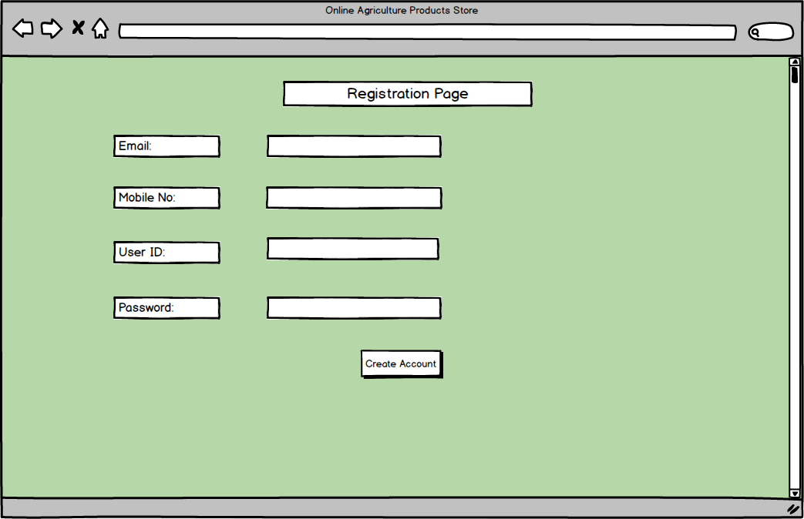
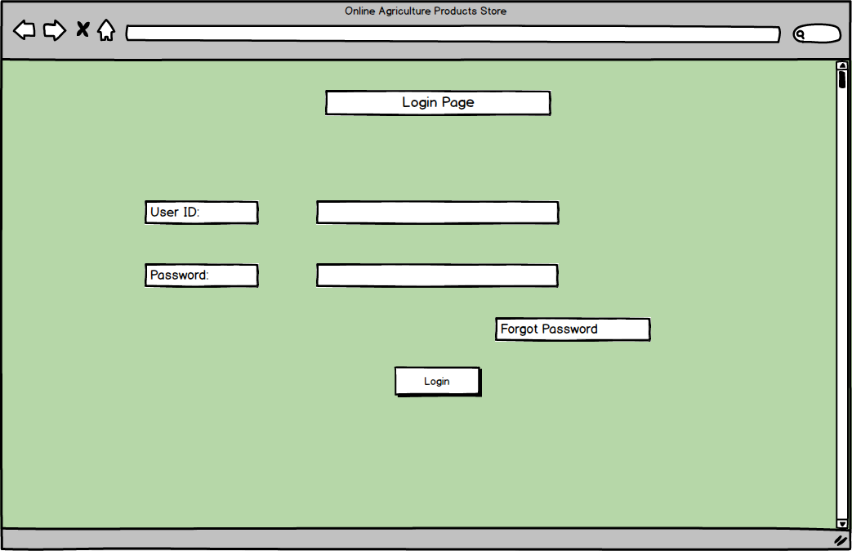
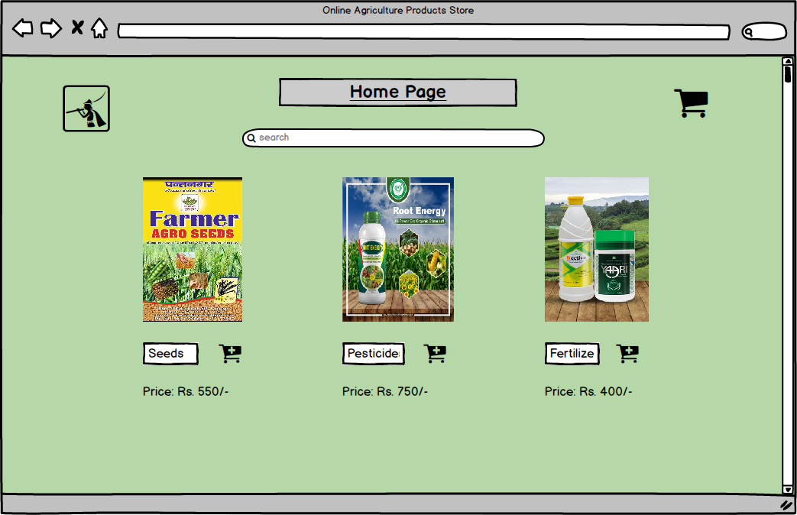
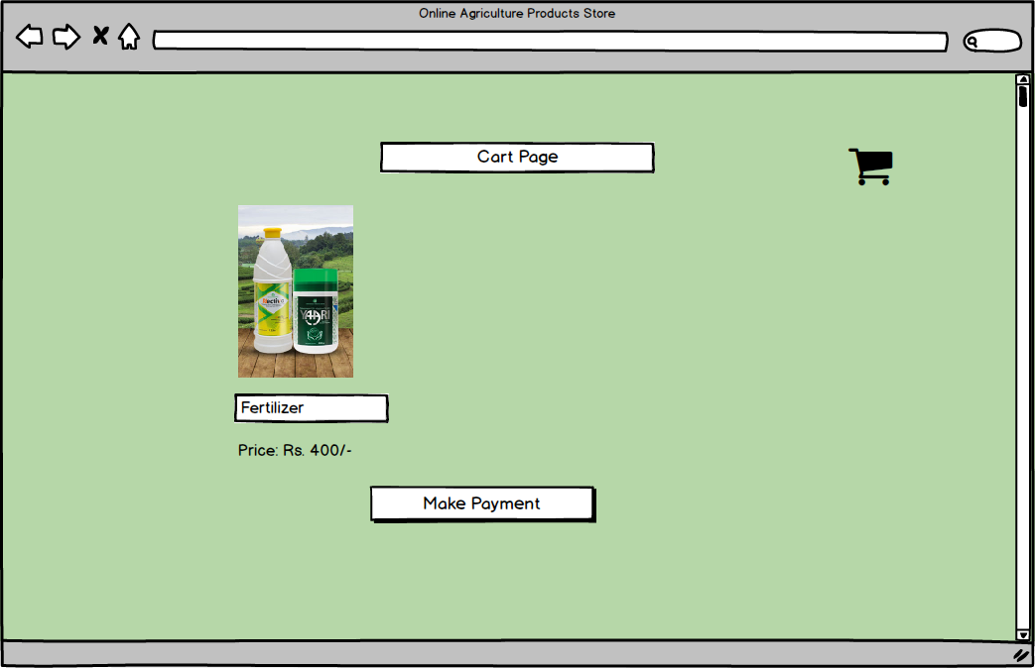
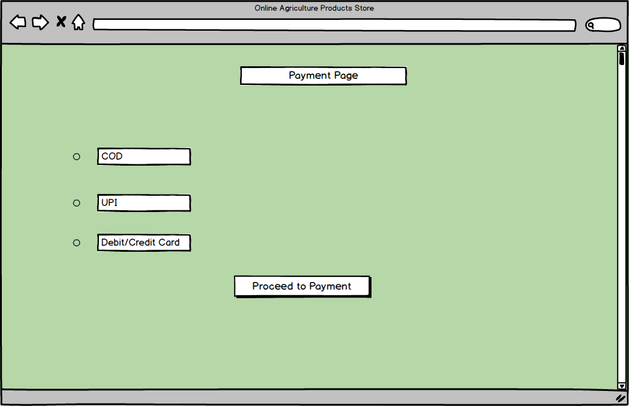
Question 3 – Tools (Visio, Balsamiq):
- MS Visio: MS Visio (Microsoft Visio) is a diagramming and vector graphics application developed by Microsoft. It is commonly used for creating professional diagrams, flowcharts, organizational charts, network diagrams, process maps, floor plans, engineering designs, and more.
- Balsamiq: Balsamiq is a wireframing tool designed to help users quickly create mock-ups and low-fidelity sketches of user interfaces for websites, web applications, and mobile apps. Its main feature is its simple, drag-and-drop style that looks and feels like drawing on a whiteboard, making it easy to focus on layout and structure rather than detailed design.
- Axure: Axure (Axure RP) is a professional prototyping and wireframing tool used for designing interactive, high-fidelity prototypes of web and mobile applications. Unlike simple sketching tools, Axure allows users to build clickable, realistic demos that closely mimic real software behaviour, including complex interactions, dynamic content, and conditional logic.

Question 4 – RTM:
Req ID | Req Name | Description | Design | Code | UT | CT | ST | SIT | UAT
FR001 | User Registration | Users (Farmer, Manufacturer, Delivery Partner) should be able to register into the application with their Email ID & Mobile No | ✅ | ✅ | ✅ | ✅ | ✅ | ✅
FR002 | Login | User should be able to login with their User ID and Password | ✅ | ✅ | ✅ | ✅ | ✅ | ✅
FR003 | Browse & Search | Farmers should be able to browse and search for the products by category, brand and price. | ✅ | ✅ | ✅ | ✅ | ✅ | ✅
FR004 | Add to Cart | Farmers should be able to add their products to their carts to save or to buy later. | ✅ | ✅ | ✅ | ✅
FR005 | Place Order | Farmers should be able to place an order with selected products | ✅ | ✅ | ✅ | ✅
FR006 | Multiple Payment Options | Farmers should be able to make pay through multiple payment options (UPI, COD, Debit/Credit Card) | ✅ | ✅ | ✅ | ✅
FR007 | Payment Confirmation | Farmers should get the payment confirmation to their email and SMS. | ✅ | ✅ | ✅ | ✅
FR008 | Track Order | Farmers should be able to track their products in real time. | ✅ | ✅ | ✅ | ✅
FR009 | Notifications / Alerts | Farmers should get notifications for order updates | ✅ | ✅ | ✅ | ✅
FR010 | Manage Product Listing | Manufacturer should be able manage their products listing (add, delete, update) | ✅ | ✅
FR011 | Stoke & Price Management | Manufacturers should be able to set their price and stock levels | ✅ | ✅
FR012 | View & Approve Orders | Manufacturers should be able to view and approve the orders they received from farmers. | ✅ | ✅
FR013 | Delivery Assignment | Delivery partners should accept and update delivery assignment. | ✅ | ✅
FR014 | Delivery Status Update | Delivery partners should accept and update the delivery status | ✅ | ✅
FR015 | Profile Management | Users should be able to update their profiles. | ✅ | ✅
FR016 | Password Reset | Users should be able to reset their password via email or mobile otp. | ✅
FR017 | Order Cancellation & Refund | Farmers should be able to cancel the order and process for refund. | ✅
FR018 | Support Requests | The system shall allow admins to support queries or complaints | ✅
FR019 | Reporting Dashboard | The System should generate reporting dashboards for orders, sales, revenue, ratings and delivery performances. | ✅
FR020 | Rating & Reviews | Farmers should be able to give rating & review for the purchased products after delivery. | ✅
NFR001 | No of Users | The system shall support at least 1000 users without decrease in performance. | ✅ | ✅ | ✅
NFR002 | Response Time | The system shall display the search results within 3 seconds. | ✅ | ✅ | ✅
NFR003 | Data Encryption | The system shall encrypt all sensitive data using AES-256 encryption. | ✅ | ✅ | ✅
NFR004 | Two-Factor Authentication | The system should allow two-factor authentication for login. | ✅ | ✅ | ✅
NFR005 | Session Timeout | The system shall log out automatically after 15 minutes of inactivity. | ✅ | ✅ | ✅
NFR006 | Availability | The system shall be available 99.9% of the time (uptime) | ✅ | ✅ | ✅
NFR007 | Backup & Restore | The system shall provide backup & restore functionality daily. | ✅ | ✅ | ✅
NFR008 | Disaster Recovery | The system shall ensure recovery from system failure with two hours. | ✅
NFR009 | User Friendly UI | The system shall provide a user-friendly interface for farmers with minimum digital skills. | ✅
NFR010 | Multilingual Support | The system shall support multiple languages | ✅
NFR011 | Platform Support | The system shall support multiple platforms (Android, iOS, Windows, Web) | ✅
NFR012 | Browser Compatibility | The system shall support different browsers (Chrome, Edge, Opera, Firefox) | ✅
NFR013 | GST Compliance | The system shall generate invoices that meet GST compliance requirements. | ✅
NFR014 | API Integration | The system shall support API integration with payment gateways and logistics services. | ✅
NFR015 | Maintainability | The system shall allow easy configuration changes without major code updates. | ✅
NFR016 | Mobile Responsiveness | The system shall allow easy navigation with mobile responsiveness. | ✅
NFR017 | Logging & Auditing | The system shall log all errors and user activities for audit and troubleshooting. | ✅
NFR018 | Deployment Flexibility | The system shall be deployable on both cloud and on-premises environments. | ✅
NFR019 | Data Privacy Compliance | The system shall comply with GDPR/Indian Data Protection laws for user privacy | ✅
NFR020 | Scalability | The system shall scale horizontally to handle increased users during peak seasons. | ✅

Question 5 – 10 Test Case Documents:
Test Case ID | PQ786T001 | Test Case Name | Registration
Project ID | PQ786 | Project Name | Online Agriculture Products Store
PM ID | 4869 | PM Name | Mr. Vandanam
Test Strategy ID | PQ786TS001 | Tester ID | 5717
Test Plan ID | PQ786TP001 | Tester Name | Mr. Jason
Test Schedule ID | PQ786TS001 | Date of Test
Scenario | User Registration – To verify Farmer can register successfully
Link to that Page:
 | Set 1 | Set 2 | Set 3
Input Data | Name: Peter  Email: peter@gmail.com  Mobile No: 91xxxxx7  User ID: Peter.Farmer  Password: test@123 | Name: Ben  Email: ben@gmail.com  Mobile No: 91xxxxx4  User ID: Ben.Farmer  Password: test@456 | Name: Kevin  Email: kevin@gmail.com  Mobile No: 91xxxxx5  User ID: Kevin.Farmer  Password: test@789
Expected Behaviour | Farmer account created & confirmation displayed | Farmer account created & confirmation displayed | Farmer account created & confirmation displayed
Actual Behaviour
Comments
Result Pass/Fail

Test Case ID | PQ786T002 | Test Case Name | Farmer Login
Project ID | PQ786 | Project Name | Online Agriculture Products Store
PM ID | 4869 | PM Name | Mr. Vandanam
Test Strategy ID | PQ786TS002 | Tester ID | 5717
Test Plan ID | PQ786TP002 | Tester Name | Mr. Jason
Test Schedule ID | PQ786TS002 | Date of Test
Scenario | Verify registered farmer can login
Link to that Page:
 | Set 1 | Set 2 | Set 3
Input Data | User ID: Peter.Farmer  Password: test@123 | User ID: Ben.Farmer  Password: test@456 | User ID: Kevin.Farmer  Password: test@789
Expected Behaviour | Farmer logged in & redirected to dashboard | Farmer logged in & redirected to dashboard | Farmer logged in & redirected to dashboard
Actual Behaviour
Comments
Result Pass/Fail

Test Case ID | PQ786T003 | Test Case Name | Browse Product
Project ID | PQ786 | Project Name | Online Agriculture Products Store
PM ID | 4869 | PM Name | Mr. Vandanam
Test Strategy ID | PQ786TS003 | Tester ID | 5717
Test Plan ID | PQ786TP003 | Tester Name | Mr. Jason
Test Schedule ID | PQ786TS003 | Date of Test
Scenario | Verify that farmers can view products
Link to that Page:
 | Set 1 | Set 2 | Set 3
Input Data | Category: Seeds | Category: Fertilizers | Category: Pesticides
Expected Behaviour | Products displayed with name, price, quantity | Products displayed with name, price, quantity | Products displayed with name, price, quantity
Actual Behaviour
Comments
Result Pass/Fail

Test Case ID | PQ786T004 | Test Case Name | Manage Product
Project ID | PQ786 | Project Name | Online Agriculture Products Store
PM ID | 4869 | PM Name | Mr. Vandanam
Test Strategy ID | PQ786TS004 | Tester ID | 5717
Test Plan ID | PQ786TP004 | Tester Name | Mr. Jason
Test Schedule ID | PQ786TS004 | Date of Test
Scenario | Verify manufacturer can add product
Link to that Page:
 | Set 1 | Set 2 | Set 3
Input Data | Product: Seeds  Price: 550  Qty: 100 | Product: Fertilizers  Price: 400  Qty: 100 | Product: Pesticides  Price: 750  Qty: 100
Expected Behaviour | Product added successfully & visible to farmers | Product added successfully & visible to farmers | Product added successfully & visible to farmers
Actual Behaviour
Comments
Result Pass/Fail

Test Case ID | PQ786T005 | Test Case Name | Place Order
Project ID | PQ786 | Project Name | Online Agriculture Products Store
PM ID | 4869 | PM Name | Mr. Vandanam
Test Strategy ID | PQ786TS005 | Tester ID | 5717
Test Plan ID | PQ786TP005 | Tester Name | Mr. Jason
Test Schedule ID | PQ786TS005 | Date of Test
Scenario | Verify farmer can place order
Link to that Page:
 | Set 1 | Set 2 | Set 3
Input Data | Product: Seeds  Qty: 10 | Product: Fertilizer  Qty: 7 | Product: Pesticides  Qty: 5
Expected Behaviour | Order placed successfully with order ID | Order placed successfully with order ID | Order placed successfully with order ID
Actual Behaviour
Comments
Result Pass/Fail

Test Case ID | PQ786T006 | Test Case Name | Payment Processing
Project ID | PQ786 | Project Name | Online Agriculture Products Store
PM ID | 4869 | PM Name | Mr. Vandanam
Test Strategy ID | PQ786TS006 | Tester ID | 5719
Test Plan ID | PQ786TP006 | Tester Name | Ms. Alekya
Test Schedule ID | PQ786TS006 | Date of Test
Scenario | Verify successful payment for order
Link to that Page:
 | Set 1 | Set 2 | Set 3
Input Data | UPI: 9186xxxxx8@upi | Debit Card: 5712 8547 5621 | Credit Card: 2452 1547 5628
Expected Behaviour | Payment processed and confirmation shown | Payment processed and confirmation shownPayment processed and confirmation shown | Payment processed and confirmation shownPayment processed and confirmation shown
Actual Behaviour
Comments
Result Pass/Fail

Test Case ID | PQ786T007 | Test Case Name | Add to Cart
Project ID | PQ786 | Project Name | Online Agriculture Products Store
PM ID | 4869 | PM Name | Mr. Vandanam
Test Strategy ID | PQ786TS007 | Tester ID | 5719
Test Plan ID | PQ786TP007 | Tester Name | Ms. Alekya
Test Schedule ID | PQ786TS007 | Date of Test
Scenario | Verify Farmer can add products to Cart
Link to that Page:
 | Set 1 | Set 2 | Set 3
Input Data | Product: Seeds  Qty: 10 | Product: Fertilizer  Qty: 7 | Product: Pesticides  Qty: 5
Expected Behaviour | Products added to cart & saved | Products added to cart & saved | Products added to cart & saved
Actual Behaviour
Comments
Result Pass/Fail

Test Case ID | PQ786T008 | Test Case Name | Track Order
Project ID | PQ786 | Project Name | Online Agriculture Products Store
PM ID | 4869 | PM Name | Mr. Vandanam
Test Strategy ID | PQ786TS008 | Tester ID | 5719
Test Plan ID | PQ786TP008 | Tester Name | Ms. Alekya
Test Schedule ID | PQ786TS008 | Date of Test
Scenario | Verify farmer can track order
Link to that Page:
 | Set 1 | Set 2 | Set 3
Input Data | OrderID: 1001 | OrderID: 1002 | OrderID: 1003
Expected Behaviour | Correct delivery status displayed | Correct delivery status displayed | Correct delivery status displayed
Actual Behaviour
Comments
Result Pass/Fail

Test Case ID | PQ786T009 | Test Case Name | Update Order Status
Project ID | PQ786 | Project Name | Online Agriculture Products Store
PM ID | 4869 | PM Name | Mr. Vandanam
Test Strategy ID | PQ786TS009 | Tester ID | 5719
Test Plan ID | PQ786TP009 | Tester Name | Ms. Alekya
Test Schedule ID | PQ786TS009 | Date of Test
Scenario | Verify delivery partner updates status
Link to that Page:
 | Set 1 | Set 2 | Set 3
Input Data | Status: Out for delivery | Status: In transit | Status: Delivered
Expected Behaviour | System shows updated delivery status | System shows updated delivery status | System shows updated delivery status
Actual Behaviour
Comments
Result Pass/Fail

Test Case ID | PQ786T010 | Test Case Name | Logout Functionality
Project ID | PQ786 | Project Name | Online Agriculture Products Store
PM ID | 4869 | PM Name | Mr. Vandanam
Test Strategy ID | PQ786TS010 | Tester ID | 5719
Test Plan ID | PQ786TP010 | Tester Name | Ms. Alekya
Test Schedule ID | PQ786TS010 | Date of Test
Scenario | Verify logout works for all roles
Link to that Page:
 | Set 1 | Set 2 | Set 3
Input Data | Farmer Login | Manufacturer Login | Admin Login
Expected Behaviour | User logged out & redirected to login page | User logged out & redirected to login page | User logged out & redirected to login page
Actual Behaviour
Comments
Result Pass/Fail

Question 6 – DB Design:
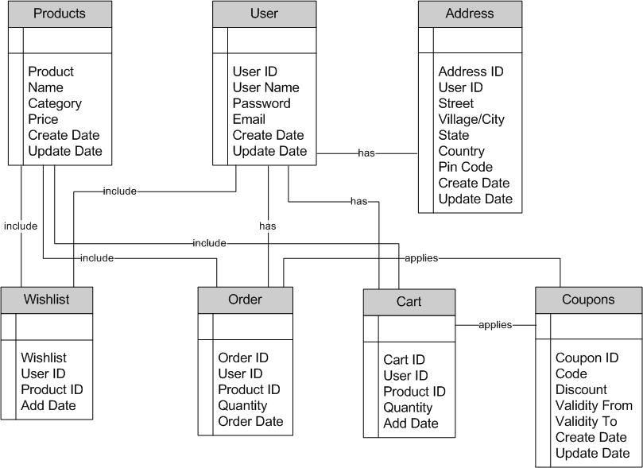
Question 7 – Data Flow Diagram:
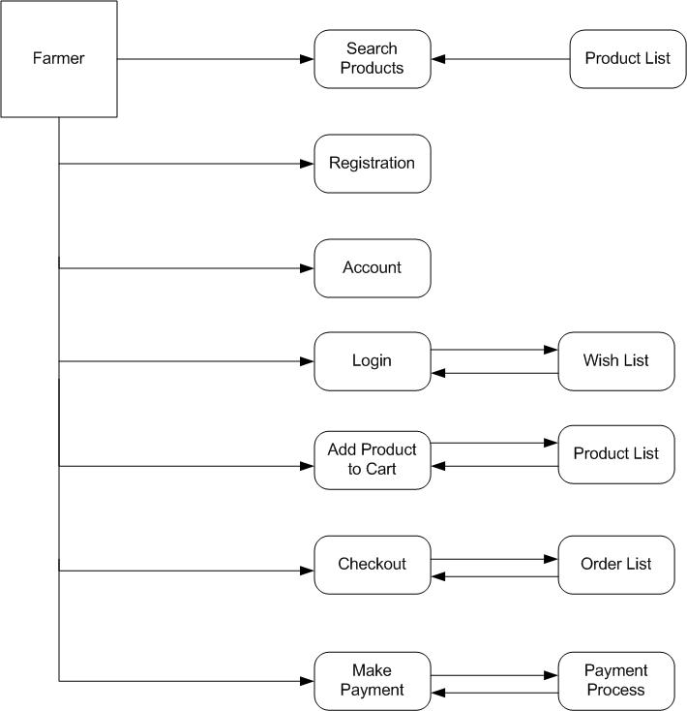

Question 8 – Change Request:
- Understand the scope of change request and document the change request formally in change request form.
- The change manager or project manager must provide an initial approval if BA needs to move further in analyzing the change requested.
- Do Impact Analysis and analyze how change affects scope, schedule, cost, resources and quality.
- Prioritize change requests based on its urgency, importance and impact on the project.
- Present the impact to stakeholders/Change Control Board (CCB) and seek approvals from project sponsor for the change request.
- Update and revise the requirements documents.
- Communicate the change request and its potential impacts to all the stakeholders including project team.
- Ensure the change works as expected.

Question 9 – Change Request Vs an Enhancement:
Change Request: A modification to existing functionality or requirements after the project scope is defined. Usually triggered by external factors like regulatory updates (e.g., Govt Taxation change), errors, or stakeholder feedback. Can impact scope, cost, timeline, and requires approval through the Change Control Process.
Enhancement: An improvement or new feature added to the system to provide extra value but not mandatory for compliance. Usually planned for future releases or continuous. improvement. Does not always impact baseline scope; considered an upgrade, not a correction.
In this project adding the sell crop yields or products and auction system for their crop yields would be considered as an Enhancement as it involves adding a new feature to the system. As a Business Analyst we should document the requirement and work with development team to determine the feasibility and impact of the new feature. We should also consider the potential benefits, risks and costs associated with the enhancement before making any recommendations to the client.

Question 10 – Estimations
The technique of finding an approximation with the help of limited available information is known as Estimation. The estimation is done with sampled data and sources. The estimation is a part of business planning, and it is the responsibility of BAs to estimate the factors related to cost, revenue, resources and future enhancements.
Man hours are the required efforts of the resources to complete a project. There are three types of projects:
- Small – Upto 500 hours
- Medium – Upto 1000 hours
- Large – Upto 1500 hours
Man hours required for this project:
- As per the case study, the duration of the project is 18 months, and the team size is 12 members. Total Working Days in 18 Months is approximately 396 days. Total hours for one person is approximately 3168 hours. Total Manhours required for this project would be approximately 27968 manhours.
- This project is considered as a large project because it requires around 27968 manhours, a 12-member team, and an 18-month duration, with complex workflows like ordering, payments, delivery, and tracking.
Question 11 – UAT:
Planning: In this step, Blue Prints are made to implement UAT testing for every feature that needs to test and get minimum standards for accepting the test.
Designing: Here the test cases are designed to hide all the possibilities of software packages in a real-world environment.
UAT Testers: A testing team consists of an end users that meet the criteria for implementing testing. The end user must have expertise in subject matter, the ability to report the problems.
Bug Fixing: Whatever Bugs are found UAT testing, the development team should work on them and make it software error free.
Sign Off: After removing all the bugs, the testing team indicates acceptance of the completion of the bugs. In this phase all the stakeholders come to a conclusion that the software is ready to GO LIVE and sign it off.
Question 12 – Project Closure Document:
A Project closure document is also known as project closure report. It is a formal document that summarizes the key outcomes, lessons learned and final details of a complete project.
Points to be included in the project closure document are:
- Project Overview: The Online Agriculture Store Project was developed to connect farmers, manufacturers, and delivery partners through a unified platform. The system enables farmers to browse and purchase agricultural products, place orders, make secure payments, and track deliveries. Manufacturers manage product listings and inventory, while delivery partners handle logistics and order fulfilment. The project followed the V-Model SDLC and was executed over 18 months with a 12-member team.
- Achievements: Successfully designed and developed core modules like Farmer Registration & Login, Browsing & Ordering, Secure Payment Gateway, Manufacture Product Management, Delivery Tracking. Delivered the project on schedule within 18 months and within budget constraints.
- Lessons Learned: stakeholder involvement during requirement gathering reduced misunderstandings and rework. Implementing V-Model ensured strong alignment between development and testing phases. Regular sprint reviews improved team collaboration and early defect detection.
- Quality Assurance: Performed unit testing, integration testing, system testing, and UAT to ensure defect-free delivery. Achieved 98% test case pass rate during UAT, confirming alignment with business needs.
- Resource Utilization: Effective allocation of 12 team members, including developers, testers, DB admins, and network admins. Resource productivity was consistently above 90% utilization rate throughout the project.
- Risk Management: Key risks included payment gateway integration failures, server downtime, and delays in UAT. No critical risks escalated to production, and project delays were minimized to under 2% variance.
- Challenges: Mid-project request to include the future auction feature required re-planning but was deferred to Phase 2 to maintain timelines. Initial payment gateway errors were resolved through vendor collaboration and additional testing.
S No | Points to Include | Details | Reference Link
1 | Did the client signed off UAT Testing
 | Date of signoff | 04th September 2025
 | Name of the resource
2 | Objectives of the report
 | User Friendliness | Achieved
 | Customer Satisfaction | ROI in 6 months
 | More Categories | Achieved
3 | Functionalities worked on
 | Registration | Achieved
 | Login | Achieved
 | Browse & Search | Achieved
 | Secured Payment Process | Achieved
4 | Infrastructure
 | Software's installed | Achieved
 | Laptops purchased | Achieved
5 | Funding
 | Amount Approved | Rs. 2 Crore
 | Amount Used | Rs. 1.9 Crore
6 | Overall Project Information
 | Escalations | 50
 | Customer Satisfaction | High
7 | Value to the Company
 | Positive/Negative

