Online Agriculture Products Store

Q.1 – Audits
Ans – Audits:
What is an Audit: - Audit is an inspection of various books of different departments by an auditor followed by physical checking of inventory, financial statement and several other documents to make sure that all the departments are following a documented system of recording transactions.
What is a Project Audit: - A project management audit is a formal review that seeks to evaluate a given project based on the specific criteria. Examples of these can include project quality, performance and adherence to the statement of work.
While doing the audit of a BA, the auditor needs to check the following details.
In Q1 the Auditor will check the following details:
- Understanding of company goal the BA has.
- Work is planned and tracked.
- Understood the current AS IS process.
- BA’s understanding of requirement.
- BA conducted Stakeholder Analysis.
- Requirements gathering and analysis were done correctly.
- What Elicitation techniques have been used to gather requirements.
In Q2 the Auditor will check the following details:
- Documents have been prepared by the BA.
- Has the BA prepared all the required documents like RTM and BPM to understand the requirements correctly.
- How is BA prepared the use case and Activity diagram.
- Were all these documents signed and agreed by the stakeholders, before the start of the development.
In Q3 the Auditor will check the following details:
- Requirements were correctly explained to the development team.
- BA tracking the status of the project.
- JAD session organized by BA.
- Timesheet sent to the reporting manager.
- BA keeping the stakeholders updated on the status of the project.
In Q4 the Auditor will check the following details:
- BA tracking the Testing of the project.
- BA assisting the testing team for testing the product.
- BA sending the test data to the client.
- BA preparing the End user manual.
- BA preparing the client for UAT.
- BA assisting the Delivery manager to implement the product.
- BA helping the client to do UAT.
- BA organizing the training session for the users.
- BA taking sign off document from the client.
- BA sending the complete timesheet to the reporting manager.

Q.2 – BA approach strategy.
Ans – BA approach strategy – The Business analysis approach strategy outlines how Business analysis activity will be conducted within a project. It is a plan that defines the method, techniques, deliverables and timeline for business analysis work. This approach helps ensure that business analysis efforts are aligned with project goals. This could include:
- Business Analysis resource and their Roles and responsibility.
- Requirements gathering approach for the project (techniques to be used, high level planning)
- Stakeholder engagement
- Requirements review process and approval cycles.
- Change management approach to requirement and agreed deliverables.
- Other elements such as team structure, assumption and constraint could also be included.
As a Business Analyst, the following are the steps which need to be followed to complete the project
- Elicitation technique to Apply – There are several techniques to be used to elicit the requirement, however for this project we are going to use the below Elicitation technique-
- Brainstorming – We are going to arrange session, where participants are allowed to provide inputs without criticism, discussion or evolution. The goal is to be creative and gather as many ideas as possible in a short period of time.
- Interviews – We will be interviewing every Stakeholder to elicit the requirements needed to complete the project.
- Workshop – We are going to arrange workshops, which will be focused event and will be attended by key stakeholders and SMEs. The purpose of these workshops will be Planning, Analysis, Design, Scoping, requirement elicitation, modeling or combination of these. This elicitation technique will also be used for gathering ideas for new features of products, to reach consensus on a topic and to review requirements and design.
- Surveys or Questionnaire – There will be survey or Questionnaire sent to all the stakeholders and SMEs, which will be include multiple range of open and close ended questions, which will extract the information about the desired product, work practice and behavioral attitudes etc.

- Stakeholder Analysis – Stakeholder analysis involves identifying the Stakeholders who will be directly or indirectly impacted by the change and analyzing the information once collected.
- Identifying Stakeholders:
- Internal Stakeholders –
- Project Manager – Mr. Vandanam
- Senior Java Developer – Ms. Juhi
- Java developers – Mr. Tyson, Ms. Lucie, Mr. Tucker, Mr. Bravo
- Network Admin – Mr. Mike
- DB Admin – Mr. Jhon
- Testers – Mr. Jason and Ms. Alekya
- BA – Piyush Chaudhary

- External Stakeholders –
- Sponsor – Mr. Henry
- Financial Head – Mr. Pandu
- Project Coordinator – Mr. Dooku
- Key Stakeholders – Peter, Kevin and Ben
- Prioritizing Stakeholders – RACI matrix
RACI -Responsible (R), Accountable (A), Consulted (C), Informed (I)
Task | Mr. Henry (Project Sponsor) | Peter, Kevin, Ben (Key stakeholder) | Mr. Karthik (DH) | Mr. Vandanam (PM) | Ms. Juhi (Sr. Java Developer) | Teyson, Lucie, Bravo & Tucker (Developer) | Mr. Jason & Ms. Alekya (tester) | Mr. Piyush (BA)
Requirement Gathering | - | C | - | A/I | - | A | - | R
Requirement Analysis | - | - | - | I | - | - | - | R
Development | - | - | - | R/A | C/A | R | - | C
Testing | - | - | - | R/A | I | - | R | I
Implementation | - | - | R | I | I | - | - | R
UAT | I | - | - | R/A | - | - | - | C

- Documents to write –
- Project Vision document
- Business Analysis plan Stakeholders analysis document (RACI)
- Business Requirement document
- Functional requirement specification (FRS)/Functional specification document (FSD)
- System requirement specification (SRS)/System requirement document (SRD)

- Signing off the document – Once the above-mentioned documents are prepared, as a BA, I will take up the sign off on the above documents via Email and Physical sign off as well as from the respective stakeholders.
- Project vision document – Email to – Project Sponsor and CC – Financial Head, Project coordinator and project manager
- Business Requirement Document – Project Document (Email and Physical)
- FRS/FRD and SRS/SRD – Email to Project sponsor and CC – Financial Head, Project Coordinator and Project Manager

- Taking Approvals – While taking approvals for all of the above documents, I will call the respective Stakeholder and send them an Email with the details.

- Communication Channel to establish and implement – As a BA, I would prefer the below communication channel:
- Face to Face communication – for requirement gathering stage. For example, interviews with stakeholders.
- Video Conferencing – This communication is also used when the stakeholders is at different locations.
- Phon Calls – This communication is used for setting up the meeting with stakeholders and for taking approvals.
- Emails – These communications used for setting up meeting with stakeholders and for taking approvals.

- How to Handle change request – As a BA, I will handle the change request by understanding the below steps:
- Understanding the scope of Change.
- Determine the scope of incorporating the change request.
- Understanding the feasibility of the change request.
- Taking approval for change.
- Communicating and implementing the change request.

- Updating the Progress of the Project – As a BA before we update the project status, we need to understand few key areas:
- Understand stakeholder Need – WE need to know the stakeholder who we are working with. Stakeholders sometimes prefer the review the date everyday/weekly/biweekly/monthly. Other stakeholders may like to only read descriptive text.
- Proactively listen to your Stakeholders ‘concern – Stakeholders may want to share the specific concern with us in confidence and will rely on us to address potential issues/Risks. As a BA, we need to know how we provide status to our stakeholders. This includes making sure that the project progress status report or dashboards provide enough details. Finally, it should also address their concerns without having them ask about it.
- Develop and execute a communication plan – which means, we need to do stakeholders analysis, an analysis on stakeholders that provide details on who the stakeholder is, and the division are they aligned to. This analysis will contain details of the project that will impact them and interest level of the stakeholders. The analysis also contains details on the stakeholder ability to influence others, and their stance on the overall project.
Once we understand these key areas, we will now have to focus on sharing the project status with stakeholders.
- Utilize online collaboration tools to share regular progress.
- Send out weekly or biweekly reports.
- Develop a follow-up meeting with actively involved stakeholders.

Cont to next page
- Signing off on the UAT – Client Project Acceptance Form –
Project Sign off Sheet
Version Date: **/**/****
Project Name – Online Agriculture Product Store
Project Goals:
- To provide online agriculture facility to farmers, to help farmers with online product stores.
- New applicants should be able to accept the products (fertilizers, seeds, pesticides) details from the manufacture and should be able to display them to farmers.
- To build this online store is to facilitate farmers to buy seeds, pesticides and fertilizers from anywhere through internet connectivity.
Project Manager: Mr. Vandanam Sponsor: Mr. Henry
Start Date: 12 Apr 2025 Planned Budget: 2 Crores
Planned Completion date: 12 oct 2026 Actual Budget:
Actual completion date: Variance:
Variance:
Duration: 18 Months
Days Past Planned completion date:
Project Deliverables:
By signing this document, I acknowledge By signing this document, I acknowledge
that I have delivered all the stated that I have received all the stated
deliverables at the agreed to quality levels. deliverables at the agreed to quality levels.

Project manager’s signature: Sponsor Signature:
Date: **/**/**** Date: **/**/****
Remarks:

Q.3 – 3 – Tier Architecture
Ans. - 3 – Tier Architecture – Three tier architecture is a hierarchical software architecture with three distinct, independent tiers or layers. Three-tier architecture is comprised of the following tiers: Presentation Tier (Client layer), Business Tier (Business Logic Layer) and Data Access (Data Layer). The Main job of the Architecture is to enable software applications to efficiently and quickly respond to user request or inputs.

SQL query
Lv 1 – Client
Lv 2 – Application server
Lv 3 – Database server
Sending request
Presentation Tier – This layer is also called client layer and is responsible for accepting inputs or request form the user and displaying data for the user in a user-friendly format. It accepts inputs and sends the inputs or requests to the Business logic layer.
Business Tier – This Layer is also called Business Logic Layer and helps in define solution to complex Business Problems. It acts as a middle layer between the client and the database server which is used to exchange partially processed data.
Database Tier – In this layer data or information stored. This layer performs operations like insert, update or delete to connect with database.
Prestation Layer | All user interfaces will be visible on the screen in the client layer Example – Application name, Login username and password, Product list, new user registration, New Arrivals etc.
Business Logic Layer | Reusable component or changing rules and regulations are included in the Business logic layer Example – GST, Multiple payment options etc.
Database Layer | Storage place for all the information related to products, Client credentials etc. Example – Product price, Quality, Quantity, Client details etc.

Q.4 – BA approach strategy for framing questions.
Ans. - BA approach strategy for framing questions
- 5W1H – As a BA, the following points should be kept in mind before framing questions to ask a stakeholder.
- What is a project and what are the objectives?
- What is the timeline for the project?
- Who is the client and who are the users of the project?
- Who will benefit from the project?
- Where will the product be deployed?
- How much is the budget?
- Why are clients developing this product?
- SMART – Confirm the requirement is SMART before accepting it for development.
- Specific – Narrowing the question, so let every single question only include one element you can get.
- Measurable – The question is better to be quantified and countable example multiple choice questions.
- Action Oriented – Does the question influenced creation of different or new feature package.
- Relevant – Does the question identify which feature are most required from the customer.
- Timebound – It can let you or your customer decide priority in a specific time frame.
- RACI matrix –
- Responsible – The person who does the work to achieve the task. They have responsibility for getting the work done or decision made. The people responsible are typically working level project team members, such as project manager, Business analyst and developers.
- Accountable – The person who is responsible for the correct and through completion of the task. They are responsible for ensuring the work is complete and suitable.
- Consulted – The people from whom feedback and input should be solicited. They are going to provide information for the project and with whom they can be two – way communication.
- Informed – People kept informed of progress by keeping them in loop. These individuals do not have to be consulted or be a part of decision making.
- 3 – Tier Architecture –
- Presentation Layer – This layer displays screens, pages, validation on page, company specific logic, functionality.
- Business Layer - In a business logic layer all reusable components, frequently changing components, governing body rules, regulation, compliance.
- Data Layer – In this layer the data or information stored. This layer performs operations like insert, update and delete to connect with the database.
- Use Cases –
- What type of product will we deliver?
- Where is the location where we will deliver the application?
- When should the process be completed?
- Who are all responsible for doing this?
- Why will this product be used?
- How will we deliver this project?
- Use Case Specs –
- Who are the primary and secondary Actors?
- What are the Actor’s goals?
- What is the main task or functions that are performed by the Actor?
- What information does the Actor desire from the system?
- Activity Diagrams - Activity diagrams are visual representations of a series of actions or flow of control in a system similar to a data flow diagram. It is basically a flow chart to represent the flow from one activity to another activity. The activity can be described as an operation of the system. The purpose of the Activity diagram can be described as:
- Draw the activity flow of a system.
- Describe the sequences from one activity to another activity.
- Describe the parallel, branched and concurrent flow of the system.

- Models –
- Conceptual Model
- Data Model
- Physical Model
- Page Design –
- What is the core functionality of the page?
- What kind of content will be featured on this page?
- How should the user be able to interact with the page?
- What is the desired user flow on this page?

Q.5 – Elicitation techniques.
Ans. – Elicitation Techniques (BDRFOWJIQU):
- Brainstorming – This technique is used to generate new ideas and find a new solution for a specific issue. The members included for Brainstorming can be domain experts, subject matter experts. Multiple ideas and information give us a repository of knowledge, and we can choose from different ideas.
- Document Analysis – During this step of requirement elicitation process, Business analyst review existing documents in hand, with the intent of identifying requirements for change or improvement. Examples of document analysis source include pre- existing project plan, system specifications, process documentation, market research dossier, customer feedback, meeting minutes and user manuals. Document analysis is performed before scheduling more in-depth requirement elicitation session or interview with stakeholders.
- Reverse Engineering – In this technique, any outdated documentation in an existing system, can be reversed to understand what the system does. This is an elicitation technique that can extract implemented requirements from the system. There are two types of reverse engineering technique:
- Black Box Reverse Engineering: The system is studied without examining its internal structure (function and composition of software).
- White Box Reverse Engineering: The inner working of the system is studied (analyzing and understanding of the software codes).
- Focus Group – By using a focus group, you can get information about a product, service from a group. The focus group includes the subject matter experts. The objective of this group is to discuss the topic and provide information. A moderator manages this session. There are two types of focus group:
- Homogeneous – In this type of focus group all the individuals with the similar characteristics.
- Heterogenous – In this type of focus group individuals with different backgrounds.

- Observation – Observation is an excellent elicitation technique that helps understand requirements based on observation related to process flow and work environments of the stakeholders. Observation requires a Business Analyst to go and look at the work, for example, to observe the business process in scope of the project. The elicitation technique observation is an effective means of understanding how a user does their job by assessing their work environment. There are two basic approaches for observation technique:
- Passive/Invisible – In this approach the business analyst observes the subject matter expert working through the Business routine but does not ask any questions.
- Active/Visible – In this approach while the Business analyst observe the current process and take note he may dialog with the subject matter expert.
- Workshop – Workshop comprise a group of user or stakeholder working together to identify requirements. A requirements workshop is a structured way to capture requirements. Workshops are used to scope, discover, define and prioritize the requirements for the proposed system.
- JAD (Joint Application Development) – This technique is more process-oriental and formal as compared to other techniques. These are the structured meeting involving PMs, SMEs. This is used to define, clarify and complete requirements.
- Interview – An interview is a systematic approach to elicit the information from a person or a group of people. This is the most common technique for requirement elicitation. Interview technique should be used for building strong relationship between Business Analyst and stakeholders. In this technique the interviewer directs the questions to stakeholders to obtain information. One-to-one interviews are the most commonly used technique.
- Prototyping – Prototyping is used to identify missing or unspecified requirement. In this technique, frequent demos are given to the client by creating the prototype so that the client can get an idea of how the product will look like. Prototypes can be used to create a mock-up of sites and describe the process using diagrams.
- Questionnaire and Survey – For Questionnaire/survey a set of questions is given to stakeholders to quantify their thought. After collecting the response from stakeholders, data is analyzed to identify the area of interest of stakeholders. Questions should be based on high priority risk. Questions should be direct and unambiguous. Once the survey is ready, notify the participants and remind them to participate.
- Use Case Spec – Use cases are an effective and widely used technique for eliciting software requirements. The Use-case approach focusses on the goal that user have with a system, rather than emphasizing system functionality. This technique combines text and pictures to provide a better understanding of requirements. The use case describes the ‘what’ of a system and not ‘how’. Hence they only give a functional view of the system. The components of the use case design include three major things – Actor, use case and Use case diagram.

Q.6 – This project Elicitation technique.
Ans. - This project Elicitation technique – For this project, I would prefer to use the below Elicitation Technique.
- Prototyping – Prototyping is a visual technique, where we can create a representation of any idea and allow us to test our idea directly with the user before developing into a fully- fledge product. For this project I would draw down the idea on paper and share it with the stakeholders. It is a completely new project on the market, for which there are no details or documents available. I would use this technique to find the feasibility of the project, before spending money on the project.
- Use Case Spec – This technique is a combination of text and picture which will provide me a better understanding of the requirement. This technique shows the behavior of the system and helps to capture the requirement of the system. These diagrams also identify interaction between the system and its actors.
- Document Analysis - During this step of requirement elicitation process, Business analyst review existing documents in hand, with the intent of identifying requirements for change or improvement.
- Brainstorming – By using this technique, we can extract several ideas to make the online store more useful for farmers and other users. Once we have these ideas, we can analyze and select the best idea to implement. Brainstorming is effective with a group of 8 to 12 people. It helps to get good ideas from users and stakeholders.

Q.7 – 10 Business Requirements.
Ans. - 10 Business Requirements
Identify Business Requirements (which includes stakeholders Requirements)
- BR001 – Farmers should be able to search for the products in fertilizers, seeds and pesticides.
- BR002 – Manufacturer should be able to upload and display their products.
- BR003 – All user should have login details with username and password.
- BR004 – Once the user login to the portal, they should also update their address details, to make sure the delivery happens to their requested address only.
- BR005 – A fresh user should be able to create a new account by submitting their Email id and creating a secure password.
- BR006 – Users should be able to browse through the product catalog once they visit the website.
- BR007 – User should have to buy Now option if they want to purchase the product immediately.
- BR008 – Users can have a Save for later or Wishlist option, if they want to buy any product later.
- BR009 – Farmers need to have an easy-to-use payment gateway which should include cash-on delivery (COD), Credit/Debit card and UPI options so that the user experience should be better.
- BR010 – User should get an Email confirmation regarding their order status.
- BR011 – Users should be able to track their order, once placed.
- BR012 – User should be able to cancel or return the product, if not happy with it.
- BR013 – User should have an option to rate the product, Delivery and overall
experience.

Q.8 – Assumptions.
Ans. – Assumptions
- User should either have laptop or Desktop or Mobile.
- They should have an active Email address.
- They should have an active Bank account with active payment mode, like Credit card/Debit card, UPI payment or mobile banking facility etc.
- They should also have an active registered mobile number to receive OTPs to pay for the product and accept delivery.
- Does the application have price comparison options for multiple products.
- How competitive the price of the product is going to be.
- The application should have a chat facility to speak to any customer service executive querying the product they want to buy.
- The application should have a delivery tracking facility.

Cont to next page

Q.9 – This Project Requirements priority.
Ans. - This Project Requirements priority
Req Id. | Req Name | Requirements Description | Priority
BR001 | Farners search for Product | Farmers should be able to search for available products in fertilizers, seeds and Pesticides | 8
BR002 | Manufacturers upload their product | Manufacturers should be able to upload and display their products. | 8
BR003 | Username & Password | All users should have Login details with Username and password | 9
BR004 | User Details | Once the user logs in to the portal, they should also update their address details to make sure the delivery happens to their requested address only. | 9
BR005 | User Details | A fresh user should be able to create a new account by submitting their Email id and creating a secure password. | 8
BR006 | Browsing through product catalog | Users should be able to browse through the product catalog once they visit the website | 7
BR007 | Purchase Option | Users should have to buy the new option if they want to purchase immediately. | 6
BR008 | Wishlist | Users can have a save for latter or Wishlist option if they want to buy any product latter | 6
BR009 | Payment Gateway | Farmers need to have an easy-to-use payment gateway which should include cash-on delivery (COD)  Credit/debit card and UPI option so that the user experience should be better. | 9
BR010 | Notification | Users should get an Email confirmation regarding their order status | 7
BR011 | Order Tracking | Users should be able to track their order once places | 7
BR012 | Cancel/Return | Users should be able to cancel or return the product if they are not happy with it. | 9
BR013 | Feedback | Users should have an option to rate the product, deliver and overall experience | 7

Cont to next page

Q.10 – Use Case Diagram.
Ans. – Use Case diagram
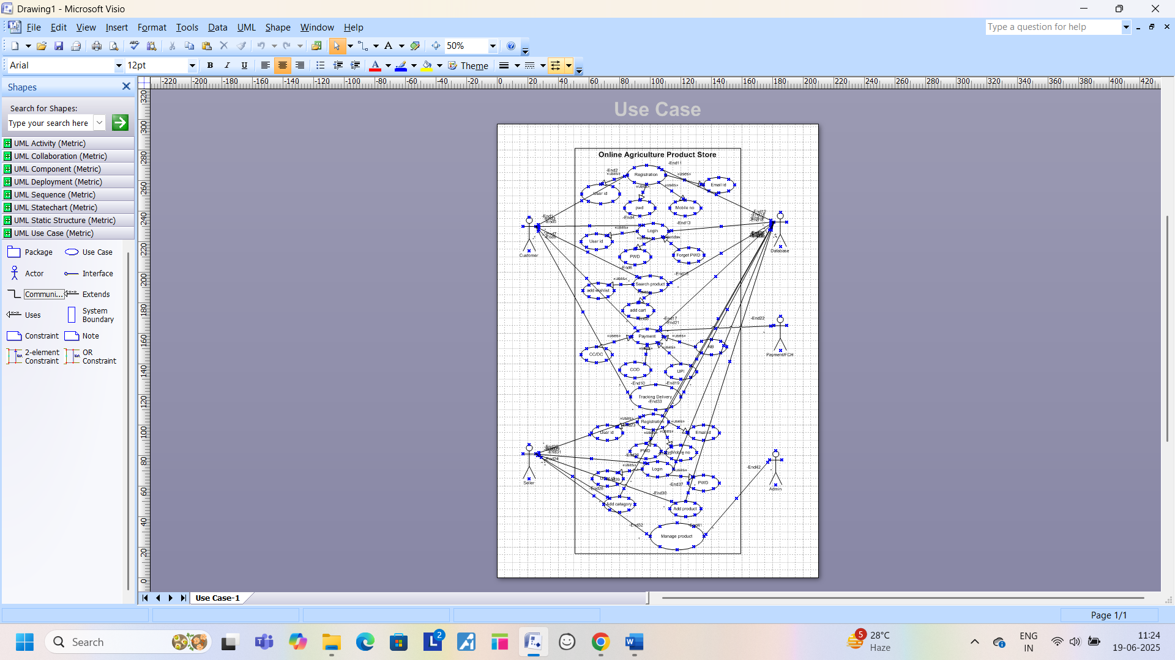
Q.11 – (Minimum 5) Use case spec.
Ans. – Use Case Spec.
- Use Case Spec – User buying fertilizers
Document Title | Buying fertilizers from Online Agriculture Store
Document Owner | Piyush Chaudhary
Version
Status | In Progress
Date | 3 May 2025
Brief Description | The Use case explains how a farmer uses the online Agriculture product store to buy Fertilizers
Actors | - Actor  - Database Admin
Pre-condition | - There should be an active internet connection  - Farmers should have Laptop/Mobile
Basic Flow | - Use case begin with User log in  - User Validation is performed  - Customers begin to search for Agriculture products  - Application displays multiple products for the searched product  - Users select the product and add it to the cart  - User selects the delivery location for delivery of products  - User selects the payment mode to pay  - Order plays and user receives an SMS for order confirmation  - Use case end successfully
Alternate Flow | - Invalid User – This happen when the user validation fails. App displays msg: user validation not completed successfully. Use case fails with failure condition  - Product out of stock – If the user selects the product which is out of stock. App displays msg: Product out of stock. Select from similar products available.  - Product out of stock for selected location – If the product id not available for the selected location. App displays msg: Product out of stock for selected location. Please try after few days when the product is available / try selecting from similar product  - No response from payment server – While making payment, if the server disconnect or there is no response from server.  - Use Case End
Post condition | < Successful Completion – User bought the Fertilizer successfully.  < Failure Condition – User couldn’t purchase the product due to some technical/financial reason.
SUPPLEMENT REQUIRMENTS | < Price of all the Agriculture product should be as per the govt. policy.  < The Application shell keep a usage detail of all complete and incomplete transections.

- Use Case Spec – User registering in the Application
Document Title | User Registering with user datils
Document Owner | Piyush Chaudhary
Version
Status | In Progress
Date | 4 May 2025
Brief Description | This Use case describes how a user registers him in an online Agriculture store
Actors | - Farmer  - Admin
Pre-condition | - There Should be an active internet connection  - Farmer should have Laptop/mobile  - The user should have an active Email address  - Ther should have an active mobile number
Basic Flow | Use Case Begin – When a new user start registers him with user details  1 Users enter details: Name, address, Mobile number and Email id  2 Application displays option to send OTP to mobile for mobile verification.  3 User sends OTP to the mobile number  4 User enter OTP received  5 Application displays OTP verified  6 User validation performs  7 Application displays user created successfully  Use Case End.
Alternate Flow | 1 Invalid OTP – If the user enters the incorrect OTP. Display msg: please enter the correct OTP  2 Mobile Number already used – In this case if the user enters the mobile number which already in use, which means that the user is already is a register user. Display msg: Mobile number is already in use. Please enter the correct mobile number.  3 Email address is already used – If the user enters the Email address which is already used to register, which means that the user has already a register user. Display msg: Email address already in use. Please enter the correct Email address  4 User ID not available – If the user enters the User ID which is already used, then the application gives the below msg. Display msg: User ID already used. Please enter another user ID  5 Server Issue – If the user not able to create the user ID, when the server breakdown. Display msg: Server busy, please try later.
Post condition | < Successful Completion – The User ID has been successfully Created.  < Details updated in the log accordingly.
SUPPLEMENT REQUIRMENTS | < The Application shall keep a log, including date and time, of all complete and incomplete transection.
- Use Case Spec - User making payment for the Purchase product
Document Title | User Registering with user datils
Document Owner | Piyush Chaudhary
Version
Status | In Progress
Date | 6 May 2025
Brief Description | This Use case describes how a user goes through a payment process after the product selection
Actors | - Farmer  - Admin  - Bank
Pre-condition | - There Should be an active internet connection  - Farmer should have Laptop/mobile  - The user should have an active Bank Account  - Ther should have an active mobile number to receive Bank OTP
Basic Flow | Use Case Begin – When a user initiates the payment after the selection of product  1 User Validation performed  2 Application displays multiple options to pay by credit card, debit card, net banking and UPI  3 User has options to pay by credit card, debit card, net banking, UPI  4 User select the payment mode and fill the details  5 Application displays payment completed  6 User receives Email and SMS with order completion  Use Case End.
Alternate Flow | 1 Incorrect card details – If the user enters the incorrect card details. Users receive SMS from Bank about payment failure due to incorrect card details entered. Display msg: Payment not completed  2 Incorrect OTP – If the user entered incorrect OTP. Display msg: Payment decline. Incorrect OTP entered  3 Insufficient Fund – Payment got declined due to insufficient fund. Display msg: Payment declined. Users get SMS from the bank confirming the payment declined due to insufficient funds.  4 Server Busy – Payment did not complete due to server busy. Display msg: Payment not completed. Server busy. Please try later.
Post condition | Successful Completion – Payment completed, and the order placed successfully.
SUPPLEMENT REQUIRMENTS | The Application shall keep a log, including date and time, of all complete and incomplete transection.

- Use Case Spec – Seller adding and updating the products in portal
Document Title | Seller Adding /Updating products
Document Owner | Piyush Chaudhary
Version
Status | In Progress
Date | 8 May 2025
Brief Description | This Use case describes how a Seller/ Manufacturer adds this product in portal
Actors | - Seller/Manufacturer  - Database/Admin
Pre-condition | - There Should be an active internet connection  - Farmer should have Laptop/mobile
Basic Flow | Use Case Begin – When Seller wants to add/update any new Agriculture product at Agriculture product store  1 Seller select the sell option before login  2 User validation performed  3 Application displays different Product alternative. In this case the seller selects an Agriculture product option  4 Seller choose product category  5 Seller enters product details i.e. Product name, Type of Product, Price and offer on product and Approximate delivery date  6 Application displays the new product details update successfully  7 Seller also receive a receipt by SMS or Email.  Use Case End.
Alternate Flow | 1 Region wise product price display to customer – Seller tries to update the price as per region; however, the application throws an error. Display msg: Price not matching as per the region. Please enter the correct price.  2 Incorrect Product category – Seller selects the wrong product category. Display msg: Incorrect product category. Please select the correct category.
Post condition | Successful Completion – Product has been successfully updated
SUPPLEMENT REQUIRMENTS | The Application shall keep a log, including date and time, of all complete and incomplete transaction with the admin.

- Use Case Spec – User cancelling the product
Document Title | Seller Adding /Updating products
Document Owner | Piyush Chaudhary
Version
Status | In Progress
Date | 10 May 2025
Brief Description | This Use case describes how a User cancel/Return the product at online Agriculture Product store
Actors | - Farmers  - Database/Admin  - Seller
Pre-condition | - There Should be an active internet connection  - Farmer should have Laptop/mobile
Basic Flow | Use Case Begin – When the user wants to cancel/Return agriculture product at agriculture product store  1 User validation performed  2 Application displays multiple orders, which have already been placed  3 User select the order/product for cancellation/return  4 Application displays the reason for cancellation/return  5 users provide reason for cancellation/return  6 Application displays the product cancellation/return requested. Product will be picked up at certain time and date  7 Seller receives message or product cancellation/return  8 Seller arranges the product pick up  9 User receives the refund  Use Case End.
Alternate Flow | 1 Cancel period over – Application displays this message when the user tried to cancel after the cancellation/return period is over.
Post condition | - Successful Cancellation/Return – The product has been successfully canceled, and internal log have been updated  - Refund Initiated – Refund has been initiated
SUPPLEMENT REQUIRMENTS | The Application shall keep a log, including date and time, of all complete and incomplete transaction with the admin.

Q.12 – (Minimum 5) Activity Diagram.
Ans. – Activity Diagram
- Login Page

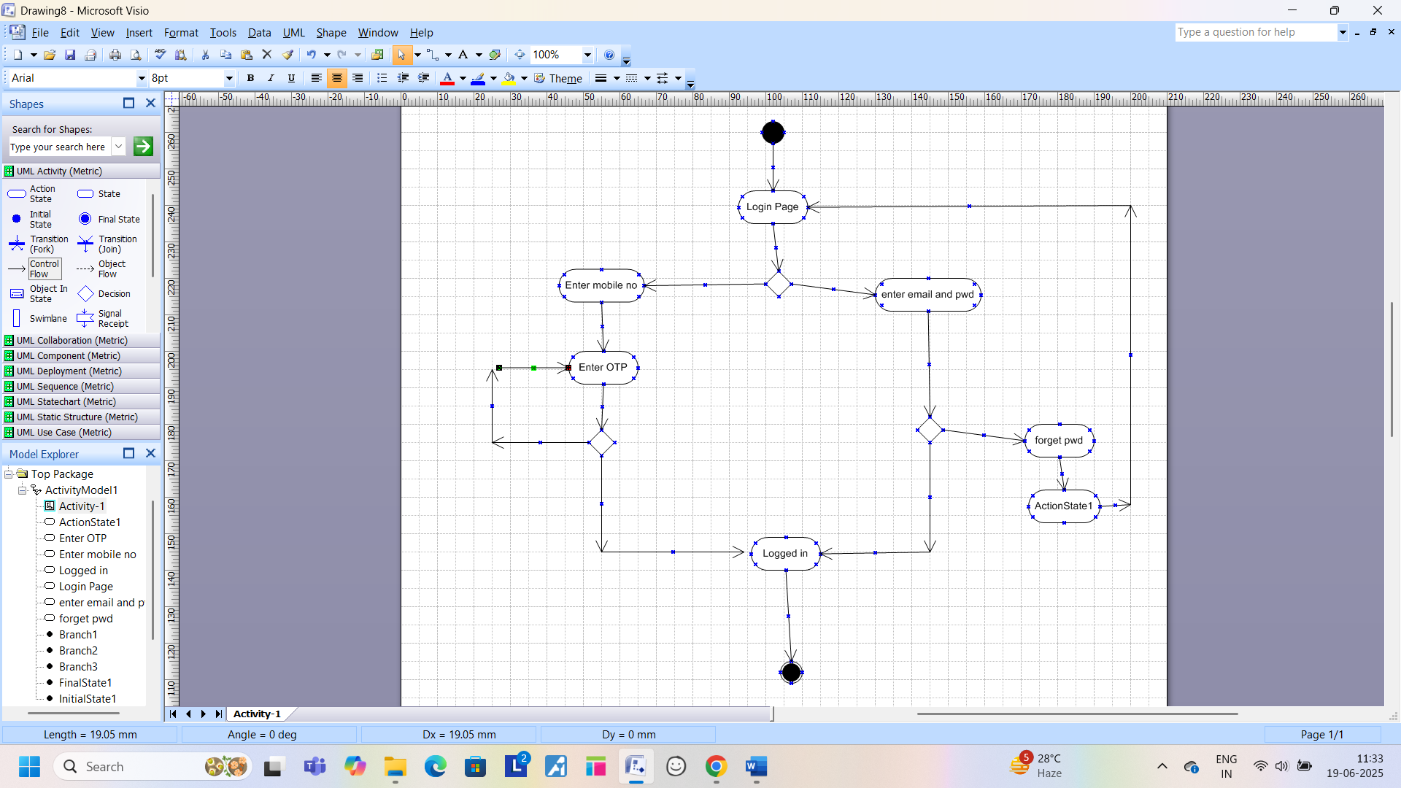

- Registration Page
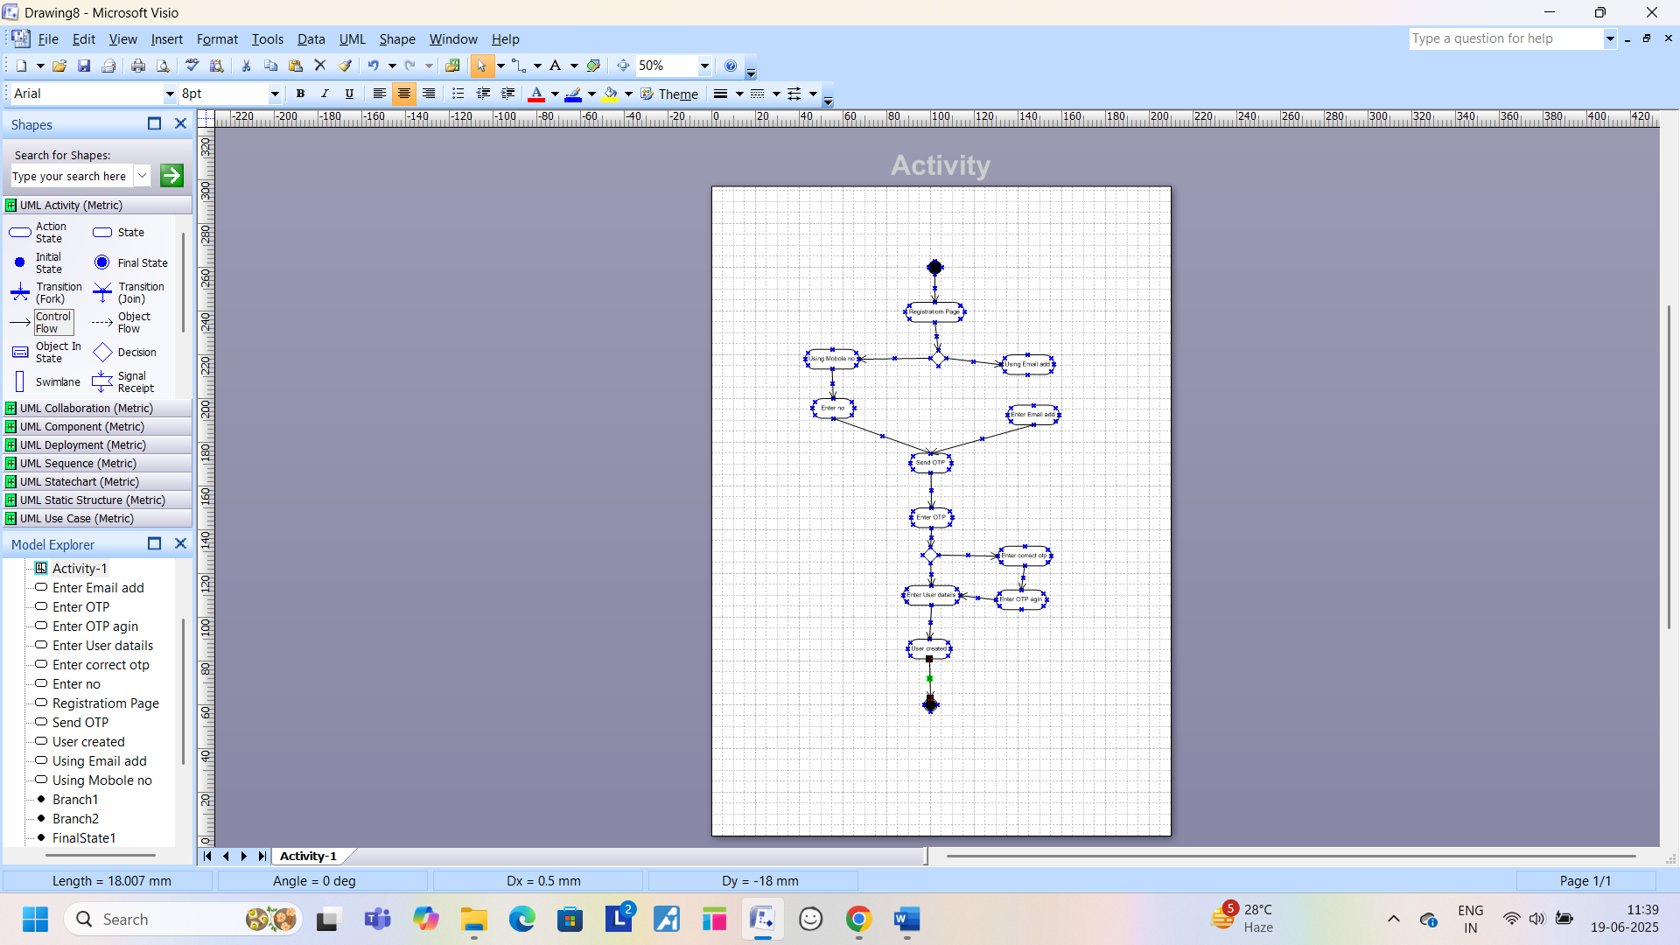

- Buying Fertilizer

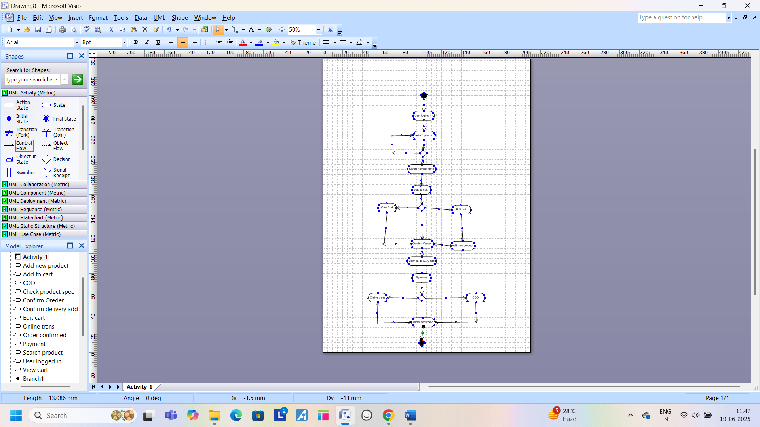

- Order Cancellation

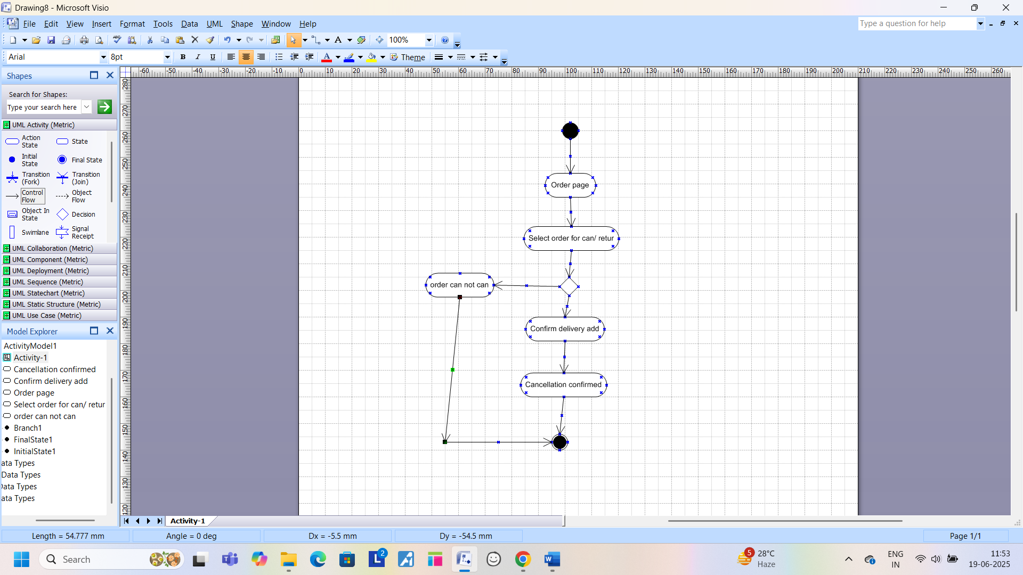

- Adding or Updating product
