Question 1 – Functional Requirements - 15 Marks
Identify minimum 20 functional requirements
Here are 20 functional requirements for the online agriculture products store, prioritized based on stakeholder needs and industry standards:

Functional Requirements (Prioritized)
Req ID | Req Name | Req Description | Priority
FR0001 | Farmer Registration | Farmers can register using email ID, phone number, and location details. | 7
FR0002 | Manufacturer Registration | Manufacturers can register by providing business credentials and tax details. | 7
FR0003 | User Login/Logout | All users (farmers/manufacturers) can securely log in/out using email and password. | 9
FR0004 | Product Catalog Display | Farmers can browse fertilizers, seeds, and pesticides with images, prices, and stock status. | 10
FR0005 | Product Search | Farmers can search products by name, category, or manufacturer. | 8
FR0006 | Product Filtering | Farmers can filter products by price range, brand, or customer ratings. | 8
FR0007 | Add to Cart | Farmers can add products to a cart for checkout. | 8
FR0008 | Save to Buy Later | Farmers can save products to a wishlist for future purchases. | 6
FR0009 | Checkout Process | Farmers can review cart items, select delivery address, and proceed to payment. | 9
FR0010 | Multi-Payment Integration | Supports COD, credit/debit cards, UPI, and net banking during checkout. | 10
FR0011 | Order Confirmation | Farmers receive email/SMS notifications with order details after payment. | 6
FR0012 | Delivery Tracking | Farmers can track real-time delivery status via a map interface. | 9
FR0013 | Inventory Management | Manufacturers can update stock levels and receive low-stock alerts. | 8
FR0014 | Product Upload | Manufacturers can upload product details (description, images, pricing). | 8
FR0015 | Product Reviews | Farmers can submit ratings and written reviews for purchased products. | 6
FR0016 | Customer Support | Farmers can submit queries via a contact form or live chat. | 7
FR0017 | Profile Management | Users can update personal details, addresses, and payment methods. | 7
FR0018 | Order History | Farmers can view past orders, including delivery status and invoices. | 7
FR0019 | Multi-Language Support | Interface available in regional languages (e.g., Hindi, Tamil). | 6
FR0020 | Product Returns | Farmers can initiate returns/exchanges for damaged or incorrect products. | 5

Key Rationale
- High Priority (8–10): Core features like payment integration, product catalog, and delivery tracking are critical for usability and stakeholder satisfaction15.
- Medium Priority (6–7): Features like wishlists and multi-language support enhance user experience but are not mission-critical26.
- Low Priority (5): Returns management is deprioritized initially due to logistical complexities5.
This list aligns with stakeholder interviews1, e-commerce best practices26, and agricultural platform needs
Certainly! Below is a list of some non-functional requirements for the Online Agriculture Products Store project formatted as per your request:
Non-functional Req ID | NF_Req Name | NF_Req Description | Priority (1-10)
NF_001 | Usability | The application must be user-friendly and intuitive for farmers and manufacturers with minimal digital literacy. | 9
NF_002 | Performance | The system should return search results within 3 seconds under normal load conditions. | 8
NF_003 | Availability | The platform should ensure 99.5% uptime to allow access anytime by users in remote areas. | 9
NF_004 | Security | All user data including passwords and payment information must be encrypted in transit and at rest. | 10
NF_005 | Scalability | The system should support scaling to accommodate increasing numbers of users and products without performance degradation. | 8
NF_006 | Reliability | Transactions such as orders and payments must be processed accurately without data loss. | 9
NF_007 | Maintainability | The system should allow updates and bug fixes to be deployed with minimal downtime. | 7
NF_008 | Accessibility | The application should be accessible via both web and mobile devices, supporting low bandwidth connections. | 8
NF_009 | Compliance | The system must comply with applicable data privacy and e-commerce regulations. | 7
NF_010 | Support | The platform should provide user support options such as FAQs, chatbots, or contact forms. | 6

Priority Explanation:
- 10 = Critical for project success
- 7-9 = High importance
- 5-6 = Medium importance
- Below 5 = Low importance
Let me know if you need further details or additional NFRs!

Question 2–Minimum 5 page designs - 15 Marks
Make wireframe and prototypes
Below are wireframe-style text representations for five essential pages of the Online Agriculture Products Store. These wireframes are suitable for early-stage business analysis and communication with stakeholders and the development team.

Creating 5-page designs for reference to 00.
1. Login page
2. Search page
3. Add to cart page
4. Payment page
5. Logout page

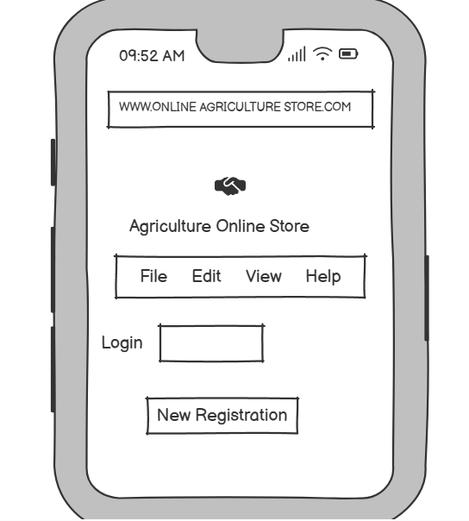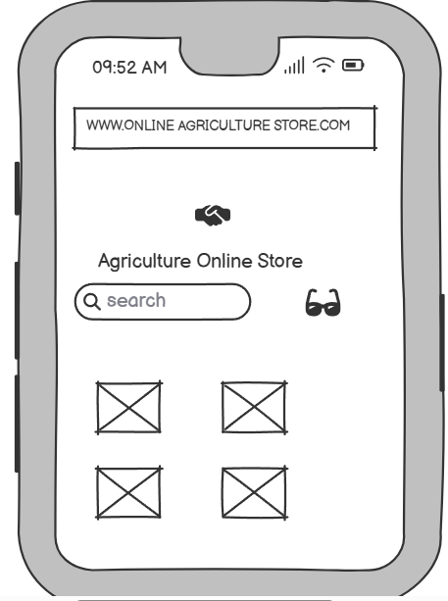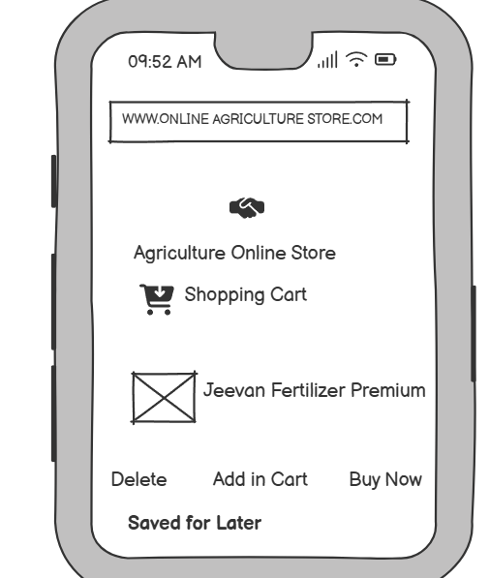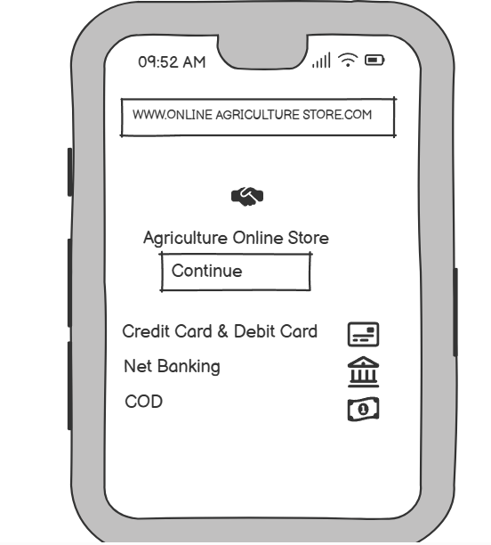
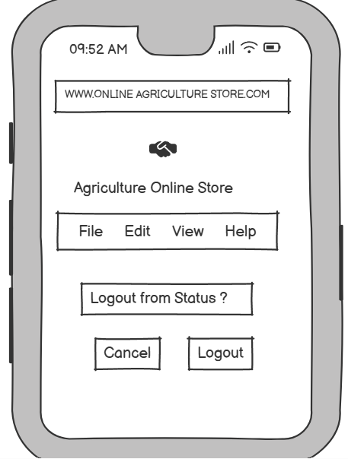

1. Home / Landing Page
text
----------------------------------------------------
| LOGO | Home | Products | About | Login |
----------------------------------------------------
| Banner: "Welcome to AgriStore - Empowering Farmers" |
----------------------------------------------------
| [Search Bar: "Search seeds, fertilizers, pesticides"] |
----------------------------------------------------
| [Category Icons: Fertilizers] [Seeds] [Pesticides] |
----------------------------------------------------
| Featured Products: |
| [Product Image] [Name] [Price] [Add to Cart] |
| [Product Image] [Name] [Price] [Add to Cart] |
----------------------------------------------------
| Footer: Contact | Terms | Support |
----------------------------------------------------

2. User Registration / Login Page
text
----------------------------------------------------
| LOGO | Home | Products | Help |
----------------------------------------------------
| [Login] [Register] |
----------------------------------------------------
| [Email] [Password] [Login Button] |
| [Forgot Password?] |
| -- or -- |
| [Register New Account] |
| [Name] [Email] [Phone] [Password] [Confirm] |
| [Register Button] |
----------------------------------------------------

3. Product Catalog / Search Results Page
text
----------------------------------------------------
| LOGO | Home | Products | Cart | Profile |
----------------------------------------------------
| [Search Bar] [Filter: Category | Price | Brand] |
----------------------------------------------------
| [Product List] |
| [Image] [Name] [Price] [Add to Cart] [Details] |
| [Image] [Name] [Price] [Add to Cart] [Details] |
| ... |
----------------------------------------------------
| Pagination: [1] [2] [3] ... |
----------------------------------------------------

4. Product Details Page
text
----------------------------------------------------
| LOGO | Home | Products | Cart | Profile |
----------------------------------------------------
| [Product Image] |
| [Product Name] |
| [Price] |
| [Stock Status] |
| [Description] |
| [Add to Cart] [Buy Now] |
| [Manufacturer Info] |
| [Customer Reviews: ***** (4.5/5)] |
| [Write a Review] |
----------------------------------------------------

5. Order Tracking Page
text
----------------------------------------------------
| LOGO | Home | Orders | Cart | Profile |
----------------------------------------------------
| [Order ID: #12345] |
| [Product Summary: Image, Name, Qty, Price] |
| [Order Status: Shipped / Out for Delivery / Delivered] |
| [Visual Progress Bar: Ordered > Packed > Shipped > Delivered] |
| [Estimated Delivery Date] |
| [Track on Map Button] |
| [Contact Support] |
----------------------------------------------------

Prototypes
For clickable prototypes, tools like Figma, Balsamiq, or Adobe XD are recommended. The above wireframes can be translated into interactive prototypes using those tools, allowing stakeholders to visualize navigation and user flows.

Question 3 – Tools (Visio, Balsamiq) - 15 Marks
Make a note of the Tools, which you are using for above concepts.
Tools Used by Business Analysts: Visio and Balsamiq
As a business analyst, leveraging the right tools is essential for effective requirements gathering, process modeling, and communication with stakeholders. Two widely used tools in this context are Microsoft Visio and Balsamiq. Here is a note on how these tools are applied to business analysis concepts:
Microsoft Visio
- Visio is a diagramming tool that allows business analysts to create a variety of visual representations, including flowcharts, process diagrams, organizational charts, timelines, mind maps, and Entity Relationship Diagrams (ERDs)
- It is particularly valuable for business process modeling, enabling the creation of both "as-is" and "to-be" process diagrams that help visualize current operations and design future improvements
- Visio supports BPMN (Business Process Model and Notation), UML diagrams, and other modeling standards commonly used in business analysis
- The tool integrates with Microsoft Office products, making it easier to share diagrams and collaborate with stakeholders
- Visio’s extensive library of templates and shapes allows for the rapid creation of professional-quality diagrams, which are essential for clear communication and documentation of business requirements
Balsamiq
- Balsamiq is a wireframing tool designed for creating low-fidelity prototypes of web and mobile applications
- It is used by business analysts to quickly sketch user interfaces, enabling rapid iteration and early feedback from stakeholders and development teams.
- The tool’s simplicity and drag-and-drop interface make it easy to visualize concepts and user journeys without getting bogged down in design details, which is ideal during the requirements gathering and validation phases.
- Balsamiq supports both cloud-based and desktop versions, facilitating collaboration in different working environments.
- Export options (such as PNG and PDF) help in sharing wireframes with clients and team members, streamlining the review and approval process.

Summary Table
Tool | Primary Use | Key Features | Typical Business Analyst Applications
Visio | Diagramming & Process Modeling | BPMN, UML, ERDs, flowcharts, templates, Office integration | Process modeling, system diagrams, stakeholder communication
Balsamiq | Wireframing & Prototyping | Low-fidelity UI mockups, drag-and-drop, export options | UI/UX prototyping, requirements validation, early feedback

Question 4 – RTM - 6 Marks
A business analyst’s key responsibilities are to keep track of the requirements and make sure that no requirement is missed.

Mr. Henry and peter have approached you regarding the current status of the project. How will you tackle this situation?
Req ID | Req Name | Req Description |  | Design | D1 | T1 | T2 | T3 | T4 | UAT
FR0001 | Farmer Registration | Farmers should be able to register with their Email ID and mobile no | Completed |  | Yes | Yes | Yes | Yes | Yes | Completed
FR0002 | Login | Famer should be able to login after registering | Completed |  | Yes | Yes | Yes | No | No | Pending
FR0003 | Search for Product | Famer should be able to search for the product | Completed |  | Yes | Yes | Yes | Yes | Yes | Completed
FR0004 | Add to cart | Famer should be able to add to card | Completed |  | Yes | Yes | Yes | Yes | Yes | Completed
FR0005 | View the cart | Farmer should be able to view the cart | Completed |  | Yes | No | No | No | No | Pending
FR0006 | Completing the order | Farmer should be able to complete the required order | Completed |  | Yes | Yes | Yes | Yes | Yes | Completed
FR0007 | Payment | Farmer should be able to view the payment option | Completed |  | Yes | Yes | No | Yes | Yes | Pending
FR0008 | Order confirmation | Farmer should be able to view the order confirmation | Completed |  | Yes | Yes | No | No | No | Pending
FR0009 | Delivery Tracking | Farmer should be able to view the delivery tracking | Completed |  | Yes | Yes | No | No | No | Pending

Req ID | Req Name | Req Description | Design | D1 | T1 | T2 | T3 | T4 | UAT
NFR0101 | Page load time | Each page should load with in 2 seconds | Yes | Yes | Yes | Yes | No | No | Pending
NFR0102 | Description | Description of the product to be mentioned | Yes | Yes | Yes | Yes | Yes | Yes | Completed
NFR0103 | Web Content accesibility guidelines | The system must meet Web Content accesibility guidelines | Yes | Yes | Yes | Yes | Yes | No | Pending
NFR0104 | Security | Date of the user to be secured | Yes | Yes | No | No | No | No | Pending
NFR0105 | Maintainability | application should be maitained without bug | Yes | No | No | No | No | No | Pending

Question 5 – 10 Test Case Documents - 10 Marks
Prepare 10 Test Case Documents
Test Case 1
Test Case ID: TC01
Title: Farmer Registration
Description: Verify that a new farmer can register successfully with a valid email and password.
Preconditions: User is on the registration page.
Test Steps:
- Enter a valid email address.
- Enter a valid password.
- Confirm the password.
- Click the "Register" button.
Expected Result: Registration is successful, and a confirmation email is sent.

Test Case 2
Test Case ID: TC02
Title: Farmer Login
Description: Verify that a registered farmer can log in with valid credentials.
Preconditions: Farmer account exists.
Test Steps:
- Enter registered email.
- Enter correct password.
- Click "Login".
Expected Result: Farmer is logged in and redirected to the dashboard.

Test Case 3
Test Case ID: TC03
Title: Invalid Login Attempt
Description: Verify that login fails with invalid credentials.
Preconditions: User is on the login page.
Test Steps:
- Enter invalid email or password.
- Click "Login".
Expected Result: Error message is displayed, login is not successful.

Test Case 4
Test Case ID: TC04
Title: Product Search Functionality
Description: Verify that a farmer can search for products using keywords.
Preconditions: Farmer is logged in.
Test Steps:
- Enter a product keyword in the search bar.
- Click "Search".
Expected Result: Relevant products are displayed in the search results.

Test Case 5
Test Case ID: TC05
Title: Add Product to Buy-Later List
Description: Verify that a farmer can add a product to the buy-later list.
Preconditions: Farmer is logged in and viewing a product.
Test Steps:
- Click "Add to Buy-Later".
Expected Result: Product is added to the buy-later list, and a confirmation message is shown.

Test Case 6
Test Case ID: TC06
Title: Manufacturer Product Upload
Description: Verify that a manufacturer can upload a new product.
Preconditions: Manufacturer is logged in.
Test Steps:
- Navigate to "Upload Product".
- Enter product details (name, type, price, description).
- Upload product image.
- Click "Submit".
Expected Result: Product is submitted for approval and appears in the pending list.

Test Case 7
Test Case ID: TC07
Title: Place Order with UPI Payment
Description: Verify that a farmer can place an order and pay using UPI.
Preconditions: Farmer is logged in, has products in cart.
Test Steps:
- Go to cart and click "Checkout".
- Select UPI as payment method.
- Enter UPI ID and authorize payment.
- Confirm order.
Expected Result: Payment is processed, order is placed, and confirmation is displayed.

Test Case 8
Test Case ID: TC08
Title: Order Confirmation Email
Description: Verify that a confirmation email is sent after placing an order.
Preconditions: Order is successfully placed.
Test Steps:
- Place an order.
- Check registered email inbox.
Expected Result: Order confirmation email is received with order details.

Test Case 9
Test Case ID: TC09
Title: Delivery Tracking
Description: Verify that a farmer can track the status of their order.
Preconditions: Order has been placed and is in transit.
Test Steps:
- Log in as farmer.
- Go to "My Orders".
- Click on the order to view tracking.
Expected Result: Order status and tracking information are displayed.

Test Case 10
Test Case ID: TC10
Title: Cash on Delivery (COD) Payment Option
Description: Verify that COD is available and works as a payment option.
Preconditions: Farmer is logged in, has products in cart.
Test Steps:
- Go to cart and click "Checkout".
- Select "Cash on Delivery" as payment method.
- Confirm order.
Expected Result: Order is placed successfully, and payment is marked as COD.

Question 6 – DB Design – 8 Marks
After the requirements are thoroughly explained to the entire project team by business analyst, the database architects have decided to do the database design and also to represent the in-flow and out-flow of data. Draw database schema and ER diagram
DB Design
Database design has 2 approaches:
•Top to bottom approach
•Bottom to top approach
All tables + entities = DB Schema
DB Schema + ER Diagram = DB Design

Entity Relationships Diagram
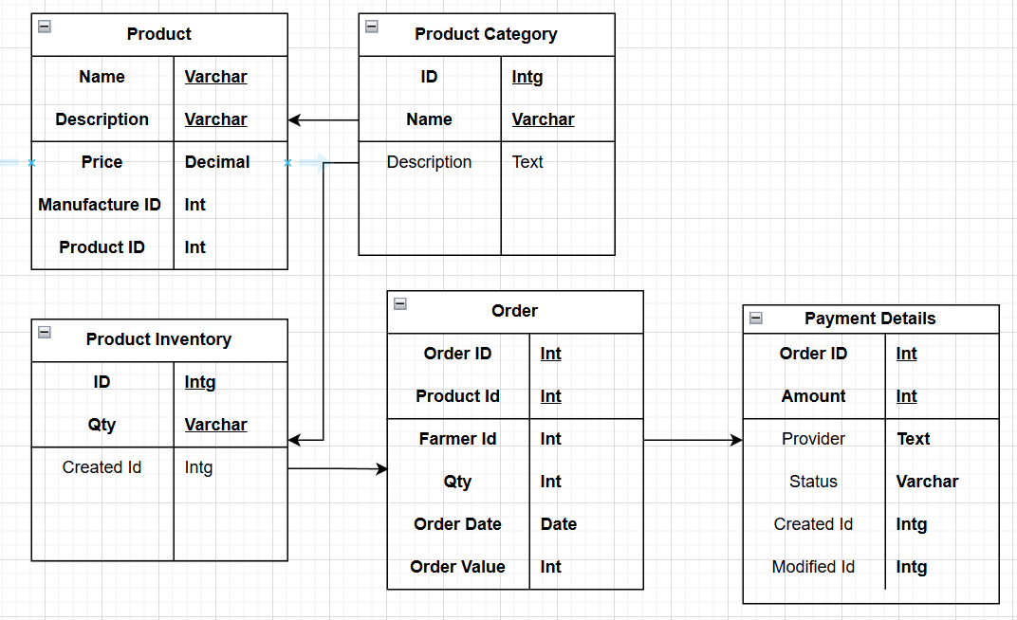

DB Schema – with tables & entities:
Varchar is used when the data to be dealt with is a set of characters on which numerical operations cannot be performed directly whereas int is used when certain numerical are to be performed on it. Varchar includes numbers, alphabets as well as special characters whereas int only include numbers. For example, varchar: email, int: user_id.

Question 7 – Data Flow Diagram - 3 Marks
What is a data flow diagram? Draw a data flow diagram to represent the in-flow and out-flow of data when a Farmer is placing an order for the product

7. Data flow diagram
A data flow diagram (DFD) is a graphical representation of the flow of data through an information
system. It visualizes the processes, data stores, and external entities that interact to produce or
consume data. The data flow diagram also provides Information about the outputs and inputs of each
entity and the process itself. A dataflow diagram has no control flow, there are no decision rules and no
loops.
It uses defined symbols like rectangles, circles, and arrows plus short test labels to show data inputs,
outputs, storage points and the routes between each destination.
•External entity – Rectangle
•Data flow – arrow
•Process or bubble – circle (process)
•Data store –Parallel lines (Backend)
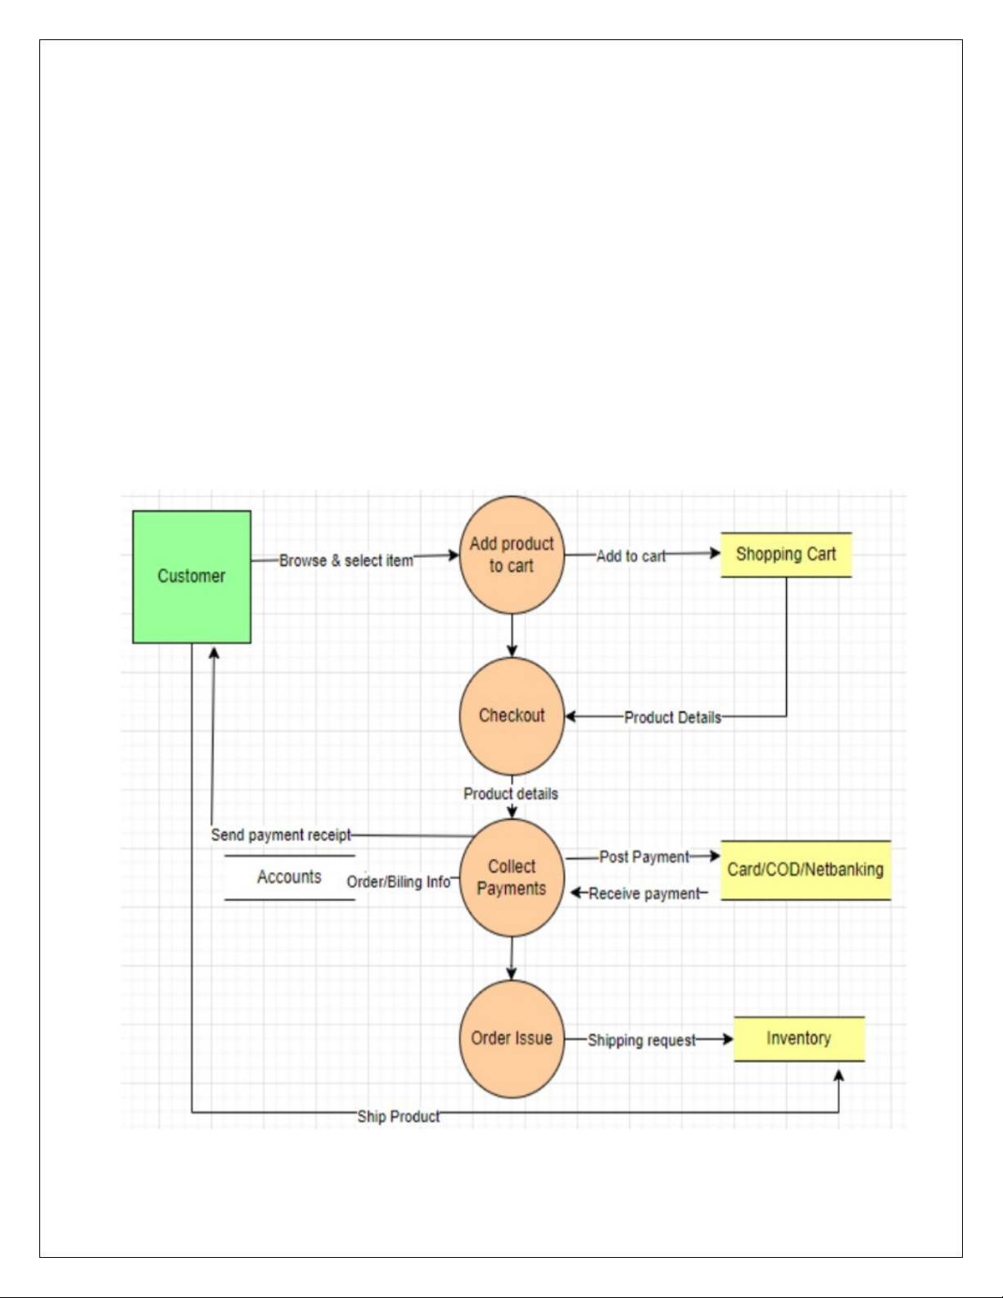

Question 8 – Change Request - 10 Marks
Due to change in the Government Taxation structure . we should change the Tax structure
How do you handle change requests in a project?

When a change request—such as a new government taxation structure—arises, a Business Analyst (BA) should follow a structured change management process to ensure the change is handled efficiently and transparently. Here’s how to handle such change requests:

Document the Change request.
  - Look for any Supporting materials to help in adding this Change.
  - Need to assess, whether the Change is an Inside or Outside scope. As it’s an outside scope, the Budget and time will get impacted.
  - BA and PM should ensure whether the change is a minor or a major change. Policy changes by Govts a major change request and we need to ensure that the change should be done according to the Govt. instruction.
  - Fill the Change request Form (CRL) and get the approval from the Project Manager.
  - We also need to ensure that our Team understands the priority of this change request.
  - We also need to discuss the change with Change Control Board (CCB) who will recommend the necessary change on the Project.
  - Once this change is approved, the project deliverables will need to be updated. This can include plans and schedules, business process documents, and the requirements documents.
  - Once these updates have been made, the project manager can communicate the new course of action to everyone who will be impacted. Now you can delegate the necessary tasks to the people in charge of implementing these new changes

Question 9 – Change Request Vs an Enhancement - 5 Marks
Nurturing Process - Capstone Project1 – Part -3/3 V2D2 Aug 2024
As the project is in process, Ben and Kevin have contacted you. The reason is to inform you that they want the Farmers to sell their crop yields through this application i.e. Farmers should be able to add their crop yields or products and display to general public and should be able to sell them. They also want to introduce Auction system for their Crop yields. As a BA, what will be your response?
Is this a change request or an enhancement???

Change Request Vs an Enhancement
Ans. The request from Ben and Kevin is an Enhancement request, as they want to add another feature inthe Online store which acts as an application upgrade, which will also help the Farmers to sell the yields directly in the online store, apart from buying products. Hence my response would a positive response to them. Therefore, as a BA, I should analyse the request and provide a project plan, requirement, design, testing plans for this request. I must prepare an enhancement request form and decide how much man-power and man-hours required for this enhancement request.

As a Business Analyst, My Response
"Thank you, Ben and Kevin, for sharing your new ideas. Based on the current project scope, your request to enable farmers to sell their crop yields and introduce an auction system represents a significant expansion of the platform’s functionality. This is classified as an enhancement rather than a standard change request, as it involves introducing entirely new features and business processes that were not part of the original requirements.
I will document your enhancement request and initiate a feasibility and impact analysis. This will include gathering detailed requirements, assessing the technical and business implications, estimating additional resources and time needed, and presenting these findings to the project steering committee for decision-making on inclusion, prioritization, and possible adjustments to the project’s scope, budget, and timeline."

Question 10 – Estimations - 6 Marks
Come up with estimations – How many Manhours required

To estimate man-hours required for a project as a Business Analyst, you should follow a structured and justified estimation approach. Here’s how you would approach this, referencing industry standards and best practices:

Step-by-Step Approach to Man-Hour Estimation
1. Choose the Right Estimation Technique
- Bottom-up Estimation: Break down the project into smaller tasks/modules and estimate each separately. This is the most accurate for detailed requirements
- Top-down Estimation: Estimate the overall effort based on similar past projects, then allocate to components.
- Analogous/Experience-based Estimation: Use historical data from similar projects and adjust for complexity.
- Expert Judgment/Delphi: Gather estimates from experienced team members and reach consensus.
- Three-Point/PERT: Use optimistic, pessimistic, and most likely scenarios to create a weighted average.
2. Decompose the Project
- List all major features and modules (e.g., user registration, product catalog, order management, payment integration, delivery tracking, admin features, etc.).
- Break each feature into sub-tasks (design, development, testing, deployment).
3. Estimate Each Task
- Assign estimated hours for each sub-task based on complexity and team expertise.
- Involve relevant team members (developers, testers, DBAs) for more accurate estimates4.
4. Sum Up and Add Contingency
- Add up all sub-task estimates to get the total man-hours.
- Include a contingency buffer (typically 10–20%) for risks, rework, and unforeseen issues.

Example: Man-Hour Estimation Table (Bottom-Up)
Module/Task | Estimated Hours (Design) | Estimated Hours (Dev) | Estimated Hours (Test) | Total Hours
User Registration/Login | 8 | 16 | 8 | 32
Product Catalog/Search | 8 | 24 | 12 | 44
Product Upload (Mfr) | 6 | 14 | 8 | 28
Cart/Buy-Later | 6 | 12 | 8 | 26
Order Placement/Tracking | 8 | 20 | 12 | 40
Payment Gateway | 10 | 24 | 12 | 46
Delivery Tracking | 6 | 16 | 8 | 30
Admin Functions | 8 | 16 | 8 | 32
Notifications/Emails | 6 | 12 | 8 | 26
Testing & Bug Fixing | - | 10 | 20 | 30
Total |  |  |  | 334
Contingency (15%) |  |  |  | 50
Grand Total |  |  |  | 384
This is a hypothetical breakdown. Actual numbers should be based on team input and project specifics.

Key Points
- Document assumptions: Clearly state what is included/excluded in the estimate.
- Review and refine: Estimates should be reviewed with the team and refined as requirements become clearer.
- Track actuals: Compare estimated vs. actual man-hours during the project for future accuracy.

Question 11 – UAT – 6 Marks
Project has finally completed all the stages i.e., design, development, testing etc. Now, it is the role of a business analyst to contact the client for testing of the final product and have to successfully complete it. How are you going to handle this situation? And once it is done, what will be the process to close the project?
Explain UAT Acceptance process

As the business analyst for the online agriculture products store project, your role at this stage is crucial in ensuring the solution meets client expectations and is formally accepted. Here’s how you should proceed:

1. User Acceptance Testing (UAT) Process
A. Preparation
- Review all business requirements and ensure traceability to test cases.
- Prepare a UAT plan, including objectives, scope, schedule, test scenarios, and acceptance criteria.
- Identify UAT participants from the client side (e.g., Mr. Henry, Peter, Kevin, Ben) and ensure they have access and training to use the system1.
B. UAT Execution
- Organize a UAT kickoff meeting to explain the process, roles, and expectations.
- Provide UAT scripts or scenarios for users to follow, covering all critical business processes (e.g., registration, product search, buying, payment, order tracking, crop yield listing, auction features)1.
- Support users during testing, clarifying doubts and logging any issues or feedback.
C. Issue Management
- Collect and document all defects, issues, or change requests raised during UAT.
- Coordinate with the development and QA teams to resolve critical issues promptly.
- Retest resolved issues with the client until all acceptance criteria are met.
D. Formal Acceptance
- Once users confirm that the system meets all agreed requirements and is functioning as expected, obtain formal sign-off on the UAT completion document from authorized client representatives.

2. Project Closure Process
A. Handover and Documentation
- Deliver all final project documentation, user manuals, and training materials to the client.
- Ensure knowledge transfer to client-side support or operations teams.
B. Final Review
- Conduct a project closure meeting with the client and internal team to review deliverables, lessons learned, and confirm all contractual obligations are fulfilled.
C. Obtain Final Sign-off
- Secure formal project closure sign-off from the client, confirming satisfaction and acceptance of the product.
D. Archive and Transition
- Archive all project documents and code as per company policy.
- Transition the system to maintenance/support mode if applicable.

Summary Table: UAT Acceptance Process
Step | Description
UAT Planning | Define objectives, scope, participants, and acceptance criteria
UAT Execution | Client tests the system using real-world scenarios
Issue Resolution | Log, fix, and retest any defects or feedback
Formal Acceptance | Obtain client sign-off on successful UAT completion
Project Closure | Handover, final review, documentation, and formal project closure sign-off

Question 12 – Project Closure Document - 6 Marks
Explain Project closure document

Certainly! Here’s a clear and practical explanation of a Project Closure Document:

What is a Project Closure Document?
A Project Closure Document is a formal record that marks the official completion of a project. It confirms that all project deliverables have been met, client acceptance has been obtained, and the project is ready to be closed. This document is essential for transitioning the project to maintenance/support and for capturing lessons learned for future projects.

Key Components of a Project Closure Document
- Project Overview
  - Project name, ID, sponsor, manager, start and end dates, and a brief summary.
- Objectives & Deliverables
  - List of original objectives and deliverables, with confirmation that each has been met.
- Acceptance Criteria & Sign-off
  - Statement confirming that all acceptance criteria have been satisfied.
  - Client/user sign-off, usually with signatures from authorized stakeholders.
- Outstanding Issues
  - List any open issues, risks, or deferred items, and how they will be handled (e.g., moved to maintenance).
- Lessons Learned
  - Summary of what went well, what could be improved, and key takeaways for future projects.
- Transition Plan
  - Details on handover to support/operations, including documentation, training, and ongoing responsibilities.
- Financial Summary
  - Overview of the budget, actual spend, and any variances.
- Project Artifacts and Documentation
  - List of all final documents delivered (e.g., user manuals, technical docs, test results).
- Closure Approval
  - Section for final approvals and signatures from the project manager, sponsor, and client.

Why is it Important?
- Ensures formal agreement that the project is complete and successful.
- Provides transparency about what was delivered and any remaining work.
- Facilitates knowledge transfer to support teams or the client.
- Documents lessons learned to improve future projects.
- Releases project resources and closes the project financially and administratively.

In summary:
A Project Closure Document is the final, formal step in project management. It ensures all parties agree the project is finished, captures valuable knowledge, and provides a clear record for future reference.

