Assignment 1:
1. Please make a BRD which can be presented to the client along with complete development and resource plan.
BRD Document

Project Title: Inventory & Delivery Management System (IDMS)
Client: ABC Dairy Private Limited
Prepared By: Shrimi Rastogi (BA)
Date: 05/11/2025
1. Document Revisions
Date | Version Number | Document Changes
05/11/2025 | 0.1 | Initial Draft

2. Approvals
Role | Name | Title | Signature | Date
Project Sponsor | Mr. R Mehta | Senior VP | RM | 20-10-2025
Business Owner | Ms. N Kapoor | Head – Business Operations | NK | 20-10-2025
Project Manager | Mr. A Sharma | IT Project Manager | AS | 22-10-2025
System Architect | Mr. S Iyer | Enterprise Architect | SI | 25-10-2025
Development Lead | Ms. P Nair | Technical Lead | PN | 25-10-2025
User Experience Lead | Mr. A Verma | UX/UI Designer | AV | 29-10-2025
Quality Lead | Ms. S Gupta | QA/Test Lead | SG | 31-10-2025
Content Lead | Mr. K Bhatia | Documentation Specialist | KB | 01-11-2025

3. RACI Chart for This Document
Name | Position | * | R | A | S | C | I
Mr. R Mehta | Senior VP – (Project Sponsor) | Authorize |  |  |  |  | ✔
Ms. N Kapoor | Head – Business Operations (Business Owner) | Authorize |  |  |  | ✔ | ✔
Mr. A Sharma | IT Project Manager |  |  | ✔
Mr. S Iyer | Enterprise Architect |  | ✔
Ms. P Nair | Technical Lead (Development) |  | ✔
Mr. A Verma | UX/UI Designer (UX Lead) |  | ✔
Ms. S Gupta | QA/Test Lead (Quality Lead) |  | ✔
Mr. K Bhatia | Documentation Specialist |  | ✔
Business Users | End-Users/Operations Team |  |  |  |  | ✔ | ✔

4. Introduction
4.1. Business Goals
- Optimize stock distribution between warehouses and plants.
- Enable real-time visibility of inventory.
- Automate delivery route planning and reduce delivery time.
- Enhance customer satisfaction with transparent order tracking.
Need: ABC Dairy Pvt. Ltd. requires an integrated system to streamline inventory management and ensure quickest delivery of products to customers across the country.
4.2. Business Objectives
To provide an IT solution for:
- Inventory Management System
- Delivery Route Optimization
- Customer Order Management
- Mobile application for Android and iOS for delivery staff and customers
- Integration with existing ERP for finance and HRMS
4.3. Business Rules
- Each warehouse must maintain a minimum stock threshold.
- Orders are auto-routed to the nearest warehouse based on location.
- Expiry-based inventory rotation (FIFO/LIFO).
- Delivery staff must update status in the mobile app.
- Automated invoicing post-delivery confirmation.

4.4. Background
Currently, ABC Dairy manages inventory manually via spreadsheets, leading to data discrepancies and delivery delays. The proposed system will automate operations, reduce human error, and improve real-time tracking and coordination.
4.5. Project Objective
- Build an integrated Inventory and Delivery Management System (IDMS).
- Centralize data to provide unified dashboards for management.
- Enable cross-communication between manufacturing, warehouse, and delivery.
- Aligns with company’s goal to improve operational efficiency by 30%.
4.6. Project Scope
4.6.1. In-Scope Functionality
- Real-time inventory tracking
- Order management
- Delivery route optimization
- Mobile app for delivery and warehouse staff
- Customer tracking interface
- Role-based access management
- Reporting and analytics
4.6.2. Out of Scope Functionality
- Payment gateway integration
- Vendor management
- HRMS modules (except attendance sync)
- Third-party logistics integration
5. Assumptions
- Users have internet access.
- Warehouses are equipped with barcode scanners.
- GPS-enabled delivery vehicles are available.
- Client will provide access to existing ERP APIs.
6. Constraints
- Limited budget allocation for cloud hosting.
- Integration dependent on ERP API availability.
- Compliance with FSSAI and transport regulations.
7. Risks
A risk is something that could affect the success or failure of a project. Risks are analyzed regularly as the project progresses. While every risk cannot be eliminated, its impact can be minimized by planning. Each risk below is documented with likelihood, impact, and mitigation strategy.
7.1 Technological Risks
- Risk: Integration challenges with ERP.
  - Mitigation: API documentation review and pilot testing.
  - Likelihood: Medium
  - Impact: High
7.2 Skills Risks
- Risk: Lack of mobile app testing expertise.
  - Mitigation: Allocate dedicated QA with Android/iOS experience.
  - Likelihood: High
  - Impact: Medium to High
7.3 Political Risks
- Risk: Stakeholder conflicts between production and logistics teams.
  - Mitigation: Weekly review meetings and transparent dashboards.
  - Likelihood: Medium
  - Impact: High
7.4 Business Risks
- Risk: System delay may impact seasonal sales.
  - Mitigation: Phased rollout and pilot run.
  - Likelihood: Medium
  - Impact: High
7.5 Requirements Risks
- Risk: Unclear reporting requirements.
  - Mitigation: Conduct additional workshops with business users.
  - Likelihood: High
  - Impact: High
7.6 Other Risks
- Risk: Power or internet outage during delivery.
  - Mitigation: Offline data caching on mobile apps.
  - Likelihood: Medium
  - Impact: High
8. Business Process Overview
8.1. Legacy System (AS-IS)
- Manual inventory update.
- Delivery assignment based on phone communication.
- Lack of route optimization.
8.2. Proposed Recommendations (TO-BE)
- Centralized cloud-based system.
- Automated order allocation to nearest warehouse.
- GPS-enabled delivery tracking and route optimization.
- Real-time dashboards for management.
9. Business Requirements
Functional Business Requirements (FBRs)
- FBR001 – Inventory Management
Add/update stock, track quantities, set reorder levels, monitor expiry dates
- FBR002 – Warehouse Management
View plant/warehouse stock levels, manage transfers between locations
- FBR003 – Order Management
Order creation, approval, processing, and cancellation workflows
- FBR004 – Delivery & Logistics
Automatic warehouse assignment, route optimization, GPS tracking, delivery confirmation.
- FBR005 – Customer Portal
Order creation, approval, processing, and cancellation workflows
- FBR006--Reports & Analytics
Automatic warehouse assignment, route optimization, GPS tracking, delivery confirmation.
- FBR007 – User Management
Role-based access (Admin, Warehouse, Driver, Customer)
Non-Functional Business Requirements (NFRs)
8. NFBR001 – Performance
The system must support at least 5,000 concurrent users with an average response time <2 seconds.
9. NFBR002 – Security & Compliance
Role-based access control, encrypted API communications
10. NFBR003 – Availability & Uptime
The system must provide at least 99.9% uptime (excluding planned maintenance).
11. NFBR004 – Scalability
Must handle nationwide operations and future expansion.
12. NFB005 – Disaster Recovery
Daily backups and the ability to restore operations within 4 hours in case of system failure.
10. Appendices
10.1. List of Acronyms
- IDMS- Inventory and Delivery Management System
- ERP- Enterprise Resource Planning
- GPS- Global Positioning System
- UAT (User Acceptance Testing)- Final phase of testing performed by business users to validate that the system meets requirements
10.2. Glossary of Terms
- Inventory Management: Tracking stock levels and movements.
- Route Optimization: Computing the most efficient delivery path.
10.3. Related Documents
- Project Charter
Outlines project objectives, scope, stakeholders, and high-level milestones.
- Business Case Document
Provides justification for initiating the project, including cost-benefit analysis, ROI, and resource planning.
- Functional Requirement Specification (FRS)
Detailed description of system functionalities and business requirements.
- Non-Functional Requirement Specification (NFRS)
Defines system performance, availability, security, and scalability requirements.
- Requirement Traceability Matrix (RTM)
Maps requirements to design, development, testing, and UAT deliverables.

Process Flow Diagram
2. Prepare process flow diagram using your imagination.
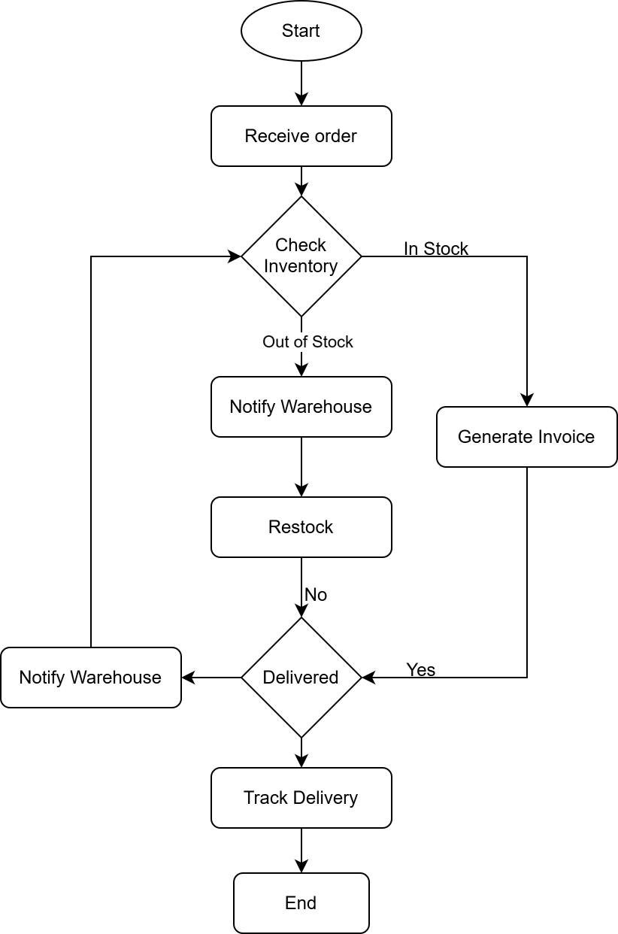

Assignment 2:
1. Write an introduction letter to a client introducing yourself as a business analyst in charge of working with the client and his team to start the business understanding process.
Subject: Introduction – Business Analyst for the Inventory & Delivery Management System Engagement
Dear Mr. X,
I hope this message finds you well.
My name is Shrimi Rastogi, and I am the Business Analyst assigned to collaborate with you and your team on the Inventory & Delivery Management System initiative. I will be responsible for driving the business understanding and requirement-gathering process, ensuring that the proposed solution aligns seamlessly with your organization’s goals and operational needs.
Over the next few weeks, I will work closely with you to:
- Understand your existing business processes, challenges, and objectives.
- Document detailed business and functional requirements.
- Facilitate workshops, meetings, and discussions to clarify priorities and success criteria.
- Collaborate with our design, development, and QA teams to translate your requirements into effective technical solutions.
I look forward to partnering with you to establish a clear roadmap for the project and ensure smooth communication throughout the engagement. Please feel free to reach out to me directly at shrimi@company.com or phone – 91- 9999XXXX99 to schedule our initial business discovery session.
Thank you for the opportunity to work with you. I am confident that together, we can deliver a solution that supports your vision and business growth.
Warm regards,
Shrimi Rastogi
Business Analyst
XYZ Private Limited

2. Prepare a brief BRD and SRS for a project- Horoscope or Ticketing system or online store.
A) BRD (Business Requirement Document)
Project Title: Online Ticketing System
Client: XYZ Events Pvt. Ltd.
Prepared By: Shrimi Rastogi – Business Analyst
Date: 05/11/2025
1. Document Revisions
Date | Version Number | Document Changes
05/11/2025 | 0.1 | Initial Draft
2. Approvals
Role | Name | Title | Signature | Date
Project Sponsor | Mr. R Mehta | Senior VP | RM | 20-10-2025
3. RACI Chart for This Document
Name | Position | * | R | A | S | C | I
A | Senior VP –(Project Sponsor) | Authorize |  |  |  |  | ✔
B | Head – Business Operations (Business Owner) | Authorize |  |  |  | ✔ | ✔
C | IT Project Manager |  |  | ✔
D | Enterprise Architect |  | ✔
E | Technical Lead (Development) |  | ✔
F | UX/UI Designer (UX Lead) |  | ✔
G | QA/Test Lead (Quality Lead) |  | ✔
H | Documentation Specialist |  | ✔
I | End-Users/Operations Team |  |  |  |  | ✔ | ✔

4. Introduction
4.1 Business Goal
To develop a centralized online platform that enables users to search, book, and purchase tickets for events, movies, concerts, and travel in real time.
4.2 Business Objectives
- Provide a user-friendly portal and mobile app for ticket booking.
- Integrate secure payment gateways (UPI, credit/debit card, wallets).
- Manage real-time seat availability and booking confirmations.
- Allow event organizers to list, manage, and monitor their events.
4.3. Business Rules
- Each event must define its start and end date/time.
- Users cannot book more tickets than available.
- Refunds for cancellations will be processed within 5 business days.
- Payment confirmation required before ticket issuance.
4.4. Background
Currently, customers must visit different platforms to book tickets for various event types. The proposed system will unify these under one application with automated booking, cancellation, and reporting features.
4.5. Project Objective
The main objective of the Online Ticketing System project is to design and implement a web-based and mobile application that enables users to conveniently search, book, and purchase tickets for movies, concerts, sports events, and other entertainment activities.
The system aims to:
- Provide a centralized and seamless ticket booking experience for users across various event categories.
- Offer real-time seat availability and secure online payments.
- Enable event organizers and administrators to manage events, pricing, and bookings efficiently through an admin portal.
- Generate automated e-tickets and send instant confirmations via email and SMS.
- Ensure scalability, data integrity, and high performance even during high-traffic events or peak booking hours.
4.6. Project Scope
4.6.1. In Scope Functionality
- Event listing and search
- User registration and authentication
- Ticket booking and cancellation
- Payment gateway integration
- Email/SMS confirmation

4.6.2 Out of Scope
- Offline ticket booking
- Event photography or merchandise sales
- Integration with third-party loyalty systems
5. Assumptions
- Internet access available to users.
- Event organizers will maintain accurate event data.
- Third-party payment APIs are reliable and secure.
6. Constraints
- Budgetary Constraint – Total project expenditure (hardware, software, services, and training) must not exceed the approved budget.
- Resource Availability – Limited availability of skilled IT staff, subject matter experts, and vendor resources may impact timelines.
- Business Constraints - Ticket pricing and event details must be updated only by verified organizers or administrators.
- Technical Constraints- The system must be web-based and mobile-compatible (Android and iOS) and must integrate only with pre-approved payment gateways (e.g., Razorpay, PayPal)

7. Risk
- Payment gateway downtime
  - Likelihood: Medium
  - Impact: High
  - Mitigation Strategy: Integrate multiple payment options
- High traffic during peak hours
  - Likelihood: High
  - Impact: High
  - Mitigation Strategy: Implement cloud auto-scaling to cater large volumes
- Fake event listings
  - Likelihood: Medium
  - Impact: High
  - Mitigation Strategy: Verification process for organizers
8. Business Process Overview
8.1. Legacy System (AS-IS)
- Manual ticket booking and confirmation process.
- Limited visibility into real-time seat availability.
- Risk of overbooking or duplicate bookings.
- Manual report generation for sales and revenue.
- No integration with digital payment systems.
AS-IS Flow (Simplified)
- Customer contacts agent or visits ticket counter.
- Agent manually checks event availability with the organizer.
- Organizer confirms ticket availability (via phone or email).
- Customer pays in cash or transfers money to organizer’s account.
- Agent/organizer manually issues ticket or sends confirmation email.
- Organizer updates booking records manually in spreadsheets or notebooks.
8.2. Proposed Recommendations (TO-BE)
In the proposed Online Ticketing System, the entire booking process becomes automated, centralized, and digital. Customers can easily search for events, select preferred seats, make online payments, and receive e-tickets instantly.
The system integrates with secure payment gateways, real-time inventory management, and automated notifications, minimizing human errors and improving efficiency.
Key Recommendations
- Fully automated booking and payment system.
- Real-time availability tracking and confirmation.
- Integration with multiple secure payment gateways.
- Admin dashboard for organizers to manage events and analyze data.
- Digital ticket generation (QR-based e-tickets).
- 24x7 accessibility through web and mobile platforms.
TO-BE Flow (Simplified):
- User Registration/Login – The customer registers or logs into the online ticketing portal or mobile app.
- Event Search – The user searches for events, movies, or concerts using filters such as date, location, or category.
- Seat Selection – The system displays available seats in real time; the user selects preferred seats.
- Payment Processing – The customer proceeds to a secure online payment gateway (UPI, card, wallet, etc.).
- Booking Confirmation – Once payment is successful, the system automatically confirms the booking.
- E-Ticket Generation – The system generates a digital ticket (with QR/barcode) and sends it via email/SMS.
- Database Update – The event database and seat inventory update automatically to reflect the new booking.
- Organizer Dashboard – Event organizers can view real-time sales, attendance, and performance reports.
- Customer Access – The customer can download or show the e-ticket through the app or website for entry.
9. Business Requirements
Functional Business Requirements (FBRs)
- FBR001 – User Registration & Login
Users must be able to register, log in, and manage their profile securely.
- FBR002 – Event Listing & Search
The system should allow users to search and filter events by name, date, location, and category
- FBR003 – Seat Selection
The system must display real-time seat availability and allow users to select preferred seats
- FBR004 – Online Payment
Integrate secure payment gateways (credit/debit cards, UPI, wallets) for instant payments
- FBR005 – E-Ticket Generation
Automatically generate and deliver e-tickets via email and SMS upon successful payment
- FBR006 – Booking Management
Allow users to view, cancel, or download tickets from their accounts
- FBR007 – Refund Management
Allow automatic refund initiation for cancelled events or tickets
- FBR008 – Notifications
Send automated notifications for booking confirmations, cancellations, and reminders
Non-Functional Business Requirements (NFRs)
- NFBR001 – Performance
The system must support at least 5,000 concurrent users with an average response time <2 seconds.
- NFBR002 – Security & Compliance
The system must comply with RBI/NHB/PNB Housing Finance policies, ensuring encryption, secure access, and audit logs.
- NFBR003 – Availability & Uptime
The system must provide at least 99.9% uptime (excluding planned maintenance).
- NFBR004 – Scalability
The system must scale to support double the loan application volume within the next 5 years.
- NFB005 – Disaster Recovery
Daily backups and the ability to restore operations within 4 hours in case of system failure.
10. Appendices
10.1 List of Acronyms
- UPI-Unified Payments Interface
- API- Application Programming Interface
- OTP- One-Time Password
10.2 Glossary of Terms
- E-Ticket- Electronic ticket sent via email or SMS for entry verification.
- Payment Gateway- Third-party service that authorizes and processes online payments
- Booking ID- Unique identifier for each confirmed ticket booking.
- Seat Availability- Real-time status showing how many seats are available for an event
- Refund Policy- Rules governing ticket cancellations and money refunds
- Dashboard- Interface showing key metrics such as total bookings and revenue
- Inventory- Collection of available tickets or seats for specific events
10.3 Related Documents
- Project Charter- Defines project purpose, scope, and stakeholders
- Business Case- Provides justification for initiating the ticketing system project.
- System Design Document (SDD)- Describes architecture and design details of the system.
- User Manual- Provides instructions on using the ticketing platform
- Maintenance and Support Plan- Defines post-deployment support structure and responsibilities

B) SRS ( Software Requirement Specifications)
Project Title: Online Ticketing System
Version: 1.0
Date: 06-11-2025
Prepared by: Shrimi Rastogi – Business Analyst
1.0 Introduction
1.1 Overview
The Online Ticketing System is a web-based and mobile-friendly platform that allows users to search, book, and purchase tickets for various events such as movies, concerts, sports, and theater shows. The system provides real-time seat availability, secure online payments, digital ticket generation, and email/SMS confirmations.
The system will be used by both customers and administrators — customers for purchasing tickets, and administrators for managing events, prices, and bookings.
1.2 Acronyms and Definitions
Term | Description
UI | User Interface
API | Application Programming Interface
DBMS | Database Management System
SQL | Structured Query Language
OTP | One-Time Password
UAT | User Acceptance Testing
SRS | Software Requirements Specification
1.3 Operational Requirements
1.3.1 Software Requirements
- Operating System: Windows / macOS
- Backend: Java / .NET Core
- Frontend: HTML5
- Database: MySQL
- Payment Gateway API Integration (e.g., Razorpay, PayPal)
1.3.2 Hardware Requirements
- Server Requirements:
  - Processor: Intel Xeon or higher
  - Memory: 16GB RAM or above
  - Storage: 500GB SSD
  - Internet: High-speed connection with 99.9% uptime
- Client Requirements:
  - Any device with an internet browser (Chrome, Edge,)
  - Minimum 4GB RAM recommended
1.4 References
- Project Proposal Document
- Business Requirements Document (BRD)
- User Requirements Document (URD)
- System Design Document (SDD)- Describes architecture and design details of the system
1.5 Design and Implementation Constraints
- Technology Stack: Must use open-source technologies (MySQL).
- Programming Language: JavaScript, TypeScript (preferred).
- Database Constraint: Use relational database only (MySQL/PostgreSQL).
- Development Standard: Must follow Agile methodology and API design.
- Hardware Limitation: The mobile version should run efficiently on low-end Android devices (2GB RAM minimum).
- Security: Must use security for all data transmissions.
- Data Format: JSON format for all API communications.
1.6 Assumed Factors That Could Affect Requirements
- Payment Gateway downtime may affect ticket confirmation timelines.
- The system relies on real-time event data from organizers. Any delay in updates from organizers can cause discrepancies.
- Dependence on SMS and email service providers for timely delivery of confirmations.
- External integrations (Google Maps API, Payment Gateways) must be fully operational during implementation.
2.0 System Overview
2.1 Current System
Currently, ticket bookings are done manually through physical counters or over the phone. Customers need to visit the location or contact the ticket counter, leading to:
- Time delays
- Manual errors in seat allocation
- Payment inconveniences
- Limited accessibility and availability
2.2 Proposed System
The proposed Online Ticketing System automates the ticket booking process using a centralized web and mobile platform.
Key Features:
- User registration and authentication
- Real-time event browsing and filtering
- Seat selection and booking
- Online payment processing
- E-ticket generation and notifications
- Admin dashboard for event and booking management
2.3 Benefits of the Proposed System
- 24/7 availability for users to book tickets anytime
- Faster and more accurate seat booking
- Reduced manpower costs for organizers
- Improved user experience and convenience
- Secure digital payments
- Centralized database and analytics for management
3.0 UI Requirements
3.1 Project Contents
The system consists of the following modules and functionalities:
- User Management- Registration, login, password reset, and profile management.
- Event Management- Event creation, modification, scheduling, and categorization by admin.
- Booking Management- Real-time seat selection, ticket reservation, and booking confirmation
- Payment Gateway Integration- Secure online payment options (credit/debit cards, UPI, wallets).
- Notification System- Email/SMS confirmations, reminders, and updates
- Reports and Analytics- Sales and booking reports for admins
- Support Module- User queries and feedback submission
4.0 Other Parameters
4.1 Acceptance Criteria
The client will review and accept the application upon receiving and validating the following deliverables:
- Prototypes: Approved user interface and workflow designs.
- Application: Fully functional web and mobile application that meets all specified requirements.
- Documentation:
  - Installation Guide
  - User Manual
  - System Maintenance Guide

3. Make an ERD of creating a support ticket/Ticketing life cycle.
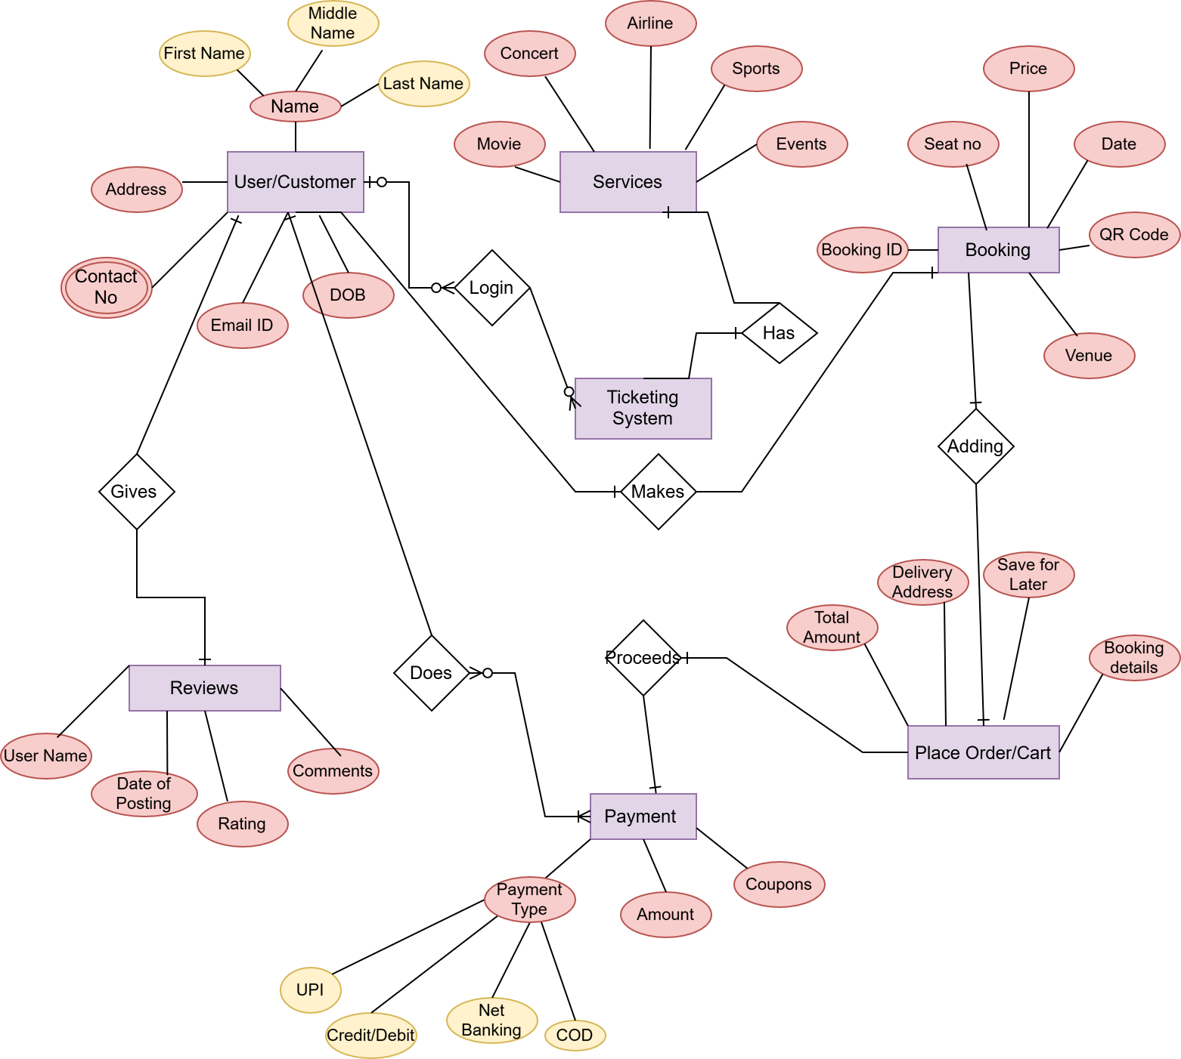

4. User story of shopping from ecommerce.
User Story 1 | Task 1 – Create user registration and login | Priority: High
As a new customer
I want to register and log in to the e-commerce platform
so that I can securely access my account and make purchases
BV: 200 |  | CP: 8
Acceptance Criteria:
Users can register with email, phone, and password.
System validates unique email/phone.
Login authenticates registered users.
Password recovery option is available

User Story 2 | Task 2 – Build product browsing and search functionality | Priority: High
As a customer
I want to browse and search for products by name or category so that I can easily find items I wish to buy
BV: 200 |  | CP: 13
Acceptance Criteria:
Search bar supports keyword-based search.
Products are displayed with name, image, price, and rating.
Categories and filters (price, brand, etc.) work correctly

User Story 3 | Task 3 – Develop product detail view | Priority: Medium
As a customer
I want to view detailed product information

so that I can make an informed purchasing decision.
BV: 200 |  | CP: 5
Acceptance Criteria:
Product page shows description, specifications, and reviews.
Displays real-time stock availability.
Users can add product to cart or wishlist from this page

User Story 4 | Task 4 – Create shopping cart module | Priority: High
As a customer
I want to add, view, and update products in my shopping cart

so that I can review items before purchasing
BV: 500 |  | CP: 8
Acceptance Criteria:
Users can add/remove products.
Quantity updates recalculate total price.
Cart persists between sessions for logged-in users.

User Story 5 | Task 5– Implement checkout and payment processing | Priority: High
As a customer
I want to complete my order using preferred payment methods

so that I can finalize my purchase securely.
BV: 500 |  | CP: 13
Acceptance Criteria:
Checkout includes address, delivery options, and payment method.
Supports multiple payment modes (card, UPI, net banking).
Displays order summary and confirmation message

User Story 6 | Task 6 – Build order tracking and history dashboard | Priority: Medium
As a customer
I want to track the status of my orders

So that I can know when my items will be delivered.
BV: 200 |  | CP: 5
Acceptance Criteria:
Displays real-time order status (placed, shipped, delivered).
Allows viewing of past order history.
Option to cancel order before shipping

User Story 7 | Task 7 – Create wishlist feature | Priority: Medium
As a customer
I want to add products to a wishlist

So that I can purchase them later
BV: 100 |  | CP: 5
Acceptance Criteria:
Users can add/remove items to wishlist.
Wishlist is saved to user account.
Items show availability and price changes

User Story 8 | Task 8 - Enable product reviews and ratings | Priority: High
As a customer
I want to rate and review purchased products

So that I can share my experience and help others
BV: 200 |  | CP: 3
Acceptance Criteria:
Users can post, edit, or delete reviews.
Average rating displayed on product page.
Only verified buyers can review

User Story 9 | Task 9 - Build admin product management | Priority: High
As an Admin
I want to add, update, or remove products from the catalog

So that the store’s inventory stays accurate and updated.
BV: 500 |  | CP: 8
Acceptance Criteria:
Admin can CRUD products (Create, Read, Update, Delete).
Image uploads and category assignments work correctly.
Changes reflect in customer-facing product listings.

User Story 10 | Task 10 - Add password recovery feature | Priority: High
As a user
I want to reset my password

So that I can regain access if I forget it
BV: 200 |  | CP: 3
Acceptance Criteria:
Password reset link sent via email.
Secure token-based reset.
Confirmation displayed upon success

User Story 11 | Task 11 - Implement recommendation engine | Priority: Low
As a customer
I want to see recommended products

So that I can discover items related to my interests
BV: 200 |  | CP: 8
Acceptance Criteria:
Related/recommended products shown dynamically.
Personalized suggestions based on browsing history

User Story 12 | Task 12 - Develop order management system for admin | Priority: High
As an Admin
I want to view and process all customer orders

So that I can fulfill them efficiently
BV: 500 |  | CP: 8
Acceptance Criteria:
Admin dashboard lists all orders.
Status can be updated (Processing, Shipped, Delivered).
Filters by date, customer, or status available.

User Story 13 | Task 13 - Add email/SMS notification system | Priority: High
As an Customer
I want to receive notifications about my orders and offers

So that I stay updated on my purchases and promotions
BV: 500 |  | CP: 5
Acceptance Criteria:
Email/SMS sent for order confirmation and shipping updates.
Users can manage notification preferences

User Story 14 | Task 14 - Order confirmation message | Priority: High
As an Customer
I want to get order confirmation

So that I know my purchase was successful
BV: 200 |  | CP: 3
Acceptance Criteria:
Confirmation page and email/SMS sent automatically

User Story 15 | Task 15 - Build category-based browsing | Priority: High
As an Customer
I want to browse products by category

So that I I can find products easily
BV: 500 |  | CP: 8
Acceptance Criteria:
Categories/subcategories displayed

User Story 16 | Task 16 - Enable filtering options | Priority: Medium
As an Customer
I want to filter results by price, brand, rating

So that I can refine my search
BV: 500 |  | CP: 8
Acceptance Criteria:
Filters apply dynamically

User Story 17 | Task 17 - Add sorting feature | Priority: Medium
As an Customer
I I want to sort products by popularity or price

So that I can view the most relevant options first
BV: 500 |  | CP: 5
Acceptance Criteria:
Sorting works for all product lists

User Story 18 | Task 18 - Add sorting feature | Priority: Medium
As an Customer
I I want to compare products

So that I can choose the best option
BV: 500 |  | CP: 5
Acceptance Criteria:
Comparison table displays features side by side

User Story 19 | Task 19 - Add coupon system | Priority: Medium
As an Customer
I I want to apply discount codes

So that I can save money
BV: 500 |  | CP: 5
Acceptance Criteria:
Valid coupons reduce order total

User Story 20 | Task 20 - Add stock alert system | Priority: Medium
As an Customer
I want to get notified when out-of-stock items are restocked

So that I can buy them when available
BV: 200 |  | CP: 5
Acceptance Criteria:
“Notify Me” option triggers email/SMS alerts

User Story 21 | Task 21- Enable return/refund requests | Priority: High
As an Customer
I want to return defective products

So that I can get a replacement or refund
BV: 500 |  | CP: 8
Acceptance Criteria:
Return request allowed within 15 days

User Story 22 | Task 22- Add loyalty program | Priority: Medium
As a Regular Customer
I want to earn points for purchases

So that I can redeem them later
BV: 500 |  | CP: 8
Acceptance Criteria:
Points automatically calculated on orders

User Story 23 | Task 23- Add loyalty program | Priority: Medium
As a Customer
I want to use the website in my preferred language

So that I can understand everything clearly
BV: 200 |  | CP: 5
Acceptance Criteria:
Switch between at least two languages

User Story 24 | Task 24- Create seller management module | Priority: High
As a Seller
I want to manage my listings and sales

So that I can track performance.
BV: 200 |  | CP: 8
Acceptance Criteria:
Seller dashboard with analytics and product management

User Story 25 | Task 25- Add live chatbot for support | Priority: Medium
As a Customer
I want to get instant help

So that my queries are resolved quickly
BV: 500 |  | CP: 8
Acceptance Criteria:
Chatbot handles FAQs and routes to agent if needed

