CAPSTONE PROJECT – PREP 2.
SUBMITTED BY – AISHWARYA AJIT KHULE
BATCH – 10TH AUGUST, 2024.
SUBMISSION DATE – 21ST SEPT, 2024.

Online Agriculture Products Store :-
Mr. Henry, after being successful as a businessman and has become one of the wealthiest persons in the city. Now, Mr. Henry wants to help others to fulfil their dreams. One day, Mr. Henry went to meet his childhood friends Peter, Kevin and Ben. They live in a remote village and do farming. Mr. Henry asked his friends if they are facing any difficulties in their day-to-day work. Peter told Mr. Henry that he is facing difficulties in procuring fertilizers which are very important for farm. Kevin said that he is also facing the same problem in-case of buying seeds for farming certain crops. Ben raised his concern on lack of pesticides which could help in greatly reducing pests in crops. After listening to all his friends’ problems, Mr. Henry thought that this is a crucial problem faced not only by his friends but also by so many other farmers. So, Mr. Henry decided to make an online agriculture product store to facilitate remote area farmers to buy agriculture products. Through this Online Web / mobile Application, Farmers and Companies (Fertilizers, seeds and pesticides manufacturing Companies) can communicate directly with each other. The main purpose to build this online store is to facilitate farmers to buy seeds, pesticides, and fertilizers from anywhere through internet connectivity. Since new users are involved, Application should be user friendly. This new application should be able to accept the product (fertilizers, seeds, pesticides) details from the manufacturers and should be able to display them to the Farmers. Farmers will browse through these products and select the products what they need and request to buy them and deliver them to farmers location. Mr. Henry has given this project through his Company SOONY. In SOONY Company, Mr Pandu is Financial Head and Mr Dooku is Project Coordinator. Mr. Henry , Mr Pandu , and Mr Dooku formed one Committee and gave this project to APT IT SOLUTIONS company for Budget 2 Crores INR and 18 months Duration under CSR initiative. Peter, Kevin and Ben are helping the Committee and can be considered as Stakeholders share requirements for the Project. Mr Karthik is the Delivery Head in APT IT SOLUTIONS company and he reached out to Mr Henry through his connects and Bagged this project. APT IT SOLUTIONS company have Talent pool Available for this Project. Mr Vandanam is project Manager, Ms. Juhi is Senior Java Developer, Mr Teyson, Ms Lucie, Mr Tucker, Mr Bravo are Java Developers. Network Admin is Mr Mike and DB Admin is John. Mr Jason and Ms Alekya are the Tester. And you joined this team as a BA.
Question 1.
4 Quarterly Audits are planned Q1, Q2, Q3, Q4 for this Project. What is your knowledge on how these Audits will happen for a BA?
Answer 1.
Quarter | Task | Description | Audit Point | Remark / Observation
Q1 | Identify the | Identifying | Were all Stakeholders | Pass
Q1 | Stakeholder | Stakeholders | identified | Pass
Q1 | Conduct Interview | Conducting Interview | Was Interview Conducted | Pass
Q1 | Conduct Interview | with Stakeholder | will all the Stakeholders | Pass
Q1 | Review Existing | Reviewing existing | Was the existing | Pass
Q1 | Docs | Documents | documents reviewed | Pass
Q1 | Define Scope | Clearly define the scope | Was the scope of the | Pass
Q1 | Define Scope | Clearly define the scope | project clear | Pass
Q1 | Define Function & | Defining all | Were all the | Pass
Q1 | Non-Functional | the | requirements | Pass
Q1 | Requirement | Requirements | defined | Pass
Q1 | Prioritize | Prioritizing | Were all requirements | Pass
Q1 | Requirements | Requirements | prioritized | Pass
Q1 | Validate | Validating | Were all requirements | Pass
Q1 | Requirement | Requirements | validated | Pass
Q1 | Obtain Sign-Off | Obtaining Sign off | Was Sign Off taken | Pass
Q2 | Solution Design | Designing Solution | Was solution decided | Pass
Q2 | Prototype | Developing Prototype | Was prototype | Pass
Q2 | Development | Developing Prototype | developed | Pass
Q2 | Code Development | Developing Code | Was codes developed | Pass
Q2 | Code Development | Developing Code | correctly | Pass
Q2 | Unit Testing | Testing Units | Was unit testing done | Pass
Q3 | Integrated Testing | Testing multiple | Was integrated testing | Pass
Q3 | Integrated Testing | modules | done | Pass
Q3 | Security Testing | Testing security | Was security features | Fail
Q3 | Security Testing | features | done | Fail
Q3 | System Testing | Testing the system as a | Was system testing done | Pass
Q3 | System Testing | whole | Was system testing done | Pass
Q3 | Bug Fixing | Fixing the errors | Was debugging done | Pass
Q4 | Regression Testing | Regression Testing | Was regression testing | Pass
Q4 | Regression Testing | Regression Testing | done | Pass
Q4 | UAT | User Acceptance testing | Was UAT performed | Pass
Q4 | Testing Report | Preparing Test Report | Was test report | Pass
Q4 | Testing Report | Preparing Test Report | published | Pass
Q4 | Obtain Sign off | Obtaining Sign Off | Was sign off taken | Pass

QUESTION 2.
Before the Project is going to Kick Start, The Committee asked Mr Karthik to submit BA Approach Strategy. Write BA Approach strategy (As a business analyst, what are the steps that you would need to follow to complete a project – What Elicitation Techniques to apply, how to do Stakeholder Analysis RACI/ILS, What Documents to Write, What process to follow to Sign off on the Documents, How to take Approvals from the Client, What Communication Channels to establish n implement, How to Handle Change Requests, How to update the progress of the project to the Stakeholders, How to take signoff on the UAT- Client Project Acceptance Form )
Your Team
Project Manager - Mr Vandanam
Senior Java Developer - Ms. Juhi
Java Developers - Mr Teyson, Ms Lucie, Mr Tucker, Mr Bravo
Network Admin - Mr Mike
DB Admin - Mr John.
Testers - Mr Jason and Ms Alekya
BA - You
Technical Team have assembled to discuss on the Project approach and have finalised to follow3-tier architecture for this project.
ANSWER 2.
- What Elicitation Techniques to Apply-
- Workshops: Conduct workshops with key stakeholders (Peter, Kevin, Ben) and technical leads (Ms. Juhi, Mr. Vandanam) to discuss high-level functional and non-functional requirements.
- Interviews: Conduct one-on-one interviews with Mr. Henry, Mr. Pandu, and Mr. Dooku to understand their vision, expectations, and key goals for the project.
- Surveys/Questionnaires: Distribute surveys to target farmers and manufacturers to gather insights on user requirements, ease of use, and the functionalities they expect.
- Document Analysis: Review existing processes, documentation, and research papers related to e-commerce and agriculture to identify relevant features for the online platform.
- Observation: Understand the current pain points by observing how Peter, Kevin, and Ben procure fertilizers, seeds, and pesticides.
- How to do Stakeholder Analysis RACI –

- Stakeholders:
- Mr. Henry: Sponsor
- Mr. Pandu: Financial Head
- Mr. Dooku: Project Coordinator
- Peter, Kevin, Ben: Farmers/Stakeholders
- Mr. Karthik: Delivery Head at APT IT Solutions
- Mr. Vandanam: Project Manager at APT IT Solutions
- Technical Team (Java Developers, Network Admin, DB Admin, Testers)

- Roles and Responsibilities:
Each stakeholder has a specific role and set of responsibilities in the project. This breakdown ensures clarity in expectations and minimizes confusion during project execution.
- Responsible (R): Who is responsible for carrying out the task? These are the doers.
- Accountable (A): Who is ultimately accountable for the task? This is usually a senior person who delegates the work.
- Consulted (C): Who needs to be consulted before a decision is made or an action is taken? These are typically subject matter experts.
- Informed (I): Who needs to be informed about decisions or progress? They are kept in the loop but not involved in the task's execution.
RACI Matrix:

Task | Responsible | Accountable | Consulted | Informed
Requirements Gathering | You (BA) | Mr. Henry | Peter, Kevin, Ben, Mr. Karthik | All Stakeholders
Project Planning | Mr. Vandanam | Mr. Karthik | Technical Team | Mr. Henry, Mr. Pandu, Mr. Dooku
Design Phase | Ms. Juhi | Mr. Vandanam | Technical Team | You (BA)
Development | Technical Team | Mr. Vandanam | You (BA) | Stakeholders
Testing | Mr. Jason, Ms. Alekya | Mr. Vandanam | Technical Team, You (BA) | Stakeholders
Change Request Management | You (BA) | Mr. Vandanam | All Stakeholders | Stakeholders
User Acceptance Testing (UAT) | You (BA) | Mr. Henry | Mr. Dooku, Technical Team | All Stakeholders

- What documents to write
- Business Requirements Document (BRD): Detailed documentation of all business requirements gathered from stakeholders.
- Functional Requirements Specification (FRS): Describes how the system will function to meet the business requirements.
- Non-Functional Requirements (NFR): Capture performance, scalability, and user experience expectations.
- Use Cases/User Stories: Define specific scenarios of user interaction with the system.
- Wireframes and Mockups: Visual representation of the user interface and flow.
- Stakeholder Communication Plan: Define how and when to communicate project updates.
- Change Request Log: Track all changes requested during the project life cycle.
- UAT Plan: Detailed steps and criteria for User Acceptance Testing.

- What process to follow to Sign off on the documents
- Drafting: Create drafts of BRD, FRS, NFR, and other relevant documents.
- Review: Share the documents with key stakeholders (Mr. Henry, Mr. Pandu, Mr. Dooku, and APT IT Solutions team) for review.
- Feedback Incorporation: Update documents based on stakeholder feedback.
- Approval: Send final versions of documents to the Committee (Mr. Henry, Mr. Pandu, Mr. Dooku) for formal sign-off.
- Version Control: Use version control to track changes and maintain signed copies.

- How to take approvals from the client
- Formal Meetings: Schedule formal meetings to review key milestones and documents (BRD, FRS).
- Change Request Management: Keep the client informed about changes via documented requests and approvals to avoid scope creep. Use tools like Jira or emails for tracking.
- Sign-off Process: Ensure that the client signs off at key stages (requirements, development, UAT) through formal approval forms.

- What communication channels to establish and implement
- Emails and Official Communication: Use email for formal communication with the committee and stakeholders.
- Daily Standups: Conduct daily or weekly standup meetings with the technical team (developers, testers, etc.) to monitor progress.
- Project Management Tools: Implement tools like Jira or Trello for task tracking and updates, ensuring all stakeholders can track progress.

- How to handle change request
- Change Request Form: Create a standardized change request form that documents the requested changes, their impact on the timeline and budget, and the approval process.
- Impact Analysis: Perform an impact analysis for every change request and review it with the committee before making adjustments.
- Change Control Board: Establish a change control board (CCB) comprising key stakeholders who approve or reject change requests.

- How to update the progress of the project to the stakeholder
- Weekly Progress Reports: Share weekly reports highlighting key milestones achieved, pending tasks, and potential risks.
- Monthly Steering Committee Meetings: Present a detailed progress report to the committee (Mr. Henry, Mr. Pandu, Mr. Dooku) once a month.
- Burndown Charts: Use burndown charts to visually display project completion against timelines.

- How to take signoff on the UAT- Client Project Acceptance Form
- UAT Preparation: Define acceptance criteria clearly in the UAT Plan and ensure that these criteria are agreed upon by the client (Mr. Henry).
- UAT Execution: During UAT, have key stakeholders (Peter, Kevin, Ben) test the system based on predefined test cases.
- Issue Resolution: Document all issues found during UAT, and ensure they are resolved before final signoff.
- Final Acceptance: Once UAT is complete and all issues are resolved, present the Client Project Acceptance Form to Mr. Henry and the committee for their signatures.
- Project Closure: Once signoff is obtained, prepare a Project Closure Report and hand over all documentation to the client.

QUESTION 3.
Explain and illustrate 3-tier architecture?
ANSWER 3.
The fundamental advantage of 3-tier architecture is the separation of concerns into a tier methodology. Each tier operates independently with independent teams working simultaneously on the respective layers, allowing developers to focus on specific aspects of the application without affecting other layers. This enhances maintainability, as updates or changes can be made to a single tier with minimal impact on the others. 3-tier applications are also highly scalable since each tier can be scaled horizontally or vertically to handle increased demand as usage grows.
- Presentation Layer:
This layer handles the user interface and user interaction. The components of this layer are Web pages, mobile app screens, or desktop application interfaces. It receives user input, displays data, and communicates with the application logic layer.
- Application Logic Layer (Business Logic Layer):
This layer processes user input from the presentation layer and makes decisions based on the business rules of the application. The components of this layer are Server-side scripts, application servers, and APIs. It handles data processing, business logic, and communication with the data layer. It can also enforce business rules and perform calculations.
- Data Layer:
This layer manages data storage, retrieval, and management. The components of this layer are Databases (SQL, NoSQL), data warehouses, or file storage systems. It interacts with the application logic layer to store and retrieve data, ensuring data integrity and security.

Presentation Layer (e.g., HTML, CSS, JavaScript, mobile apps)
(User Interface)

Application Logic Layer (e.g., APIs, business logic, server-side processing)
(Business Rules)

Data Layer (e.g., MySQL, MongoDB, Oracle)
(Data Storage)

Advantages of 3-Tier Architecture
- Separation of Concerns: Each layer has distinct responsibilities, making the system easier to manage.
- Scalability: Each tier can be scaled independently based on demand.
- Maintainability: Changes in one layer (like UI updates) can be made without impacting others.
- Reusability: Components in one layer can be reused in different applications.
3-tier architecture is widely used in modern software development due to its modular approach, which enhances flexibility and efficiency in application design and deployment. This architecture is particularly beneficial for web applications, enterprise solutions, and cloud-based services.

QUESTION 4.
Business Analyst should keep What points in his/her mind before he frames a Question to ask to the Stakeholder (5W 1H – SMART – RACI – 3 Tier Architecture – Use Cases, Use case Specs, Activity Diagrams, Models, Page designs).
ANSWER 4.

1. 5W1H Framework
- Who: Identify key stakeholders.
Question:
  - Who will be the primary users (farmers, manufacturers)?
  - Who is responsible for managing product listings?
- What: Define the specific needs and features.
Questions:
  - What types of products need to be listed (fertilizers, seeds, pesticides)?
  - What functionalities are essential for the application?
- Where: Understand the usage context.
Questions:
  - Where will users access the application (mobile, web)?
  - Are there specific geographical constraints we should consider?
- When: Clarify timelines.
Questions:
  - When do farmers typically need these products?
  - What is the timeline for project milestones?
- Why: Explore the underlying reasons.
Questions:
  - Why is this application important for the farmers?
  - What specific problems are we trying to solve?
- How: Investigate processes and methods.
Questions:
  - How do farmers currently source their products?
  - How will the application facilitate communication between farmers and manufacturers?
2. SMART Criteria
- Specific: Ensure clarity and precision.
Questions:
  - What specific features should the application have for product search?
- Measurable: Enable quantifiable outcomes.
Questions:
  - How many products do you expect to be available at launch?
- Achievable: Assess feasibility.
Questions:
  - Is it realistic for farmers to use mobile devices for this application?
- Relevant: Align with project goals.
Questions:
  - How does this application fit into the farmers' daily routines?
- Time-bound: Set deadlines.
Questions:
  - When do you expect to place your first order through the application?
3. RACI Model
- Responsible: Identify task performers.
Questions:
  - Who will input product details into the application?
- Accountable: Determine decision-makers.
Questions:
  - Who is ultimately accountable for the project’s success?
- Consulted: Identify who should provide input.
Questions:
  - Who among the farmers should we consult for feedback on usability?
- Informed: Clarify who needs updates.
Questions:
  - Who should be kept informed about project progress and milestones?
4. 3-Tier Architecture
- Application Layer: Focus on user experience.
Questions:
  - What key features are most important for the user interface?
- Business Logic Layer: Inquire about operational rules.
Questions:
  - What rules should govern the listing and ordering of products?
- Database Layer: Gather data management needs.
Questions:
  - What types of data do we need to store for products and users?
5. Use Cases and Use Case Specifications
- Identify Use Cases: Discuss different user scenarios.
Questions:
  - Can you describe a typical buying process for a farmer using the app?
- Detail Requirements: Focus on specific functionalities.
Questions:
  - What information must farmers provide when placing an order?
6. Activity Diagrams and Models
- Process Understanding: Ask about existing workflows.
Questions:
  - How do farmers currently purchase their agricultural products?
- Identify Pain Points: Discuss challenges in current processes.
Questions:
  - What specific difficulties do you encounter in sourcing fertilizers or seeds?
7. Page Designs
- User Interface Needs: Explore preferences for design.
Questions:
  - What layout and design elements do you find most user-friendly?
- User Experience: Inquire about the user journey.
Questions:
  - app What steps do you envision for a farmer placing an order through the?

QUESTION 5.
As a Business Analyst, What Elicitation Techniques you are aware of?
ANSWER 5.
As a Business Analyst, there are several elicitation techniques that I am aware of. Some commonly used elicitation techniques include brainstorming, focus groups, prototypes, meetings, interviews, workshops, document analysis, surveys, and observations.
- Brainstorming: - Brainstorming is a group creativity activity used to generate ideas, identify root causes of problems, and solve complex business problems. In requirements gathering, brainstorming can be used to get a variety of ideas from a group of people and identify possible solutions to problems

- Focus Groups: - Focus groups involve gathering stakeholders who represent the customer and can be used to collect information in a relatively short period of time. Multiple viewpoints can be shared and discussed with the assistance of a facilitator. Feedback gathered from a focus group can be used to identify or validate requirements and stakeholder attitudes and beliefs about the solution.

- Prototypes: - Prototyping is a requirements gathering and elicitation technique used to gather preliminary requirements for building an initial version of the solution. The prototype can be shown to stakeholders, who will review and give recommendations for improvement to meet business requirements.

- Interviews: - Interviews are one of the most effective ways of gathering information from stakeholders and can be used to engage with stakeholders, identify, elicit, and document requirements. Business analysts can use structured or unstructured interviews, depending on the situation.

- Workshops: - Workshops involve a group of individuals and can be a very effective way of gathering requirements and establishing collaboration between business analysts and stakeholders. During a requirements workshop, a facilitator will play a leading role by presenting the topics to be discussed as well as coming up with documentation.

- Document analysis: - Document analysis involves reviewing existing documentation, such as business processes procedures, project charter, and data models, to identify requirements. Document analysis can also help create the as-is process flow diagrams in the business requirements document.

- Surveys: - Surveys are a data-gathering method used to collect, analyze, and interpret the views of a group of people from a target population. Surveys can be used to gather and elicit requirements from a large number of people in a short period of time.

- Observations: - Observations present an opportunity to interact with stakeholders within an organization. Observations can be used effectively with other techniques, such as interviewing and surveys, to help gather and validate requirements.

- Joint Application Development (JAD): Collaborative workshops that involve stakeholders and developers to refine requirements and solutions.

- Questionnaires (P): Distributing surveys to gather information from a larger audience, which can help identify trends and requirements.

- Use Cases (U): Defining scenarios that describe how users will interact with the system, which helps clarify requirements.

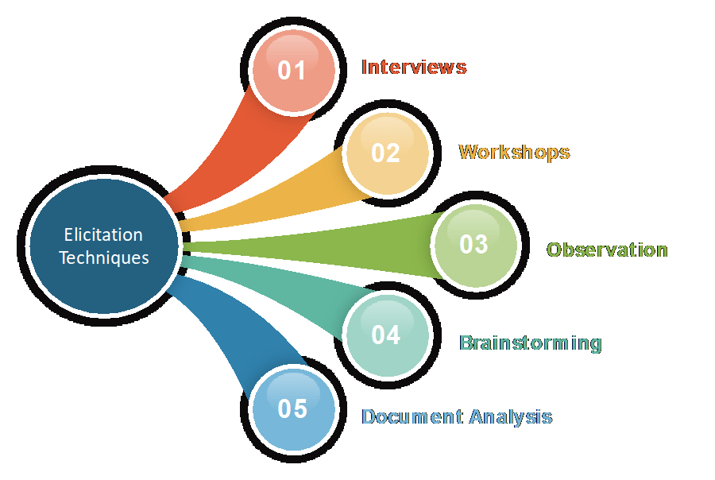
QUESTION 6.
Which Elicitation Techniques can be used in this Project and Justify your selection of Elicitation Techniques?
ANSWER 6.
According to me, as a BA I would use the below given elicitation techniques in this project-
- Brainstorming: By using this Technique, we can extract several ideas to make the Online store more useful for farmers and other users. Once we have these ideas, we can analyse and select the best ideas to implement. Brainstorming is effective with group of 8 to 12 people it helps to get the good number of ideas from user and stakeholders.
- Prototype: Prototyping is a visual technique, where we can create a representation of any ideas and allow us to test our ideas directly with the users before developing into a fully-fledged product. For this project, I would draw down the idea in a paper and share it with the stakeholders. Being a completely new project in the market, for which there are no details or document available, I would use this technique to find the feasibility of the project, before spending money on the project.
- Use case specs: This technique is a combination of text and pictures which will provide me a better understanding of the requirements. This technique shows the behaviour of the system and help to capture the requirement of the system. These diagrams also identify the interactions between the system and its actors.

Fertilizers, seeds, pesticides details from the manufacturers and should be able to display them to the Farmers. To gather the business requirements from the client, you went to SOONY and met Mr. Henry. When Mr. Henry was asked about the project and what are they expecting from the project, Mr. Henry stated that he is expecting to have a login for all its users (fertilizers, seeds, pesticides manufacturers and Farmers) , a product catalogue of fertilizers, seeds, pesticides, a search option to search for products, payment process, and delivery tracking. After doing the stakeholder analysis, you have found out that Peter, Kevin, Ben are the key stakeholders and you have scheduled an appointment to meet them. After meeting with them and trying to gather the stakeholder requirements, Kevin said that, a Farmer should be able to browse through the products catalogue once they visit the website and need to have a search option so that they can search for any product they need. Peter said that, if a farmer wants to buy any product or add them to buy-later list, they need to log in first using their email id and password. If it is a new user, then they can create a new account by submitting their email ID and creating a secure password. Ben added saying that, Farmers needs to have an easy-to-use payment gateway which should include cash-on-delivery (COD), Credit/Debit card and UPI options so that the user’s experience should be better. Kevin mentioned that, a user gets an email confirmation regarding their order status. A delivery tracker to track the whereabouts of their order. Identify Business Requirements (which includes Stakeholder Requirements)
BR001 – Farmers should be able to search for available products in fertilizers, seeds, pesticides
BR002 – Manufacturers should be able to upload and display their products in the application

QUESTION 7.
Make suitable Assumptions and identify at least 10 Business Requirements.
ANSWER 7.
- BR001 - User Registration and Authentication:
- The application must allow farmers and manufacturers to create accounts securely and authenticate their identities.
- BR002 - Product Catalogue Management:
- The system must enable manufacturers to upload and manage product listings, including fertilizers, seeds, and pesticides.
- BR003 - Search and Filter Functionality:
- Farmers must be able to search for products and filter results based on categories, such as type (fertilizer, seed, pesticide), price range, and manufacturer.
- BR004 - Product Details and Information:
- Each product listing must include detailed descriptions, usage instructions, pricing, and availability status.
- BR005 - Shopping Cart and Order Management:
- The application must allow farmers to add products to a shopping cart and manage their orders, including viewing order history and tracking deliveries.
- BR006 - Payment Processing:
- The system should support multiple payment methods, including credit/debit cards, mobile wallets, and cash on delivery.
- BR007 - Delivery Scheduling:
- Farmers should be able to choose preferred delivery times, and the system must manage logistics to ensure timely delivery to remote areas.
- BR008 - User Reviews and Ratings:
- The application must include a feature for farmers to review and rate products, providing feedback to both manufacturers and other users.
- BR009 - Customer Support:
- The application should offer customer support options, such as FAQs, chat support, or contact forms for users facing issues.
- BR010 - Reporting and Analytics:
- The system must provide reporting tools for manufacturers to track sales performance, inventory levels, and user engagement metrics.
- BR011 – Return and Refund Policy:
- There should be a set refund and return or exchange policy on the goods that are displayed on the website. And, the system must provide all the necessary details.

QUESTION 8.
List your assumption.
ANSWER 8.
Assumptions:
- The platform is a web-based marketplace where farmers can buy fertilizers, seeds, and pesticides directly from manufacturers.
- Users (farmers and manufacturers) need an easy-to-use interface with secure access and clear navigation.
- The system must handle multiple forms of payments and track deliveries for orders.
- Manufacturers require a simple way to upload and manage their product catalog.
- The platform needs to send notifications to users regarding their order status, payment confirmations, and delivery tracking.
- Present Tense
- Needs to be connected to a network

QUESTION 9.
Give Priority 1 to 10 numbers ( 1 being low priority – 10 being high priority) to these Requirements after discussions with the stakeholders.
ANSWER 9.
Req. ID | Req. Name | Req. Description | Priority
BR001 | User Registration and Authentication | The application must allow farmers and manufacturers to create accounts securely and authenticate their identities. | 8
BR002 | Product Catalogue Management | The system must enable manufacturers to upload and manage product listings, including fertilizers, seeds, and pesticides. | 8
BR003 | Search and Filter Functionality | Farmers must be able to search for products and filter results based on categories, such as type (fertilizer, seed, pesticide), price range, and manufacturer. | 9
BR004 | Product Details and Information | Each product listing must include detailed descriptions, usage instructions, pricing, and availability status. | 9
BR005 | Shopping Cart and Order Management | The application must allow farmers to add products to a shopping cart and manage their orders, including viewing order history and tracking deliveries. | 10
BR006 | Payment Processing | The system should support multiple payment methods, including credit/debit cards, mobile wallets, and cash on delivery. | 7
BR007 | Delivery Scheduling | Farmers should be able to choose preferred delivery times, and the system must manage logistics to ensure timely delivery to remote areas. | 7
BR008 | User Reviews and Ratings | The application must include a feature for farmers to review and rate products, providing feedback to both manufacturers and other users. | 6
BR009 | Customer Support | The application should offer customer support options, such as FAQs, chat support, or contact forms for users facing issues. | 10
BR010 | Reporting and Analytics | The system must provide reporting tools for manufacturers to track sales performance, inventory levels, and user engagement metrics | 9
BR011 | Return and Refund Policy | There should be a set refund and return or exchange policy on the goods that are displayed on the website. And, the system must provide all the necessary details | 9

QUESTION 10.
Draw use case diagrams.
ANSWER 10.
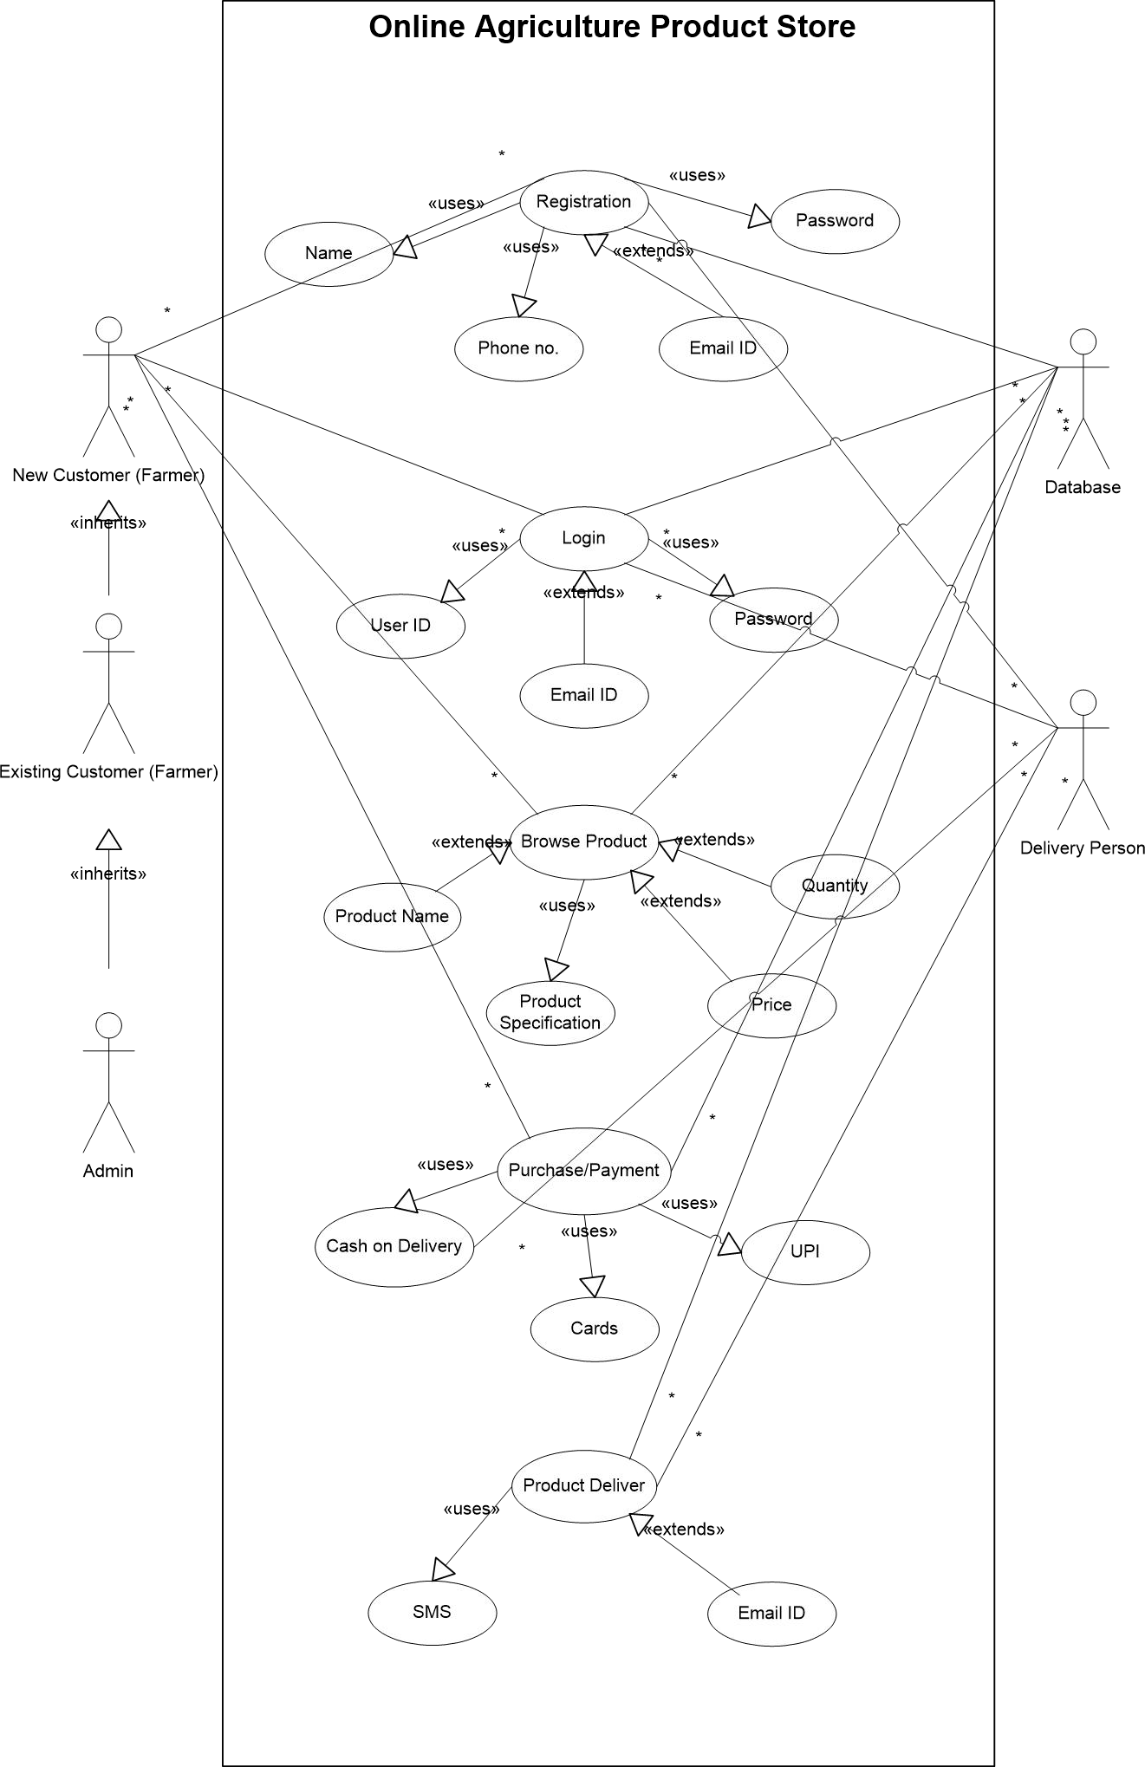

QUESTION 11.
Prepare use case specs for all use cases. (minimum 5)
ANSWER 11.

Use case ID | US001
Use case  Name | New User Registration
Created by | Ms. Aishwarya | Last Updated
Date created | Sep 25th 2024 | Last Revision Date
Actor | Farmer, Manufacturer
Description | This use case allows a new user to create an account by providing required details such as phone number, email ID
Pre- condition | The user is not yet registered in the system.
Post- condition | A new user account is created, and the user can log in.
Basic flow | - The user selects the "New User" option.  - The system prompts the user to enter details like name, phone number, email ID, and password.  - The system validates the details.  - The system creates a new account for the user and sends a  confirmation email or SMS.
Alternative flow | If the email or phone number is already in use, the system informs the user and asks them to try logging in or using a different email/phone number.
Exceptions | If the user-provided details are invalid or incomplete, the system prompts  the user to correct the input.
Frequency  of use | Medium
Assumptions | The user has a valid email ID or phone number to register.

Use case ID | US002
Use case  Name | Login
Created by | Ms. Aishwarya | Last Updated
Date created | Sep 25th 2024 | Last Revision Date
Actor | Farmer, Manufacturer
Description | This use case allows a user to access the system by entering their credentials.
Pre-  condition | The user must be registered in the system with valid login credentials.
Post-  condition | The user is successfully logged into the system and can access their account.
Basic flow | - The user selects the "Login" option.  - The system prompts the user to enter their phone number/email ID and password.  - The user enters their credentials.  - The system verifies the credentials.  - Upon successful verification, the user is logged in and redirected to the dashboard.
Alternative  flow | If the credentials are incorrect, the system displays an error message and asks  the user to re-enter their credentials.
Exceptions | If the system is down or the server is unavailable, the user will be notified, and they will not be able to log in.
Frequency  of use | High
Assumptions | The user has already created an account.

Use case ID | US003
Use case  Name | Browse Products
Created by | Ms. Aishwarya | Last Updated
Date created | Sep 25th 2024 | Last Revision Date
Actor | Farmer
Description | The user can browse through the products listed on the platform to check  for availability and details before making a purchase.
Pre-  condition | The user must be logged in.  Products must be uploaded by manufacturers.
Post-  condition | The farmer views a list of products and selects those they are interested in.
Basic flow | - The farmer logs in.  - The farmer navigates to the "Browse Products" section.  - The system displays available products with details (price, description, availability).  - The farmer can apply filters to refine the search.  - The farmer selects a product for more information or to add to the cart.
Alternative  flow | If no products are available, the system displays a message indicating that  the stock is empty
Exceptions | If there is a system error, the farmer may not be able to browse products.
Frequency  of use | High
Assumptions | Products are listed and available in the system.

Use case ID | US004
Use case  Name | Perform Online Purchase
Created by | Ms. Aishwarya | Last Updated
Date created | Sep 25th 2024 | Last Revision Date
Actor | Farmer
Description | The user (Farmer) can perform an online purchase by browsing, selecting,  and paying for products through the system.
Pre-  condition | The user must be logged in.  Products must be available for browsing.
Post-  condition | The farmer successfully places an order, and the system sends confirmation  details.
Basic flow | - The farmer logs into the system.  - The farmer browses available products.  - The farmer selects desired products and adds them to the cart.  - The system checks product availability.  - The farmer proceeds to payment.  - The system confirms the order and provides an order confirmation
Alternative  flow | If the product is out of stock, the system informs the farmer and suggests  alternatives.
Exceptions | If there is a payment failure, the system informs the farmer and prompts them to retry.
Frequency  of use | High
Assumptions | Products are in stock, and payment options are available.

Use case ID | US005
Use case  Name | Upload Product Details
Created by | Ms. Aishwarya | Last Updated
Date created | Sep 25th 2024 | Last Revision Date
Actor | Manufacturer
Description | The manufacturer can upload product details (name, price, description,  availability) to the system for farmers to view and purchase.
Pre- condition | - The manufacturer must be logged in.  - The manufacturer has valid product details to upload.
Post-  condition | The product details are uploaded and visible to farmers on the platform.
Basic flow | - The manufacturer logs into the system.  - The manufacturer navigates to the "Upload Product Details" section.  - The system prompts the manufacturer to enter the product information (name, description, price, stock availability).  - The system validates the entered details.  - Upon successful validation, the product is listed in the system.
Alternative  flow | If the product details are incomplete or invalid, the system notifies the  manufacturer to correct the errors.
Exceptions | If the system encounters an error, the product details may not be uploaded  successfully.
Frequency of use | Medium
Assumptions | The manufacturer has access to valid product information

QUESTION Q12.
Activity diagram. (minimum 5)
ANSWER 12.
Activity diagram 1- Registered Customer Login

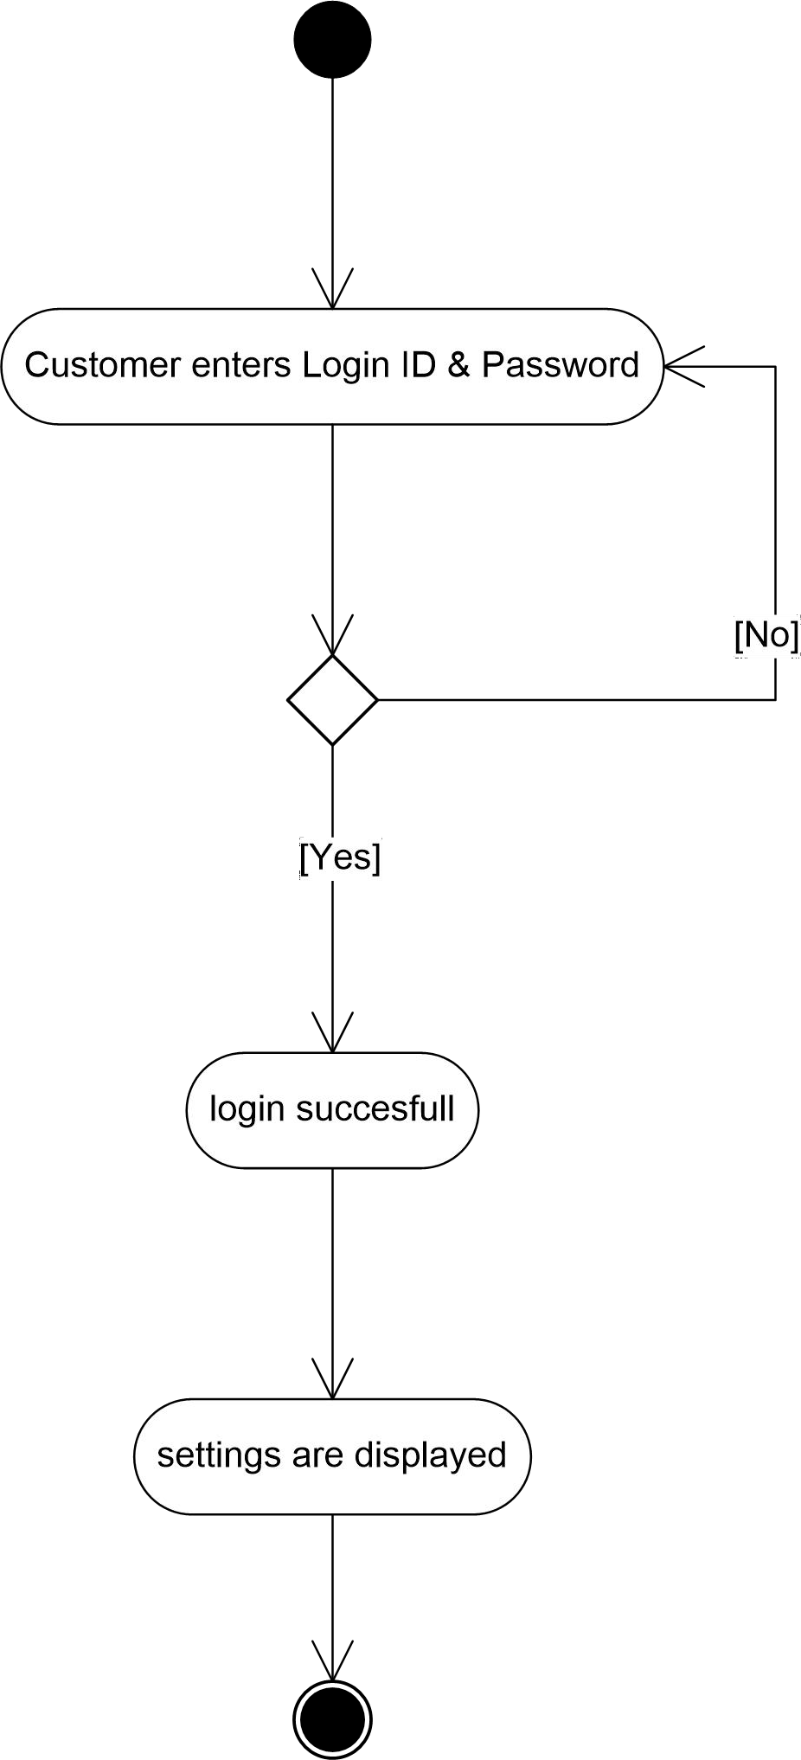

Activity diagram 2 – Search Product

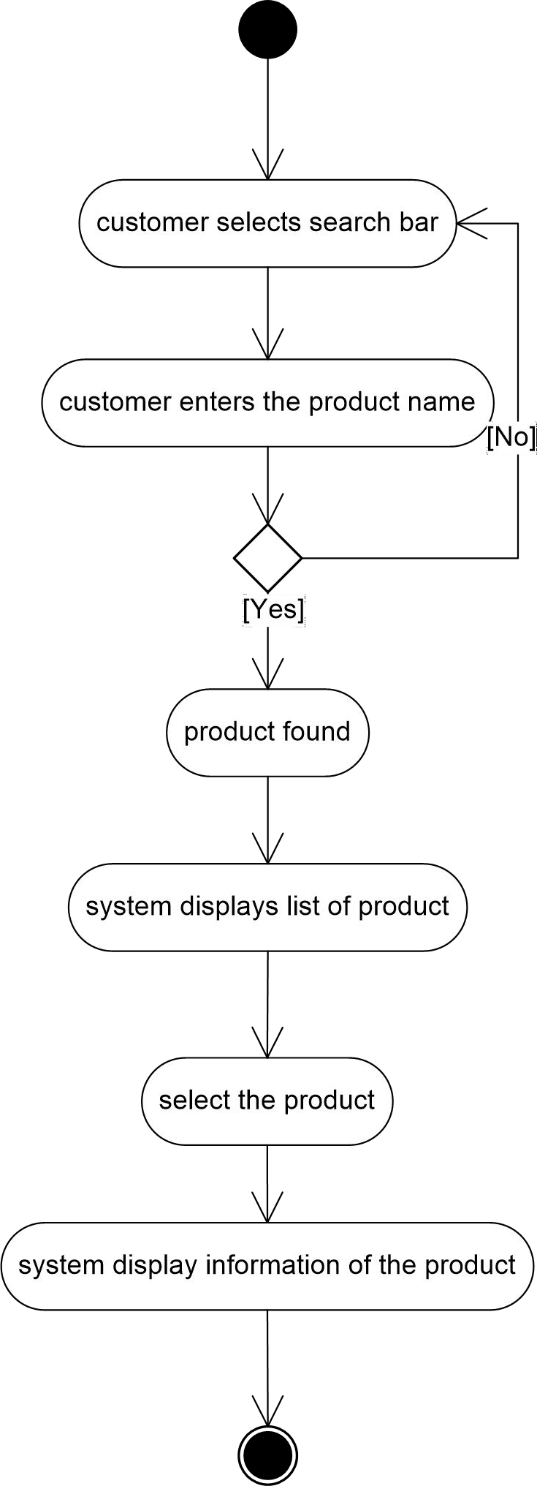

Activity diagram 3 – Add Product to Cart

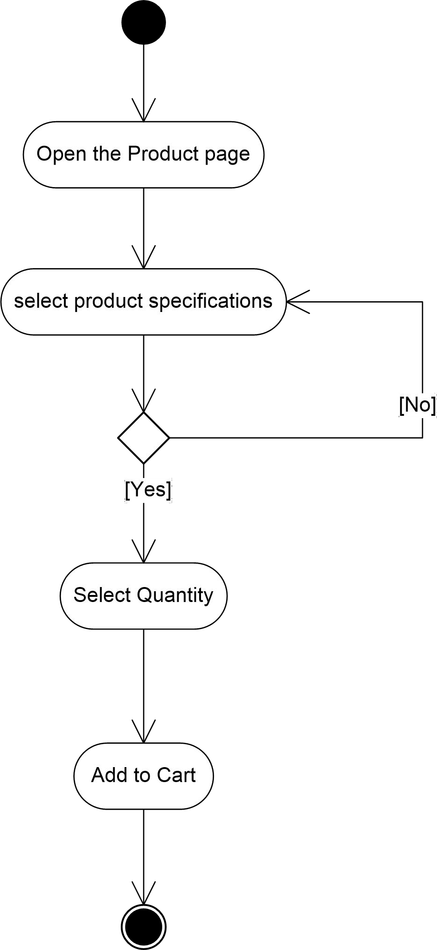

Activity Diagram 4 – Making a Payment

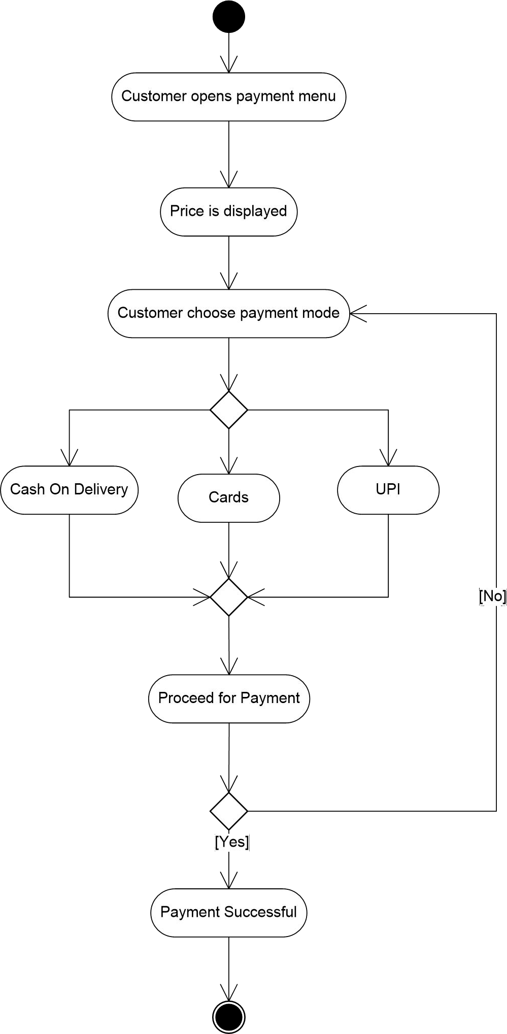

Activity Diagram 5 – Delivery

