- Business Requirement Document (BRD)

Project Overview
The company operates multiple manufacturing plants and warehouses across the country, producing ice-cream and milk products. Currently, managing inventory and ensuring timely delivery to customers is challenging. The proposed system will streamline inventory management and enable fastest possible delivery by optimizing warehouse operations, tracking stock, and integrating logistics.
Project Title
Inventory & Delivery Management System for Dairy Products
Project Name: Inventory & Delivery Management System for Dairy Products
Project ID: DIMS-001
Version ID: 0.1
Author: Gouthami Palepu

1. Document Revisions
Date | Version Number | Document Changes
05/02/20xx | 0.1 | Initial Draft
10/02/20xx | 0.2 | Added Business Objectives
15/02/20xx | 0.3 | Included Scope & Assumptions
20/02/20xx | 1.0 | Final Version Approved

2. Approvals
Role | Name |  | Title | Signature | Date
Project Sponsor | Anil Sharma | VP – Operations
Business Owner | Priya Mehta | Director – Business
Project Manager | Ramesh Iyer | Sr. Project Manager
System Architect | Rajeev Kulkarni | Lead System Architect
Development Lead | Deepak Rao | Development Lead
User Experience Lead | Neha Verma | UX Lead
Quality Lead | Kavitha Nair | QA Manager
Content Lead | Sandeep Menon | Content Strategist

3. RACI Chart for This Document
Name | Position | * | R | A | S | C | I
Ram | Project Sponsor |  |  | ✔
Shiva | Business Owner |  |  |  | ✔
Vasu | Project Manager |  | ✔
Javier | System Architect |  | ✔
Tony | Development Lead |  | ✔
Bhargav | UX Lead |  |  |  |  | ✔
Meena | Quality Lead |  |  |  |  |  | ✔
Manish | Content Lead |  |  |  |  |  | ✔

Business Goals
The primary goal of the dairy organization is to enhance operational efficiency and improve customer satisfaction through digital transformation. The company requires a reliable and scalable IT solution that can automate inventory management, streamline delivery operations, and provide transparency across the supply chain.
Need:
- Reduce manual dependency in managing stock, deliveries, and customer records.
- Enable faster and more accurate order fulfillment.
- Provide a central system to monitor sales, stock levels, and logistics.
- Support future digital initiatives such as HRMS and E-Learning integration.

Business Objectives
To provide an IT solution for:
- Mobile Application (Android & iOS) for customers to place orders, track deliveries, and make payments.
- Inventory Management System to track dairy product availability, stock movement, and wastage control.
- Delivery Management System to optimize route planning, delivery scheduling, and tracking.
- E-Learning Management System (future scope) for staff training and compliance awareness.
- HRMS (Human Resource Management System) (future scope) for employee record management, payroll, and attendance.

Business Rules
- Orders must be processed within the same day if received before the cut-off time.
- Dairy products must be dispatched only if they meet quality and freshness standards.
- Delivery staff must update order status (Delivered / Pending / Cancelled) in real time.
- Inventory levels must be automatically updated upon successful delivery.
- Customer data must comply with data protection and privacy regulations.
- Payment refunds for cancelled orders must be processed within 7 working days.

Background
Currently, the dairy company manages inventory and deliveries using manual records and spreadsheets, which often results in errors, stock-outs, and delayed deliveries. Customers lack visibility into order tracking, and management struggles to get real-time insights on stock and sales performance.
This project was proposed to:
- Eliminate inefficiencies caused by manual operations.
- Improve delivery accuracy and timeliness.
- Provide better visibility into inventory and supply chain.
- Enhance customer satisfaction by offering mobile-based ordering and tracking.
- Support the company’s vision of adopting digital platforms for growth.

Project Objective
The objective of this project is to develop an integrated Inventory & Delivery Management System for dairy products that:
- Automates order processing, inventory tracking, and delivery scheduling.
- Provides real-time updates to customers and management.
- Ensures data accuracy, transparency, and compliance with organizational policies.
- Aligns with broader business objectives of digital transformation and operational efficiency.
- Integrates with future systems such as HRMS and E-Learning platforms.

Project Scope
In Scope Functionality
- Customer mobile applications (Android & iOS) for ordering and tracking.
- Inventory management module for product stock, batch, and expiry tracking.
- Delivery management module for route planning, scheduling, and driver assignment.
- Payment integration with online payment gateways and cash-on-delivery option.
- Reporting and analytics dashboard for sales, stock, and delivery performance.
- Admin panel for user management, product catalog management, and pricing.
Out Scope Functionality
- Integration with third-party ERP systems (not part of the current phase).
- International delivery management (only local/regional deliveries in current phase).
- E-Learning Management System (planned for later phase).
- HRMS system (planned for later phase).
- Advanced AI-driven demand forecasting (future roadmap).

Assumptions
The following assumptions were made while defining the business requirements:
- Internet connectivity will be available for all users (customers, staff, and delivery personnel).
- Mobile applications will support Android (v11 and above) and iOS (v14 and above).
- Customers will have access to smartphones to place and track orders.
- Adequate budget and resources will be allocated for system development and deployment.
- The company will provide accurate and up-to-date product, pricing, and customer data for migration.
- Delivery staff will be trained to use mobile applications for updating delivery statuses.
- Payment gateway integration will be provided by an authorized third-party provider.

Constraints
The following constraints apply to the system development:
- Limited project budget, requiring phased implementation of advanced features.
- System must comply with local food safety regulations and data protection laws.
- Delivery service is restricted to specific regions/local areas (not nationwide).
- System must integrate with the company’s existing accounting system only through APIs.
- Mobile apps must be lightweight to support low-end smartphones used by some customers.
- Project delivery timeline is fixed at 6 months for Phase 1.
- System must operate with minimal downtime (99.5% uptime target).

Risks
Risk analysis identifies potential issues that could impact project success. Each risk will be tracked and mitigated through appropriate strategies.

Technological Risks
- Risk: New mobile technology adoption may create compatibility issues across devices.
  - Likelihood: Medium
  - Impact: High
  - Strategy: Mitigate → Thorough testing across multiple devices and OS versions.
- Risk: Server downtime may affect order processing.
  - Likelihood: Low
  - Impact: High
  - Strategy: Transfer → Use cloud-based hosting with guaranteed SLAs.

Skills Risks
- Risk: Lack of skilled mobile app developers or delivery management experts.
  - Likelihood: Medium
  - Impact: Medium
  - Strategy: Mitigate → Provide training and, if needed, outsource specialized roles.

Political Risks
- Risk: Changes in government regulations related to food delivery, dairy products, or data privacy.
  - Likelihood: Low
  - Impact: High
  - Strategy: Accept/Mitigate → Monitor regulation changes and adapt processes accordingly.

Business Risks
- Risk: Project cancellation due to budget reallocation or shifting company priorities.
  - Likelihood: Low
  - Impact: Very High
  - Strategy: Mitigate → Secure executive sponsorship and demonstrate early ROI through phased rollout.
- Risk: Low customer adoption of the mobile app.
  - Likelihood: Medium
  - Impact: High
  - Strategy: Mitigate → Run marketing campaigns and provide customer training.

Requirements Risks
- Risk: Incorrectly captured requirements for inventory tracking or delivery process.
  - Likelihood: Medium
  - Impact: High
  - Strategy: Mitigate → Conduct regular stakeholder reviews, prototyping, and UAT sessions.

Other Risks
- Risk: Data migration issues from existing manual systems to the new platform.
  - Likelihood: Medium
  - Impact: High
  - Strategy: Mitigate → Perform trial migrations and validate data accuracy.
- Risk: Resistance to change from staff and delivery personnel.
  - Likelihood: High
  - Impact: Medium
  - Strategy: Mitigate → Provide training and change management workshops.

Business Process Overview
This section describes the overall process flow of the inventory and delivery management lifecycle, highlighting both the current (AS-IS) and proposed (TO-BE) systems.

Legacy System (AS-IS)
Currently, the dairy company relies on manual processes such as paper-based order entry, phone calls for delivery requests, and spreadsheet-based inventory tracking. This results in:
- Frequent stock mismanagement due to lack of real-time visibility.
- Delays in delivery scheduling and inefficient routing.
- Customer dissatisfaction due to lack of order tracking.
- Errors in payment reconciliation and refunds.
AS-IS Process Flow (Legacy):
- Customer calls customer service to place an order.
- Orders are written manually and updated in a spreadsheet.
- Delivery manager manually assigns routes and schedules drivers.
- Inventory levels are adjusted manually at the end of the day.
- Payments are collected in cash only.
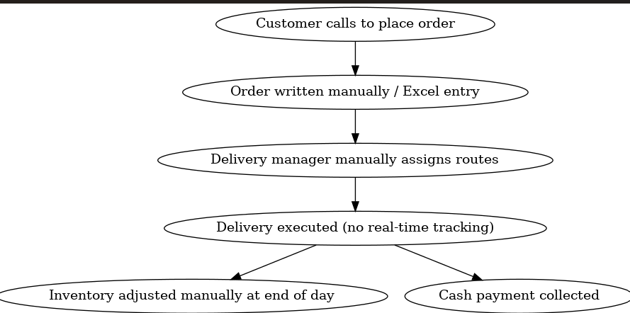

Proposed Recommendations (TO-BE)
The Inventory & Delivery Management System will automate the entire process using mobile applications and a centralized backend system.
Improvements with TO-BE system:
- Customers place orders directly via mobile apps (Android/iOS).
- Orders are automatically updated in the inventory system.
- Delivery scheduling and route optimization handled by the system.
- Customers can track deliveries in real-time.
- Payments can be made online (credit/debit/UPI) or cash-on-delivery.
- Management dashboards provide real-time stock, sales, and delivery insights.
TO-BE Process Flow:
- Customer places order in mobile app.
- System checks inventory availability automatically.
- Delivery module assigns driver & optimizes route.
- Customer tracks status in real time.
- Driver updates delivery status from mobile app.
- Inventory auto-updates and reports are generated.
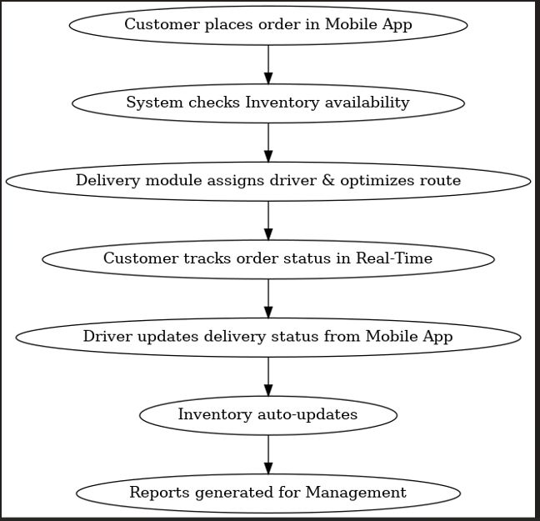

Business Requirements
The business requirements are categorized by priority (High, Medium, Low) and functional area (Customer App, Inventory, Delivery, Payments, Reporting).
ID | Requirement Description | Category | Priority
BR-01 | Customers must be able to register and log in via mobile app. | Customer App | High
BR-02 | Customers must be able to view and search available dairy products. | Customer App | High
BR-03 | System must update inventory in real time after each order. | Inventory | High
BR-04 | Delivery module must optimize routes based on order addresses. | Delivery | High
BR-05 | Customers must be able to track order status in real time. | Delivery | High
BR-06 | Multiple payment options (online, COD) must be supported. | Payments | High
BR-07 | Admin must generate daily/weekly/monthly reports on sales and deliveries. | Reporting | Medium
BR-08 | Customers must receive notifications (SMS/Push) for order confirmation and delivery status. | Customer App | Medium
BR-09 | System should allow promotions and discount codes. | Customer App | Low

Appendices
List of Acronyms
- BRD – Business Requirements Document
- HRMS – Human Resource Management System
- UAT – User Acceptance Testing
- API – Application Programming Interface
- COD – Cash on Delivery
- ROI – Return on Investment

Glossary of Terms
- Inventory Management – The process of tracking stock levels, product availability, and movement.
- Delivery Management – Scheduling, assigning, and tracking the distribution of products.
- Route Optimization – System-generated shortest/fastest path for delivery staff.
- Traceability Matrix – A document linking requirements with test cases to ensure coverage.
- Push Notification – Alerts sent to the customer’s mobile device from the app.

Related Documents
- Feasibility Study Document
- Functional Requirements Document (FRD)
- System Architecture Document
- User Stories & Use Case Specifications
- Test Plan and UAT Document

2. Process Flow Diagram (PFD)
Here’s a simple flow you can show to your client:
Customer Places Order
↓
Check Nearest Warehouse
↓
Is Stock Available?
┌─────────────┐
│ Yes │────→ Allocate Order → Assign Delivery Partner → Deliver Product → Update Inventory
└─────────────┘
│ No
↓
Redirect to Next Nearest Warehouse → Allocate Order
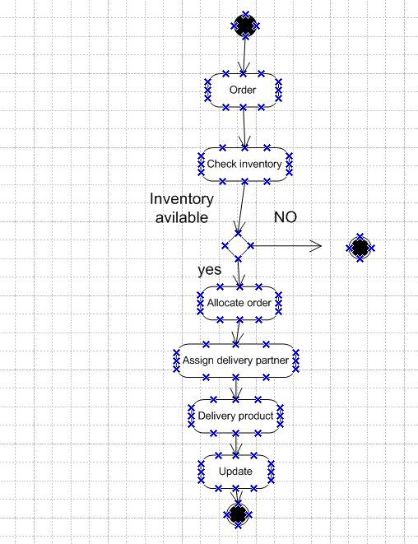
Simplified Process:
- Customer order captured.
- System checks stock availability at nearest warehouse.
- If available → order confirmed → delivery scheduled.
- If not available → system checks next nearest warehouse.
- Delivery executed → system updates inventory in real time.
Assignment 2

1. Introduction Letter (Business Analyst → Client)
Subject: Introduction as Business Analyst for Your Project
Dear Javier,
I hope this message finds you well. My name is Gouthami Palepu, and I will be working as the Business Analyst for your upcoming project. My role will involve understanding your business needs, gathering requirements, and ensuring smooth communication between your team and our development team.
Over the next few weeks, I will work closely with you and your stakeholders to capture requirements, document processes, and translate them into functional specifications for the technical team. This will help us build a solution that aligns with your business goals and adds real value to your operations.
I look forward to collaborating with you and your team. Please feel free to share any initial inputs or expectations so we can start the business understanding process effectively.
Best Regards,
Gouthami Palepu
Business Analyst

2. BRD & SRS (Choose – Online Ticketing System Example)
Business Requirements Document (BRD)
Project Name: Online Ticketing System
Project ID: OTS-001
Version ID: 0.1
Author: [Your Name]

Document Revisions
Date | Version Number | Document Changes
05/03/20xx | 0.1 | Initial Draft
10/03/20xx | 0.2 | Added Business Objectives
15/03/20xx | 0.3 | Included Scope & Assumptions
20/03/20xx | 1.0 | Final Version Approved

Approvals
Role | Name | Title | Signature | Date
Project Sponsor | Anil Sharma | VP – Operations
Business Owner | Priya Mehta | Director – Business
Project Manager | Ramesh Iyer | Sr. Project Manager
System Architect | Rajeev Kulkarni | Lead System Architect
Development Lead | Deepak Rao | Development Lead
QA Lead | Neha Verma | UX Lead
UX Lead | Kavitha Nair | QA Manager

3. RACI Chart for This Document
Name | Position | R | A | S | C | I
[Name 1] | Project Sponsor |  | ✔
[Name 2] | Business Owner |  |  | ✔
[Name 3] | Project Manager | ✔
[Name 4] | System Architect | ✔
[Name 5] | Development Lead | ✔
[Name 6] | UX Lead |  |  |  | ✔
[Name 7] | QA Lead |  |  |  |  | ✔

4. Introduction
4.1. Business Goals
The organization aims to digitize its ticket booking process (movies, events, travel) to:
- Provide customers with a convenient and user-friendly platform for booking tickets.
- Reduce dependency on manual ticket counters.
- Increase revenue by enabling online sales and digital marketing promotions.
Need:
- Simplify booking process for customers.
- Reduce queues at physical counters.
- Provide real-time seat/availability tracking.

4.2. Business Objectives
To provide an IT solution for:
- Customer-facing mobile app (Android/iOS) & web portal for ticket booking.
- Real-time availability of seats/events/travel tickets.
- Integrated payment system (credit/debit/UPI/wallets).
- Digital ticketing (QR code/Barcode) to reduce paper usage.
- Admin console for managing events, schedules, pricing, and reports.

4.3. Business Rules
- One user cannot book more than a defined number of tickets per transaction.
- Tickets once booked are non-transferable (unless cancellation/refund policies apply).
- Seats must be blocked for a maximum of 10 minutes during checkout.
- Refunds must comply with payment gateway policies.
- Data must be stored securely in compliance with data protection laws.

4.4. Background
Currently, tickets are booked manually at physical counters, leading to:
- Long queues and customer dissatisfaction.
- Limited sales opportunities due to location constraints.
- High operational costs in managing ticket booths.
The Online Ticketing System is proposed to solve these issues, reduce manual operations, and expand customer reach.

4.5. Project Objective
To develop an integrated Online Ticketing Platform that:
- Allows customers to search, view, and book tickets online.
- Provides secure digital payment and ticket issuance.
- Supports multiple platforms (Web, Android, iOS).
- Provides real-time updates on availability.
- Generates sales and usage reports for management.

4.6. Project Scope
4.6.1. In Scope
- Customer web and mobile apps (Android/iOS).
- Event/movie/travel ticket booking.
- Real-time seat availability tracking.
- Online payment integration.
- E-ticket generation (QR/Barcode).
- Admin portal for event/ticket management.
4.6.2. Out of Scope
- Physical ticket printing and delivery.
- Integration with third-party travel aggregators (future phase).
- Loyalty programs (future roadmap).
- AI-based demand forecasting.

5. Assumptions
- Customers have access to smartphones and internet.
- Payment gateway will be provided by an authorized third-party.
- Event organizers will provide accurate schedules and seat layouts.
- Budget and skilled resources are available.

6. Constraints
- Must comply with local digital transaction and consumer protection laws.
- Phase 1 delivery timeline limited to 6 months.
- Limited budget → advanced features like loyalty programs deferred.
- System must support high concurrency during peak booking hours.

7. Risks
7.1 Technological Risks
- Risk of server crashes during high booking loads. (Mitigate: Cloud scaling)
- Device/browser compatibility issues. (Mitigate: Cross-platform testing)
7.2 Skills Risks
- Lack of skilled UI/UX designers. (Mitigate: Outsource design team)
7.3 Political Risks
- Changes in e-commerce or taxation regulations. (Accept/Mitigate)
7.4 Business Risks
- Low adoption if customers prefer physical booking. (Mitigate: Promotions, discounts)
7.5 Requirements Risks
- Misunderstanding refund policies. (Mitigate: Frequent stakeholder reviews)
7.6 Other Risks
- Cybersecurity risks (hacking, fraud). (Mitigate: Security audits, encryption)

8. Business Process Overview
8.1 Legacy System (AS-IS)
- Customers stand in queues at physical counters.
- Staff manually record ticket sales.
- Seat allocation errors common.
- Only cash payments accepted.
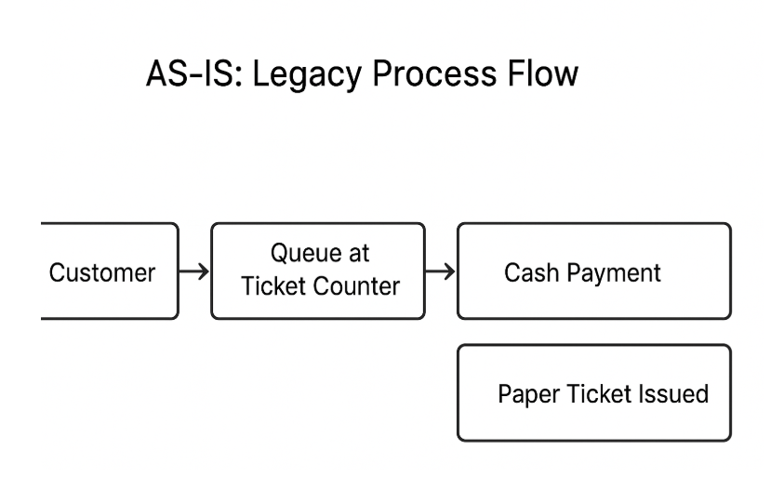
8.2 Proposed Recommendations (TO-BE)
- Customers browse and book tickets online.
- System shows real-time seat availability.
- Online payment and auto ticket generation.
- QR/Barcode-based entry validation.
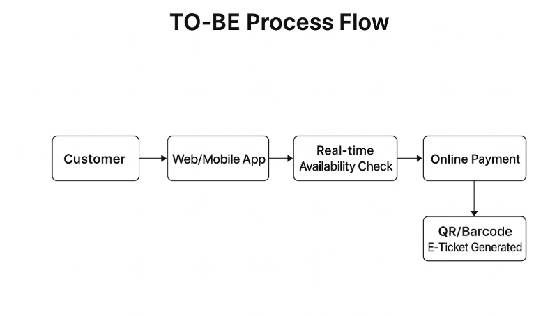

9. Business Requirements
ID | Requirement | Category | Priority
BR-01 | Customers can search and view available events/movies/travel schedules. | Customer App | High
BR-02 | System must display real-time seat availability. | Booking Engine | High
BR-03 | Customers can book tickets via Web/Mobile. | Customer App | High
BR-04 | Support multiple payment options. | Payments | High
BR-05 | Generate QR/Barcode e-tickets. | Ticketing | High
BR-06 | Allow cancellations/refunds as per policy. | Payments | Medium
BR-07 | Admin can manage events, pricing, and seating layouts. | Admin Portal | High
BR-08 | Reports on sales, bookings, and cancellations. | Reporting | Medium
BR-09 | Notifications (Email/SMS/Push) for booking confirmation. | Customer App | Medium

10. Appendices
10.1 Acronyms
- OTS – Online Ticketing System
- QR – Quick Response Code
- API – Application Programming Interface
- UPI – Unified Payments Interface
10.2 Glossary of Terms
- E-Ticket – Digital ticket issued electronically with a QR/Barcode.
- Booking Engine – Software handling ticket availability, seat blocking, and reservations.
- Refund Policy – Rules governing ticket cancellations and reimbursements.
10.3 Related Documents
- Feasibility Study Document
- Functional Requirements Document (FRD)
- System Design Document
- UAT Plan
Software Requirements Specification (SRS) for Online Ticketing System

1. Introduction
1.1 Purpose
The purpose of this document is to define the requirements for the Online Ticketing System (OTS). This system will provide users with a convenient, efficient, and secure way to purchase tickets for events such as movies, concerts, sports matches, and theater shows. The SRS will serve as a reference for developers, testers, project managers, and stakeholders to ensure alignment and completeness.
1.2 Scope
The Online Ticketing System will allow customers to:
- Browse upcoming events.
- View seat availability.
- Book and purchase tickets.
- Receive e-tickets via email/SMS.
- Cancel or reschedule bookings (subject to policies).
The system will also support event organizers with:
- Event management (add, edit, cancel events).
- Ticket pricing and promotions.
- Sales and revenue reporting.
Benefits:
- Reduces manual ticketing processes.
- Provides 24/7 availability for customers.
- Enhances user experience with secure and instant booking.
1.3 Definitions, Acronyms, and Abbreviations
- OTS: Online Ticketing System
- API: Application Programming Interface
- OTP: One-Time Password
- UI/UX: User Interface/User Experience

2. Overall Description
2.1 Product Perspective
The Online Ticketing System is a web and mobile-based application. It will integrate with:
- Event organizer databases.
- Payment gateways (PayPal, credit/debit card, UPI).
- Notification services (SMS/Email APIs).
2.2 Product Functions
Key features include:
- Event search and filter.
- Real-time seat selection.
- Secure ticket booking and payment.
- E-ticket generation with QR code.
- User account management (profile, history, preferences).
- Event organizer dashboard with analytics.
2.3 User Classes and Characteristics
- End Users (Customers): Book tickets, view history.
- Event Organizers: Manage events, view sales reports.
- Admin: Manage users, resolve disputes, generate overall system reports.
2.4 Operating Environment
- Web: Modern browsers (Chrome, Edge, Safari, Firefox).
- Mobile: Android 9+ and iOS 13+.
- Server: Cloud-based hosting with 99.9% uptime.
2.5 Constraints
- Payment must comply with PCI-DSS standards.
- System must handle peak loads during popular event ticket releases.
- Legal compliance with GDPR for data privacy.
2.6 Assumptions and Dependencies
- Users will have stable internet connections.
- Third-party payment gateways will be operational.
- SMS/Email service providers must ensure timely delivery.

3. External Interface Requirements
3.1 User Interfaces
- Intuitive, responsive UI for web and mobile.
- Seat selection will be displayed in a graphical map format.
- Multi-language support (English + regional).
3.2 Hardware Interfaces
- QR code scanning devices at event entrances.
- Mobile phones for ticket display.
3.3 Software Interfaces
- Payment Gateway APIs.
- Event database systems.
- SMS/Email notification APIs.
3.4 Communication Interfaces
- HTTPS protocol for secure transactions.
- REST APIs for system integration.

4. System Features (Functional Requirements)
4.1 User Registration and Login
- Users can register via email, mobile number, or social media.
- OTP/email verification required.
- Login with password or biometric (for mobile).
Acceptance Criteria:
- User receives OTP instantly.
- Login succeeds only with valid credentials.

4.2 Event Search and Browsing
- Users can search events by category (music, sports, movies).
- Filters: Date, location, price range.
- Event details: Description, time, location, available seats.
Acceptance Criteria:
- Search results displayed within 3 seconds.
- Only active/upcoming events appear.

4.3 Seat Selection and Booking
- Real-time seat map for each event.
- Seats marked as Available, Reserved, Booked.
- Multiple tickets can be booked in one order.
Acceptance Criteria:
- No double booking of seats.
- User cannot proceed with empty selection.

4.4 Payment and Ticket Confirmation
- Multiple payment methods supported.
- Automatic confirmation email/SMS sent after payment.
- E-ticket with QR code generated.
Acceptance Criteria:
- Payment gateway must confirm transaction success.
- Tickets instantly available in user account.

4.5 Ticket Cancellation and Refund
- Users can cancel tickets based on event policy.
- Refund processed via original payment method.
Acceptance Criteria:
- Refund confirmation email sent to user.
- Refund amount calculated as per organizer’s rules.

4.6 Event Organizer Dashboard
- Add, update, and cancel events.
- Set ticket pricing and promotions.
- View ticket sales and revenue reports.
Acceptance Criteria:
- Organizers can only manage their own events.
- Sales data updated in real-time.

4.7 Admin Functions
- Manage users and event organizers.
- Generate global reports.
- Handle fraud detection and dispute resolution.

5. Non-Functional Requirements
5.1 Performance
- System should handle 10,000 concurrent users.
- Seat selection updates in less than 2 seconds.
5.2 Security
- SSL encryption for all transactions.
- Two-factor authentication for logins.
- PCI-DSS compliance for payments.
5.3 Usability
- Mobile-first design.
- Accessibility compliance (WCAG 2.1).
5.4 Reliability and Availability
- 99.9% uptime guaranteed.
- Automatic failover and backup every 24 hours.
5.5 Scalability
- Horizontal scaling to handle large event demand spikes.

6. Use Case Scenarios
Use Case: Book a Ticket
Actors: Customer, Payment Gateway, System
Precondition: User logged in, event available.
Steps:
- User searches for event.
- User selects seat(s).
- System checks availability.
- User makes payment.
- System confirms booking, generates e-ticket.
Postcondition: Ticket stored in user account, confirmation email sent.

7. Data Requirements
- Event Data: Name, location, date, seating chart, pricing.
- User Data: Profile, booking history, payment info.
- Transaction Data: Booking ID, payment status, refund details.

8. Risk Analysis
- Technical Risk: Payment gateway downtime → Mitigation: Multiple providers.
- Business Risk: Ticket scalping → Mitigation: Limit ticket purchases per user.
- Security Risk: Data breaches → Mitigation: Encryption, intrusion detection.

3. ERD – Support Ticket / Ticketing Lifecycle
Here’s a simple Entity Relationship Diagram (ERD)
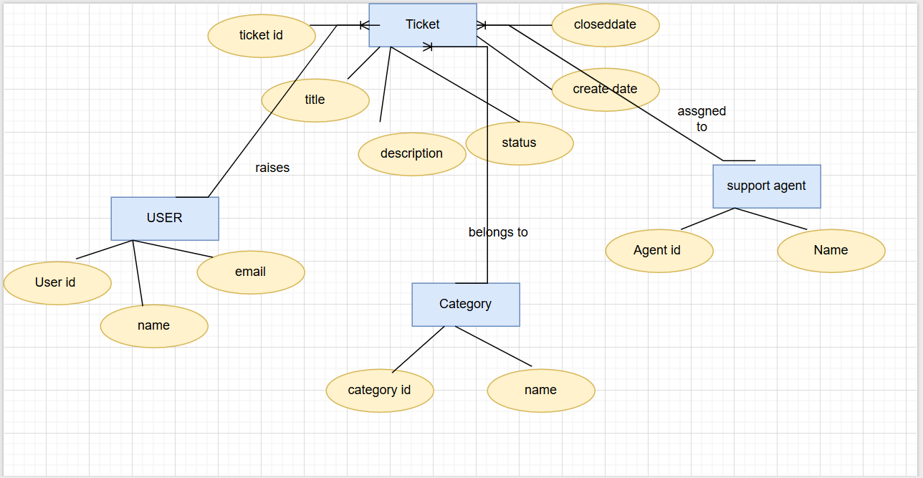
Entities:
- User (UserID, Name, Email)
- Ticket (TicketID, Title, Description, Status, CreatedDate, ClosedDate)
- Support Agent (AgentID, Name, Role)
- Category (CategoryID, Name, Priority)
Relationships:
- A User raises a Ticket (1:M).
- A Ticket is assigned to a Support Agent (M:1).
- A Ticket belongs to a Category (M:1).
- A Support Agent handles many Tickets (1:M).

4. User Story – Shopping from eCommerce
Epic: Online Shopping

User Story No: 1
Tasks: 02 | Priority: Low
As a customer,
I want to search products by name or category,
so that I can quickly find what I need.
BV: 500 | CP: 2
Acceptance Criteria:
- User can enter product name in search bar.
- System returns matching results within 2 seconds.
- User can filter results by category, price, or rating.
- If no results are found, system displays “No products found.”

User Story No: 2
Tasks: 02 | Priority: HIGH
As a customer,
I want to make a secure payment,
so that I can complete my order confidently.
BV: 500 | CP: 5
Acceptance Criteria:
- System supports multiple payment methods (Card, UPI, Wallet).
- Payment transactions are encrypted (SSL/TLS).
- Successful payment generates an order confirmation.
- Failed payment prompts retry or alternative option.

User Story No: 3
Tasks: 02 | Priority: HIGH
As a customer,
I want to track my order status,
so that I know when my product will arrive.
BV: 500 | CP: 5
Acceptance Criteria:
- User can see status updates (Placed → Processed → Shipped → Delivered).
- System sends email/SMS updates at each stage.
- Order tracking page is accessible from “My Orders.”
- Delivery estimate is shown.

User Story No: 4
Tasks: 02 | Priority: HIGH
As an admin,
I want to manage product inventory,
so that the website always shows updated availability.
BV: 500 | CP: 5
Acceptance Criteria:
- Admin can add, update, or remove products.
- System updates stock in real time after each purchase.
- Out-of-stock items are marked as “Unavailable.”
- Low-stock alerts are generated automatically.

User Story No: 5
Tasks: 02 | Priority: HIGH
As a customer,
I want to add products to a cart,
so that I can purchase multiple items together.
BV: 500 | CP: 5
Acceptance Criteria:
- User can add any available product to cart.
- Cart icon updates with number of items.
- User can view, edit, or remove items from cart.
- Cart persists until checkout or manual removal.

User Story No: 6
Tasks: 06 Priority: High
As a customer, I want a secure checkout process, so that I can complete my purchase confidently.
BV: 599 CP: 2
Acceptance Criteria:
1. User can enter shipping and billing details.
2. System validates payment information.
3. Order summary is displayed before payment.

User Story No: 7
Tasks: 07 Priority: Medium
As a customer, I want multiple payment options, so that I can choose my preferred method.
BV: 200 CP: 3
Acceptance Criteria:
1. System supports credit/debit cards, net banking, UPI, wallets.
2. Payment is processed securely via SSL.
3. System confirms payment success or failure.

User Story No: 8
Tasks: 08 Priority: High
As a customer, I want to receive an order confirmation, so that I know my purchase was successful.
BV: 500 CP: 5
Acceptance Criteria:
1. System displays confirmation page with order details.
2. Email confirmation is sent to user.
3. Order ID is generated for tracking.

User Story No: 9
Tasks: 09 Priority: Medium
As a customer, I want to track my order status, so that I know when it will arrive.
BV: 100 CP: 3
Acceptance Criteria:
1. System shows order status (processing, shipped, delivered).
2. Tracking ID is provided with courier partner.
3. User can view estimated delivery date.

User Story No: 10
Tasks: 10 Priority: High
As a customer, I want to cancel my order, so that I can change my mind before it ships.
BV: 200 CP: 3
Acceptance Criteria:
1. User can cancel order before dispatch.
2. Refund process is initiated automatically.
3. Cancellation confirmation is sent via email.

User Story No: 11
Tasks: 11 Priority: Medium
As a customer, I want to return products, so that I can get a refund if not satisfied.
BV: 100 CP: 2
Acceptance Criteria:
1. User can request return from order history.
2. System generates return slip.
3. Refund is initiated once product is received.

User Story No: 12
Tasks: 12 Priority: High
As a customer, I want to register an account, so that I can manage my orders and wishlist.
BV: 500 CP: 3
Acceptance Criteria:
1. User can sign up with email or social login.
2. System validates email address.
3. Confirmation email is sent.

User Story No: 13
Tasks: 13 Priority: Medium
As a customer, I want to log in securely, so that I can access my account.
BV: 200 CP: 3
Acceptance Criteria:
1. System supports username/password and social logins.
2. Forgot password option is available.
3. Login session persists until logout.

User Story No: 14
Tasks: 14 Priority: High
As a customer, I want to update my profile, so that my account information is accurate.
BV: 500 CP: 5
Acceptance Criteria:
1. User can update name, email, phone, and password.
2. System validates changes before saving.
3. Profile picture can be uploaded.

User Story No: 15
Tasks: 15 Priority: Medium
As a customer, I want to save multiple addresses, so that I can choose them during checkout.
BV: 100 CP: 1
Acceptance Criteria:
1. User can add/edit/delete addresses.
2. System validates address format.
3. Default address can be selected.

User Story No: 16
Tasks: 16 Priority: High
As a customer, I want to leave product reviews, so that I can share my experience with others.
BV: 500 CP: 2
Acceptance Criteria:
1. User can submit star rating and comments.
2. System verifies that user purchased product.
3. Reviews are visible on product page.

User Story No: 17
Tasks: 17 Priority: Medium
As a customer, I want personalized recommendations, so that I can discover relevant products.
BV: 200 CP: 3
Acceptance Criteria:
1. System suggests products based on browsing history.
2. Recommendations appear on homepage and product page.
3. User can dismiss recommendations.

User Story No: 18
Tasks: 18 Priority: High
As a customer, I want search suggestions, so that I can quickly find popular products.
BV: 500 CP: 3
Acceptance Criteria:
1. System suggests products while typing in search bar.
2. Suggestions are based on top-selling products.
3. User can click suggestion to go to product page.

User Story No: 19
Tasks: 19 Priority: Medium
As a customer, I want to apply discount codes, so that I can save money on my order.
BV: 200 CP: 3
Acceptance Criteria:
1. User can enter coupon code at checkout.
2. System validates coupon.
3. Discount is applied to total if valid.

User Story No: 20
Tasks: 20 Priority: High
As a customer, I want to earn loyalty points, so that I can redeem them for discounts.
BV: 500 CP: 5
Acceptance Criteria:
- 1. Points are added after each purchase.
- 2. User can redeem points at checkout.
- 3. Points balance is visible in profile.

User Story No: 21
Tasks: 21 Priority: Medium
As a customer, I want to receive notifications, so that I stay updated about offers and orders.
BV: 100 CP: 2
Acceptance Criteria:
1. System sends order updates as push notifications.
2. Promotional offers are notified.
3. User can manage notification preferences.

User Story No: 22
Tasks: 22 Priority: High
As an admin, I want to manage products, so that I can update catalog easily.
BV: 500 CP: 5
Acceptance Criteria:
1. Admin can add, edit, and delete products.
2. System validates product details.
3. Changes reflect in real time.

User Story No: 23
Tasks: 23 Priority: Medium
As an admin, I want to manage customer orders, so that I can process them efficiently.
BV: 100 CP: 2
Acceptance Criteria:
1. Admin can view all customer orders.
2. Admin can update order status.
3. Admin can issue refunds and cancellations.

User Story No: 24
Tasks: 24 Priority: High
As an admin, I want to manage users, so that I can ensure platform security.
BV: 500 CP: 3
Acceptance Criteria:
1. Admin can block/unblock users.
2. Admin can view user order history.
3. Admin can reset user passwords.

User Story No: 25
Tasks: 25 Priority: Medium
As an admin, I want to see analytics, so that I can track sales and performance.
BV: 200 CP: 2
Acceptance Criteria:
1. Dashboard shows sales trends.
2. Top products and categories are displayed.
3. Revenue and profit reports are available.

User Story No: 26
Tasks: 26 Priority: High
As an admin, I want to track inventory, so that I can avoid stockouts.
BV: 500 CP: 5
Acceptance Criteria:
1. System updates stock after each order.
2. Low stock alerts are generated.
3. Admin can update stock levels.

User Story No: 27
Tasks: 27 Priority: Medium
As an admin, I want courier integration, so that I can automate shipping updates.
BV: 200 CP: 2
Acceptance Criteria:
- 1. System integrates with courier APIs.
- 2. Tracking ID is auto-generated.
- 3. User is notified of shipment.

User Story No: 28
Tasks: 28 Priority: High
As a customer, I want to contact support, so that I can resolve my issues quickly.
BV: 500 CP: 2
Acceptance Criteria:
1. Live chat and email support are available.
2. System generates support ticket.
3. User can track ticket status.

User Story No: 29
Tasks: 29 Priority: Medium
As a customer, I want to use the app in my language, so that I can shop comfortably.
BV: 200 CP: 3
Acceptance Criteria:
1. System supports multiple languages.
2. User can switch language anytime.
3. Content updates instantly.

User Story No: 30
Tasks: 30 Priority: High
As a customer, I want to pay in my currency, so that I avoid conversion issues.
BV: 500 CP: 1
Acceptance Criteria:
1. System supports multiple currencies.
2. Exchange rates update daily.
3.Currency can be chosen at checkout

