Agile Document
1.Definition of Done: Definition of Done is a technique where the team agrees on, and permanently displays a list of criteria which must be met before a backlog item is considered done.
That is the team has to create a well, defined, unambiguous, measurable, agreed upon, and shared definition of done between all team members.
The best form of definition of done representation is a checklist of activities that has to demonstrate the agreed valued and quality of a user story so, this checklist should include.
- Acceptance criteria (To satisfy customer requirements for a product)
- Quality criteria (to satisfy quality requirements for a product)

Check list for DOD:

- Product code for presumed functionalities:

A student information system needs functionalities for managing student data, admissions, attendance, grades and communication.

- Assumptions of user stories met:

For user stories related ton student information, several assumptions can be made their assumptions depends upon user needs, system capabilities and the environment in which system will operate.

Example: the student information entered in the system is accurate and up to date

- projects build without errors for student information system:

To ensure that this project builds without errors, focus on very careful planning, proper implementation and through leveling.

Unit tests and written and passing:

This indicates that the software developers have created and successfully executed tests for individual components and student information system, ensuring each past function as intended.

- Project deployed on the test environment identical to production platform:
For student information system, deploying the project on a test environment that missions the productions platform ensures through testing going line this approach allows for accurate simulation of the real-world scenario the goal is to identify resolve potential issues in a n on production environment, minimizing risks and ensuring a smooth transition to the line system.

Example: Testing outline registration or perform load testing to ensure the system can handle peak usage during enrollment period.

- Test on devices/ browsers listed in this project assumptions passed.

This means that the system functions as expected on the specified devices or browsers outline in the projects initial assumptions. This validation ensures that a board range of users including those with different devices and browsers can access and utilize the system without accounting any functional issues.
- Feature ok-ed by UX designers.

A UX designer can significantly enhance a student information system by focusing on features that prioritize users – friendliness, efficiency and accessibility.
Example. Prioritize dashboard, search and filter options.

- QA performed and issues resolved:

This project requires quality assurance (QA) to ensure data security accuracy. QA testing involves various functionalities like identifying and resolving issues such as incorrect data handling, security breaches.

Ex: Assuring system quality to protect sensitive student data form unauthorized login. This includes testing user authentication, data encryption and access control.

- Feature is tested against acceptance criteria:

Feature like displaying students’ past assessments scores, would be a specific condition that must be met for the feature to the considered complete and functional.

Ex: to display student past assessment scores.
To valid student ID, options to select form multiple assessment and clear exact display.

- Feature ok- end by product owner:

Product owner focusing on ensuring the system meets the needs of students, teachers and administrators.

As product owner is responsible for designing, prioritizing and maintain the product backlog, which includes users’ stories and defects, ensuring that it aligns with overall product vision and goals.

Ex: Attendance management, fee management, admission management etc.

- Refactoring completed:
Refactoring is nothing but systematically improving the structure without alerting its external behavior.

Ex: generating a report which will improving the accuracy and efficiency and regenerating a report.

- Any configuration or build changes.

A student information system manages various aspects of student’s data, including academic records attendance and communication.

So, any configuration or updates its database structure, user interface and underlaying software components.

Ex: A build in change might involve in adding a new field in student record in the data base like adding students pressured pronouns (his/her) this change would be documented in released page, including data base schema modification and also any chamoe in the API for accessing the field.

- Documentation updated:

Any information on the student information system documentation that has been updated.

EX: data management, user access etc.

- Peer code review performed:
Students assessing each other’s code to improve its quality learn from each other and enhance their understanding of the system.

Document 2:
product vision:
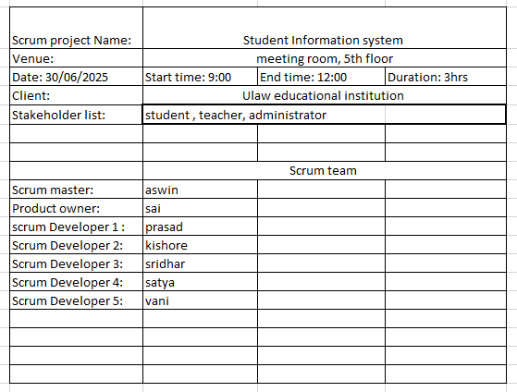

Target group | needs | product | value
educational institutes are the market segment the product address | primarily solves the problem of inefficient and scattered student data management. streamlines various administrative and academic tasks, making information readily accessible to stakeholders | Student information system, Student information system can significantly improve efficiency, reduce manual work load and ultimately contribute to a more supportive and effective learning environment | A Student Information System (SIS) significantly benefits universities by streamlining operations, improving communication, and enhancing data-driven decision-making. It centralizes student data, automates tasks, and provides valuable insights, ultimately leading to increased efficiency, better student outcomes, and a more effective learning
The target users are students, teachers and administrators. | the need of the project is to mainly to manage and utilize student data efficiently, communication and over all student experience | Yes, it is feasible to develop student information system | The business goals of a student information system (SIS) are multifaceted, generally aiming to improve operational efficiency, enhance student success, and support data-driven decision-making.

Document 3:
user story No: 01 | tasks: 01 | Priority:01
As a student
I want to log in to the system
so that I can access my personal information and course details.
BV: 50 | CP:05
Acceptance Criteria

user story No: 02 | tasks: 02 | Priority:01
As a student
I want to view my class schedule
so that I can see what classes I have when
BV: 500 | CP:40
Acceptance Criteria

user story No: 03 | tasks: 03 | Priority:01
As a student
I want to access course materials (like materials and lecturer notes and assignments)
so that I can study and complete my course work.
BV: 100 | CP:20
Acceptance Criteria

user story no: 04 | tasks: 04 | Priority:02
As a student
I want to view my grades
so that I can track my academic progress
BV: 10 | CP:03
Acceptance Criteria :
the student is viewing their grades, When the system displays a grade that is below a certain threshold (e.g., 60%), Then the system should highlight the grade in red to indicate a potential issue.

user story no: 05 | tasks: 05 | Priority:03
As a student
I want to submit assignments online
so that I can easily turn in my work
BV: 50 | CP:05
Acceptance Criteria

user story no: 06 | tasks: 01 | Priority:01
As a student
I want to view and pay my fees
so that I can manage my financial obligations
BV: 500 | CP:100
Acceptance Criteria

user story no: 07 | tasks: 01 | Priority:01
As a student
I want to register of course
so that I can enroll in the classes I need
BV: 500 | CP:100
Acceptance Criteria

user story no: 08 | tasks: 01 | Priority:01
As a student
I want to update my personal information (like address or phone number)
so that profile is accurate
BV: 50 | CP:05
Acceptance Criteria

user story no: 09 | tasks: 02 | Priority:03
As a student
I want to receive notifications about importance deadlines or announcements
so that I don’t miss anything important
BV: 50 | CP:03
Acceptance Criteria

user story no: 10 | tasks: 01 | Priority:02
As a student
I want to view academic calendrer
so that I can plan my activities
BV: 100 | CP:20
Acceptance Criteria

user story no: 11 | tasks: 03 | Priority:04
As a student
I want to communicate with my instructors and class mates through the system
so that I can collaborate on projects
BV: 100 | CP:03
Acceptance Criteria

user story no: 12 | tasks: 01 | Priority:01
As an administrator
I want to manage student records
so that I can keep track of student information
BV: 500 | CP:03
Acceptance Criteria

user story no: 13 | tasks: 02 | Priority:01
As an administrator
I want to generate reports on student performance
so that I can analyze trends and identify areas of improvement
BV: 50 | CP:13
Acceptance Criteria

user story no: 14 | tasks: 01 | Priority:01
As an administrator
I want to assign course to students
so that they are enrolled in the correct classes
BV: 10 | CP:05
Acceptance Criteria

user story no: 15 | tasks: 02 | Priority:03
As an administrator
I want to manage user accounts so that I can control access to the system
so that I can
BV: 50 | CP:08
Acceptance Criteria

user story no: 16 | tasks: 03 | Priority:02
As an administrator
I want to track attendance
so that I can monitor student participation
BV: 100 | CP:40
Acceptance Criteria

user story no: 17 | tasks: 01 | Priority:04
As an administrator
I want to manage the curriculum
so that I can ensure it is up to date and relevant
BV: 50 | CP:13
Acceptance Criteria

user story no: 18 | tasks: 01 | Priority:01
As an administrator
I want to manage the fee structure
so that I can ensure fee accurate billing
BV: 500 | CP:40
Acceptance Criteria

user story no: 19 | tasks: 03 | Priority:04
As an administrator
I want to send out announcement to students and staff
so that I can communicate important information
BV: 100 | CP:40
Acceptance Criteria

user story no: 20 | tasks: 01 | Priority:02
As an administrator
I want to manage system settings
so that I can customize system to meet the needs of the institution
BV: 50 | CP:20
Acceptance Criteria

user story no: 21 | tasks: 03 | Priority:04
As an administrator
I want to manage the library
so that I can track books and other resources
BV: 10 | CP:13
Acceptance Criteria

user story no: 22 | tasks: 03 | Priority:04
As an administrator
I want to manage the events calendrer
so that I can keep track of my important dates
BV: 1000 | CP:08
Acceptance Criteria

user story no: 23 | tasks: 02 | Priority:03
As a teacher
I want upload course material
so that students can access them
BV: 500 | CP:05
Acceptance Criteria

user story no: 24 | tasks: 01 | Priority:02
As a teacher
I want to create and grade assignments
so that I can assess student learning
BV: 100 | CP:03
Acceptance Criteria

user story no: 25 | tasks: 01 | Priority:02
As a teacher
I want to view student submissions
so that I can evaluate their work
BV: 50 | CP:02
Acceptance Criteria

user story no: 26 | tasks: 01 | Priority:02
As a teacher
I want to communicate with my students through the system
so that I can provide feedback and support
BV: 10 | CP:01
Acceptance Criteria

Document: 4

The responsibilities of PO in a project:
Market Analysis:
A market analysis for a Student Information System (SIS) project involves assessing the current market landscape, identifying potential customers, and understanding the competitive environment.
Enterprise Analysis:
Enterprise analysis in a student information system (SIS) project involves understanding the current state of the organization, defining future needs, and identifying solutions to bridge the gap competitive environment.
Product vision and road map:
A student information system (SIS) project needs a clear product vision and roadmap to guide development and ensure alignment. The vision acts as a long-term aspiration, while the roadmap outlines the specific steps and timelines for achieving that vision.
Managing product features:
Managing product features in a Student Information System (SIS) project involves careful planning, prioritization, and execution to ensure the system effectively meets the needs of students, faculty, and administrators. This includes defining the scope of features, gathering requirements, developing, testing, and iteratively improving them.
Managing product backlog:
Managing a product backlog for a student information system project involves maintaining a prioritized list of all desired features, bug fixes, and improvements, continuously updated based on feedback and business needs. This list, the product backlog, is crucial for guiding development and ensuring the system evolves effectively.
Managing over all iteration progress:
Managing the overall iteration progress in a Student Information System (SIS) project involves tracking tasks, identifying potential roadblocks, and ensuring timely completion within each iteration.

Meetings:
1 Sprint planning meeting:
Sprint planning meeting is a student information system. Is a collaborative session where the development team, product owner, and scrum master plan the work for the upcoming sprint?
This meeting focuses ion selecting which product backlog. Items (user stories) will be addressed in the sprint, breaking them down into tasks, estimating effort and defining a sprint goal.
The goal is to ensure the team is aligned and what needs to be done and how they will achieve with in the sprints time frame.
The sprint planning process is often supported by project management tools like Jira.
2 Daily scrum meeting is student information system:
In the daily scrum meeting, team member discussing. What they accomplished. The previous day, what they plan today, any obstacles they face. The goal is to ensure everyone is aligned, identify potential issues early, and keep the project moving forward.

3 Sprint review meeting:
A sprint review meeting is a student information system is an event where the development team demonstrate the work completed during a sprint (typically 2 to 4 weeks) to stake holders including product owners, users, and other relevant parties the primary goal is together feedback on the implemented features, assess progress and adapt product backlog for the future sprints.
4 Sprint retrospective meeting in student information system:
A sprint retrospective meeting in a student information system is a meeting held at the end of a sprint (a short development life cycle) to review what happen during that sprint. The team discusses what went well, what could be improved, and what actions they can take to make the next sprint better. The goal is to learn from the past sprint and continuously improves the team’s processes and performance.

5 Backlog refinement meeting in a student information system:
A backlog refinement meeting in a student information system in project involves reviewing, clarifying, and prioritizing user stories, (tasks) for future development. This ensures the team is prepared for upcoming sprints, with a clear understanding of the work to be done and its relative importance. It’s a collaborative effort, typically including the product owner, development team, and sometimes stakeholder’s or subject matter experts (SME).

6 User story creation and what things will be including in user story’s such as student information system:
Creating user stories for a student information system involves. Describing features from the user’s perspective these stories should be concise, focusing, on what the user wants to achieve.
- What things will be included in user stories such as student information system:

- User role: who is user: foe example (student, teacher, administrator).

- Goal: what does the user want to accomplish

- Benefit: why is this important to the user

Example:
- User role: student: student.

- Goal: As a student, I want to view my grades online.

- Benefit: so that I can track my academic progress.

Each story should be testable and have clear acceptance criteria.

User story Number: typically, a number that allows developers to keep track of how many user stories there are and to count the status on which are completed.

Task Number: Task number is a unique identifier assigned to individual tasks within a larger project or system

Priority Number: Priority number in a user story is indicated to display its relative importance or urgency compared to other stories.

Acceptance criteria: Acceptance criteria in a user story are the specific conditions that must be met for the story to be considered complete and accepted by the stakeholders.

BV value:
BV stands for business value; business value assesses the potential benefits of a feature or initiative. For example, a feature that significantly improves user experience and needs to increase sales would have highway business value. Business value is important feature of the business. This is estimated by scrum currency notes. The denominations are RS1000, Rs100, Rs500, Rs 50, Rs10.
CP value:
CP stands for complexity points. Reflects the effort and difficulty required to implement a feature or initiative, considering factors like technical challenges, risk, uncertainty. For example; a feature requiring integration with multiple systems or dealing with complex data structures would likely have higher complexity points. CP is the effort required by the scrum developers to develop this feature (user story) using technology. Efforts include time taken to solve the complexity and right the code. CP is estimated by scrum developers by using poker cards. We provide pokers with values “?”,1,2,3,5,8,13,20,40,100, and big

Document 5:

Product backlog:
User story ID | User Story | Task | priority | BV | CP | sprint
1 | As a student I want to login the system | 1 | 1 | 50 | 5 | 2 weeks
2 | As a student I want to view my class schdule | 2 | 1 | 500 | 40 | 2 weeks
3 | As a student want to access course (materials, lecturer notes assignments) | 3 | 1 | 100 | 20 | 2 weeks
4 | As a student I want to view my grades | 4 | 2 | 10 | 3 | 2 weeks
5 | As a student I want to submit assignments online | 5 | 3 | 50 | 5 | 2 weeks

Sprint backlog:
User story ID | User story | Task | priority | BV | CP | sprint
6 | As an administrator I want to manage student records | 1 | 6 | 500 | 3 | 2 weeks
7 | aAs an administrator I want to generate reports on students performance | 2 | 1 | 50 | 13 | 2 weeks
8 | As an administrator I want to assign course on students | 1 | 1 | 10 | 5 | 2 weeks
9 | As an administrator I want to manage user accounts | 2 | 3 | 50 | 8 | 2 weeks
10 | As an administrator I want to track attandance | 3 | 2 | 100 | 40 | 2 weeks

Sprint burndown:
How to read this report
Share
, (opens new window)
Sprint
Registration 2
Estimation field
Story points
Date - June 25th, 2025 - July 9th, 2025
Date - June 25th, 2025 to July 9th, 2025

Remaining work
Number of story points left to complete this sprint

Guideline
Ideal burn rate
Burn down chart:

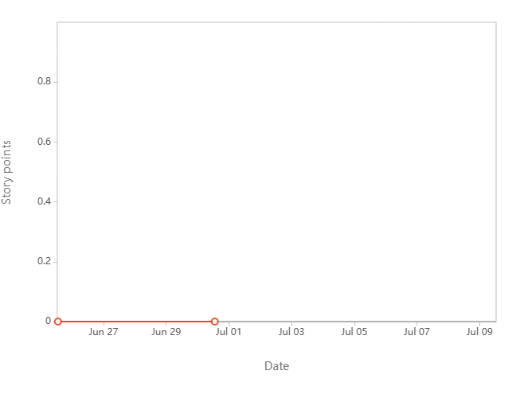

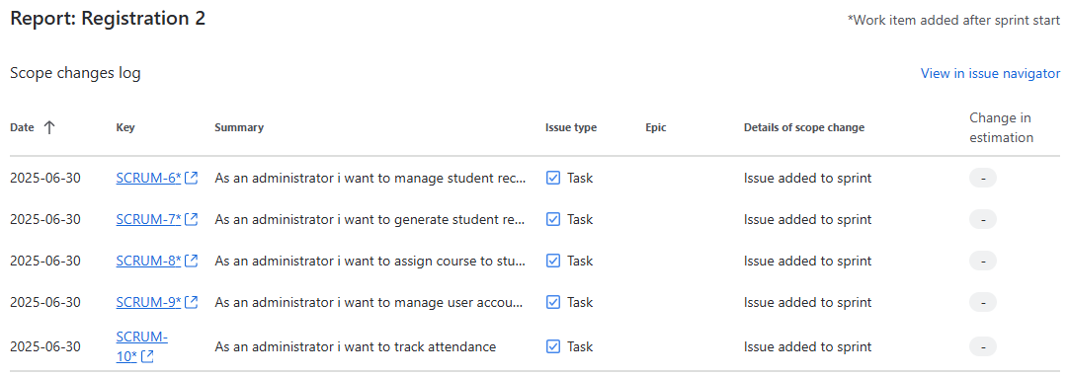

Incomplete work items

Product burn down:

How to read this report
Share
, (opens new window)
Sprint
Registration
Estimation field
Story points
Date - June 10th, 2025 - June 24th, 2025
Date - June 10th, 2025 to June 24th, 2025
Sprint goal - Registration feature must be completed

Completed work
Number of story points completed this sprint

Guideline
Ideal burn rate

Work Scope
Number of story points to be completed this sprint

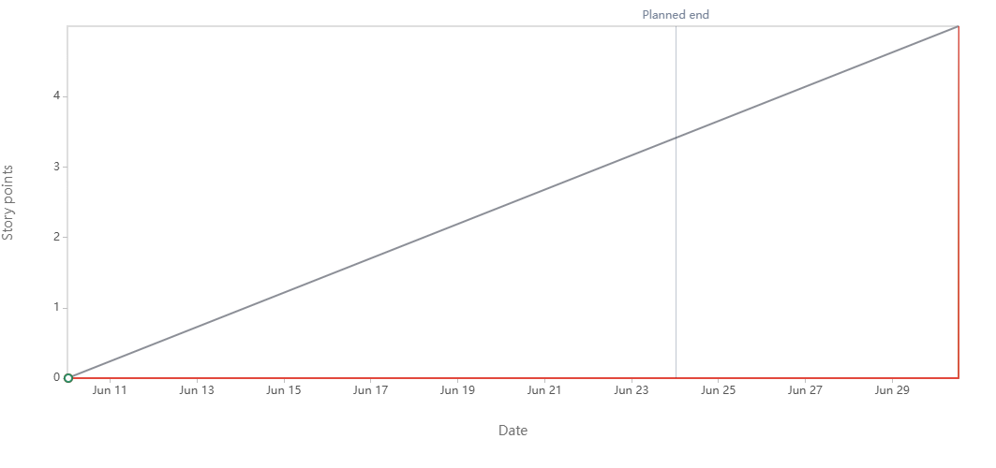
Date | Event | Work item | Completed | Scope
Tue, Jun 10 2025, 12:30am | Sprint started |  | 0 | 0
Mon, Jun 30 2025, 12:09pm | Added to sprint | SCRUM-1 As a student i want login to the system | 0 | 0
Mon, Jun 30 2025, 12:09pm | Added to sprint | SCRUM-2 As a student i want to view my class schdule | 0 | 0
Mon, Jun 30 2025, 12:09pm | Added to sprint | SCRUM-3 As a student i want access course materials\ | 0 | 0
Mon, Jun 30 2025, 12:09pm | Added to sprint | SCRUM-4 As a student i want to view my grades | 0 | 0
Mon, Jun 30 2025, 12:09pm | Added to sprint | SCRUM-5 As a student i want to submit assignments online | 0 | 0
Mon, Jun 30 2025, 12:25pm | Estimate updated | SCRUM-1 As a student i want login to the system | 0 | 05
Mon, Jun 30 2025, 12:31pm | Work item completed | SCRUM-3 As a student i want access course materials\ | 0 | 5
Mon, Jun 30 2025, 12:31pm | Work item re-opened | SCRUM-3 As a student i want access course materials\ | 0 | 5
Mon, Jun 30 2025, 12:32pm | Work item completed | SCRUM-5 As a student i want to submit assignments online | 0 | 5
Mon, Jun 30 2025, 12:32pm | Work item re-opened | SCRUM-5 As a student i want to submit assignments online | 0 | 5
Mon, Jun 30 2025, 12:33pm | Work item completed | SCRUM-5 As a student i want to submit assignments online | 0 | 5
Mon, Jun 30 2025, 12:33pm | Work item completed | SCRUM-4 As a student i want to view my grades | 0 | 5
Mon, Jun 30 2025, 12:33pm | Work item completed | SCRUM-2 As a student i want to view my class schedule | 0 | 5
Mon, Jun 30 2025, 12:33pm | Work item completed | SCRUM-1 As a student i want login to the system | 05 | 5
Mon, Jun 30 2025, 12:33pm | Work item completed | SCRUM-3 As a student i want access course materials\ | 5 | 5
Mon, Jun 30 2025, 12:35pm | Sprint completed | SCRUM-1 As a student i want login to the system  SCRUM-2 As a student i want to view my class schedule  SCRUM-3 As a student i want access course materials\  SCRUM-4 As a student i want to view my grades  SCRUM-5 As a student i want to submit assignments online | 5 | 5

Document 6:
Sprint planning meeting:
Date | 2/7/2025
Time | 9am to 11 am
location | Meeting room
prepared by | Kritika (BA)
attendees | Development team, product owner, scrum master

Sprint review meeting:
Date | 15/7/2025
Time | 9am to 11 am
location | Meeting room
prepared by | Kritika (BA)
attendees | stake owner, product owner, users

Sprint retrospective meeting:
Date | 8/7/2025
Time | 9am to 11am
Location | meeting room
prepared by | Kritika (BA)
attendees | all team members who work on the project and scrum master or product owner

