Nurturing Process – Waterfall Deliverables – Part -1/2- V2D2 August 2024
Part 1/2 Evaluation
Document 1- Business case document template
Document 2: BA Strategy
Document 3- Functional Specifications
Document 4- Requirement Traceability Matrix
Document 5- BRD Template
Answers:
Document 1- Business case document template
Document 1 – Business Case
1. Why is this project initiated?
The iView enhancement project is initiated to improve the existing internal banking application by adding critical features such as account statement viewing and customer contact information update. This project aims to streamline bank staff operations, improve first-contact resolution rates, and enhance customer satisfaction by reducing dependence on multiple systems.
2. What are the current problems?
Currently, iView only allows users to view basic customer information such as account balance using identifiers like Customer ID, PAN, or Mobile Number. However, it lacks key functionalities such as viewing account statements and updating customer contact details, resulting in operational delays, poor customer experience, and manual overhead.
3. With this project how many problems could be solved?
This enhancement solves multiple problems:
- Enables bank staff to provide complete assistance to customers.
- Reduces customer service turnaround time.
- Eliminates manual processes and system switching.
- Improves customer satisfaction.
- Ensures data is updated securely and compliantly.
4. What are the resources required?
Human Resources: Business Analyst, UI/UX Designer, Developers, Tester and Project Manager
Technology: iView application codebase, OTP integration services, test environment
Tools: Project management tools, testing tools, development IDE
Infrastructure: Development and staging servers
5. How much organizational change is required to adopt this technology?
Minimal organizational change is required. Staff training on the new features and internal communication about the upgraded functionalities will be necessary. No major structural or technological shifts are needed.
6. Time frame to recover ROI?
ROI is expected to be recovered within 6 to 9 months through improved operational efficiency, time savings, and reduced manual tasks. However, since the benefits are operational, ROI will be measured through qualitative and performance KPIs.
7. How to identify stakeholders?
Stakeholders can be identified through stakeholder analysis methods such as interviews, document analysis, and stakeholder mapping. Key stakeholders include branch operations staff, relationship managers, IT team members, project sponsor, compliance officers, and the end customers indirectly impacted by the changes.

Document 2 BA Approach Strategy
BA Approach Strategy
As a Business Analyst for the iView enhancement project, I will follow a structured approach to ensure the project's success by gathering accurate requirements, engaging stakeholders effectively, managing scope, and ensuring deliverables align with business objectives. Below are the detailed steps of the strategy:
1. Requirement Elicitation Techniques
To gather the requirements, I will use a combination of elicitation techniques:
- Interviews: Conduct one-on-one sessions with stakeholders to understand their needs.
- Workshops: Organize group discussions with key users to brainstorm and validate requirements.
- Document Analysis: Review existing system documentation, logs, and help manuals.
- Observation: Observe current processes performed by customer service representatives.
- Questionnaires: Circulate surveys to gather feedback from a larger user base.
2. Stakeholder Analysis and RACI/ILS Matrix
I will identify stakeholders using stakeholder mapping and categorize them by influence and interest.
- Create a RACI Matrix:
- R – Responsible: Business Analyst, Developers
- A – Accountable: Project Manager
- C – Consulted: Operations Manager, Compliance Officer
- I – Informed: Senior Management, Support Teams
- I will also prepare an Influence/Interest matrix to prioritize stakeholder engagement.
3. Documents to be Prepared
As part of the Waterfall methodology, I will prepare the following deliverables:
- Business Case Document
- BA Strategy Document
- Functional Specification Document
- Requirement Traceability Matrix
- Business Requirements Document (BRD)
- UAT Test Cases and Acceptance Criteria
- Change Request Log and Meeting Minutes
4. Document Sign-Off Process
After preparing draft versions of each document:
- Share the document with stakeholders via email or shared folder.
- Conduct review meetings to walkthrough the content.
- Collect feedback and incorporate changes.
- Circulate the final version and obtain approval through email confirmation or e-signatures.
- Store signed documents in a version-controlled repository.
5. Client Approval Process
- Present finalized documents to client in a formal review meeting.
- Capture any final comments and adjust documents accordingly.
- Seek formal approval and obtain signatures on each key deliverable.
- Archive approvals securely for future reference.
6. Communication Channels
To ensure transparency and timely updates:
- Email: Official communication and document exchange.
- Project Management Tool (e.g., JIRA, Trello): Track progress and task ownership.
- Instant Messaging (e.g., Slack, Teams): Quick queries and daily standups.
- Weekly Meetings: Progress reviews with stakeholders.
- Status Reports: Weekly status update reports shared with all key parties.
7. Handling Change Requests
- Maintain a Change Request (CR) log.
- Evaluate each CR for business impact, cost, and technical feasibility.
- Present CR to Change Control Board (CCB).
- Upon approval, update impacted documents, timelines, and inform all stakeholders.
- Ensure traceability by updating the RTM and version logs.
8. Project Progress Updates
- Provide weekly or bi-weekly progress reports.
- Include completed tasks, upcoming activities, risks, blockers, and pending approvals.
- Present updates during steering committee or stakeholder meetings.
- Update dashboards in project management tools for real-time visibility.
9. UAT Sign-Off and Client Project Acceptance
- Create detailed UAT scenarios based on business requirements.
- Conduct UAT sessions with end users and document their feedback.
- Fix issues, retest, and confirm successful completion.
- Prepare a Client Project Acceptance Form.
- Obtain formal sign-off from the client to confirm the project meets expectations.
- Store signed form as proof of project closure.

Document 3- Functional Specifications
Project Information
Project Name | iView Banking Application Enhancement
Customer Name | COEPD BANK
Project Version | 1.0
Project Sponsor | Mr. Henry
Project Manager | Raju
Project Initiation Date | 12/7/2025
Functional Requirement Specifications

Req ID | Req Name | Req Description | Priority
FR0001 | Login | User should be able to login to the application securely. | High
FR0002 | Search Customer | Search customer by Customer ID, PAN, or Mobile Number. | High
FR0003 | View Account Balance | Display current balance after customer search. | High
FR0004 | View Account Statement | Allow user to select date range and view transaction history. | High
FR0005 | Download/Print Statement | Enable downloading or printing of the statement. | Medium
FR0006 | Update Mobile Number | Allow updating mobile number with OTP validation. | High
FR0007 | Update Email ID | Allow updating email address with OTP validation. | Medium
FR0008 | Update Address | Enable editing and updating of residential address. | Medium
FR0009 | Audit Logging | Maintain audit logs for all data updates for compliance and security auditing. | High

Document 4- Requirement Traceability Matrix

Req ID | Req Name | Req Description | Design (D1) | Test Case (T1) | Design (D2) | Test Case (T2) | UAT
FR0001 | Login | User must be able to login to access the application | Yes | Yes | Yes | Yes | Yes
FR0002 | Search Customer | Search customer using Customer ID, PAN, or Mobile Number | Yes | Yes | Yes | Yes | Yes
FR0003 | View Account Balance | View customer’s current account balance | Yes | Yes | Yes | Yes | Yes
FR0004 | View Account Statement | View transaction history for a selected date range | Yes | Yes | Yes | Yes | Yes
FR0005 | Download Statement | Download or print the account statement | Yes | Yes | Yes | Pending | Yes
FR0006 | Update Mobile Number | Update customer’s mobile number with OTP verification | Yes | Yes | Pending | Pending | Yes
FR0007 | Update Email ID | Update email address with OTP validation | Yes | Yes | Pending | Pending | Yes
FR0008 | Update Address | Edit and save customer’s residential address | Yes | Yes | Pending | Pending | Yes
FR0009 | Audit Logging | Keep audit logs for all data updates | Yes | Yes | Yes | Yes | Yes

Document 5- BRD Template
Project Information
Project Name : iView Banking Application Enhancement
Project ID : IVW2025-001
Version ID : 1.0
Author : Lolabhattu Surya Likhitha
1. Document Revisions
Date | Version Number | Document Changes
12/07/2025 | 0.1 | Initial Draft
13/07/2025 | 0.2 | Updated Business Objectives and scope
14/07/2025 | 0.3 | Added AS-IS and TO-BE Diagrams
14/07/2025 | 0.4 | Finalized Business Requirements and RTM
15/07/2025 | 1.0 | Approved Final Version
2. Approvals
Role | Name | Title | Signature | Date
Project Sponsor | Mr. Henry | Sponsor
Business Owner | Vijay | Operations Lead
Project Manager | Raju | PM
System Architect | Varshini | Architect
Development Lead | Vivek | Tech Lead
User Experience Lead | Praneetha | UX Lead
Quality Lead | Sai | QA Lead
3. RASCI Chart for this Document
Name | Position | R | A | S | C | I
Business Analyst | Surya Likhitha | Y |  | Y | Y
PM | Raju |  | Y |  | Y | Y
Developer | Manoj | Y |  | Y
QA Lead | Sai |  |  | Y |  | Y

4. Introduction
4.1. Business Goals
The primary goal of this project is to enhance the operational efficiency, data accuracy, and service delivery capabilities of the bank’s internal customer servicing tool, iView.
The organization aims to:
- Improve first-call resolution by providing front-line staff with the ability to perform end-to-end servicing within a single system.
- Eliminate manual dependencies by introducing modules to fetch account statements and update contact information securely.
- Enhance employee productivity by reducing the time spent switching systems or raising manual service requests.
- Ensure regulatory compliance and data integrity through OTP/email verification and audit trails for customer data updates.
- Improve customer satisfaction by offering quick, accurate, and seamless in-branch and call-based support.
This enhancement aligns with the bank’s digital transformation strategy and focuses on customer-centric service delivery.
4.2. Business Objectives
To provide an IT solution that includes the following functional enhancements:
- iView Mobile Application (Android & iOS)
- Responsive and secure app for staff use on tablets or mobile devices.
- Enable on-the-go access to customer data, statements, and update functionality.

- Account Statement Module
- Allow staff to retrieve account statements by selecting custom date ranges.
- Provide print/download/export options in standard formats (PDF/CSV).
- Present clear transaction history (date, amount, type, description).

- Contact Update Module
- Enable staff to update customer contact details (mobile number, email ID, address).
- Ensure customer verification through OTP (One-Time Password) or email confirmation.
- Record every update with time-stamped logs and staff IDs for audit compliance.

- E-Learning Management System (LMS) (if part of broader system scope)
- Onboard new staff through mandatory compliance and system usage training.
- Track training completion status before providing iView access.

- Human Resource Management System (HRMS) (if integrated with enterprise solution)
- Monitor staff access logs and usage patterns for iView modules.
- Automate leave, shift, and access provisioning based on staff roles.
These features collectively improve service speed, reduce operational bottlenecks, and streamline internal workflows.
4.3. Business Rules
Below are the organizational policies, rules, and procedures relevant to the enhanced iView system:
Rule ID | Rule / Policy Description
BR-01 | Only authenticated bank employees with valid credentials can access iView.
BR-02 | Contact information changes must be verified using OTP or email confirmation.
BR-03 | Statement retrieval must be limited to customer-requested ranges (e.g., max 12 months).
BR-04 | All contact updates and statement views must be audit-logged with user ID and timestamp.
BR-05 | Bank employees must complete LMS-based compliance training before accessing the enhanced iView.
BR-06 | Customer data access is role-based and aligned with the bank’s internal data privacy policy.
BR-07 | No personal or third-party device access is allowed; mobile use must be through MDM-enforced bank devices only.
4.4 Background
iView was originally built to help staff retrieve basic account details. However, it lacks features necessary to resolve most customer queries. Employees currently rely on manual processes or multiple systems, leading to delays and inefficiency.
4.5 Project Objective
To empower front-line staff by integrating additional modules into iView for statement viewing and secure contact information updates, ensuring seamless and compliant service delivery.
4.6 Project Scope
Enable bank staff to view customer account statements (with data range, export, and print options) and update contact information security within iView. Implement audit logging, OTP-based verification, and UI enhancements, with testing and post-launch support-all confined to the internal iView tool.
4.6.1 In Scope Functionality
- View account statement (date range filter)
- Download/print statement
- Update mobile number with OTP
- Update email ID with OTP
- Update customer address
- Audit logging for all updates
4.6.2 Out of Scope Functionality
- Customer self-service via internet/mobile banking
- Backend data migration
5. Assumptions
- Staff will be trained to use the enhanced system.
- OTP and email/SMS gateway integrations will be available.
- Access rights are managed via existing user roles.
6. Constraints
- Limited access based on staff roles.
- Compliance with banking regulations on customer data changes.
- OTP delivery is dependent on third-party SMS/email service availability.
7. Risks
The success of this IT solution depends on proactively identifying and managing potential risks that could impact project delivery, budget, scope, and quality. The following risk types have been analyzed and categorized for better control and mitigation.
Risk Type | Description | Strategy
Technological | OTP/email integration failure | Mitigate
Skills | Staff may need time to adapt to new features | Accept & Train
Business | Resistance to change from current manual process | Mitigate
Requirements | Misinterpretation of contact update workflow | Mitigate
Technological Risks
Risk | Likelihood | Impact | Strategy | Mitigation Plan
Integration challenges between LMS, HRMS, and Mobile App | Medium | High | Mitigate | Allocate sufficient time for system integration and API testing. Use standardized protocols and experienced integration developers.
Mobile app compatibility issues across Android and iOS devices | High | Medium | Mitigate | Use cross-platform development tools and conduct device compatibility testing.
Data breach or system vulnerability | Low | High | Avoid | Apply encryption, regular vulnerability scans, and comply with data security best practices. Conduct periodic audits.
Skills Risks
Risk | Likelihood | Impact | Strategy | Mitigation Plan
Lack of skilled developers or trainers for LMS/HRMS | Medium | Medium | Mitigate | Provide training, outsource critical roles if needed, or hire experienced consultants.
Inadequate testing team for mobile and web platforms | Medium | High | Mitigate | Hire a dedicated QA team with experience in both mobile and enterprise system testing.
Political Risks
Risk | Likelihood | Impact | Strategy | Mitigation Plan
Change in organizational leadership may affect priorities | Medium | Medium | Accept | Keep all documentation updated; ensure buy-in from multiple stakeholders.
Regulatory or compliance changes (e.g., labor laws, data protection) | Low | High | Mitigate | Regularly review legal frameworks and update systems accordingly. Consult legal experts during development.
Business Risks
Risk | Likelihood | Impact | Strategy | Mitigation Plan
Project cancellation due to budget constraints | Low | High | Transfer | Ensure project has executive sponsorship; break project into smaller deliverables for phased investment.
Low adoption rate by employees or students | Medium | High | Mitigate | Run awareness campaigns, provide training, and ensure user-friendly UI/UX design. Collect feedback early and iterate.
Requirements Risks
Risk | Likelihood | Impact | Strategy | Mitigation Plan
Misunderstanding of user needs or incomplete requirements | Medium | High | Mitigate | Conduct detailed requirement elicitation using workshops, interviews, and surveys. Validate requirements with all stakeholders.
Frequent scope changes | Medium | Medium | Mitigate | Implement a change control process and freeze baseline requirements early in the project.
Other Risks
Risk | Likelihood | Impact | Strategy | Mitigation Plan
Project delays due to resource unavailability or external dependencies | Medium | High | Mitigate | Maintain a resource backup plan, buffer timelines in the project plan.
Resistance to system change or new process adoption | High | Medium | Mitigate | Provide onboarding support, training sessions, and communicate the benefits clearly.
8. Business Process Overview
This section provides a detailed understanding of the current (AS-IS) state of the iView application used by bank staff and the recommended improvements (TO-BE) being implemented as part of the iView enhancement project.
8.1 Legacy System (AS-IS)
Overview:
The current version of the iView application is used by bank staff to view limited customer information such as name, account number, and current balance. However, it lacks critical functionalities such as viewing transaction history or updating customer contact details. To perform these tasks, staff must switch to other systems or initiate manual processes.
Current Process Challenges:
• No Access to Account Statements: Employees cannot fetch or export customer transaction history during customer interactions.
• No Contact Update Feature: Customers who want to update their mobile number, email ID, or address must go through a separate manual process or use another application.
• Operational Inefficiency: Employees must raise manual service requests or rely on other platforms, leading to delays.
• Poor Customer Experience: Customers face waiting times or return visits due to fragmented systems and limited service at the first point of contact.
• Lack of Integration: No centralized or consolidated system to complete multiple customer service tasks.
AS-IS Process Flow:

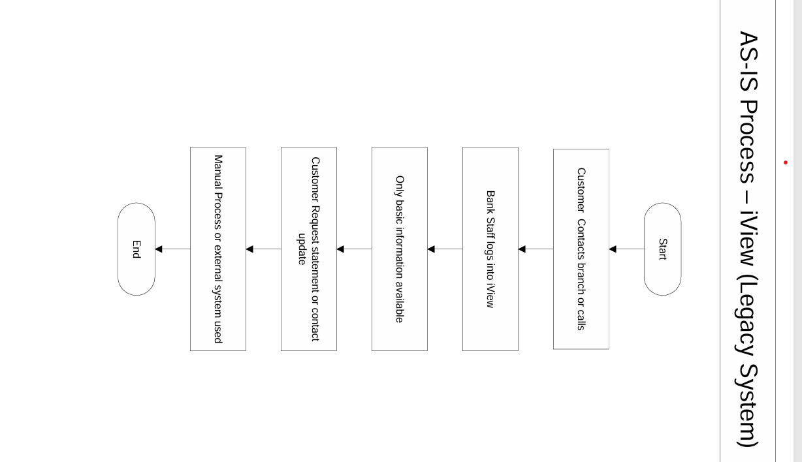
8.2 Proposed Recommendations (TO-BE)
Overview:
The proposed enhancements to iView will introduce new modules for:
• Viewing account statements over a custom date range with export options.
• Updating mobile number, email ID, and address securely using OTP/email validation.
• Providing a single unified interface for front-desk staff to handle customer service efficiently and securely.
Key Functional Improvements:
• Statement View Module: Enables staff to retrieve and download customer transaction history instantly.
• Contact Update Module: Securely updates contact details after validating customer identity via OTP or email.
• Improved Integration: No need to switch systems—everything is handled within the iView interface.
• Compliance Ready: All updates are logged for audit purposes; ensures data security and adherence to regulatory requirements.
TO-BE Process Flow :
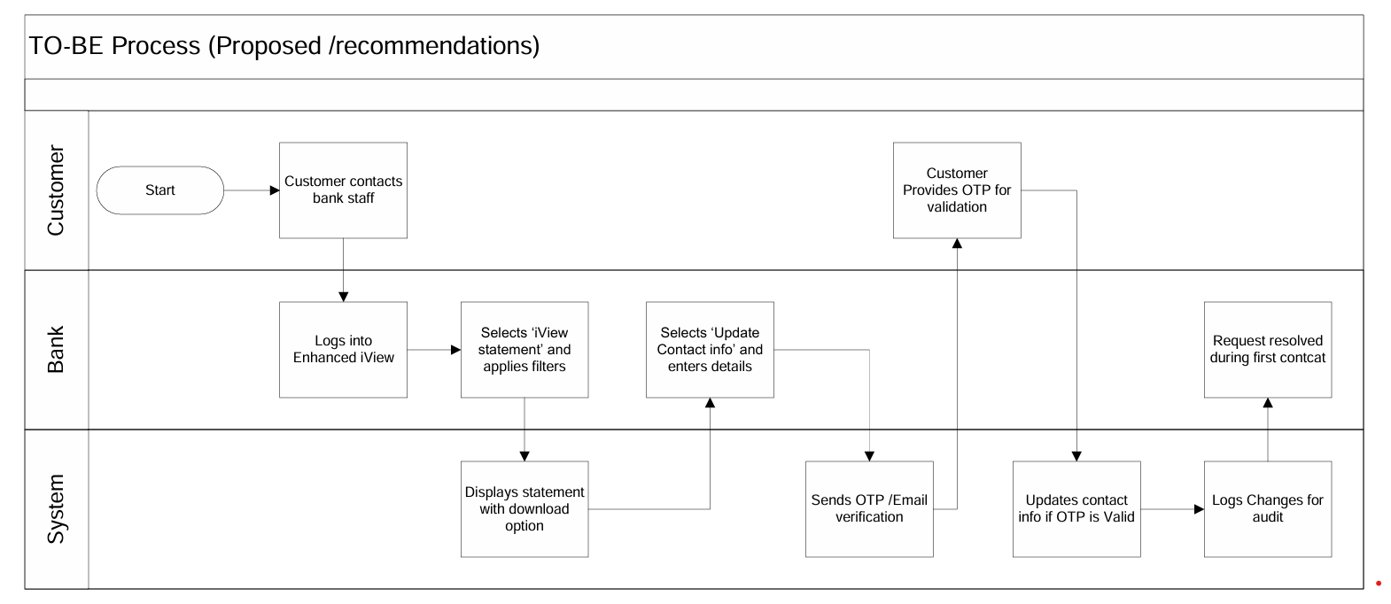
How the Proposed System Resolves Legacy Issues:
AS-IS Limitation | TO-BE Solution
No access to account transaction history | Custom date-range statement view with export
No direct contact update option | In-system update with OTP/email validation
Multi-system dependency | Unified iView interface with new modules
Manual request delays | Real-time updates with audit logging
Regulatory and security gaps | Secure, compliant update processes with audit trail
9. Business Requirements
This section captures the specific business requirements gathered from stakeholders across various functional areas of the proposed system. Requirements are organized by priority (High, Medium, Low) and functional domain for clarity and traceability. These requirements serve as the foundation for system design, development, and testing.
Req ID | Requirement Description | Priority
BR001 | Allow account statement view with date filters | High
BR002 | Enable statement download and print | Medium
BR003 | Enable updating of mobile number with OTP verification | High
BR004 | Enable updating of email ID with OTP verification | Medium
BR005 | Allow address updates with validation | Medium
BR006 | Maintain audit logs for all contact updates | High
10. Appendices
10.1 List of Acronyms
- OTP – One-Time Password
- UAT – User Acceptance Testing
- BRD – Business Requirements Document
10.2 Glossary of Terms
- iView – Internal bank application for customer info retrieval
- Audit Log – Record of changes made to customer data
10.3 Related Documents
- Business Case Document
- BA Strategy
- Functional Specification
- Requirement Traceability Matrix

