Question 1 – Audits - 5 Marks
Answer:
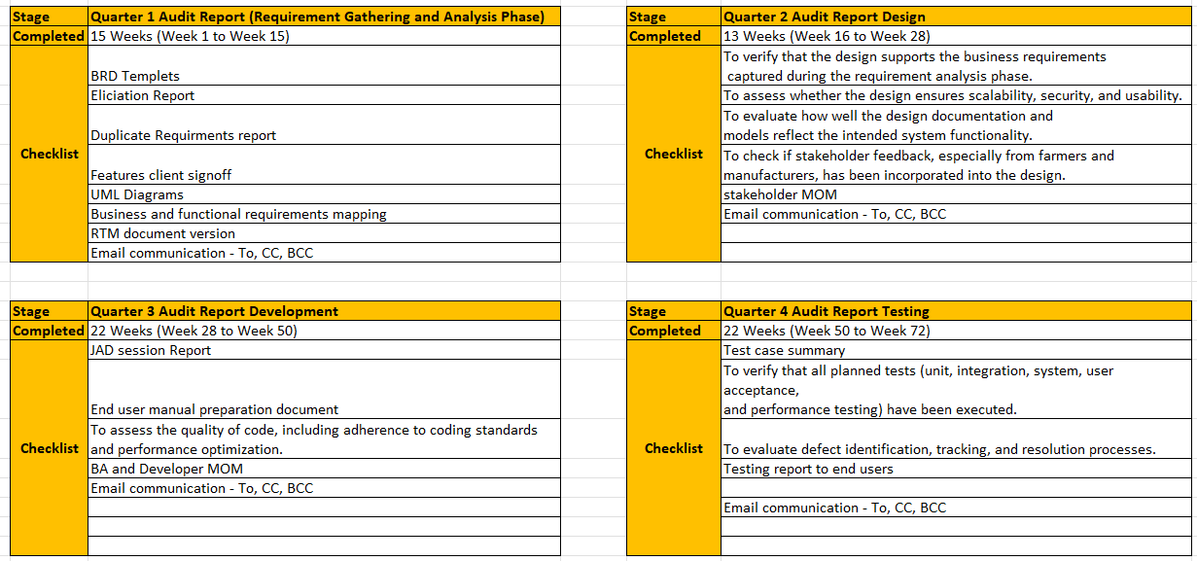

Question 2 – BA Approach Strategy - 6 Marks
Before the Project is going to Kick Start, The Committee asked Mr Karthik to submit BA Approach
Strategy
Write BA Approach strategy (As a business analyst, what are the steps that you would need to
follow to complete a project – What Elicitation Techniques to apply, how to do Stakeholder Analysis
RACI/ILS, What Documents to Write, What process to follow to Sign off on the Documents, how to
take Approvals from the Client, What Communication Channels to establish n implement, how to
Handle Change Requests, how to update the progress of the project to the Stakeholders, how to
take signoff on the UAT- Client Project Acceptance Form)
Answer:
Elicitation Techniques
Elicitation is crucial to gather requirements from stakeholders. For this project, I will employ the following techniques:

Interviews: Conduct one-on-one or group interviews with key stakeholders (Mr. Henry, Peter, Kevin, Ben, Mr. Pandu, Mr. Dooku) to understand their expectations.
Workshops: Host workshops with farmers, manufacturers, and SOONY management to collaboratively define the product features.
Surveys/Questionnaires: Send questionnaires to a broader group of farmers to understand their pain points and product preferences.
Document Analysis: Review any existing documents from SOONY or similar projects for insights.
Observation: Visit farmers' fields to observe their processes, especially when procuring fertilizers, seeds, or pesticides.
Prototyping: Use low-fidelity prototypes to validate user interface and functionality before development.
3. Stakeholder Analysis and RACI/ILS
Stakeholder Analysis:
I will categorize stakeholders into primary (e.g., farmers like Peter, Kevin, Ben), secondary (manufacturers), and tertiary (SOONY management and committee members). This will help prioritize their involvement in decision-making and requirement gathering.

RACI Matrix:
A RACI (Responsible, Accountable, Consulted, Informed) matrix will clarify the roles of each stakeholder:

R: Responsible for executing tasks (e.g., Development Team)
A: Accountable for the final outcome (e.g., Mr. Karthik)
C: Consulted for their expertise (e.g., farmers)
I: Informed of progress (e.g., Committee members)
ILS (Interest, Level of Influence, Stakeholder Strategy):
This will assess the interest and influence levels of each stakeholder, helping manage communications and decision-making processes efficiently.

4. Documentation Process
The following documents will be created to ensure the project is well-documented:

Business Requirements Document (BRD): Captures the high-level business needs and goals of the project.
Functional Requirements Document (FRD): Details the system functionalities that need to be built.
Use Cases/User Stories: Describes how different types of users will interact with the system.
Process Flow Diagrams: Visual representation of processes like product purchase, order tracking, and delivery.
Prototypes/Wireframes: Visual sketches of the user interface for early feedback.
Test Plan and Test Cases: To ensure the requirements are testable and meet the acceptance criteria.
Change Request Document (CRD): To handle any changes in scope during the project.
UAT Sign-off Document: For user acceptance testing and final approval from the client.
5. Document Sign-off Process
Stakeholder Review: Once the initial versions of documents like BRD, FRD, and use cases are prepared, they will be sent to stakeholders (Committee, Development Team, Mr. Henry) for review and feedback.
Revisions: Based on feedback, revisions will be made until the documents align with stakeholder expectations.
Formal Sign-off: Use a digital or physical sign-off mechanism (such as email approvals or a sign-off sheet) to confirm that stakeholders agree with the documented requirements. This is critical before proceeding to the next phase.
6. Client Approvals
Progress Updates: Regular updates will be provided to Mr. Henry, the Committee, and SOONY through email reports, weekly meetings, and sprint demos.
Formal Approval Milestones: At key stages (e.g., after requirement gathering, design, and UAT), I will request formal client approval before proceeding to the next phase. A Project Approval Form will be created for each milestone.
Escalation Mechanism: If there is a delay or disagreement during approvals, an escalation to Mr. Henry or the Committee will be done for quick resolution.
7. Communication Channels
Effective communication is critical to the success of this project. Here’s the strategy:

Weekly Stand-ups: Regular meetings with the project team (Mr. Karthik, development team, testers) to discuss progress and any roadblocks.
Stakeholder Meetings: Bi-weekly or monthly meetings with SOONY management and the Committee to provide project updates and gather feedback.
Email and Collaboration Tools: Use platforms like Microsoft Teams or Slack for daily communication, document sharing, and feedback collection.
Project Management Tools: Use tools like JIRA or Trello for task tracking, defect management, and progress reporting.
Meeting Minutes: Keep a record of all major discussions, decisions, and actions in meeting minutes, which will be circulated to stakeholders after each meeting.
8. Change Request (CR) Process
Handling change requests is crucial to managing scope creep and timeline slippages. The process will include:

Formal Request Submission: Stakeholders must submit a Change Request Form, detailing the reason and impact of the change.
Impact Analysis: I will work with the project team (Mr. Vandanam, Ms. Juhi, development team) to assess the impact of the requested change on cost, timeline, and resources.
Approval: The Change Request will be reviewed by the Committee (Mr. Henry, Mr. Pandu, Mr. Dooku). A decision to approve or reject will be made.
Implementation: If approved, the change will be implemented in the next sprint or phase.
9. Progress Reporting
To ensure transparency, I will provide:

Weekly Status Reports: A summary of completed tasks, upcoming work, and any issues or risks. This will be shared with Mr. Karthik, Mr. Vandanam, and the Committee.
Monthly Progress Reports: More detailed reports sent to SOONY’s management, highlighting major milestones achieved, budget spent, and overall progress.
Sprint Demos: At the end of each sprint, a demonstration of the completed features will be conducted with key stakeholders to gather feedback.
Key Performance Indicators (KPIs): Metrics like project velocity, defect resolution rate, and milestone completion will be tracked and reported.
10. UAT and Client Sign-off
UAT Preparation: Once development is complete, we will prepare for User Acceptance Testing (UAT) by involving farmers (Peter, Kevin, Ben) and manufacturers to test the system.
UAT Feedback: Gather feedback on usability, functionality, and performance. Ensure that critical issues are addressed.
UAT Sign-off: After the UAT phase is complete and stakeholders are satisfied, the UAT Sign-off Form will be shared with Mr. Henry and the Committee for formal approval. This document will confirm that the system meets the business needs and is ready for deployment.
11. Conclusion
The approach outlined above ensures that the Online Agriculture Products Store project is delivered on time, within budget, and meets stakeholder expectations. The use of clear communication channels, structured documentation, and formal approval processes will mitigate risks and ensure that the project proceeds smoothly.

Question 3 – 3-Tier Architecture - 5 Mark
Answer:
Presentation Tier (UI Layer)

Role: This is the user interface of the application where users interact with the system.
Components: Includes web browsers, desktop applications, or mobile applications.
Purpose: Displays data to the user and collects input. The presentation tier doesn’t perform business logic, it only communicates with the business layer to fetch or send data.
Example: For an Online Agriculture Products Store, this layer could be the website or mobile app that farmers use to browse products and place orders.
Business Logic Tier (Application Layer)

Role: This is the core of the application where all business logic is processed.
Components: Server-side application logic, written in languages like Java, Python, etc.
Purpose: This layer processes user requests, performs operations like validation, business calculations, and interacts with the data layer to fetch or store data.
Example: For the agriculture store, this layer would handle operations such as product searching, pricing calculations, inventory management, and order processing.
Data Tier (Database Layer)

Role: This is where the data is stored and managed.
Components: Database systems like MySQL, Oracle, or MongoDB.
Purpose: The data layer is responsible for retrieving, inserting, updating, and deleting data. It interacts with the business logic layer via queries and stored procedures.
Example: In the Online Agriculture Products Store, this would be where product details, farmer information, order details, and payment information are stored and retrieved.

+-------------------+
| Presentation| (Web browser, Mobile App)
| Layer |
+-------------------+
|
|
+-------------------+
|Business Logic| (Server-side logic: Java, APIs)
| Layer |
+-------------------+
|
|
+-------------------+
| Data | (Database: MySQL, MongoDB)
| Layer |
+-------------------+

Question 4 – BA Approach Strategy for Framing Questions – 10 Marks
Answer:

Before a Business Analyst (BA) frames a question to ask a stakeholder, it is crucial to keep several frameworks, techniques, and models in mind. This ensures that the questions are well-structured, goal-oriented, and aligned with the project’s needs. Here are the key aspects:

1. 5W 1H Framework
This framework helps the BA ask comprehensive and focused questions to gather all necessary details:

Who: Who are the users of the system? Who will perform this action?
What: What is the functionality or feature needed? What are the pain points?
Where: Where will the system be used (context of use)? Where do the transactions occur?
When: When should the feature be available (timing or schedule)? When are key project deadlines?
Why: Why is this feature important to the business and stakeholders? Why should the change be made?
How: How will the solution be implemented, and how will success be measured? How should the user interact with the system?

Example:
When asking about the product procurement process in the Online Agriculture Products Store:

"Who are the key users interacting with the procurement feature?"
"What challenges do farmers face in buying fertilizers?"
"Where do the transactions take place — online or at physical locations?"

2. SMART Criteria
The BA should ensure that questions lead to gathering requirements that are SMART:
Specific: The question should lead to precise and clear requirements.
Measurable: Ensure that the stakeholder response can be translated into measurable outcomes.
Achievable: Verify if the goals discussed are realistically achievable within constraints.
Relevant: Questions should focus on aspects relevant to the business goals.
Time-bound: Understand the timeline expectations through the questions.
Example:

"What specific features must the mobile app have to assist farmers in placing fertilizer orders?"
"By when do you expect the product catalog to be finalized for the first release?"

3. RACI Matrix
The BA should frame questions based on the roles and responsibilities of stakeholders, as defined by the RACI matrix:

Responsible: Ask questions to those who will be doing the work.
Accountable: Ask questions to those who make final decisions.
Consulted: Ask questions to gather expert advice.
Informed: Ensure questions also consider those who need to be kept in the loop.
Example:

"Who will be responsible for providing product data?"
"Who is accountable for final decisions on the feature set?"

4. 3-Tier Architecture
When framing questions related to system design or functionality, understanding the 3-tier architecture can help focus the conversation:
Presentation Layer: Questions about the user interface, user experience, and accessibility.
"What user interface components are needed for farmers to browse products?"
Business Logic Layer: Questions about business rules, calculations, and system behavior.
"How should the system handle discount calculations for bulk orders?"

Data Layer: Questions about data storage, retrieval, and security.

"What data fields are required when farmers input their delivery address?"

5. Use Cases, Use Case Specs, Activity Diagrams, Models, and Page Designs
Use Cases: Frame questions that help in identifying the actors, triggers, and actions within the system. Use cases help define how a user interacts with a feature.

"What are the typical steps a farmer follows to place an order for seeds?"
Use Case Specifications: Go deeper into the technical details or alternate flows.

"What should the system do if the payment gateway fails during checkout?"
Activity Diagrams: Help visualize workflow, so questions should seek to clarify processes.

"What is the sequence of activities when a manufacturer updates product prices?"
Models: Ask questions to gather data for designing process models, data flow diagrams, or ER diagrams.

"What entities should be included in the product catalog database?"
Page Designs: Questions to gather details on the layout and usability of pages.

"What are the key elements that should be visible on the product search page?"

Question 5 – Elicitation Techniques - 6 Marks
Answer:
As a Business Analyst, I am aware of a variety of elicitation techniques that help gather requirements and insights from stakeholders. The acronym BDRFOWJIPQU can be used to remember some of the key elicitation techniques. Here’s what each letter stands for:

B - Brainstorming
Description: A group activity where stakeholders come together to generate ideas, identify requirements, and explore potential solutions.
Use: Useful during the early stages of a project when exploring ideas or when multiple stakeholders need to provide input.
D - Document Analysis
Description: Reviewing existing documents, reports, and process flows to extract relevant information or requirements.
Use: Ideal when previous systems, procedures, or similar projects exist, and information can be reused or referenced.
R - Reverse Engineering
Description: Analyzing an existing system or solution to extract knowledge or requirements.
Use: Useful when replacing or upgrading an old system to ensure that all functionalities are captured in the new system.
F - Focus Groups
Description: A moderated discussion with a selected group of stakeholders to gather opinions, feedback, and suggestions.
Use: Ideal for collecting perspectives from diverse user groups quickly, especially on customer-facing products.
O - Observation
Description: Watching stakeholders in their working environment to understand their processes, challenges, and interactions with the system.
Use: Effective for understanding real-world workflows, especially when users find it difficult to articulate their needs.
W - Workshops
Description: Collaborative sessions where stakeholders and subject matter experts work together to gather requirements, clarify goals, and explore solutions.
Use: Particularly effective when requirements need to be defined collaboratively, and group consensus is required.
J - Job Shadowing
Description: A form of observation where the BA follows a user through their daily tasks to understand their roles, responsibilities, and system interactions.
Use: Useful when a detailed understanding of user activities and their challenges is necessary.
I - Interviews
Description: One-on-one or group discussions with stakeholders to ask detailed, specific questions about their needs, challenges, and expectations.
Use: One of the most common techniques for eliciting detailed requirements directly from stakeholders.
P - Prototyping
Description: Creating a mock-up or model of the system to gather feedback on the design, functionality, and usability.
Use: Helps stakeholders visualize the final system and ensures that the requirements align with their expectations.
Q - Questionnaires/Surveys
Description: Structured forms with a set of questions that are sent to stakeholders to gather their input and feedback.
Use: Ideal for gathering data from a large group of stakeholders, especially when they are dispersed geographically.
U - Use Case Analysis
Description: Defining the interactions between users (actors) and the system to capture functional requirements.
Use: Useful for identifying how users will interact with the system in different scenarios, helping to detail system functionality and user behaviour.

Question 6 – This project Elicitation Techniques - 5 Marks
Which Elicitation Techniques can be used in this Project and Justify your selection of Elicitation Techniques?
Prototyping
Use case Specs
Document Analysis
Brainstorming

Answer:
For the Online Agriculture Products Store project, the following elicitation techniques would be suitable based on the project's requirements and complexity. Here’s why each technique would be beneficial:

1. Prototyping
Justification:

The project involves building a user-friendly web and mobile application for farmers who may not be tech-savvy. A prototype can help stakeholders (like farmers Peter, Kevin, and Ben) visualize the interface and features.
Since farmers may struggle to describe their needs technically, showing a prototype of how they can browse, select, and order products will provide clarity and ensure their expectations align with the design.
It will also help manufacturers visualize how they will enter product details (fertilizers, seeds, pesticides) into the system, ensuring both sides are on the same page before moving forward with development.
Use: Early design and feedback sessions to refine the user interface and experience.

2. Use Case Specifications
Justification:

Since this project will have multiple interactions between users (farmers) and the system, use cases will be important to define these interactions in detail.
Each use case will specify how a user (farmer) interacts with the system for actions like searching for products, adding them to the cart, placing an order, and checking order status.
Use case specs can also define alternate flows like what happens if the product is out of stock or if there is a payment failure, ensuring that all scenarios are covered.
Use: To detail functional requirements and clarify the user-system interaction.

3. Document Analysis
Justification:

Existing documentation on current agricultural processes, product catalogs, inventory systems, or even procurement methods from manufacturers can be useful.
By reviewing these documents, the BA can understand the current pain points that farmers face when trying to procure products, and what information is required from the manufacturers.
It will also help ensure that no important detail is missed when designing the system.
Use: To understand current processes and requirements from existing documentation.

4. Brainstorming
Justification:

In the initial stages of the project, a brainstorming session with stakeholders (Peter, Kevin, Ben, and representatives from SOONY like Mr. Henry, Mr. Pandu, and Mr. Dooku) can help identify the broad challenges farmers face and possible solutions.
It will foster collaborative thinking, helping to uncover insights or innovative ideas on how to structure the store to make it most accessible for farmers and efficient for manufacturers.
This technique will help gather diverse perspectives quickly and set the foundation for further elicitation through prototyping and use cases.
Use: To generate ideas, explore challenges, and gather diverse opinions from different stakeholders.

Conclusion
For this project, the combination of Prototyping, Use Case Specifications, Document Analysis, and Brainstorming provides a comprehensive approach to understanding both the high-level vision and the detailed functional requirements. These techniques will ensure that both farmers and manufacturers are well represented in the system design, and that the project is aligned with the goals of the CSR initiative.

Question 7 – 10 Business Requirements- 10 Marks
Make suitable Assumptions and identify at least 10 Business Requirements
Answer:
Business Requirements:
BR1: User-Friendly Interface for Farmers
The platform should provide a simple, easy-to-use interface that allows farmers with limited technical knowledge to browse, search for, and purchase agricultural products (fertilizers, seeds, pesticides) without difficulty.

BR2: Multilingual Support
The system should support multiple regional languages so farmers from different parts of the country can comfortably navigate and use the platform.

BR3: Manufacturer Product Upload
The platform should allow manufacturers to create and manage product listings, including product descriptions, pricing, availability, and delivery timelines.

BR4: Product Search and Filter
The platform must include robust search and filter functionalities to help farmers find products based on categories like type (fertilizers, seeds, pesticides), price range, brand, and availability.

BR5: Secure Payment Gateway Integration
The platform should integrate with a secure and reliable payment gateway, supporting multiple payment methods like credit/debit cards, UPI, mobile wallets, and net banking.

BR6: Order Tracking and Notifications
The system should provide real-time order tracking for farmers, along with SMS or app notifications to inform them of their order status (placed, shipped, delivered, etc.).

BR7: Delivery Service Integration
The platform must integrate with logistics providers to offer delivery services, allowing farmers to receive products at their remote locations with accurate delivery time estimates.

BR8: Data Security and Privacy
The system must comply with data protection regulations, ensuring that all personal, financial, and transaction data of farmers and manufacturers are securely stored and transmitted.

BR9: Offline Mode/Low Connectivity Support
The mobile app version should be optimized for areas with poor internet connectivity, allowing users to browse products or complete transactions even with limited bandwidth.

BR10: Scalability to Accommodate Growth
The platform should be scalable to handle increased traffic as the number of farmers and manufacturers grows, ensuring that system performance is maintained.

Question 8 –Assumptions- 5 Marks
List your assumptions

Answer:
Target Users: The primary users of the Online Agriculture Products Store are farmers (like Peter, Kevin, and Ben) who have access to basic internet connectivity and are not tech-savvy.
Manufacturers: Fertilizer, seed, and pesticide manufacturers are responsible for uploading product information to the system.
Payment Gateway: The system will integrate with a secure third-party payment gateway.
Logistics: The store will partner with logistics providers to deliver products to remote locations.
Multilingual Support: The platform will need to support multiple regional languages to cater to farmers from different regions.
Regulations: The store must comply with agricultural product regulations in different regions, especially concerning fertilizers and pesticides.
Internet Access: The platform must work optimally even with slower internet connections, as many farmers may not have high-speed internet.
Mobile Application: A mobile app version of the platform will be crucial for easy access in remote areas.
Security: The platform will prioritize data security, especially for sensitive personal and payment information.
Scalability: The platform must be scalable to accommodate an increasing number of users (both farmers and manufacturers) over time.

Question 9 – This project Requirements Priority - 8 Marks
Answer:
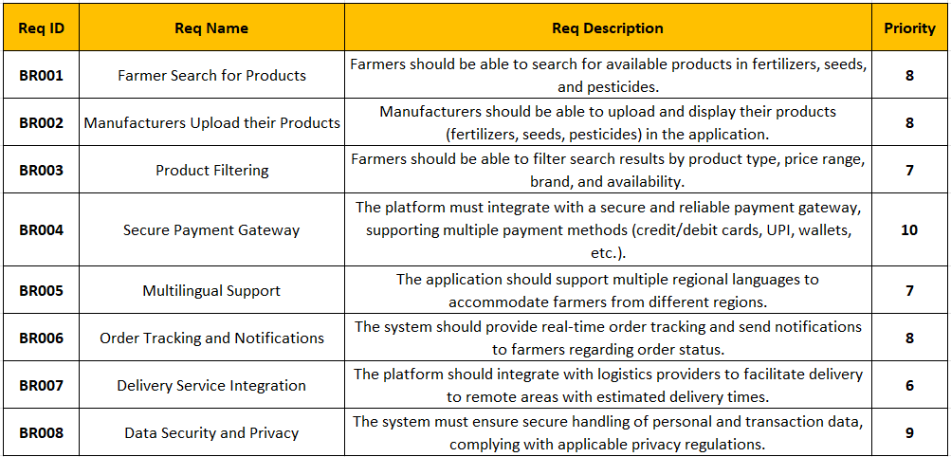

Question 10 – Use Case Diagram - 10 Marks
Answer:

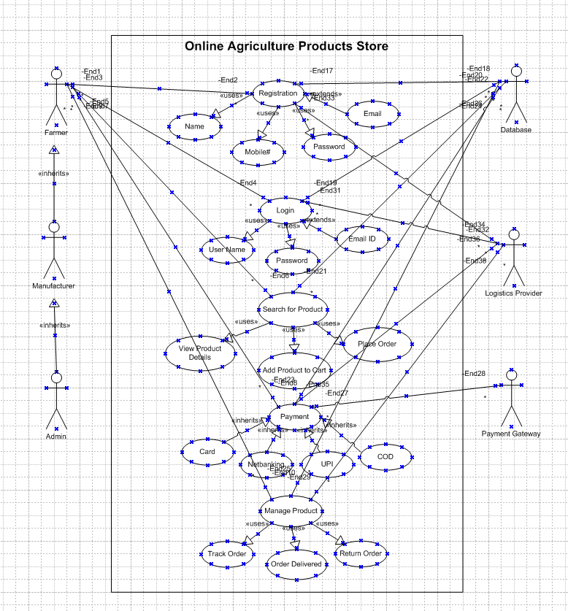

Question 11 – (minimum 5) Use Case Specs - 15 Marks
Answer:
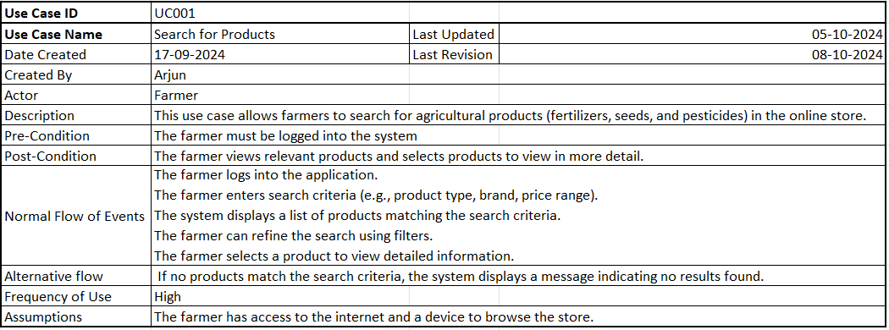
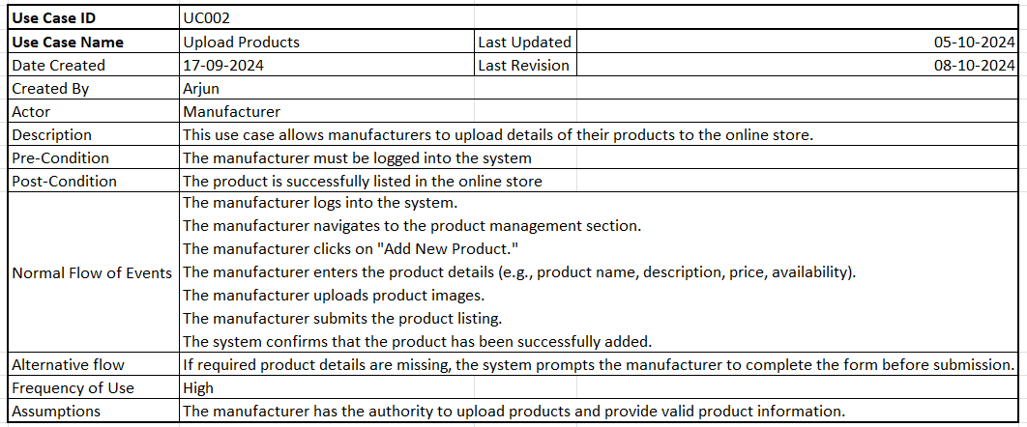
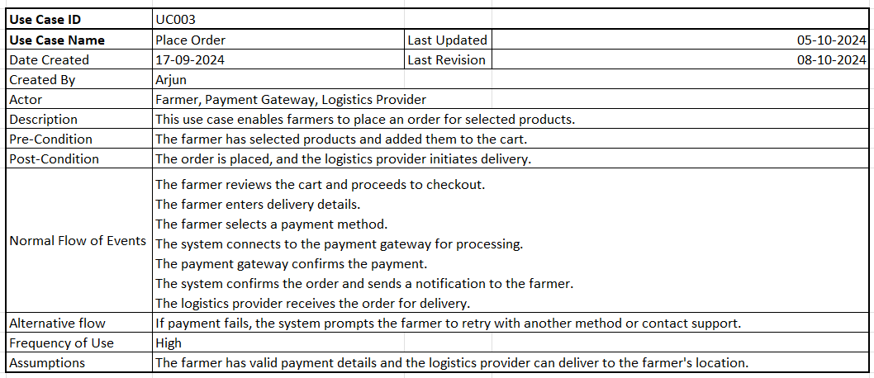
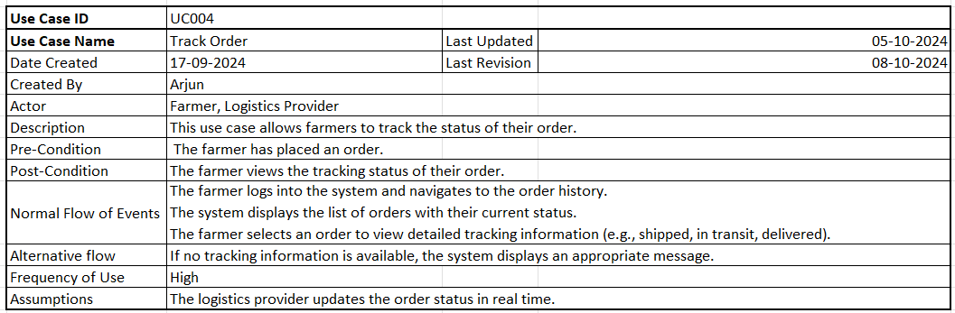
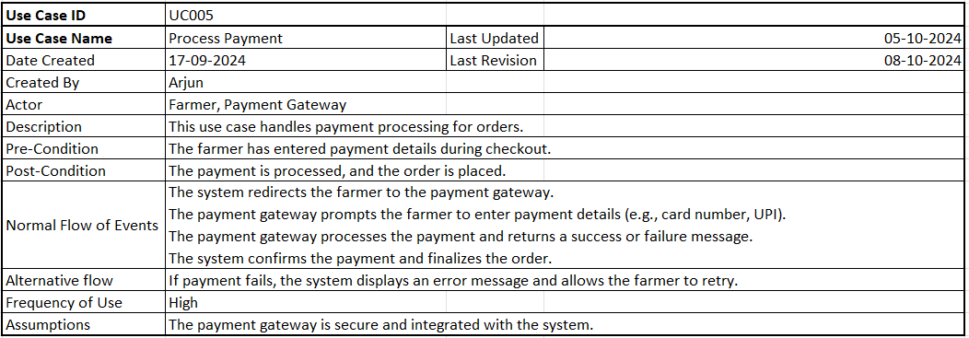

Question 12 – (minimum 5) Activity Diagrams - 15 Marks
Answer:

Activity Diagram 1: Login

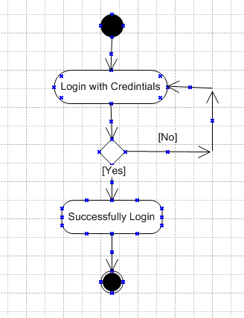

Activity Diagram 2: Search Product
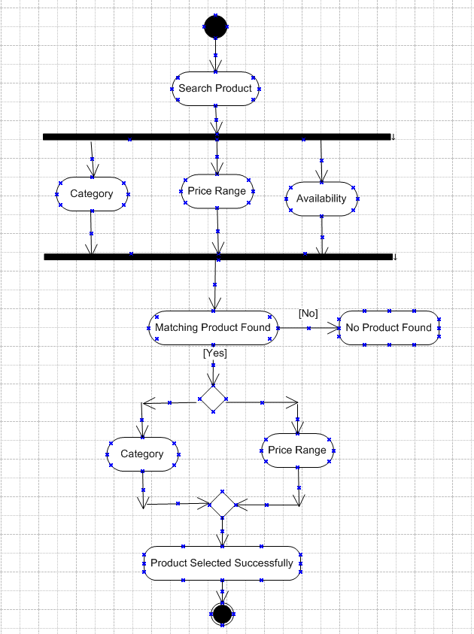

Activity Diagram 3: Add Product
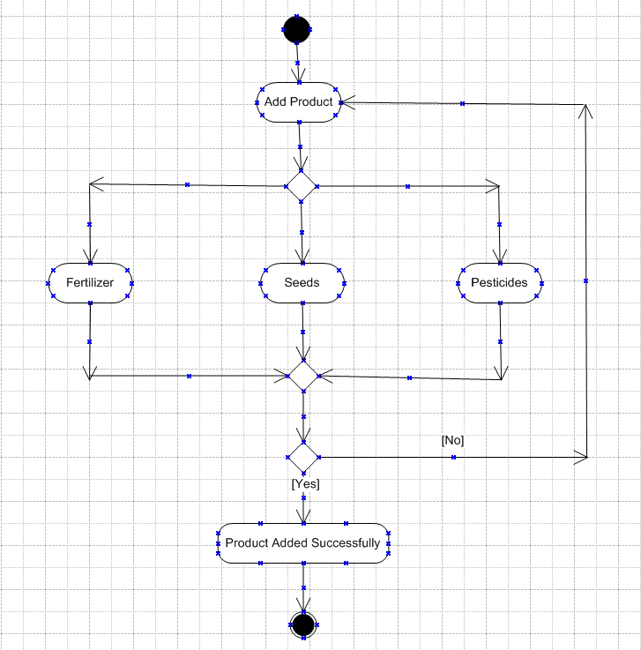

Activity Diagram 4: Delivery Status
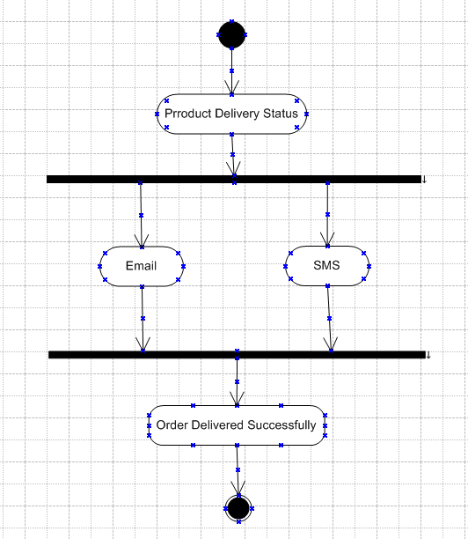

Activity Diagram 5: Initiate Payment
