COEPD
Waterfall Model Documents
Waterfall Project Part 3

Submitted by – Annu Singh

USECASE DIAGRAM ON CRM

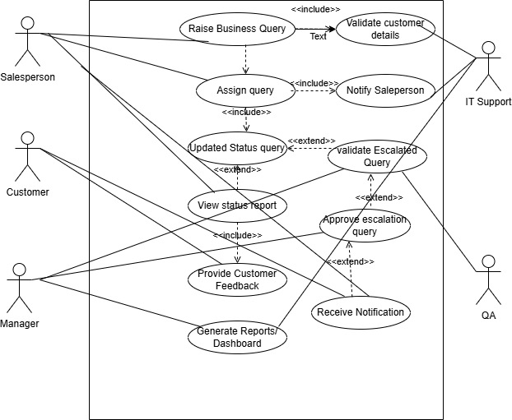

ACTIVITY DIAGRAM ON CRM
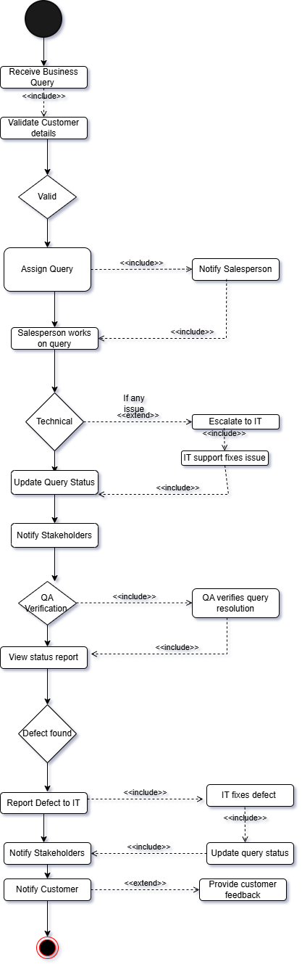

Use Case Name: Manage Leads

Actors:

Primary Actors:

Sales Representative

Marketing Executive

Secondary Actors:

CRM System Database

System Administrator

Description:

This use case describes the process of creating, viewing, updating, and managing leads in the CRM system. It ensures proper tracking of potential customers and supports sales follow-up actions.

Basic Flow:

1. User navigates to the CRM dashboard.

2. User selects the “Leads” module.

3. System displays the list of existing leads.

4. User clicks “Add New Lead.”

5. User enters lead information (name, contact number, email, lead source, and lead status).

6. System validates entered data.

7. System saves lead information in the CRM database.

8. System displays confirmation message “Lead created successfully.”

9. User can edit or update lead information when required.

Alternate Flow:

Invalid or Incomplete Data If required fields are missing, the system displays an error message. Users correct the input and resubmit the form.

Exceptional Flow:

System or Database Downtime

User attempts to save lead when the database is unavailable.

System displays “Service temporarily unavailable” message. User retries once the connection is restored.

Pre-Conditions:

User must be logged in to the CRM system.

Database service must be active.

Post-Conditions:

New lead is saved successfully in the database.

Lead appears in the lead dashboard list.

Assumptions:

User has valid CRM access rights.

Internet connectivity is available.

CRM modules for Leads, Contacts, and Opportunities are already configured.

Constraints:

Duplicate email IDs or phone numbers are not allowed.

Form data must meet field validation requirements (e.g., valid email format).Lead source list is predefined by the administrator.

Response time may be slow under heavy network load.

Dependencies:

CRM Database for storing and retrieving lead information.

Notification/Email service for lead assignment updates.

Authentication module for user login and access control.

Inputs and Outputs:

Inputs:

Lead details such as Name, Contact Number, Email, Company Name, Lead Source, and Remarks.

Outputs:

Confirmation message after successful save.

Updated lead record in the lead dashboard.

Notification sent to the assigned sales representative.

Business Rules:

1. Each lead must have a unique email address or contact number.

2. Only authorized users can create or modify leads.

3. Leads must be assigned to a sales representative within 24 hours of creation.

4. System automatically marks stale leads as “Inactive” after 30 days of no activity.

5. Only administrators can delete leads from the CRM system.

Miscellaneous Information:

The system logs all actions (create, update, delete) with timestamps for audit purposes.

Data is encrypted during transmission and storage to maintain confidentiality.

System must comply with company’s data protection policy and CRM standards.

Future versions may integrate lead scoring based on engagement or conversion probability.

Document 7- Screens and pages
Home Page
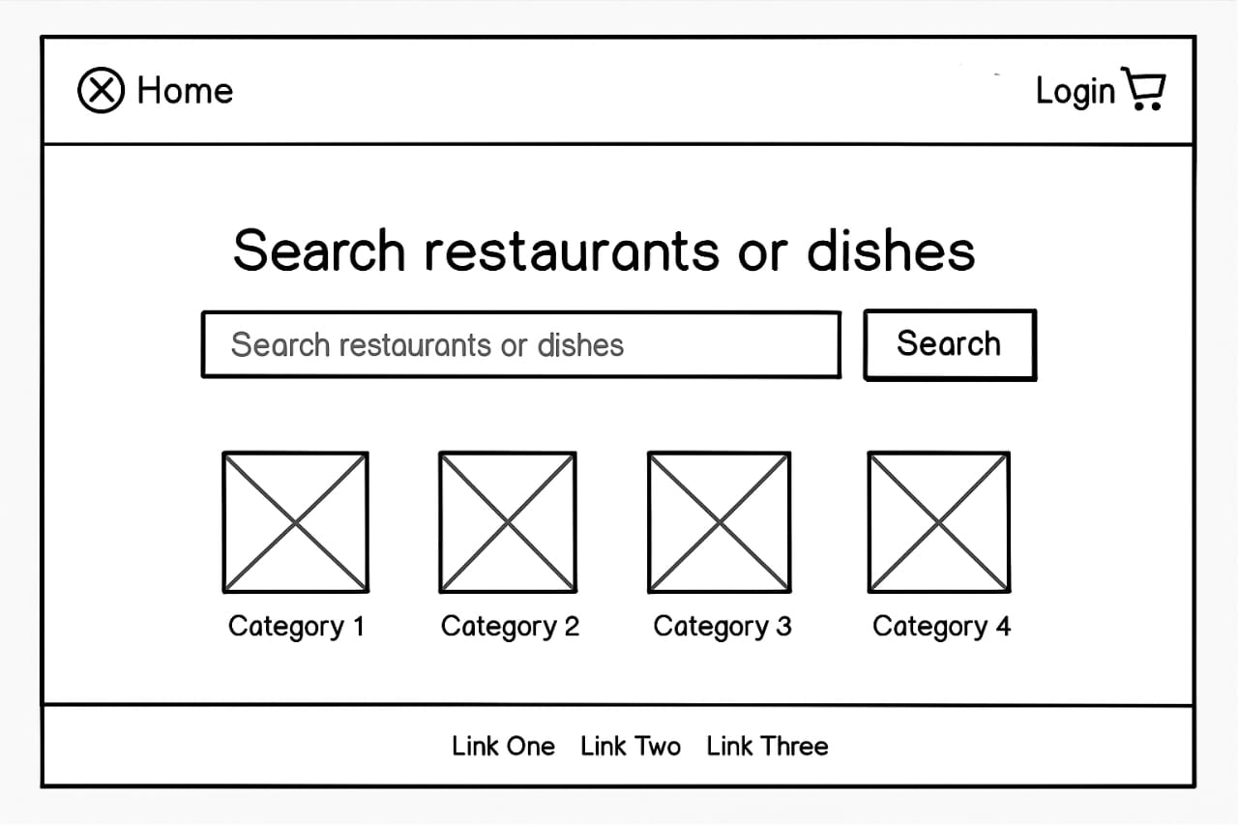

Login Page
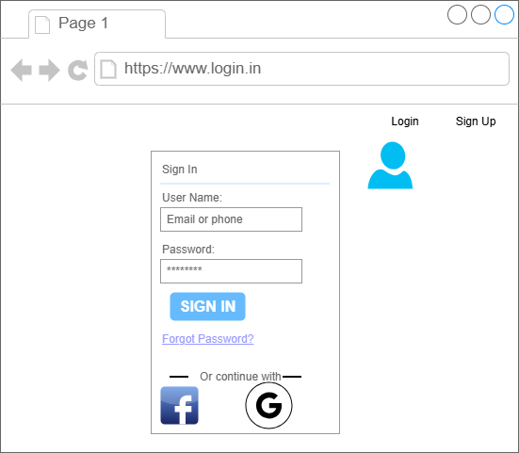
Search Page
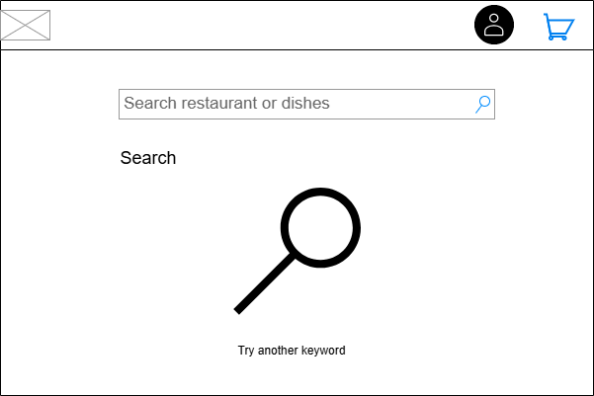

Search Page
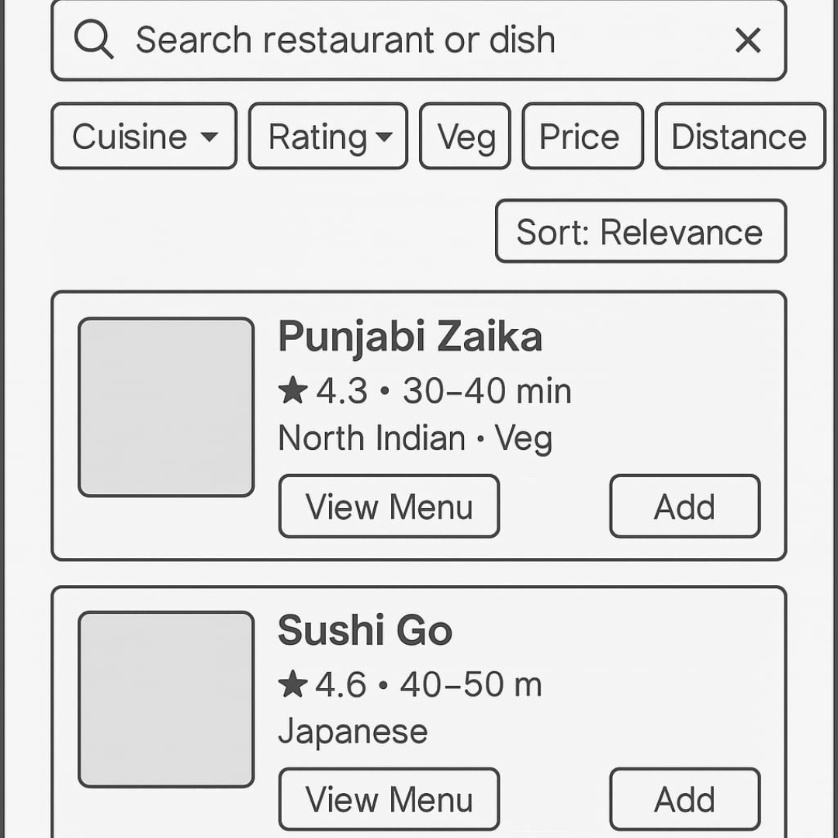

Add to Cart Page

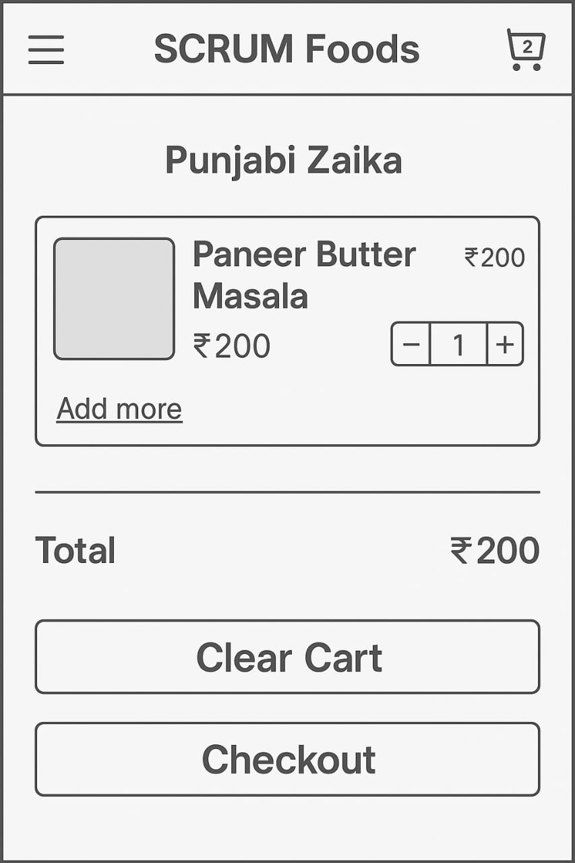

Logout

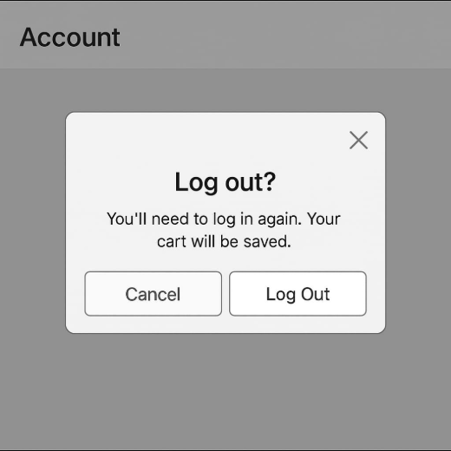

Document 8- Tools-Visio and Axure
During the project, I used Microsoft Visio and Axure RP as essential tools to design and document the system workflows and screen mock-ups.
Visio was used to create flowcharts, UML diagrams, and process maps that visually represented the business processes and system interactions. It helped in understanding the functional flow of the CRM/food ordering application, and in communicating requirements clearly to developers and stakeholders.

Axure RP was used to design interactive wireframes and prototypes of the application screens. I created step-by-step mock-ups starting from the Home page to the Payment and Logout screens. The tool helped visualize the end-user experience before development began. Using Axure’s dynamic panels and linking features, I demonstrated navigation between pages, which supported better review and feedback from the client.

Overall, both tools ensured better clarity, early validation of requirements, and reduced rework during design and development phases of the project.

Document 9 – BA Experience

My experience as a Business Analyst in the following phases:
1. Requirement Gathering
To gather requirements, we used the MOSCOW technique (Must Have, Should Have, Could Have, Won’t Have).
During this phase, sometimes the client was unavailable, so I identified alternate points of contact to obtain the necessary information.
I validated the gathered requirements using the FURPS technique (Functionality, Usability, Reliability, Performance, Supportability).
Some requirements were found to be duplicate or repetitive as a BA, I removed or merged them to maintain clarity.
Created meeting minutes (MoM) after each discussion to ensure alignment between business and technical teams.
Used prototyping and screen mock-ups to help stakeholders visualize the requirements more clearly and provide feedback.
Ensured that requirements were documented in the BRD (Business Requirement Document) and reviewed by all key stakeholders.
2. Requirement Analysis
Analyzed and prioritized requirements to confirm feasibility and business value.
Created UML diagrams (use case diagrams, activity diagrams) to visually describe the system’s flow and interactions.
Used Visio to design process flow diagrams, making it easier to communicate requirements to the technical team.
Conducted review sessions with the development and QA teams to ensure mutual understanding of the requirements.
Addressed differences in interpretation by clarifying the business logic and updating documents as required.
Prepared SRS (Software Requirement Specification) and BRS (Business Requirement Specification) documents for sign-off.
Ensured that all requirements were testable, traceable, and measurable.

3. Design Phase
Collaborated with the UI/UX and technical architects to transform approved requirements into design components.
Reviewed wireframes and prototypes created in Axure to validate that the visual design matched the business flow.
Ensured that non-functional requirements such as performance and usability were included in the design.
Conducted review meetings with stakeholders to validate designs and collected change requests when needed.
Maintained a Requirements Traceability Matrix (RTM) to track each business requirement through design and development.

4. Development Phase
Worked closely with the development team to clarify requirements and resolve doubts during coding.
Participated in scrum meetings / daily stand-ups to monitor progress and highlight blockers related to requirements.
Ensured that the developed features aligned with the approved SRS document.
Reviewed the builds or sprint deliverables and provided feedback to ensure compliance with business needs.
Documented and managed change requests through proper version control and approval processes.

5. Testing Phase
Assisted the QA team in preparing test cases and test scenarios based on the requirements.
Conducted Requirement Traceability to ensure that all requirements were covered during testing.
Supported User Acceptance Testing (UAT) by guiding end users and validating that the system met the intended objectives.
Participated in defect triage meetings to prioritize and resolve issues.
Validated that all critical defects were fixed before giving UAT sign-off for production release.
6. Deployment Phase
Coordinated with the technical team and client for final deployment planning.
Ensured all pre-deployment checklists, including environment readiness, data migration, and configuration, were completed.
Verified deployment steps and confirmed that production changes matched the signed-off version.
Conducted post-deployment validation to ensure system stability and functionality.
Collected user feedback post go-live and prepared a lessons learned report for continuous improvement.

