Document 6 – Please prepare a use case diagram, activity diagram and a use case specification document.
Use Case Diagram Link to Visio File
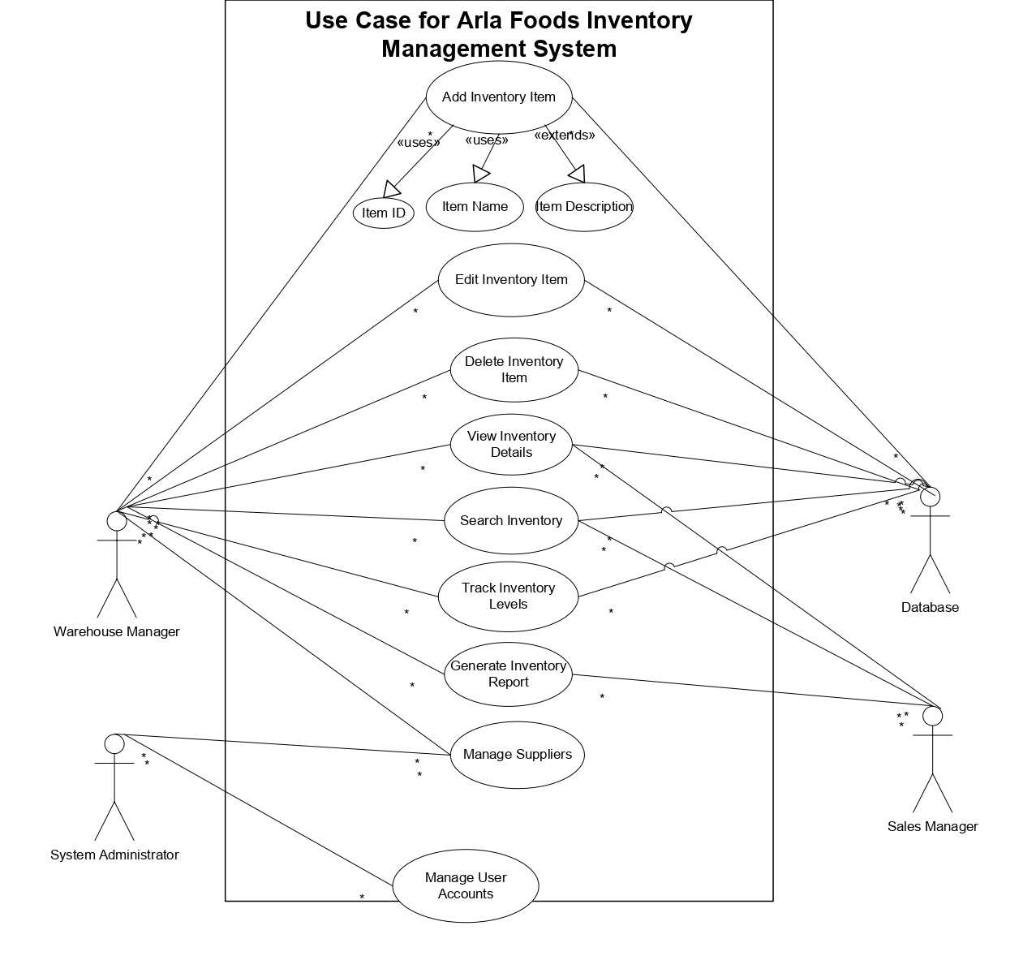

Activity Diagram Link to Visio File
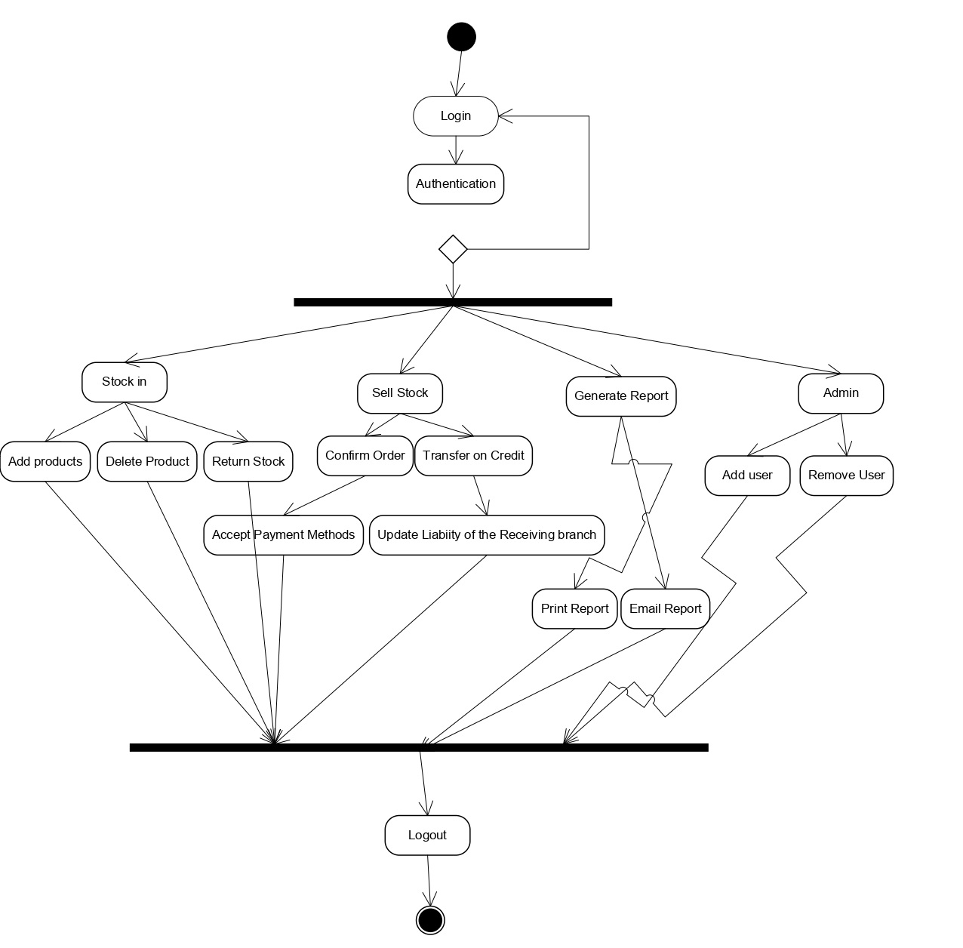

Use Case Specification
Use Case Name: Inventory Tracking
Use Case Description: Track all incoming, current, and outgoing stock within the warehouse system in real time.
Actors:
- Primary Actor: Warehouse Staff
- Secondary Actor: Inventory Manager, Procurement Officer
Basic Flow:
- User logs in → navigates to stock dashboard → views current inventory → selects batch → views movement history.
Alternate Flow:
User filters stock by expiry date or product category for reporting.
Exceptional Flows:
System error due to incorrect SKU; user notified and redirected.
Pre-Conditions: User must be authenticated.
Post-Conditions: Updated stock logs and audit trail entry.
Assumptions: All inventory has correct barcodes and labels.
Constraints: Limited access based on user roles; operates only on internal LAN.
Dependencies: Integrated supplier and procurement modules must function correctly.
Inputs and Outputs:
Input – Stock data, barcode scan
Output – Stock levels, reports, alerts
Business Rules:
- Real-time update on every transaction
- No deletion of stock records
Miscellaneous:
- Logs stored in compliance with company data policy for 12 months

Document 7 – Screens and Pages (Axure/Balsamiq)
Mock-up Flow (Pages): Link for Axure File

Document 8 – Tools: Visio & Axure Experience
I utilized Microsoft Visio as the primary tool for creating a comprehensive set of UML diagrams, including Use Case Diagrams, Activity Diagrams, and Data Flow Diagrams (DFDs). Visio’s rich library of built-in UML stencils allowed me to design these diagrams with precision and clarity. For the Use Case Diagrams, I used the UML templates to define system boundaries, identify key actors, and represent their interactions with the system through clearly labeled use cases. This helped communicate system functionality and scope to both technical and non-technical stakeholders.
In Activity Diagrams, I leveraged decision points, parallel execution bars, swimlanes, and control flows to accurately represent user interactions, background processes, and conditional logic. These diagrams were particularly effective in illustrating business workflows, exception handling, and interdepartmental processes. Visio’s auto-alignment, layering tools, and shape connectors made it easier to maintain diagram readability as the system architecture evolved over time. This visual modeling approach played a crucial role in aligning with stakeholders, validating system requirements, and supporting design documentation.
For Axure RP, I developed high-fidelity, interactive prototypes for major UI components such as user dashboards, intake forms, and reporting modules. One of the key features I implemented was dropdown menus that allowed users to select categories or options dynamically, which would in turn trigger specific form behaviors. I made extensive use of Axure’s conditional logic via the Case Editor, which enabled me to define if-else conditions and show/hide elements based on user inputs.
In the "Add Case" functionality, for example, I designed multi-step conditional pages using dynamic panels, where different screens or form sections appeared depending on prior selections. This created a seamless, context-sensitive experience that mimicked real application logic. I also incorporated form validation, tooltip messages, and state changes to make the prototype behaviorally rich and user-friendly.
The click-through prototypes created in Axure were shared with both end users and developers during early-stage feedback sessions. These interactive wireframes helped validate the overall screen flow, field-level usability, and navigation logic before development began, reducing ambiguity and minimizing rework. By combining the strengths of Visio for backend logic and system modeling with Axure for frontend simulation, I was able to bridge the gap between design and development effectively, ensuring that both technical and user experience requirements were clearly addressed.

Document 9 – BA Experience: My experience as BA in following phases:

Requirement Gathering:
In the Arla Foods Milk Inventory Management System project, which aimed to streamline inventory tracking and distribution between the Viby branch (head office) and the Riyadh warehouse, I played a key role in requirements engineering and stakeholder coordination. One of the main challenges involved coordinating across time zones and working with multiple stakeholders with varying availability. To ensure uninterrupted progress, I used the MoSCoW technique (Must have, Should have, Could have, Won’t have) for prioritizing requirements effectively, which helped align cross-functional teams on what features were essential for the initial release versus what could be deferred to later phases.
During client communication gaps—especially when the main point of contact (POC) in Viby was unavailable—I proactively identified and engaged alternate POCs from the local operations team in Riyadh to continue validation and feedback cycles without delay. This approach maintained project momentum and ensured continuous clarification of business needs.
To validate the quality and completeness of requirements, I applied the FURPS model (Functionality, Usability, Reliability, Performance, Supportability). This allowed us to assess each requirement not just for its functional correctness, but also in terms of user experience, system reliability across logistics operations, and the support needed for scaling the system across multiple branches.
One of the critical steps in the requirement management process was cleansing duplicate or overlapping requirements, particularly those coming from parallel documentation from both regions. I carefully consolidated similar requests—especially those related to real-time inventory tracking, shipment logging, and temperature-sensitive storage—to eliminate redundancy and simplify the development roadmap.
Additionally, I used prototyping techniques—mainly through Axure RP—to clarify vague or loosely defined requirements. For example, stakeholders often described desired features like “dynamic stock level updates” or “automated reordering” in abstract terms. By creating interactive wireframes and mock interfaces, I translated these abstract needs into tangible design elements. This not only helped in reducing misunderstandings but also allowed end users to validate the UI and system behavior early in the process, leading to more accurate requirements and fewer revisions during development.
This structured, multi-pronged approach ensured that the Milk Inventory Management System was well-aligned with both logistical workflows in Riyadh and corporate compliance standards in Viby, ultimately improving inventory visibility, order accuracy, and responsiveness across the supply chain.
Requirement Analysis:
Created UML and activity diagrams. Addressed team feedback and updated visuals. Delivered BRS and SRS aligned with stakeholder needs.

Design:
  - From the use case diagrams, we prepare test cases
  - Communicate with client on design and solution documents
  - Write negative test cases as well along with positive test cases.
  - Do not miss a single test case. It might have huge impact on project development in later stages
  - Prepare test data for testing
  - Update RTM. This is just as we need to make sure that all the requirements are met

Development:
  - Organized JAD sessions
  - Clarifying queries of tech team during coding
  - There might be some team members who doesn't agree with the concept or who doesn’t cooperate during JAD sessions. As a BA i handle the situation gently and had one on one discussion with them. Explained how their actions are going to affect the project. Setup healthy environment within the team.
  - Referred diagrams to code the Unit
  - Conduct regular meetings with technical team and client which is challenging. Some team members might not be available for the meeting. Recording the session and providing that to missed one and having one to one discussion later with that missed person is all i need to do

Testing:
  - Prepare test cases from use cases
  - Perform high level testing
  - Test data is requested by BA from client
  - Updated RTM
  - Take signoff from client
  - Prepare client for UAT

Deployment:
  - Forwarded RTM to client which should be attached to project closure document
  - Coordinates to complete and share end user manuals
  - Plans and organizes training sessions
  - Make sure all the candidates attend the meeting

