Capstone Project- 3 Part – 1
Question 1. Draw a Use Case Diagram
Answer: Use case Diagram is a UML diagram that visually depicts the system’s boundary, the external actors interacting with it and high-level functions (use cases) they perform highlighting relationships like include, exclude and associations between actors and use cases.
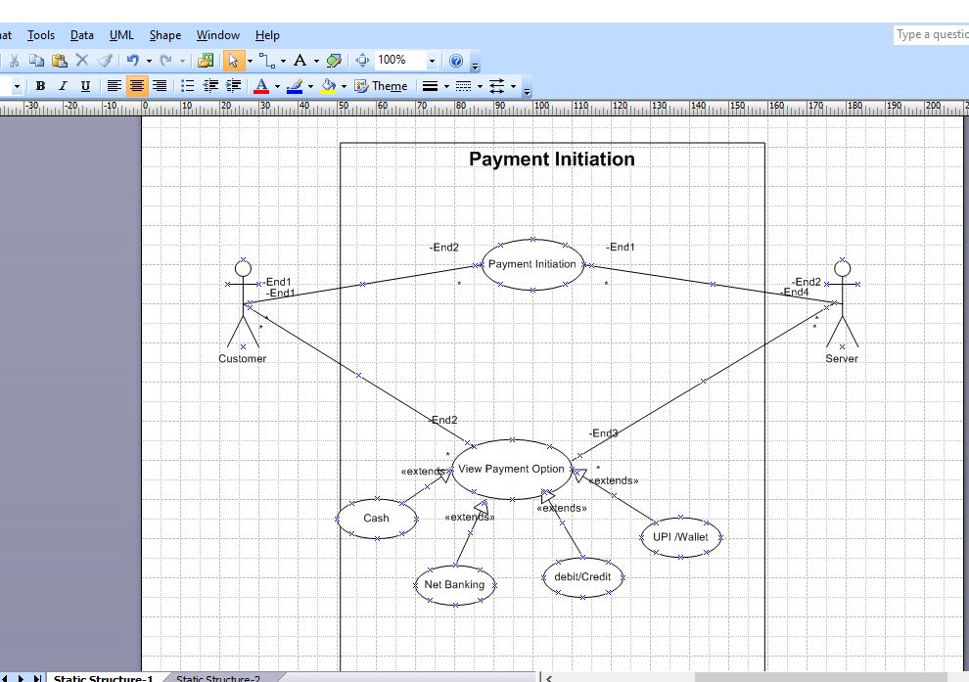
Payment Use case Diagram
Question 2. Derive Boundary Classes, Controller classes, Entity Classes.
Answer:
Boundary Classes: Boundary classes are the interfaces that connect the system with external actors such as customers or external services (like banks). In the system, the boundary classes include the different screens or forms through which actor interacts with the system.
Example: PaymentUI, CardPaymentForm, NetBankingForm, WalletPaymentForm, CashPaymentForm, PaymentConfirmationScreen, ReceiptScreen.
Controller Classes: Controller classes handle the application logic and acts as the middle layer between boundary class and entity classes. They are responsible for coordinating the flow of operations when a customer initiates a payment.
Example: PaymentController, CardPaymentController, WalletPaymentController, NetBankingController, CashPaymentController, AuthenticationController, ValidationController, DiscountController.
Entity Classes: Entity classes represent the core business objects and data that need to be stored and maintained in the system.
Example: Payment, Card, Wallet, BankAccount, Customer, TransactionLog, Order
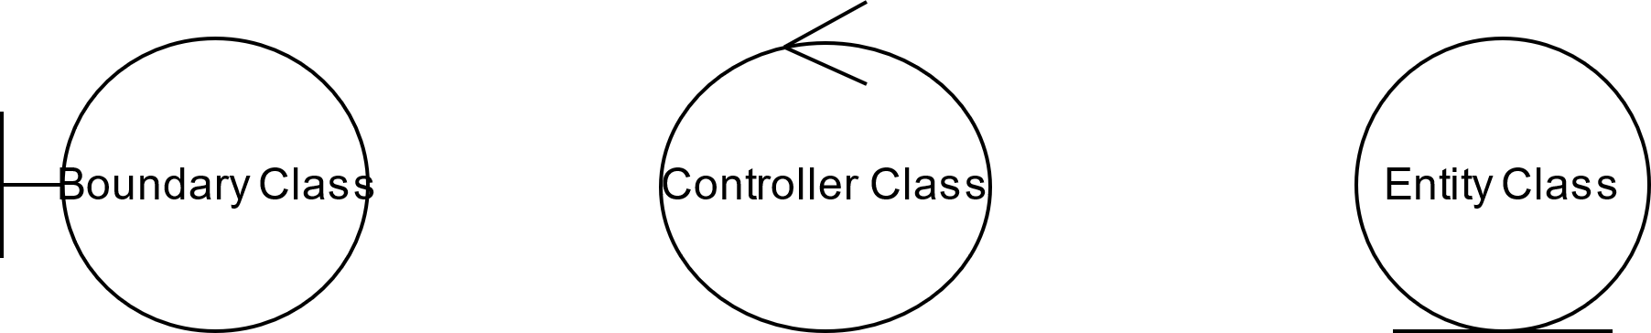
Question 3. Place these classes on a three tier Architecture.
Answer:
Application Tier
PaymentUI, CardPaymentForm, NetBankingForm, WalletPaymentForm, CashPaymentForm, PaymentConfirmationScreen, ReceiptScreen.
Business Logic Tier
PaymentController, CardPaymentController, WalletPaymentController, NetBankingController, CashPaymentController, AuthenticationController, ValidationController, DiscountController.
Database Tier
Payment, Card, Wallet, BankAccount, Customer, TransactionLog, Order

Question 4. Explain Domain Model for Customer making payment through Net Banking
Answer: A Domain Model is a visual representation of real-world concepts, entities and their relationships within a specific problem space. It captures business objects, their attributes and associations providing a high-level understanding of system requirements.
When a customer makes a payment through Net Banking, the domain model highlights the main entities, their attributes and how they interact with each other. It consists of entities Customer, Payment, Net Banking Account, Bank and Transaction Log. Each with attributes and relationship, where the Customer places Orders, makes payments via net banking using a linked Net Banking Account, the Bank authenticates and processes transactions and all attempts are recorded in Transaction Log.

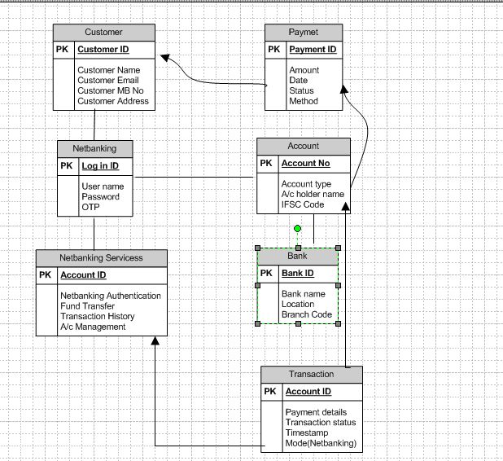
Domain Model for Customer making payment through Net Banking

Question 5. Draw a sequence diagram for payment done by Customer Net Banking
Answer: A sequence diagram is a UML Diagram that shows how different objects or actors interact with each other over time to complete a process. It represents the flow of messages step by step using vertical lifelines for each actor or object and horizontal arrows shows communication
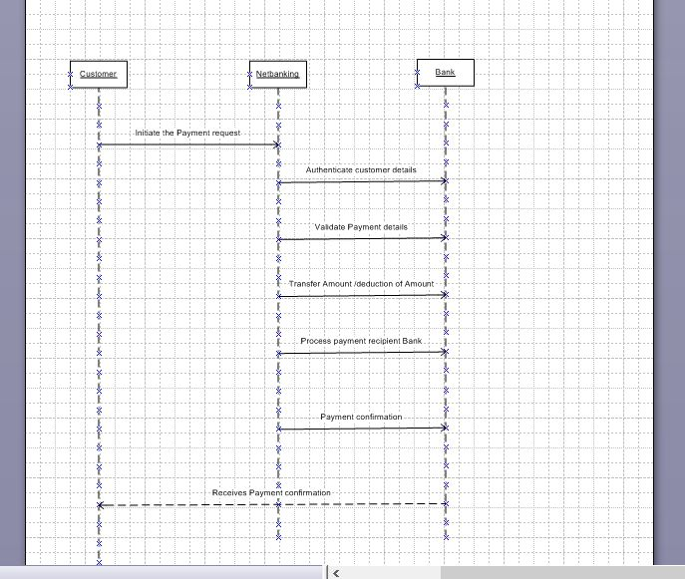
Sequence diagram for payment done by Customer Net Banking

Question 6. Explain Conceptual Model for this Case
Answer: A conceptual model is a high representation of the main entities in a system and how they are related. Unlike technical models, it does not go into database tables or code-level details. Instead, it shows the core concepts involved in the domain. These core concepts are Entities, Actors and Relationships.
Entities
- Customer
- Payment
- Net Banking Account
- Bank
- TransactionLog
Attributes
- Customer_Id, Name, Email, Phone_No
- Payment_Id, Amount, Date, Payment_status
- Account_No, IFSC, Bank_Name, User_Id
- Bank_Id, Bank_Name, Branch, Bank_API
- Transaction_Id, Timestamp, Result, Ref_No
Relationship
- Customer -> Payment
- Payment -> NetBankingAccount (Many-to-One)
- Payment -> Bank (Association)
- Payment -> TransactionLog (One-to-Many)
Question 7: What is MVC architecture? Explain MVC rules to derive classes from use case diagram and guidelines to place classes in 3-tier architecture
Answer: MVC (Model-View-Controller) is a software design pattern used to separate concerns in an application. It divides the application into three interconnected components.
Model: The model class knows about all the data that needed to be displayed. It is the model who is aware about all the operations that can be applied to transform that class. It only represents the data of an application. The model represents enterprise data and the business rules that govern access to and updates of this data. All model classes are represented as Entity Classes.
View: The view represents the presentation of the application. The view class refers to the model. It uses the query methods of the model to obtain the contents and renders it. The view is not dependent on the application logic. It remains same if there is any modification in the business logic, View class is the data required by this query. View class is represented as Boundary Class.
Controller: Whenever the user sends a request for something then it always go through the controller. The controller is responsible for intercepting the requests from view and passes it to the model for the appropriate action. Ater the action has been taken on the data; the controller is responsible for directing the appropriate view to the user.
MVC rules to derive classes from Use Case diagram:
- Boundary Classes (View Layer): It is derived from the actors and their interactions with the system. It represents interfaces between the user and the application.
- Controller Classes (Controller Layer): It is derived from use cases and coordinate flow between the boundary and the entity classes.
- Entity Classes (Model Layer): It is derived from domain model which stores and manages application data.
Guidelines to Place classes in 3-tier architecture
- Combination of One Actor and a use case results in one boundary class
- Combination of two actors and a use case results in two boundary classes
- Combination of three actors and a use case results in three boundary classes and so on .. Note: Only one primary actor is to be considered with a use case
- Use Case will result in a controller class
- Each actor will result in one entity class
Question 8: Explain BA contributions in project (Waterfall Model – all Stages)
Answer: Waterfall model is the most common and classic of life cycle models, where each phase must be completed on its entirely before the next phase can begin. At the end of each phase, a review takes place to determine if the project is on the right path and whether or not to continue or discard the project.
Stage of Waterfall Model | Activities | Artifacts and Resources
Pre Project | Support feasibility study, identify business needs, align with goals | Business case, Feasibility Study
Planning | Assist in creating communication plan, identify high-level requirements, support PM in planning | Communication Plan, High-Level Requirement List
Project Initiation | Identify stakeholders, define project scope, support charter creation, clarify responsibilities | Stakeholder Register, RACI Matrix, Scope Statement
Requirements Gathering | Conduct elicitation sessions capture user needs, document raw requirements | Elicitation Notes, MoM, Use Case Diagrams, User Stories, Interview Questionaries
Requirements Analysis | Analyse, refine, prioritise and validate requirements | BRD, SRS/FRS, Non-functional Requirements Spec, Process Flow diagram, RTM
Design | Validate design against requirements, support wireframes/prototypes | Review SDD, DFD, Wireframes/Prototypes
Development | Clarify requirements, maintain traceability | CR, RTM (updated)
Testing | Support QA team, review/ validate test cases for coverage, defects against requirements | Test case documents, RTM (for validation)
UAT | Support business users in UAT, review UAT test cases, validate requirements fulfilment, ensure sign-off | UAT Plan, UAT Test Cases Review, UAT Sign-off Document

Question 9: What is conflict management? Explain using Thomas – Kilmann technique
Answer: Conflict management is the process of handling disagreements or disputes between individuals, teams or stakeholders in a constructive way. The goal is not to eliminate conflict, but to resolve it productively so that project objectives are not impacted. For a BA, conflict management is key when stakeholders have differing priorities, requirements or viewpoints.
Thomas-Kilmann Conflict Management Technique (TKI)
It is a model that explains 5 styles of handling conflict, based on two dimensions:
- Assertiveness: It means how much you try to satisfy your own concerns.
- Cooperativeness: It means how much you try to satisfy other’s concerns.

- Competing (High Assertiveness, Low Cooperation)
It is a “I win, you lose” approach, used when quick, decisive action is required
Example: Enforcing a regulatory compliance requirement even if stakeholders resist.

- Collaborating (High Assertiveness, Low Cooperation)
It is a “win-win” solution where both parties work together to find a solution that satisfy everyone.
Example: Two departments agree on a new feature scope that addresses both efficiency and customer needs.

- Compromising (Moderating Assertiveness, High Cooperation)
It is a “Partial Win-Partial Lose” where each party gives up something to reach a middle ground.
Example: Reducing the scope of a feature to meet a tight deadline.

- Avoiding (Low Assertiveness, Low Cooperation)
Ignoring or postponing the conflict, it is useful when the issue is trivial or when emotions are too high.
Example: A Business Analyst avoids discussing a minor UI preference until major requirements are finalised.

- Accommodating (Low Assertiveness, High Cooperation)
It is “I lose, you win” where one party yields to the other to preserve harmony.
Example: Accepting a stakeholder’s non-critical request to maintain goodwill.

Question 10: List down the reasons for project failure
Answer: Project failure can happen due to the following reasons:
- Improper requirement gathering
- Incomplete, vague or misunderstood requirements
- Leads to rework, scope, gaps and wrong deliverables
- Continuous change in requirements
- Frequent changes without impact analysis or approval
- Causes confusion, cost/time escalation and frustration
- Lack of User involvement
- End users are not consulted during requirements gathering or design
- Results in a solution that doesn’t meet actual nosiness needs

- Lack of Executive support
- No strong project sponsor or leadership backing
- Leads to poor funding, delays in decisions and lack of authority to resolve conflicts
- Unrealistic expectations
- Over promising on features, timelines or ROI
- Creates pressure, poor quality deliverables and ultimately dissatisfaction
- Improper planning
- Inadequate scoping, risk analysis, resource allocation or scheduling
- Causes cost overruns, missed deadlines and chaotic execution
- Poor Communication
- Misalignment between business, development and testing teams.
- Technical Challenges
- Wrong tool/technology choice, integration features or infrastructure issues

Question 11: List the Challenges faced in projects for BA
Answer: The challenges faced in projects for BA are:
- Unclear Requirements
- Stakeholders struggle to articulate needs
- Leads to ambiguity and misinterpretation
- Scope creep
- Continuous addition of new features without proper impact analysis
- Increases rework and delays

- Lack of stakeholder engagement
- Stakeholder are unavailable, unresponsive or provide conflicting inputs

- Communication Gaps
- Misalignment between business teams, developers, testers and management

- Conflicting Stakeholder interests
- Different departments pushing different priorities
- BA has to balance and negotiate

- Time Constraints
- Short deadlines for gathering and analysing requirements
- Risk of skipping validation or documentation

- Inadequate Domain Knowledge
- New or complex domains may slow understanding
- Requires extra effort in learning
- Managing Stakeholder Expectations
- Balancing what stakeholders want vs what is feasible within budget and time
Question 12: Write about Document Naming Standards
Answer: Document Naming Standards are a set of agreed rules and conventions used for naming project documents in a consistent, structured, and meaningful way. They ensure that every file created during the project lifecycle can be easily identified, located, and version controlled by all team members.
Key Elements in Document Naming Standards
- Project Identifier – Short code for project (e.g., PROJ123 for Online Agriculture store)
- Document Type – Indicates the nature of the document (e.g., BRD, SRS)
- Version Number – To track updates (e.g., v1.0, v1.1)
- Date – In standard format (e.g., 2025-08-20)
So, Document Naming Formats: [Project Code] [Document Type] [Version][Date]
Example: PROJ123-BRD-v1.0-2025-08-20.docx
Question 13: What are the Do’s and Don’ts of a Business analyst
Answer: For a Business Analyst there are few Do’s and Don’ts that need to be followed are:
- Always use 5W1H for probing into any concept
- Never say NO to client – Always listen in your first meetings and if you have to say No then come with proper reasons explaining why it is not possible
- Banned word for BA is “I know”
- There is No word called as “By Default”
- Never imagine anything in terms of GUI (Graphical User Interface), Page designs and Screens
- Question the existence of existence
- Be a Good Team Player

Question 14: Write the difference between packages and sub-systems
Answer:
Packages | Sub-systems
- A package is a logical grouping of related classes, interfaces or use cases in UML | - A sub-system is a self-contained, semi-independent unit of the system that provides a set of related functionalities.
- It is used mainly for organisation and big/complex model, making it easier to manage complexity | - It is used to partition the system into functional blocks, often with their own interfaces and responsibilities.
- It is structural only means it does not define behaviour, just groups elements instead.  E.g., User Management, payment processing | - It defines both structure and behaviour, it can be developed, deployed and tested independently.  E.g., Authentication Service, Bank Integration service

Question 15: What is camel-casing and explain where it will be used
Answer: Camel-casing is a naming convention, where entire first word will be in lowercase and subsequent words first letter should be in upper case. There will be no gap between words. E.g., getEmpId (), turnLeftAndSlowDown ()
Camel-casing is used in:
- Programming languages like Java, C#, JavaScript, Python etc for naming variables, methods, classes etc.
- Databases & API Design to keep attribute name consistent. E.g., JSON field -> “customerId: 1234”
- Document Naming Standards (in projects) to maintain clarity and avoid spaces in file names.
E.g., BusinessRequirementDocument.docx

Question 16: Illustrate Development server and what are the accesses does business analyst has?
Answer:
- A development server is an environment where the software is built, tested and refined before it goes to higher environments like QA, UAT or Production. It is mainly used by developers for coding, integration and initial testing. As it is not customer facing therefore frequent changes, bug fixes and feature additions happen here. It usually has dummy/test data for testing the functionalities without harming production data.
- A BA typically has limited or read only access to the development environment. The main accesses could be,
- Read-only access: To verify requirements mapping with what developers are building, to review screens, workflow or UI changes and to check data flows.
- Test data setup: In some project, BAs may be allowed to create dummy test data to validate scenarios.
- Limited Access to Logs or reports: To analyse whether requirements are working as expected.
- No code level Access: BAs do not write/modify code on the development server.

Question 17: What is Data Mapping
Answer: Data mapping is the process of connecting/mapping data fields one source to another target system so that data can be transferred, integrated or transformed correctly. It ensures that the right data from the source goes to the right place in the destination, even if field names, formats or structures are different.
E.g., Suppose you are mitigating customer data from old system to new system
Old system field: Cust_Name -> New system filed: CustomerFullName
Types of Data mapping:
- Direct Mapping (One-to-One)
A source field is directly mapped to a target field with the same meaning/format, when both have similar structures.
E.g., CustomerID -> CustomerID
- Transformation Mapping (One-to-One with Rule)
Data is transformed or reformatted before mapping when data is in different formats
E.g., DOB (DD/MM/YYYY) -> BirthDate (YYYY-MM-DD)
- Concatenation (Many-to-One)
Multiple fields from the source are combined into one filed in the target.
E.g., FirstName + LastName -> FullName
- Splitting (One-to-Many)
One source filed is divided into multiple data fields
E.g., FullName -> FirstName, LastName
- Reference Mapping
Mapping uses a look up table or external reference to convert values
E.g., CountryCode (IN) -> CountryName (India)
- Conditional Mapping
Data is mapped depending on conditions or rules
E.g., If PaymentMode = “1” -> Card, then “2” -> NetBanking etc
- Hierarchical/Complex Mapping
Used when mapping structured data (XML, JSON) where parent-child relationship exists.
E.g., Order -> OrderItems -> ItemDetails

Question 18: What is API. Explain how you would use API integration in the case of your application Date format is dd-mm-yyyy and it is accepting some data from Other Application from US whose Date Format is mm-dd-yyyy
Answer: An API (Application Programming Interface) is a set of rules and products that allows two different software applications to communicate with each other. It acts like a bridge where one system can request data or services from another in a standardized way, without needing to know its internal details.
In this application, the format dd-mm-yyyy and it is accepting some data from other US application through API with mm-dd-yyyy format
Steps to handle this via API integration-n:
- Receive Data from US application:
The API will transfer data like 08-20-2025 (i.e., 20th August 2025 in US format)
- Data Transformation Layer
Before saving into your system, a conversion logic is applied where
mm-dd-yyyy -> dd-mm-yyyy is converted
E.g., 08-20-2025 -> 20-08-2025
- Validation
Ensure the converted date is valid
- Store in Database
Save it in the required dd-mm-yyyy format
- Send response back (if needed)
If our system sends back dates, convert them again to mm-dd-yyyy before sending to the US application, keeping consistency.

