- A customer can make a payment either by Card or by Wallet or by Cash or by Net banking. Draw a Use Case Diagram?
- Below shows the Payment Use Case Diagram
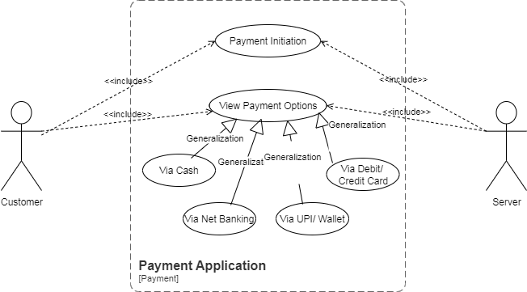

- Derive Boundary Classes, Controller classes, Entity Classes?
- Boundary Class: It is used to handle interactions between the System and external actor. Example:
- Payment Option Boundary
- Card Payment Boundary
Controller Class: Act as Intermediaries between Boundary and entity classes. Example:
- Payment Initiated Controller
- Card Payment Controller
Entity Class: Represent the core data and business logic of the Application. Example:
- Customer
- Payment

- Place these classes on a three tier Architecture?
- User Layer:
- Payment Method Selection Boundary
- Card Payment Boundary
Business Logic:
- Payment Controller
- Wallet Controller
Data Tier:
- Customer ( Entity Class)
- Payment ( Entity Class)

- Explain Domain Model for Customer making payment through Net Banking?
- A Domain Model is a conceptual representation that defines the structure, relationships, and behaviors of entities within a specific problem domain
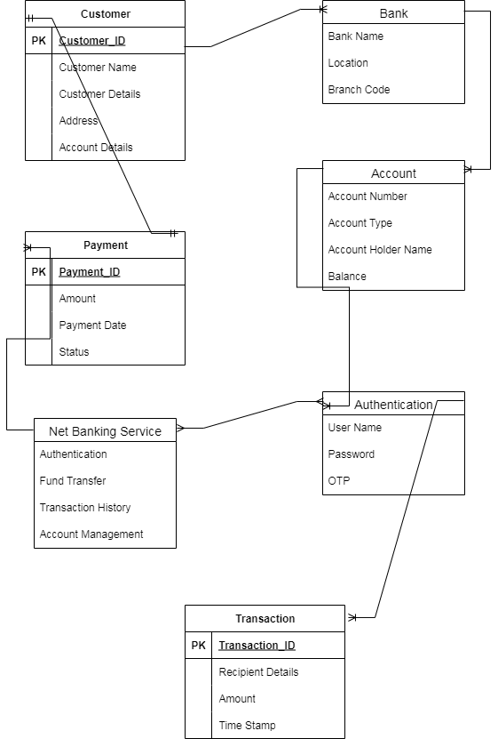

- Draw a sequence diagram for payment done by Customer Net Banking?
- A sequence diagram is a type of interaction diagram used in software engineering and systems design to illustrate how processes operate with one another and in what order.
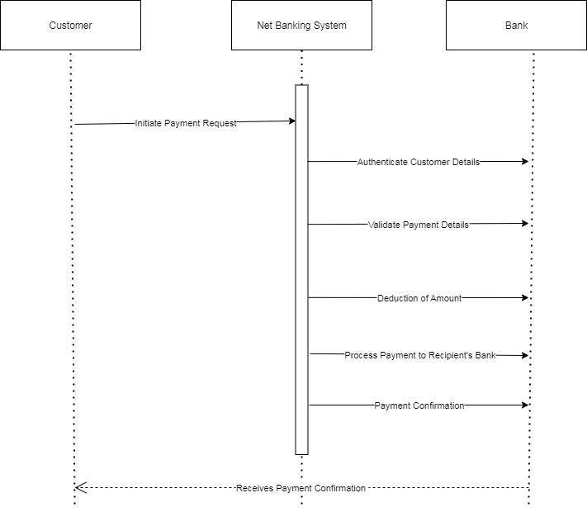

- Explain Conceptual Model for this Case?
- A conceptual model is a high – level representation of a system that helps in understanding, visualizing and communicating the essential system of a Domain. It Provides a clear and simplified view of the domain, making it easier to understand. Key elements of this model:
- Entities: Customer, Product, Order, Payment
- Attributes: Customer ID, Name, Email, Phone Number
- Relationships: For example, a Customer places an Order

- What is MVC architecture? Explain MVC rules to derive classes from use case diagram and guidelines to place classes in 3-tier architecture?
- To identify Classes from use case Diagram, we apply MVC rules on each use case to derive Classes
- Model: The model class knows about all the data that need to be displayed. It is model who is aware about all the operations that can be applied to transform that class. It only represents the data of an application. The model represents enterprise data and the business rules that govern access to and updates of this data. This represents Database ( Tables in DB). All Model Classes are represented as Entity Classes
- View: The View represents the presentation of the application. The view class refers to the model. It uses the query methods of the model to obtain the contents and renders it. The view is not dependent on the application logic. It remains same if there is any modification in the business logic. View Class is the data required by the query. View Class is represented as Boundary Class or Form Class
Actor speaks to system and vice-versa through boundary
Authenticating information between boundary and entity class
- Controller: Whenever the user sends a request for something then it always go through the controller. The controller is responsible for intercepting the requests from view and passes it to the model for the appropriate action. After the action has been taken on the data, the controller is responsible for directing the appropriate view to the user. In GUIs, the views and the controllers often work very closely together.
Controller class is working based on the user’s command. Understands the command/request given by user through Boundary/Form Class
MVC Architecture Rules
- Combination of One Actor and an use case results in one Boundary class
- Combination of Two Actors and an use case results in two Boundary classes
- Combination of Three Actors and an use case results in Three Boundary classes and so on....
Note: only one primary actor is to be considered with a use case.
- Use case will result in a controller class
- Each Actor will result in one entity class
Guidelines to place identified MVC Classes in a 3 Tier Architecture
- Place all Entity Classes in DB Layer
- Place Primary Actor associated Boundary Class in Application Layer
- Place Controller Class in Application Layer
- If governing Body influence or Reusability is there with any of remaining Boundary Classes, place them in Business Logic Layer else place them in Application Layer

- Explain BA contributions in project (Waterfall Model – all Stages)?
- Below are some BA contribution in Waterfall Model Project
Stage | Activities | Artifacts & Resources
Pre-Project | - Understand business need  - Feasibility analysis  - Stakeholder identification | - Business Case  - Feasibility Report  - Stakeholder Register
Planning | - Contribute to project scope  - Define BA approach  - Identify information sources | - Project Charter (BA contribution)  - BA Plan  - Stakeholder Analysis Document
Project Initiation | - Conduct stakeholder analysis  - Define requirements management plan  - Support project kick-off | - Requirements Management Plan  - Communication Plan  - Kick-off Presentation
Requirements Gathering | - Elicit requirements via workshops, interviews, etc.  - Capture business and user needs | - Business Requirements Document (BRD)  - Use Cases / User Stories  - Interview Notes
Requirements Analysis | - Analyze and validate requirements  - Resolve conflicts  - Prioritize requirements | - Functional Requirements Document (FRD)  - Process Flows  - Requirements Traceability Matrix (RTM)
Design | - Support design decisions  - Clarify requirements  - Participate in design reviews | - Updated RTM  - Design Review Notes  - UI Wireframes (BA-supported)
Development | - Clarify functional requirements  - Handle change requests  - Support developers | - RTM Updates  - Change Request Logs  - Clarification Documents
Testing | - Support test case creation  - Validate test coverage  - Help with defect triage | - Test Scenarios (BA-reviewed)  - RTM Verification  - Defect Logs
User Acceptance Testing (UAT) | - Support UAT planning  - Assist users during UAT  - Facilitate issue resolution | - UAT Plan  - UAT Feedback Reports  - Sign-Off Document

- What is conflict management? Explain using Thomas – Kilmann technique?
- Conflict Management: It is the process of resolving conflicts or disagreements between individuals or groups in a constructive manner
Thomas Kilmann Technique: It is a widely used tool for assessing conflict resolution styles & guiding individuals in selecting appropriate strategies to manage conflicts
- Conflict Management - Thomas Kilmann Technique
X Axis- Co-operation, Y Axis- Assertiveness
- 5 Options of Conflict Management
Competing
Avoiding
Accommodating
Collaborating
Compromising
- 5 Steps to Conflict Management
Identify Conflict
Discuss the details
Agree with root problem
Check for the every possible solution for the conflicts.
Negotiate the solution to avoid the future conflicts

- List down the reasons for project failure?
- Below are some of the reasons for project failure
Category | Reason for Failure
Requirements | - Incomplete or unclear requirements  - Changing requirements (scope creep)  - Poor requirements gathering process
Planning | - Inadequate project planning  - Unclear project scope  - Unrealistic timelines or budgets
Stakeholder Issues | - Lack of stakeholder involvement  - Misalignment of stakeholder expectations  - Poor communication with stakeholders
Resource Constraints | - Inadequate resources (time, money, people)  - Unskilled team members  - Poor resource allocation
Leadership & Management | - Poor project management  - Lack of executive support  - Ineffective decision-making
Communication | - Poor communication across teams  - Miscommunication of requirements or progress  - Lack of transparency
Technology | - Use of outdated or unsuitable technology  - Integration issues  - Technical complexity underestimated
Risk Management | - Failure to identify or manage risks  - No contingency planning
Testing & Quality | - Inadequate testing  - Defects found too late  - No proper QA processes
Change Management | - Resistance to change  - Poor user adoption  - No training or transition plan
Monitoring & Control | - Lack of performance tracking  - No corrective actions for deviations from plan

