Document 6- Please prepare a use case diagram, activity diagram and a use
case specification document.

Use Case Diagram

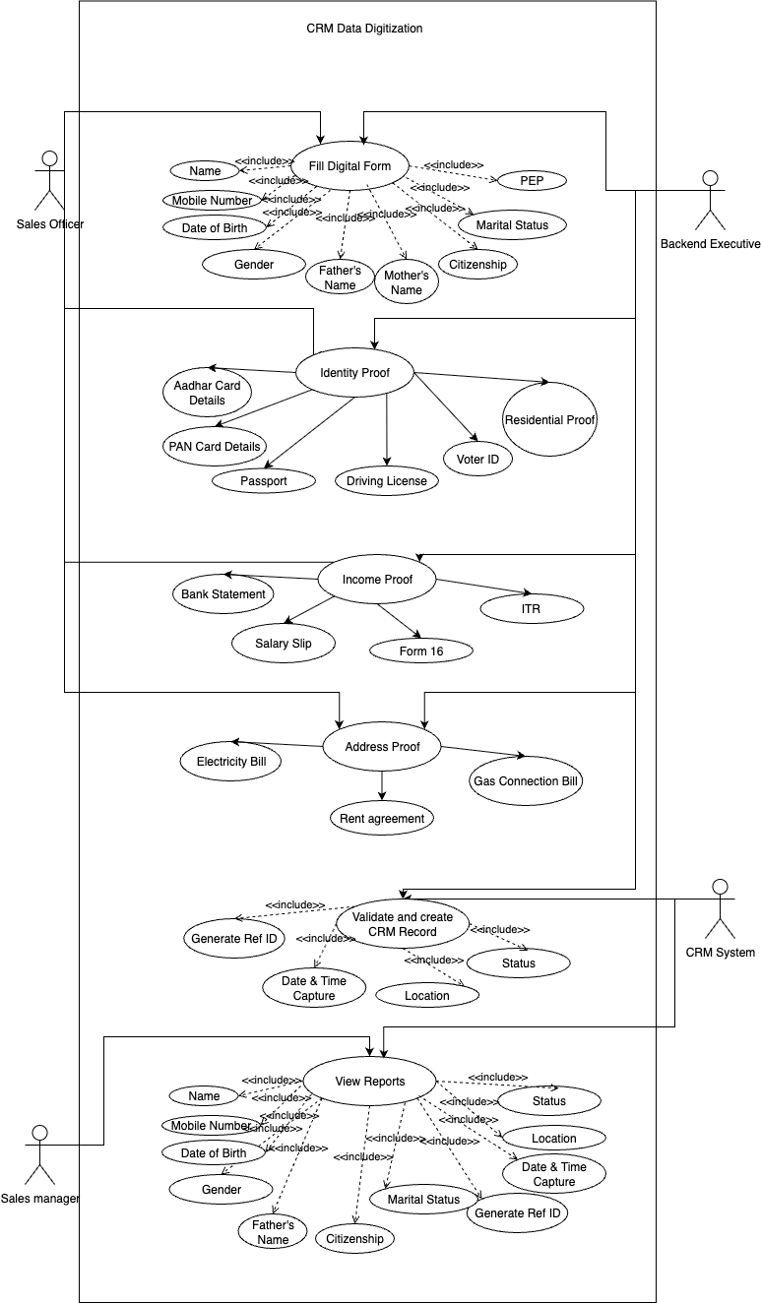

Activity Diagram: -

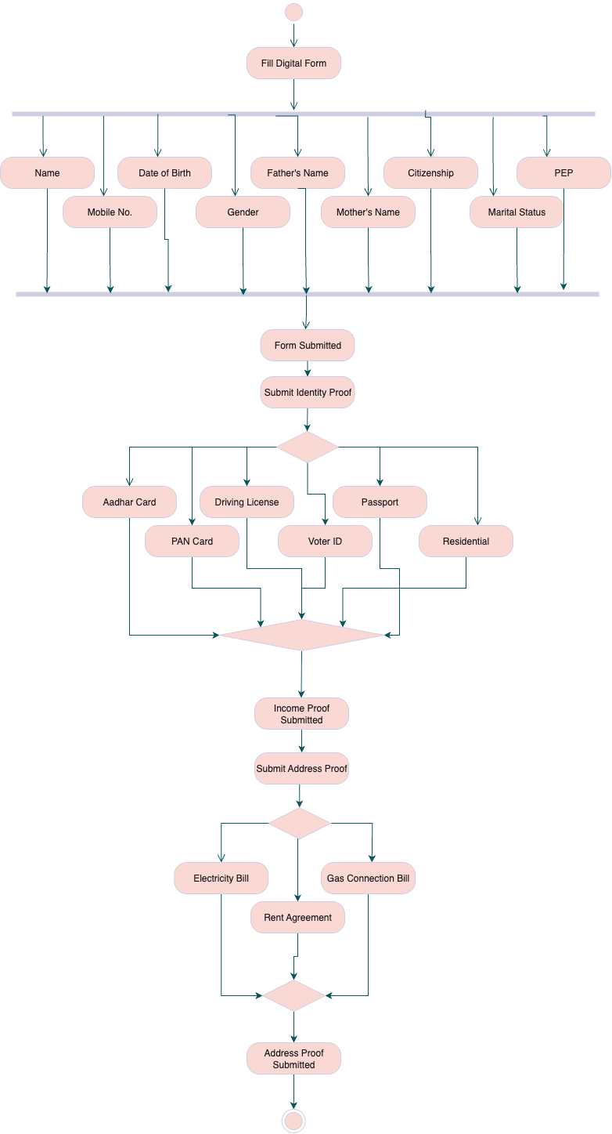

Use Case Specification: CRM Data Digitization

1. Use Case Name:
Fill Digital Customer Form and Create CRM Record

2. Use Case Description:
This use case captures the end-to-end process of a Sales Officer collecting customer details using a digital form instead of a manual paper form. The captured data is validated and stored in the CRM system. It includes personal, identity, income, and address proof information. The Sales Manager later views these records in reports.

3. Actors:
- Primary Actors:
  - Sales Officer (initiates form filling and submission)
  - CRM System (validates and stores data)
- Secondary Actors:
  - Backend Executive (optional review/assistance)
  - Sales Manager (accesses reports)

4. Basic Flow:
- Sales Officer logs into the system.
- Selects “New Customer Entry” → Opens digital form.
- Fills in personal details (name, DOB, gender, etc.).
- Adds proof documents:
  - Identity Proof (e.g., Aadhar, Voter ID)
  - Address Proof (e.g., Rent Agreement, Bills)
  - Income Proof (e.g., Salary Slip, ITR)
- Submits the form.
- CRM System validates fields, auto-generates Ref ID, captures location and timestamp.
- CRM record is created.
- Sales Manager can later view the details in reports.

5. Alternate Flow:
- If Internet is unavailable:
  - Data is saved offline and synced later.
- If Sales Officer skips optional fields:
  - Only required fields are validated and processed.

6. Exceptional Flows:
- If required fields are empty → Show error message.
- If duplicate Ref ID is detected → Block submission.
- If document upload fails → Prompt retry.
- If CRM is down → Show maintenance/error message.

7. Pre-Conditions:
- Sales Officer is authenticated.
- CRM system is accessible.
- Device is location-enabled.
- Digital form template is configured.

8. Post-Conditions:
- CRM record is stored and retrievable.
- Confirmation is shown to the Sales Officer.
- Record is available to Sales Manager for review/reporting.

9. Assumptions:
- Sales Officer is trained in using the application.
- All backend fields are correctly mapped.
- Each customer record is unique (Ref ID, email, phone).

10. Constraints:
- Limited device performance in rural areas.
- Intermittent internet connectivity may delay syncing.
- Image uploads may be restricted due to size limits.
- Required to comply with data protection laws.

11. Dependencies:
- Mobile/Web app availability
- CRM system APIs
- Location/GPS services
- ID verification services (if integrated)

12. Inputs and Outputs:
- Inputs:
  - Personal Info (Name, DOB, etc.)
  - Documents (Proof of ID, Address, Income)
  - Form Data (Citizenship, PEP status, Marital Status)
- Outputs:
  - Ref ID
  - CRM Record
  - Status message
  - Data available in reports

13. Business Rules:
- Ref ID must be unique per customer.
- Email and phone number cannot be reused.
- Mandatory fields must be filled before submission.
- Identity and Address proof types are system-configurable.
- Status of record should be “Pending/Approved/Rejected” based on validation rules.

14. Miscellaneous Information:
- The process helps eliminate paper-based errors and reduces turnaround time.
- Data can be exported for audit or regulatory purposes.
- Backend team can override/update data in exceptional cases.

Document 7- Screens and pages
Please follow the following steps to create the mock-ups
- Kindly use balsamic or Axure.
- Always start with a home page of an application.
- Take a feature and follow it to the end
a. Eg: Home page of SCRUM Foods
b. Select Login- Create a login page
c. Let’s assume, you want to search a restaurant
d. Search page- Type the restaurant name and select the dish
e. Add to cart page
f. Payment page
g. Logout page

- CRM Digital Form need to filled by the Sales officer in the field when they meet the customers and adding all the personal details of customer to create a Reference ID and store it in the CRM System.

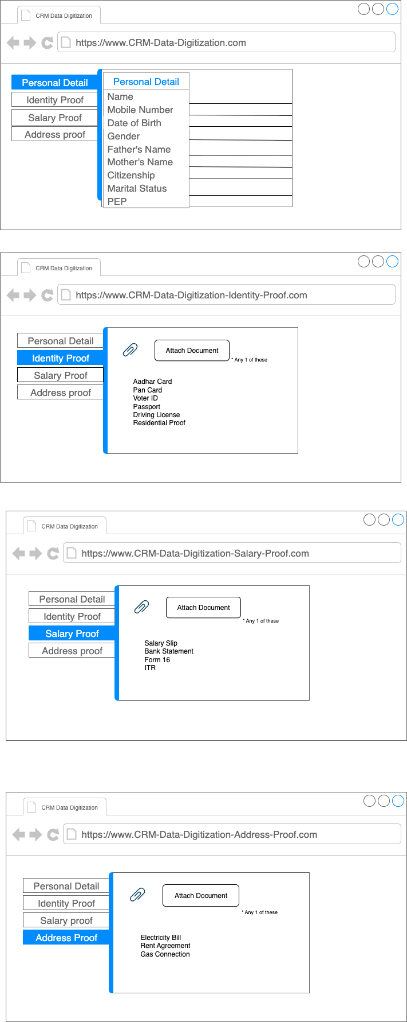

- Adding Identity proof to identify the customer is not Fake

- Adding Salary proof to identify the customer is working or not in the that organization and how much he/she is earning.

- Adding Address proof to validate, is the customer is citizen of India or Not.

Document 8- Tools-Visio and Axure
Write a paragraph on your experience using Visio and Axure for the project.

Experience Using Visio and Axure for CRM Data Digitization Project
During the CRM Data Digitization Project, I extensively used Microsoft Visio and Axure RP to streamline the documentation and UI/UX planning process. Visio was particularly effective for creating structured UML diagrams such as use case, activity, and process flow diagrams, which helped clearly visualize interactions between the Sales Officer, Backend Executive, and CRM system. It provided a professional and standardized format that could easily be shared with both technical and business stakeholders. On the other hand, Axure proved to be highly valuable in building interactive wireframes and low-fidelity prototypes for the customer data entry form. Using Axure, I was able to demonstrate real-time form validations, screen transitions, and conditional logic, which significantly helped stakeholders visualize the user journey before development began. Both tools complemented each other well and contributed to efficient requirement communication, improved design accuracy, and faster stakeholder approvals.

Document 9- BA experience My experience as BA in following phases:

Business Analyst Experience

Project: CRM Data Digitization
Role: Business Analyst
Model Followed: Waterfall Methodology

1. Requirement Gathering Phase
- Utilized the MoSCoW technique to prioritize requirements into Must have, Should have, Could have, and Won’t have.
- Faced client unavailability during critical phases, so proactively identified and collaborated with alternate Point of Contacts (POCs) to avoid project delays.
- Applied the FURPS model (Functionality, Usability, Reliability, Performance, Supportability) to validate the quality of requirements.
- Identified and eliminated duplicate or repetitive requirements to streamline scope.
- Created prototypes and mockups to help stakeholders visualize requirements, which resulted in more specific and accurate inputs.

2. Requirement Analysis Phase
- Developed UML diagrams (Use Case, Activity, and Class diagrams) to visually interpret business flows and interactions.
- Prepared Activity Diagrams to map out each user journey clearly, enhancing communication with the development team.
- Facilitated collaborative review sessions where team members provided feedback; adapted the diagrams and documents accordingly.
- Authored Business Requirement Specification (BRS) and Software Requirement Specification (SRS) documents for stakeholder sign-off.

3. Design Phase
- Created detailed test cases (both positive and negative) from use cases to cover every functional possibility.
- Participated in solution review meetings with clients to ensure alignment on design expectations.
- Ensured no test case was missed, knowing the significant impact this could have on development.
- Built test data aligned with all use scenarios and updated the RTM to ensure traceability of each requirement.

4. Development Phase
- Conducted Joint Application Development (JAD) sessions to bridge gaps between technical teams and business needs.
- Resolved interpersonal challenges among team members by conducting one-on-one discussions, explaining the impact of their roles on project success.
- Referred to approved UML diagrams to help the development team translate requirements into functional modules.
- Maintained clear communication with both client and internal teams, and when members missed meetings, ensured they were updated via recordings and individual follow-ups.

5. Testing Phase
- Derived test cases directly from the approved use cases for alignment with business goals.
- Performed high-level functional testing and coordinated with the QA team for further validations.
- Requested and collected test data from the client to simulate real-time conditions.
- Updated the Requirement Traceability Matrix throughout to ensure no requirement was left untested.
- Obtained UAT sign-off and worked with the client to prepare for User Acceptance Testing by providing scenario walkthroughs and user guidance.

6. Deployment Phase
- Ensured the final RTM was shared with the client and included in the Project Closure documentation.
- Coordinated with the documentation team to create end-user manuals and help guides.
- Scheduled and facilitated training sessions for end-users, ensuring full attendance and understanding.
- Confirmed that all training feedback was addressed and system usability was optimal prior to closure.

