Question 1 – What is the difference between Brainstorming and JAD Sessions?

Brainstorming and JAD Sessions are part of requirement elicitation techniques.

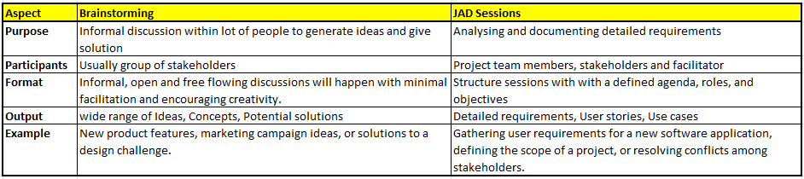

Question 2 - Why Document Analysis is one of the compulsory technique we use in a Project?

- Document Analysis is one of the requirement elicitation techniques.
- It involves systematically reviewing existing documents to understand the project context, identify requirements, and determine potential challenges.
- Documents like business plans, process flows, and user manuals provide valuable context about the project's goals, target audience, and existing systems.
- Analysing documents can help identify key stakeholders and their roles within the project.
- Documents like policy and procedure manuals, business rules, and process documentation tells BA how the organization operates and what rules govern its activities.
- It also contains Quality Assurance related information like Standards, Guidelines, Procedures etc.
- Document analysis can uncover functional and non-functional requirements by examining existing documentation.
- Document Analysis helps establishing the baseline or reference point for the project.
- Instead of starting from scratch, document analysis allows BA to leverage existing documentation, saving time and resources.
- By analysing documents early in the project lifecycle, potential issues can be identified and addressed proactively, preventing costly rework later.

Question 3 - In Which Context we will use Reverse Engineering?

- Reverse Engineering is one of the requirement elicitation techniques.
- It is used to understand and analyse the existing system/product.
- the process of deconstructing an existing product, system, or software to understand its design, functionality, and internal workings.
- This technique is used to extract knowledge about Product/Application by studying its internal structure or working.
- It is essentially working backward from the finished product to uncover its construction and operational principles.
- There are two categories:
  - Black Box – The system/product is studied without examining its internal structure
  - White Box – The internal structure/working of system/product is studied.
- This technique is commonly used for:
  - Market research: Understand the already developed application/product by competitor
  - Product recreation: Creating a functional replica of a product, potentially to replace a discontinued or unavailable item.
  - Design improvement: Analysing existing designs to identify areas for optimization or innovation.
  - Failure analysis: Determining the cause of a product's failure by examining its components.
  - Security analysis: In software, reverse engineering can be used to identify vulnerabilities or malicious code.
  - Legacy system maintenance: Understanding the design of older systems to maintain and update them.

Question 4 - What is the difference between Brainstorming and Focus Groups?

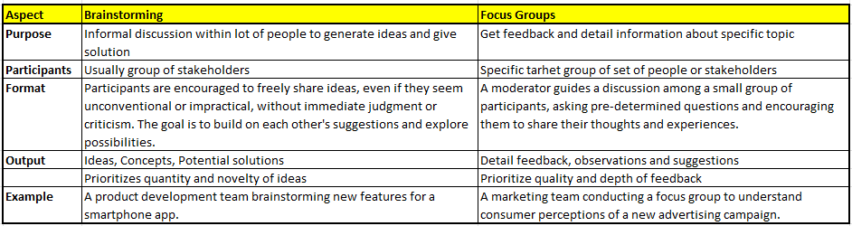

Question 5 - Observation Technique – Explain both Active and Passive approaches

- Observation is one of the requirement elicitation techniques.
- It is done by directly observing individuals, process or system.
- It is done by systematically watching and recording behaviours, events to gather data.
- Two main approaches:
  - Active – By doing direct engagement and interaction with participants by asking questions etc.
    - Example - A researcher observing a software developer coding and asking questions about their process or the challenges they are facing
  - Passive - By doing in-direct engagement. They simply observe and record the behaviour, activities, events.
    - Example - A researcher observing how customers interact with a product display in a store without approaching them.

Question 6 - How do you conduct the Requirements Workshop?

- Requirement Workshop is a structured approach to capture the requirements.
- It is used to Scope, Discover, Define, Prioritize requirements for the target system.
- Activities done for the workshop:
  - Define objective of workshop
  - Identify Stake Holders
  - Create an Agenda for workshop
  - Gather necessary documents, templates, and tools to support the discussions and capture requirements.
  - Inform participants about the workshop details, including the agenda, objectives, and any pre-reading materials.
  - Facilitate the workshop with key stakeholders
  - Keep the workshop on track with the agenda, manage time effectively, and ensure the discussion remains relevant to the objectives.
  - Document all requirements, decisions, and action items clearly and accurately.
  - Regularly summarize key points and decisions to confirm understanding and alignment among participants.
  - Address any disagreements or conflicts constructively and guide the group towards resolution
  - Validate requirements
  - Assign responsibilities for each action item and set realistic deadlines for completion.
  - Distribute a comprehensive summary of the workshop, including key findings, decisions, and action items.

Question 7 - In which context, Interview Technique can be conducted by a BA ? How may approaches are there in conducting Interviews? (Structured – Unstructured) Explain them. Explain the difference between Open Ended Questions and Closed ended Questions

BA can conduct interviews for:
- Gathering requirements
- Understanding Stakeholders needs
- Process analysis
- Collect information
- Clarify requirements
- Get feedback

Approaches to conduct interviews:
- Structured
  - BA follows pre-determine set of questions in standard manner
  - Not flexible with close-ended questions
  - All candidates are asked the same questions in the same order, ensuring consistency and fairness.
  - Structured interviews are designed to elicit data that can be easily quantified and compared, such as responses to multiple-choice or numerical questions.
  - Example - Questions about specific technical skills, past experiences with a particular software, or knowledge of data analysis methodologies.
- Unstructured
  - Based on answer for one question, BA frame the next question and so on
  - Flexible and with open-ended questions.
  - Allows BA to explore topic in depth and follow participant responses to uncover new information.
  - Unstructured interviews are primarily used to gather rich, detailed information about a candidate's personality, motivations, and problem-solving approaches.
  - Example - Questions about application goals, how to handle challenging situations, or approach to collaborative work.

Difference between Open and Close ended questions:

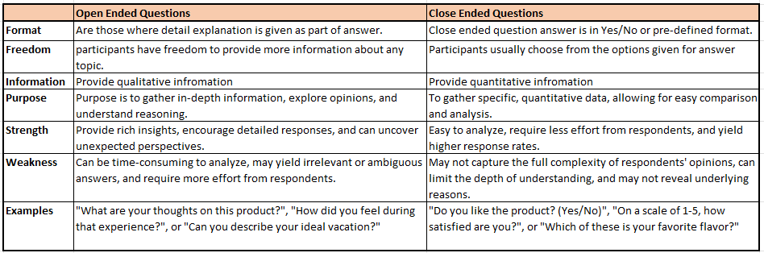

Question 8 - Questionnaire Technique – Where we will use? Give one example.

- It is one of ways to gather the requirements from large number of participants.
- Questionnaire Technique is a method of data collection.
- It is mainly used in Research, Surveys and Assessments.
- It involves giving a set of questions to participants and collecting their responses.
- Questionnaires can be done in various ways like Paper/Pencil, Online, face-to-face interviews etc.
- A questionnaire is a document, either physical or digital, containing a series of questions designed to elicit specific information.
- The questions are typically standardized, meaning they are presented in the same way to all respondents, ensuring consistency and comparability of responses.
- Example – Market research, Collect data about Consumer preferences, opinions etc.
- How it works:
  - Questionnaires can be given in person, through mail, email, or online platforms.
  - Respondents read the questions and provide their answers, either by selecting from provided options or writing their own responses.
  - The collected data is then analysed to identify patterns, trends, and relationships among the responses.
- Benefits:
  - Cost-effective - Questionnaires can be a relatively inexpensive way to gather data from a large number of people.
  - Efficient - They allow for quick data collection and analysis.
  - Accessibility: They can reach a wide and diverse audience.
- Drawbacks:
  - Low response rates - Not everyone who receives a questionnaire may complete and return it.
  - Potential for bias - Respondents may not always answer honestly or accurately or may not fully understand the questions.
  - Limited depth - Close-ended questions may not capture the full complexity of respondents' opinions and experiences.

Question 9 - How to Sort the Requirements – Where we will use? Give one example

- During requirements gathering, there are many requirements that may come up. So BA need to refine/sort them.
- Sorting the requirements helps BA to organize, prioritize and categorize the requirements.
- Sorting helps in identifying the most critical and important requirements for development and implementation.
- Sorting is mostly done during requirement gathering and finalising process.
- Requirements can be sorted in various ways like:
  - Functional and Non-functional
  - As per User role
  - As per time when it is needed
  - As per sections/departments
  - Feasibility
  - Features
- Benefits of sorting the requirements:
  - Improved Communication - A well-organized requirements document ensures that all stakeholders (business users, developers, testers, etc.) have a shared understanding of what needs to be delivered.
  - Reduced Ambiguity - Clear organization helps minimize misinterpretations and inconsistencies in the interpretation of requirements.
  - Organized requirements are easier to analyse for completeness, consistency, and conflicts.
  - Organized requirements can be easily tracked, prioritized, and managed throughout the project lifecycle.
- Example – In the software application project, requirements can be sorted based on 3-tier architecture like Front-end, Backend, Middleware.

Question 10 - Prioritise the Requirements – Where we will use? Give one example

- Prioritization of requirement is done after Sorting them.
- Prioritizing the requirements in nothing but arranging the requirements as per priority.
- Prioritization involves ranking requirements based on their value, urgency, and impact on project goals.
- It helps teams to focus on what is most important for success of the project. It also helps in determining the resource allocation.
- It helps ensure that the most critical requirements are addressed first, maximizing value and minimizing wasted effort.
- Prioritization is typically done based on following factors:
  - Business value
  - Impact
  - Dependencies
  - ROI
  - Urgency
- One of the widely used technique for Prioritization is MoSCow (Must-have, Should-have, Could-have, Would-have).
- It is a crucial step in managing projects, especially when resources like time and budget are limited.
- Benefits:
  - Resource optimization - Prioritization ensures that the most valuable requirements are addressed with available resources, maximizing the return on investment.
  - Reduced risk - High-priority requirements, often those with the highest risk or impact, are tackled first, mitigating potential project setbacks.
  - Improved focus - Prioritization helps teams stay focused on the most critical aspects of the project, preventing distractions from less important features.
  - Better decision-making - With a clear understanding of priority, stakeholders can make informed decisions about trade-offs and adjustments throughout the project lifecycle.
  - Increased customer satisfaction - By delivering the most essential features first, prioritization helps meet customer needs and expectations, leading to higher satisfaction
- Example – In Scrum, the product backlog all the requirements are prioritize for team to work upon. It is responsibility of Product Owner to keep the product backlog Prioritize as per requirements.

Question 11 - Weekly status reporting – How we will drive?

- Weekly status report is a report that is created and sent to all the stakeholders in the project.
- The report is summary of all work done during a week and how it is contributed towards completion of project.
- It is a document that summarizes the progress, key achievements, and challenges encountered during a specific week for a project/team.
- This report helps the stakeholders to understand the overall status of the project highlighting completed tasks, ongoing activities, upcoming plans, and any roadblocks faced.
- This report helps stakeholders stay informed, track progress against goals, and identify potential issues early on for timely intervention.
- Key components of the report:
  - Project/Team Name: Clearly identifies the subject of the report.
  - Report Date: Specifies the week covered by the report.
  - Summary: A brief overview of the week's key activities and accomplishments.
  - Completed Tasks: A list of tasks finished during the week.
  - Ongoing Tasks: Details of tasks still in progress, with updates on their status.
  - Upcoming Tasks: Outlines the planned activities for the following week.
  - Challenges/Roadblocks: Identifies any obstacles encountered during the week.
  - Action Items: Lists specific tasks or steps to address the challenges and move forward.
  - Risks: Highlights potential risks associated with the project or tasks.
  - Mitigation Strategies: Explains how identified risks will be managed.
- Benefits:
  - Regular communication promotes better teamwork and coordination.
  - Identifying problems early allows for timely corrective action.
  - Streamlined reporting can save time and effort in the long run.
  - Openly sharing information builds trust and accountability.
  - Tracking progress and identifying issues provides greater control over project outcomes.

Question 12 - Meeting Minutes Document – prepare one Sample

- Minutes Of Meeting (MoM) is a formal written document that summarizes below points from the meeting:
  - When meeting happened
  - Who all attended the meeting
  - Discussions happened in the meeting
  - Decisions made in the meeting
  - Actions taken during the meeting
- During the meeting, all key points are noted down. Once the meeting is over, the MoM document is prepared and circulated to all the meeting invitees.
- MoM serves as official record of the meeting. This help in bringing everyone on the same page.
- MoM serves as a crucial reference point for participants, stakeholders, and even those who were not in attendance.
- Key elements in MoM document:
  - Date, Time, and Location
  - Attendees and Absentees
  - Agenda Items
  - Discussion Summaries
  - Decisions Made
  - Action Items
  - Next Steps
- Why MoM is important:
  - Accountability - Meeting minutes clearly define who is responsible for which tasks, promoting accountability.
  - Transparency - They provide a transparent record of decisions and discussions, preventing misunderstandings.
  - Reference Point - They serve as a valuable reference for participants and stakeholders who need to recall decisions, action items, or specific discussions.
  - Historical Record - Minutes offer a historical record of project progress and decision-making, which can be useful for future analysis and reference.
- Sample format:

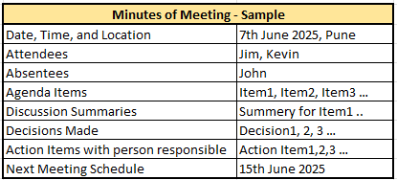

Question 13 - Change Tracker Document – prepare one Sample

- Change Tracker Document is used by the project team to log and track all the changes made in project, system, or requirements throughout the project life cycle.
- It documents all the changes made to the document and other relevant details like what change made, when, who asked for change, who approved the change etc.
- This document helps ensure that all changes are documented, assessed, and approved before implementation.
- It helps to have better project control and minimizing potential disruptions.
- It provides a structured way to submit and record requests for changes to the project scope, requirements, or system.
- Change tracker documents help assess the potential impact of a requested change on the project's timeline, resources, and overall scope.
- It ensures that all changes are traceable, allowing stakeholders to understand the history of modifications and their justification.
- The document serves as a central point of communication and information sharing among stakeholders regarding proposed changes.
- A change tracker document (or change request form) usually includes:
  - Change Request ID: A unique identifier for each change request.
  - Requester Information: Details about the individual or group submitting the request.
  - Date of Request: When the change was initially proposed.
  - Module/Component: The specific part of the system or project affected by the change.
  - Requirement ID: If applicable, the ID of the requirement being changed.
  - Requirement Description: A clear description of the change being requested.
  - Justification: Explanation for why the change is needed.
  - Impact Analysis: Assessment of the potential impact on the project.
  - Proposed Solution: Suggestions for how the change can be implemented.
  - Estimated Effort/Cost: An estimate of the resources required for the change.
  - Priority: How critical the change is.
  - Status: Tracking the progress of the change (e.g., submitted, approved, in progress, completed).
  - Approval Information: Details about who approved the change and when.
  - Link to Project Management Tool: A link to the ticket or task in the project management system.
- Examples:
  - Adding a new feature to a software application.
  - Modifying an existing business process.
  - Adjusting project timelines or deadlines.
  - Changing the scope of a project deliverable.
- Sample Format:
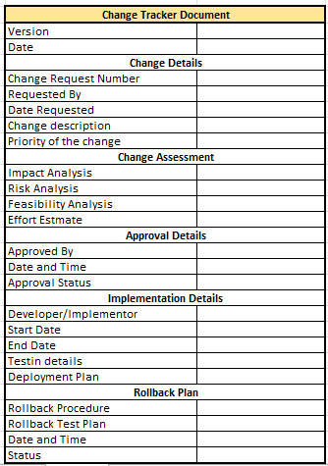

Question 14 - Difference between Traditional Development Model and Agile Development Models

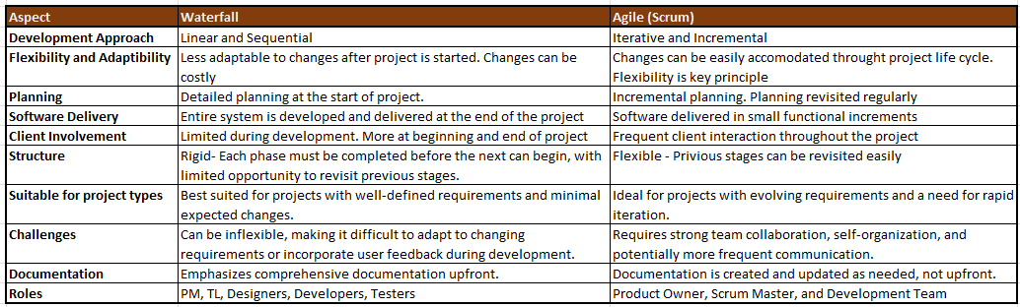

Question 15 - Explain Brainstorming Technique – Where to use?

- Brainstorming is a technique used to generate creative ideas and solution to a specific problem or challenge.
- Usually done though a group discussion.
- It encourages participants to freely express their thoughts, ideas and suggestions without criticism or judgement
- It involves a group of individuals, often stakeholders, who contribute ideas in a structured or unstructured way, with the goal of exploring possibilities and fostering creativity.
- This technique is valuable for uncovering innovative solutions, identifying potential issues, and gaining diverse perspectives.
- The primary goal is to produce a large quantity of ideas, regardless of their immediate feasibility or practicality.
- The ideas generated during brainstorming are typically evaluated and prioritized based on the organization's objectives and the desired outcome.
- Benefits:
  - Uncovering Hidden Solutions
  - Promoting Creativity and Innovation
  - Enhancing Stakeholder Engagement
  - Identifying Potential Issues and Risks
  - Improving Teamwork and Collaboration
- Common scenarios where Brainstorming is useful:
  - Idea generation
  - Project planning
  - Problem Solving
  - Team Building
  - Product Development
  - Strategic Planning

Case study (Q16 – Q20)

Question 16 - What reports Accounts Departments will generate (minimum 5 reports)

- Employee Financial Statement – To get overview of employee’s financial position and ability to repay the loan.
- Company reserve loan amount report – This report helps to understand how much amount company can afford to give the loan, how much amount is already utilised and how much is left.
- Employee Credit Report – The account department can obtain the credit report of employee from Credit Bureau. This report provides information on employee’s credit history, repayment track record, Outstanding loans and Credit score.
- Collateral evaluation – If the loan requires Collateral, then accounts department can evaluate the value of the proposed Collateral. This is to ensure that the Collateral is worth for the applied loan amount.
- Employee’s income and expenditure – The account department can verify how much is the income of the employee and what are his/her expenditure. This is to ensure that employee will be able to repay the monthly loan amount EMI from salary.

Question 17 - What is the structure of the message/mail communicated from the HR department to the employee in case the Loan is rejected?

Subject – Loan application (LN000537) rejection notification.

Dear Parag,

We hope this email finds you well. We would like to inform you that loan approval committee has gone through your loan application very carefully and did the evolution of your loan application. We regret to inform you that your loan application is rejected by loan approval committee.

We understand that this news will be disappointing for you. But we want to assure you that decision was made after thorough assessment of various factors and policies.

While we cannot provide the reasons of the application rejection, we encourage you to review your financial position.

Please note that this decision does not reflect on your value as am employee and will not have any impact on your employment or benefits. We remain committed supporting your professional growth with the company.

If you have questions, feel free to reach out to HR department and we will be more than happy to assist you.

Thank you for your understanding.

Best Regards,
HR Dept
TTS Company

Question 18 - What is the structure of the message/mail communicated from the HR department to the employee in case the Loan is approved?

Subject – Loan application (LN000634) approval notification.

Dear Sumit,

We are pleased to inform you that you loan application has been approved by the loan approval committee. Congratulations!!!

Below are the details of your approved loan:

Loan Amount – Rs. 30,000,000
Loan Term – 10 Years
Interest Rate – 8.5%
Repayment Schedule – Monthly instalment of Rs 50,000

Please review the loan agreement and associated terms and conditions. Also, note that the monthly amount towards your loan repayment will be automatically deducted from your salary. The entry of same will be reflected in your payslips.

If you have questions, feel free to reach out to HR department and we will be more than happy to assist you throughout the loan process.

Once again, congratulations on your loan approval. We wish you every success in achieving your financials goals.

Best Regards,
HR Dept
TTS Company

Question 19 - Design a sample report on the Loans applications Received by the accounts department.

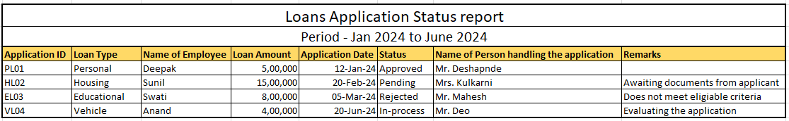

Q20. Which reporting Tools we will use for generating reports.

The choice of reporting tool depends on various factors like:
- Nature of Data
- Reporting requirements
- User skill level
- Budget
- Integration capabilities with other interface applications

Some of the commonly used tools for generating reports are:

- Microsoft Excel – Excel is a widely used spreadsheet application that offers powerful data analysis and reporting capabilities.
- Google sheets – It is similar to Excel but operates in the cloud and offers real-time collaboration features.
- Jira - A popular tool for issue tracking, project management, and requirements management.
- Tableau – It is a leading data visualization and reporting tool. It helps user to create interactive and visually appealing reports and dashboards.
- Power BI – This a business intelligence tool developed by Microsoft. It allows users to connect, transform and visualize data from different sources.

