 Business Requirements Document (BRD)
Project Title: Dairy Flow – Inventory & Logistics Management System
 1. Executive Summary
The company owns and operates manufacturing plants and warehouses across various regions in India. It manufactures perishable dairy products such as ice creams and milk-based items and delivers them through a distribution and logistics network.
The proposed software aims to:
- Provide real-time inventory tracking and control at all locations.
- Ensure optimized and fastest delivery to customers using automated route planning and warehouse allocation logic.
- Eliminate manual errors, stock mismatch, and delivery delays.
- Improve decision-making using advanced reporting and analytics.

 2. Business Objectives
Objective | Description
BO1 | Maintain accurate stock levels across all plants and warehouses
BO2 | Automate the order assignment to the nearest warehouse with sufficient stock
BO3 | Implement a smart delivery routing system using location intelligence
BO4 | Send automated alerts for low stock, expired stock, and delivery delays
BO5 | Build dashboards to monitor business health (stock aging, sales, fulfilment rate, etc.)
BO6 | Enable scalability to support more regions, products, and partners in future

 3. In-Scope & Out-of-Scope
 In Scope
- Inventory tracking by location, product, and batch
- Customer order capture (portal + mobile)
- Order-to-dispatch flow (WMS → Delivery)
- Route optimization with real-time location APIs
- Mobile tracking for delivery partners
- Web dashboard for Admins and Managers
- Alerts via Email/SMS
- Reporting for stock, delivery, and customer analytics
 Out of Scope (Current Phase)
- In-app payment processing
- Real-time cold-chain monitoring (hardware-based)
- Third-party supplier integration

 4. Functional Requirements
A. Inventory Management
- Auto-update stock post production
- Track stock across plants and warehouses
- Record product expiry dates and batches
- Trigger alerts for low or aging inventory
- Barcode/QR scanning for real-time updates
B. Order Management
- Allow customers to place B2B/B2C orders
- Auto-assign orders to the nearest warehouse
- Enable order tracking and cancellation
- View order status (Placed, In-Progress, Shipped, Delivered)
C. Delivery Management
- Assign delivery agents and routes
- Integrate with Google Maps API for shortest path
- View delivery status and ETAs
- Capture Proof of Delivery (image or signature)
D. Admin & Dashboard
- Role-based access: Admin, Manager, Agent
- View orders, deliveries, inventory levels
- Generate and download reports
- Perform manual overrides (e.g., reassign order)
E. Reporting & Analytics
- Track fulfillment rates by region/warehouse
- Monitor delivery time trends
- Predict future demand using historical data
- Inventory aging and waste analysis

 5. Non-Functional Requirements
Category | Requirement
Performance | <2 second response time for every action
Scalability | System should handle >100,000 daily orders
Security | Role-based access, data encryption, audit logging
Availability | 24x7 uptime with auto-recovery in case of system failure
Integration | Plug-and-play with APIs like Google Maps, WhatsApp, SMS Gateways
Mobility | Mobile responsive for managers and a dedicated app for delivery agents

 6. Stakeholders
Role | Responsibility
Business Owner | Approves requirements, budgets, and timelines
IT Manager | Ensures alignment with enterprise systems and security
Operations Lead | Provides warehouse and delivery process details
Plant/Warehouse Managers | End-users of inventory and dispatch features
Delivery Partners | Execute delivery operations using the mobile app
Product Team | Monitors delivery and order lifecycle

 7. Assumptions & Constraints
- Internet access available at all warehouse/plant locations.
- Delivery agents are provided smartphones.
- Route optimization APIs are licensed or open-source.
- Barcode scanners are available at dispatch points.
- All orders are fulfilled only from company-owned warehouses (no third-party drop shipping).

 8. Project Plan (Timeline)
Phase | Duration | Key Deliverables
Requirement Gathering | Week 1–2 | BRD, user stories, use cases
UI/UX and Architecture | Week 3–4 | Wireframes, system design
Core Development | Week 5–9 | Frontend, Backend, API, Integration
Testing & UAT | Week 10–11 | System testing, bug fixing
Deployment & Training | Week 12–13 | User manuals, production setup, training sessions
Go-Live & Monitoring | Week 14 | Final rollout and support team onboarding

 9. Resource Plan
Role | Count | Responsibilities
Business Analyst | 1 | Requirement gathering, use case definition
Project Manager | 1 | Project delivery and team coordination
Backend Developer | 2 | API creation, DB management
Frontend Developer | 2 | Dashboard, UI for web and mobile
Mobile Developer | 1 | Delivery partner mobile app
QA Tester | 1 | Test plan, test cases, UAT, defect management
DevOps Engineer | 1 | CI/CD pipeline, deployment, monitoring

 10. Deliverables
- Web-based Dashboard (Inventory + Order + Delivery)
- Delivery Partner Android/iOS App
- Admin Panel (for IT/Admins)
- API Integration with Maps and SMS
- Documentation (User manual + Technical specs)
- Reports Module (PDF/Excel export)
- Go-live support + Maintenance plan

Process flow diagram

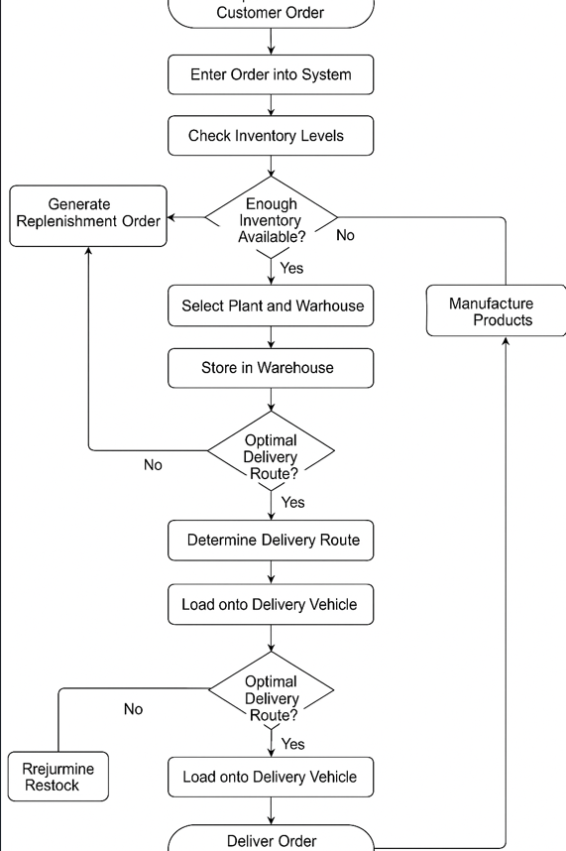

Introduction letter to a client
Subject: Introduction – Your Business Analyst for Project Initiation
Hi Team,
I hope this message finds you well.
My name is Sai varun and I will be your Business Analyst for the upcoming project. I’ll be working closely with you and your team to understand your business needs, gather and document requirements, and ensure we align our solutions with your objectives.
Our first step will be to initiate the business understanding phase, where I’ll aim to gain a comprehensive view of your processes, challenges, and goals. This foundation will guide the overall design and implementation strategy for the solution.
I look forward to collaborating with you and your stakeholders, and I’m confident that together we can deliver a solution that adds real value to your business.
Please feel free to reach out if you have any immediate questions or would like to schedule our initial discovery meeting.
Looking forward to working with you.
Warm regards,
Sai varun
Business Analyst
LTIMindtree
[Saivarunaitha1122@gmail.com] | [6304049810]

 Business Requirements Document (BRD)
Project Title: Internal Ticketing & Support System
Prepared By: Sai varun, Business Analyst
Date: 31-05-2025
1. Executive Summary
The objective of this project is to design and implement a centralized Ticketing System that allows employees/customers to raise, track, and resolve support issues across various departments (IT, HR, Admin, etc.). The system should streamline support workflows, reduce resolution time, and improve accountability.

2. Business Objectives
Objective ID | Description
BO1 | Enable users to raise support tickets easily and categorize them properly
BO2 | Allow teams to assign, prioritize, and resolve issues efficiently
BO3 | Provide real-time tracking and status updates for users
BO4 | Generate analytics reports for SLA tracking and team performance
BO5 | Integrate with email and optionally with communication tools like Teams/Slack

3. In-Scope
- User ticket submission and tracking
- Admin dashboard for ticket assignment and status control
- Priority and SLA configuration
- Role-based access (User, Support Agent, Manager)
- Notifications via Email
- Reporting & analytics module

4. Out-of-Scope (Phase 1)
- AI-based ticket classification
- Voice support integration
- Chatbot integration

5. Stakeholders
Role | Responsibility
End Users | Raise and monitor tickets
Support Teams | Resolve and close tickets
Admin | Manage users, configure categories
Management | Review reports and metrics

 Software Requirements Specification (SRS)
System Name: Support Ticketing System
Version: 1.0
Document Owner: Saivarun

1. Functional Requirements
ID | Description
FR1 | Users must be able to raise a ticket with subject, description, and category
FR2 | System shall allow assignment of tickets to specific support agents
FR3 | Support agents can update ticket status (Open, In Progress, Resolved, Closed)
FR4 | Tickets can be marked with priority (Low, Medium, High, Urgent)
FR5 | Admin can view and filter all tickets by status, department, and user
FR6 | Email notifications must be sent on status changes and agent responses
FR7 | System must support file attachment to tickets
FR8 | Generate reports on average resolution time, open/closed ticket ratio

2. Non-Functional Requirements
ID | Description
NFR1 | System must be web-based and mobile responsive
NFR2 | Data must be encrypted and access controlled
NFR3 | Response time should be under 2 seconds for all user actions
NFR4 | Support up to 10,000 concurrent users
NFR5 | Daily backup of ticket data to secure cloud storage

3. User Roles
Role | Permissions
User | Create, view, and comment on tickets
Support Agent | Assign, update, and close tickets
Admin | Full control including user management and configuration

4. System Interfaces
- Email Server (SMTP)
- Database (e.g., MySQL or PostgreSQL)
- REST APIs for future third-party integration

ERD of creating a support ticket/Ticketing life cycle

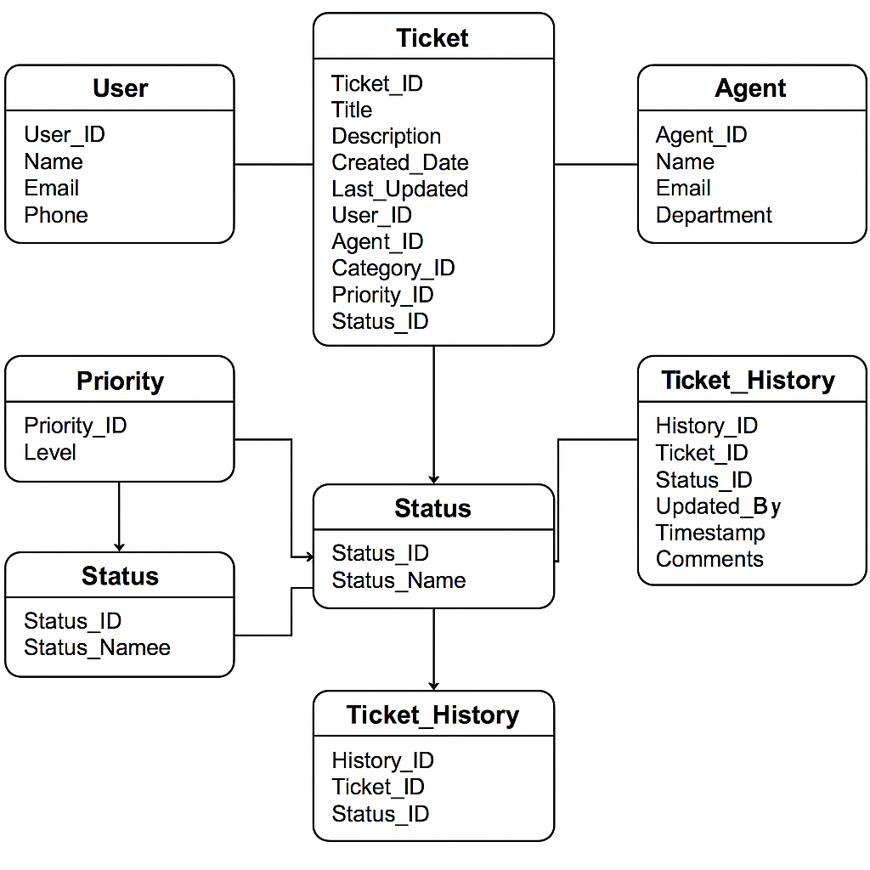

40 User stories of shopping from ecommerce

1. User Registration
As a new user
I want to register an account
So that I can access personalized features
BV: 8
CP: 3
Acceptance Criteria:
- User can enter required details (name, email, password).
- System validates inputs and shows errors for invalid data.
- User receives a confirmation email after successful registration.
- User can log in after registration.

2. User Login
As a registered user
I want to log in to my account
So that I can access my shopping profile and orders
BV: 9
CP: 2
Acceptance Criteria:
- User can enter email and password to log in.
- System validates credentials.
- User is redirected to the homepage/dashboard after successful login.
- Error shown for invalid credentials.

3. Password Reset
As a user
I want to reset my password if I forget it
So that I can regain access to my account
BV: 7
CP: 2
Acceptance Criteria:
- User can request a password reset by providing registered email.
- System sends password reset link to email.
- User can set a new password via the reset link.
- Confirmation shown after password reset.

4. Browse Products by Category
As a shopper
I want to browse products by category
So that I can find products of interest easily
BV: 9
CP: 5
Acceptance Criteria:
- Categories are clearly listed on the homepage/menu.
- Clicking a category shows relevant products.
- Pagination or infinite scroll is available.
- Products show basic info (image, name, price).

5. Search Products
As a shopper
I want to search for products by keywords
So that I can quickly find specific items
BV: 10
CP: 5
Acceptance Criteria:
- Search bar is accessible from every page.
- Results show products matching keywords in name or description.
- Search handles misspellings and partial words.
- Results are paginated or scrollable.

6. View Product Details
As a shopper
I want to view detailed information about a product
So that I can make informed purchase decisions
BV: 10
CP: 3
Acceptance Criteria:
- Clicking a product shows product page with detailed info.
- Details include images, description, price, availability, reviews.
- Product options (size, color) are selectable if applicable.
- "Add to Cart" button is available.

7. Add Product to Cart
As a shopper
I want to add products to my shopping cart
So that I can purchase them later
BV: 10
CP: 3
Acceptance Criteria:
- User can add a product with selected options to cart.
- Cart icon updates with the number of items.
- Confirmation message shown after adding.
- Cannot add more than available stock.

8. View Shopping Cart
As a shopper
I want to view my shopping cart contents
So that I can review items before checkout
BV: 10
CP: 3
Acceptance Criteria:
- Cart page lists all added products with details.
- Shows quantity, price per item, and total price.
- User can proceed to checkout from cart page.

9. Update Cart Quantities
As a shopper
I want to update product quantities in my cart
So that I can buy the desired number of items
BV: 8
CP: 2
Acceptance Criteria:
- User can increase or decrease quantity in cart.
- Quantity cannot exceed available stock.
- Cart total updates dynamically.

10. Remove Item from Cart
As a shopper
I want to remove items from my cart
So that I can adjust my purchase list
BV: 8
CP: 2
Acceptance Criteria:
- User can remove any product from cart.
- Confirmation requested before removal.
- Cart total updates after removal.

11. Guest Checkout
As a shopper
I want to check out without creating an account
So that I can make a quick purchase
BV: 9
CP: 5
Acceptance Criteria:
- Guest can enter shipping and payment info without login.
- System saves guest order with unique ID.
- Guest receives order confirmation email.

12. Save Address for Future Use
As a registered user
I want to save shipping addresses
So that I can use them for future orders
BV: 7
CP: 3
Acceptance Criteria:
- User can add, edit, delete multiple addresses.
- Saved addresses are selectable at checkout.
- System validates address format.

13. Select Shipping Method
As a shopper
I want to select a preferred shipping method
So that I can choose the delivery speed and cost
BV: 9
CP: 3
Acceptance Criteria:
- Different shipping options displayed with cost/time.
- User can select one option at checkout.
- Selected method is reflected in order summary.

14. Enter Payment Information
As a shopper
I want to enter payment details securely
So that I can pay for my order
BV: 10
CP: 5
Acceptance Criteria:
- User can enter credit/debit card or other payment details.
- Payment information is encrypted and secure.
- Payment gateway confirms successful payment.
- Errors shown on payment failure.

15. Order Confirmation Page
As a shopper
I want to see an order confirmation page after purchase
So that I know my order was placed successfully
BV: 9
CP: 2
Acceptance Criteria:
- Confirmation page shows order number, summary, and estimated delivery.
- Option to print or save order details.
- Confirmation email sent.

16. View Order History
As a registered user
I want to view my past orders
So that I can track what I have bought
BV: 8
CP: 3
Acceptance Criteria:
- User sees a list of all previous orders.
- Each order shows status, date, and total amount.
- User can click to see order details.

17. Track Order Status
As a shopper
I want to track the shipping status of my orders
So that I know when to expect delivery
BV: 9
CP: 4
Acceptance Criteria:
- Order status updates are available in order history.
- Status shows shipping stages (processing, shipped, delivered).
- Tracking number and carrier info provided.

18. Product Reviews and Ratings
As a shopper
I want to see reviews and ratings on products
So that I can make better buying decisions
BV: 7
CP: 3
Acceptance Criteria:
- Product page shows average rating and reviews.
- Reviews show username, date, rating, and comment.
- Reviews can be sorted by most recent or highest rating.

19. Write a Product Review
As a shopper
I want to write reviews for products I bought
So that I can share my experience with others
BV: 7
CP: 4
Acceptance Criteria:
- Only users who purchased the product can write reviews.
- User can rate and write comments.
- Reviews are moderated before publishing.

20. Apply Discount Coupons
As a shopper
I want to apply discount coupons at checkout
So that I can save money
BV: 8
CP: 3
Acceptance Criteria:
- User can enter coupon code during checkout.
- System validates coupon and applies discount if valid.
- Invalid/expired coupons show error messages.

21. Wishlist Feature
As a shopper
I want to add products to a wishlist
So that I can save items for future purchase
BV: 7
CP: 4
Acceptance Criteria:
- User can add/remove products from wishlist.
- Wishlist is saved to user profile.
- User can move wishlist items to cart.

22. Product Sorting Options
As a shopper
I want to sort products by price, popularity, etc.
So that I can find the best options for me
BV: 7
CP: 3
Acceptance Criteria:
- Sorting dropdown available on product listing pages.
- Sort options include price (low to high, high to low), popularity, newest.
- Products reorder correctly when a sort is selected.

23. Product Filtering
As a shopper
I want to filter products by attributes like brand, price, size
So that I can narrow down choices
BV: 8
CP: 4
Acceptance Criteria:
- Filters available on product listing pages.
- Multiple filters can be combined.
- Products update dynamically as filters are applied.

24. Responsive Design
As a shopper
I want to use the website comfortably on mobile devices
So that I can shop anytime anywhere
BV: 10
CP: 5
Acceptance Criteria:
- Website layout adjusts for mobile, tablet, desktop.
- Navigation and buttons are touch-friendly.
- No horizontal scrolling on small devices.

25. User Profile Management
As a registered user
I want to update my profile details
So that my account info is current
BV: 7
CP: 3
Acceptance Criteria:
- User can update name, email, password, and contact info.
- Changes are validated and saved.
- Confirmation shown after update.

26. Email Notifications
As a shopper
I want to receive emails for important events
So that I stay informed about my account and orders
BV: 8
CP: 3
Acceptance Criteria:
- Emails sent for registration, password reset, order confirmation, shipping updates.
- Emails contain correct user and order details.
- Unsubscribe link available in marketing emails.

27. Admin Dashboard - Product Management
As an admin
I want to add, edit, and remove products
So that product catalog is up to date
BV: 9
CP: 5
Acceptance Criteria:
- Admin can create new products with all details.
- Admin can update or delete existing products.
- Changes reflect immediately on the website.

28. Admin Dashboard - Order Management
As an admin
I want to view and manage customer orders
So that I can process shipments and returns
BV: 9
CP: 5
Acceptance Criteria:
- Admin can view all orders with status and customer details.
- Admin can update order status.
- System logs changes with timestamps.

29. Multi-language Support
As a shopper
I want to use the website in my preferred language
So that I can understand content easily
BV: 6
CP: 4
Acceptance Criteria:
- Language selector available on every page.
- Website content changes according to selected language.
- Default language is English.

30. Currency Selection
As a shopper
I want to view prices in my local currency
So that I can understand product costs better
BV: 6
CP: 3
Acceptance Criteria:
- Currency selector available on the site.
- Prices update according to selected currency.
- Currency changes reflect throughout the purchase process.

31. Save Payment Methods
As a registered user
I want to save my payment methods securely
So that I can check out faster
BV: 7
CP: 4
Acceptance Criteria:
- User can save and manage multiple payment methods.
- Payment info is encrypted and PCI compliant.
- User can select saved method at checkout.

32. Cart Persistence
As a user
I want to have my cart saved across sessions
So that I don’t lose items if I leave the site
BV: 8
CP: 3
Acceptance Criteria:
- Items added to cart remain after logout or closing browser.
- Cart updates correctly when user logs back in.

33. Social Media Login
As a user
I want to log in using my social media accounts
So that I can sign in quickly without remembering passwords
BV: 7
CP: 4
Acceptance Criteria:
- Options for Google, Facebook login on login/register page.
- Social login creates or links user account.
- User can switch to standard login if desired.

34. Product Recommendations
As a shopper
I want to see product recommendations
So that I discover items I may like
BV: 7
CP: 3
Acceptance Criteria:
- Recommendations shown on product and cart pages.
- Recommendations are based on browsing and purchase history.
- User can dismiss recommendations.

35. Secure Checkout
As a shopper
I want to have my data secured during checkout
So that my payment and personal info are safe
BV: 10
CP: 5
Acceptance Criteria:
- Checkout pages use HTTPS encryption.
- Sensitive data is not stored in logs or cookies.
- System complies with data protection regulations.

36. Order Cancellation
As a shopper
I want to cancel my order before it ships
So that I can change my mind
BV: 7
CP: 3
Acceptance Criteria:
- User can cancel orders in "processing" status.
- System updates order status and refunds payment.
- Cancellation confirmation sent via email.

37. Product Availability Notification
As a shopper
I want to get notified when an out-of-stock product is available
So that I can purchase it later
BV: 6
CP: 3
Acceptance Criteria:
- User can subscribe to notifications on out-of-stock products.
- System sends email when product is restocked.

38. Live Chat Support
As a shopper
I want to chat with support in real-time
So that I get help quickly
BV: 8
CP: 5
Acceptance Criteria:
- Live chat widget available on every page.
- Chat is routed to support agents.
- Chat transcripts can be emailed to users.

39. Newsletter Subscription
As a shopper
I want to subscribe to newsletters
So that I receive updates and promotions
BV: 6
CP: 2
Acceptance Criteria:
- User can enter email to subscribe.
- Confirmation email sent.
- User can unsubscribe anytime.

40. Return & Refund Process
As a shopper
I want to request returns and refunds
So that I can get my money back for unsatisfactory products
BV: 9
CP: 4
Acceptance Criteria:
- User can submit return request within return window.
- System validates eligibility.
- Refund processed and confirmation sent.

