Capstone Project1 – Part -3/3
Case Study Topic: Online Agriculture Products Store
Q1. Identify minimum 20 functional requirements and some non- functional requirements.
Answer –
Functional Requirements – It specify the features, operations and behaviour that a system must provide to meet business or user requirements. They define “What” of the system should do response to specific inputs or under particular condition. Business requirements are the high level requirements whereas functional requirements are the detailed behaviour of a system that will help in achieving the business requirements.
In function requirements gathering soft wares, developers, testers, engineers will be involving.

Requirement ID | Requirement  Name | Requirement  Description
FR001 | Create Account | System must allow new users to create new account using unique email ID and secure password.
FR002 | Account Exists | System should inform users if the email ID is already in our DB, and try to login inn with the same.
FR003 | Login | System must verify the credentials entered by the users with the DB.
FR004 | Invalid Password or Email ID | System should check if credentials are invalid and must ask to re-enter valid credentials.
FR005 | Forgot Password | System would give users an option to reset the password if they forgot.
FR006 | Search Product | System must give users search bar option to look for specific products, delivery status or payment process.
FR007 | Search Result for product | System could show the results for products with its detailed description, MRP and ratings.
FR008 | Search filters | System should give user the filter options as per ratings, values.
FR009 | Browse Catalogue | System must display an engaging and user friendly catalogues with all the categories like seeds, fertilizers and pesticides.
FR010 | Catalogue | System could provide an image of a product with its MRP, SP, Special offers and rating of products.
FR011 | Add to Cart | System should give users flexibility to add or remove product from cart.
FR012 | Buy Product | System should connect with payment gateways and proceed with purchase.
FR013 | Offers | System should show available offers on specific cards and any coupons applicable.
FR014 | Payments | System should connect with the payment gateways.
FR015 | Payments options | System must show users with payment options like COD, Card and UPI.
FR016 | Payment Error | System could ask users for different payment option if any technical/connectivity issue occurs.
FR017 | Orders placed | System with the help of email gateways should send user a confirmation email.
FR018 | Confirmation Email | The email must be send with the details of the product the link to check its delivery status, payment status etc.
FR019 | Delivery Tracker | System should be able to share the tracking of the package so the user get to know in case of early deliveries.
FR020 | Past records | System must store past purchases in the history for user's and organizational benefits.

Non-functional Requirements – These requirements describes the “How” rather than what such as how the system must perform rather than what it should do.

Requirement ID | Requirement  Name | Requirement  Description
NF001 | Response time | The application must load pages within 3 seconds.
NF002 | Security | The user data like passwords, credit card details should be encrypted.
NF003 | Availability | Application must run smoothly 24/7.
NF004 | Reliability | In case of crash system must record all the essential data.
NF005 | Maintainability | Easily updated and quick bugs resolution.

Q2. Make wireframes and prototypes.
Answer –
Wireframes: A wireframe is a two dimensional skeleton blueprint of the website or application that outlines its layout. This are low fidelity, static, 2D designs. It needs basic soft and design at early stages. It is designed by BA with the help of UX and PM.
Prototypes: It allow user to interact with the interface and experience its functionality. It has high fidelity, it allows navigations between screens. It is prepared at the later stages like test and development. It is designed by UX and developers.

Mockups:
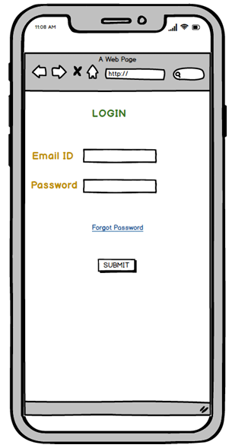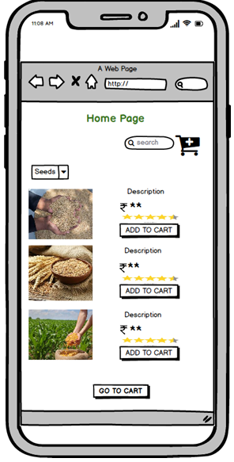

Prototypes:
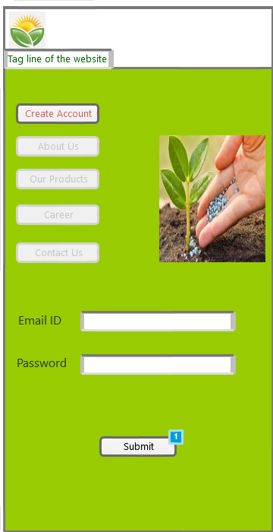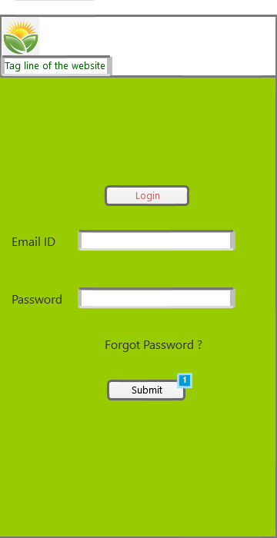

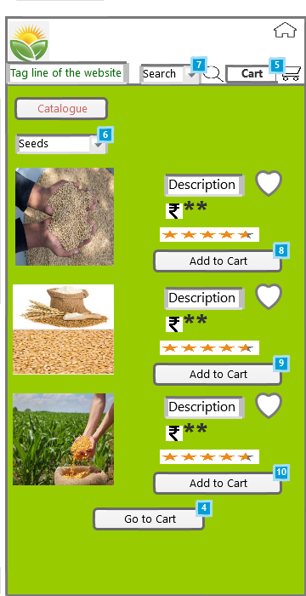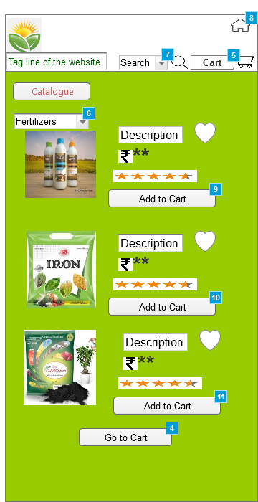

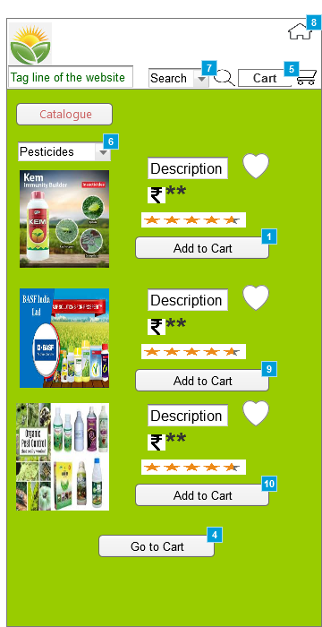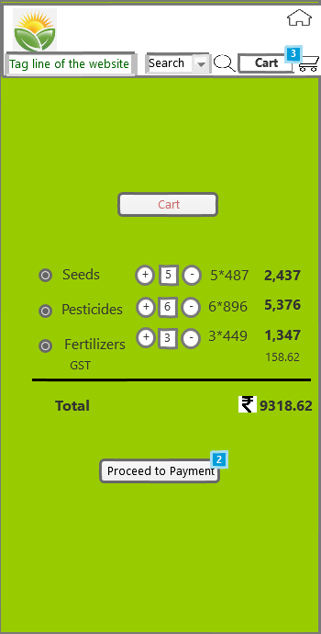

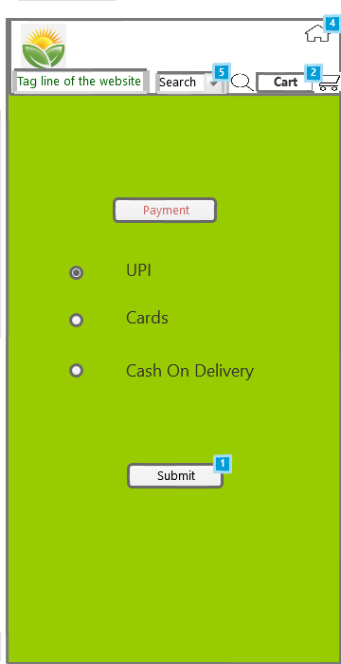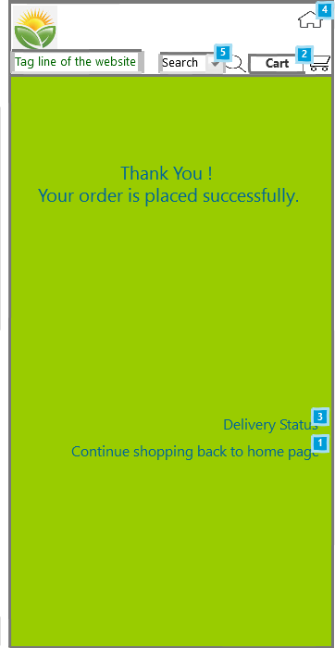

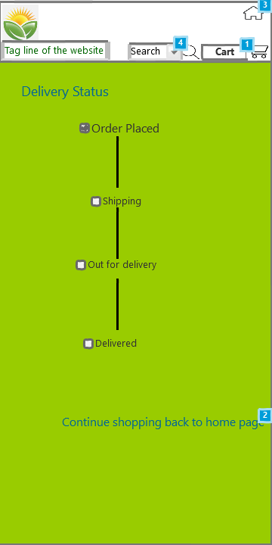

Axure RP Prototype link-

Q3. Make a note of the Tools, which you are using for wireframes, mock-ups and prototypes.
Answer –
For a BA, wire framing, mock-ups and prototyping tool helps in visualization and communication with user and software requirements to stakeholders and developers. There are multiple tools from low fidelity to high fidelity.
Some commonly used tools by BA are Balsamiq mock-ups 3, Axure RP and Visio.
Balsamiq: Balsamiq is a low-fidelity wire framing tool that helps us quickly create mock-ups for applications or websites. Its drag-and-drop, sketch-style interface allows non-designers to focus on functionality and user flow rather than visual details. It is used to generate digital sketches and used in early stage design discussions.
Axure RP Pro 7.0: Azure RP Pro 7.0 was a version of user experience (UX) design tool Axure RP, released around 2014. It introduced significant features for creating responsive, adaptive prototypes, allowing designers to build one page with different views for various screen sizes. It also includes improved interactive events, adaptive view handling and faster HTML generations for collaborative prototyping.
Wire framing- Is a basic skeleton outline of design. It is a low fidelity, static, sketched, and uses basic software, not clickable, for early stages like requirements gathering. Uses by UX (User experience Designer), BA and PM. Generally obtain by Balsamiq.
Mock-ups- A mock-up is an improved version of wireframes and it shows how the future system will look like. It has mid to high fidelity. It add design, colour, logo, font and icon. It is also non clickable. Used at mid stage like design stage. Used by UI designer.
Prototype- High fidelity clickable tool. It can navigate between screens. Used at later stages like test stage before development. Used by UX and developer.
Microsoft Office Visio 2007: It is a versatile tool for visualizing, documenting, and communicating complex business processes, system requirements and data flow. By translating complicated text and tables into easy-to-understand diagrams. Visio helps in analysis, collaboration, and stakeholder communication. Visio offers templates for creating different types of process, this helps to identify inefficiencies, bottlenecks and area of improvements.

Q4. Prepare Requirement Traceability Matrix.
Answer – Requirement Traceability Matrix: RTM is a document in software development lifecycle that links project requirements to test cases and project deliverables to ensure all requirements are tested and verified.

Requirement ID | Requirement  Name | Requirement  Description | Design | (Unit)  Development 1 | (Unit)  Test  1 | (Component)  Development  2 | (Component)  Test  2
FR001 | Create Account | System must allow new users to create new account using unique email ID and secure password. | Completed | Completed | Completed | Completed | Completed
FR002 | Account Exists | System should tell users if the email ID is already in our DB, So try login inn. | Completed | Completed | Completed | Completed | Completed
FR003 | Login | System must verify the credentials entered by the users with the DB. | Completed | Completed | Completed | Completed | Completed
FR004 | Invalid Password or Email | System should deteched if credentials are invalid and must ask to reenter valid credentials. | Completed | Completed | Completed | Completed | Completed
FR005 | Forgot Password | System would give users an option to reset the password if they forgot it. | Completed | Completed | Completed | Completed | Completed
FR006 | Search Product | System must give users search bar option to look for specific products, delivery status or payment process. | Completed | Completed | Completed | Completed | Completed
FR007 | Search Result for product | System could show the results for products with its detailed description, MRP and ratings. | Completed | Completed | Completed | Completed | Completed
FR008 | Search filters | System should give users the filter options as per ratings, values. | Completed | Completed | Completed | Completed | Completed
FR009 | Browse Catalogue | System must show an engaging and user friendly catalogues with all the catagories like seeds, fertilizers and pesticides. | Completed | Completed | Completed | Completed | Completed
FR010 | Catalogue | Syatem could provide an image of a product with its MRP and SP. Special offeres and rating of products. | Completed | Completed | Completed | Completed | Completed
FR011 | Add to Cart | System shouls give users flexibility to add or remove product from cart. | Completed | Completed | Completed | Completed | Completed
FR012 | Buy Product | System should connect with payment gateways and proceed with purchase. | Completed | Completed | Completed | Completed | Completed
FR013 | Offers | System should should available offers on specific cards and any coupons applicable. | Completed | Completed | Completed | Completed | Completed
FR014 | Payments | System should connect with the payment gateways. | Completed | Completed | Completed | Completed | Completed
FR015 | Payments options | System must show users with options like COD, Card and UPI. | Completed | Completed | Completed | Completed | Completed
FR016 | Payment Error | System could ask users for different payment option if any technical issue occurs. | Completed | Completed | Completed | Incomplete | Incomplete
FR017 | Orders placed | System with the help of email gateways should send user a confirmation email. | Completed | Completed | Completed | Incomplete | Incomplete
FR018 | Confirmation Email | The email must be sent with the details of the product the link to check its delivery status as well. | Completed | Completed | Completed | Incomplete | Incomplete
FR019 | Delivery Tracker | System should be able to share the tracking of the package so the user get to know in case of early deliveries. | Completed | Completed | Completed | Incomplete | Incomplete
FR020 | Past records | System must store past purchases in the history for user's and organizational's benefits. | Completed | Completed | Completed | Incomplete | Incomplete

Requirement ID | Requirement  Name | Requirement  Description | (System)  Development  3 | (System)  Test  3 | (System Integration)  Development 4 | (System Integration)  Test  4 | UAT
FR001 | Create Account | System must allow new users to create new account using unique email ID and secure password. | Completed | Completed | Completed | Completed | Completed
FR002 | Account Exists | System should tell users if the email ID is already in our DB, So try login inn. | Completed | Incomplete | Incomplete | Incomplete | Incomplete
FR003 | Login | System must verify the credentials entered by the users with the DB. | Completed | Completed | Completed | Completed | Incomplete
FR004 | Invalid Password or Email | System should deteched if credentials are invalid and must ask to reenter valid credentials. | Completed | Completed | Incomplete | Incomplete | Incomplete
FR005 | Forgot Password | System would give users an option to reset the password if they forgot it. | Completed | Completed | Completed | Incomplete | Incomplete
FR006 | Search Product | System must give users search bar option to look for specific products, delivery status or payment process. | Completed | Completed | Completed | Completed | Completed
FR007 | Search Result for product | System could show the results for products with its detailed description, MRP and ratings. | Completed | Incomplete | Incomplete | Incomplete | Incomplete
FR008 | Search filters | System should give users the filter options as per ratings, values. | Completed | Completed | Completed | Completed | Incomplete
FR009 | Browse Catalogue | System must show an engaging and user friendly catalogues with all the catagories like seeds, fertilizers and pesticides. | Completed | Completed | Incomplete | Incomplete | Incomplete
FR010 | Catalogue | Syatem could provide an image of a product with its MRP and SP. Special offeres and rating of products. | Completed | Completed | Completed | Incomplete | Incomplete
FR011 | Add to Cart | System shouls give users flexibility to add or remove product from cart. | Completed | Completed | Completed | Completed | Completed
FR012 | Buy Product | System should connect with payment gateways and proceed with purchase. | Completed | Incomplete | Incomplete | Incomplete | Incomplete
FR013 | Offers | System should should available offers on specific cards and any coupons applicable. | Completed | Completed | Completed | Completed | Incomplete
FR014 | Payments | System should connect with the payment gateways. | Completed | Completed | Incomplete | Incomplete | Incomplete
FR015 | Payments options | System must show users with options like COD, Card and UPI. | Completed | Completed | Completed | Incomplete | Incomplete
FR016 | Payment Error | System could ask users for different payment option if any technical issue occurs. | Incomplete | Incomplete | Incomplete | Incomplete | Incomplete
FR017 | Orders placed | System with the help of email gateways should send user a confirmation email. | Incomplete | Incomplete | Incomplete | Incomplete | Incomplete
FR018 | Confirmation Email | The email must be sent with the details of the product the link to check its delivery status as well. | Incomplete | Incomplete | Incomplete | Incomplete | Incomplete
FR019 | Delivery Tracker | System should be able to share the tracking of the package so the user get to know in case of early deliveries. | Incomplete | Incomplete | Incomplete | Incomplete | Incomplete
FR020 | Past records | System must store past purchases in the history for user's and organizational's benefits. | Incomplete | Incomplete | Incomplete | Incomplete | Incomplete

Non Functional Requirements-
Requirement ID | Requirement  Name | Requirement  Description | Design | (Unit)  Development 1 | (Unit)  Test  1 | (Component)  Development  2 | (Component)  Test  2
NF001 | Response time | The application must load pages within 3 seconds. | Completed | Completed | Completed | Completed | Completed
NF002 | Security | The user data like passwords, creadit card details should be encrypted. | Completed | Completed | Completed | Completed | Completed
NF003 | Availability | Application must run smoothly 24/7. | Completed | Completed | Completed | Completed | Completed
NF004 | Reliability | In case of crash system must record all the essential data. | Completed | Completed | Completed | Incomplete | Incomplete
NF005 | Maintainability | Easily updated and quick bugs resolution. | Completed | Completed | Completed | Incomplete | Incomplete

Requirement ID | Requirement  Name | Requirement  Description | (System)  Development  3 | (System)  Test  3 | (System  Interface)  Development 4 | (System Interface)  Test  4 | UAT
NF001 | Response time | The application must load pages within 3 seconds. | Completed | Completed | Completed | Completed | Completed
NF002 | Security | The user data like passwords, creadit card details should be encrypted. | Completed | Incomplete | Incomplete | Incomplete | Incomplete
NF003 | Availability | Application must run smoothly 24/7. | Completed | Completed | Completed | Completed | Incomplete
NF004 | Reliability | In case of crash system must record all the essential data. | Incomplete | Incomplete | Incomplete | Incomplete | Incomplete
NF005 | Maintainability | Easily updated and quick bugs resolution. | Incomplete | Incomplete | Incomplete | Incomplete | Incomplete

Q5. Prepare 10 Test Case Document.
Answer –
A test case document is a detailed outline used by testers to ensure that the software application or system is working as expected. It provides step by step guide, allowing testers to compare the actual results of their actions against the pre-defined expected results to determine if a test passes or fails.

Test Case ID | 1 | Test Case Name | *****
Project ID | ***** | Project Name | *****
PM ID | ***** | PM Name | *****
Test Strategy ID | ***** | Tester ID | *****
Test Plan ID | ***** | Tester Name | *****
Test Schedule ID | ***** | Date of Test | *****
Scenario | Create Account: New user can create account
Link to that page | Login
Input Data | Set 1- Email ID  abc.def@ghil | Set 2- Password  ********
Expected Behaviour | Account created successfully | Account created successfully
Actual Behaviour | Account created successfully | Account created successfully
Comments | None | None
Results(Pass/Fail) | Pass | Pass
Test Case ID | 2 | Test Case Name | *****
Project ID | ***** | Project Name | *****
PM ID | ***** | PM Name | *****
Test Strategy ID | ***** | Tester ID | *****
Test Plan ID | ***** | Tester Name | *****
Test Schedule ID | ***** | Date of Test | *****
Scenario | Search: Search for product.
Link to that page | Cart page
Input Data | Set 1  Seeds  Groundnut  10kg
Expected Behaviour | 10 Results
Actual Behaviour | 09 Results
Comments | One result not displayed.
Results(Pass/Fail) | Fail
Test Case ID | 3 | Test Case Name | *****
Project ID | ***** | Project Name | *****
PM ID | ***** | PM Name | *****
Test Strategy ID | ***** | Tester ID | *****
Test Plan ID | ***** | Tester Name | *****
Test Schedule ID | ***** | Date of Test | *****
Scenario | Search: Search for delivery status.
Link to that page | Cart page
Input Data | Set 1  Delivery Status
Expected Behaviour | Display delivery status
Actual Behaviour | Delivery status displayed
Comments | None
Results(Pass/Fail) | Pass
Test Case ID | 4 | Test Case Name | *****
Project ID | ***** | Project Name | *****
PM ID | ***** | PM Name | *****
Test Strategy ID | ***** | Tester ID | *****
Test Plan ID | ***** | Tester Name | *****
Test Schedule ID | ***** | Date of Test | *****
Scenario | Search: Search for payment process.
Link to that page | Cart page
Input Data | Set 1  Payment Process
Expected Behaviour | Display payment page
Actual Behaviour | Payment page displayed
Comments | It takes more than a minute to display page.
Results(Pass/Fail) | Fail
Test Case ID | 5 | Test Case Name | *****
Project ID | ***** | Project Name | *****
PM ID | ***** | PM Name | *****
Test Strategy ID | ***** | Tester ID | *****
Test Plan ID | ***** | Tester Name | *****
Test Schedule ID | ***** | Date of Test | *****
Scenario | Browse Catalogue: Can browse for seeds, pesticides and fertilizers.
Link to that page | Cart page
Input Data | None
Expected Behaviour | Showing top selling seeds, pesticides and fertilizers with its rating and offer price.
Actual Behaviour | Showing top selling seeds, pesticides and fertilizers with its rating and offer price.
Comments | None
Results(Pass/Fail) | Pass
Test Case ID | 6 | Test Case Name | *****
Project ID | ***** | Project Name | *****
PM ID | ***** | PM Name | *****
Test Strategy ID | ***** | Tester ID | *****
Test Plan ID | ***** | Tester Name | *****
Test Schedule ID | ***** | Date of Test | *****
Scenario | Payment: Payment via card
Link to that page | Link to FCH
Input Data | Set 1  Selected card option for payment.  1234 ***********  ABC  072
Expected Behaviour | Redirect to 3rd party page for card payment.
Actual Behaviour | Redirect to 3rd party page for card payment.
Comments | It takes more than 60 seconds to connect with 3rd party page.
Results(Pass/Fail) | Fail
Test Case ID | 7 | Test Case Name | *****
Project ID | ***** | Project Name | *****
PM ID | ***** | PM Name | *****
Test Strategy ID | ***** | Tester ID | *****
Test Plan ID | ***** | Tester Name | *****
Test Schedule ID | ***** | Date of Test | *****
Scenario | Payment: Payment via UPI
Link to that page | Link to Bank
Input Data | Set 1  Selected UPI option for payment.  ABC@okefg.com
Expected Behaviour | Redirect to 3rd party page for UPI payment.
Actual Behaviour | Redirect to 3rd party page for UPI payment.
Comments | None
Results(Pass/Fail) | Pass
Test Case ID | 8 | Test Case Name | *****
Project ID | ***** | Project Name | *****
PM ID | ***** | PM Name | *****
Test Strategy ID | ***** | Tester ID | *****
Test Plan ID | ***** | Tester Name | *****
Test Schedule ID | ***** | Date of Test | *****
Scenario | Payment: Payment via Cash
Link to that page | Link to confirmation
Input Data | None
Expected Behaviour | Order will be placed.
Actual Behaviour | Order placed
Comments | None
Results(Pass/Fail) | Pass
Test Case ID | 9 | Test Case Name | *****
Project ID | ***** | Project Name | *****
PM ID | ***** | PM Name | *****
Test Strategy ID | ***** | Tester ID | *****
Test Plan ID | ***** | Tester Name | *****
Test Schedule ID | ***** | Date of Test | *****
Scenario | Email: An email confirmation will be send.
Link to that page | Link to delivery status
Input Data | None
Expected Behaviour | Once the order is placed a confirming email should be send to customer.
Actual Behaviour | Email send.
Comments | None
Results(Pass/Fail) | Pass
Test Case ID | 10 | Test Case Name | *****
Project ID | ***** | Project Name | *****
PM ID | ***** | PM Name | *****
Test Strategy ID | ***** | Tester ID | *****
Test Plan ID | ***** | Tester Name | *****
Test Schedule ID | ***** | Date of Test | *****
Scenario | Delivery status
Link to that page | Link to home page
Input Data | None
Expected Behaviour | Delivery status must be shared and update as per location.
Actual Behaviour | Accurate location shared
Comments | None
Results(Pass/Fail) | Pass

Q6. Draw DB schema and ER diagram.
Answer –
ER Diagram-
An entity relationship diagram is a visual model of a database’s logical structure that shows how different “entities” (like tables) are related to one another. It’s a blueprint used for designing and understanding databases, consisting of three main components. Entities, attributes (the data field of an entity), and the relationship that link them.
DB Schema-
A database schema is a blueprint or logical structure of a database, defining how data is organized and related. It outlines tables, fields, data types, relationships (like primary and foreign keys), and constraints, but does not contain the actual data itself.
An ER diagram is a high-level, conceptual blueprint for a database, while a database schema is the physical, technical implementation of that design.
Below enclosed are the drawn diagrams,
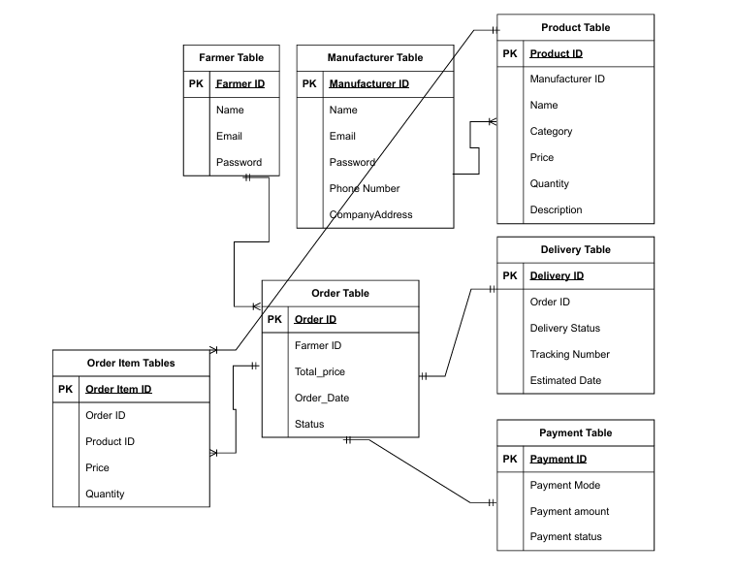
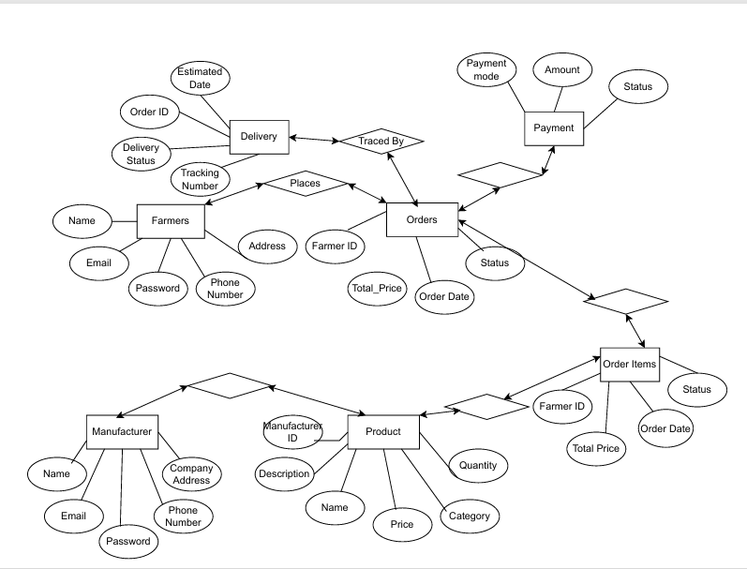

Q7. What is data flow diagram? Draw a data flow diagram to represent the in-flow and out-flow of data when a farmer is placing an order for the product.
Answer –
Data Flow Diagram-
A data flow diagram is a graphical representation of how data moves through a system. It visually shows how data moves from one process to another, how it’s stored, and where it ends up.

Q8. Due to change in government taxation structure we should change the tax structure. How to do handle this change request?
Answer –
Change Request: It is a formal proposal to alter a project, system or process.
In this scenario project process needs to be altered due to change in taxation.
Following process will be followed to incorporate the change request.
Step 1 - Document the request
I will start with a change request form, and documenting exactly what is changing (tax rate or tax type) and Why? Such as is it a change in government policy or due to new budget?
Step 2 – Conduct Impact Analysis
I will look for what are the impact will be on system, process, stakeholders and data.
System Impact – Determining with software application need modification. (ERP, payroll system, e-commerce platform etc.)
Process Impact – Identifying changes to existing business process such as invoice generating, payment process or financial reports.
Stakeholder Impact – Look for which team (finance, Sales, Account, and Legal) will be affected and how their daily task will change.
Data Impact – Identifying is there any data changes must be done and reported the changes.
Step 3 –Document requirements
Based on the above impact analysis I will updating the functional documents and look for non-functional document changes as well. Update Business requirement document, user requirement document and functional document.
Step 4 –Estimate cost, effort and risk
I will collaborate with the SMEs and accounts and HR team to estimate the effort, time and cost required to implement the change. Also will find out what sort of risk are involved and how to overcome those.
Step 5 –Seek approval
I will present the impact analysis and possible solution obtain with concerning SMEs to Change Control Board (CCB) or project sponsor. Obtains a formal documented approval before any work begins.
Step 6 –Communication
I will communicate the changes done to the required team and team members.
Step 7 –Review
I will ensure that the relevant tax changes are effectively adopted in the organization.

Q9. As the project is in process, Ben and Kelvin have contacted you. The reason is to inform you that they want the farmers to sell their crops yield through this application i.e. farmers should be able to add their crop yields or products and display to general public and should be able to sell them. They also want to introduce auction system for their crop yields.
As a BA, what will be your response? Is this a change request or an enhancement?
Answer –
As this is an addition to the given requirements rather than an alteration so it’s an enhancement and not a change request.
As a BA I will follow below process for an enhancement
Step 1 –Documenting the request
I will ask for a formal documentation for an enhancement request. I will do the requirement gathering for the enhancement. Also I will find out why clients what to customers to sell and buy crop yield? Also why they need an auction?
Step 2 –Feasibility and Impact analysis
Along with the developers and SMEs I will do the feasibility study and an impact analysis for an enhancement.
System Impact- What technical changes will be required and what add on work is needed.
Project Impact- What will be impact on the project schedule, will it be delayed or we can manage it in our time frame. Do we need additional resources? How much more budget is needed?
Stakeholder Impact- In this case all stakeholders will be impacted.
Step 3- Estimate cost, effort and risk
Options and Risk- What are possible options either we will implement it now and time and budget will adjusted or we will ask for more time or budget.
Step 4- Document requirements
Formally document all the enhancement requirements. Update business requirement document and functional document.
Step 5- Seek approval
I will present the enhancement request with its impact analysis to the authorized party as project owner or CCB (Change Control Board). Along with this I will suggest the option for an implementation. Get a formal approval or rejection from them.
Step 6- Communicate
Notify the entire team and stakeholder about the change and updates for a project plan.
Step 7- Review
I will ensure the requirements are delivered to the point. Ensure the smooth working of an enhancement.

Q10. Come up with estimation. How many man-hours required?
Answer –
As the project is for 18 months duration,
Considering 21days/month
For 18 month =18months*21days/month = 378 days for 18 months
Considering 18 days for holidays
Total man hours = Total working days * Total hours per day
= (378-18)*8 = 360*8
= 2880 Man-Hours
Analysis- Project duration is for 18 months and 2880 man-hours are required. Considering the team size is somewhat 12 to 15.

Q11. Explain UAT acceptance process.
Answer –
Below is the UAT acceptance process that needs to be follow-
Planning- In this step, blue prints are made to implement UAT testing for every feature that need to test and minimum standards are set for accepting the test to ensure the software aligns with business goal.
Designing- Detailed test cases are design based on real-life scenario and business process. This should involve the procedures, expected results and conditions for each test.
Selecting UAT testers- The appropriate end-users or stakeholders are chosen to perform the tests. These individuals who know the business processes and can provide valuable feedback.
Execute test- Selected participants runs the test cases in pre-defined or separate environment to stimulate how the software will be used. They follow the defined procedures and document any deviations or issues they encounter.
Bug fixing- During execution, tester log any bugs, usually problem, or other discrepancies. This feedback is reported to the development and business teams.
Analyse result- A determination is made based on the test results. If the software meets the acceptance criteria, it passes. If not, the identified issues are addressed, and re-testing phase may be required.
Sign off- After removing all the bugs, the testing team indicates acceptance of the completion of the bugs. In this phase, all stakeholders come to a conclusion that the software is ready to GO LIVE and sign it off.

Q12. What will be the process to close the project? Explain project closer document.
Answer –
Process to close the project-
Step 1 – Verify work completion and gain acceptance
Confirming all project requirements, scopes and deliverables have been completed as per the project plan. Work with the project manager to obtain formal sign off acceptance from the key stakeholders, clients and project sponsor. Review and close out any outstanding contracts or procurements associated with the project.
Step 2 – Finalize documentation and reporting
Prepare a comprehensive final project report that includes an executive summary, project outcomes and a comparison of results against initial goals. Ensure all project documentation including requirements, specification and test results is up to date. Archive all final document in a secure, central location for future reference.
Step 3 – Document lessons learned and performance
Conduct a post-project or “lesson learned” session with the project team and stakeholders. Document what worked well, what challenges were encountered and what can be improved for future projects.
Step 4 – Transition and release resources
Participate in the handover of the final product or services to the customer or operation team. Assist in creating any necessary training or support documentation for the transition phase. Work with the project manager to release project resources, such as team, members and budget for reassignment.
Project closer document-
A project closer document, also known as project closer report. It is a formal documentation that summarizes the key outcomes, lesson learned and final details of a completed project. It serves as a comprehensive record of the projects accomplishments, challenges and overall performance, providing valuable insights for stakeholders and future projects.
Points to be included in the project closure document are
-Project Overview
-Achievements
-Lessons learned
-Quality Assurance
-Resource Utilization
-Risk management
-Challenges
Project closer document sample-
Sr. NO | Points to include | Details | Reference link
1 | Did the client signed off on the UAT testing |  | Business scope  document.docx
 | Date of sign off | 04-11-2025 | Business scope  document.docx
 | Name of the resource | Ms. Natalia | Business scope  document.docx
2 | Objectives of the project
 | Customer satisfaction | Achieved
 | Reach wide range | Achieved
 | Meet need of end user | Achieved
3 | Functionalities worked on
 | Secure payment process | Achieved
 | Auctions | Achieved
4 | Infrastructure
 | Software installed | Achieved
 | Laptops purchased | Achieved
5 | Funding |  | Finance  breakdown.docx
 | Amount approved | 2 Crores | Finance  breakdown.docx
 | Amount used | 1.98 Crores | Finance  breakdown.docx
6 | Overall project information
 | Escalations | 50
 | Customer satisfaction | High
7 | Value to the company
 | Positive/Negative | Positive 90%
 | Positive/Negative | Company has gain an edge
 | Positive/Negative | Increased clients
 | Positive/Negative | Trained employees
 | Positive/Negative | New project in pipeline

Thank You!

