Q1. What is the difference between Brainstorming and JAD Sessions
Point | Brainstorming | JAD Sessions (Joint Application Development)
Purpose | To generate a wide range of ideas quickly | To gather detailed requirements through structured discussion
Participants | Usually internal team (BAs, developers, testers) | Involves BAs, stakeholders, SMEs, developers, testers together
Structure | Informal, free-flowing | Formal, well-structured, agenda-driven
Duration | Short (30–60 mins) | Longer sessions (can be half-day or multiple days)
Focus | Idea generation, creative problem-solving | Requirement gathering and finalizing decisions
Facilitator Required | Not always | Always has a JAD facilitator to manage the session
Documentation | May or may not be recorded formally | Output is usually documented as requirements or process flows

Q 2. Why Document Analysis is one of the compulsory techniques we use in a Project? Justify
Document Analysis is a requirement-gathering technique where the Business Analyst reviews existing documents like reports, manuals, contracts, previous system specs, or policies to understand the system, business rules, and user needs.
It is Compulsory because –
- Gives a Head Start:
It helps the BA understand the current system/process before talking to users.
- Saves Time and Effort:
Instead of asking basic questions, BAs already know the background, making meetings more effective.
- Finds Hidden or Missed Requirements:
Some requirements or rules may not be mentioned by users but can be found in old reports or contracts.

- Reduces Dependency on Stakeholders Alone:
In case stakeholders are unavailable or unclear, documents can still guide requirement understanding.
- Helps in Gap Analysis:
By comparing existing documents with current needs, the BA can identify what's missing or needs to change.
- Useful for Compliance and Legal Checks:
BAs can ensure the new system aligns with existing laws, standards, or contracts.

Q3. In Which Context we will use Reverse Engineering?
Reverse engineering is commonly used to understand and analyse existing systems, products, or technologies. Especially when documentation is missing or outdated.
1. Software Development and Maintenance
- Understanding Legacy Systems
Used to analyse old or undocumented systems.
- Interoperability and Integration
Helps in connecting old systems with new ones or external applications.
2. Product Analysis and Competitor Research
- Competitor Analysis
Used to study a competitor’s product features or structure.
- Intellectual Property Protection
Helps detect copied features or designs in software or hardware.

Q4. What is the difference between Brainstorming and Focus Groups?
Point | Focus Group | Brainstorming
Purpose | To gather opinions, feedback, or reactions to a product or idea | To generate creative ideas or solutions quickly
Participants | Selected users or stakeholders | Usually internal team (BAs, developers, designers)
Structure | Moderated and structured discussion | Informal and free-flowing
Facilitator | Yes – a moderator or BA leads and records | Optional – anyone can lead the session
Used For | Validating ideas, understanding user needs | Coming up with new ideas or solving problems
Output | Opinions, feedback, preferences | New ideas, possible solutions, feature suggestions

Q5. Observation Technique – Explain both Active and Passive approaches -
Observation is a requirement-gathering technique where the Business Analyst (BA) watches how users perform tasks in real-time to understand business processes, challenges, and workflow.
This helps the BA capture requirements that users may forget to mention in interviews or may not be able to explain clearly.
Active Observation technique- Here the observer means Business Analyst actively engages with the participants or the environment they are working with and asks questions, interact with participants, or guide the observation process.
Passive Observation technique- Here the observer takes a more non-intrusive and hands-off approach. They simply observe and record the behaviour, activity, working environment without directly interacting with the participants or influencing the observed context.
Q6. How do you conduct the Requirements Workshop- 3 Marks
Requirement Workshop is a structured meeting which involves BA, stakeholders, technical team and users sometimes to gather, discuss and finalise the requirement of the project.
1 Plan and Prepare -We need the project background details and scope.
Agenda, timing and goals needed to planned for meeting.
Decide what need to be discussed with whom, assign roles and take notes of meeting.
2 Identify Participants - Select the people who are going to be invited to meeting and who are key to the requirement discussion.
Make sure all the relevant stakeholders are invited.
3 Create Agenda - Decide what needs to be discussed and in what order it needs to be discussed, time allocation for each topic.
Share the agenda before the meeting so that participants should know what is to be discussed.

Q7. In which context, Interview Technique can be conducted by a BA? How may approaches are there in conducting Interviews? (Structured – Unstructured) Explain them. Explain the difference between Open Ended Questions and Closed ended Questions –
An interview is a commonly used elicitation technique where the Business Analyst (BA) asks questions to stakeholders, subject matter experts (SMEs), or end-users to gather requirements, clarify doubts, or understand business processes.
A BA conducts interviews in the following contexts:
1 When project is in the initiation phase and requirements are unclear
2 To gather detailed business processes from SMEs or process owners
3 To understand pain points of end users
4 To clarify functional/non-functional requirements with clients
5 To validate assumptions or fill gaps found in documents
Structured Interview – Business analyst prepares a set of questionaries to ask
Questions are asked in fixed order.
Question are useful when specific information is needed to be asked
Unstructured Interview – Business Analyst keep it open-ended and conversational.
The flow or sequence is dependent on stakeholders’ answers.
It is generally used when requirement is unclear or exploratory.
Types of questions-
Open ended - Allows detailed answers and explanation
Closed-Ended - Restricts to one-word or specific reply

Q8. Questionnaire Technique – Where we will use? Give one example -
The Questionnaire Technique is a requirement elicitation method where the Business Analyst (BA) prepares a set of written questions and shares them with multiple stakeholders or users to gather input, feedback, or preferences.
This technique is commonly used to gather information, data and research for large number of participants in structured manner.
It is used when-
When you want to gather feedback from a large group
In early stages to understand user needs or expectations
To conduct surveys about new features or improvements
When dealing with remote clients or teams
Example- A BA wants to know which payment methods customers prefer.
The BA sends a questionnaire with questions like:
- “Which payment method do you use most often?”
- “Do you trust Net Banking over UPI?”
- “How satisfied are you with our order tracking feature?” (1–5 scale)

Q9. How to Sort the Requirements – Where we will use? Give one example -
Sorting requirement means organizing or prioritizing requirements based on factors like importance, urgency, feasibility, business value, or dependencies.
This helps to identify the high propriety requirements which needs to be developed first.
This helps the Business Analyst, Product Owner, and development team to:
- Focus on what needs to be done first
- Deliver maximum value early
- Manages scope and time effectively
Where we will use it-
- During Backlog Grooming or Sprint Planning
- When working with limited budget or time
- While preparing for MVP (Minimum Viable Product)
- In Change Request handling to decide what gets included
Example- Sorting requirements is used in software development. When building a software application multiple requirements are gathered from stakeholders, users, project team, etc so it helps to identify on which requirement should we work first.

Q10. Prioritise the Requirements – Where we will use? Give one example -
Requirement Prioritization is the process of identifying which requirements are most important to the business and should be developed or delivered first.
It helps teams:
- Focus on critical features
- Deliver maximum value early
- Make smart choices when there are time, budget, or resource constraints
We use it when-
- Sprint Planning
- MVP (Minimum Viable Product) planning
- Backlog Refinement
- Roadmap creation
- Handling Change Requests
Popular techniques are –
- MoSCoW (Must Have, Should Have, Could Have, Won’t Have)
- Business Value
- Stakeholder Voting
- 100 Dollar Method
Example-
Feature | Priority
Order Tracking | Must have
Tip for Delivery Boy | Should have
Feedback via Emoji | Won’t Have (now)
Net Banking Payment | Must have

Q11. Weekly status reporting – How we will drive?
Weekly status reporting is a key responsibility of the Business Analyst (BA) to track and communicate the progress of the project to stakeholders. It ensures everyone stays aligned, risks are flagged early, and decisions can be made in time.
- Define reporting requirements
Understand what needs to be reported
- Set reporting frequency and deadline
Clearly define when and how often reports should be submitted
- Standardize reporting format
Use a consistent template (Excel, PPT, Jira dashboard, etc.)
- Communicate expectations
Inform the team what is expected from each report
- Provide guidance and support
Help team members fill reports accurately
- Remind and follow up
Ensure timely submission of updates
- Review and consolidate reports
Collect individual updates into a single, clear status view
- Share and discuss the reports
Present findings to the stakeholders or clients
- Act on the findings
Use the report to resolve blockers or adjust plans

Q12. Meeting Minutes Document – prepare one Sample -
Minutes of Meeting (MoM) is a formal written record of everything that was discussed, decided, and assigned during a meeting. It includes details like meeting date, participants, agenda points, key discussions, action items, responsibilities, and deadlines.
Sample of MOM
Minutes Of Meeting (MOM)
Date | 09-07-2025
Time | 05:23PM
Location | Pune, Maharashtra
Attendees | Ishika  Henry  Paul  Jane
Agenda | Discussion about-  Login in page  Customer feedback page.  Payment page
Discussion summary | Discussed about the user story and prioritized the requirement.
Action item | Draft user story for Feedback feature- Assigned to Paul

Q13. Change Tracker – Document - prepare one Sample –
A Change Tracker Document is a formal document used to record, track, and manage all changes made to the project requirements, scope, documents, or features during the project lifecycle. It helps the team keep a history of what changed, why it changed, when it changed, and who approved it.
Sample of Change Tracker Document-
Change Tracker Document
Version: [Insert version number]
Date: [Insert Date]
Change Details
Change Request Number
Requested by
Date Requested
Change Description
Change Assessment
Impact Analysis
Risk Analysis
Feasibility Analysis
Effort Estimation
Approval Status
Approval Date

Implementation Details
Developer/Implementer
Start date
End date
Test Coverage
Test Results
Deployment Plan
Rollback Plan
Rollback Procedure
Rollback Test plan
Rollback date
Rollback result
Documentation Updates
Document Affected
Update Description
Update date
Updated by

Approvals
Approver 1
Approver 2
Approver 3
Approval Date
References
Related Documents
Supporting Materials
Q14. Difference between Traditional Development Model and Agile Development Models –
Aspect | Traditional Development Model | Agile Development Model
Approach | Linear and sequential | Iterative and incremental
Phases | Fixed phases (Requirements → Design → Development → Testing → Deployment) | Repeated in short cycles called Sprints
Flexibility | Rigid – changes are difficult once the project starts | Highly flexible – changes can be accommodated anytime
Requirement Gathering | All requirements gathered at the beginning | Requirements evolve over time through feedback
Customer Involvement | Limited – mostly at the start and end | Continuous – customer is involved in each sprint
Delivery | Final product is delivered at the end | Working software delivered in every sprint
Documentation | Heavy documentation | Lightweight documentation, just enough to support development
Risk Handling | Risks are identified and handled late | Risks are identified early and managed in iterations
Testing | Happens after development phase ends | Testing is continuous and done within each sprint
Team Structure | Hierarchical – BA, Dev, Testers work in silos | Cross-functional and self-organizing teams
Feedback Cycle | Slow – usually after full delivery | Fast – feedback is taken after each sprint or demo

Q15. Explain Brainstorming Technique – Where to use?
Brainstorming is a creative idea-generation technique used to quickly gather multiple ideas or solutions from a group of people.
- It’s usually informal
- All ideas are welcome — even wild or unrealistic ones
- No criticism is allowed during the session
- The goal is quantity over quality (at first), and to think outside the box
We can use Brainstorming in –
- When the Client is Unsure of Requirements
- During Initial Project Planning
- To Solve Business Problems
- Team Building
- Innovation and Product Development
- Strategic Planning
- To Prioritize Features
- To Handle Change Requests

Q16. What reports Accounts Departments will generate
Department: Accounts
Prepared On: 09-07-2025
Prepared By: Meenakshi
1. Financial Statements
The Accounts Department prepares and provides key financial documents such as:
- Balance Sheets
- Income Statements
- Cash Flow Statements
These help in analyzing the borrower’s financial health, profitability, and ability to manage cash.
2. Company Reserve Loan Report
This report helps to understand the amount of reserve funds available for loan allocation. It supports financial decision-making regarding lending capabilities.
3. Credit Report
Obtained from a credit bureau, this report includes:
- Repayment track record
- Credit score
- Existing debts
It gives a full picture of the borrower’s creditworthiness.
4. Collateral Evaluation & Cash Flow Projections
This includes:
- Evaluating the value and marketability of collateral
- Preparing cash flow projections based on the borrower’s financial data
These ensure that lending risks are minimized.
5. Debt-to-Income Ratio Analysis
This analysis helps determine whether a borrower can afford to take on new loans by comparing:
- Total monthly debt obligations
- Monthly income
It is used to support loan approval decisions.
Conclusion
These reports enable the Accounts Department to evaluate financial risk, assess borrower eligibility, and maintain compliance with lending policies and regulations.

Q17. What is the structure of the message/mail communicated from the HR department to the employee in case the Loan is rejected? – 5 Marks
Subject- Loan Application Rejection.
Dear Paul,
We hope this mail fined you well. We would like to inform you that after careful consideration and evaluation of you loan application, we regret to inform you that your loan request has been rejected by the company’s loan approval committee.
We understand that this news may be disappointing, but we want to assure you that the decision was made after a thorough assessment of various factors and taking into consideration this company’s lending policies and financial guidelines.
While we cannot provide specific details regarding the reasons for the loan rejection, we encourage you to review your financial situation and consider alternative options that may better align with your current circumstances. Our HR department is available to provide guidance and support if you require assistance in exploring other avenues for financial assistance.
Please note that this decision does not reflect on your value as an employee, and it will not have any impact on your employment or benefits with the company. We remain committed to supporting your professional growth and well-being within our organization.
If you have any questions or require further clarification, please feel free to reach out to the HR department, and we will be more than happy to assist you.
Thank you for your understanding.
Best regards,
HR Dept
ABC Company

Q18. What is the structure of the message/mail communicated from the HR department to the employee in case the Loan is approved? – 5 Marks

Subject: Loan Application Approval Notification
Dear Smith,
We are pleased to inform you that your loan application has been approved by the company's loan approval committee. Congratulations on this successful outcome!
We have carefully reviewed your application and considered various factors, including your financial standing, employment history, and the loan program's eligibility criteria. Based on our assessment, we are confident that this loan will assist you in achieving your financial goals.
Below are the details regarding your approved loan:
Loan Amount: Rs. 15,00,000
Loan Term: 10 Years
Interest Rate: 7.5%
Repayment Schedule: Pay in the yearly instalments of Rs. 1,50,000
Please review the loan agreement and associated terms carefully. If you have any questions or require further clarification, please do not hesitate to reach out to the HR department. We are here to provide the necessary support and guidance throughout the loan process.
We kindly remind you of your responsibility to fulfil the loan repayment obligations as per the agreed-upon terms. Timely and consistent repayment will not only help you meet your financial objectives but also demonstrate your reliability and strengthen your creditworthiness.
We appreciate your prompt attention to the loan agreement and adherence to the repayment schedule. Should you require any assistance or encounter any challenges during the repayment period, please feel free to approach the HR department for guidance and support.
Once again, congratulations on your loan approval. We wish you every success in achieving your financial aspirations.
Best regards,
HR Dept
ABC Company

Q19. Design a sample report on the Loans applications Received by the accounts department – 8 Marks
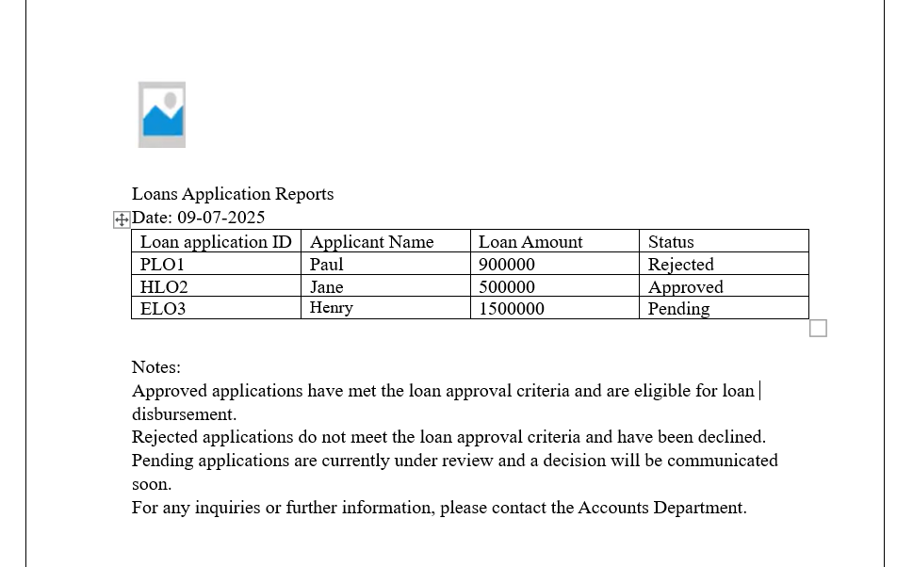

Q20. Which reporting Tools we will use for generating reports. – 5 Marks
Reporting tools are software applications that help in collecting, organizing, analysing, and presenting data in the form of charts, dashboards, or documents. These tools are commonly used in business analysis, finance, and project tracking.
Tools used for generating reports are –
Tableau
Microsoft Excel
JIRA Reports (Agile Boards)
Power BI

