Waterfall Model part 2 Answers

Document 6- Please prepare a use case diagram, activity diagram and a use case specification document.

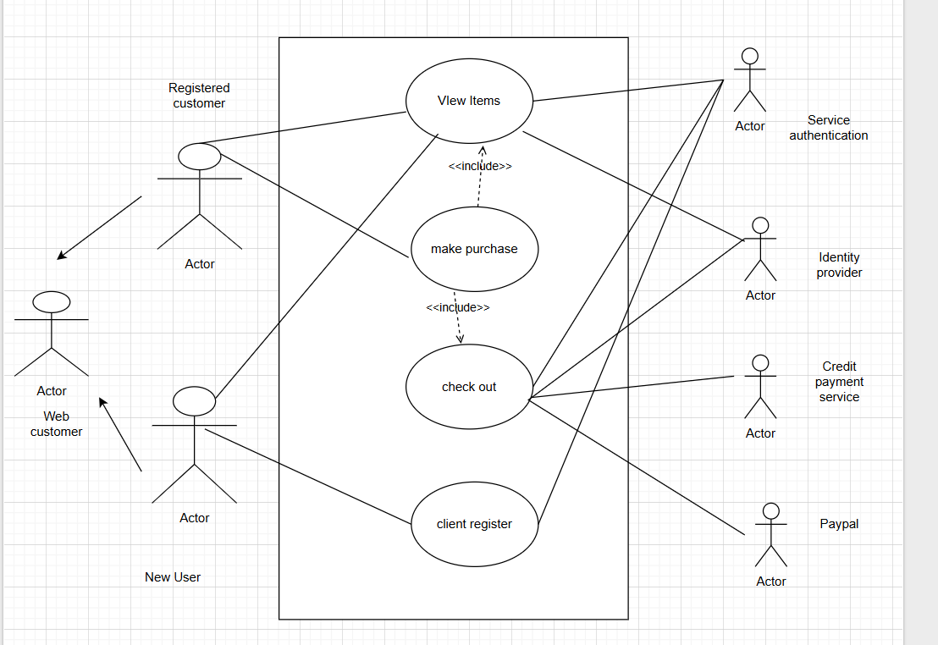

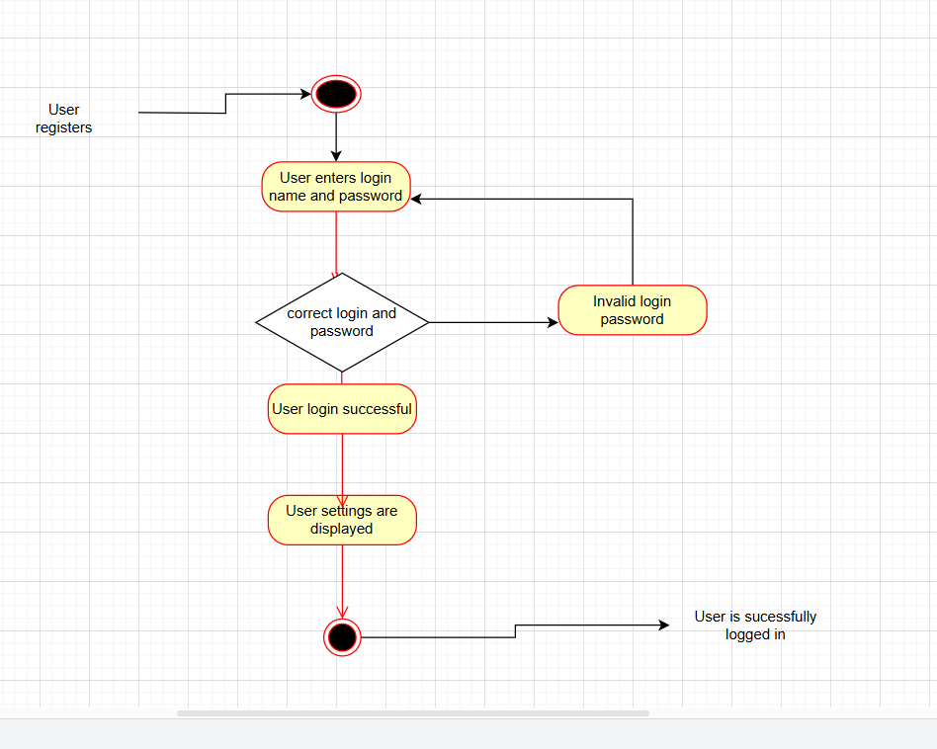

Use case ID | UC001
Use case Name
  Verify successful login with valid credentials
Created by | Ritika Last updated by 20march 2025
Date created | 19march Last revision Date 20 march 2025
Actor | Farmer,supplier
Description | This use case describes how user can login to the website
Pre conditions | User should be able to register on the portal
Post conditions | User should receive confirmation for login
Normal flow /Basic flow | Step1:User visits the online agricultural store website  Step 2:-User is asked to sign in  Step3:User clicks on create account  Step4:-User is asked to enter details such as name,dob,shopping preferences  Mobile number  Step 4:-User is asked to create an new password  Step 5:-User is successfully registered  Step 6:-User is redirected to home page  Step7:-User enters username and password  Step 8:-User enters CAPTCHA  Step 9:-User is successfully logged in
Alternative flow | At step 4:-User enters wrong details  User will be redirected to fill in details again  At Step 7:-User enters wrong user name and password  User will be redirected to forgot username and password  At step 8:-If user enters wrong CAPTCHA  User will be redirected to home page  At step 2:User clicks on sign and enters wrong username and password  User will be redirected to create new account
Exceptions | If internet connectivity is lost while visiting the site  The user will be redirected to check your internet connectivity
Frequency of use | High
Assumptions | It is assumed customer is registered  It is assumed customer has online shopping knowledge

Document 7- Screens and pages
Please follow the following steps to create the mock-ups
    - Kindly use balsamic or Axure.
    - Always start with a home page of an application.
    - Take a feature and follow it to the end
      - Eg: Home page of SCRUM Foods
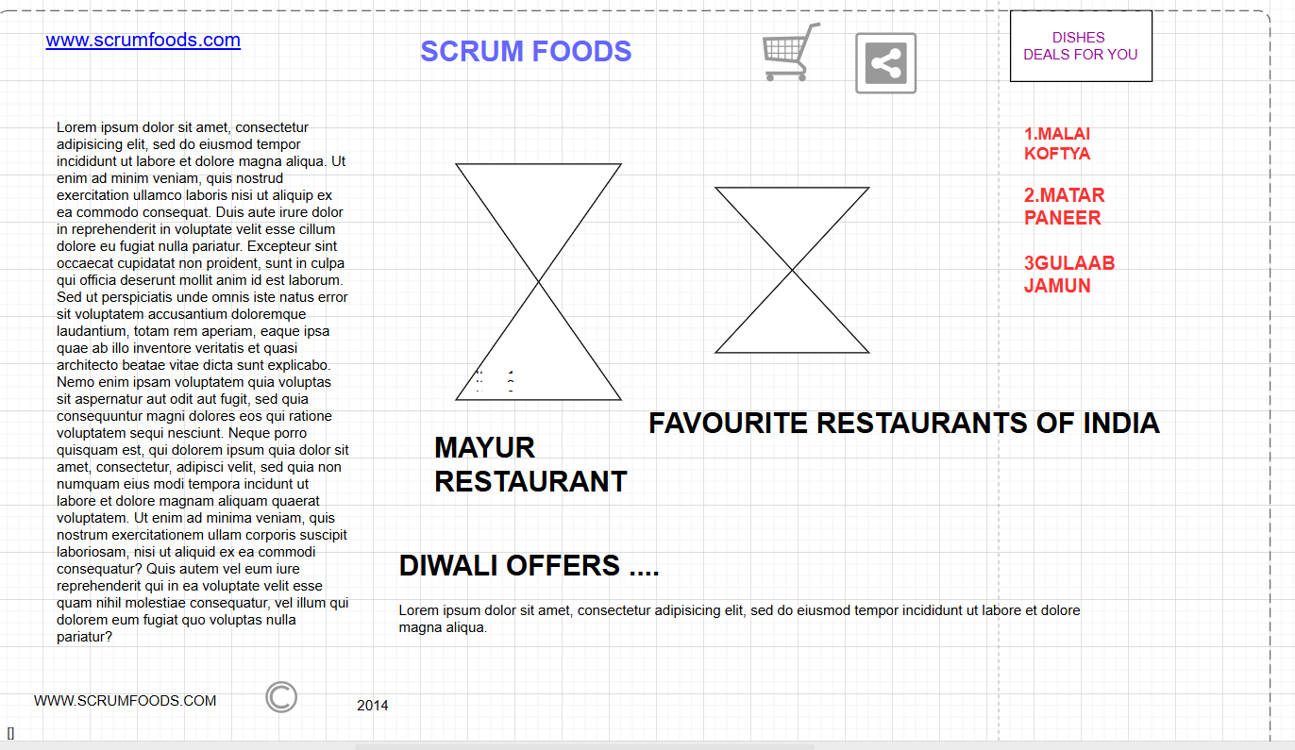
      - Select Login- Create a login page
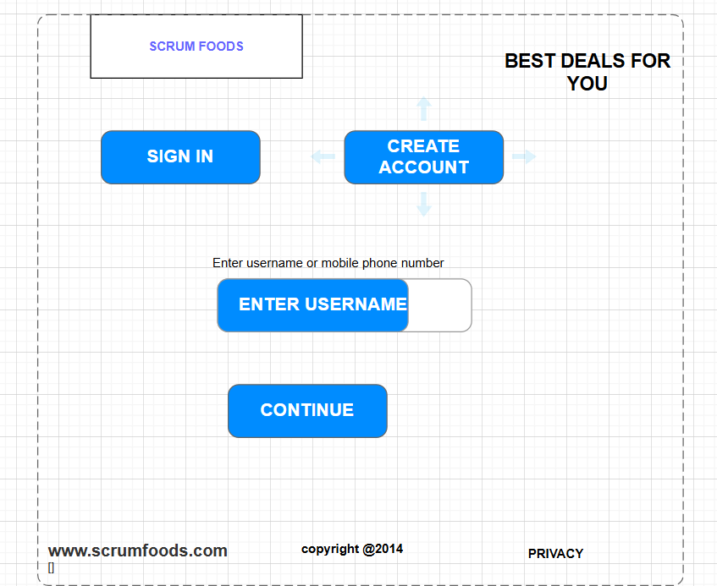

      - Let’s assume, you want to search a restaurant

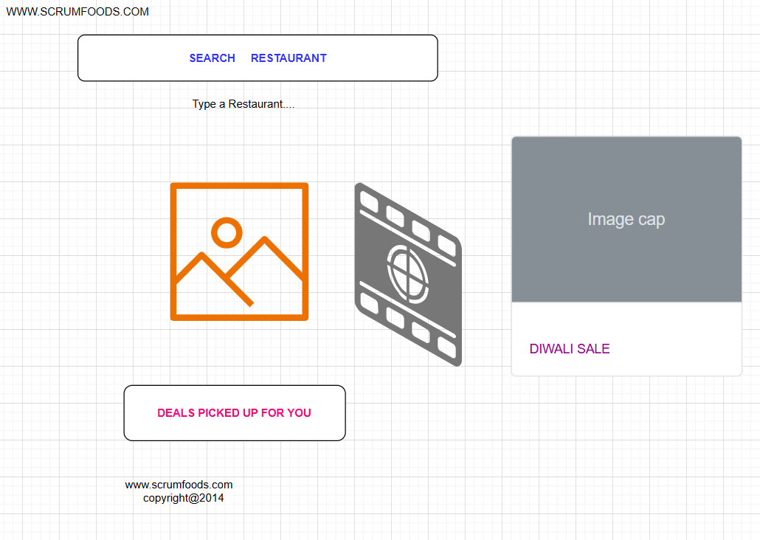
      - Search page- Type the restaurant name and select the dish

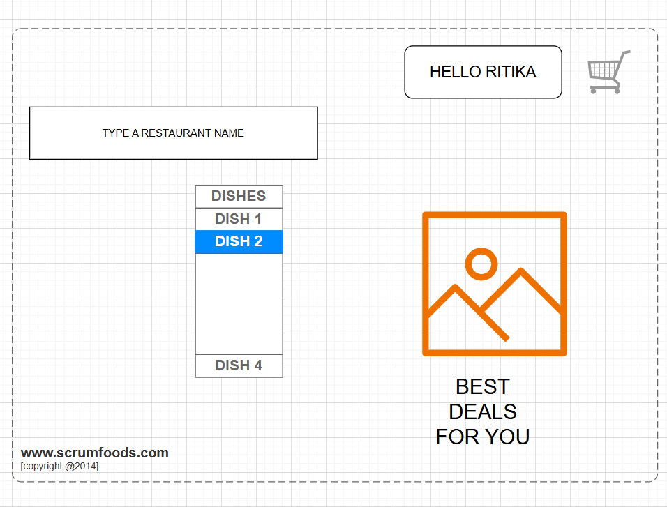
      - Add to cart page


      - Payment page
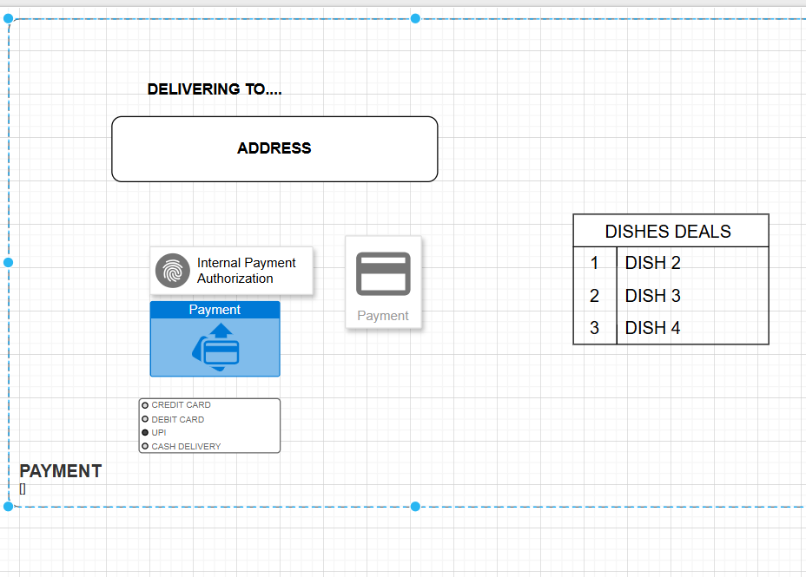

      - Logout page

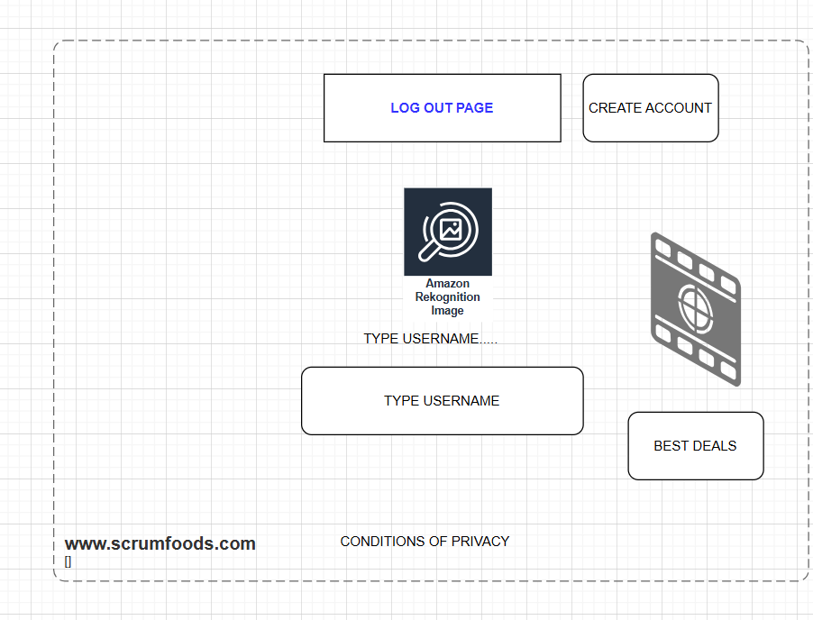

Document 8- Tools-Visio and Axure
Write a paragraph on your experience using Visio and Axure for the project.
When working with Azure, you can use Visio to create diagrams of your cloud architecture for planning, documentation, and reporting purposes. The two tools work together by using Visio for visualizing and documenting the architecture, while Azure provides the infrastructure and services that the diagram represents.
Creating Azure diagrams in Visio
Microsoft provides templates and shapes in Visio specifically for designing Azure solutions.
Manual diagram creation
You can manually create Azure architecture diagrams by following these steps:
- Open the Azure Diagrams template in the Visio desktop app or Visio for the web.
- Use Azure shapes from the available stencils to represent different components like virtual machines, networks, and databases.
- Arrange and connect the shapes to create a clear representation of your architecture, including resource groups and network topologies.
- Add details like annotations, data, or technical specifications to your diagram.
Automated diagram generation
For existing Azure environments, third-party tools can automatically generate Visio diagrams:
- Hava.io: This service can automatically create diagrams of your Azure infrastructure. You can then export these diagrams in the Visio .vsdx format for further editing.
- SmartDraw: This tool can import your Azure data directly to generate a diagram of your architecture. It allows you to visualize your cloud environment for planning or documentation.
Integrating Visio into your Azure project lifecycle
Planning and design
- Use Visio during the initial planning stages to prototype and visualize your desired cloud architecture before deploying any resources in Azure.
- Visio diagrams can help you define networking, virtual machine configurations, and service connections, aligning with the Azure Well-Architected Framework.
Documentation and governance
- Architectural diagrams created in Visio serve as vital documentation for your project.
- These diagrams can be crucial for operational readiness, governance, and audit processes, including PCI compliance.
- They provide a visual reference for your teams, which can be easier to digest than lengthy text descriptions.
Communication and collaboration
- You can save and share Visio diagrams with team members via Microsoft Teams or SharePoint. This allows for clear communication and collaboration on architectural design.
- For example, you can embed a diagram into a Microsoft 365 file for quick reference by others on the team.
Best practices for working with Visio and Azure
- Start with a template: Use the official Azure templates in Visio to ensure you are using the correct and most up-to-date icons for Azure services.
- Keep documentation current: If you're manually creating diagrams, remember to update them whenever you make changes to your Azure environment. This is where automated tools like Hava can be especially useful.
- Manage complexity with layers: Use layers in Visio to control the visibility and editing of different parts of your diagram. For example, you can lock a layer to prevent accidental changes to your network layout while editing other components.

Document 9- BA experience

My experience as BA in following phases:
- Requirement gathering:
  - To gather requirements, we used BRAINSTORMING technique.
  - We gathered in groups to do brainstorming.
  - I validated the requirements
  - There are many requirements which are duplicated or repeated. We need to remove them immediately
  - Prototyping is used to give more specific requirements

Requirement Analysis:
  - We need to draw UML diagrams to visually describe the requirements
  - Activity diagrams were also drawn.
  - Communicate the diagrams to team. Some team members might not agree with them and might make changes. As a BA we need to listen to others views and modify certain requirments.
  - Prepare BRD and SRS

Design:
  - From the use case diagrams, we prepare test cases
  - We Communicated with client on design and solution documents
  - Write negative test cases and positive test cases.
  - Do not miss a single test case. It might have huge impact on project development in later stages
  - Prepare test data for testing
  - Updated RTM. This is just as we need to make sure that all the requirements are met.

Development:
  - Organized JAD sessions
  - Clarifying queries of tech team during coding
  - There might be some team members who don’t agree with the concept or who doesn’t cooperate during JAD sessions. As a BA I handle the situation and had one on one discussion with them. Explained how their actions are going to affect the project. Setup healthy environment within the team.
  - Referred diagrams to code the Unit
  - Conduct regular meetings with technical team and client which is challenging. Recording the session and providing that to missed one and having one to one discussion later with that missed person is all i need to do

Testing:
  - Prepare test cases from use cases
  - Perform high level testing
  - Test data is requested by BA from client
  - Updated RTM
  - Take signoff from client
  - Prepare client for UAT

Deployment:
  - Forwarded RTM to client attached to the project closure document
  - Coordinated to complete and share end user manuals
  - Plans and organizes training sessions
  - All team members should attend the meeting.

