Question 1 – Functional Requirements – 1
Ans:
Functional Requirement: Functional requirement describe capabilities the system will be able to perform in terms of behaviour or operations.
Non- Functional Requirement: Non-functional requirement doesn’t directly relate to the behaviour or functionality of the solution, but rather describes environmental conditions under which the solution must remain effective like capacity, speed, security etc.

Req ID | Req Name | Req Description | Priority
FR0001 | User Registration | Users (farmers/manufacturers) can create an account by providing email and password. | 10
FR0002 | User Login/Logout | Registered users can securely log in and log out of the application. | 10
FR0003 | User Profile Management | Users can edit profile information, including address and contact details. | 7
FR0004 | Manufacturer Product Upload | Manufacturers can add new fertilizer, seed, or pesticide products to the catalog. | 9
FR0005 | Product Catalog Display | Application shows all available products with images, description, price, and manufacturer details. | 10
FR0006 | Product Search | Users can search for products using keywords, categories, or filters. | 10
FR0007 | View Product Details | Users can see detailed information for each product. | 9
FR0008 | Add to Cart | Users can add products to the cart and specify required quantity. | 9
FR0009 | Wishlist/Buy-Later List | Users can add products to a wishlist or buy-later list for future purchase. | 6
FR0010 | Place Order | Farmers can select items in the cart, enter delivery address, and place an order. | 10
FR0011 | Payment Processing | Farmers can pay using options like COD, credit/debit card, or UPI. | 10
FR0012 | Order Confirmation via Email | Users receive order confirmation email upon successful order placement. | 9
FR0013 | Order Tracking | Users can track the shipment and delivery status of their orders in real time. | 8
FR0014 | Order History | Users can view past orders under "My Account" section. | 7
FR0015 | Order Cancellation | Users can cancel their order if it has not been shipped | 7
FR0016 | Product Review & Rating | Users can rate and review products they purchased. | 5
FR0017 | Customer Support Contact | Users can contact customer support via toll-free helpline or email. | 8
FR0018 | Newsletter Subscription | Users can subscribe to an email newsletter for store updates. | 4
FR0019 | Chatbot FAQ | Users can interact with a chatbot for frequently asked questions and guidance. | 5
FR0020 | Mobile and Web Access | The system supports both web and mobile application interfaces for all functionalities. | 8
NFR001 | Usability | The application should have an intuitive and user-friendly interface. | 7
NFR002 | Performance | The application must load pages within 3 seconds. | 8
NFR003 | Security | The application must ensure secure user authentication. | 7
NFR004 | Compatibility | The application should be compatible with major web browsers. | 6
NFR005 | Response Time | The application should respond to user inputs within 2 seconds. | 7

Question 2–Minimum 5 page designs
Wire Frame and Prototype:
Wireframe | Prototype
A wireframe is a blueprint of the future without any colour and functionality. | A prototype is a replica of the future system which is meant to simulate user interaction.
Wireframes can be designed on paper with a pen or pencil. | The prototype of a product is designed by the developer and business analyst to understand the system.
A wireframe could be designed very quickly. | Prototype takes more time to develop.

Create Account:
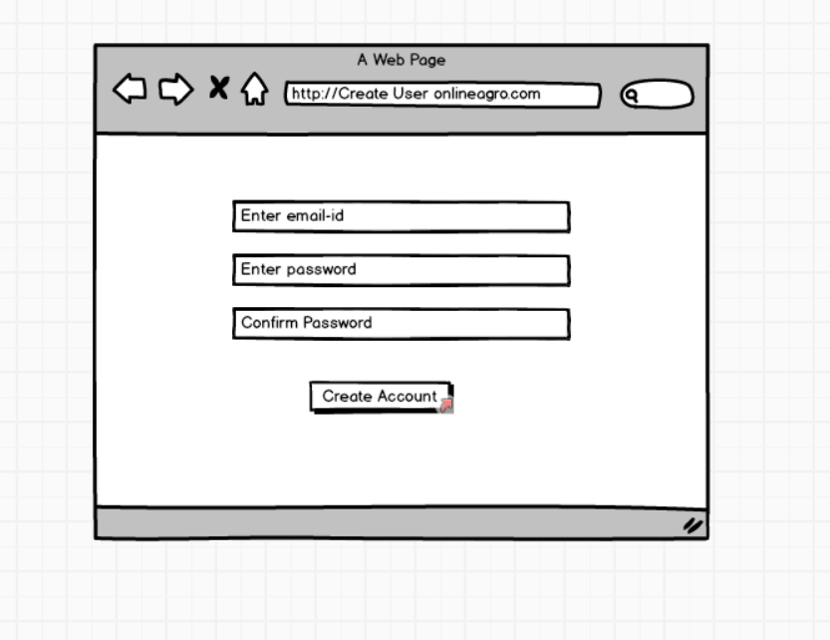
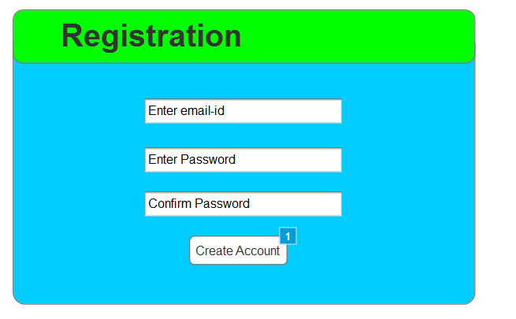

Login:
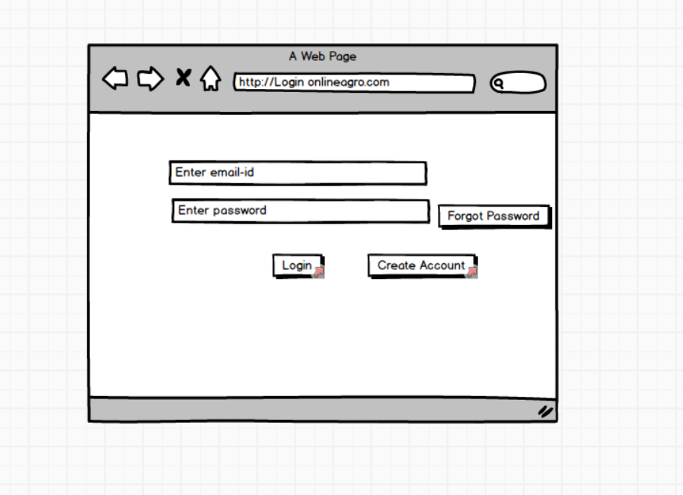
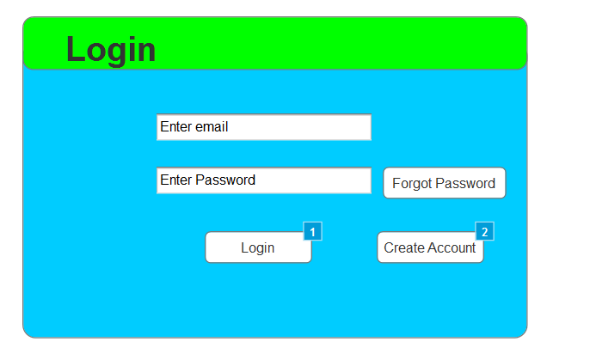

Search Product:
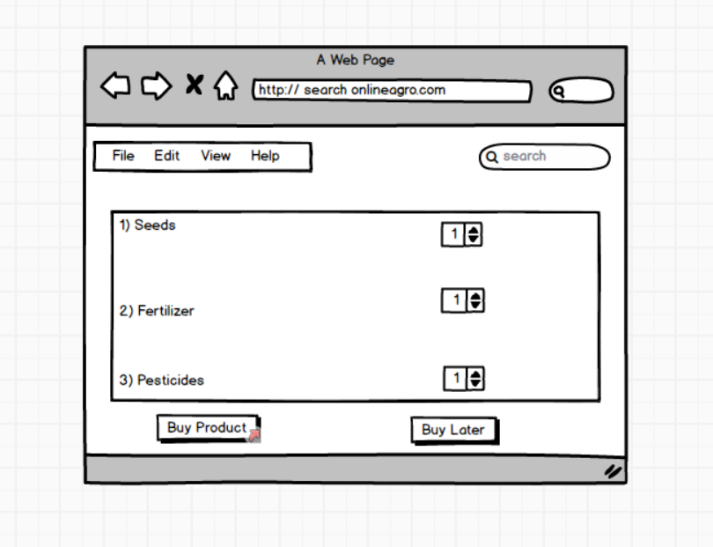
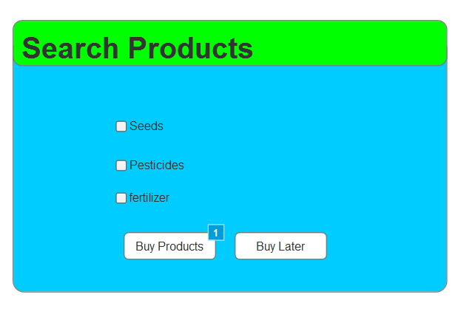
Buy Products:
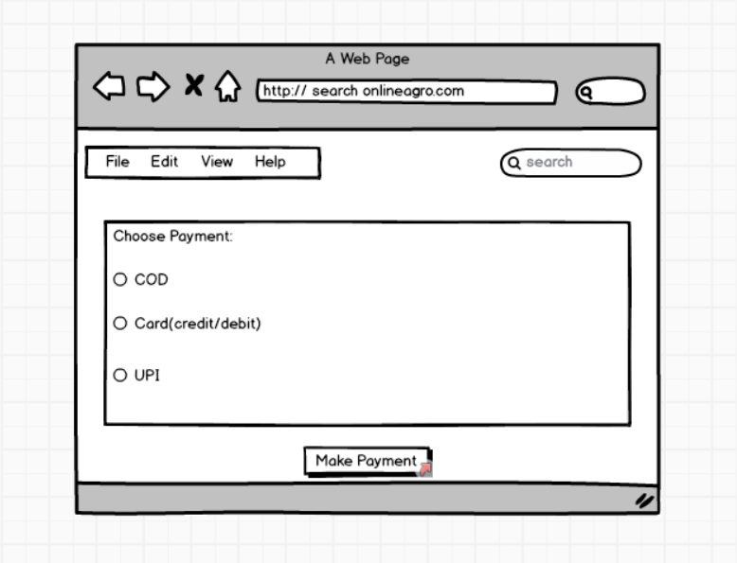

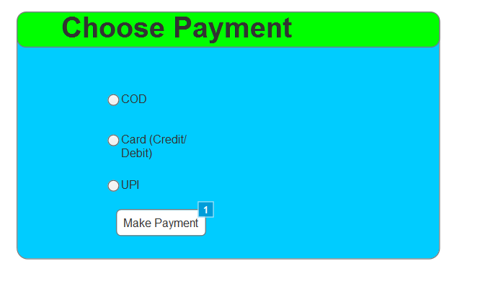

Order Confirmation:
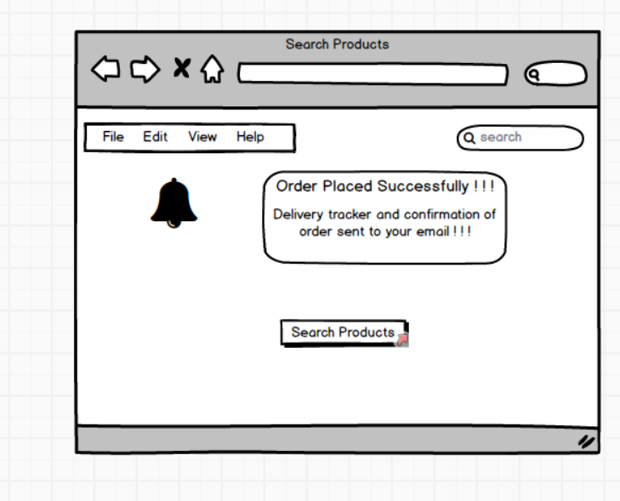
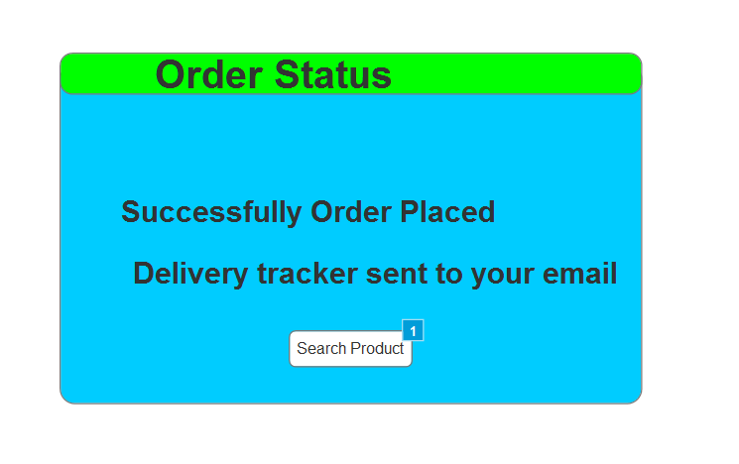
Question 3 – Make a note of the Tools, which you are using for above concepts
Ans:
Some commonly used tools for the concepts you mentioned:
- Microsoft Visio: Microsoft Visio is a popular tool for creating diagrams, flowcharts, and wireframes. It offers a wide range of templates and shapes to create visual representations of processes and systems.
- Balsamiq: Balsamiq is a wireframing tool that allows you to create low-fidelity wireframes quickly. It has a simple and intuitive interface, making it easy to sketch out ideas and concepts.
- Axure RP: Axure RP is a powerful prototyping and wireframing tool that enables you to create interactive and dynamic prototypes. It offers advanced features for creating complex interactions and user flows.

These tools can assist you in visualizing and prototyping your design concepts effectively. It's important to explore their features and determine which tool best fits your specific needs and preferences.

Question 4 – RTM
Ans: Requirements Traceability Matrix (RTM), The RTM helps in tracking the requirements and their progress throughout the project.
Req ID | Req Name | Req Description | D1 | T1 | D2 | T2 | D3 | T3 | D4 | T4 | UAT
FR0001 | User Registration | Users (farmers/manufacturers) can create an account by providing email and password. | ✓ | ✓ | ✓ |  |  |  |  |  | ✓
FR0002 | User Login/Logout | Registered users can securely log in and log out of the application. | ✓ | ✓ | ✓ |  |  |  |  |  | ✓
FR0003 | User Profile Management | Users can edit profile information, including address and contact details. | ✓ | ✓ | ✓ |  |  |  |  |  | ✓
FR0004 | Manufacturer Product Upload | Manufacturers can add new fertilizer, seed, or pesticide products to the catalog. | ✓ | ✓ | ✓ |  |  |  |  |  | ✓
FR0005 | Product Catalog Display | Application shows all available products with images, description, price, and manufacturer details. | ✓ | ✓ | ✓ |  |  |  |  |  | ✓
FR0006 | Product Search | Users can search for products using keywords, categories, or filters. | ✓ | ✓ | ✓ |  |  |  |  |  | ✓
FR0007 | View Product Details | Users can see detailed information for each product. | ✓ | ✓ | ✓ |  |  |  |  |  | ✓
FR0008 | Add to Cart | Users can add products to the cart and specify required quantity. | ✓ | ✓ | ✓ |  |  |  |  |  | ✓
FR0009 | Wishlist/Buy-Later List | Users can add products to a wishlist or buy-later list for future purchase. | ✓ | ✓ | ✓ |  |  |  |  |  | ✓
FR0010 | Place Order | Farmers can select items in the cart, enter delivery address, and place an order. | ✓ | ✓ | ✓ |  |  |  |  |  | ✓
FR0011 | Payment Processing | Farmers can pay using options like COD, credit/debit card, or UPI. | ✓ | ✓ | ✓ |  |  |  |  |  | ✓
FR0012 | Order Confirmation via Email | Users receive order confirmation email upon successful order placement. | ✓ | ✓ | ✓ |  |  |  |  |  | ✓
FR0013 | Order Tracking | Users can track the shipment and delivery status of their orders in real time. | ✓ | ✓ | ✓ |  |  |  |  |  | ✓
FR0014 | Order History | Users can view past orders under "My Account" section. | ✓ | ✓ | ✓ |  |  |  |  |  | ✓
FR0015 | Order Cancellation | Users can cancel their order if it has not been shipped | ✓ | ✓ | ✓ |  |  |  |  |  | ✓
FR0016 | Product Review & Rating | Users can rate and review products they purchased. | ✓ | ✓ | ✓ |  |  |  |  |  | ✓
FR0017 | Customer Support Contact | Users can contact customer support via toll-free helpline or email. | ✓ | ✓ | ✓ |  |  |  |  |  | ✓
FR0018 | Newsletter Subscription | Users can subscribe to an email newsletter for store updates. | ✓ | ✓ | ✓ |  |  |  |  |  | ✓
FR0019 | Chatbot FAQ | Users can interact with a chatbot for frequently asked questions and guidance. | ✓ | ✓ | ✓ |  |  |  |  |  | ✓
FR0020 | Mobile and Web Access | The system supports both web and mobile application interfaces for all functionalities. | ✓ | ✓ | ✓ |  |  |  |  |  | ✓
NFR001 | Usability | The application should have an intuitive and user-friendly interface. | ✓ |  |  | ✓ |  | ✓ |  |  | ✓
NFR002 | Performance | The application must load pages within 3 seconds. | ✓ |  |  |  | ✓ | ✓ |  |  | ✓
NFR003 | Security | The application must ensure secure user authentication. | ✓ | ✓ |  |  |  |  | ✓ |  | ✓
NFR004 | Compatibility | The application should be compatible with major web browsers. | ✓ |  | ✓ |  |  | ✓ |  |  | ✓
NFR005 | Response Time | The application should respond to user inputs within 2 seconds. | ✓ |  |  |  | ✓ | ✓ |  | ✓ | ✓

Question 5 – 10 Test Case Documents
Test Case Document 1: Farmer Registration
Test case id | TC010
Test case description | Verify that a user (farmer or manufacturer) can log out from their account.
Test Steps: | Click on the "Logout" button or link.
Expected Behaviour | The user should be successfully logged out and redirected to the login page.
Actual Behaviour
Comments
Result (Pass/ Fail)

Test Case Document 2: Farmer Login
Test case id | TC002
Test case description | Verify that a farmer can log in with their registered email and password.
Test Steps: | 1) Enter valid farmer email and password in the login form.  2) Click on the "Login" button.
Expected Behaviour | The farmer should be successfully logged in and redirected to the home page.
Actual Behaviour
Comments
Result (Pass/ Fail)

Test Case Document 3: Product Search
Test case id | TC003
Test case description | Verify that a farmer can search for products in the catalog.
Test Steps: | 1) Enter a product keyword in the search bar.  2) Click on the search button.
Expected Behaviour | The system should display relevant products matching the search keyword.
Actual Behaviour
Comments
Result (Pass/ Fail)

Test Case Document 4: Add Product to Cart
Test case id | TC004
Test case description | Verify that a farmer can add a product to their cart for purchase.
Test Steps: | 1) Browse through the product catalog.  2) Select a product.  3) Click on the "Add to Cart" button.
Expected Behaviour | The product should be successfully added to the farmer's cart.
Actual Behaviour
Comments
Result (Pass/ Fail)

Test Case Document 5: Payment Process
Test case id | TC005
Test case description | Verify that the payment process functions correctly.
Test Steps: | 1) Proceed to checkout from the cart.  2) Enter payment details (e.g., credit card information, UPI, or select cash-on-delivery option).  3) Click on the "Pay Now" button.
Expected Behaviour | The payment should be processed successfully, and the farmer should receive an order confirmation.
Actual Behaviour
Comments
Result (Pass/ Fail)

Test Case Document 6: Order Tracking
Test case id | TC006
Test case description | Verify that a farmer can track the status of their order
Test Steps: | 1) Go to the order tracking section.  2) Enter the order ID or relevant details.  3) Click on the "Track Order" button.
Expected Behaviour | The system should display the current status and location of the farmer's order.
Actual Behaviour
Comments
Result (Pass/ Fail)

Test Case Document 7: Manufacturer Login
Test case id | TC007
Test case description | Verify that a manufacturer can log in with their registered email and password.
Test Steps: | 1) Enter valid manufacturer email and password in the login form.  2) Click on the "Login" button.
Expected Behaviour | The manufacturer should be successfully logged in and redirected to their dashboard.
Actual Behaviour
Comments
Result (Pass/ Fail)

Test Case Document 8: Product Listing by Manufacturer
Test case id | TC008
Test case description | Verify that a manufacturer can list their products in the catalogue.
Test Steps: | 1) Access the product listing section in the manufacturer dashboard.  2) Enter product details, pricing, and other relevant information.  3) Click on the "List Product" button.
Expected Behaviour | The product should be successfully listed in the catalogue under the manufacturer's name.
Actual Behaviour
Comments
Result (Pass/ Fail)

Test Case Document 9: Update Product Details
Test case id | TC009
Test case description | Verify that a manufacturer can update the details of their listed products.
Test Steps: | 1) Access the product details section in the manufacturer dashboard.  2) Select a product for update.  3) Modify the product information.  4) Click on the "Update" button.
Expected Behaviour | The product details should be successfully updated and reflected in the catalog.
Actual Behaviour
Comments
Result (Pass/ Fail)

Test Case Document 10: Logout
Test case id | TC010
Test case description | Verify that a user (farmer or manufacturer) can log out from their account.
Test Steps: | Click on the "Logout" button or link.
Expected Behaviour | The user should be successfully logged out and redirected to the login page.
Actual Behaviour
Comments
Result (Pass/ Fail)

Question 6 – DB Design:
Ans:
DB design = DB schema + ER diagram
DB schema: which defined as tables in the database and Entities(column) of the tables.
Entity Relationship: Relationship between two different tables are entity relationship, it is known as joins in the SQL joining the primary key column of a table to foreign keys of columns table.
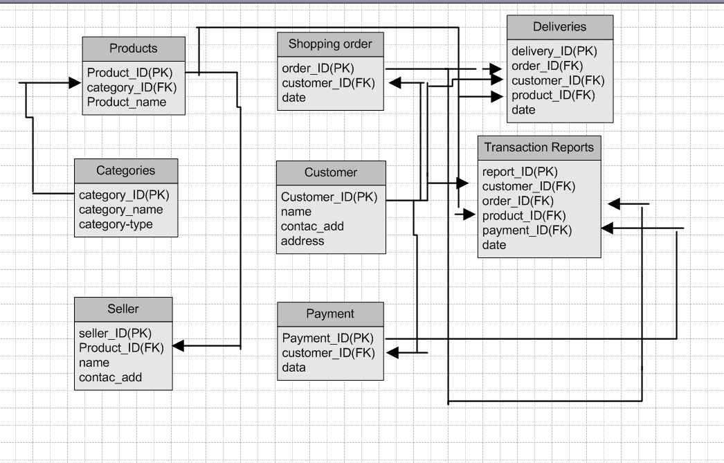

Question 7 – Data Flow Diagram
Ans: A Data Flow Diagram (DFD) is used to illustrate the flow of data through a system, showing how data moves, is transformed, and is stored
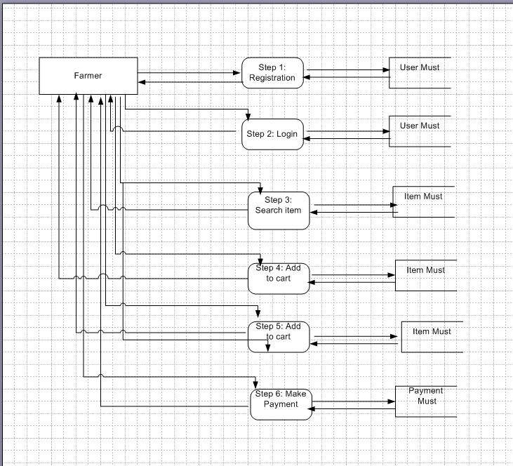

Question 8 – Change Request
Ans:
Initially BA should check the change request whether it is a defect from previous installations or not. If it is a defect then it is assigned to the technical team else
BA should be do the following
1. Impact Analysis
2. Feasibility Study
3. Effort Estimation
Impact Analysis:
- Assess the impact of the change on various aspects of the project, such as scope, timeline, cost, resources, and risks.
- This Taxation change will occur in the billing area especially in the buy product page based on the tax structure will implement the change on the concern product
- So here it impacts in the technology, resources, timeline and the cost.
Feasibility Study:
- The feasibility study focuses on helping answer the essential question of “should we proceed with the proposed idea”.
- Possibility of doing a project within some constraints like technology, budget & time.
- Technology includes Software, Hardware and Trained Resources
- Here the changes are feasible with the software, trained resources, time and cost.
- In the software we are going update the price feature of the each products, resources will spend time to change this feature and it costs their amount of time they spend.
Effort Estimation:
- Calculating the total working hours will spent on making the changes, In a day a resources will spend 8hrs/day
- Here the resources will spend 3-4 hrs to modify the feature, test the feature and Integrate into the current system.

Question 9 – Change Request Vs an Enhancement
As a business analyst, my response to Ben and Kevin's request would be to classify it as an enhancement rather than a change request. A change request typically involves modifications to existing functionality or requirements, while an enhancement introduces new features or capabilities that were not initially specified.
In this case, the request to allow farmers to add their crop yields, display them to the general public, and enable selling through the application represents an enhancement because it introduces new functionality that goes beyond the initial scope of the project.

 | Change Request | Enhancement
Definition | A request to alter something within the scope of a project, product, or system | A specific type of change that adds value, improves performance, or optimizes existing functionality.
Scope | Can be broad, covering business requirements, functional needs, data changes, new features, or bug fixes | More focused on improvement, increasing efficiency, or adding new capabilities rather than just fixing a defect.
Purpose | To document and manage desired modifications to a system or process, ensuring they are evaluated and implemented effectively. | To make an existing system, product, or process perform better, more efficiently, or to have increased value.
Examples | Adding new features, updating product specifications, changing timelines, fixing errors, or implementing enhancements. | Adding advanced reporting to software, streamlining a business process, or improving the user interface of an application.

Question 10 – Estimations
Ans: Every resource will work 8 hrs per day to complete their task activity
Phases | Activity | Hours
Requirement Gathering and Analysis | This includes meetings with stakeholders, gathering detailed requirements, analyzing the impact, and documenting the enhancements. | 10-20 man-hours
Design and Architecture | This involves designing the system components, database structure, and user interface for the new features. It also includes identifying the necessary changes to accommodate the enhancements. | 20-40 man-hours
Development and Coding | The actual development of the new features, including backend and frontend coding, integration with existing modules, and implementation of the auction system | 40-80 man-hours
Testing and Quality Assurance | This phase involves writing test cases, performing unit testing, integration testing, and ensuring the proper functioning and stability of the added features. | 20-40 man-hours
Deployment and User Acceptance Testing (UAT) | Deploying the updated system to a testing environment, conducting user acceptance testing, and resolving any issues identified during UAT. | 10-20 man-hours
Documentation and Training | Documenting the new features, updating user manuals or guides, and providing training or support materials for farmers and users. | 10-20 man-hours

Question 11 – UAT
Ans:
To handle the situation of testing the final product and successfully completing it, the business analyst can follow these steps:
- UAT Planning: Prepare a plan for User Acceptance Testing (UAT) in consultation with the client. This plan should include the scope of testing, test scenarios, test data, and timelines.
- Test Environment Setup: Ensure that the required test environment is set up and available for the client to perform testing. This may include providing access to the testing environment, necessary test accounts, and any additional resources needed for testing.
- Test Execution: Coordinate with the client to execute the planned test scenarios. Monitor the testing progress, provide support for any questions or issues that arise, and track the test results.
- Defect Management: If any defects are identified during UAT, work closely with the client to understand the issues, document them, and track their resolution. Collaborate with the development team to address the reported defects and verify their fixes.
- UAT Sign-off: Once the client has completed testing and is satisfied with the product’s functionality, obtain their formal sign-off or approval. This indicates that the client has accepted the final product and is ready to move forward with its deployment.
Regarding the process to close the project, it typically involves the following steps:
- Final Documentation: Ensure that all project-related documentation is complete, including requirements, design documents, test cases, and user manuals. Review and update these documents to reflect the final product.
- Project Review: Conduct a project review meeting with key stakeholders, including the client, to discuss the overall project performance, achievements, and lessons learned. Gather feedback and suggestions for improvement.
- Project Closure Report: Prepare a project closure report summarizing the project's objectives, deliverables, timeline, budget, and overall success. Include any important metrics or performance indicators.
- Handover or Deployment: Coordinate with the necessary teams, such as deployment or operations, to ensure a smooth transition of the final product to the production environment. Provide any necessary training or documentation to support the deployment process.
- Post-Project Evaluation: After the product is deployed and operational, conduct a post-project evaluation to assess its performance, gather user feedback, and identify any areas for further improvement.
UAT Acceptance Process:
The User Acceptance Testing (UAT) Acceptance process involves the following steps:
- Test Planning: Define the scope of UAT and identify the key features or functionalities to be tested. Prepare test scenarios and test cases based on user requirements.
- Test Execution: Perform the planned test scenarios, following the test cases provided. Validate the system’s behavior against the expected outcomes and verify that it meets the user’s acceptance criteria.
- Defect Reporting: If any issues or defects are identified during UAT, document them in a structured manner, including detailed steps to reproduce the problem. Communicate the issues to the development team for resolution.
- Defect Resolution: Collaborate with the development team to address the reported defects. Verify the fixes provided by the development team and retest the affected areas.
- Sign-off: Once all test scenarios have been executed, defects have been resolved, and the system meets the user’s acceptance criteria, provide formal sign-off or approval. This signifies that the client accepts the product as meeting their requirements.
- UAT Closure: Document the UAT results, including the test execution summary, any outstanding issues, and the overall assessment of the product.
Question 12 – Project Closure Document
Ans:
A project closure document is a comprehensive report that summarizes the entire project's lifecycle, outcomes, and lessons learned. It serves as a formal record of the project's completion and provides important information for future reference. The document typically includes the following sections:
- Project Overview: This section provides an overview of the project, including its objectives, scope, and stakeholders involved. It summarizes the project's purpose and sets the context for the closure report.
- Project Achievements: Here, the document highlights the key achievements and deliverables of the project. It outlines the successful completion of milestones, tasks, and any significant accomplishments that were achieved.
- Project Timeline and Budget: This section provides an overview of the project timeline, highlighting the start and end dates, major phases, and milestones. It also includes information on the project's budget, including any significant deviations or changes.
- Lessons Learned: The lessons learned section reflects on the project's successes and challenges. It includes a comprehensive analysis of what worked well and what could have been improved. It highlights valuable insights and recommendations for future projects.
- Stakeholder Feedback: This section gathers feedback from key stakeholders involved in the project. It includes their opinions, suggestions, and any concerns they may have expressed. The feedback helps in assessing the overall satisfaction and identifying areas for improvement.
- Risks and Issues: The closure document discusses the risks and issues encountered throughout the project. It outlines the actions taken to mitigate these risks and resolve any issues that arose during the project's lifecycle.
- Project Performance: This section evaluates the project's performance against the defined objectives and success criteria. It assesses factors such as scope adherence, timeline adherence, budget performance, quality of deliverables, and customer satisfaction.
- Project Sign-off: The closure document includes formal sign-off or approval from key stakeholders, indicating their acceptance and satisfaction with the project's outcomes. This signifies the official closure of the project.
- Project Documentation: This section provides an overview of the project documentation, including the list of documents produced, their location, and accessibility for future reference.
- Next Steps and Recommendations: The closure document outlines any recommended actions or next steps following the project's closure. It may include suggestions for further improvements, additional tasks, or follow-up activities.
The project closure document serves as a final report that captures the project's journey, outcomes, and key learnings. It provides a reference for future projects, helps in evaluating project success, and facilitates knowledge transfer to stakeholders involved in the project.

