Live Waterfall Project – Part – 2
Document 6 – Please prepare a use case diagram, activity diagram and a use case specification document.
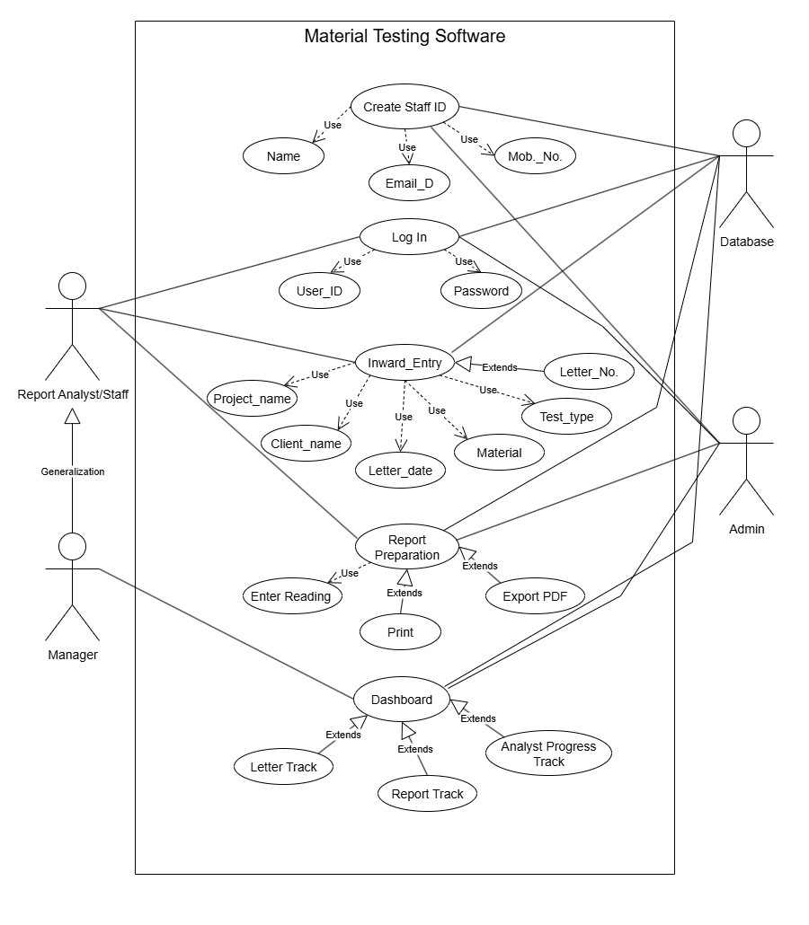
Answer: Use Case Diagram
Use Case Specification:
Use Case ID | UC001
Use Case Name | Create Staff ID
Use Case Description | This use case allows the Admin to create a new staff profile in the Material Testing Software. While creating the staff ID, details such as Name, Mobile Number, Email ID, and unique Staff ID are captured. Initially, the Admin sets a default password for the staff, which the staff can later change after first login. All information is securely stored in the database.
Actors | Primary Actors – Admin Secondary Actors – Database
Basic Flow | - Admin logs into the system.  - Admin selects the option “Create Staff ID”.  - System displays staff registration form.  - Admin enters details (Name, Mobile No., and Email ID).  - System generates a unique Staff ID.  - Admin sets a temporary password for the staff.  - The details are validated and saved into the database.  - Confirmation message is displayed to Admin.  - Staff can now log in using newly created Staff ID and the given password.
Alternate Flow | - If email ID already exists, system prompts Admin to use a different one.  - If mobile number is invalid, system requests correct format.  - If Staff ID duplication occurs, system regenerates a new unique ID.
Exceptional Flow | - Database connection fails → Staff ID creation unsuccessful.  - Mandatory fields left blank → Error message displayed.  - System crash during saving → Staff ID not created, Admin must retry.
Pre-Conditions | - Admin must be logged in with valid credentials.  - System should be connected to the database.
Post-Conditions | - New Staff ID is created and stored in the system.  - Staff can log in with given credentials and later change password.
Assumptions | - Admin has authority to create staff IDs and set passwords.  - Staff will change password after first login for security.
Constraints | - Staff ID must be unique across the system.  - Password should meet minimum security standards (e.g., 8 characters, alphanumeric).  - Mobile number must be 10 digits and Email ID should be valid format.
Dependencies | - Depends on database for storing new staff details.  - Depends on password validation rules.
Input and Output | - Inputs: Name, Mobile Number, Email ID, Password  - Outputs: Unique Staff ID, Confirmation message
Business Rules | - Only Admin can create staff IDs and assign initial passwords.  - Staff must change password on first login.
Miscellaneous Information | Staff details and passwords should be encrypted in the database.

Use Case ID | UC002
Use Case Name | Log In
Use Case Description | This use case allows Staff, Manager, and Admin to access the Material Testing Software by entering their Staff ID and Password. The system verifies credentials from the database. If valid, the user is granted access based on their role. Staff can later change their password if required.
Actors | Primary Actors – Report staff, Manager, Admin Secondary Actors – Database
Basic Flow | - User opens the Material Testing Software.  - User selects “Log In” option.  - System displays login screen.  - User enters Staff ID and Password.  - System verifies credentials against the database.  - If valid, system grants access to the application dashboard according to the user role.
Alternate Flow | - If password expired, system asks user to reset password.  - If staff is logging in for the first time, system forces a password change.  - If Caps Lock is ON while entering password, system shows a warning message.
Exceptional Flow | - Incorrect Staff ID or Password → System shows “Invalid credentials” error.  - Account locked due to multiple failed attempts → User must contact Admin.  - Database connection failure → Login unavailable, system shows error.
Pre-Conditions | - User must already have a valid Staff ID created by Admin.  - Password must be set either by Admin or changed by user earlier.
Post-Conditions | - User is logged into the system and redirected to dashboard according to role.  - Failed login attempts are recorded in the system logs.
Assumptions | - User remembers correct Staff ID and Password.  - Admin has provided initial password for first-time users.
Constraints | - Login session expires automatically after a defined idle period (e.g., 15 minutes).  - Password must follow security policy (minimum 8 characters, alphanumeric, special character).  - Maximum 3–5 invalid attempts allowed before account lock.
Dependencies | - Dependent on Staff ID created in “Create Staff ID” use case.  - Dependent on database authentication service.
Input and Output | - Inputs: Staff ID, Password  - Outputs: Successful login → Dashboard, Failed login → Error message
Business Rules | - Only valid users (Staff/Manager/Admin) can log in.  - First login requires password change.  - Admin can unlock locked accounts.
Miscellaneous Information | Option for “Forgot Password” should be available to reset via Admin approval.

Use Case ID | UC003
Use Case Name | Inward Entry
Use Case Description | This use case allows Report Analyst/Staff to enter details of incoming letters and testing requests. The details include Project Name, Client Name, Letter Number, Letter Date, Material, and Test Type. These entries are stored in the database and form the base for report preparation.
Actors | Primary Actors – Report Analyst/Staff Secondary Actors – Database, Manager (review), Admin (for oversight)
Basic Flow | - Analyst logs into the system.  - Analyst selects “Inward Entry” option.  - System displays entry form with required fields.  - Analyst enters details (Project Name, Client Name, Letter No., Letter Date, Material and Test Type).  - System validates mandatory fields and unique Letter Number.  - Data is saved into the database.  - Confirmation message is displayed.
Alternate Flow | - If Letter Number already exists, system prompts to enter a different number.  - Analyst can save entry as a draft and update later.  - If Manager approval is required, system routes entry for review before finalizing.
Exceptional Flow | - Missing mandatory fields → System shows error message.  - Invalid data format (e.g., incorrect date format, special characters in project name) → Error displayed.  - Database connection failure → Entry cannot be saved.
Pre-Conditions | - Analyst must be logged into the system.  - Staff ID must already exist in the database.  - Database should be active and connected.
Post-Conditions | - A new inward entry record is created and stored.  - Entry is available for report preparation and tracking.
Assumptions | - Analyst has authority to make inward entries.  - All required details are provided by client or letter.
Constraints | - Date format should follow system standard (e.g., DD/MM/YYYY).  - Entry form should not accept blank mandatory fields.
Dependencies | - Depends on “Log In” use case for authentication.  - Depends on database for saving entries.
Input and Output | - Inputs: Project Name, Client Name, Letter Number, Letter Date, Material, Test Type  - Outputs: Confirmation message, Saved inward entry record
Business Rules | - Only authorized staff can perform inward entry.
Miscellaneous Information | - System should maintain log of who created/updated inward entry.  - Inward entries can be searched or filtered later by project, client, or letter number.

Use Case ID | UC004
Use Case Name | Report Preparation
Use Case Description | This use case allows Report Analyst/Staff to prepare a material testing report based on inward entry details. The system fetches required data (Project, Client, Test Type and Material) and allows staff to enter test readings. After validation, the system generates a standardized report in PDF format, which can be saved, printed, or shared with clients.
Actors | Primary Actors – Report Analyst Secondary Actors – Database, Manager (review), Admin (for oversight)
Basic Flow | - Analyst logs into the system.  - Analyst selects “Report Preparation” from dashboard.  - System displays inward entries available for report preparation.  - Analyst selects an inward entry.  - System fetches client and project details automatically.  - Analyst enters test readings and observations.  - System validates the data entered.  - System generates a draft report using the standard template.  - Analyst reviews and finalizes the report.  - Final report is saved into the database and made available for printing/export.
Alternate Flow | - If analyst selects “Save as Draft,” report is stored but not finalized.  - If data is partially available, analyst can update readings later.  - If manager review is enabled, the report is routed for manager approval before finalization.
Exceptional Flow | - Invalid or incomplete data → System shows error message.  - Database connection failure → Report cannot be generated.  - Standard template missing → Report creation halted, error logged.
Pre-Conditions | - Analyst must be logged into the system.  - Inward entry must exist in the database.  - Standard report template must be available.
Post-Conditions | - A final report is generated and stored in the system.  - Report can be exported, printed, or shared with client.
Assumptions | - Analyst has valid permissions to prepare reports.  - All inward details are already entered correctly.  - Required formulas/calculations for test readings are pre-defined.
Constraints | - Reports must follow organization’s standard format (font, header, footer).  - Report should be generated within 2–3 seconds after validation.
Dependencies | - Depends on inward entry details.  - Depends on system templates and formulas.
Input and Output | - Inputs: Test Readings, Observations  - Outputs: Draft Report, Final Report PDF, Confirmation message
Business Rules | - Only staff with report preparation rights can create reports.  - Manager approval may be required before sending report to client.  - Report must follow the approved template; customization not allowed.
Miscellaneous Information | Notifications (email/SMS) may be sent to client when report is ready.

Use Case ID | UC005
Use Case Name | Dashboard
Use Case Description | The Dashboard is the central screen of the Material Testing Software that provides role-based access and overall tracking information.  - Total Letters Received (daily, monthly, overall)  - Reports Prepared (daily, monthly, overall)  - Reports Prepared by Each Analyst (performance tracking)  - Pending Reports vs Completed Reports  This helps Admin and Manager monitor overall system activity and staff performance.
Actors | Primary Actors – Manager, Admin Secondary Actors – Database (fetching real-time counts and summaries)
Basic Flow | - User logs into the system.  - System verifies user role.  - Dashboard loads with the following data:  - Number of inward letters received today, this month, and overall.  - Number of reports prepared today, this month, and overall.  - List of report analysts with the count of reports each has prepared.  - Pending vs finalized reports.  - User can filter the dashboard data by daily, weekly, monthly, or custom date range.
Alternate Flow | - If no letters or reports exist for the selected period, system shows “No records available.”
Exceptional Flow | - Database error → Summary counts not displayed.  - Dashboard refresh fails → Old data shown with warning message.
Pre-Conditions | - User must be logged into the system.  - Inward entries and reports must exist in the database.
Post-Conditions | - User gets clear visibility of system activities and performance.  - Admin/Manager can analyze workload and efficiency of report analysts.
Assumptions | - All inward entries and reports are updated in real time.  - Every report is linked with the respective analyst ID.
Constraints | - Dashboard should refresh automatically (e.g., every 1–5 minutes).  - Graphs and counts must load within 3 seconds.
Dependencies | - Dependent on inward entry module for letter details.  - Dependent on report preparation module for report counts.
Input and Output | - Inputs: Database records of letters and reports.  - Outputs: Dashboard with counts, graphs, and performance statistics.
Business Rules | - Admin and Manager can see full dashboard with all staff performance.  - Staff can only see their own activity summary.  - Dashboard statistics must match reports stored in the database.
Miscellaneous Information | - Dashboard may include graphs/charts for better visualization.  - Monthly reports can be exported from dashboard as PDF/Excel.

Activity Diagram
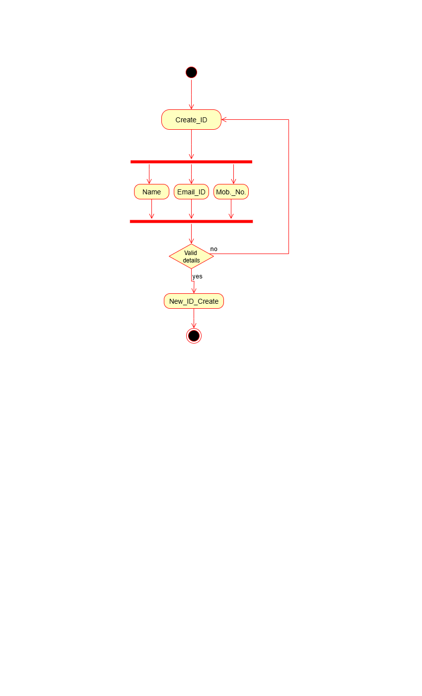
- Create ID
- Inward Letter
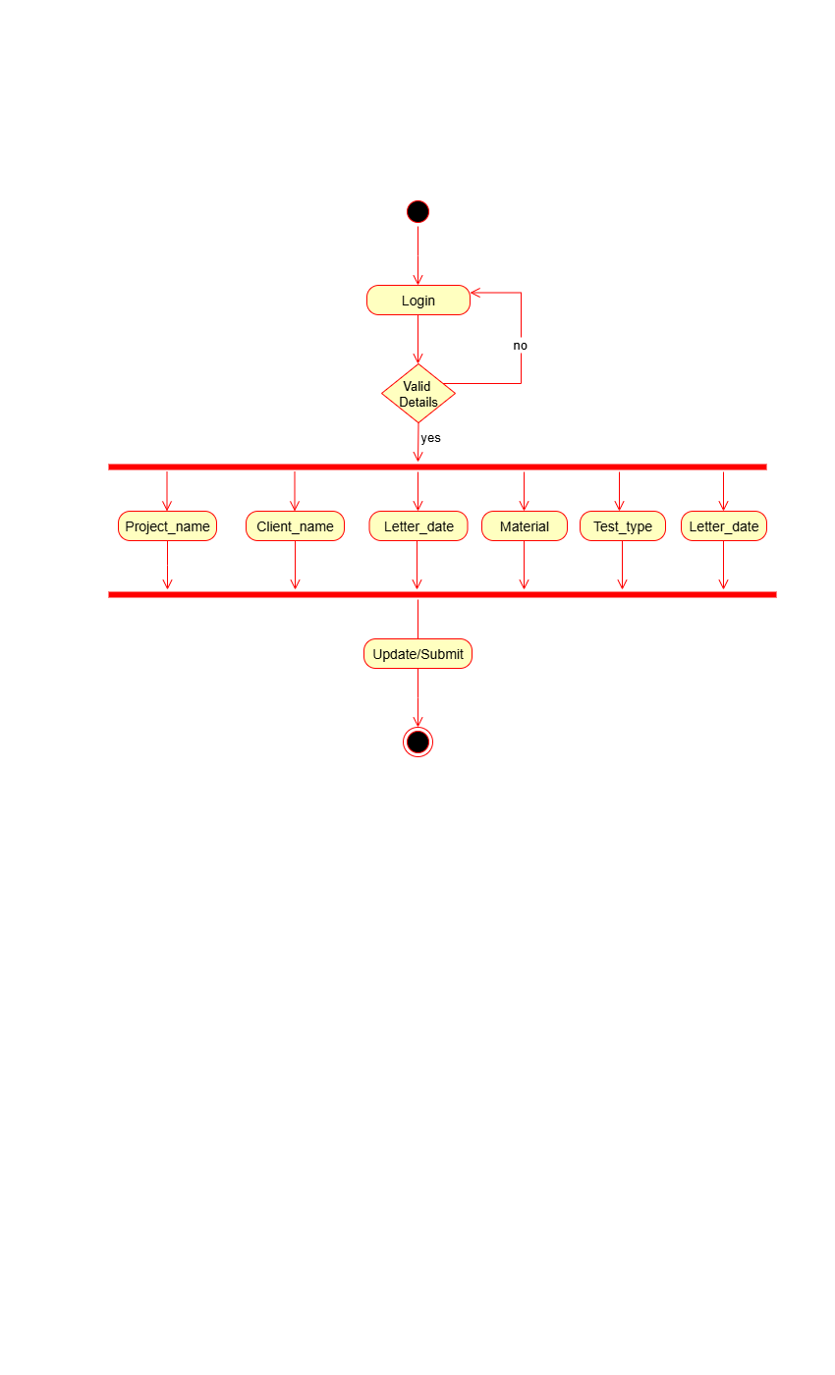
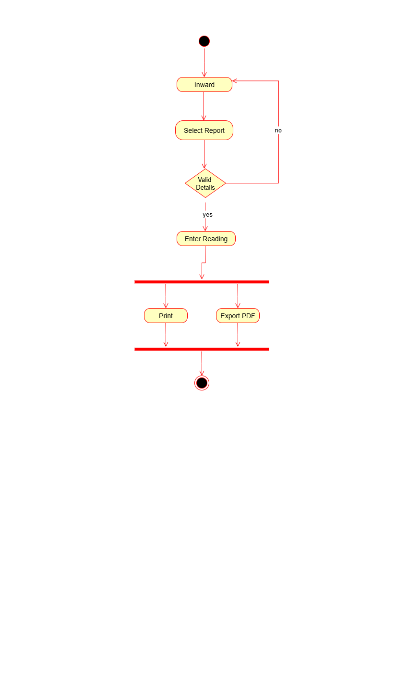
- Report & Print

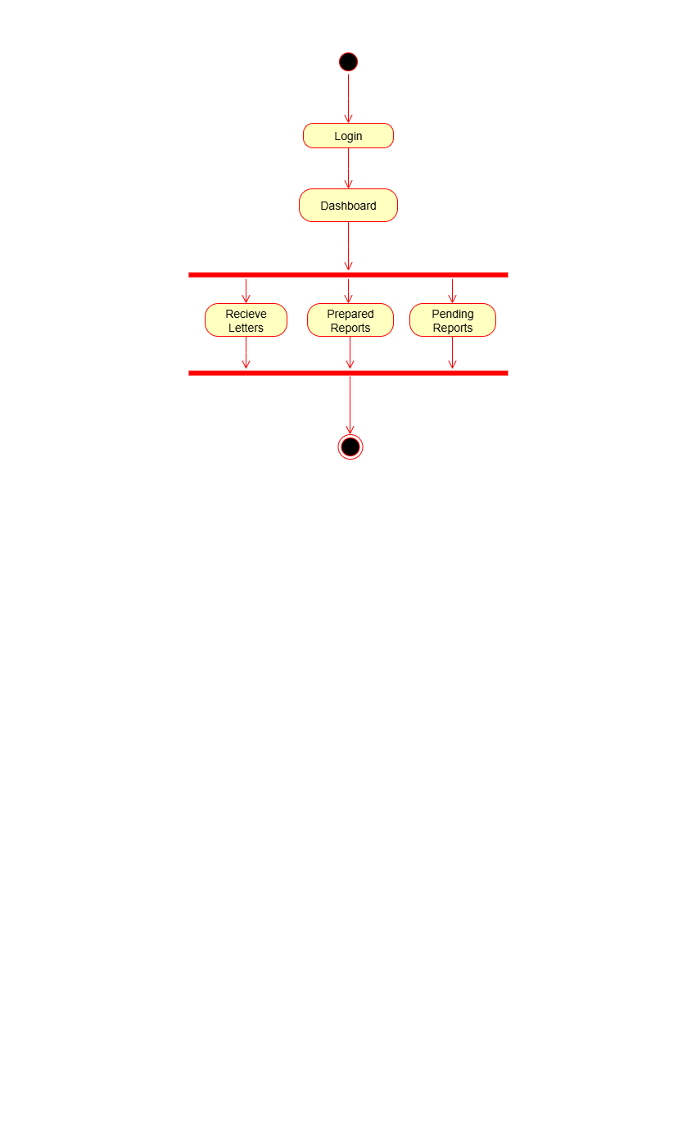
- Dashboard
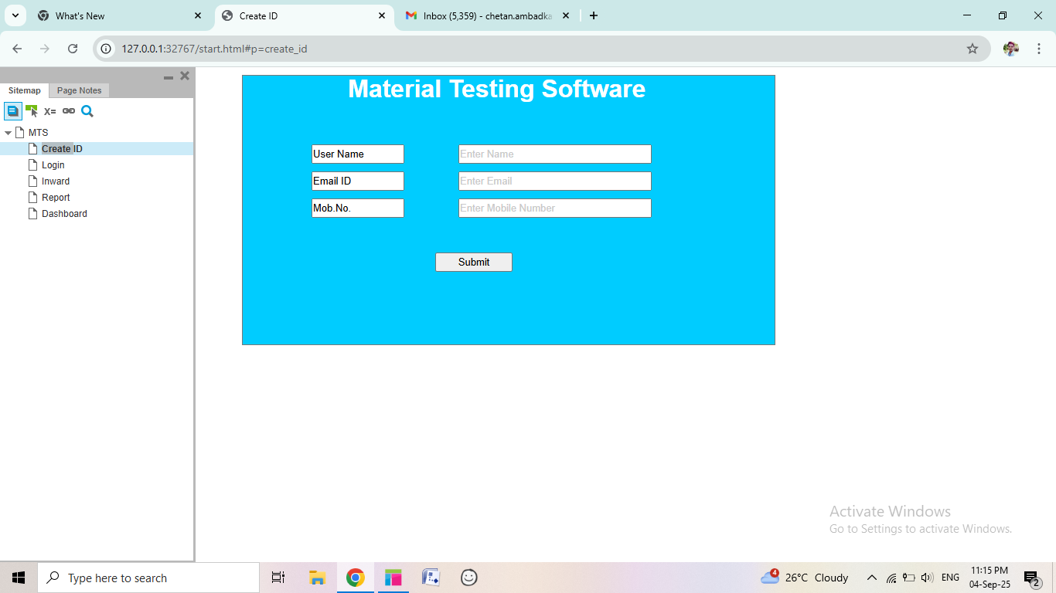
Document 7 – Screens and pages

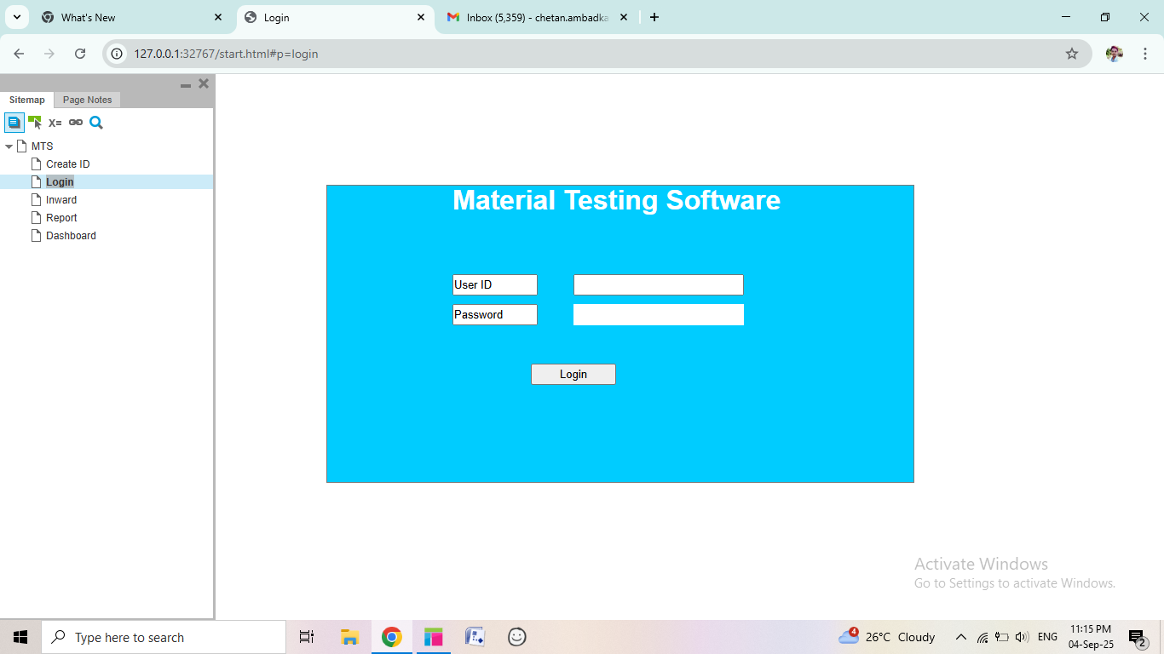

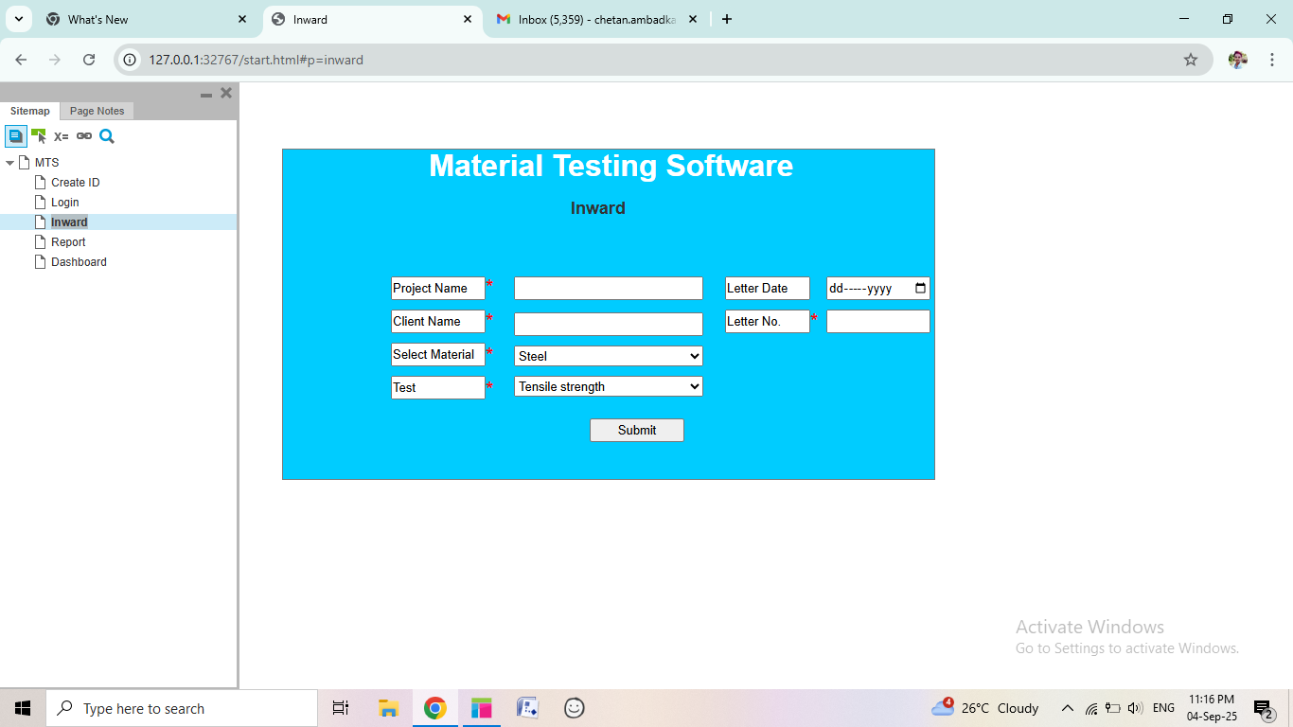

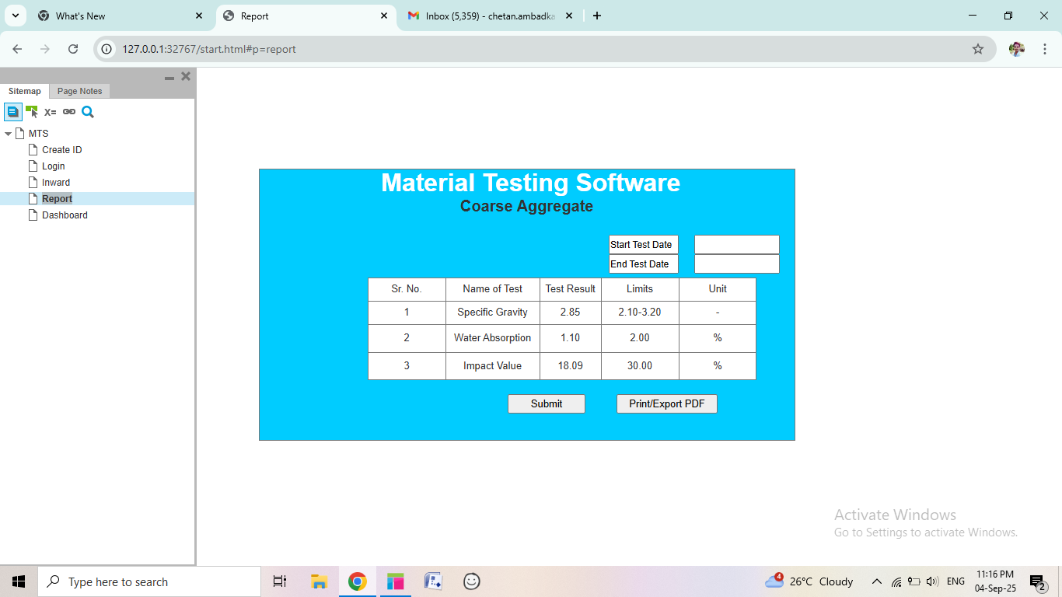

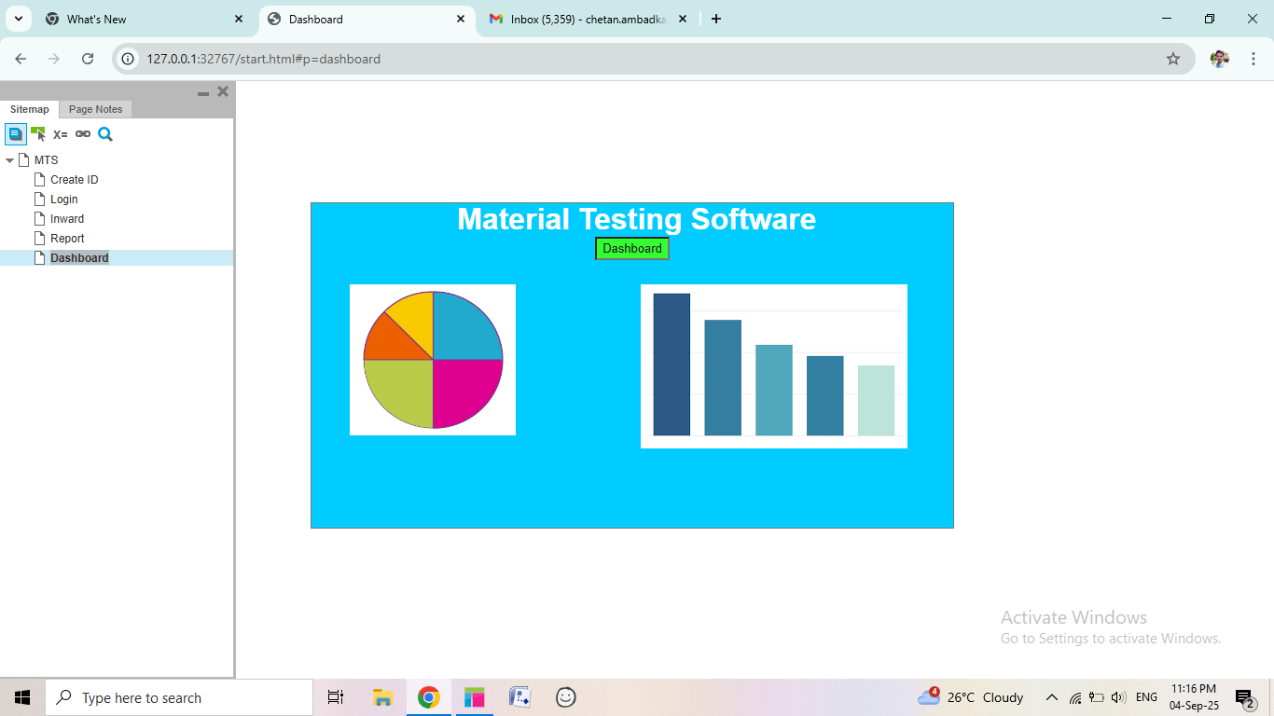

Document 8 – Tools- Visio and Axure
Write a paragraph on your experience using Visio and Axure for the project.
Answer:
Microsoft Visio: In this project, I used Microsoft Visio to prepare UML diagrams including Use Case Diagrams, Activity Diagrams, and process flowcharts. Visio provided an easy-to-use interface with ready-made UML templates, which helped me create diagrams more accurately and consistently. By using these diagrams, I was able to represent requirements in a structured and clear manner. This made it easier for both business stakeholders and the technical team to understand the system without reading lengthy text documents. Visio also improved communication within the team, as visual diagrams simplified discussions and reduced misunderstandings. Overall, Visio supported me in requirement analysis and documentation, ensuring that all requirements were properly captured and no critical process was missed.

Axure: In this project, I used Axure RP to design detailed wireframes and interactive mock-ups of the application. I created different screens such as Create ID, Login, Inward Entry, Report Preparation, and Dashboard. A major advantage of Axure was its ability to simulate navigation between pages, which helped demonstrate the user flow and overall system behaviour to the client before development started. This gave stakeholders a clear understanding of how the application would look and function in reality. By using realistic prototypes, I collected accurate feedback early, identified missing requirements, and implemented changes without extra cost or delays. Overall, Axure improved visualization, minimized misunderstandings, and built client confidence by presenting a near-real user experience in the requirement phase.

Document – 9 BA Experience
1. Requirement Gathering:
- First, I performed requirement gathering by interacting with the client and stakeholders to collect business needs.
- I used different elicitation techniques such as brainstorming, interviews, document analysis, and workshops to gather requirements.
- After collecting, I applied the MoSCoW technique to prioritize requirements into Must Have, Should Have, Could Have, and Won’t Have so that critical features were given higher importance.
- During this phase, the client was not available for some period of time. As a BA, I contacted alternate point-of-contacts from the client side and gathered the pending information to ensure there were no delays.
- I then validated all requirements using the FURPS technique (Functionality, Usability, Reliability, Performance, and Supportability) to check correctness, quality, and feasibility.
- While reviewing, I found many requirements were duplicated or repeated, which I immediately removed to avoid confusion.
- Finally, I applied Prototyping as an elicitation technique. By creating simple mock-ups and sample screens, I gave the client a visual representation of how the system would look and behave. This helped the client provide more specific inputs, identify missing requirements, and gain confidence in the proposed solution.

2. Requirement Analysis:
- We need to draw UML diagrams to visually describe the requirements.
- First, I prepare a Use Case Diagram which shows the relationship between different actors and the system functions.
- After that, I write the Use Case Specification which explains details such as use case description, actors, basic flow, alternate flow, preconditions, and post-conditions.
- I also prepare Activity Diagrams to describe the process flow step by step in a clear sequence.
- Once diagrams are ready, I communicate them to the team and explain the complete flow.
- Sometimes, team members may not agree with certain parts of the diagram or may suggest modifications.
- As a BA, it is my responsibility to consider their points, analyze them, and make changes if required.
- After finalizing the diagrams, I prepare the Business Requirement Specification (BRS).
- The BRS contains high-level business needs, goals, and scope written in simple business language for stakeholders.
- Then, I prepare the Software Requirement Specification (SRS). The SRS contains detailed functional and non-functional requirements, system features, inputs, outputs, and technical constraints for the development team.
- By completing these steps, the requirements are properly analyzed, documented, and ready for the design phase.

3. Design:
- From the use case diagrams, I prepared detailed test cases to cover different system scenarios. This helped in verifying that every functionality was properly captured.
- I communicated with the client regarding design and solution documents to ensure that the proposed design matched their expectations and business needs.
- I prepared both positive and negative test cases. Positive cases verified that the system worked correctly with valid inputs, while negative cases ensured the system could handle invalid or unexpected inputs gracefully.
- I made sure not to miss a single test case, because missing one could lead to serious issues in the later stages of development, such as defects, rework, or delays.
- I also prepared test data for different workflows to be used during the testing phase.
- Finally, I updated the Requirement Traceability Matrix (RTM) to confirm that each requirement was mapped to at least one test case. This ensured complete coverage of requirements and eliminated any possible gaps in design.

4. Development:
- I organized JAD (Joint Application Development) sessions to bring stakeholders and the technical team together for clarifying requirements.
- I helped in clarifying queries of the technical team during coding by referring to requirement documents and diagrams.
- Sometimes, a few team members did not agree with the concept or hesitated to cooperate during JAD sessions. As a BA, I handled such situations patiently by arranging one-to-one discussions with them. I explained how their actions could affect project progress and motivated them to work collaboratively, thereby maintaining a healthy team environment.
- I ensured that the prepared diagrams were referred to by the developers while coding, so that they followed the correct process flow.
- I conducted regular meetings with the technical team and client, which was challenging since not all members were always available. In such cases, I recorded the sessions, shared them with absent members, and later arranged follow-up discussions to clarify their doubts.
- Overall, I maintained smooth communication between the client and technical team during development.

5. Testing:
- In the testing phase, I first prepared test cases from the use cases to make sure that every requirement was properly validated. This step ensured that both functional and non-functional requirements were systematically tested.
- I performed high-level testing to check whether the overall system workflow was working smoothly as per the business expectations. This included testing the core features without going into detailed technical depth.
- For realistic validation, I requested test data from the client. Using actual business data made the testing more accurate and gave confidence that the system could handle real-time scenarios.
- I continuously updated the Requirement Traceability Matrix (RTM) to verify that all requirements were linked with their respective test cases, ensuring complete coverage and no gaps.
- After the completion of testing, I took formal sign-off from the client as proof that the developed features were working as expected.
- Finally, I prepared the client for User Acceptance Testing (UAT) by training them on how to execute test cases, observe results, and report any deviations. This made the client comfortable and confident before final deployment.

6. Deployment
- In the deployment phase, I forwarded the RTM (Requirement Traceability Matrix) to the client, which was later attached to the project closure document for reference and compliance.
- I coordinated with the team to complete and share end-user manuals. These manuals provided step-by-step instructions to help users operate the system effectively.
- I also planned and organized training sessions for the end users. During these sessions, I explained system features, workflows, and answered user queries.
- As a BA, I made sure that all relevant candidates attended the training meetings, since proper participation was necessary for smooth adoption of the system.
- Overall, this phase ensured that the client team was well-prepared to use the system independently after deployment.

