A Document 6- Please prepare a use case diagram, activity diagram and a use case specification document.

- Use Case Diagram

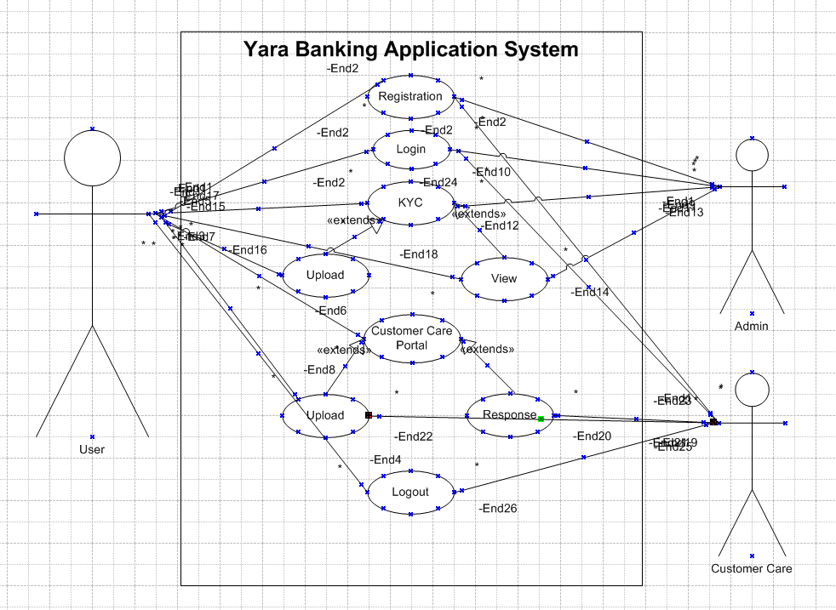

- Activity Diagram

  - Activity Diagram for Transaction
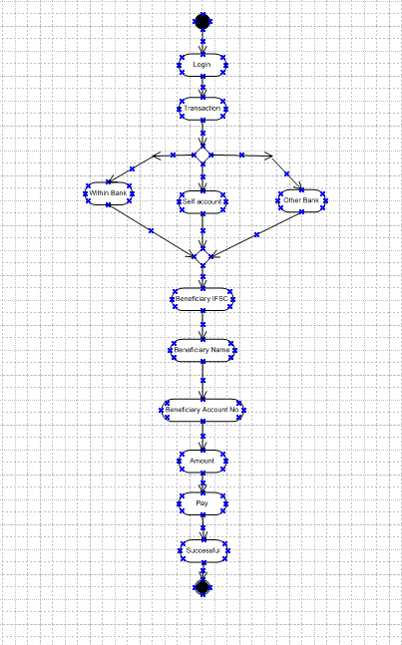

  - Activity Diagram for login

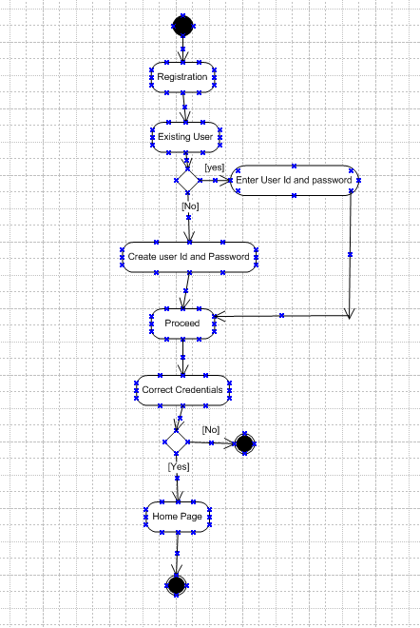
  - Activity for Payment
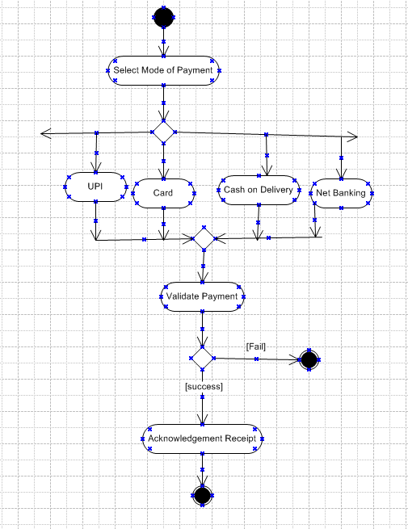
Use Case Specifications:

Use Case Id | UC0001
Use Case Name | Transaction in application
Created By | Ms. | Last Updated By
Created Date | 25-04-2025 | Last Revision Date
Actors | User, System
Description | This use case describes how user can make transactions in the application.
Pre-Condition | User should have application in his system.
Post Condition | User can successfully transfer the funds in the application.
Basic Flow | Step 1: User Clicks on “Fund transfer”.  Step 2: User Clicks on one option from “within Bank”, “other bank” and “self-account”.  Step 3: User Re-enters Beneficiary IFSC, account No, amount and name.  Step 4: User Re-enters Account No.  Step 5: User enters Transaction Pin.  Step 6: User clicks on Pay.  Step 7: User gets Reply “Transaction Successful”.
Alternative Flow | At Step 3: If User entered wrong Account No, system will Reply please enter correct account No.  At Step 5: If User entered wrong Transaction Password, system will Reply please enter correct Transaction Password.
Exceptions | If Internet connection fails, system will generate message “Kindly check your Internet Connection”.
Frequency | High
Assumptions | It is assumed that User has computer Knowledge.
Constraints | Time
Dependencies | Internet Connection
Business Rules | Application should follow RBI guidelines.

Use Case Id | UC0002
Use Case Name | View Transactions in Application
Created By | Ms. Kalyani | Last Updated By
Created Date | 25-04-2025 | Last Revision Date
Actors | Customer, System
Description | This use case describes how user can view the transaction in the app.
Pre-Condition | User should have application in his system.
Post Condition | User can successfully view the transaction in the application.
Basic Flow | Step 1: User logins in the system.  Step 2: User enters user ID.  Step 3: User enters Password.  Step 4: User clicks on Fund Transfer.  Step 5: User Clicks on “View transaction”.  Step 6: User enters “Transaction Password”.  Step 7: User views the transaction.
Alternative Flow | At Step 2: If User entered wrong user Id, system will Reply user Id is invalid  At Step 5: If User entered wrong Password, system will Reply enter correct Password  At Step 9: If User enters invalid transaction Pin
Exceptions | If Internet connection fails, system will generate message “Kindly check your Internet Connection”.
Frequency | High
Assumptions | It is assumed that User has computer Knowledge.
Constraints | Time
Dependencies | Internet connection
Business Rules | Application should follow RBI guidelines.

Use Case Id | UC0003
Use Case Name | Apply for KYC in Application
Created By | Ms. Kalyani | Last Updated By
Created Date | 25-09-2025 | Last Revision Date
Actors | Customer, System
Description | This use case describes how user can upload KYC documents in the app.
Pre-Condition | User should have application in his system.
Post Condition | User can successfully Upload KYC documents in the application.
Basic Flow | Step 1: User Clicks on “KYC documents”.  Step 2: User Clicks on “upload KYC documents”.  Step 3: User clicks on upload aadhar.  Step 4: User clicks on Browse.  Step 5: User Selects desired file.  Step 6: User Uploads aadhar.  Step 7: User clicks on upload PAN.  Step 8: User clicks on Browse.  Step 9: User Selects desired file.  Step 10: User Uploads PAN.  Step 11: User clicks on upload address Proof.  Step 12: User clicks on Browse.  Step 13: User Selects desired file.  Step 14: User Clicks on Upload address Proof.  Step 15: User gets message Documents uploaded successfully.
Alternative Flow | At Step 6: If file of aadhar uploaded by user exceed the size criteria, the system will show the error file size exceeded.  At Step 10: If file of PAN uploaded by user exceed the size criteria, the system will show the error file size exceeded.  At Step 14: If file of address Proof uploaded by user exceed the size criteria, the system will show the error file size exceeded.
Exceptions | If Internet connection fails, system will generate message “Kindly check your Internet Connection”.
Frequency | High
Assumptions | It is assumed that User has computer Knowledge.
Constraints | Time
Dependencies | Internet connection
Business Rules | Application should follow RBI guidelines.

Use Case Id | UC0004
Use Case Name | View uploaded KYC documents in the Application
Created By | Ms. Kalyani | Last Updated By
Created Date | 25-09-2025 | Last Revision Date
Actors | Customer, System
Description | This use case describes how user can view uploaded KYC documents in the app.
Pre-Condition | User should have application in his system.
Post Condition | User can successfully view uploaded KYC documents in the application.
Basic Flow | Step 1: User Clicks on “View Uploaded KYC”.  Step 2: User clicks on view uploaded Aadhar”.  Step 3: User clicks on view uploaded PAN”.  Step 4: User clicks on view uploaded Address Proof”.  Step 5: User gets message Documents uploaded successfully.
Exceptions | If Internet connection fails, system will generate message “Kindly check your Internet Connection”.
Frequency | High
Assumptions | It is assumed that User has computer Knowledge.
Constraints | Time
Dependencies | Internet connection
Business Rules | Application should follow RBI guidelines.

Use Case Id | UC0005
Use Case Name | Raise a service request in the Application
Created By | Ms. Kalyani | Last Updated By
Created Date | 25-09-2025 | Last Revision Date
Actors | Customer, System
Description | This use case describes how user can Raise a service request in the app.
Pre-Condition | User should have application in his system.
Post Condition | User can successfully raise a service request in the application.
Basic Flow | Step 1: User Clicks on “Feedback or Customer Service”.  Step 2: User clicks on “raise a service request”.  Step 3: User writes his request.  Step 4: User Clicks “Upload the request”.  Step 5: User Uploads the request.  Step 6: User gets reply Request raised successfully.
Alternative Flow | At Step 4: If the words entered by user are below the minimum words limit he will fail to submit the request.
Exceptions | If Internet connection fails, system will generate message “Kindly check your Internet Connection”.
Frequency | High
Assumptions | It is assumed that User has computer Knowledge.
Constraints | Time
Dependencies | Internet connection
Business Rules | Application should follow RBI guidelines.

Use Case Id | UC0006
Use Case Name | Reply of Customer Request from customer service
Created By | Ms. Kalyani | Last Updated By
Created Date | 25-04-2025 | Last Revision Date
Actors | Customer service, system
Description | This use case describes how Service centre replies in the app.
Pre-Condition | Customer service people should have login in their system.
Post Condition | Customer service people can successfully reply in the application.
Basic Flow | Step 1: Customer service people Clicks on “View Request”.  Step 2: Customer service people view the customer request.  Step 3: Customer service people click on “reply”.  Step 4: Customer service people give reply to request.  Step 5: Customer service people click on “submit the reply”.  Step 6: Customer service people get “Reply submitted successfully” Message
Alternative Flow | At Step 3: If Customer Service people forget to click on submit reply within time, they would have to fill all the fields again.
Exceptions | If Internet connection fails, system will generate message “Kindly check your Internet Connection”.
Frequency | High
Assumptions | It is assumed that Customer service people have the application.
Constraints | Resources, Time
Dependencies | Resources, Internet connection
Business Rules | Application should follow RBI guidelines

Document 7- Screens and pages

- Login Page
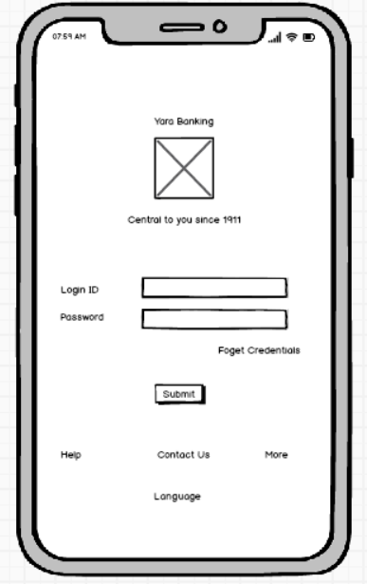

- Home page
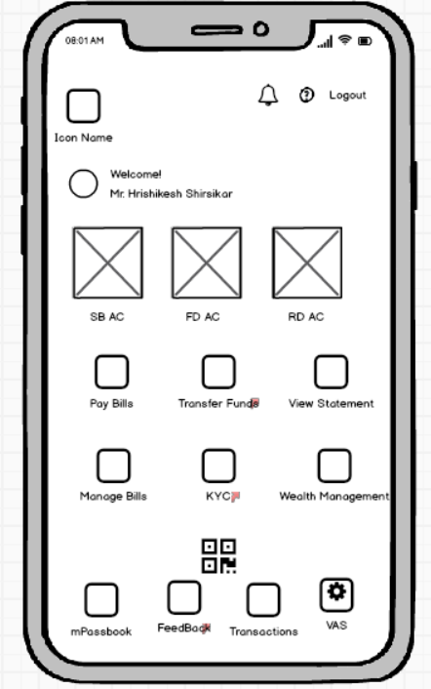

- Transaction 1st Page.

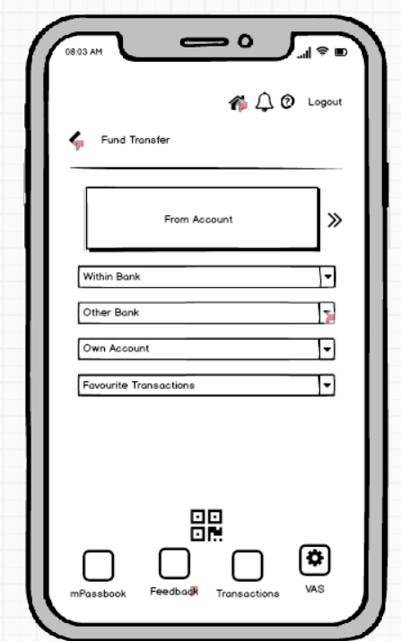

- Transaction Page
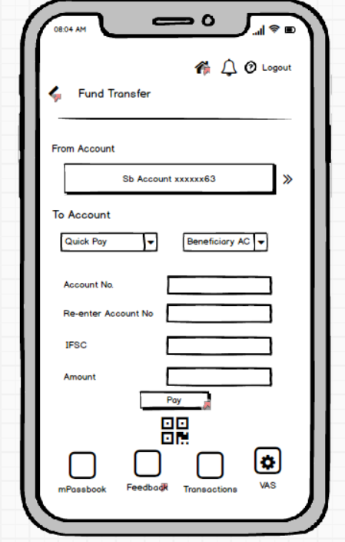

- Transaction Successful
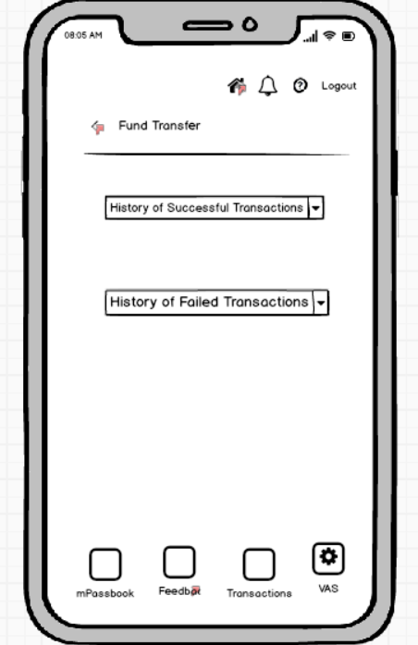

- KYC Document
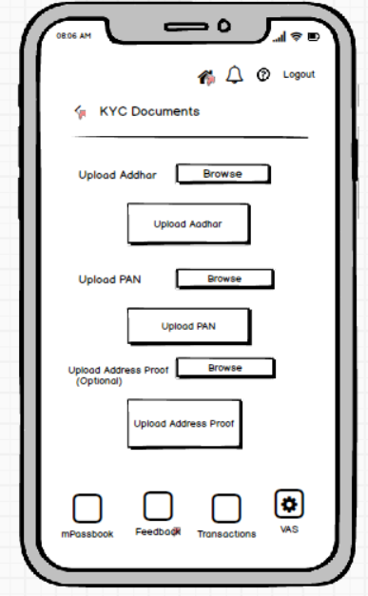

- KYC Upload Status
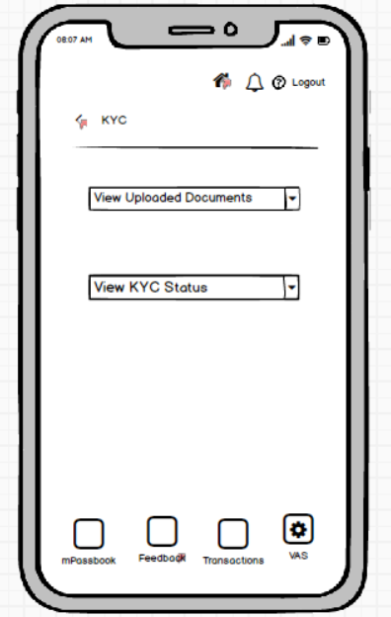

- Service Request
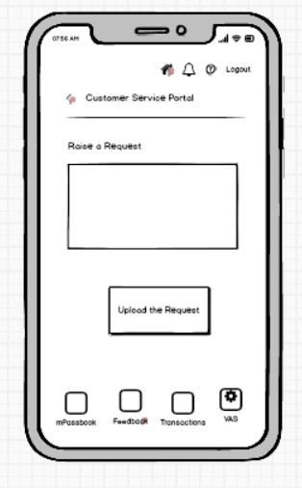

- Request Status
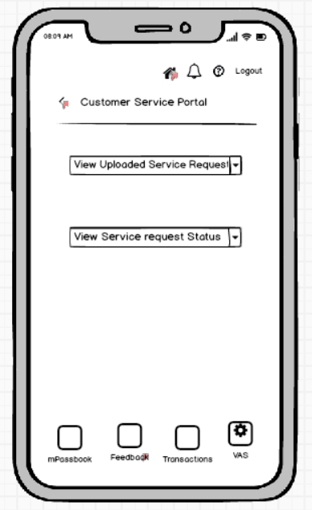

Document 8- Tools-Visio and Axure
These two applications are very easy to use, viewer can easily understand what actually diagram tries to say.
I created detailed flowcharts, network diagrams, and process maps to visualize business operations and technical systems using MS visio.
Using Axure, I created interactive wireframes and high-fidelity prototypes, incorporating dynamic content and conditional logic to simulate real user experiences.
The both applications have increased my skills communicate my ideas clearly to viewer.
Document 9- BA experience
My experience as BA in following phases:

- Enterprises Analysis:
As a BA, first I did the Enterprise analysis.
For enterprise analysis I used the SWOT method and GAP analysis.
SWOT Analysis helped me to identify the strengths of the project, the weaknesses of the project, the available opportunities and the threats we can face in the project. It helped me to do strategic planning and risk management.
Then I did GAP analysis to identify the between current position and desired state.

2. Stakeholders analysis:
For stakeholders’ analysis I used RACI matrix to understand who is responsible, who is accountable, who is has to be consulted and who has to be informed regarding the project.

3. Requirements Gathering:
Requirements MOSCOW technique, using this technique categorised the requirements according to Must do, should do, could do and would do.
Then I validated the requirements using FURPS Technique.

4. Requirements Analysis:
Then I analysed the requirements.
Then I draw UML diagrams to describe the requirements.
The Use case diagram and Activity diagram I drew helped the technical team and development team to understand the flow of the system.
The team also made some changes as they did not agree with my points.

5. Design:
From Use cases we Created the use case specifications and test cases for project.
I made communication with client regarding design and solution document.
We prepared the test case data for testing and used RTM to check we will meet all the requirements.

6. Development:
We organised JAD sessions to help the team.
We conducted regular meetings with the technical team and client, and provided recorded sessions to those who were absent in the meetings.

7. Testing:
Prepared test cases using use cases. We updated the RTM and informed it to client time to time. We took sign off from the client and prepared client for UAT.

8. Deployment:
We planned and organised the training session and deployed the project.

