Document 1- Business case document template
1. Project Initiation
Why is this project initiated?
This project is initiated to streamline and automate the payment transaction processing system. Currently, payment transactions are received through emails in Excel sheets or PDF documents, leading to several inefficiencies, including:

Manual Processing Delays – Reviewing and processing transactions manually takes time and increases turnaround time.
High Risk of Errors – Manual data entry and validation increase the chances of human errors, resulting in incorrect payments or missing transactions.
Lack of Real-Time Tracking – There is no centralized system to track transaction statuses, approvals, or rejections in real-time.
Compliance & Security Risks – Handling sensitive payment data over emails increases security vulnerabilities and makes it harder to ensure compliance with financial regulations.
Scalability Issues – As transaction volumes grow, the current process becomes increasingly inefficient and difficult to manage.
By developing an automated application, the organization can improve efficiency, accuracy, security, and scalability while reducing operational costs.

2. Current Problems
What are the current problems?
anual email-based processing is inefficient.
Risk of errors in Excel/PDF files.
Lack of real-time tracking and reporting.
Security and compliance concerns.

3. Problem Resolution
With this project, how many problems could be solved?
Automated processing and validation.
Centralized system for transaction tracking.
Reduced human errors and increased efficiency.
Improved compliance and security.

4. Resource Requirements
What are the resources required?
Human Resources: Development team, business analysts, testers, project managers.
Technology: Software framework, database, servers/cloud infrastructure.
Financial Resources: Budget estimation for development, deployment, and maintenance.

5. Organizational Change
How much organizational change is required to adopt this technology?
Changes in job roles and responsibilities.
Employee training and onboarding requirements.
Adoption strategy to ensure a smooth transition.

6. ROI and Time Frame
Time frame to recover ROI?
Cost of development and deployment.
Time and efficiency gains.
Expected cost savings due to automation.
Projected timeline for break-even.

7. Stakeholder Identification
Internal Stakeholders: Finance department, IT team, compliance officers, executive leadership.
External Stakeholders: Banks, payment processors, vendors.
Methods to engage stakeholders: Meetings, surveys, workshops.

Document 2: BA Strategy

Requirement Elicitation
Interviews:
One-on-one discussions with stakeholders to gather detailed requirements.

Workshops:
Group sessions to identify business needs and potential solutions.

Surveys & Questionnaires:
Collecting input from a larger audience.

Document Analysis:
Reviewing existing documentation (Excel reports, emails, policies) to understand the current process.

Prototyping:
Creating wireframes/mockups to visualize the solution before development.

Stakeholder Analysis (RACI/ILS)

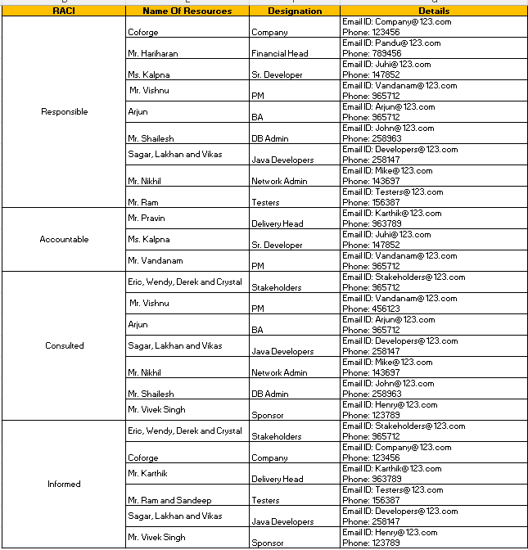

Documents to write:
Business Case Document – Justification of the project initiation.
Business Requirements Document (BRD) – To Capture high-level business needs.
Functional Requirements Specification (FRS) – Details system functionalities.
Process Flows & Use Cases – Defines workflows and user interactions.
Data Flow Diagrams (DFD) – Illustration data movement within the system.
Traceability Matrix – Ensures all requirements are met during development.
User Acceptance Test (UAT) Plan – Defines test scenarios and acceptance criteria.

Document Sign-Off Process
- Documents will be reviewed internally with the project team.
- Formal review sessions will be conducted with stakeholders.
- Any feedback will be incorporated, and the revised document will be sent for approval.
- Sign-off will be obtained via email confirmation or digital signature.

Client Approvals & Communication Plan
- Regular status meetings to present updates and gather feedback.
- Define a structured review timeline for each document.
- Maintain a change request process to address modifications.
- Client approvals will be documented via formal sign-off forms.

Communication Channels
- Meetings: Weekly stand-ups, bi-weekly stakeholder meetings.
- Emails: Official communication and approval tracking.
- Project Management Tools (JIRA, PowerBI, tableau, SQL): Track progress and issues.
- Collaboration Platforms (MS Teams, Slack): Real-time discussions
Change Request Management
- Establish a Change Control Board (CCB) for reviewing and approving changes.
- Use a Change Request Form (CRF) to document requested modifications.
- Evaluate changes for impact on scope, timeline, and budget.
- Obtain necessary approvals before implementing changes.
Project Progress Updates
- Weekly Status Reports to stakeholders.
- Monthly Steering Committee Meetings to discuss project health.
- Risk and Issue Log Updates to track challenges.
- Live Dashboards for real-time tracking (if applicable).
UAT & Client Project Acceptance
- Prepare UAT Test Cases covering all business scenarios.
- Conduct UAT Workshops with key users.
- Capture feedback and log any defects.
- Retest after fixes and obtain final confirmation.

Sign-Off on UAT & Client Project Acceptance
- Prepare a Client Project Acceptance Form summarizing test results.
- Obtain written confirmation (email or document signature) from the client.
- Officially transition to deployment and support phase.

Document 3- Functional Specifications

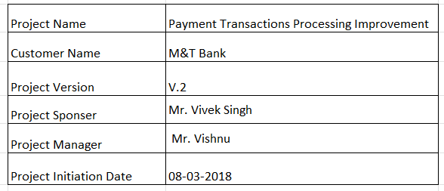
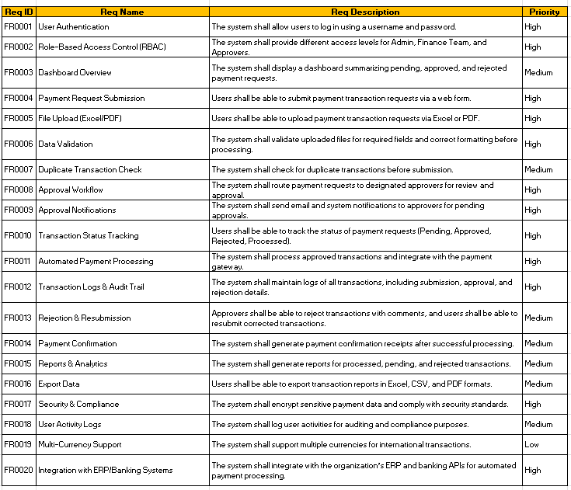

Document 4- Requirement Traceability Matrix
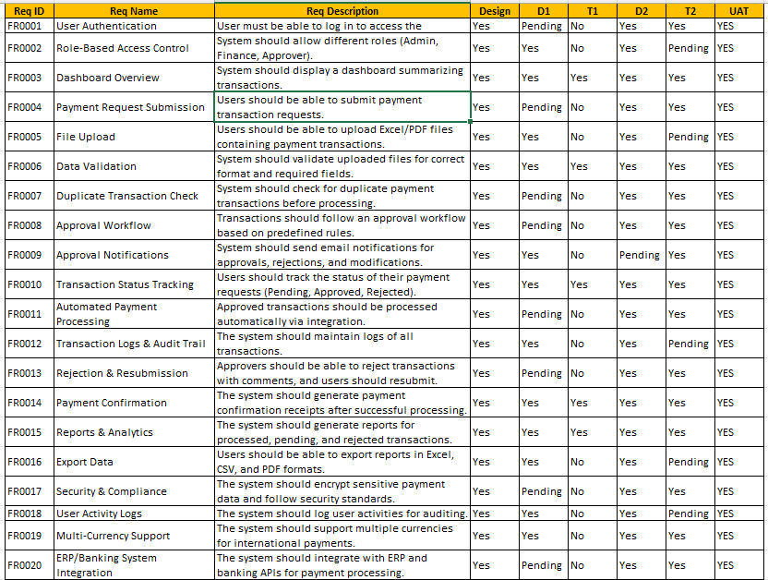

Document 5- BRD Template
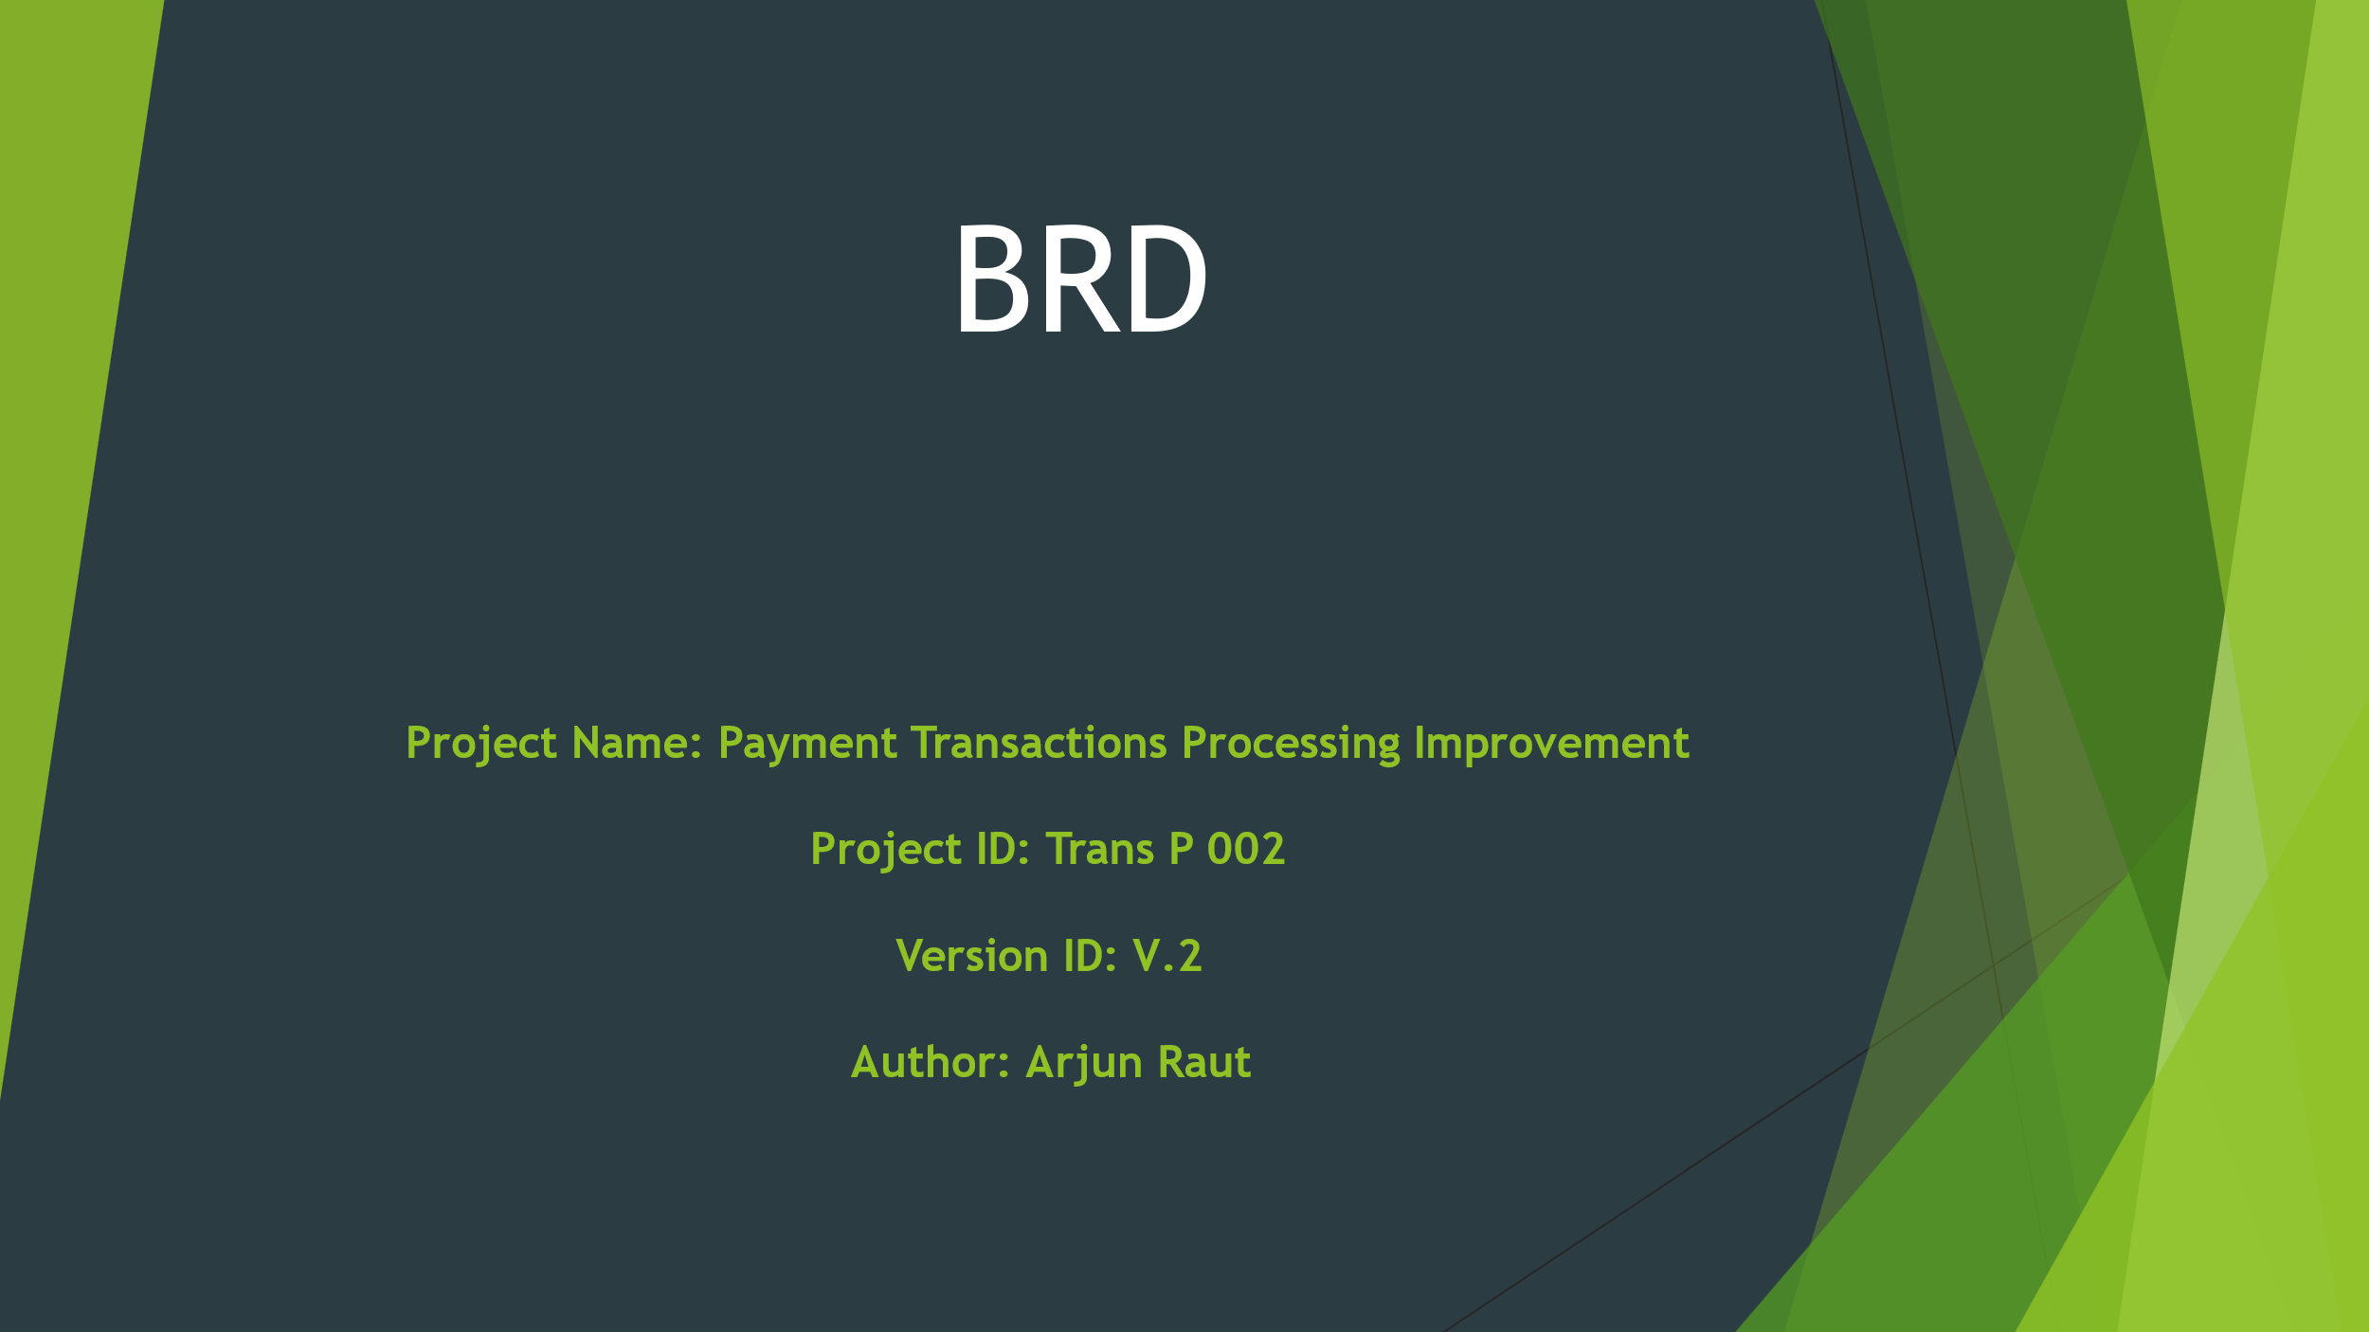

  - Document Revisions
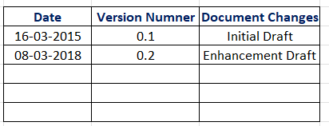

  - Approvals
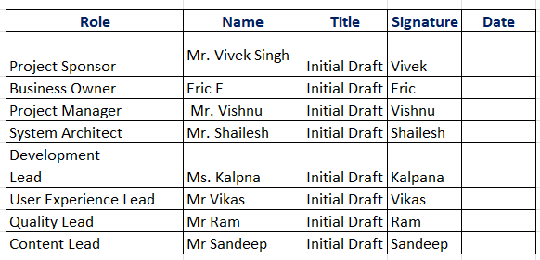

  - RACI Chart for This Document

  - Introduction
4.1. Business Goals

- Eliminate Manual Email-Based Processing
- Stop receiving payment transaction requests via email attachments (Excel/PDF).
- Replace with a centralized, secure application-based submission system.
- Streamline Payment Transaction Workflow
- Automate the entire lifecycle of a transaction—from submission to approval to processing.
- Introduce validation, approval hierarchies, and real-time tracking.
- Enhance Data Accuracy and Validation
- Implement rules to validate transaction data at the time of upload or entry.
- Minimize manual errors caused by incorrect or inconsistent data formats.
- Improve Transparency and Auditability
- Provide audit trails and logs for every action taken on each payment transaction.
- Ensure stakeholders have access to status updates and historical records.
- Accelerate Approval and Processing Time
- Reduce the turnaround time for approvals through automated notifications and workflows.
- Allow faster processing of approved payment transactions.
- Enable Real-Time Reporting and Monitoring
- Generate reports on pending, approved, rejected, and processed payments.
- Provide visual dashboards for finance and management teams.
- Improve Compliance and Security
- Ensure all payment transactions meet internal policies and external compliance requirements.
- Secure sensitive financial data through encryption and role-based access.
- Centralize Data and Integrate with Backend Systems
- Store all transaction data in a single repository for easy access and reporting.
- Integrate with ERP, accounting, or banking systems for seamless processing.
- Support Scalability and Growth
- Create a flexible system that supports increasing volumes of transactions.
- Enable easy expansion to support new business units or payment types.
- Achieve ROI Through Operational Efficiency
- Reduce resource dependency and manual efforts.
- Generate long-term cost savings by streamlining the payment processing function.

4.2. Business Objectives
- Implement a Centralized Payment Submission Portal
- Deliver a secure web-based application for internal and external users to submit payment requests.
- Deadline: Within 3 months from project initiation.
- Automate Data Validation Rules
- Apply pre-defined validation logic (e.g., mandatory fields, format checks, duplicate detection) to uploaded Excel/PDF files.
- Objective: Achieve at least 95% accuracy in submitted data.
- Enable Multi-Level Approval Workflow
- Define and configure role-based approval hierarchies for transaction authorization.
- Objective: Ensure all high-value payments pass through at least two approval levels.
- Implement Audit Trail and Transaction History
- Record all user actions and changes made to each payment transaction.
- Objective: Meet compliance/audit standards with complete traceability.
- Integrate with Existing ERP/Banking Systems
- Ensure seamless data flow from the new application into backend accounting or ERP platforms.
- Objective: Complete system integration by end of development phase.
- Introduce Automated Notifications and Alerts
- Notify approvers, requestors, and admins for every important event (submission, approval, rejection, etc.).
- Objective: Reduce follow-up emails and missed approvals by 90%.
- Enable Real-Time Status Tracking for Users
- Provide users the ability to track the status of their payment requests (Pending, Approved, Rejected, Processed).
- Objective: Improve user satisfaction and transparency.
- Generate Financial Reports and Analytics
- Provide downloadable and exportable reports categorized by payment status, approvers, dates, and types.
- Objective: Deliver reporting module by UAT phase.
- Ensure Secure Access and Data Encryption
- Implement authentication, authorization, and encryption practices for all sensitive data.
- Objective: Achieve full compliance with internal IT security guidelines.
- Reduce Processing Time by 50%
- Compare average transaction processing time (from submission to payment) before and after implementation.
- Objective: Cut down processing cycle time by half within 3 months post-launch.
4.3. Business Rules
I. Access Control & Security
- Only authenticated users with valid credentials can access the system.
- Role-based access control (RBAC) must be enforced (e.g., Finance User, Approver, Admin).
- Password policies must comply with organizational IT standards (e.g., min. 8 characters, alphanumeric).
- Session timeouts will occur after 15 minutes of inactivity.
II. Payment Request Submission
- Only authorized employees are allowed to submit payment requests.
- All payment submissions must include required fields such as vendor name, invoice number, amount, currency, and payment method.
- Attachments must be in .xls, .xlsx, or .pdf formats only.
- Duplicate payment requests (based on invoice number and vendor) must be flagged and prevented.
III. Data Validation & Format Rules
- Uploaded files must be validated for data structure, field types, and required information before processing.
- Currency formats must follow ISO 4217 standards (e.g., USD, EUR, INR).
- Payment amount fields must be positive numerical values with up to 2 decimal points.
IV. Approval Workflow Rules
- Payment requests over predefined thresholds (e.g., ₹50,000 or $1,000) must go through a 2-level approval process.
- Approvers must not be the same person as the requestor.
- Approval/rejection decisions must be recorded along with comments.
V. Notification Policy
- Automated email notifications must be sent:
  - To approvers when a request is submitted.
  - To requestors when a request is approved, rejected, or requires modifications.
- Email content must comply with company communication guidelines.
VI. Reporting & Auditability
- All actions (submission, approval, rejection, edit, delete) must be logged with timestamp and user ID.
- Historical data must be retained for at least 5 years for audit purposes.
- Reports must be generated monthly and submitted to the Finance Head.
VII. Compliance & Regulatory Rules
- The system must comply with internal audit requirements and external financial regulations such as:
  - SOX (Sarbanes-Oxley Act) – for public companies.
  - GST compliance for domestic transactions in India.
  - AML (Anti-Money Laundering) – for international fund transfers.
- Sensitive data must be encrypted at rest and in transit.
VIII. Change Management
- Any changes to workflows, thresholds, or rules must be approved by the Finance Admin and documented via change requests.
- All configuration changes should be version-controlled and logged.
IX. Payment Execution Rules
- Only fully approved transactions can be processed.
- Transactions must be batch processed daily at a specific cut-off time (e.g., 3 PM IST).
- Cancelled transactions cannot be reversed once processed.
X. SLA & Escalation Procedures
- Payment requests must be approved within 2 business days.
- Escalation emails will be triggered if no action is taken within SLA time.
- Monthly SLA compliance reports must be reviewed by the operations team.
4.4. Background
The current process of handling payment transaction requests within the organization is manual and highly inefficient. Employees submit payment transaction details via email, often attaching Excel sheets or PDF documents that require manual review, validation, and data entry by the finance team. This method has led to numerous operational challenges including data entry errors, processing delays, lack of traceability, and difficulty in maintaining a centralized audit trail.
Over time, as the volume of transactions has increased, these inefficiencies have become more pronounced, impacting turnaround times, increasing operational costs, and exposing the organization to compliance risks and missed payments. Moreover, with no centralized platform for submission, tracking, and approval, stakeholders face difficulty in monitoring payment statuses or identifying bottlenecks in the workflow.
To address these growing concerns, the project for building a Payment Transaction Processing Application was proposed and approved. The primary objective is to automate the end-to-end transaction submission and approval process by replacing email-based workflows with a secure, centralized, and rule-based system.
This application will:
- Provide a structured interface for submitting payment requests,
- Validate data upfront to reduce manual errors,
- Streamline multi-level approvals with role-based access control,
- Offer real-time tracking and notifications,
- Ensure regulatory compliance and maintain a full audit trail.
By implementing this project, the organization expects to improve operational efficiency, reduce processing time, strengthen data governance, and enhance user experience for both submitters and approvers. The system will also support integration with ERP and banking systems to enable end-to-end automation of payment processing.

4.5. Project Objective
High-Level Product Capabilities
The application will:
Enable users to submit payment requests via an online form or through uploading Excel/PDF documents.
Validate transaction data against business rules before submission.
Support a multi-level approval workflow based on transaction amount and user roles.
Provide real-time dashboards and reports for transaction monitoring and audit.
Send automated notifications to users and approvers at different workflow stages.
Maintain detailed logs and audit trails for compliance and tracking purposes.
Allow export of reports in multiple formats (Excel, PDF, CSV).
Ensure secure access control and encrypted data handling.

Alignment with Business Objectives
This project supports the following key business objectives:
Reduce manual processing and human error.
Increase operational efficiency and transaction throughput.
Improve transparency and traceability of all payments.
Enable regulatory compliance through secure and auditable processes.
Enhance user satisfaction with faster processing and real-time status visibility.
Support scalability as transaction volumes grow over time.

System Integration Requirements
To support seamless end-to-end processing, the application will integrate with the following systems:
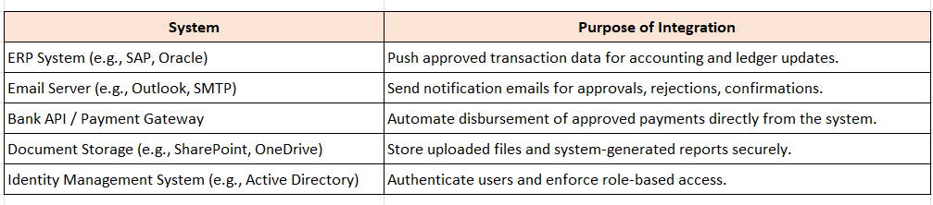

4.6. Project Scope
The scope of this project includes the design, development, testing, deployment, and support of a web-based Payment Transaction Processing Application. This application will serve as a centralized platform for submitting, validating, approving, and tracking payment transactions within the organization.
4.6.1 In-Scope Activities
The following components and functionalities are within the scope of the current project:
- User Management & Authentication
  - User registration and login.
  - Role-based access control (e.g., Submitter, Approver, Admin).
- Payment Request Submission
  - Online form-based transaction entry.
  - File upload functionality (Excel/PDF).
  - Data validation and duplicate detection.
- Approval Workflow
  - Configurable multi-level approval workflow based on roles and transaction amount.
  - Approver actions: Approve, Reject (with comments), Request modification.
- Notifications and Alerts
  - Automated email alerts for submission, approval, rejection, and pending actions.
  - SLA-based reminders/escalations.
- Transaction Status Tracking
  - Real-time tracking of transaction status.
  - History of actions taken per transaction.
- Reports & Dashboards
  - Dashboard for users and admins to view status summaries.
  - Downloadable reports by date, status, approver, etc.
- Audit Trail
  - Logging of all user actions and system events for compliance and audit purposes.
- System Integration
  - Integration with ERP systems (for posting approved transactions).
  - Integration with email services (for notifications).
- Security & Compliance
  - Secure data storage and transfer (encryption at rest and in transit).
  - Compliance with internal audit and regulatory standards.
- User Acceptance Testing (UAT) and Training
  - Preparation of test cases, execution of UAT, and capturing feedback.
  - User manuals and training sessions for end users.
4.6.2 Out-of-Scope Items
To avoid scope creep, the following are explicitly excluded from the current project phase:
- Mobile application development.
- Real-time bank payment integration (will be handled in Phase 2).
- Integration with third-party invoice OCR tools.
- International currency exchange and forex calculation modules.
- Advanced analytics or AI-based fraud detection.
5. Assumptions
The following assumptions have been made during the initiation and planning phases of this project. These assumptions form the basis of the current requirements and solution design:
Technical & System Assumptions
The organization has an existing ERP or accounting system that can receive approved transaction data via integration.
A secure, scalable server environment (on-premises or cloud) is available to host the application.
All users will access the system via a modern web browser (e.g., Chrome, Edge, Firefox).
Existing IT infrastructure supports integration with email services (SMTP/Exchange) for notification delivery.
The application will be developed using technologies approved by the organization’s IT policy.

User & Access Assumptions
All users (submitters, approvers, admins) will have unique login credentials managed via Active Directory or internal authentication mechanisms.
User roles and approval hierarchies will be defined and shared by the business team prior to development.
Users are trained on how to submit payment requests and interpret system messages/notifications.
Process & Data Assumptions
All payment requests will follow a standardized data format, whether submitted manually or via file upload.
Submitted files will be in supported formats only: Excel (.xls/.xlsx) or PDF (.pdf).
There will be a clear distinction between domestic and international payment types, if applicable.
Data validation rules and approval thresholds will be finalized and signed off before development begins.
Testing & UAT Assumptions
Business users will actively participate in User Acceptance Testing (UAT) and provide timely feedback.
Test data for UAT will be provided by the client and will be representative of real use cases.
Any issues discovered during UAT will be prioritized and resolved based on agreed-upon timelines.
Change Management Assumptions
All changes to requirements after the design phase will follow a formal Change Request process.
Minor cosmetic changes post-development will be handled in a future enhancement release, unless deemed critical.
Timeline & Delivery Assumptions
Stakeholders and SMEs will be available for requirement discussions and clarifications within agreed timelines.
No major external dependencies (e.g., third-party services, regulatory changes) will delay the project.
The project will be delivered using the Waterfall model, with clear phase-wise deliverables and sign-offs.

6. Constraints
Here is a comprehensive list of Constraints for Payment Transaction Processing Application Project. These constraints will help define the boundaries and limitations under which the project must operate.
Project Constraints
I. Time Constraints
The project must be completed within a fixed timeline (e.g., 12–16 weeks) as per the waterfall model.
Delays in approvals, requirement sign-offs, or testing feedback may impact project delivery.
II. Budget Constraints
The project must be delivered within a predefined budget approved by the management.
Any request for additional features or changes outside the original scope must undergo a formal change approval process and budget re-evaluation.
III. Resource Constraints
Limited availability of business users, SMEs, and approvers for workshops, requirement elicitation, and UAT.
Technical development and testing resources may be shared with other concurrent projects.
IV. Technology Constraints
The application must be built using technologies approved by the organization’s IT governance.
Must be compatible with existing infrastructure, databases, and integration points (e.g., ERP, email system).
The application must be browser-based and responsive across desktop devices only (mobile support not included in this phase).

All data must be encrypted at rest and in transit as per the company’s data protection policy.
The solution must comply with relevant financial regulations (e.g., SOX, internal audit rules, data retention policies).
Personal and financial data must not be stored or transferred to any unauthorized third-party systems.
V. Integration Constraints
Integration with ERP/accounting systems and email servers must use available APIs or data formats.
If external systems change (e.g., ERP upgrade), rework will not be covered under the current scope.
VI. Documentation & Sign-Off Constraints
All requirements’ documents (BRD, FRS, UAT Plan) must be signed off before moving to the next waterfall phase.
Late-stage feedback cannot be accommodated without formal change control.
VII. File Format Constraints
Only specific file types (.xls, .xlsx, .pdf) are allowed for upload.
File size will be restricted (e.g., max 10MB) to avoid performance issues.
VIII. Testing Constraints
Testing will be conducted in a dedicated UAT environment that mimics the production setup.
Real financial transactions will not be used during testing—only dummy/test data will be permitted.
IX Out-of-Scope Constraints
Mobile application development is out of scope for this release.

7. Risks
This section outlines the potential risks that could impact the success of the project, along with strategies to address them. Each risk is analysed in terms of likelihood, impact, and response strategy.
Technological Risks:
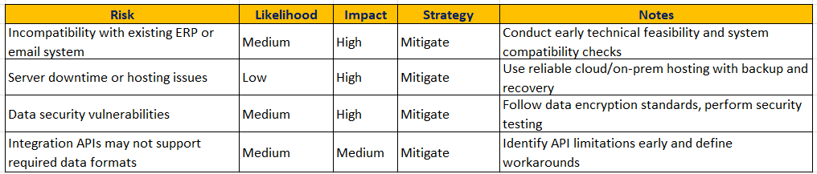
Skills Risks:
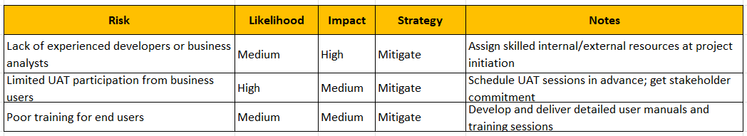
Political Risks:
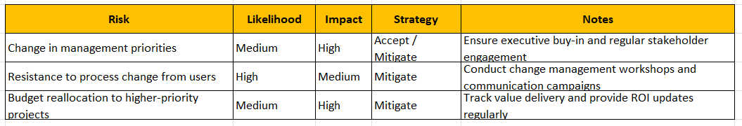
Business Risks:
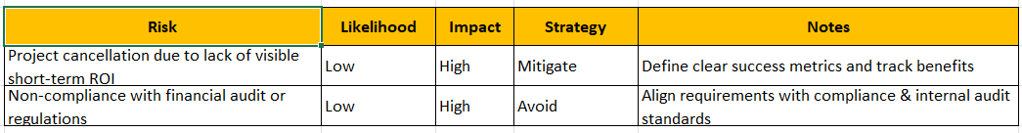
Requirements Risks:
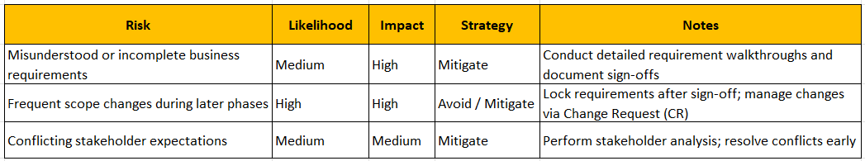
Other Risks:
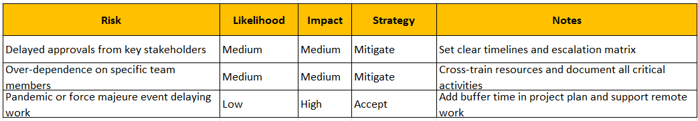
8. Business Process Overview
This section compares the existing legacy process (AS-IS) with the proposed solution (TO-BE), highlighting how the new system will resolve current inefficiencies and modernize the organization’s payment transaction processing.

I. Legacy System (AS-IS)
Currently, payment transaction requests are handled manually and submitted via email. Files are sent in various formats (Excel sheets, PDFs), creating issues around:
- Inconsistent data formatting
- Manual data entry errors
- No automated validation
- Difficult approval tracking
- No centralized database
- Delayed approvals and processing
- Compliance and audit challenges due to lack of transparency
AS-IS Process Steps
- Requestor fills out a payment transaction Excel sheet or PDF manually.
- Document is emailed to a central finance mailbox.
- Finance team manually reviews the request.
- Finance team forwards it to approvers via email.
- Approvers reply via email with approval/rejection.
- Approved transactions are keyed into the ERP system.
- No audit trail or automation.

🗺️ AS-IS Process Flow Diagram (Textual)
[Requestor fills Excel/PDF]
↓
[Emails to Finance Mailbox]
↓
[Manual Review by Finance Team]
↓
[Forward to Approver via Email]
↓
[Approver Email Response]
↓
[Manual ERP Entry]
↓
[Payment Processed]

II. Proposed Recommendations (TO-BE)
The proposed Payment Transaction Processing Application will automate, streamline, and digitize the entire process, offering:
- A centralized web portal for all users
- Standardized digital payment request forms
- Automatic validation and duplicate detection
- Role-based workflow and approval routing
- Real-time status tracking and dashboards
- Audit trail and compliance readiness
- Integration with ERP for seamless data hand-off

🧭 TO-BE Process Flow Diagram (Textual)

[User Submits Payment Request Online]
↓
[System Auto Validates Data]
↓
[Auto Workflow to Approver(s) Based on Rules]
↓
[Approver Logs In and Takes Action]
↓
[System Sends Status Notifications]
↓
[Approved Data Sent to ERP]
↓
[Payment Completed and Archived]

9. Business Requirements
This section outlines the specific business requirements elicited from key stakeholders, organized by priority and functional area. These requirements represent the foundation for functional design and implementation and are traceable through the project lifecycle.
