Question 1 – Functional Requirements
Identify minimum 20 functional requirements
Req Id | Req Name | Req Description
RQ001 | User Registration | User should be able to register with the app using his contact details
RQ002 | Search for Product | User should be able to search for the product which he intend to buy
RQ003 | Select the product | User should be able to select & place the order for the product after searching for it, by single click
RQ004 | Select No of qty | User should able to select no.of qty while adding the product into
RQ005 | Add to cart | User should able to add the product into the cart
RQ006 | Proceed check out | Once the product is added , proceed to check out
RQ007 | Select the delivery address | User should add or update the new delivery address to get their product
RQ008 | Proceed with payment using different mode | Select the payment method (G-Pay/ CC/ COD/ Net-banking
RQ009 | Cod | The end user should pay the cash at the time of receiving the product
RQ010 | Initiate payment using OTP | If it is CC/ Net-banking. The user should have the mobile ready to check and update the OTP to successfully update the otp to complete the transaction
RQ011 | Return/ Cancel order | There should be a comment box to add reasons for return or cancel he order
RQ012 | Feedback | User can add feedback / comment about the service provided
RQ013 | Order History | The user can search for previous order booked / Order placed
RQ014 | Profile Management | User should able to manage his or her profile by accessing the settings . Password update/ password change/ Contact details
RQ015 | Customer Support | User should able to reach the helpline / toll free for any queries or concerns
RQ016 | Forget Password | User should able to access the forget password link to change their password incase if they forget
RQ017 | Voice assistance | User can add voice note for their requirement asking for specific product . This voice assistance must recognize their requirement & it must be language barrier free!

Non-Functional Requirements
Req Name | Req Description | Priority
Performance | Page Loading time-The page must be loaded with the catalogue items in less than 2 seconds | 9
Scalability | App should able to handle 5000 concurrent users without glitch | 10
Security | App should be secure enough to maintain the profiles of users records, transaction including their password | 9
Reliability | App should be available (Uptime) 99% | 7
Usability | User experience must be friendly - Chances of the users literacy rate are limited | 7
OTP Authentication | OTP Authentication must be received in less than 6 seconds to initiate payment | 10
Email/ SMS | Email confirmation/ SMS Alert to be sent to the users once the order is placed | 7
Order Tracking | User must be able to see the order status (Tracking) | 6

Question 2 - Make wireframe and prototypes

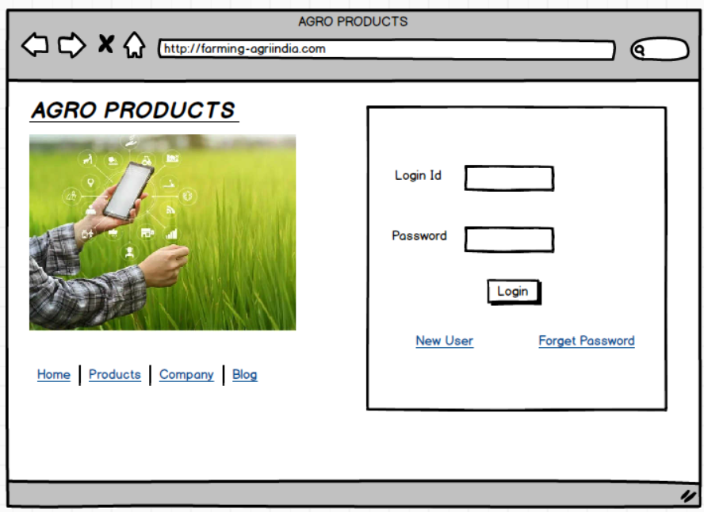

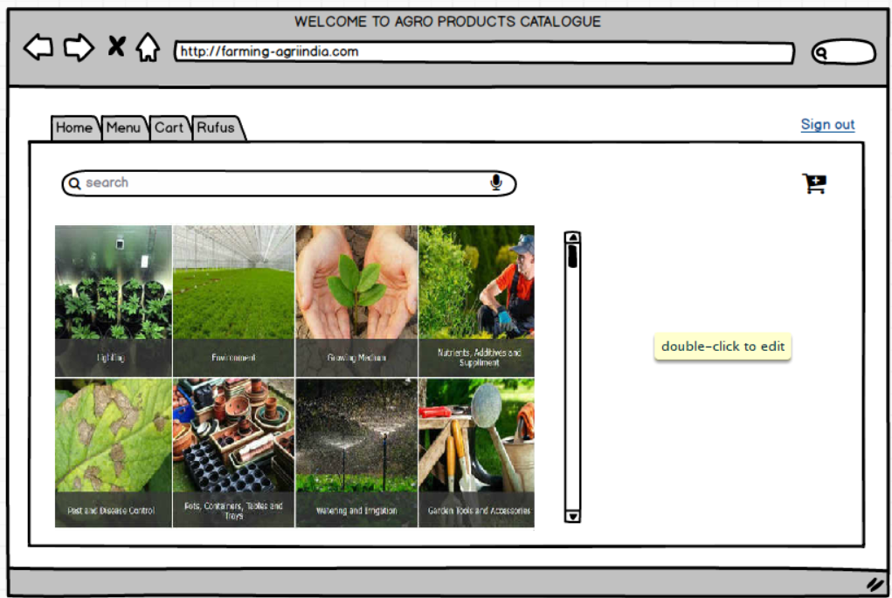

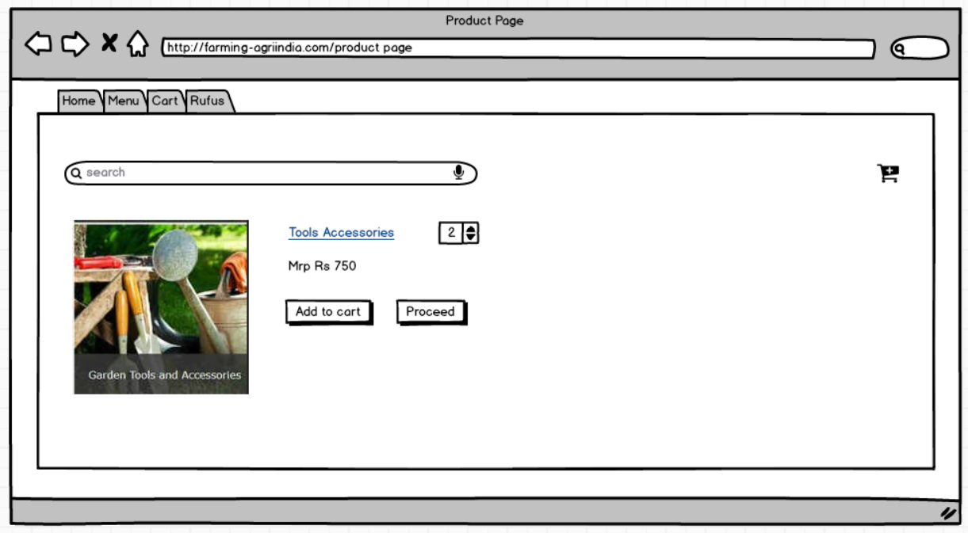

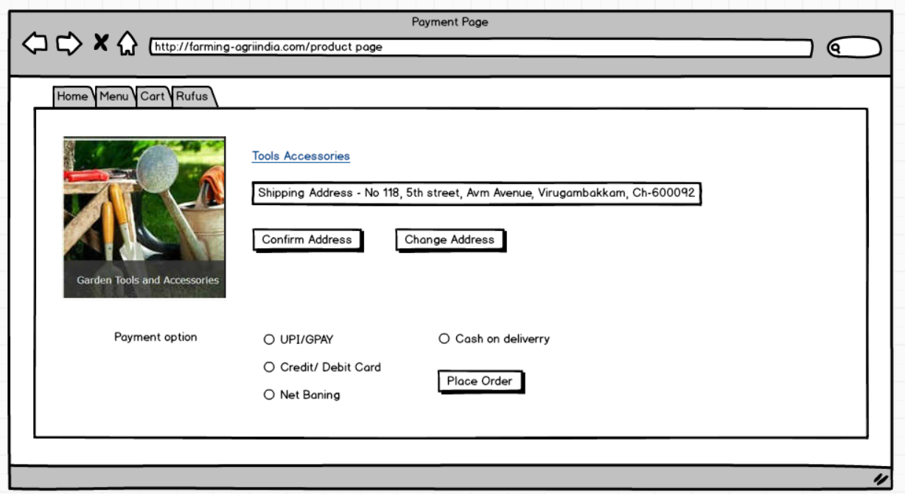

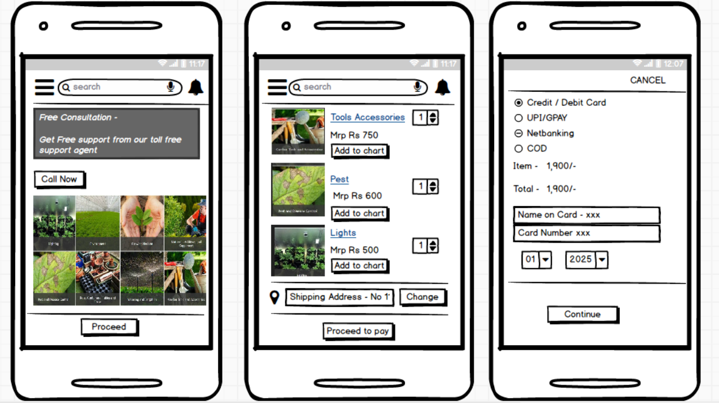

Question 4 - A business analyst’s key responsibilities are to keep track of the requirements and make sure that no requirement is missed.

Req ID | Req Name | Req Description | Design | D-1 | T-1 | D-2 | T-2 | D-3 | T-3 | D-4 | T-4 | UAT
FR001 | Farmer Registration | New user registration - Farmer should be able to register for new user |  |  |  |  |  |  |  |  |  | 
FR002 | Farmer search for Product | Farmer should be able to search for the desired product |  |  |  |  |  |  |  |  |  | 
FR003 | Product Selection | User (Farmer) should be able to select the product which he intends to buy |  |  |  |  |  |  |  |  |  | 
FR004 | Select No of qty | User (Farmer) should be able to select the quantity before proceeding for payment |  |  |  |  |  |  |  |  |  | 
FR005 | Add to chart | User (Farmer) should be able to add the product to the cart from mobile or website |  |  |  |  |  |  |  |  |  | 
FR006 | Check-out process | After successfully adding farmer should able to give check-out to confirm |  |  |  |  |  |  |  |  |  | 
FR007 | Adding or editing delivery address | Farmer should be able to add or modify the existing delivery address |  |  |  |  |  |  |  |  |  | 
FR008 | Payment process | User (Farmer) should be able to select the required / convinent payment option with CC/ GPAY/COD to proceed for placing the order. Payment gateway must be safe and secure. |  |  |  |  |  |  |  |  |  | 
FR009 | Initiate otp | User (Farmer) should make sure whether they get the otp to their registered mobile number to complete the transaction. If the payment option is CC/ Netnabking |  |  |  |  |  |  |  |  |  | 
FR010 | Return/ Cancel order | Option for either cancelling the order placed and also the choice for returning the item because of quality issue or damaged product should be available |  |  |  |  |  |  |  |  |  | 
FR011 | Feedback | Adding feedback about the product or feedback about the convinence of using the mobile app even placing order through wesite must be user friendly |  |  |  |  |  |  |  |  |  | 
FR012 | Order History | User (Farmer) must able to see his/her previous order history through their registered login or mobile number |  |  |  |  |  |  |  |  |  | 
FR013 | Profile Management | User (Farmer) must able to manage his profile settings to change password or pin and other privacy settings |  |  |  |  |  |  |  |  |  | 
FR014 | Customer Support | User (Farmer) must able to reach the toll-free support for any queries / concerns |  |  |  |  |  |  |  |  |  | 
FR015 | Forget Password | User (Farmer) must able to change his possword by accessing the link "Forget Password" incase unable to login |  |  |  |  |  |  |  |  |  | 
FR016 | Voice assistance | User (Farmer) must able to easily add voice note which should recognize their requirement and should display the catlogue or specific product. This voice assistance must be free from language barrier. has low litr |  |  |  |  |  |  |  |  |  | 
FR017 | Order Tracking | User (Farmer) should easily able to track their order to know the status of delivery |  |  |  |  |  |  |  |  |  | 
NFR01 | Page Loading time | User Must be able to see their catalogue page/ home page in less than 2 seconds once they click |  |  |  |  |  |  |  |  |  | 
NFR02 | Handling No.of users | The mobile app/ website server must handle >5000 users minimum concurrently |  |  |  |  |  |  |  |  |  | 
NFR03 | Security | App should be secure enough to maintain the profiles of users records, transaction including their password |  |  |  |  |  |  |  |  |  | 
NFR04 | Availability | The uptime of the app. I mean the usage of app must be always available (99%) |  |  |  |  |  |  |  |  |  | 
NFR05 | User Experience | User experience must be friendly. Even farmers with low litreacy rate must be able to handle the app without much challenge |  |  |  |  |  |  |  |  |  | 
NFR06 | OTP Authentication | OTP Authentication must be received in less than 6 seconds to initiate payment |  |  |  |  |  |  |  |  |  | 
NFR07 | Order Confirmation | Email confirmation/ SMS Alert to be sent to the users once the order is placed |  |  |  |  |  |  |  |  |  | 

Question 5 – Test Case Documents

TEST CASE ID | 001
TEST CASE DESCRIPTION | Login Functionality
PRIORITY | High
PRE-CONDITION | Internet/ Device
POST-CONDITION | Should be able to login successfully
S No | Action | Input | Expected Output | Test Results | Test Comments
1 | Should have proper loin id/ password to enter home page | Enter login pin/ user name & Password  raj_01@gmail.com/ Raj@123 | The app or mobile should take us to the home page successfully once we enter the credentials | Pass | Initiated for login to the profile & it is successful.

TEST CASE ID | 002
TEST CASE DESCRIPTION | Product Search
PRIORITY | Medium
PRE-CONDITION | Internet/ Device
POST-CONDITION | Should be able to easily search for the desired product which we are searching
S No | Action | Input | Expected Output | Test Results | Test Comments
2 | User should be able to search for the required product in a search option feature available in the mobile app or on the website. | Type the product or search for the product or add voice note in search box to view your product | The app should display the products available in the catalogue / also it should pull the product which we are looking for. The voice note must be recognized | Pass | Initiated for searching the product and it is successful

TEST CASE ID | 003
TEST CASE DESCRIPTION | Adding the product with no. of qty
PRIORITY | Medium
PRE-CONDITION | Internet/ Mobile or Laptop
POST-CONDITION | Stock availability must be shown on notification once the product is added into cart
S No | Action | Input | Expected Output | Test Results | Test Comments
3 | Navigate to the product / search for the product / select and move it to cart and also click +/- to choose no.of products required | User should add the product into the cart by clicking proceed and also he should add the no.of qty based on requirement | The app should display the add to cart notification and it should also display the no.of qty | Pass | Initiated for adding the product and selecting the quantity required. It is successful

TEST CASE ID | 004
TEST CASE DESCRIPTION | Payment Module
PRIORITY | High
PRE-CONDITION | Internet/ Mobile or Laptop  Card Validation (Valid & Active card)
POST-CONDITION | Payment confirmation  Order status  Warehouse packing generated
S No | Action | Input | Expected Output | Test Results | Test Comments
4 | Initiate for payment by choosing the payment method > Enter the card details if it CC/Deb Card. | User should process for payment by generating otp to their registered mobile that should be successful . If it is COD. Choose the radio button appropriately | Payment must be successful it should throw the payment confirmation status & also order confirmed | Pass | Payment done successfully & booked the product

TEST CASE ID | 005
TEST CASE DESCRIPTION | Return/ Cancel of order
PRIORITY | Medium
PRE-CONDITION | Internet/ Mobile or Laptop  Order Eligibility (Product delivered within last 7 days )
POST-CONDITION | Reverse pickup scheduled within 48hrs.  Refund processed in 3-5 business days. Once the return/ refund is initiated
S No | Action | Input | Expected Output | Test Results | Test Comments
5 | Initiate Return for Defective Product> Login>Navigate to "My Orders">Click Return Item > Confirm return method | Valid credentials (e.g., mobile/OTP) > Select product & also the reason: "Damaged Packaging > Proof (Photo/video of damaged item) | The entire process my be successful until the order is placed for return | Pass | Successfully able to initiate for return / refund of product

TEST CASE ID | 006
TEST CASE DESCRIPTION | Order History
PRIORITY | Medium
PRE-CONDITION | Internet/ Mobile or Laptop
POST-CONDITION | Should see overall Order history in past / Including Order Cancellation
S No | Action | Input | Expected Output | Test Results | Test Comments
6 | Home > Menu > Order> Order History | Search for Order History by navigating via home tab to see the past orders | The entire journey & navigating criteria must be successful to see the previous orders | Pass | Tested the functionality & its successful

TEST CASE ID | 007
TEST CASE DESCRIPTION | Order Tracking
PRIORITY | Medium
PRE-CONDITION | Internet/ Mobile or Laptop  Delivery partner's GPS enabled  Farmer's device location permissions granted
POST-CONDITION | ETA prediction  Weather risk
S No | Action | Input | Expected Output | Test Results | Test Comments
7 | Open the app by tapping it on screen> Home > Menu > Orders> Checking order status> | Tap on transit order > Taping it further will show the flow of  (Packed - Shipped - Out for delivery - Delivered) | The entire process must be successful until the order is placed for return | Pass | Tested the functionality and the process of checking the tracking status is successful

TEST CASE ID | 008
TEST CASE DESCRIPTION | Feedback
PRIORITY | Medium
PRE-CONDITION | Internet/ Mobile or Laptop
PRE-CONDITION | Delivery partner's GPS enabled
PRE-CONDITION | Farmer's device location permissions granted
POST-CONDITION | Feedback option must be enabled
S No | Action | Input | Expected Output | Test Results | Test Comments
8 | Home > Menu > Feedback | Document the feedback about the product and also the features and functionality of using this app (How user Friendly) | The feedback option or the box must be available in the app all the time | Pass | Able to add feedback successfully and able to submit the reviews

Question 6 – DB Design
After the requirements are thoroughly explained to the entire project team by business analyst, the Database architects have decided to do the database design and also to represent the in-flow and out-flow of data
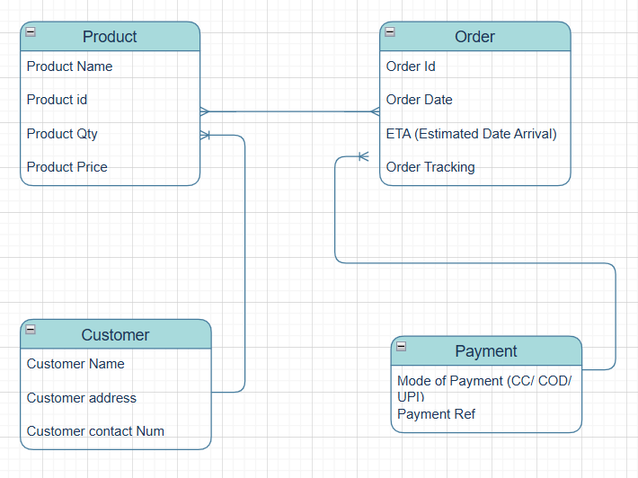

Question 7 – Data Flow Diagram

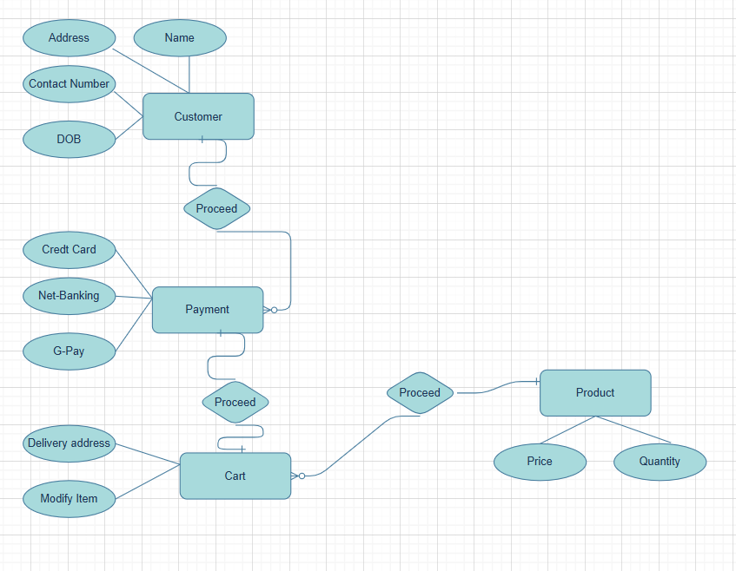
Question 8 – Change Request
Due to change in the Government Taxation structure . we should change the Tax structure How do you handle change requests in a project

Accept the Change Request | - Ensure a Change Request (CR) is submitted through the formal process  - Collect the complete reason for the change information

Analyze the Change | - Impact Analysis: How does this affect scope, cost, schedule, and resources?  - Business Value: Does the change deliver significant value or reduce risk?

Collaborate with Stakeholders | - Farmers – Colloborate with farmers to explain the recent implementation of new tax system & its workings.  - Development Team – Organize a meeting with Dev team to explain the necessary changes to be implented in the app  - Auditors – Initiate a meeting with auditors to gather the requirement & what implementation to be performed in regard to the Govt tax policy on products & the tax rates. And document accordingly.

Update Requirements Documentation | - Update Business Requirement Documents (BRD), Functional Specs, etc  - Include traceability matrices if required.

- Govt Tax policy Change
Document change specifics: "Effective 1 July 2025, fertilizer GST increases from 5% → 12%"

- Update Tax rates

Document the Tax Change Alert / Document the revised charges on all products

Question 9 – Change Request Vs an Enhancement

As the project is in process, Ben and Kevin have contacted you. The reason is to inform you that they want the Farmers to sell their crop yields through this application i.e. Farmers should be able to add their crop yields or products and display to general public and should be able to sell them. They also want to introduce Auction system for their Crop yields. As a BA, what will be your response? Is this a change request or an enhancement???

Change Request (CR) | Enhancement
Alters agreed scope/baseline | Improves existing functionality without changing the original scope (eg - new feature)

  - Technical Complexity
  - User Experience

Question 10 – Estimations

Come up with estimations – How many Man-hours required

If this project needs to be completed in 12 Months or less than 12 Months (11-12 Months)
No of working Days in a week | 5
No of working hours per day | 8
Total No of working days in a month | 21
Total No of current team strength | 9
This overall hours is excluding of all public holidays / client off  Which comes around 10 Months | 1512 hr

Note – Multiply the Total no days in a month * Total No of working hours * Team strength

Question 11 – UAT

Project has finally completed all the stages i.e., design, development, testing etc. Now, it is the role of a business analyst to contact the client for testing of the final product and have to successfully complete it. How are you going to handle this situation? And once it is done, what will be the process to close the project? Explain UAT Acceptance process

Phase 1: Preparing for UAT (User Acceptance Testing)

Stakeholder Alignment: | Meeting with the client (Farmers) to make sure all requirements are met. Need to connect with client product owner to check no major defects are identified in the app before launch.
UAT Environment Setup | It is a step by step process (Device/ Network / Security / Saftey) these are the primary checklist
UAT Documentation: | Business Requirement Document / Function Requirement Document / Use case / Process flow
Executing UAT | UAT should be thoroughly tested make sure there are no bug or block . Train farmers on app features using video demos & 24/7 WhatsApp Support
UAT Acceptance & Sign-off | After the functions are thoroughly tested, and any failures identified should be resolved List of approved features should be once again clearly tested . Finally after reviewing all the necessary documents & features / functionalities are working effectively . It should be ready for signoff before the app hits go-live
Project Closure | Ensure Project head/ Delivery head / Sponsor all reviewed the documents

Question 12 – Project Closure Document

Project Overview | Enable farmers to purchase their agriculture products raw material & other accessories through mobile app using single click.
Achievements | Total No of Farmers using the app increases as it is user friendly . This also significantly reduces the travel time , transit charge, (Can avoid language barrier while interacting with direct vendor at the time of purchasing)
Lesson Learnt | Training for all the farmers who has less exposure in handling the gadgets & who has very limited technical exposure.
Quality Assurance | 100% trustable in terms of security (End to end encrypted) profile! Also payment gateway is also more trustable
Resource Utilization | Development Team / UI & UX Team / BA team / Testers
Risk Management | Payment must be secured / Supply chain & Logistic should be safe during monsoon & resulting in potential delays in delivery
Challenges | Language Barriers / Transit by delivery partners / Identifying the exact location

1 | Did the client sign-off on the UAT testing | Yes
 | Sign-off dates | 12-05-2025
 | Name of the resource | Nathan Jones
2 | Objective of the project
 | User Friendly | 
 | Customer Satisfaction | 
3 | Functionalities worked on
 | Searching product | 
 | Adding product into cart | 
 | Updating the delivery address | 
 | Proceeding for payment | 
 | Selecting Payment method | 
 | Making Payment | 
 | Order confirmation | 
 | Tracking delivery (Order status) | 
 | Feedback | 
 | Customer support | 
 | Voice search assistance | 

