Waterfall Project 2 – Part -2/2 Evaluation

Document 6- Please prepare a use case diagram, activity diagram and a use case specification document.
Answer:
Use case diagrams
- Customer Inquiry Phase
Customer initiates contact via chat, email, or call.
The system automatically logs the interaction and identifies the customer using account details.

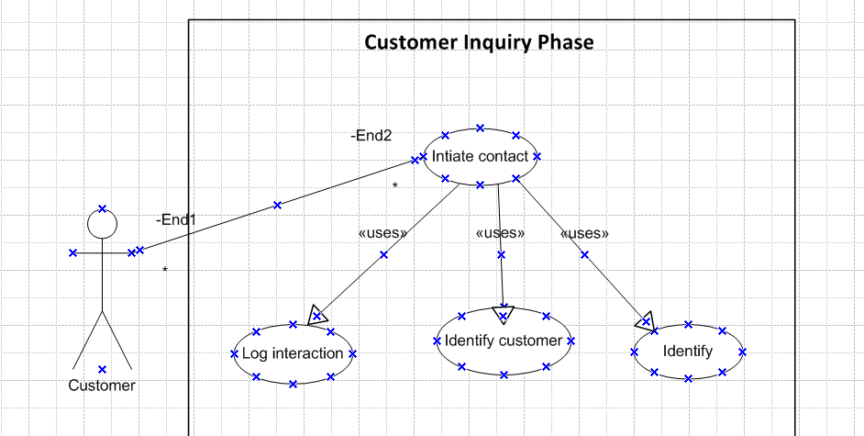

- Case Creation Phase
A support ticket is automatically created in the system.
The agent receives the ticket with all customer context and previous interaction history.
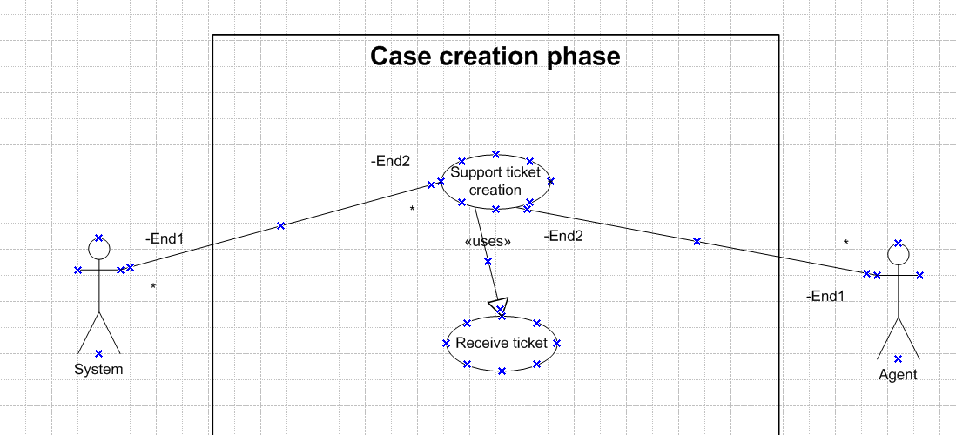

- Response & Resolution Phase
Agent uses the built-in knowledge base and customer account access to resolve the issue.
Agent communicates with the customer through the same channel or switches channel (if needed) seamlessly.
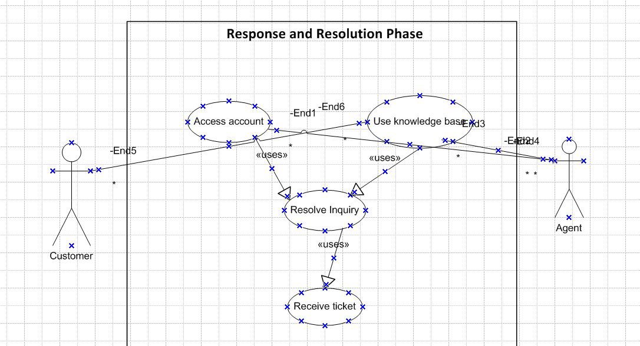

4. Follow-Up Phase
Once the issue is resolved, a customer feedback survey is sent automatically.
Survey results are stored in the system for analysis and reporting.
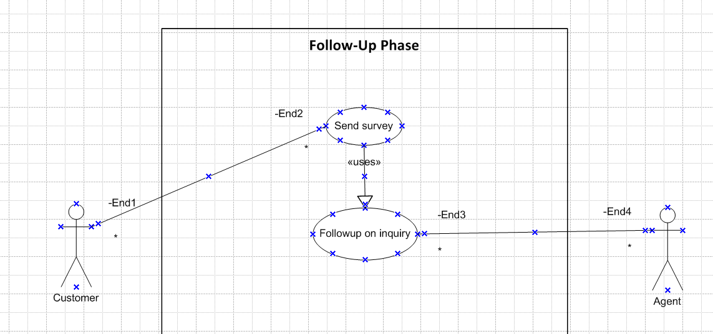

5. Escalation Phase (If Needed)
If the issue cannot be resolved at Level 1 support, it is escalated to Level 2/3.
The system notifies the relevant support level and carries forward all case details.
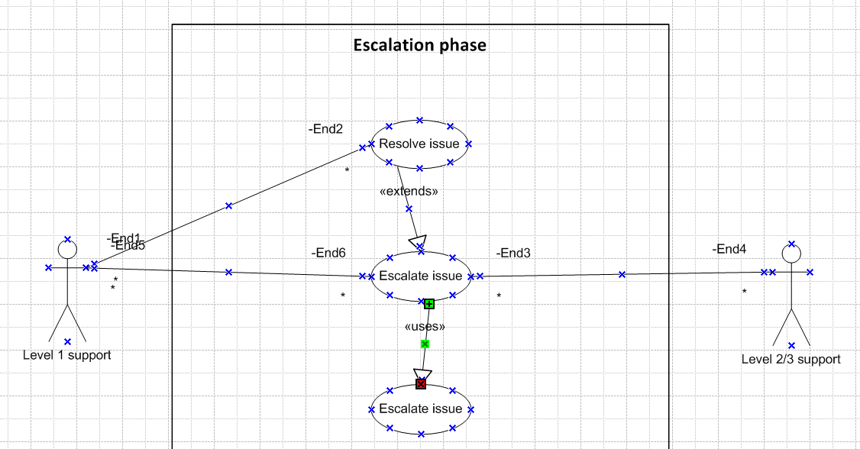

6. Reporting & Analytics Phase
Managers generate reports on resolution time, customer satisfaction, and agent performance.
Data from all support channels is unified for strategic decision-making.
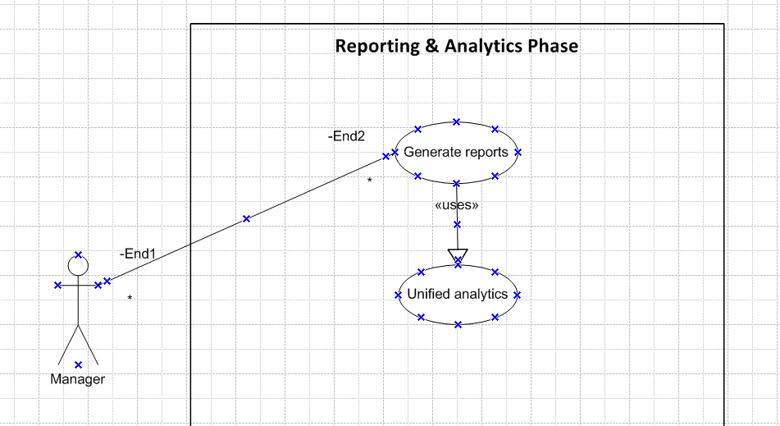

Activity diagrams

- Customer Inquiry Phase:

Here guard condition is “Contact method”

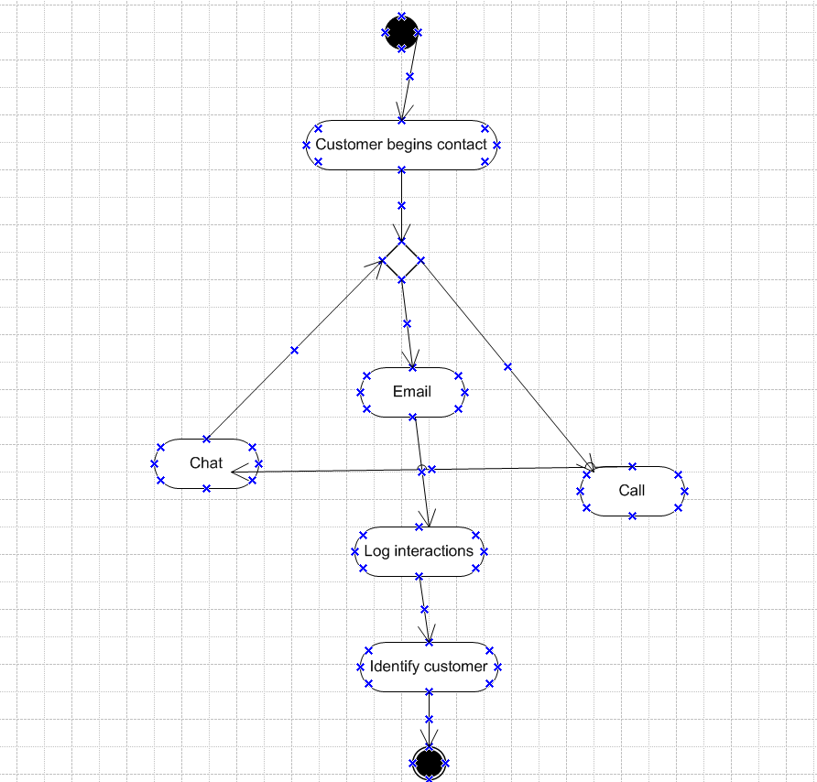

- Case Creation Phase
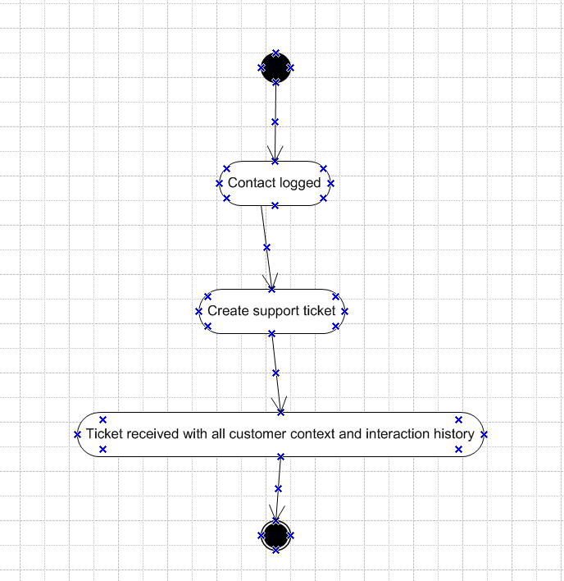

- Response & Resolution Phase
Here guard condition is “Issue resolved”

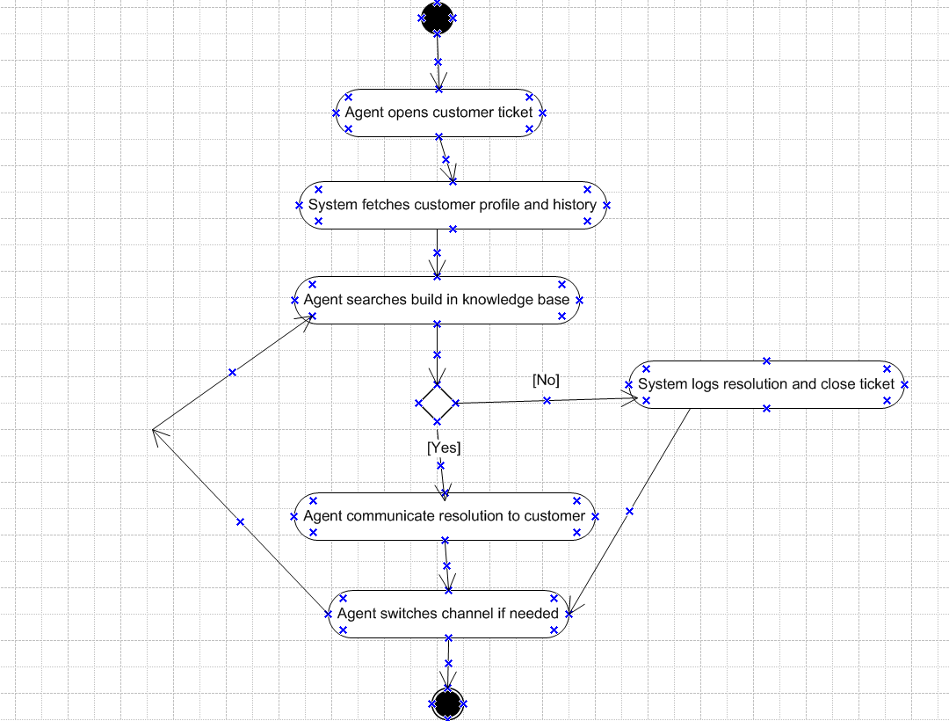

4. Follow-Up Phase
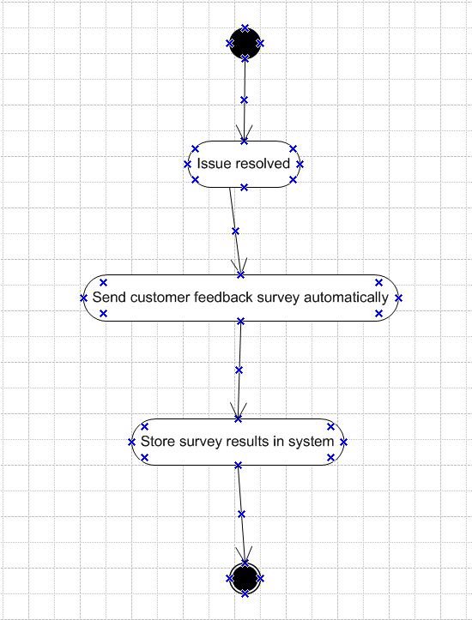

5. Escalation Phase (If Needed)
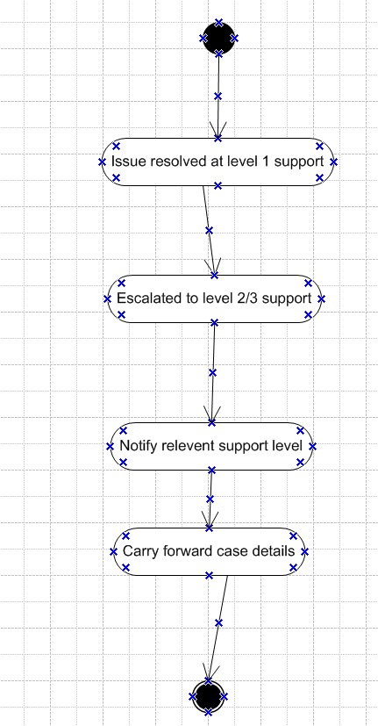

6. Reporting & Analytics Phase
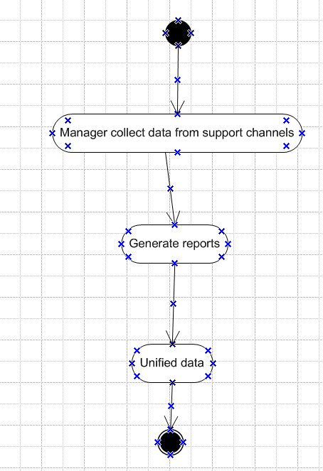

Use Case Specification Document

Customer Inquiry Phase
1. Use Case Name : Customer Inquiry Logging
2. Use Case Description
This use case covers the initial phase where the customer initiates contact through chat, email, or voice call. The system logs the inquiry and automatically identifies the customer using the provided account details (such as phone number, email ID, or login session).
3. Actors:
Primary Actor: Customer
Secondary Actors: Customer Support Agent, System
4. Basic Flow
- Customer initiates contact via chat/email/call.
- System captures the channel and time of contact.
- System fetches customer information using account details.
- System logs the inquiry in the database.
- System notifies the agent with customer details and interaction history.
5. Alternate Flow
If the system cannot auto-identify the customer:
Prompts the customer to enter verification details.
Once validated, it proceeds with Step 4 in the Basic Flow.
6. Exceptional Flows
Communication fails (e.g., dropped call or chat disconnect):
System saves partial inquiry.
Flags the case as "incomplete" and notifies agent for follow-up.
Customer provides invalid or unverifiable information:
System logs attempt and escalates to manual agent verification.
7. Pre-Conditions
Communication channels (chat, email, call) must be active.
System must have access to customer database.
8. Post-Conditions
Inquiry is logged in the system.
Agent is assigned or notified.
Customer context is available for follow-up.
9. Assumptions
Customer information exists in the system.
Customer is using registered communication channels.
10. Constraints
Real-time identification must occur within 5 seconds.
Inquiry data must be stored securely and in compliance with data protection laws.
11. Dependencies
Functional chat/email/voice systems.
Integration with CRM or customer data repository.
12. Inputs and Outputs
Inputs: Customer contact (message/call/email), account identifier
Outputs: Inquiry ID, customer profile data, agent alert
13. Business Rules
All inquiries must have a unique identifier.
System must auto-tag inquiry by source (chat/email/call).
First Response Time must be recorded for SLA tracking.
14. Miscellaneous Information
Inquiry data may be used for reporting, analytics, and audit trails.
This use case initiates downstream processes like case creation or resolution.

Case Creation Phase
1. Use Case Name: Case Creation
2. Use Case Description
This use case captures the process of automatically creating a support ticket (case) when a customer inquiry is received. The system assigns the case to a customer support agent, providing them with all relevant customer context and historical interaction data.
3. Actors
Primary Actor: System
Secondary Actors: Customer Support Agent, Customer
4. Basic Flow
- Customer inquiry is received and logged by the system.
- System generates a unique support case ID.
- System retrieves the customer profile and past interaction history.
- A case is created and populated with the current inquiry details and customer context.
- System assigns the case to an available agent based on business rules (e.g., skill, availability).
- Agent is notified and views the case details.
5. Alternate Flow
If no agent is currently available:
The case is placed in a queue.
System notifies the supervisor or auto-assigns when an agent becomes available.
6. Exceptional Flows
Case creation fails due to system error:
An error message is logged.
Supervisor is alerted.
Customer profile not found:
Case is created with partial details and flagged for verification.
7. Pre-Conditions
An inquiry must already exist in the system.
Agent assignment rules must be preconfigured.
8. Post-Conditions
Case is created with a unique ID.
Agent is assigned and notified.
Case appears in the agent’s task list or dashboard.
9. Assumptions
Customer is already identified or identifiable.
CRM integration is functional for retrieving history.
10. Constraints
Case creation must occur within 2 seconds of inquiry.
System must prevent duplicate case generation for the same inquiry.
11. Dependencies
Integration with CRM/customer database
Agent assignment engine or logic
Notification/alert system for agent dashboard
12. Inputs and Outputs
Inputs: Inquiry log, customer ID, interaction details
Outputs: Case ID, case details (assigned agent, timestamp, status)
13. Business Rules
One case per inquiry
Auto-assignment based on agent workload and skill
Cases must be timestamped and audit-tracked
14. Miscellaneous Information
Case status is initially set to "New"
All agent actions are tracked for SLA compliance

Response & Resolution Phase
1. Use Case Name: Response & Resolution
2. Use Case Description
This use case describes how a customer support agent uses available tools such as the knowledge base and customer account data to resolve a customer inquiry. The agent responds through the original communication channel (chat, email, or call) or switches channels if required.
3. Actors
Primary Actor: Customer Support Agent
Secondary Actor: Customer, System
4. Basic Flow
- Agent opens the assigned case.
- Agent reviews customer account data and interaction history.
- Agent searches the knowledge base for relevant solutions.
- Agent prepares and sends a response to the customer via the original communication channel.
- If needed, agent switches to a more appropriate channel (e.g., from email to call).
- Agent updates the case with resolution details and marks it as resolved.
5. Alternate Flow
Agent finds solution in previous resolved cases and applies it.
Customer prefers a different communication channel—agent switches as requested.
6. Exceptional Flows
Knowledge base access failure—agent escalates the case or requests tech support.
Customer does not respond—case is put on hold and follow-up is scheduled.
7. Pre-Conditions
Case must be assigned to an agent.
Agent must have access to the knowledge base and customer profile.
8. Post-Conditions
Customer receives a response.
Case is updated with resolution and marked closed, or escalated if unresolved.
9. Assumptions
Agent is trained in using all system tools.
Customer is reachable through at least one channel.
10. Constraints
SLA time limits must be met for resolution.
Channel switching must be logged and transparent.
11. Dependencies
Availability of knowledge base content
Functional communication tools (chat, email, call)
Accurate customer account integration
12. Inputs and Outputs
Inputs: Case details, customer data, KB articles
Outputs: Customer response, resolution status, case notes
13. Business Rules
All interactions must be logged.
Only authorized agents may access account data.
Knowledge base must be used before escalation.
14. Miscellaneous Information
Metrics such as time to resolve and satisfaction scores are tracked during this phase.
Agent performance is monitored based on resolution quality and communication.

Follow-Up Phase
1. Use Case Name: Follow-Up Phase
2. Use Case Description
This use case captures the process followed after a customer issue is resolved. The system automatically sends a feedback survey to the customer. Once the customer completes the survey, the results are stored and made available for analysis and reporting.
3. Actors
Primary Actor: System
Secondary Actors: Customer, Support Manager, Analyst
4. Basic Flow
- Agent resolves and closes the case.
- System triggers and sends a feedback survey to the customer via the same communication channel.
- Customer receives and submits the feedback survey.
- System stores the feedback data in the database.
- Survey results become available to managers and analysts for reporting and insights.
5. Alternate Flow
If the customer does not respond to the survey, a reminder is sent after 24 hours.
6. Exceptional Flows
Survey fails to send — system logs error and alerts admin.
Survey response is incomplete or corrupted — system requests resubmission.
7. Pre-Conditions
The customer issue must be marked as resolved in the system.
Customer contact details must be available and valid.
8. Post-Conditions
Survey feedback is stored and linked to the case ID.
Data is available for dashboards and reports.
9. Assumptions
Customer is willing to provide feedback.
Survey link is compatible with multiple devices and channels.
10. Constraints
Surveys must be sent within 24 hours of case resolution.
Survey length is limited to 5 questions to ensure completion.
11. Dependencies
Functioning email/chat/call infrastructure for sending surveys
Active feedback collection module
Data storage and analytics tools
12. Inputs and Outputs
Inputs: Case closure event, customer contact info
Outputs: Survey sent confirmation, feedback data
13. Business Rules
One survey per case can be sent.
Feedback data must be anonymized before being used in reports.
Customers can opt out of surveys at any time.
14. Miscellaneous Information
Survey results contribute to agent KPIs and customer satisfaction scoring.
Surveys are customizable by the support manager based on case type.

Escalation Phase
1. Use Case Name: Escalation Phase
2. Use Case Description
This use case covers the process followed when a customer issue cannot be resolved by Level 1 support. The system escalates the case to Level 2 or Level 3, notifies the relevant team, and ensures that all case-related data is carried forward without any loss of context.
3. Actors
Primary Actor: Level 1 Support Agent
Secondary Actors: Level 2/3 Support Agent, System, Support Manager
4. Basic Flow
- Level 1 Agent determines that the issue cannot be resolved at their level.
- Agent selects "Escalate" option in the system.
- The system updates the ticket status to "Escalated" and tags the appropriate support level.
- Case details, including chat logs, attachments, and previous interactions, are forwarded to Level 2/3 team.
- Notification is sent to the relevant Level 2/3 support agent.
- Level 2/3 agent takes over the case.
5. Alternate Flow
If no Level 2/3 agent is immediately available, the system places the ticket in a queue and notifies the team lead.
6. Exceptional Flows
Escalation fails due to system error — agent receives an alert to retry or contact admin.
Incorrect team selected for escalation — agent can reassign before Level 2/3 agent accepts the case.
7. Pre-Conditions
Case must be active and assigned to Level 1 support.
Agent must have escalation permissions.
8. Post-Conditions
Case is reassigned to Level 2/3 team.
All relevant information is transferred without data loss.
Ticket history reflects escalation timeline.
9. Assumptions
Escalation teams (Level 2/3) are defined in the system.
Escalation thresholds and guidelines are available to agents.
10. Constraints
Escalation must occur within the SLA time window.
System must maintain audit trail for all escalation actions.
11. Dependencies
Escalation routing logic must be configured correctly.
Role-based access control must ensure only authorized escalations.
12. Inputs and Outputs
Inputs: Existing support ticket, escalation trigger from Level 1 agent
Outputs: Updated ticket status, notification sent to next level, full case handover
13. Business Rules
Level 1 support can escalate only after one attempt to resolve.
Every escalation must be justified with notes in the ticket.
Escalation teams must acknowledge reassigned cases within 30 minutes.
14. Miscellaneous Information
Escalations are tracked in performance reports.
Customers are notified if the escalation will delay resolution time.

Reporting & Analytics Phase
1. Use Case Name: Reporting & Analytics Phase
2. Use Case Description
This use case describes how managers utilize the system to generate reports based on customer support data. The goal is to monitor key performance indicators (KPIs) such as resolution time, customer satisfaction, and agent efficiency by aggregating data from all communication channels (chat, email, calls, surveys).
3. Actors
Primary Actor: Support Manager
Secondary Actors: System, BI (Business Intelligence) Tool/Module
4. Basic Flow
- Manager logs into the reporting dashboard.
- Selects the type of report to generate (e.g., Resolution Time, Agent Performance, CSAT).
- Chooses the time period and relevant filters (team, channel, ticket type).
- The system fetches and aggregates the data from different modules.
- Reports are displayed in visual format (charts, tables) or exported.
- Manager reviews the report and uses it for decision-making.
5. Alternate Flow
Manager schedules automated recurring reports (e.g., daily, weekly).
Manager shares report via email or exports to Excel/PDF.
6. Exceptional Flows
Data source unavailable — system prompts retry or alerts administrator.
User selects invalid filter — system requests correction.
7. Pre-Conditions
User must have reporting access rights.
Data must exist for the selected timeframe.
8. Post-Conditions
Report is generated and optionally saved or exported.
Insights can be used to optimize team performance and service quality.
9. Assumptions
All support channels (chat, email, call, surveys) are integrated.
Historical data is stored in a retrievable format.
10. Constraints
Large volumes of data may increase report generation time.
Data retention policies might limit how far back data can be analyzed.
11. Dependencies
Dependence on operational modules (ticketing, survey, chat logs) to supply accurate data.
Requires stable BI or reporting engine integration.
12. Inputs and Outputs
Inputs: Filtered criteria (date range, agent/team, metrics), data logs
Outputs: Reports, dashboards, analytics graphs, downloadable files
13. Business Rules
Only authorized roles can access sensitive performance data.
Reports must be generated using up-to-date data.
Survey data must be anonymized before aggregation.
14. Miscellaneous Information
Reports are archived for compliance tracking.
System must support drill-down capability for deeper insights.

Document 7- Screens and pages
Answer:
1. Customer Inquiry Phase
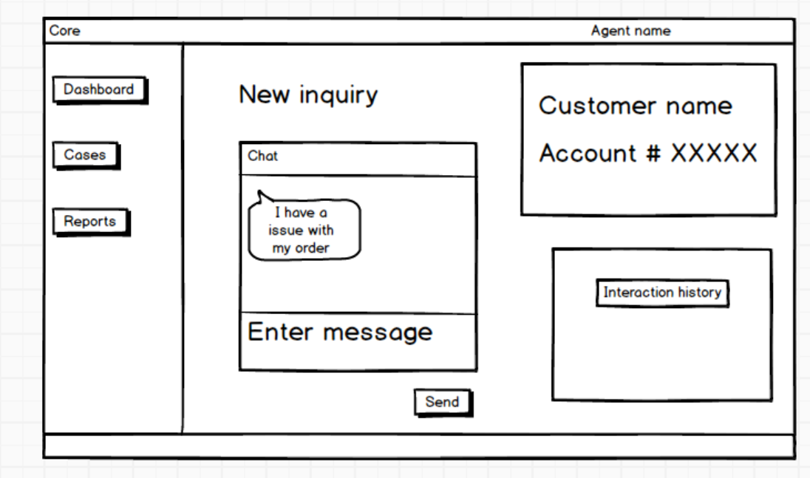
2. Case Creation Phase
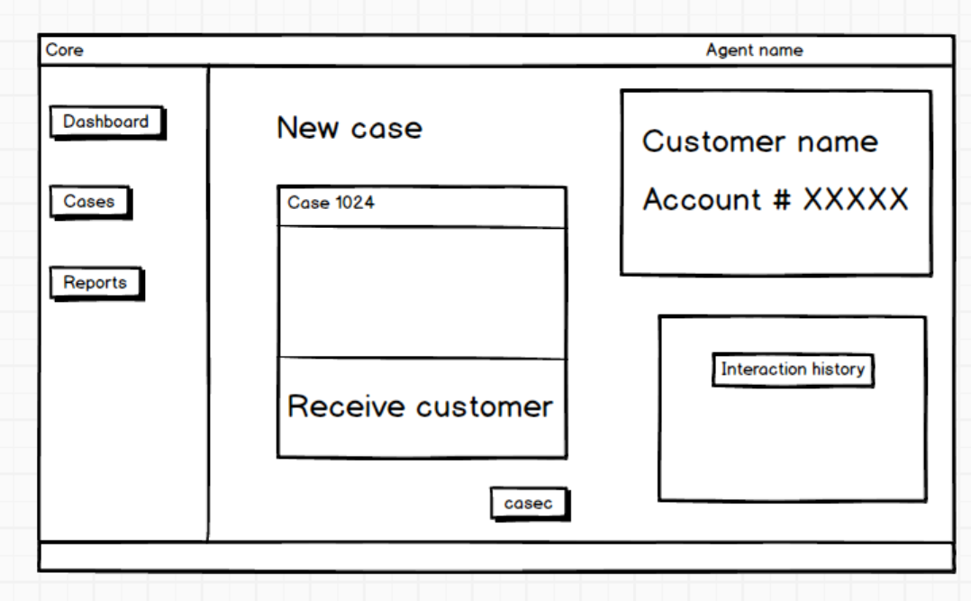
3. Response & Resolution Phase
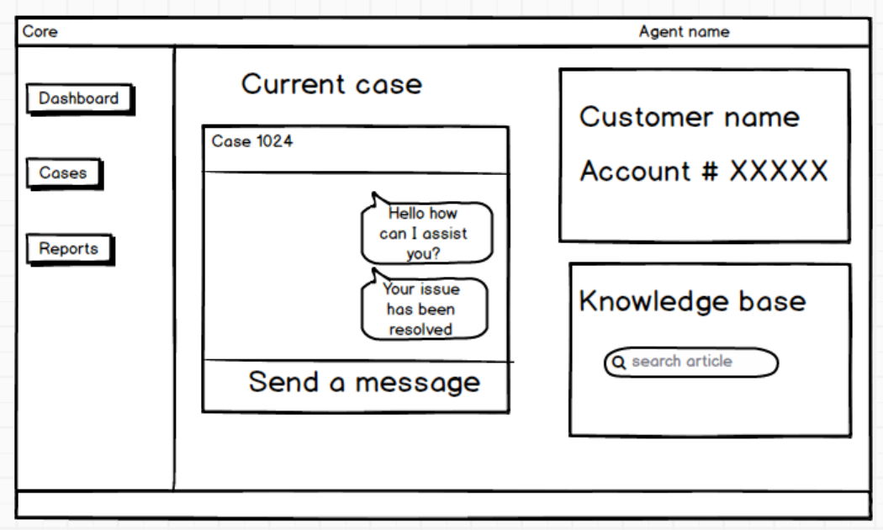
4. Follow-Up Phase
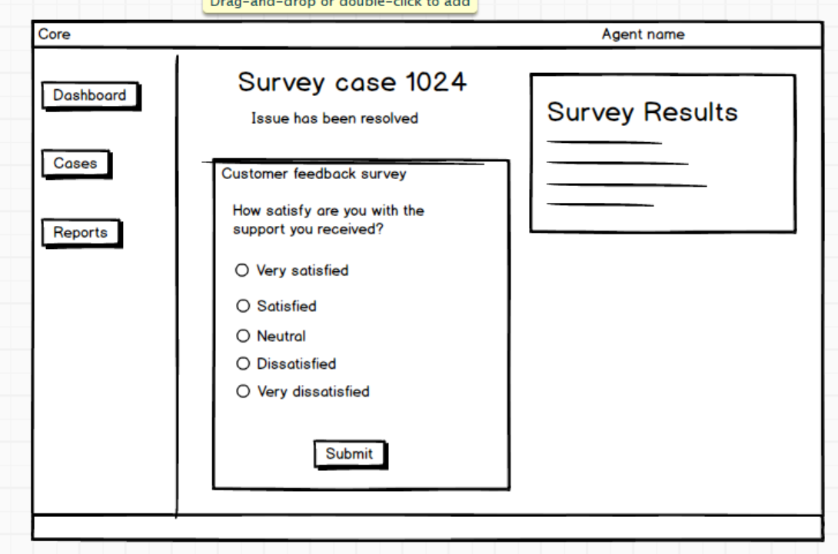
5. Escalation Phase (If Needed)
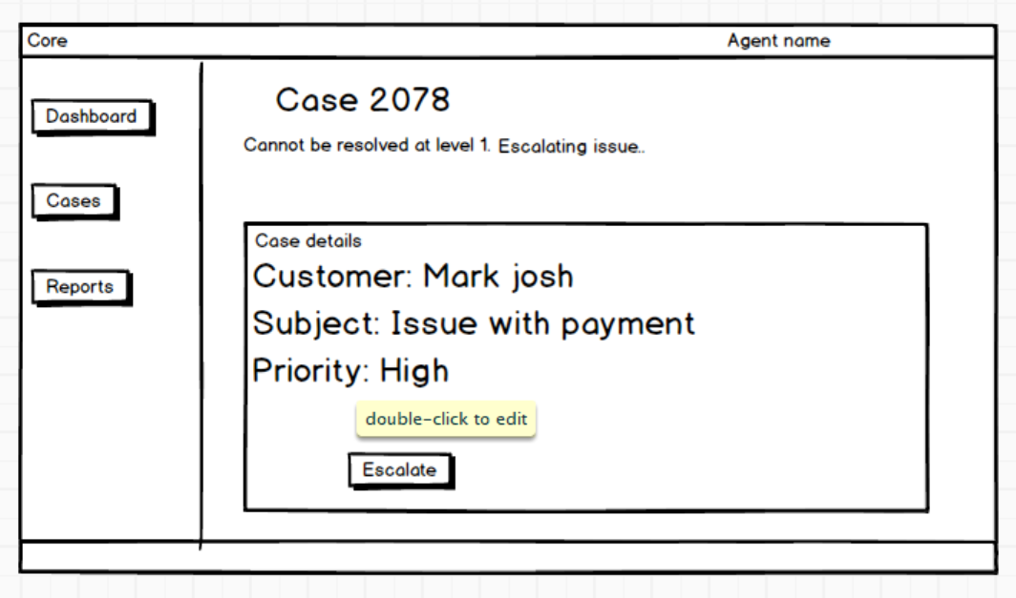
6. Reporting & Analytics Phase
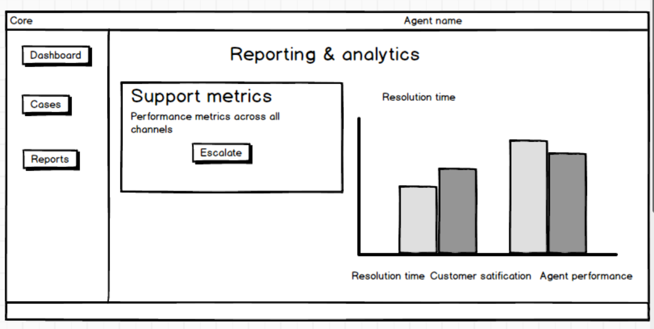

Document 8
Tools-Visio and Axure Write a paragraph on your experience using Visio and Axure for the project.
Answer:
Using Microsoft Visio for the core customer support application project was a valuable experience, especially for creating detailed and structured visual models. Visio enabled us to design comprehensive use case diagrams and activity diagrams for each phase of the customer support process, such as Customer Inquiry, Case Creation, Response & Resolution, and Reporting. The tool’s intuitive interface and wide range of diagramming templates helped in clearly representing workflows, system interactions, and actor relationships. These visuals were instrumental during stakeholder discussions, helping to ensure a shared understanding of the system’s functionality and processes. Overall, Visio contributed significantly to the clarity and quality of the project’s documentation, making it easier to align business requirements with technical implementation.
Axure, on the other hand, will be used for designing interactive wireframes and mockups, providing a realistic preview of user interface screens across different stages of the application. Its drag-and-drop functionality and ability to simulate user interactions enhanced our ability to gather early feedback, validate requirements, and align design expectations with development goals. Together, these tools contributed significantly to efficient communication, improved documentation, and reduced design ambiguity.

Document 9- BA experience
My experience as BA in following phases:
Answer:
- Requirement gathering:
As a Business Analyst (BA) during the Requirement Gathering phase of the core customer support application project, my approach focused on structured elicitation and validation methods to ensure clarity and completeness. I began by applying the MoSCoW technique to prioritize requirements into Must Have, Should Have, Could Have, and Won’t Have categories, which helped manage stakeholder expectations and scope definition effectively. One challenge faced was the limited availability of the client, which required me to proactively identify alternate points of contact from the client side to avoid delays and gather key inputs on time.
To validate the collected requirements, I utilized the FURPS model (Functionality, Usability, Reliability, Performance, and Supportability), ensuring all aspects of the system were considered. During this process, I identified duplicate or redundant requirements, which were promptly reviewed and eliminated to maintain a clean and actionable requirement set. Additionally, I introduced prototyping techniques, including early wireframes and mock-ups, to help stakeholders visualize the application features. This method led to more precise and refined requirements, as visual representation enabled better feedback and engagement. Overall, the phase required strong coordination, analytical thinking, and effective communication to gather high-quality requirements despite constraints.
- Requirement Analysis:

As a Business Analyst (BA) during the Requirement Analysis phase of the core customer support application project, my role was to interpret and structure the gathered requirements into clear, actionable artifacts for the development team. I began by preparing UML diagrams, such as use case diagrams to represent system interactions and activity diagrams to illustrate detailed process flows like Customer Inquiry, Case Creation, and Escalation phases. These visual representations helped in conveying complex requirements in a more understandable format.

Once the diagrams were prepared, I presented them to the development and QA teams. During discussions, some team members raised valid concerns or offered improvements based on their technical perspectives. As a BA, I facilitated collaborative reviews, ensured all feedback was documented, and made necessary modifications to reflect a shared understanding of the system.

Simultaneously, I was responsible for drafting both the Business Requirements Specification (BRS) and the System Requirements Specification (SRS) documents. The BRS outlined the high-level goals and needs from the business perspective, while the SRS translated these into detailed functional and non-functional system specifications. This phase was critical in bridging the gap between business intent and technical implementation, requiring clear documentation, effective communication, and iterative refinement.

- Design:
As a Business Analyst during the Design phase of the core customer support application project, my primary responsibility was to ensure that the transition from requirements to solution design was both accurate and comprehensive. Starting with the finalized use case diagrams, I collaborated with the QA team to derive detailed test cases, covering both positive and negative scenarios. I was particularly meticulous about not missing any edge cases, as even a small oversight could lead to major issues during development or UAT.
In parallel, I regularly communicated with the client to review and validate the design and solution documents, ensuring that what was being proposed aligned with their expectations. I also played an active role in preparing test data that could be used during the testing phase to simulate real-world scenarios, helping testers verify the system’s robustness and accuracy.
Additionally, I updated the Requirements Traceability Matrix (RTM) consistently to ensure each requirement from the BRS and SRS was mapped to its corresponding test cases and design components. This was crucial for maintaining end-to-end traceability and ensuring complete coverage. My involvement in this phase was instrumental in laying a strong foundation for testing and eventual implementation.
- Development:
As a Business Analyst during the Development phase of the core customer support application project, my role was centered around facilitating smooth communication between the technical team and the client, and ensuring that the development progressed in alignment with the defined requirements. I organized JAD (Joint Application Development) sessions to bring together stakeholders and developers for collaborative discussions, which proved essential for addressing ambiguities in implementation.
During development, I actively clarified queries from the technical team regarding business logic, functional expectations, and data flow. There were instances where certain team members either disagreed with the proposed design or showed reluctance during JAD sessions. I handled such situations tactfully by having one-on-one discussions, explaining the potential impact of their disengagement on project outcomes, and fostering a healthy team environment based on mutual understanding and respect.
To support the developers, I regularly referred to use case and activity diagrams, helping them visualize the workflow and code each module correctly. I also conducted regular meetings with both the technical team and the client to ensure consistent progress and feedback. When some team members couldn’t attend, I ensured the sessions were recorded and followed up with individual discussions to keep everyone on the same page. These efforts helped maintain transparency, accountability, and steady development momentum throughout the phase.
- Testing:
As a Business Analyst during the Testing phase of the core customer support application project, my primary responsibility was to ensure that the developed application aligned with the documented requirements and delivered the expected functionality. I began by preparing detailed test cases derived directly from the use cases and user stories created earlier. These test cases covered both positive and negative scenarios, ensuring thorough validation of each feature.
I was actively involved in performing high-level testing alongside the QA team to verify end-to-end workflows, including chat, email, voice call handling, knowledge base access, and feedback mechanisms. To facilitate effective testing, I coordinated with the client to request and obtain realistic test data, which was essential for simulating actual user interactions and edge cases.
As part of traceability and compliance, I regularly updated the RTM (Requirements Traceability Matrix) to track the coverage of each requirement against test cases. Once the testing was complete and all issues were addressed, I worked on obtaining a formal sign-off from the client, confirming that the application met their expectations.
In preparation for User Acceptance Testing (UAT), I collaborated closely with the client team, helping them understand the scope of UAT, walk through the test scenarios, and ensure they were equipped to validate the application independently. This proactive involvement helped minimize UAT defects and enabled a smooth transition toward deployment.
- Deployment:
As a Business Analyst in the Deployment phase of the core customer support application project, my role focused on ensuring a seamless transition from development to production and preparing end users for adoption. I forwarded the finalized Requirements Traceability Matrix (RTM) to the client, ensuring it was properly attached to the project closure documentation for formal recordkeeping and audit purposes.
I also coordinated the creation and distribution of end user manuals, collaborating with the documentation and product teams to ensure the guides were clear, user-friendly, and aligned with the final functionality. To support successful onboarding, I planned and organized comprehensive training sessions for end users, tailoring the content to different user roles such as customer service agents, team leads, and managers.
Additionally, I worked diligently to track attendance and follow up individually with users who missed the training to ensure full coverage. By making sure all relevant users attended the sessions, I helped reduce future support queries and ensured the application was used effectively from day one. This proactive engagement during deployment was crucial for achieving a smooth go-live and ensuring client satisfaction.

