AGILE DELIVERABLES
Document 1- Definition of Done
Definition of Done (DoD) Checklist for the Credit Monitoring Application, structured as per the Agile Extension to the BABOK Guide v2. The checklist is broken down into three levels: User Story, Sprint, and Release -covering both acceptance criteria and quality criteria.
Definition of Done Checklist – Credit Monitoring Application
User Story Level DoD Checklist
S.No | Criteria
1 | All acceptance criteria for the user story are met and verified.
2 | Code is written for all the functionalities mentioned in the story.
3 | All functional and non-functional assumptions in the user story are addressed.
4 | Unit tests are written for new code and pass successfully.
5 | Code is peer-reviewed and approved.
6 | Code compiles/builds without any errors or warnings.
7 | Code is integrated into the main branch without merge conflicts.
8 | Feature is deployed in the development/test environment.
9 | UX/UI review completed and approved by UX designer.
10 | Story functionality is tested on specified devices/browsers.
11 | QA testing completed with defects logged and resolved.
12 | Feature is verified against acceptance criteria by QA.
13 | Product Owner has reviewed and signed off the story.
14 | Refactoring (if needed) is completed.
15 | Configuration/build changes are documented.
16 | User and system documentation is updated.

Sprint Level DoD Checklist
S.No | Criteria
1 | All committed user stories meet their DoD.
2 | All major/blocking bugs are fixed and retested.
3 | Integrated code is stable and tested end-to-end.
4 | All test cases (manual & automation) are documented and stored.
5 | Sprint review/demo is completed with stakeholders.
6 | Burn down chart is updated.
7 | Retrospective conducted and action items documented.
8 | Any incomplete items are moved back to the product backlog.

Release Level DoD Checklist
S.No | Criteria
1 | All sprints for the release are completed and stories meet their DoD.
2 | Full system integration testing is completed.
3 | Regression testing is passed successfully.
4 | Performance and security testing conducted as needed.
5 | Deployment checklist reviewed and approved.
6 | Release is approved by stakeholders (Product Owner, QA Lead, Business).
7 | Release notes are prepared and shared.
8 | Production deployment is successfully executed.
9 | Monitoring and support plans are in place.
10 | End-user documentation and training materials are updated.

Document 2- Product Vision
Project Name and Stakeholders list:
Project Name: | Qconneqt (Loan Monitoring Application)
Venue: | Conference Room 2B / Microsoft Teams (Hybrid Mode)
Date: 24-07-2025 | Start time: 10:00 AM | End time: 12:30 PM | Duration: 2 Hours 30 Minutes
Client: | Union Bank of India
Stakeholder list: | Chief Technology Officer (CTTO) | General Manager Credit Risk | Credit Monitoring Officers
 | Branch Managers | Compliance Team | Legal & Recovery Team
 | IT Vendor Partner (APT IT Solutions)
Scrum Team
Scrum Master: | Ravi Kumar
Product owner: | Prem Kumar
Scrum Developer 1: | Ankit Rao | Front End Developer
Scrum Developer 2: | Nisha Jain | Back End Developer
Scrum Developer 3: | Farhan Ali | Database Engineer
Scrum Developer 4: | Rekha Iyer | QA/Test Engineer
Scrum Developer 5: | Vikram Shetty | API Integration Specialist

Product Vision Details:
Vision: To build a smart, centralized Credit Monitoring Application that enables early detection of risk accounts, supports proactive recovery actions, and ensures regulatory compliance through real-time tracking, reporting, and communication capabilities.
Target group  1.Banking and  Financial Services  2.Retail & MSME  Lending Units  3.Public Sector and  Private Banks  4.NBFCs (Non-Banking  Financial Companies)  Target users  - Credit Monitoring Officers  - Branch Credit Officers  - Risk & Recovery Teams  - Credit Managers | Needs  Manual tracking of  overdue loans are  inefficient and error-  prone  Lack of timely alerts  causes delayed  recovery actions  Difficulty in generating  real-time credit  portfolio reports  Benefits  Enables automated  alerts and proactive  follow-ups.  Enhances visibility into  loan performance  across branches.  Reduces NPAs through  early warning systems.  Facilitates quick  decision-making with  real-time dashboards. | Product  An enterprise-grade  web-based and mobile-  enabled Credit  Monitoring Application  integrated with the  Bank's CBS (Core Banking  System) and Credit  Bureau APIs.  Real-time alerts for  overdue EMIs.  Integration with  SMS/Email/WhatsApp  for communication.  Role-based access  control for secure  usage.  Feasibility  With the availability of modern web technologies, secured APIs, and internal CBS access, the application is feasible within a 8–12 months sprint roadmap. | Value  Reduction in NPAs and  delinquency ratios,  Improved recovery  rates and timely  interventions.  Reduced manual  effort & operational  costs.  Better customer  engagement  through  structured  communication.  Reduce delinquency  >30 days by 25% in the  next 2 quarters.  Improve collection  efficiency ratio by 15%.  Automate 80% of  follow-up reminders  and escalations.  Business Model  Internal enterprise  deployment across  Branches & Zones.  SaaS-model  availability for  future scaling with  other institutions.  Licensing to partner  NBFCs (in future  phases).

Document 3 – User stories
User Story 01: View real-time list of overdue accounts
User story No: 01 | Tasks: 02 |  | Priority: High
Value statement:
As a Credit Monitoring Officer,
I want to see a real-time list of all overdue accounts,
so that I can prioritize recovery actions effectively.
BV: 500 |  | CP: 13
Acceptance criteria:
- Shows borrower name, account number, overdue amount, and days past due
- Data refreshes every 15 minutes
- Option to filter by branch, product, and priority

User story No: 02 | Tasks:02 |  | Priority: High
Value statement:
As a Credit Monitoring Officer,
I want to set follow-up tasks for overdue accounts,
so that I can track actions taken and ensure timely recovery.
BV: 100 |  | CP:5
Acceptance criteria:
- Tasks can be assigned with due date and notes
- Status options: Pending, Completed, Escalated
- Task list visible on dashboard

User Story No 02: Set reminders and follow-up tasks for overdue accounts
User Story No 03: Generate branch-wise delinquency reports

User story No: 03 | Tasks: 02 |  | Priority: High
Value statement:
As a Credit Monitoring Officer,
I want to generate delinquency reports branch-wise,
so that I can analyze NPA trends and escalate issues where necessary.
BV: 100 |  | CP: 5
Acceptance criteria:
- Reports available in PDF and Excel format
- Shows overdue %, NPA %, and ticket size bands
- Filters for date range, loan type, and product

User Story No 03: Generate branch-wise delinquency reports
User Story No 04: Flag high-risk customers
User story No: 04 | Tasks: 01 |  | Priority: Medium
Value statement:
As a Credit Monitoring Officer,
I want to flag high-risk customers,
so that I can closely monitor them and reduce future defaults.
BV:50 |  | CP:3
Acceptance criteria:
- Risk flags: High Risk, Watchlist, Repeat Defaulter
- Flags visible on borrower profile
- Only authorized officers can edit flags

User story No: 5 | Tasks: |  | Priority: High
Value statement:
As a Credit Monitoring Officer,
I want to access borrower contact details,
so that I can initiate reminders or recovery calls easily.
BV:100 |  | CP:5
Acceptance criteria:
- Contact info includes phone, email, and address
- Visible only to authorized officers
- Option to export limited contact list

User Story No 5: Access borrower contacts details for follow-up

User Story No 6: View and track repayment trends
User story No: 6 | Tasks: 02 |  | Priority: High
Value statement:
As a Credit Monitoring Officer,
I want to track repayment trends over time,
so that I can identify habitual late payers or declining repayment behavior.
BV: 100 |  | CP:5
Acceptance criteria:
- Graphical view of EMI payments over past 6–12 months
- Trends by loan type and risk category
- Downloadable insights report

User Story No 7: Monitor loans under restructuring or moratorium
User story No:7 | Tasks:2 |  | Priority: Medium
Value statement:
As a Credit Monitoring Officer,
I want to track loans under restructuring or moratorium,
so that I can ensure compliance and recovery post-moratorium
BV:50 |  | CP:3
Acceptance criteria:
- Separate tab for restructured/moratorium loans
- Shows original vs revised terms
- Highlights upcoming review dates

User story No:8 | Tasks:2 |  | Priority: High
Value statement:
As a Credit Monitoring Officer,
I want to automate follow-up reminders for overdue accounts,
so that I can save time and ensure timely communication.
BV:500 |  | CP:13
Acceptance criteria:
- Templates triggered by number of overdue days
- SMS/Email log viewable by officer
- Manual override option

User Story No 8: Send automated follow-up emails/SMS for overdue accounts
User Story No 9: Escalate accounts to Legal or Recovery Team
User story No: | Tasks:2 |  | Priority: Medium
Value statement:
As a Credit Monitoring Officer,
I want to escalate chronic overdue accounts to Legal or Recovery Team,
so that I can initiate formal recovery proceedings.
BV: 50 |  | CP:3
Acceptance criteria:
- Escalation option available after X days overdue
- Notes must be entered with reason
- Email notification sent to escalated party

User Story No 10: Filter and download defaulter list by loan product
User story No:10 | Tasks:2 |  | Priority: Medium
Value statement:
As a Credit Monitoring Officer,
I want to filter and download defaulter lists by loan product,
so that I can analyze problem areas by product or geography.
BV:50 |  | CP:3
Acceptance criteria:
- Filters: Loan product, branch, days overdue
- Download available in Excel format
- Includes loan ID, borrower name, contact, overdue amount

User Story No 11: Dashboard for Credit Exposure Overview
User story No:11 | Tasks:2 |  | Priority: High
Value statement:
As a Regional Credit Monitoring Officer,
I want to see a real-time dashboard displaying key credit risk metrics (NPA %, overdue loans, high-risk accounts) for my region,
so that I can quickly identify problem areas and take corrective actions.
BV:100 |  | CP:5
Acceptance criteria:
- Dashboard loads in <3 seconds.
- Displays at least 5 critical risk KPIs.
- Allows filtering by branch/portfolio.

User Story 12: Automated High-Risk Account Alerts
User story No:12 | Tasks:2 |  | Priority: High
Value statement:
As a Zonal Credit Monitoring Officer,
I want to receive automated alerts when any account in my zone breaches predefined risk thresholds,
so that I can proactively mitigate potential defaults.
BV:100 |  | CP:5
Acceptance criteria:
- Alerts trigger within 15 mins of threshold breach.
- Notifications include account ID, risk level, and recommended actions.
- Configurable thresholds for different risk categories.

User Story 13: Cross-Region Portfolio Performance Report
User story No:13 | Tasks:2 |  | Priority: Medium
Value statement:
As a Zonal CMO,
I want to generate a report comparing credit performance (NPA %, recovery rates) across all regions in my zone,
so that I can allocate resources to underperforming regions.
BV:50 |  | CP:3
Acceptance criteria:
- Report shows side-by-side comparisons for ≥3 KPIs.
- Supports date range filters (e.g., quarterly/annual).
- Exported files retain all formatting.

User Story 14: Loan Restructuring Approval Workflow
User story No:14 | Tasks:2 |  | Priority: Medium
Value statement:
As a Regional CMO,
I want to review and approve/reject exception-based loan restructuring requests through a digital workflow,
so that I can reduce manual paperwork and delays.
BV:50 |  | CP:3
Acceptance criteria:
- System records approver name/timestamp for audit.
- Pending requests highlight overdue items.
- Rejections require mandatory comments.
User Story 15: NPA Trend Analysis & Forecasting
User story No:15 | Tasks:2 |  | Priority: Medium
Value statement:
Value Statement:
As a Zonal CMO,
I want to analyze NPA trends over the past 5 years and forecast future risks,
so that I can adjust credit policies pre-emptively.
BV:50 |  | CP:3
Acceptance criteria:
- Trends visible at region/zone levels.
- Forecasts include confidence intervals.
- Supports drill-down to granular data.

Document 4 – Agile PO Experience

As a Product Owner (PO) for the Credit Monitoring Application, I played a pivotal role in driving the vision, roadmap, and delivery of a product that addresses critical needs in the Banking domain—especially around loan performance, early warning signals, credit risk insights, and proactive borrower engagement.
Key Responsibilities and Contributions
1. Market Analysis
- Conducted an in-depth market study to assess the need for credit monitoring tools due to increasing NPAs (Non-Performing Assets) and regulatory demands for real-time credit performance tracking.
- Benchmarked our solution against existing credit monitoring products used by other Banks and Fintechs, identifying gaps such as lack of automation, delayed alerts, and poor UI/UX.
- Engaged with end users including Loan Monitoring Officers (LMOs), Branch Managers, and Credit Heads to gather pain points in the current manual processes.
2. Enterprise Analysis
- Performed due diligence on the market opportunity in collaboration with stakeholders from the Risk, Credit, and IT departments.
- Validated the business case, highlighting operational efficiency gains, better risk visibility, and compliance alignment as ROI drivers.
3. Product Vision and Roadmap
- Defined a clear product vision focused on creating a centralized, intelligent credit monitoring dashboard with configurable alerts, repayment tracking, and portfolio risk scoring.
- Developed a high-level roadmap with phased rollouts:
  - Phase 1: Loan account ingestion and repayment tracking
  - Phase 2: Alert engine and scoring model integration
  - Phase 3: Portfolio-level analytics and reporting features

4. Managing Product Features
- Acted as the bridge between business stakeholders and the Scrum team to translate needs into Epics, Features, and Stories.
- Applied MoSCoW prioritization and ROI-based assessment to decide which features to include in early sprints.
- Used JIRA to track feature development and ensure alignment with business goals.
5. Managing Product Backlog
- Owned the Product Backlog and ensured it was continuously refined based on feedback from:
  - Sprint reviews
  - Regulatory updates
  - Business changes
- Coordinated epics planning and broke down high-level features into granular user stories.
- Reprioritized stories and features during backlog refinement sessions based on criticality, business value, and stakeholder urgency.

6. Managing Iteration Progress
- Monitored Sprint velocity and participated in Daily Stand-ups to unblock development bottlenecks.
- Led Sprint Review Meetings to demonstrate completed functionalities and gather feedback.
- Collaborated with the Business Analyst in Sprint Retrospective Meetings to review what went well and what could be improved for future sprints.
- Ensured continuous alignment between roadmap goals and actual delivery by adjusting priorities when required.
Agile Ceremonies Managed
As the Product Owner, I actively led or participated in the following Scrum ceremonies:
- Sprint Planning Meeting – Defined sprint goals, prioritized backlog items, and clarified story expectations.
- Daily Scrum Meeting – Participated to stay informed on progress and provide clarifications if blockers arose.
- Sprint Review Meeting – Facilitated reviews with stakeholders to gather early feedback and demonstrate increments.
- Sprint Retrospective Meeting – Encouraged improvements in team performance and delivery processes.
- Backlog Refinement Meeting – Continuously refined backlog items with updated priorities and new stories.
User Story Development
Developed comprehensive User Stories for each functionality and ensured they followed INVEST criteria. Each user story included:
- Story Number: Unique identifier in tracking tools (e.g., CRM-123)
- Tasks: Development, testing, and documentation tasks
- Priority: MoSCoW or custom ranking scale
- Acceptance Criteria: Clear, testable outcomes using Given-When-Then format
- Business Value (BV): Score based on ROI impact or stakeholder value
- Complexity Point (CP): Based on story size (using Fibonacci scale)

Example:
Story No: LMA-101
Task: Display repayment alerts for overdue accounts
Priority: Must Have
Acceptance Criteria:
- Given a borrower has missed an EMI,
- When LMO logs into the system,
- Then a red alert is shown with account details
BV: 100
CP: 20

Cross-functional Collaboration
- Collaborated with Business SMEs, Credit/Risk Officers, and IT teams for seamless requirements translation.
- Acted as a liaison between the business and Scrum team, ensuring constant flow of feedback and updates.
- Ensured all stakeholders remained informed and aligned on sprint progress, release plans, and backlog priorities.

Key Learnings as Product Owner
- Gained hands-on experience in handling Agile ceremonies and product backlog grooming.
- Understood how to balance stakeholder expectations, technical constraints, and market demands.
- Enhanced skills in user story creation, prioritization, and delivering incremental value through each sprint.

Document 5 – Product and sprint backlog and product and sprint burndown charts
Product backlog:
User story ID | User story | Tasks | Priority | BV | CP | Sprint
LMA-101 | Display repayment alerts for overdue accounts | UI design, backend logic, DB query, test cases | Must Have | 500 | 40 | Sprint 4
LMA-102 | Create configurable alert rules for CMOs | Alert config UI, backend rule engine, validation logic | Must Have | 100 | 20 | Sprint 4
LMA-103 | Generate EWS (Early Warning Signal) reports | Data aggregation, report layout, export to PDF | Should Have | 50 | 13 | Sprint 5
LMA-104 | Build repayment tracking dashboard | Frontend dashboard, backend APIs, graph plotting | Must Have | 100 | 20 | Sprint 4
LMA-105 | Send automated email notifications for missed payments | Email template, email server config, trigger logic | Could Have | 20 | 8 | Sprint 5
LMA-106 | Integrate with Core Banking System for loan status | API integration, testing with CBS sandbox, data sync | Must Have | 100 | 20 | Sprint 5

Sprint backlog:
User story ID | User story | Tasks | Owner | Status | Estimated effort
LMA-101 | Display repayment alerts | UI design, backend logic, DB query | Developer 1 | In Progress | 12
LMA-101 | Display repayment alerts | Test cases, UI validation | QA | Pending | 6
LMA-102 | Configurable alert rules | UI components, alert rule engine, validation | Developer 2 | Completed | 14
LMA-104 | Repayment tracking dashboard | Frontend charts, backend APIs | Developer 3 | In Progress | 18
LMA-104 | Repayment tracking dashboard | Graph plotting, DB integration | Developer 3 | Pending | 10

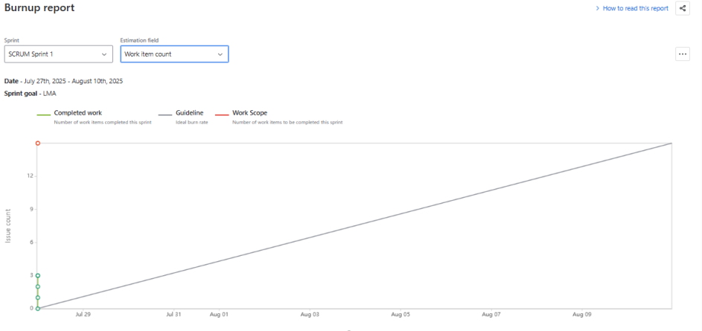

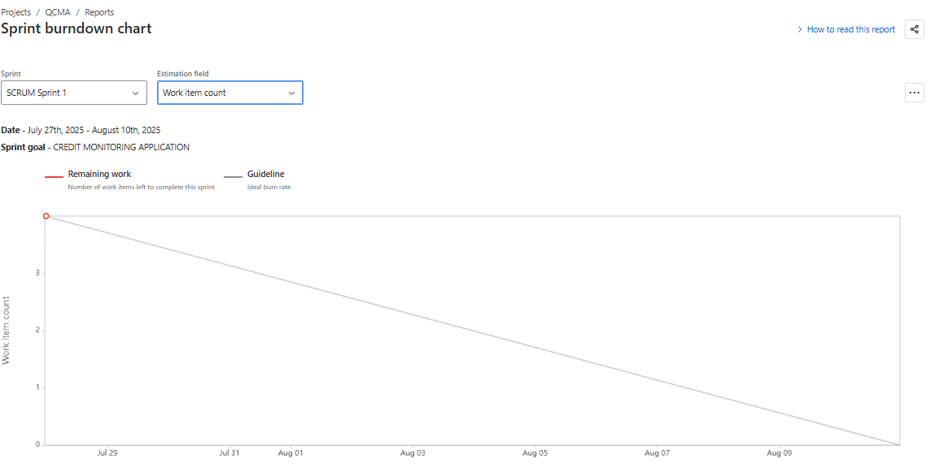
Document 6 – Sprint meetings
Meeting Type 1: Sprint Planning meeting
Date | 25-07-2025
Time | 10:00 AM TO 11:30 PM
Location | Union Bank India – Digital Projects Room / MS Teams
Prepared By | Product Owner – Prem Kumar
Attendees | Product Owner, Scrum Master, BA, Development Team, QA Team

Topic | Presenter | Time allotted
Sprint Goal Discussion | Product Owner | 15 mins
Backlog Item Review | Business Analyst | 20 mins
Task Estimation (Story Points) | Scrum Master | 25 mins
Resource Availability & Risks | Scrum Master | 15 mins
Sprint Commitment & Capacity | All Developers | 15 mins
Agenda Topics

Other Information
Observers | Project Sponsor
Resources | JIRA board, Sprint Burndown Charts, Credit Monitoring User Stories
Special Notes | Focus on "Overdue Alert System" and "Repayment Tracking Dashboard" features in this sprint.

Meeting Type 2: Sprint review meeting

Date | 08-08-2025
Time | 4:00 PM – 5:00 PM IST
Location | UBI IT Conference Room / Zoom
Prepared By | Scrum Master – Ravi Kumar
Attendees | Product Owner, Scrum Team, QA, Business Stakeholders
Sprint status | Things to demo | Quick updates | What’s next
Sprint 4 – 95% done | Alert Dashboard, Overdue Email Notifications | Bug fixes completed for Loan Status screen | Integration with CBS and generation of EWS reports

Meeting Type 3: Sprint retrospective meeting
Date | 11-08-2025
Time | 11:00 AM – 12:00 PM IST
Location | Hybrid (In-office + Teams)
Prepared By | Business Analyst – Shweta Rao
Attendees | Scrum Master, Product Owner, Dev Team, QA Team

Agenda | What went well | What didn’t go well | Questions | Reference
Sprint 4 Review | Timely completion of development tasks | Delay in QA testing due to test data issues | Can we start QA in parallel next time? | Sprint 4 JIRA Board
Team Collaboration | Smooth communication via Slack and Teams | Lack of test case documentation | Can QA team share checklists in advance? | JIRA Board
Tools & Processes | Good use of burndown chart for tracking | Estimation mismatch for backend stories | Should we break backend stories further? | Estimation Logs

Meeting Type 4: Daily Stand-up meeting
Question | Name/Role |  |  | Week “01” (from 01-08-2025 to 14-08-2025)
Question |  |  |  | Monday | Tuesday | Wednesday | Thursday | Friday | Saturday | Sunday
What did you do yesterday? |  | Developer 1 (Ankit Rao) |  | Worked on Alert UI  Setup API auth  DB scripts update | Fixed Alert UI Bugs  Created alert rules  Data mapping tasks | Backend API Testing  Mapped EWS logic  Dashboard backend dev | Configured Notification  Tested backend alerts  Performance optimization | UI Sync with QA  Integrated alerts  Backend testing | N/A  N/A  N/A | N/A  N/A  N/A
What did you do yesterday? |  | Developer 2 (Nisha Jain)
What did you do yesterday? |  | Developer 3 (Farhan Ali)
What will you do today? |  | Developer 1 |  | Implement sorting  Alert email template  Complete dashboard | Finalize layout  Code review  Optimize queries | Validate UI workflow  Backend report AP  I  Integrate with front | UI/UX refinements  Unit testing  Final testing | Ready for demo  Review EWS logs  Prepare for review | N/A  N/A  N/A | N/A  N/A  N/A
What will you do today? |  | Developer 2
What will you do today? |  | Developer 3
What (if any) is blocking your progress? |  | Developer 1 |  | No blockers  Awaiting test data  DB access delay | No blockers  Dependency on Ajay  Fixed | Data mismatch issue  No blockers  None | Awaiting final QA data  None  Waiting for UI update | None  No blockers  None | N/A  N/A  N/A | N/A  N/A  N/A
What (if any) is blocking your progress? |  | Developer 2
What (if any) is blocking your progress? |  | Developer  3

