Audits

4 Quarterly Audits are planned Q1 , Q2, Q3, Q4 for this Project What is your knowledge on how these Audits will happen for a BA ?

Audits are systematic inspections of the workflow.

Stage | Q1- Audit report-Req Gathering phase | Stage | Q2-Audit report-(Req Analysis report)
Completed | 19 weeks (Week 1 to week 19) | Completed | 19 weeks (Week 20-week 38)
Check List | Business Req Doc report | Check List | UML diagrams
 | Elicitation results |  | Business to functional req mapping
 | Duplicate req reports |  | Client sign off
 | Grouping of functionalities/features client sign off |  | (RTM)Req Traceability Matrix document version control
 | Email-communication-To, CC, BCC or other communication channels |  | Email-communication-To, CC, BCC or other communication channels

Stage | Q3- Audit Report-Design & Development | Stage | Q4- Audit Report-Testing/delivery
Completed | 18 weeks (Week 39 to week 57) | Completed | 18 weeks (Week 39 to week 76)
Check List | Utilization of tools | Check List | Test case summary
 | Documented evidence on clients comm. |  | Training reports to end user
 | Stakeholder MOM |  | Lesson learnt document
 | JAD session report |  | Email-communication-To, CC, BCC or other communication channels
 | End user manual prep doc
 | BA & Developer MOM
 | Email-communication-To, CC, BCC or other communication channels

2, BA Approach strategy.

- Elicitation Techniques: We have many many options on this technique, these are few-Brainstorming, Document Analysis, Reverse Eng, Focus Groups, Observation, Interview, etc.
- Stakeholder Analysis using RACI matrix: This involves identifying and defining their roles and responsibilities within the project.
- Documents to write: Business Req Docu, Functional Req Docu, Test Case documents etc.
- Process on signing off the project: Can be done on SRS-Software Requirement Specification and this is the primary document and the sign off process can be done through email-confirmation from the client.
- Approvals from the client: Formal meeting with the clients to keep them informed and get continuous feedback.
- Communication Channels: Regular meetings, Weekly status meeting, bi-weekly sprint reviews and monthly stakeholder meetings.
- Handle Change request: Change request form, do impact analysis, approval process & Documentation.
- Updation of the progression of the project to the stakeholders: Weekly status reports, monthly review meetings.
- Sign-off on the UAT-Client Project Acceptance Form: UAT preparation, Conduct UAT, Fix issues, Acceptance form, Final review meetings and execute/obtain Sign-off.

3, 3-Tier Architecture:

- Presentation Layer: The top layer which handles as a front end (UI components) which displays information and takes user input. (Web or Mob application)
- Business logic layer or Application layer: The middle layer which acts as an intermediatory between presentation and Data Tier layer. (Order processing and authentication)
- Database layer: Responsible for storing and retrieving datas. ( MySQL, MongoDB, Snowflake, Oracle) etc..

Presentation Layer
Web/Mobile
Application
Company Dashboard
Application Layer
Business Logic
Order Processing
Payment Authentication
Data Tier
MySQl
Users Table
Product Table
Orders Table

4. BA approach strategy for framing question:
5W & 1H-useful tool for gathering information and understanding a situation by answering questions about who, what, when, where, why and How.

Who: Identify the people involved in.
What: Understand the requirement or problem.
Where: Know the context or environment.
When: Determine timing or frequency.
Why: Find the purpose.
How: Understand the process.

SMART-this technique is help in creating or framing questions.
Specific, Measurable, Attainable, Relevant and Time-bound.
Specific: Focused & Clear.
Measurable: Can be validated with the data.
Achievable: Realistic within project scope.
Relevant: Connected to the business goals
Time bound: Linked to the timeline.

RACI: this technique helps to clarify roles and responsibilities within a team by outlining who is responsible, accountable, consulted and Informed for each task.

UML: Unified Modelling language: standardized diagramming and modelling software systems to aid in design, development and communication between the team members.

5. Various Elicitation Techniques:

Brainstorming: generating new ideas in a group to discover new solutions and requirements.
Document Analysis: Reviewing existing documents and materials to extract requirements.
Reverse Engineering: Examine the existing systems/products to identify how they work and derive requirements.
Focus groups: Discussing with the selected group of stakeholders to gather diverse perspectives.
Observation: Watching users performs the daily tasks and understand the real needs and challenges.
Workshops: Facilitating collaborative sessions with the stakeholders for joint req gathering.
JAD-Conducts structured workshops involving business users, stakeholders and IT team. The goal is to collaboratively gather req, design solution and make key decisions in real time.
Interviews: Conduct one on one group sessions to ask targeted questions.
Prototyping: create sample user interface screens or mockups to clarify needs.
Questionnaire: Collecting structured responses from a large group for date insight driven.
Use Case Spec: It expands the use case diagram into structed document that captures, all functional requirements, steps, actors and business rules related to the process.

6. Which Elicitation Techniques can be used in this Project and Justify your selection of Elicitation Techniques?

Prototyping: This is the focused and key technique I prefer, this process creates visual representation or early model of the system (Screens, work flows etc.)to stakeholders review and validate requirements before the full development begins.

It bridges the communication between the farmers (non technical ) and developers (technical team).
Its supports user friendly visual validation of the requirements.
Its ensure high accuracy and acceptance of final requirements.

7, Make suitable Assumptions and identify at least 10 Business Requirements.

BR-01-The system shall allow users to register, log in and manage their profile.
BR-02-The system shall allow the company to register and list their products under specific categories.
BR-03-The system shall allow the users to search, view and compare the products by category, price and manufacturer.
BR-04-The system shall the users to add selected products to cart and place their orders.
BR-05-The system shall send the orders confirmation, delivery details via SMS and email.
BR-06-The system shall allow users to track the order status from dispatch to delivery.
BR-07-The system shall provide the multiple language support (English + Local language)
BR-08-The system shall allow the admin to manage users, products and transactions.
BR-09- The system shall generate monthly and quarterly reports for the company/committee on sales, delivery, performance and usage statics.
BR-10-The system shall ensure data security, privacy and back up of user and transaction information.

Optional and can be included ( The system shall allow the users to rate and review products. Provides customer service contact and help desk)

8. List your assumptions:

- The user shall login using Mobile-Otp/Facebook/Google Account etc.
- The system will be available in English and at least one local language.
- The system will support COD on the initial stage.
- Delivery and logistics will be managed by the local courier and transport services.
- Real time order tracking.
- User can purchase minimum order and no maximum orders.
- User must have cooling off period.
- Users should be able to reach out the help desk from the App/browser itself. Etc….

9. This requirements priority:

Req | Priorotized Business requirements | Description | Priority
BR-01 | Users search for the products | Users should be able to search the products by category wise | 8
BR-02 | Company upload their products | Companies should be able to upload & display their products in the app. | 8
BR-03 | User registration & log in | Users should be able to register and securely log in to the platform | 10
BR-04 | Company Registration and login | Company should be able to register, verify and login. | 9
BR-05 | Order Placement & Check out | Users should be able to add items to the cart and checkout. | 9
BR-06 | Order Tracking and Notification | User should get delivery status updates vis SMS/Email | 7
BR-07 | Multi-language support | App should be available in English & at least one local language | 6
BR-08 | Admin Mgmt Dashboard | Admin should manage users, products and transaction | 8
BR-09 | Reports and Analytics | System should generate reports for audits and performance | 5
BR-10 | Security and Data Privacy | System should protect all users and transactions data | 10
BR-11 | Product rating and review | User should be rate and review the products | 4
BR-12 | Customer Support/Helpdesk | User should be contact support for queries or issues | 5

10. Use Case Diagram:

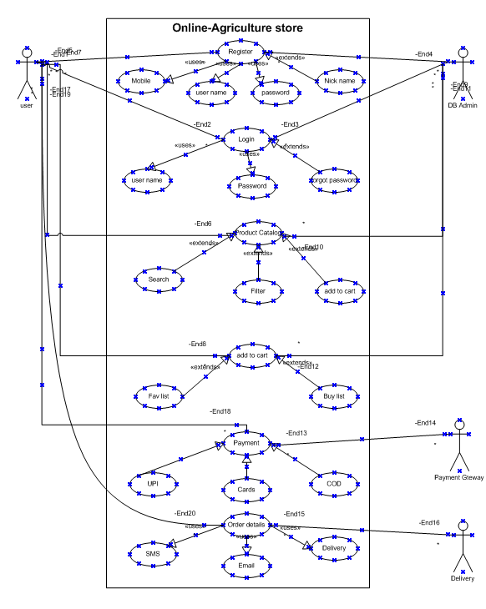

11. Prepare use case specs for all use cases:

UC-01-Search for products:
Actor(s) (Farmers)-(User)
Description: User search for available products based on product name category and manufacturer.
Pre-conditions: Users must be a registered & logged in user.
Post-Conditions: List of products matching search criteria is displayed.
Basic Flow:
- User log into the system.
- User enters product keyword or filters by category.
- System retrieves matching products.
- Users views product details.

Alternative Flow: If no product match the search, system displays “No products found”
Exceptions: Internet connectivity lost or server error.

UC-02: Place Order:
Actor(s) (Farmers)-(User)
Description: User places an order for selected products.
Pre-Conditions: Users must be logged in and have selected a product.
Post-Conditions: Order Confirmation and payment receipt generated.
Basic Flow:
- User selects products.
- User adds products to the cart.
- User enters the delivery details.
- Users confirm and make payments.
- System generates order ID and confirms purchase.
Alternative Flow:
- If payment fails order remains pending until retry.
Exceptions: Payment gateway failure, Invalid address or stock unavailability.

UC-03: Track Order:
Actor(s) (Farmers)-(User)
Description: User can view the current status & shipment details of the orders placed.
Pre-Conditions: User must have placed atleast one order.
Post-Conditions: Order status is displayed to the user.
Basic Flow:
- Users logs in.
- Navigates to My Orders.
- Select and order to track.
- System displays current order status (Processing, shipped, delivered)
Alternative Flow: Order ID not found or tracking system temporarily unavailable.
Exceptions: Database error or order cancelled.

UC-04: Rate Product:
Actor(s) (Farmers)-(User)
Description: Users provides feedback and rating after product delivery.
Pre-Conditions: User must have received the order.
Post-Conditions: Rating and review stored in the system.
Basic Flow:
- User logs in.
- Selected a delivered product.
- Provides rating (1 to 5*****) and comments.
- System saves and updates product rating.
Alternative Flow: Farmer skips rating.
Exceptions: System fails to save rating due to database error or issues.

UC-05: Upload Products:
Actor(s) (Manufacturer)
Description: Manufacturer uploads new product details including name, description, price and quality.
Pre-Conditions: Manufacturer must be registered and approved by Admin.
Post-Conditions: Product details visible to users.
Basic Flow:
- Manufacturer logs in.
- Navigate to upload products.
- Enters all required products details.
- Uploads image and submit.
- System validates and add products to catalog.
Alternative Flow: Missing mandatory fields ( System prompts correction)
Exceptions: Network error and invalid data format.

UC-06: Manage Orders:
Actor(s): Admin
Description: Admin monitors and manages all farmers orders, including order status, updates and issues resolutions.
Pre-Conditions: Admin must be logged in with the valid credentials.
Post-Conditions: Orders updated and notification sent to concerned users.
Basic Flow:
- Admin logins.
- Open Manage orders.
- Views all ongoing orders.
- Updates status ( Processing, shipped, delivered, cancelled ).
Alternative Flow: Admin filters by date, order id or user.
Exceptions: Data not loading or restricted access.

12. Activity Diagram (Minimum 5)

BASIC STAGE ( registration )


Register
Mobile
User name
Password

DATA VALIDATION


Payment
UPI
Cards
COD
[NO]
[YES

]

Payment Successful
BRANCHING & MERGING

FORK & JOIN


Order details
SMS
EMAIL
Sent

