Document 6 – Please prepare a use case diagram, activity diagram and a use case specification document.

Use case diagram

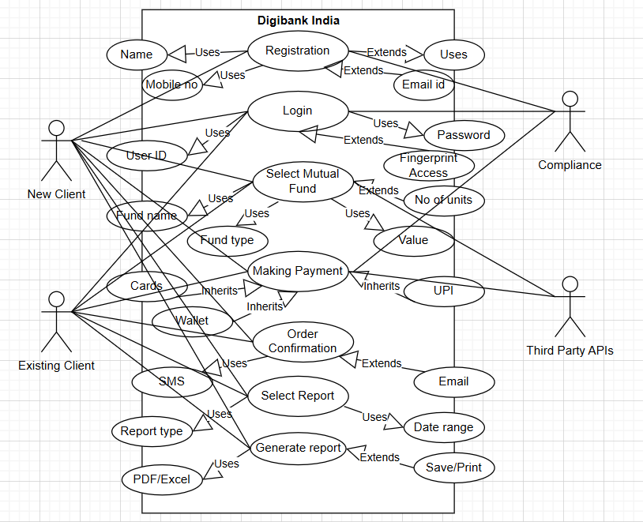

Activity diagram
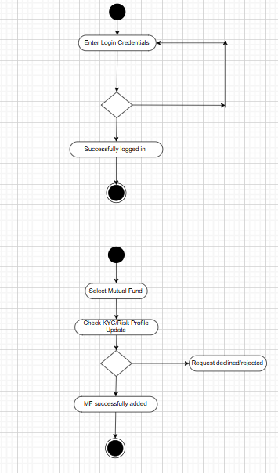

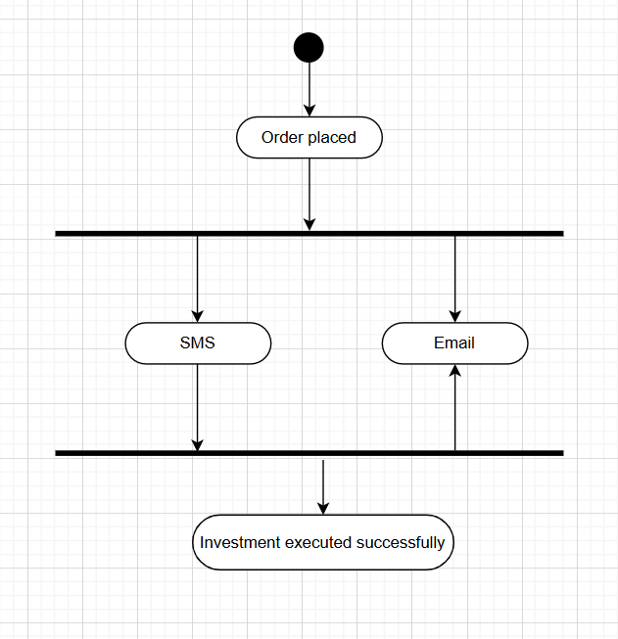

Use case specification document –

Use Case: Registration
Description | Registration
Actors | Customer, System
Preconditions | User must have valid mobile number and email id
Postconditions | New user account created successfully
Basic Flow | - Customer clicks on Register  - System displays registration form  - Customer enter details (Name, DOB, email id, PAN etc.)  - Customer sets username and password  - System sends OTP  - Customer enters OTP  - System validates OTP and creates account  - Confirmation displayed
Alternative Flow | Invalid OTP – System asks to re enter  Email/Mobile already registered – error shown
Use Case: Login
Description | Login
Actors | Customer, System
Preconditions | Customer must be registered
Postconditions | Customer logged in and redirected to dashboard
Basic Flow | - Customer clicks on Login  - Customer enters username & password  - System validates credentials  - If correct – dashboard displayed
Alternative Flow | Invalid credentials – error message  Forgotten password – redirect to reset

Use Case: Select Mutual Fund
Description | Select Mutual Fund
Actors | Customer, System
Preconditions | Customer must be logged in
Postconditions | Mutual fund selection saved
Basic Flow | - Customer clicks on Mutual funds  - System displays list  - Customer searches funds  - Customer selects one  - System shows details  - Customer confirms selection
Alternative Flow | No fund matches search criteria – no results

Use Case: Making Payment
Description | Making payment
Actors | Customer, Bank payment gateway, System
Preconditions | Customer selected a mutual fund and have sufficient balance
Postconditions | Payment completed successfully
Basic Flow | - Customer reviews order  - Redirect to payment gateway  - Customer selects payment method  - Customer enters details  - Gateway validates payment  - System updates status
Alternative Flow | Payment failed – retry option  Session timeout – redirect to login/payment

Use Case: Order Confirmation
Description | Order Confirmation
Actors | Customer, System
Preconditions | Payment completed successfully
Postconditions | Order confirmation generated
Basic Flow | - System generates confirmation number  - Confirmation displayed with details  - SMS/email sent to customer
Alternative Flow | System error – order marked as pending

Use Case: Select Report
Description | Select Report
Actors | Customer, System
Preconditions | Customer must be logged in
Postconditions | Report criteria saved
Basic Flow | - Customer clicks Reports  - System shows available reports like Portfolio, Transactions, Performance  - Customer selects type  - System asks for criteria (date, range etc)  - Customer provides criteria
Alternative Flow | Invalid date range – error shown

Use Case: Generate Report
Description | Generate Report
Actors | Customer, System
Preconditions | Report criteria selected
Postconditions | Report generated and available for view/download
Basic Flow | - Customer clicks on Generate report  - Customer submits report request  - System fetches data  - System generates report (PDF/Excel/View)  - Report displayed/downloaded
Alternative Flow | Data fetch error – report not available  Large report – sent to email

Document 7- Screens and pages
Please follow the following steps to create the mock-ups
1. Kindly use balsamic or Axure.
2. Always start with a home page of an application.
3. Take a feature and follow it to the end
a. Eg: Home page of SCRUM Foods b. Select Login- Create a login page
c. Let’s assume, you want to search a restaurant
d. Search page- Type the restaurant name and select the dish
e. Add to cart page
f. Payment page
g. Logout page

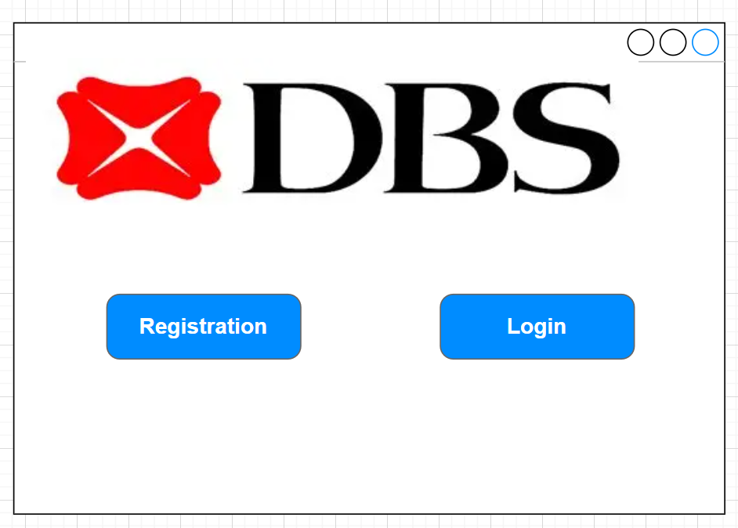

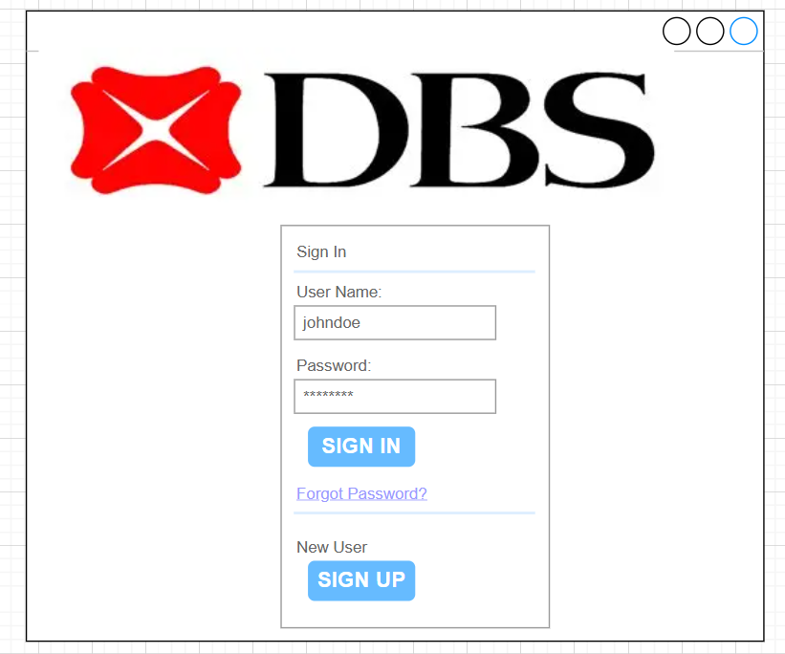

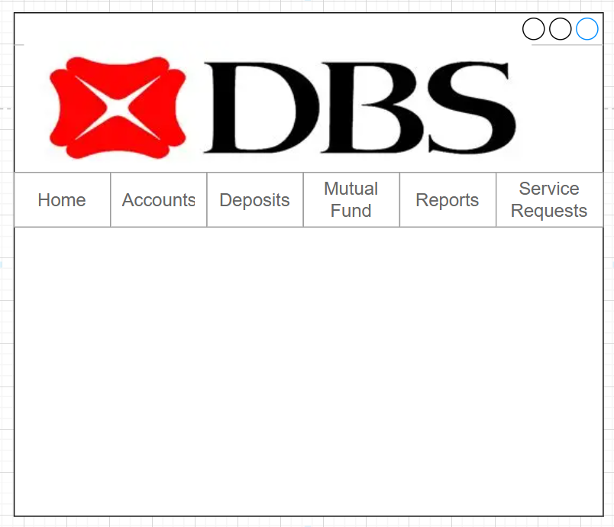

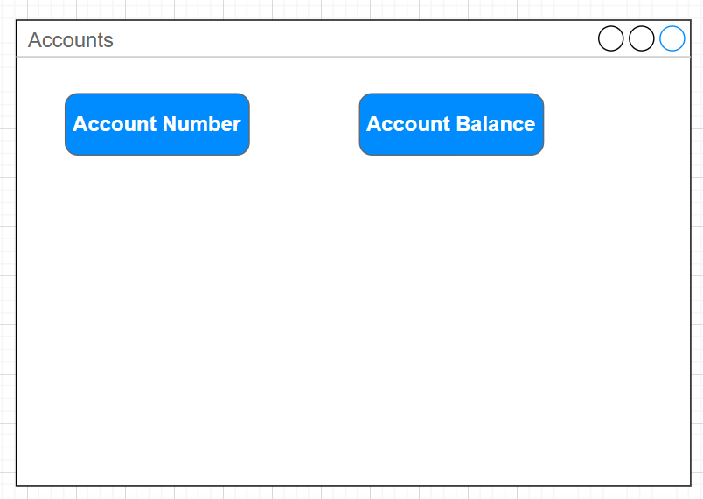

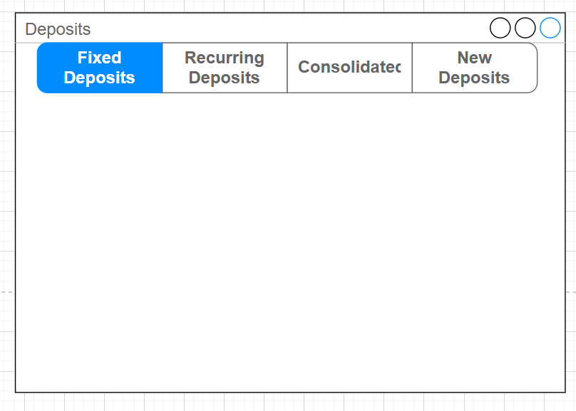

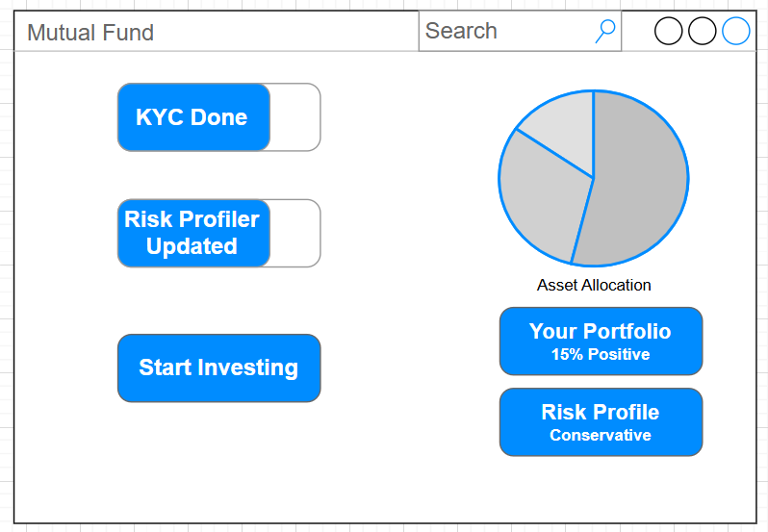

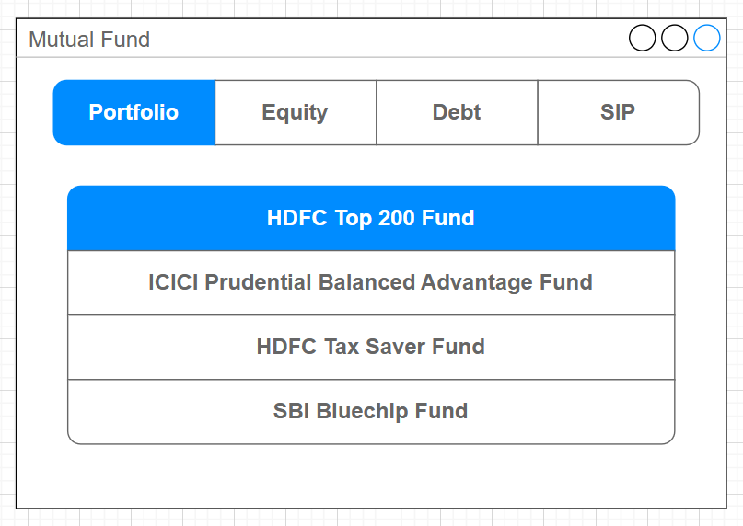

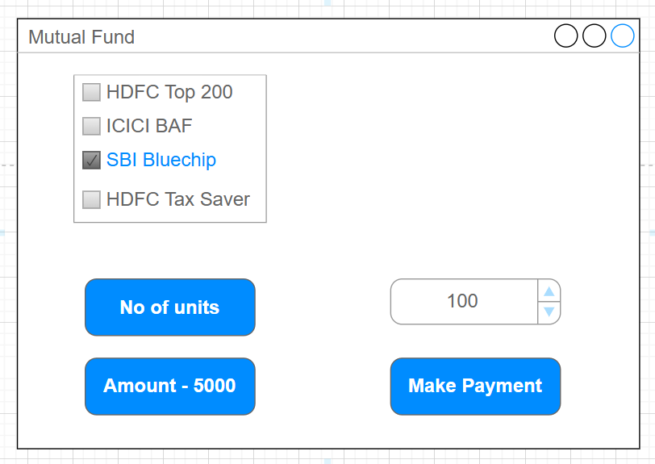

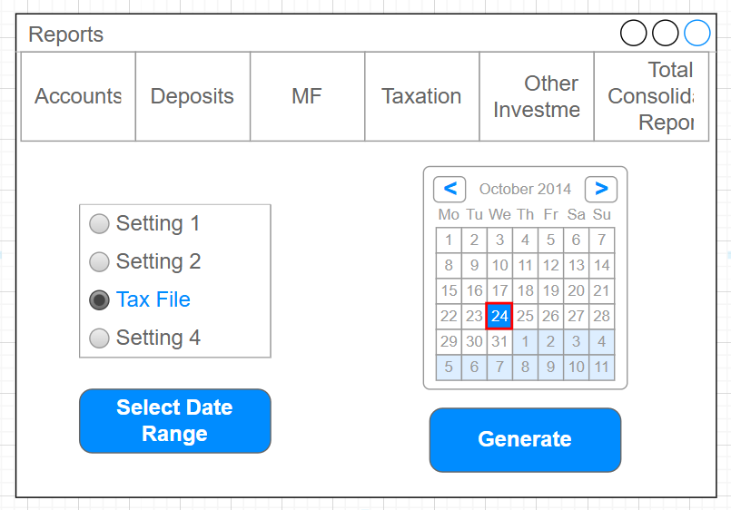

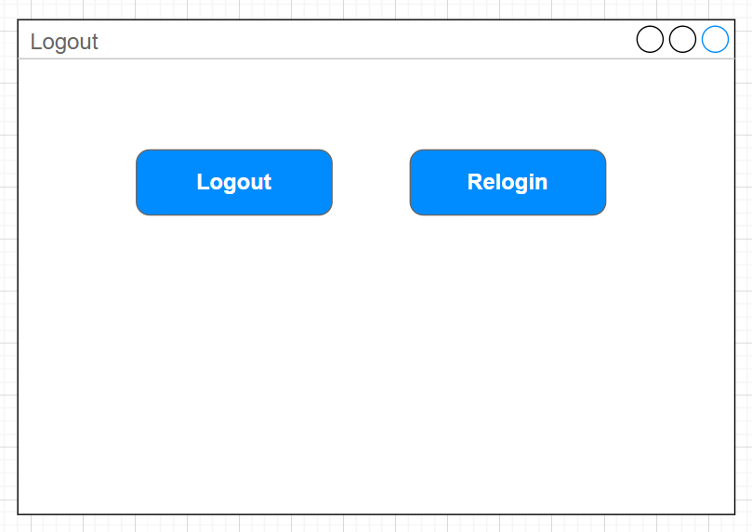

Document 8 – Tools – Visio and Axure

Write a paragraph on your experience using Visio and Axure for the project.

During this project, I used visio and axure for process visualization and UI/UX mockups.
- Microsoft Visio –
Microsoft Visio was mainly used for process flow diagrams (AS-IS and TO-BE) and UML activity diagrams. Its drag and drop stencils, connectors and templates made it easy to represent workflows such as Digital Mutual Fund Transaction and Risk Profiling. The clarity of visio diagrams helped stakeholders quickly understand business processes.

- Axure RP –
Axure RP was used for interactive screen mock-ups. It allowed me to design the Digibank app journey, starting from login to portfolio dashboards, MF search, transaction pages and payment confirmations. Axure’s prototyping features enabled me to simulate click-through flows, giving a realistic feel of the app. This was particularly useful in client demos where stakeholders could visualize the end to end customer experience.

Document 9 – BA experience
My experience as BA in following phases –

- Requirement gathering –
  - Conducted workshops and interviews with stakeholders like RMs, operations, compliance, IT teams
  - Collected business needs around digitalizing risk profiling, portfolio reporting and MF transactions
  - Facilitated Joint Application Sessions JAD to capture pain points in the AS-IS process and identify key features for the TO-BE Digibank app
  - Maintained a structured Requirement Traceability Matrix RTM to ensure all requirements were captured

- Requirement analysis –
- Translated high level business requirements into functional and non functional requirements
- Conducted gap analysis between legacy manual processes and proposed digital workflows
- Prioritized requirements using MOSCOW method
- Validated requirements against regulatory guidelines RBI, SEBI, AMFI to ensure compliance

- Design –
- Created process flow diagrams (AS-IS and TO-BE) in visio
- Designed UML diagrams like use case, activity, sequence to support development understanding
- Prepared UI/UX mock-ups in Axure to demonstrate customer journeys such as login, MF transaction, portfolio viewing
- Ensured alignment with enterprise architecture and security standards

- Development –
- Acted as a bridge between business and technical teams
- Clarified requirements, answered developer queries and updated use cases
- Reviewed API specifications and integration workflows with mf platforms and compliance engines

- Testing –
- Created test scenarios and acceptance criteria for UAT
- Supported QA team in preparing test cases and validating results
- Performed functional testing flows like login, mf transactions, risk profiling
- Validated exception handling scenarios like payment failure, compliance blocks, risk mismatch
- Ensured requirements coverage using RTM

- Deployment –
- Supported business users during UAT – sign off and production release
- Conducted training sessions and demos for RMs and operations teams
- Documented release notes, user manuals and FAQs for smooth adoption
- Monitored early adoption feedback and logged enhancements

