Document 1: Definition of Done

Project:
Delta Sales Operations Management Portal (DSOMP)

Prepared By:
CR Barath Narayanan – Lead Business Analyst & Scrum Master

Date:
13 August 2025

Purpose:
The Definition of Done ensures that all project deliverables — at the User Story, Sprint, and Release levels — meet agreed-upon, measurable, and unambiguous completion criteria. This guarantees the quality, usability, and value of the product to stakeholders, while aligning with Delta Healthcare’s strategic goal of digitizing and optimizing sales operations.

Levels of DoD:

User Story Level:
A User Story is considered “Done” when:
- All acceptance criteria are met and verified by QA.
- All assumptions documented in the story are satisfied.
- Code for the story’s functionalities is produced.
- Code builds without errors in the CI/CD pipeline.
- Unit tests are written, pass successfully, and have sufficient coverage.
- Peer Code Review is performed and approved.
- Feature is deployed to the test environment identical to the production environment.
- Tests on all targeted browsers/devices listed in project assumptions are passed.
- UX Designer has reviewed and approved the feature.
- Documentation (user guide, technical notes) is updated.
- Any configuration or build changes are documented.
- Product Owner has formally approved the story.

Sprint Level:
A Sprint is considered “Done” when:
- All committed User Stories for the Sprint meet the User Story DoD.
- Regression testing is completed across all relevant modules.
- Sprint deliverables are integrated into the main codebase without build errors.
- The working increment is demonstrated during Sprint Review and accepted by stakeholders.
- Any defects found during Sprint QA are resolved or added to the backlog with stakeholder awareness.
- Relevant operational and release notes are prepared.

Release Level:
A Release is considered “Done” when:
- All included Sprints meet the Sprint DoD.
- End-to-end testing is completed and passed in a staging environment identical to production.
- All non-functional requirements (performance, scalability, security) are met.
- All compliance and audit requirements are satisfied.
- Product Owner and key stakeholders sign off for release.
- Deployment to production is completed without critical issues.
- User documentation and training materials are delivered.
- Post-release monitoring plan is in place.

DoD Checklist:

Produced Code for Presumed Functionalities
All development tasks for the User Story are completed, and the code delivers the intended functionality described in the story. No partial or placeholder code is left behind.

Assumptions of User Story Met
Any stated assumptions (technical, business, or environmental) in the User Story are validated and satisfied before marking it complete.

Project Builds Without Errors
The build process in the CI/CD pipeline completes successfully with no compilation errors or unresolved dependencies.

Unit Tests Written and Passing
Unit tests are created for all new or modified code and pass consistently. The test coverage meets the agreed team standard.

Project Deployed on the Test Environment Identical to Production Platform
The functionality is deployed in a staging/test environment that mirrors production in configuration and setup to ensure accurate validation.

Tests on Devices/Browsers Listed in the Project Assumptions Passed
The feature is tested across all devices and browsers specified in project requirements, and all tests pass without critical issues.

Feature OK-ed by UX Designer
The UX designer reviews the implementation to ensure alignment with approved wireframes, style guides, and user experience standards.

QA Performed & Issues Resolved
Quality Assurance testing is conducted, all defects found are resolved, and retesting confirms the fixes before moving forward.

Feature is Tested Against Acceptance Criteria
The feature meets every acceptance criterion documented in the User Story, as validated by the QA and Product Owner.

Feature OK-ed by Product Owner
The Product Owner reviews and approves the delivered feature as “done” during Sprint Review or prior to release.

Refactoring Completed
Any necessary refactoring identified during development or review is carried out to maintain code quality and reduce technical debt.

Any Configuration or Build Changes Documented
Changes in environment settings, build parameters, or system configuration are recorded for future maintenance and deployment.

Documentation Updated
Both technical documentation and user-facing materials are updated to reflect the new feature and any changes in workflows.

Peer Code Review Performed
The code is reviewed by at least one other developer, feedback is addressed, and the review is approved before merging into the main branch.

Visibility & Governance:
- The DoD will be prominently displayed in the team’s Jira/Azure DevOps board.
- The Scrum Master will ensure DoD compliance during Sprint Reviews.
- Any exceptions to the DoD will require documented approval from the Product Owner.

Document 2: Product Vision
Scrum Project Name | Delta Sales Operations Management Portal (DSOMP)
Venue | Delta Healthcare Headquarters, Vadodara
Start Date | 13 Aug. 25 | Start time | 10:00 AM
End Date | 30 Nov. 25 | End Time | 5:00 PM
Duration | 3 Months, 21 Days
Client | Delta Healthcare – Sales & Operations Division
Stakeholder list | - Director of Sales & Operations – Mr. Ramesh  - National Sales Head – Mr. Mithun  - IT & Support Team Lead – Mr Jayanth  - Regional Sales Managers  - Field Sales Representatives
Scrum Team
Scrum Master |  | Barath Narayanan
Product Owner |  | Mr. Ramesh
Scrum Developer 1 |  | Arjun Menon
Scrum Developer 2 |  | Ravi Prakash
Scrum Developer 3 |  | Sameer Kulkarni
Scrum Developer 4 |  | Karthik Iyer
Scrum Developer 5 |  | Mohit Sharma
Vision | To create an agile, user-friendly, and scalable Sales Operations Management Portal that replaces manual workflows, enhances operational efficiency, and empowers Delta Healthcare’s sales teams with real-time data for faster, smarter decision-making.
Target Group | Needs | Product | Value
- Primary segment: product sales team, management, operations team.  - Target users: Field Sales Representatives, Sales Managers, and Operations & finance managers | - Eliminate inefficiencies caused by manual reporting and fragmented communication.  - Provide a single source of truth for sales operations.  - Improve approval turnaround times. | - Agile-based, modular Sales Operations Portal (web + mobile).  - Features: Meeting reporting, quotation generation, leave & expense workflows, demo product booking, dashboards.  - Designed for high scalability and adaptability to future enhancements. | - 50% reduction in reporting time.  - Real-time data access improves decision-making speed.  - Supports digital transformation goals.  - Business model: SaaS-style internal deployment with minimal operational downtime.

Document 3: User Stories
User story No | 1 | Tasks | Design and develop meeting reporting module | Priority | High
Value statement | As a sales representative, I want to submit my meeting details digitally so that I can avoid manual reporting and save time.
BV | 9 |  | CP | 5
Acceptance criteria
- Sales rep can log meeting details from web and mobile
- Data auto-saves in real-time to the system.
- Confirmation message shown after successful submission.

User story No | 2 | Tasks | Implement quotation generator feature | Priority | High
Value statement | As a sales manager, I want to generate quotations instantly so that I can respond faster to customer.
BV | 10 |  | CP | 6
Acceptance criteria
- System fetches product details automatically.
- Quotation can be exported as PDF.
- Approval workflow is triggered after creation.

User story No | 3 | Tasks | Create leave request workflow | Priority | Medium
Value statement | As a field sales representative, I want to apply for leave online so that I can get faster approval from my manager.
BV | 7 |  | CP | 3
Acceptance criteria
- Leave request form available in portal.
- Notifications sent to manager instantly.
- Status visible to requester in real-time.

User story No | 4 | Tasks | Add expense claim submission | Priority | High
Value statement | As a sales representative, I want to submit expense claims with receipts so that I can get reimbursements quickly.
BV | 10 |  | CP | 6
Acceptance criteria
- Expense form accepts scanned receipts.
- Approval workflow auto-initiated.
- Status tracking available in dashboard.

User story No | 5 | Tasks | Implement demo product booking module | Priority | High
Value statement | As a sales representative, I want to book demo products so that I can ensure availability during client visits.
BV | 9 |  | CP | 6
Acceptance criteria
- Calendar-based booking view.
- Real-time availability check.
- Confirmation notification sent to user.

User story No | 6 | Tasks | Build manager dashboards | Priority | High
Value statement | As a sales manager, I want to view real-time KPIs so that I can monitor team performance effectively.
BV | 10 |  | CP | 7
Acceptance criteria
- Dashboard updates automatically every 5 minutes.
- Graphs and charts display key KPIs.
- Drill-down to individual team member reports.

User story No | 7 | Tasks | Implement role-based access control | Priority | High
Value statement | As an administrator, I want to control access levels so that sensitive data is protected.
BV | 10 |  | CP | 8
Acceptance criteria
- Role definitions configurable by admin.
- Users see only relevant features.
- Access logs maintained.

User story No | 8 | Tasks | Create automated approval notifications | Priority | Medium
Value statement | As a manager, I want to get instant notifications for approvals so that I can respond quickly.
BV | 8 |  | CP | 3
Acceptance criteria
- Notifications sent via email and mobile.
- One-click approval/rejection option.

User story No | 9 | Tasks | Enable offline mode for mobile app | Priority | Medium
Value statement | As a sales representative, I want to log data offline so that I can work in areas with no internet connectivity.
BV | 8 |  | CP | 7
Acceptance criteria
- Data stored locally until internet is available.
- Automatic sync without data loss.

User story No | 10 | Tasks | Develop training material section | Priority | Low
Value statement | As a new team member, I want to access training materials so that I can learn to use the portal effectively.
BV | 6 |  | CP | 3
Acceptance criteria
- Materials accessible via web and mobile.
- Progress tracking available.

User story No | 11 | Tasks | Implement advanced search functionality | Priority | Medium
Value statement | As a sales manager, I want to search by customer, date, or product so that I can quickly find relevant records.
BV | 9 |  | CP | 5
Acceptance criteria
- Search returns results in under 2 seconds.
- Filters available for refining results.

User story No | 12 | Tasks | Add real-time chat support | Priority | Low
Value statement | As a user, I want to chat with support so that I can get help instantly.
BV | 6 |  | CP | 5
Acceptance criteria
- Chat available during working hours.
- Response time under 5 minutes.

User story No | 13 | Tasks | Develop analytics for expense trends | Priority | Low
Value statement | As a finance manager, I want to analyze expense trends so that I can control costs better.
BV | 7 |  | CP | 4
Acceptance criteria
- Monthly and quarterly trend reports available.
- Export to Excel option provided.

User story No | 14 | Tasks | Implement digital signature feature | Priority | Medium
Value statement | As a manager, I want to sign approvals digitally so that I can avoid paperwork delays.
BV | 8 |  | CP | 6
Acceptance criteria
- E-signature stored securely.
- Legally compliant storage format.

User story No | 15 | Tasks | Add push notification for meeting reminders | Priority | Medium
Value statement | As a sales representative, I want to get meeting reminders so that I don’t miss important appointments.
BV | 7 |  | CP | 3
Acceptance criteria
- Reminder sent 30 minutes before meeting.
- Configurable reminder settings.

User story No | 16 | Tasks | Implement performance review tracking | Priority | Low
Value statement | As a manager, I want to track performance reviews so that I can support employee development.
BV | 6 |  | CP | 4
Acceptance criteria
- Review forms stored digitally.
- Yearly performance summaries available.

User story No | 17 | Tasks | Create multi-language support | Priority | Low
Value statement | As a regional sales rep, I want the portal in my local language so that I can use it more effectively.
BV | 7 |  | CP | 5
Acceptance criteria
- Languages selectable in settings.
- All UI text translated accurately.

User story No | 18 | Tasks | Add product catalogue with images | Priority | Medium
Value statement | As a sales rep, I want to view the product catalogue with images so that I can present them to customers easily.
BV | 8 |  | CP | 4
Acceptance criteria
- High-quality images load under 2 seconds.
- Searchable product list.

User story No | 19 | Tasks | Implement audit log tracking | Priority | High
Value statement | As an administrator, I want to track all user activities so that I can ensure compliance and accountability.
BV | 10 |  | CP | 6
Acceptance criteria
- Logs stored for at least 1 year.
- Filterable by user, date, and activity type.

User story No | 20 | Tasks | Develop automated report generation | Priority | High
Value statement | As a sales manager, I want automated weekly reports so that I can track progress without manual effort.
BV | 9 |  | CP | 5
Acceptance criteria
- Reports generated every Monday morning.
- Sent automatically to manager’s email.

Document 4: Agile PO Experience

Product Owner Role Overview
The Product Owner (PO) in the Delta Sales Operations Management Portal (DSOMP) project holds the vision for the product by leveraging industry expertise and understanding market needs. The PO bridges the gap between stakeholders, the Scrum Team, and the business goals, ensuring that the product delivers maximum value.

Key Responsibilities of the Product Owner

Market Analysis
- Conduct thorough research on market needs and demand.
- Assess the availability of similar products in the market and their features.
- Identify competitive advantages and market positioning opportunities.

Enterprise Analysis
- Perform due diligence to validate the market opportunity.
- Evaluate alignment with Delta Healthcare’s strategic objectives.

Product Vision and Roadmap
- Define a clear product vision based on need analysis.
- Prepare a product roadmap highlighting high-level features, deliverables, and timelines.
- Align roadmap milestones with business priorities and ROI.

Managing Product Features
- Engage with stakeholders to gather and manage expectations.
- Prioritize epics, stories, and features based on criticality and ROI.
- Oversee daily Scrum meetings to stay updated on development progress.
- Conduct Sprint Review meetings to demonstrate deliverables to stakeholders.
- Participate in Sprint Retrospective meetings to gather feedback and improve processes.
- Lead Backlog Refinement meetings to ensure user stories are ready for upcoming sprints.

User Stories Creation
Each user story created by the Product Owner includes:
- Story Number
- Tasks
- Priority
- Acceptance Criteria
- BV (Business Value) – numeric value on a 1–10 scale
- CP (Complexity Points) – numeric value on a 1–10 scale
These stories are structured to be clear, actionable, and aligned with the product vision.

Liaison Between Teams
In Scrum, the Product Owner serves as the link between business stakeholders and the Scrum Team:
- Communicates project vision and updates to business units.
- Collaborates with developers, testers, and designers to clarify requirements.
- Ensures transparency on the project’s progress and priorities.

Managing the Product Backlog
- Maintain and prioritize the product backlog based on business goals.
- Reprioritize items according to evolving stakeholder needs.
- Plan epics and ensure their decomposition into actionable user stories.

Managing Overall Iteration Progress
- Review sprint progress regularly.
- Adjust sprint scope and epic priorities when necessary.
- Collaborate with the Business Analyst during retrospectives to refine processes.

Lessons Learned from the Project
From the DSOMP project, I have learned to:
- Effectively conduct Sprint Planning Meetings to align the team with sprint goals.
- Manage Sprint Reviews to demonstrate progress and gather feedback.
- Lead Backlog Refinement sessions to ensure clarity and readiness of user stories.
- Use Sprint Retrospectives to identify improvement opportunities and enhance team performance.

Document 5 – product and sprint backlog & product and sprint burndown charts

Product Backlog
User Story ID | User Story | Tasks | Priority | BV | CP | Sprint
US01 | Meeting reporting module | Design form, integrate with DB, QA testing | High | 9 | 5 | Sprint 1
US02 | Quotation generator | UI design, connect to product DB, PDF export | High | 10 | 6 | Sprint 1
US03 | Leave request workflow | Build form, add notifications, QA testing | Medium | 7 | 3 | Sprint 2
US04 | Expense claim submission | UI design, receipt upload, approval workflow | Medium | 8 | 4 | Sprint 2
US05 | Demo product booking | Booking calendar, inventory integration | High | 9 | 6 | Sprint 3
US06 | Manager dashboards | Data aggregation, charts, KPI logic | High | 10 | 7 | Sprint 3
US07 | Role-based access control | Role definition, permission logic, access logs | High | 10 | 8 | Sprint 4
US08 | Automated approval notifications | Email & push notifications, quick actions | Medium | 8 | 3 | Sprint 4
US09 | Offline mode for mobile app | Local storage, sync logic, conflict handling | Medium | 8 | 7 | Sprint 5
US10 | Training material section | Content upload, progress tracking | Low | 6 | 3 | Sprint 5
US11 | Advanced search functionality | Search filters, DB optimization | Medium | 9 | 5 | Sprint 6
US12 | Real-time chat support | Integrate chat API, UI design | Low | 6 | 5 | Sprint 6
US13 | Expense trend analytics | Data aggregation, chart creation | Low | 7 | 4 | Sprint 7
US14 | Digital signature feature | E-signature API integration, storage | Medium | 8 | 6 | Sprint 7
US15 | Meeting reminder push notifications | Reminder scheduling, mobile integration | Medium | 7 | 3 | Sprint 8
US16 | Performance review tracking | Review form, summary reports | Low | 6 | 4 | Sprint 8
US17 | Multi-language support | Language packs, translation UI | Low | 7 | 5 | Sprint 9
US18 | Product catalog with images | Image upload, optimization, search | Medium | 8 | 4 | Sprint 9
US19 | Audit log tracking | Activity logging, filters, export | High | 10 | 6 | Sprint 10
US20 | Automated report generation | Schedule jobs, email reports | High | 9 | 5 | Sprint 10

Sprint Backlog

Sprint 1
User Story ID | User Story | Tasks | Owner | Status | Estimated Effort
US01 | Meeting reporting module | Design UI form | Arjun Menon | In Progress | 6 hrs
US01 | Meeting reporting module | Backend integration | Ravi Prakash | To Do | 8 hrs
US01 | Meeting reporting module | QA Testing | Sameer Kulkarni | To Do | 4 hrs
US02 | Quotation generator | UI Layout Design | Karthik Iyer | In Progress | 5 hrs
US02 | Quotation generator | DB integration for product details | Mohit Sharma | To Do | 7 hrs
US02 | Quotation generator | PDF export feature | Arjun Menon | To Do | 6 hrs

Sprint 2
User Story ID | User Story | Tasks | Owner | Status | Estimated Effort
US03 | Leave request workflow | Build form | Sameer Kulkarni | To Do | 5 hrs
US03 | Leave request workflow | Notification integration | Ravi Prakash | To Do | 4 hrs
US03 | Leave request workflow | QA testing | Arjun Menon | To Do | 3 hrs
US04 | Expense claim submission | UI design | Mohit Sharma | To Do | 6 hrs
US04 | Expense claim submission | Receipt upload integration | Karthik Iyer | To Do | 5 hrs
US04 | Expense claim submission | Approval workflow | Ravi Prakash | To Do | 4 hrs

Sprint 3
User Story ID | User Story | Tasks | Owner | Status | Estimated Effort
US05 | Demo product booking | Booking calendar UI | Arjun Menon | To Do | 6 hrs
US05 | Demo product booking | Inventory check integration | Ravi Prakash | To Do | 7 hrs
US06 | Manager dashboards | Data aggregation logic | Sameer Kulkarni | To Do | 6 hrs
US06 | Manager dashboards | Chart and KPI design | Karthik Iyer | To Do | 5 hrs

Sprint 4
User Story ID | User Story | Tasks | Owner | Status | Estimated Effort
US07 | Role-based access control | Role definition module | Mohit Sharma | To Do | 7 hrs
US07 | Role-based access control | Permission enforcement | Sameer Kulkarni | To Do | 6 hrs
US08 | Automated approval notifications | Email notification setup | Arjun Menon | To Do | 4 hrs
US08 | Automated approval notifications | Push notification setup | Karthik Iyer | To Do | 4 hrs

Sprint 5
User Story ID | User Story | Tasks | Owner | Status | Estimated Effort
US09 | Offline mode for mobile app | Local storage design | Ravi Prakash | To Do | 6 hrs
US09 | Offline mode for mobile app | Sync logic | Mohit Sharma | To Do | 7 hrs
US10 | Training material section | Content upload feature | Arjun Menon | To Do | 4 hrs
US10 | Training material section | Progress tracking module | Karthik Iyer | To Do | 3 hrs

Sprint 6
User Story ID | User Story | Tasks | Owner | Status | Estimated Effort
US11 | Advanced search functionality | Filter UI | Arjun Menon | To Do | 5 hrs
US11 | Advanced search functionality | DB optimization | Sameer Kulkarni | To Do | 6 hrs
US12 | Real-time chat support | Chat API integration | Ravi Prakash | To Do | 5 hrs
US12 | Real-time chat support | Chat UI design | Mohit Sharma | To Do | 4 hrs

Sprint 7
User Story ID | User Story | Tasks | Owner | Status | Estimated Effort
US13 | Expense trend analytics | Data aggregation logic | Karthik Iyer | To Do | 5 hrs
US13 | Expense trend analytics | Chart creation | Arjun Menon | To Do | 4 hrs
US14 | Digital signature feature | API integration | Mohit Sharma | To Do | 6 hrs
US14 | Digital signature feature | Storage and security | Sameer Kulkarni | To Do | 5 hrs

Sprint 8
User Story ID | User Story | Tasks | Owner | Status | Estimated Effort
US15 | Meeting reminder push notifications | Reminder scheduling | Arjun Menon | To Do | 4 hrs
US15 | Meeting reminder push notifications | Mobile integration | Ravi Prakash | To Do | 4 hrs
US16 | Performance review tracking | Review form UI | Mohit Sharma | To Do | 4 hrs
US16 | Performance review tracking | Summary report generation | Sameer Kulkarni | To Do | 4 hrs

Sprint 9
User Story ID | User Story | Tasks | Owner | Status | Estimated Effort
US17 | Multi-language support | Language pack integration | Karthik Iyer | To Do | 5 hrs
US17 | Multi-language support | Translation UI | Arjun Menon | To Do | 5 hrs
US18 | Product catalog with images | Image upload & optimization | Ravi Prakash | To Do | 5 hrs
US18 | Product catalog with images | Search function | Mohit Sharma | To Do | 4 hrs

Sprint 10
User Story ID | User Story | Tasks | Owner | Status | Estimated Effort
US19 | Audit log tracking | Activity logging module | Sameer Kulkarni | To Do | 6 hrs
US19 | Audit log tracking | Filters & export | Arjun Menon | To Do | 5 hrs
US20 | Automated report generation | Schedule jobs | Karthik Iyer | To Do | 4 hrs
US20 | Automated report generation | Email sending module | Ravi Prakash | To Do | 4 hrs

Product burn down chart
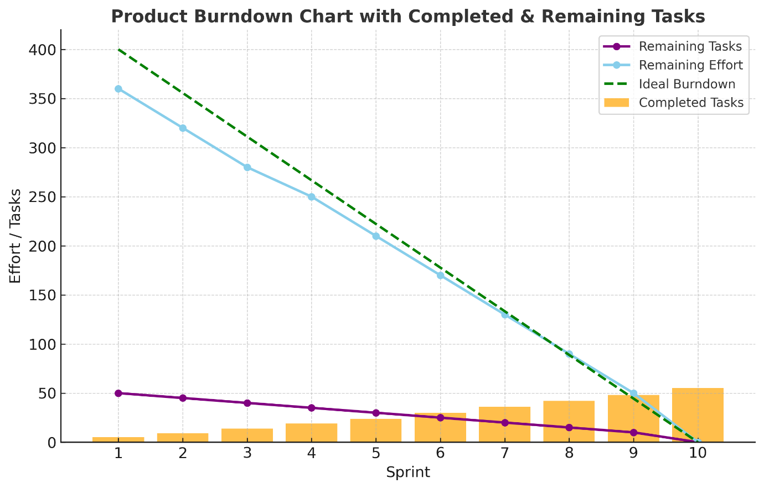

Sprint burn down charts

Sprint 1
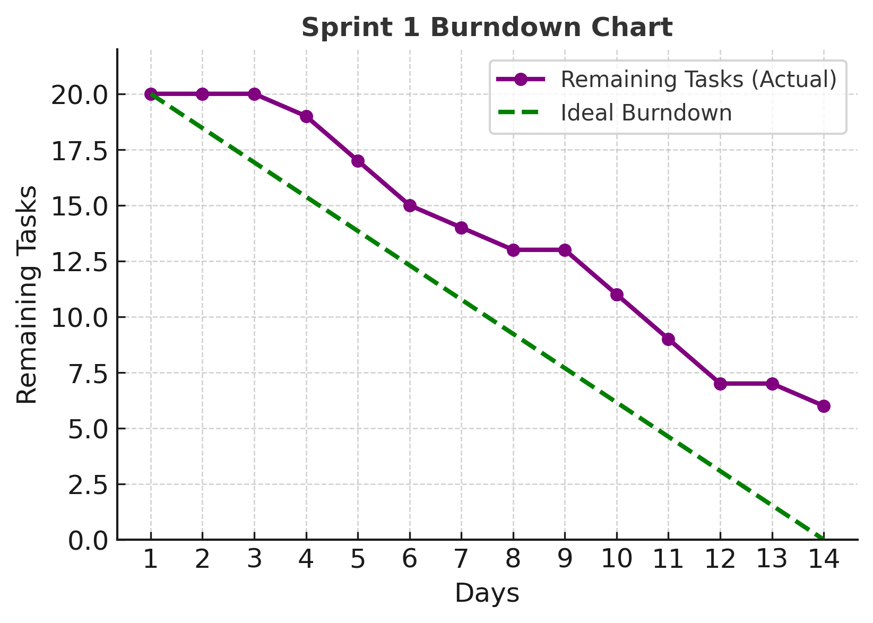

Sprint 2

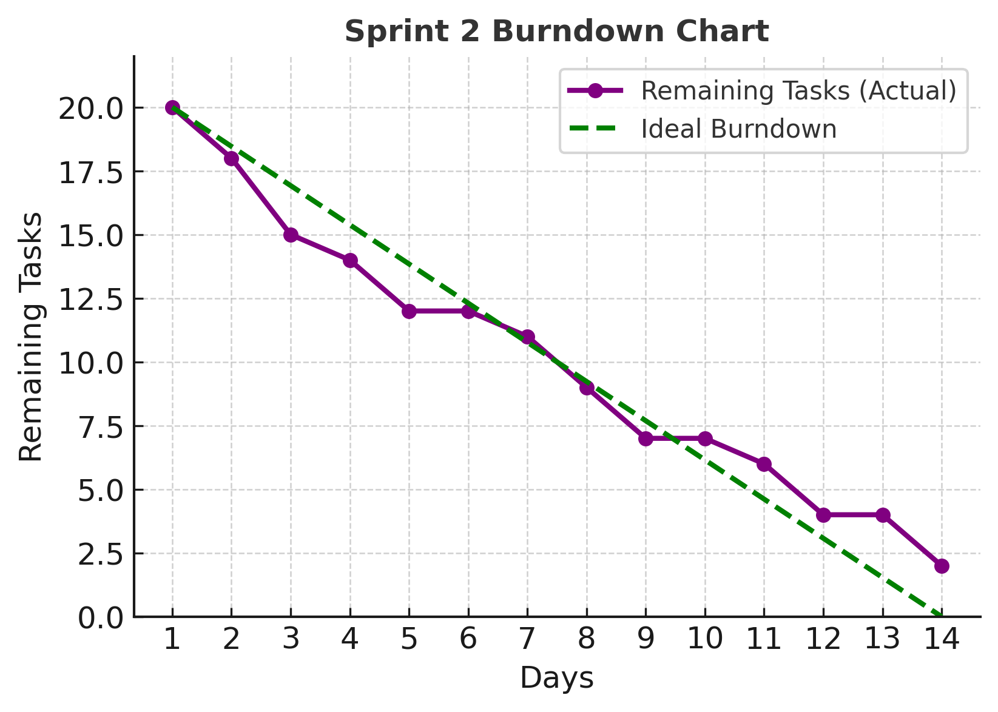

Sprint 3

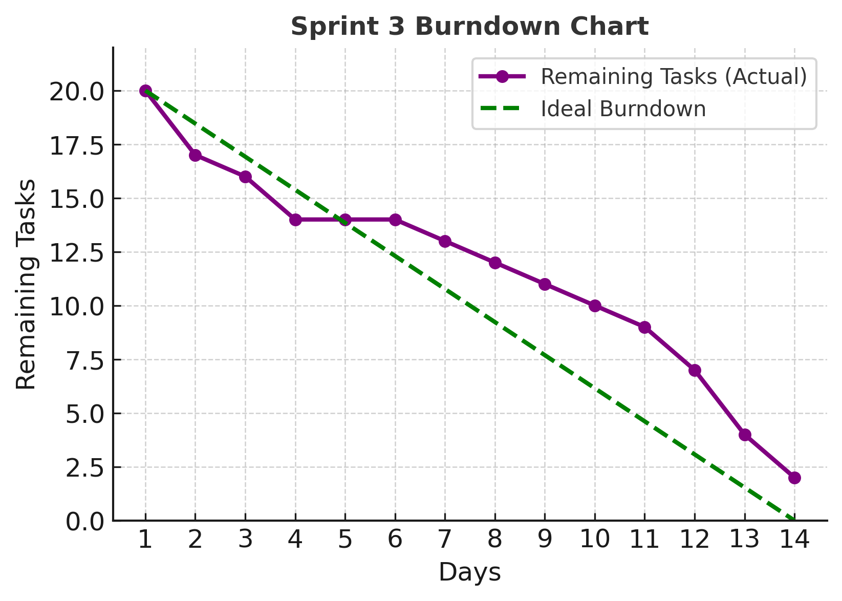

Sprint 4

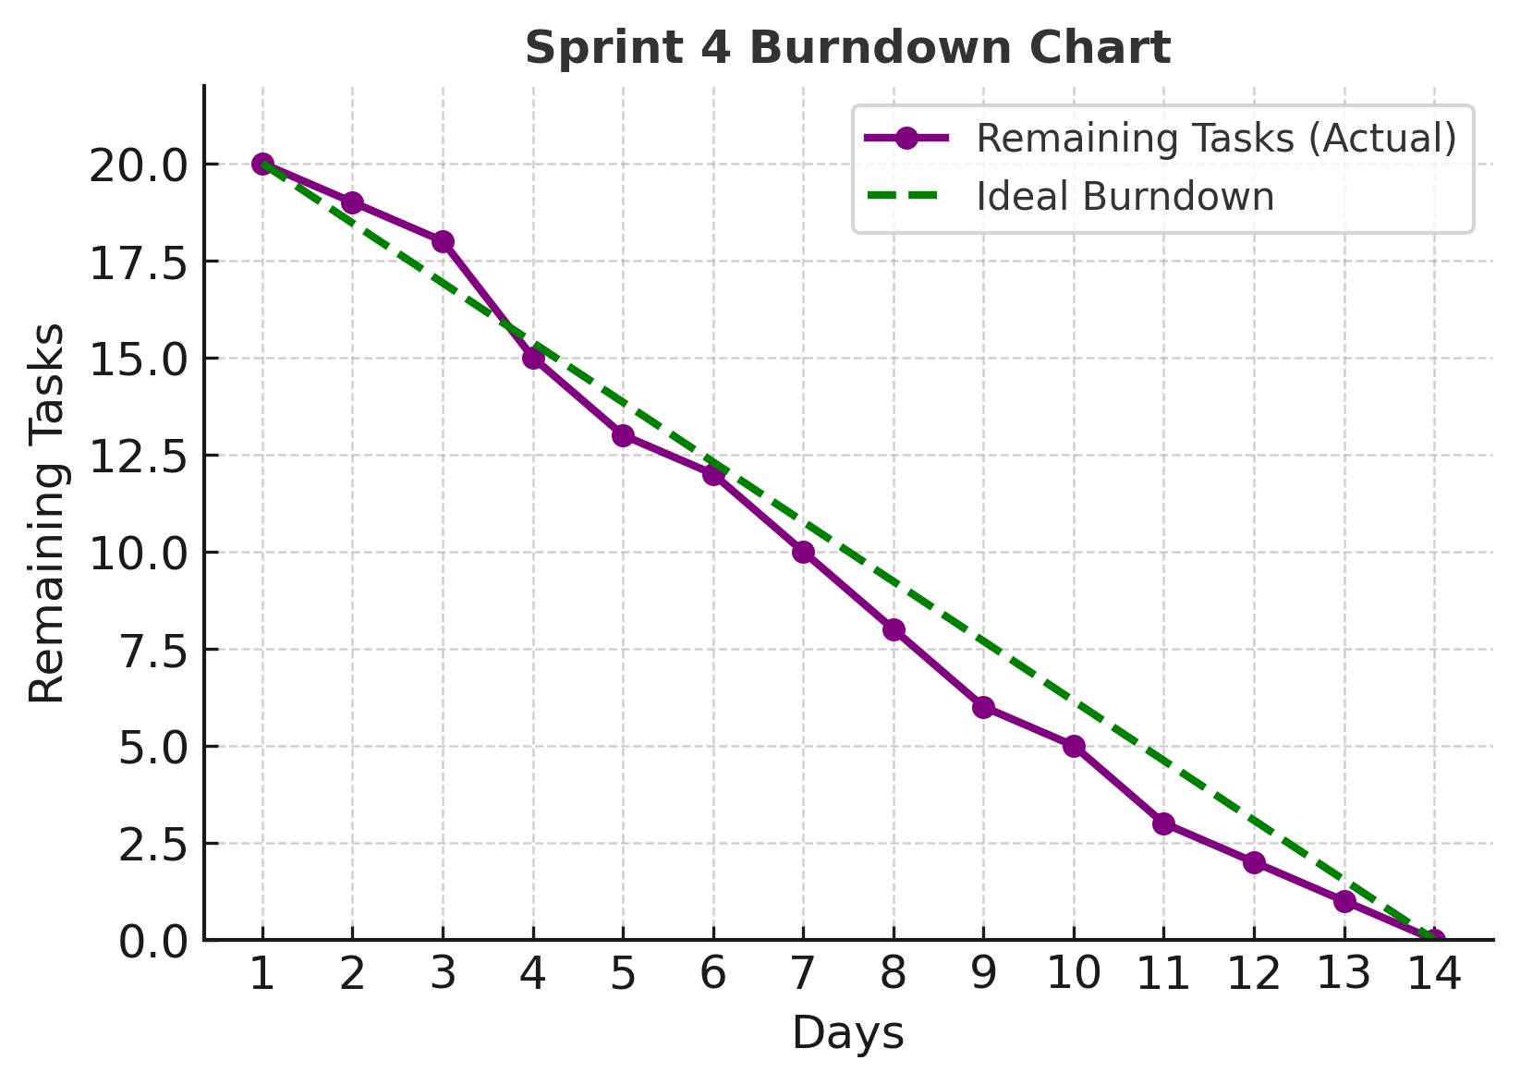

Sprint 5

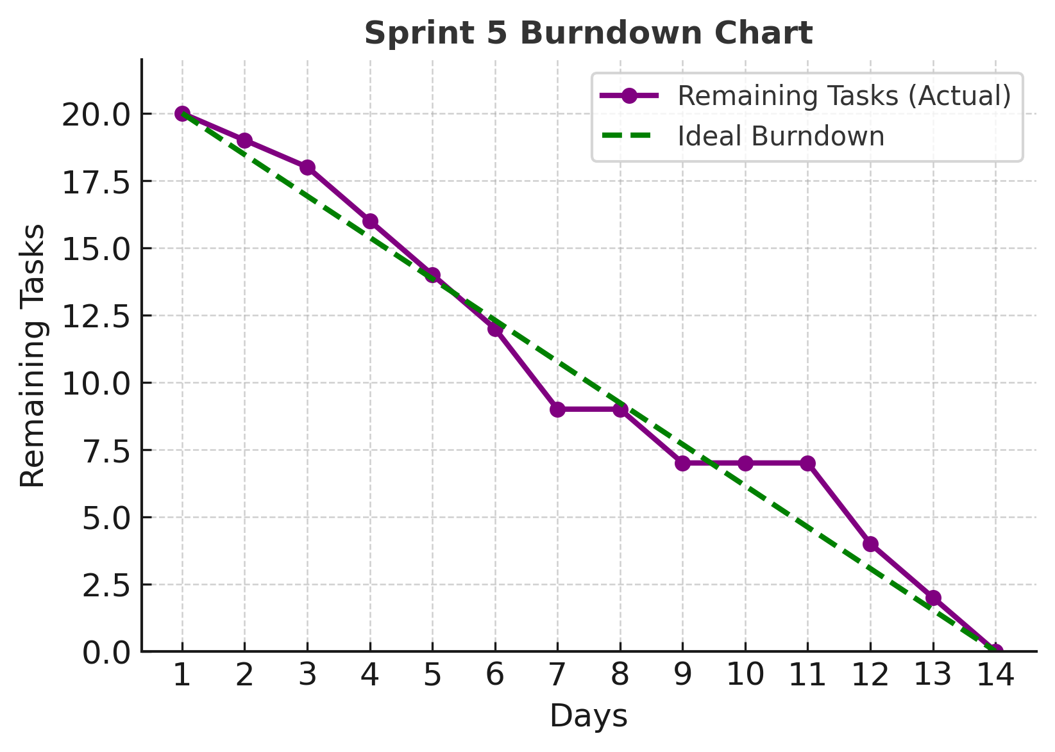

Sprint 6

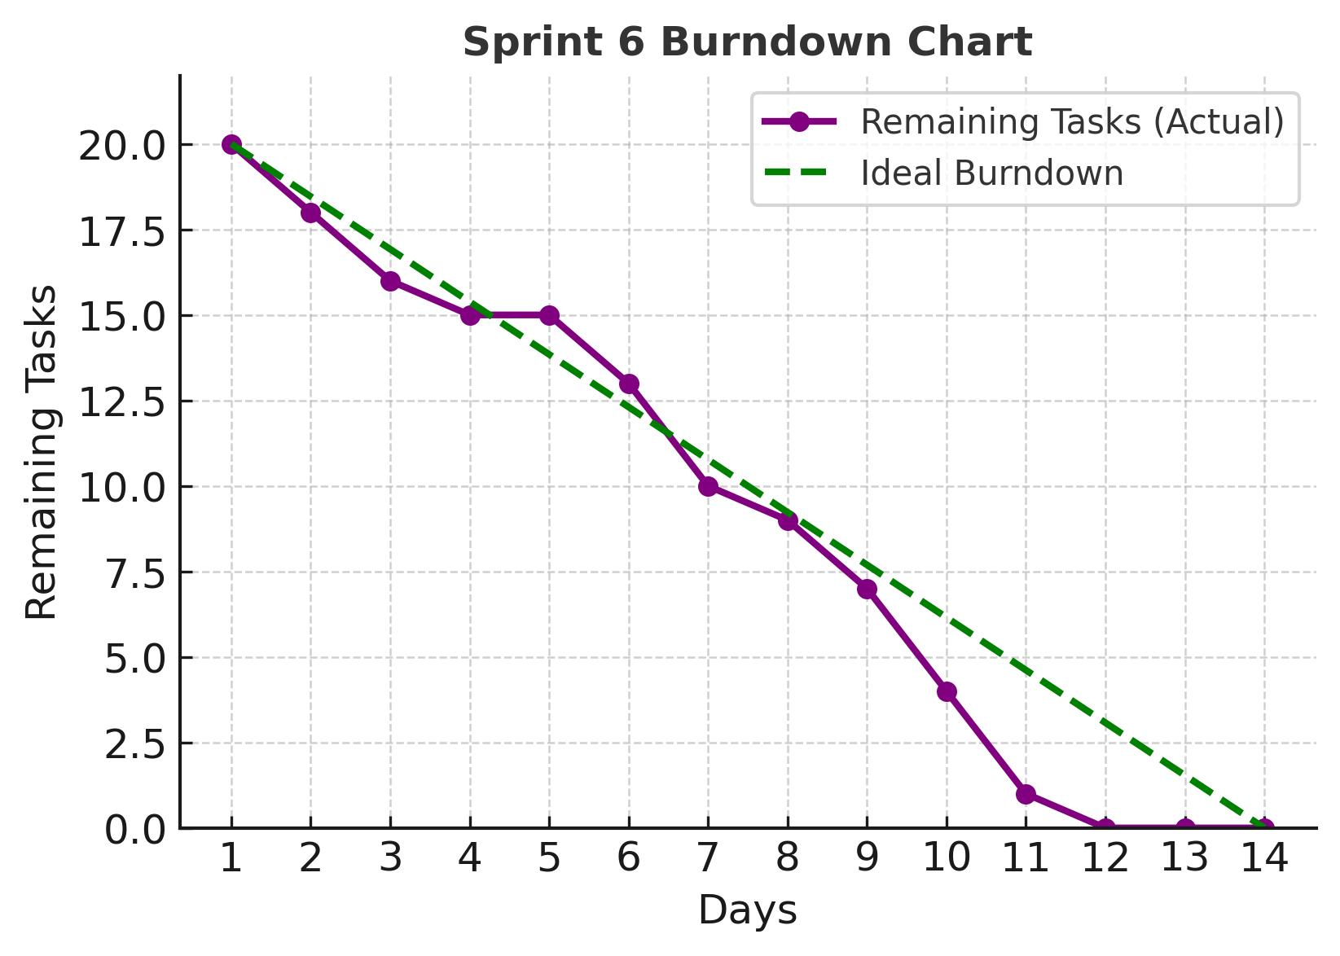

Sprint 7

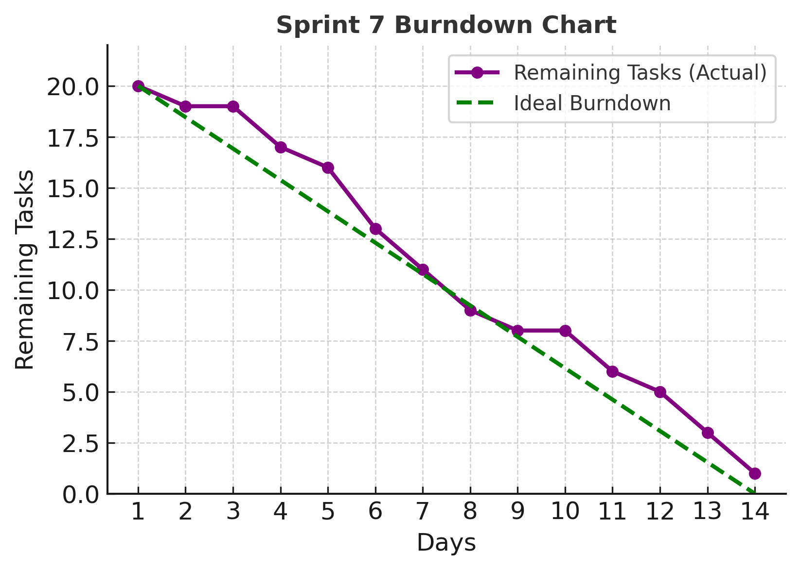

Sprint 8

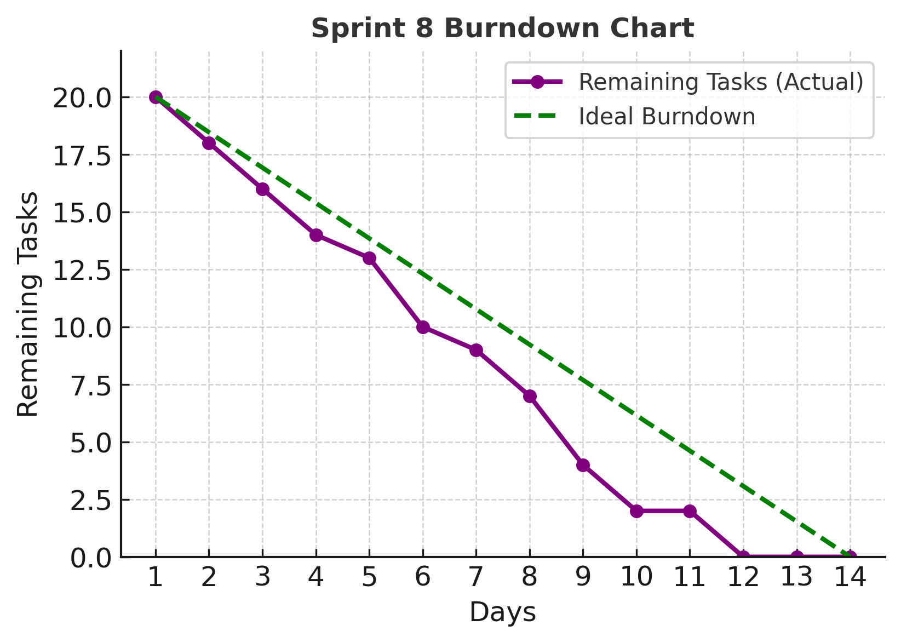

Sprint 9

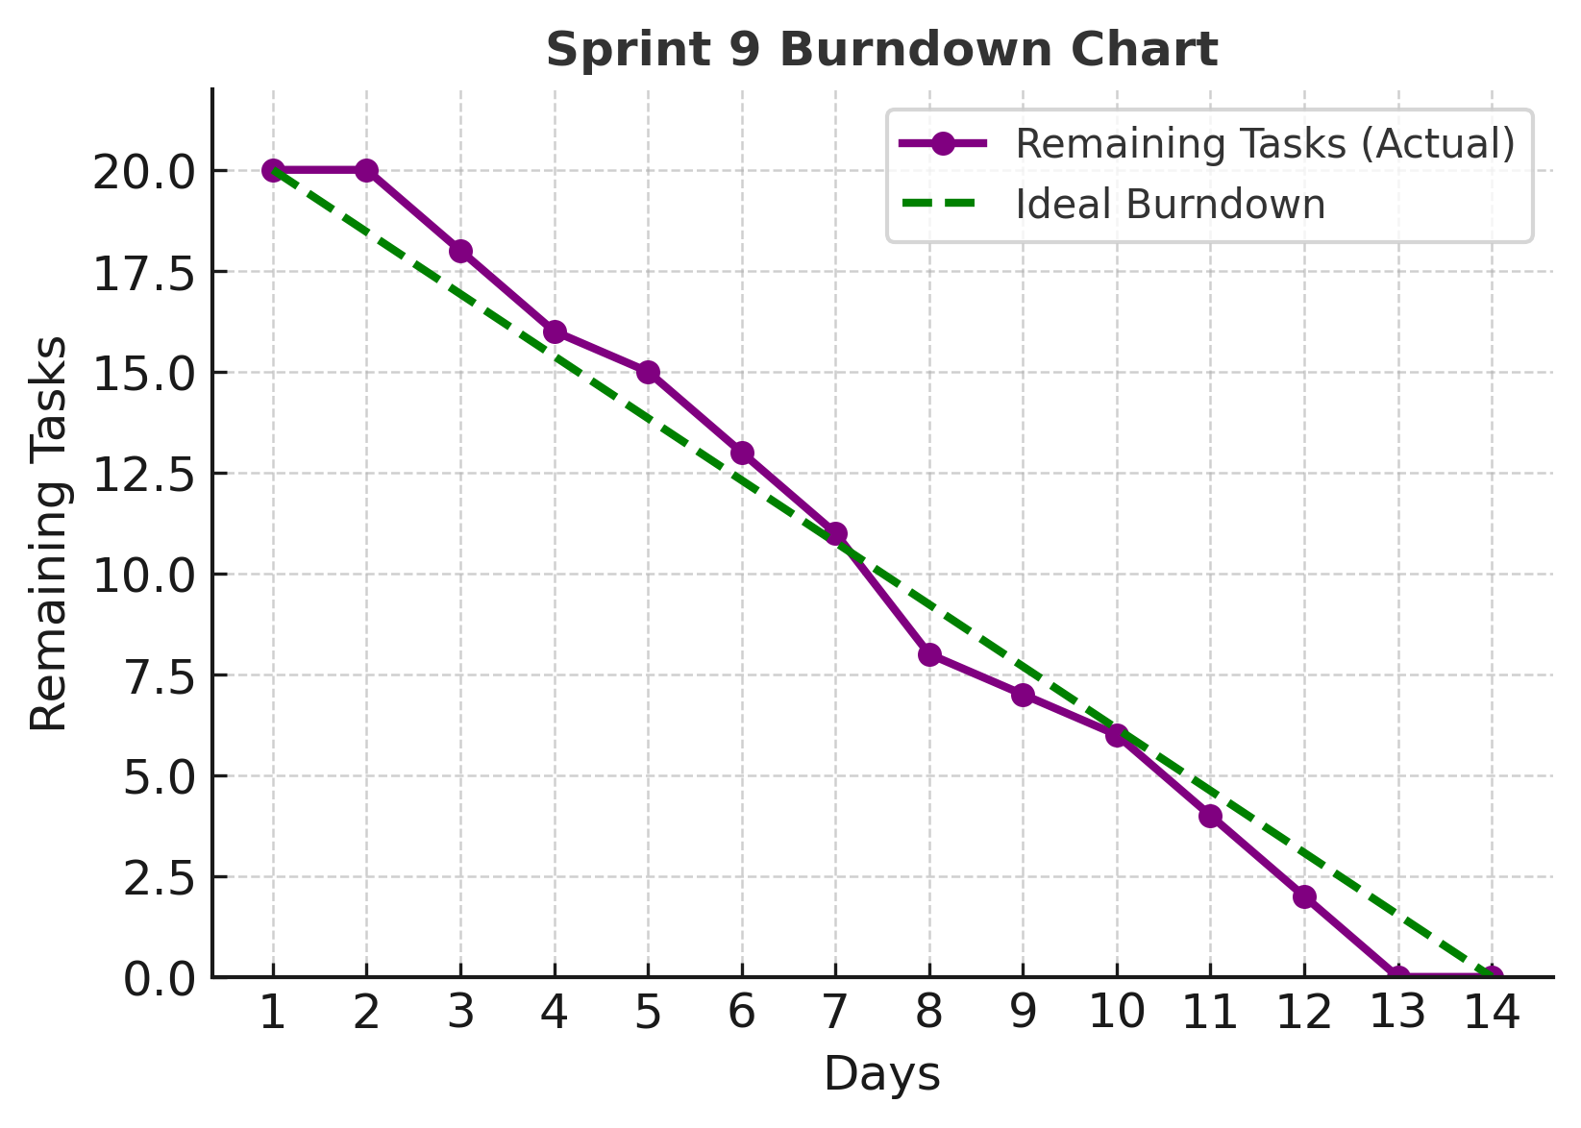

Sprint 10

Document 6 – sprint meetings

Meeting type 1 – sprint planning meeting

Sprint 1:
Date | 01/09/2025
Time | 10:00 AM – 12:00 PM
Location | Conference Room A / MS Teams
Prepared By | Mr Ramesh (Product Owner)
Attendees | Barath Narayanan (Scrum Master & Business Analyst)  Mr. Ramesh (Product Owner)  Suresh Menon  Vivek Reddy  Anil Sharma  Karthik Iyer  Prakash Rao
Agenda Topics
Topic | Presenter | Time allotted
Review Product Backlog | Mr. Ramesh | 20 mins
Define Sprint Goal | Barath Narayanan | 15 mins
Select User Stories for Sprint | Team | 30 mins
Task Breakdown & Estimation | Team | 45 mins
Finalize Sprint Plan | Barath Narayanan | 10 mins
Other Information
Observers | Resources | Special Notes
QA Lead, UI/UX Designer | Jira Board, Product Roadmap | Focus on delivering MVP core features

Sprint 2
Date | 15/09/2025
Time | 10:00 AM – 12:00 PM
Location | Conference Room B / MS Teams
Prepared By | Product Owner
Attendees | Barath Narayanan (Scrum Master & Business Analyst)  Mr. Ramesh (Product Owner)  Suresh Menon  Vivek Reddy  Anil Sharma  Karthik Iyer  Prakash Rao
Agenda Topics
Topic | Presenter | Time allotted
Review Previous Sprint Outcome | Barath Narayanan | 15 mins
Update Product Backlog | Mr. Ramesh | 20 mins
Select User Stories | Team | 30 mins
Estimate & Assign Tasks | Team | 45 mins
Confirm Sprint Goal | Barath Narayanan | 10 mins
Other Information
Observers | Resources | Special Notes
Sales Team Reps | Jira Board, Test Environment | Include high-priority bug fixes

Sprint 3
Date | 29/09/2025
Time | 2:00 PM – 4:00 PM
Location | Conference Room C / MS Teams
Prepared By | Mr. Ramesh (Product Owner)
Attendees | Barath Narayanan (Scrum Master & Business Analyst)  Mr. Ramesh (Product Owner)  Suresh Menon  Vivek Reddy  Anil Sharma  Karthik Iyer  Prakash Rao
Agenda Topics
Topic | Presenter | Time allotted
Analyze Sprint Metrics | Barath Narayanan | 15 mins
Reprioritize Backlog | Mr. Ramesh | 20 mins
Select User Stories | Team | 30 mins
Breakdown into Tasks | Team | 45 mins
Final Approval | Barath Narayanan | 10 mins
Other Information
Observers | Resources | Special Notes
Business Analyst | Jira Board, Sprint Reports | Introduce new UI features

Sprint 4
Date | 13/10/2025
Time | 10:00 AM – 12:00 PM
Location | Conference Room A
Prepared By | Mr. Ramesh (Product Owner)
Attendees | Barath Narayanan (Scrum Master & Business Analyst)  Mr. Ramesh (Product Owner)  Suresh Menon  Vivek Reddy  Anil Sharma  Karthik Iyer  Prakash Rao
Agenda Topics
Topic | Presenter | Time allotted
Backlog Refinement | Mr. Ramesh | 20 mins
Define Sprint Scope | Barath Narayanan | 15 mins
Allocate User Stories | Team | 30 mins
Task Estimation | Team | 45 mins
Risk Review | Barath Narayanan | 10 mins
Other Information
Observers | Resources | Special Notes
QA Lead | Jira Board, Risk Register | Include cross-browser testing

Sprint 5
Date | 27/10/2025
Time | 3:00 PM – 5:00 PM
Location | Conference Room B
Prepared By | Mr. Ramesh (Product Owner)
Attendees | Barath Narayanan (Scrum Master & Business Analyst)  Mr. Ramesh (Product Owner)  Suresh Menon  Vivek Reddy  Anil Sharma  Karthik Iyer  Prakash Rao
Agenda Topics
Topic | Presenter | Time allotted
Review Stakeholder Feedback | Mr. Ramesh | 20 mins
Backlog Grooming | Barath Narayanan | 15 mins
Pick High ROI Features | Team | 30 mins
Task Assignments | Team | 45 mins
Sprint Commitment | Barath Narayanan | 10 mins
Other Information
Observers | Resources | Special Notes
UX Designer | Jira Board, Feedback Docs | Improve dashboard performance

Sprint 6
Date | 10/11/2025
Time | 10:00 AM – 12:00 PM
Location | Conference Room C
Prepared By | Mr. Ramesh (Product Owner)
Attendees | Barath Narayanan (Scrum Master & Business Analyst)  Mr. Ramesh (Product Owner)  Suresh Menon  Vivek Reddy  Anil Sharma  Karthik Iyer  Prakash Rao
Agenda Topics
Topic | Presenter | Time allotted
Sprint Review Outcomes | Barath Narayanan | 15 mins
Update Priorities | Mr. Ramesh | 20 mins
Select Key Stories | Team | 30 mins
Create Task Breakdown | Team | 45 mins
Approve Sprint Plan | Barath Narayanan | 10 mins
Other Information
Observers | Resources | Special Notes
Sales team Rep | Jira Board, Design Assets | Launch ticket request feature

Sprint 7
Date | 24/11/2025
Time | 2:00 PM – 4:00 PM
Location | Conference Room A
Prepared By | Mr. Ramesh (Product Owner)
Attendees | Barath Narayanan (Scrum Master & Business Analyst)  Mr. Ramesh (Product Owner)  Suresh Menon  Vivek Reddy  Anil Sharma  Karthik Iyer  Prakash Rao
Agenda Topics
Topic | Presenter | Time allotted
Discuss New Requirements | Mr. Ramesh | 20 mins
Prioritize Stories | Barath Narayanan | 15 mins
Allocate Work | Team | 30 mins
Define Test Strategy | Team | 45 mins
Confirm Sprint Goal | Barath Narayanan | 10 mins
Other Information
Observers | Resources | Special Notes
QA Lead | Jira Board, Test Cases | Emphasis on security testing

Sprint 8
Date | 08/12/2025
Time | 10:00 AM – 12:00 PM
Location | Conference Room B
Prepared By | Mr. Ramesh (Product Owner)
Attendees | Barath Narayanan (Scrum Master & Business Analyst)  Mr. Ramesh (Product Owner)  Suresh Menon  Vivek Reddy  Anil Sharma  Karthik Iyer  Prakash Rao
Agenda Topics
Topic | Presenter | Time allotted
Backlog Grooming | Mr. Ramesh | 20 mins
Feature Selection | Barath Narayanan | 15 mins
Assign Stories | Team | 30 mins
Estimate Workload | Team | 45 mins
Lock Sprint Scope | Barath Narayanan | 10 mins
Other Information
Observers | Resources | Special Notes
UX Designer | Jira Board, Product Docs | Introduce mobile app optimization

Sprint 9
Date | 22/12/2025
Time | 3:00 PM – 5:00 PM
Location | Conference Room C
Prepared By | Mr. Ramesh (Product Owner)
Attendees | Barath Narayanan (Scrum Master & Business Analyst)  Mr. Ramesh (Product Owner)  Suresh Menon  Vivek Reddy  Anil Sharma  Karthik Iyer  Prakash Rao
Agenda Topics
Topic | Presenter | Time allotted
Review Product Milestones | Mr. Ramesh | 20 mins
Prioritize Critical Features | Barath Narayanan | 15 mins
Allocate Stories | Team | 30 mins
Plan Test Execution | Team | 45 mins
Confirm Delivery Timeline | Barath Narayanan | 10 mins
Other Information
Observers | Resources | Special Notes
QA Lead, Client Rep | Jira Board, Release Plan | Prepare for UAT phase

Sprint 10
Date | 05/01/2026
Time | 10:00 AM – 12:00 PM
Location | Conference Room A
Prepared By | Mr. Ramesh (Product Owner)
Attendees | Barath Narayanan (Scrum Master & Business Analyst)  Mr. Ramesh (Product Owner)  Suresh Menon  Vivek Reddy  Anil Sharma  Karthik Iyer  Prakash Rao
Agenda Topics
Topic | Presenter | Time allotted
Final Backlog Review | Mr. Ramesh | 20 mins
Scope Lock for Release | Barath Narayanan | 15 mins
Assign Final Tasks | Team | 30 mins
Estimate & Validate | Team | 45 mins
Sprint & Release Approval | Barath Narayanan | 10 mins
Other Information
Observers | Resources | Special Notes
Stakeholder Group | Jira Board, Release Docs | Focus on release readiness

Sprint review meetings

Sprint 1
Date | 14/09/2025
Time | 11:00 AM – 12:30 PM
Location | Conference Room A / MS Teams
Prepared By | Mr. Ramesh (Product Owner)
Attendees | Barath Narayanan (Scrum Master & BA)  Mr. Ramesh (PO)  Suresh Menon  Vivek Reddy  Anil Sharma  Karthik Iyer  Prakash Rao
Sprint status | Things to demo | Quick updates | What’s next
Completed 90% of planned stories | Login module, User dashboard | Minor API performance issues fixed | Integrate payment gateway

Sprint 2
Date | 28/09/2025
Time | 11:00 AM – 12:30 PM
Location | Conference Room B / MS Teams
Prepared By | Mr. Ramesh
Attendees | Barath Narayanan (Scrum Master & BA)  Mr. Ramesh (PO)  Suresh Menon  Vivek Reddy  Anil Sharma  Karthik Iyer  Prakash Rao
Sprint status | Things to demo | Quick updates | What’s next
Completed all planned features | Ticket request, download tickets | New security measures implemented | Develop admin analytics dashboard

Sprint 3
Date | 12/10/2025
Time | 2:00 PM – 3:30 PM
Location | Conference Room C / MS Teams
Prepared By | Mr. Ramesh
Attendees | Barath Narayanan (Scrum Master & BA)  Mr. Ramesh (PO)  Suresh Menon  Vivek Reddy  Anil Sharma  Karthik Iyer  Prakash Rao
Sprint status | Things to demo | Quick updates | What’s next
Completed 85% of scope | Admin analytics dashboard, Email notifications | Delay due to API bug resolution | Mobile app initial version

Sprint 4
Date | 26/10/2025
Time | 10:30 AM – 12:00 PM
Location | Conference Room A
Prepared By | Mr. Ramesh
Attendees | Barath Narayanan (Scrum Master & BA)  Mr. Ramesh (PO)  Suresh Menon  Vivek Reddy  Anil Sharma  Karthik Iyer  Prakash Rao
Sprint status | Things to demo | Quick updates | What’s next
Completed 95% of stories | Mobile app prototype, UI updates | Client approved mobile app design | Implement chat support

Sprint 5
Date | 09/11/2025
Time | 3:00 PM – 4:30 PM
Location | Conference Room B
Prepared By | Mr. Ramesh
Attendees | Barath Narayanan (Scrum Master & BA)  Mr. Ramesh (PO)  Suresh Menon  Vivek Reddy  Anil Sharma  Karthik Iyer  Prakash Rao
Sprint status | Things to demo | Quick updates | What’s next
All planned features completed | Chat support, Profile update module | Minor UI fixes completed | Launch beta testing phase

Sprint 6
Date | 23/11/2025
Time | 10:00 AM – 11:30 AM
Location | Conference Room C
Prepared By | Mr. Ramesh
Attendees | Barath Narayanan (Scrum Master & BA)  Mr. Ramesh (PO)  Suresh Menon  Vivek Reddy  Anil Sharma  Karthik Iyer  Prakash Rao
Sprint status | Things to demo | Quick updates | What’s next
Completed 88% of scope | Beta version walkthrough | Gathered early user feedback | Apply feedback-based improvements

Sprint 7
Date | 07/12/2025
Time | 2:00 PM – 3:30 PM
Location | Conference Room A
Prepared By | Mr. Ramesh
Attendees | Barath Narayanan (Scrum Master & BA)  Mr. Ramesh (PO)  Suresh Menon  Vivek Reddy  Anil Sharma  Karthik Iyer  Prakash Rao
Sprint status | Things to demo | Quick updates | What’s next
Completed all backlog items | Performance optimization, Faster load times | Reduced server response by 30% | Start final UAT preparation

Sprint 8
Date | 21/12/2025
Time | 11:00 AM – 12:30 PM
Location | Conference Room B
Prepared By | Mr. Ramesh
Attendees | Barath Narayanan (Scrum Master & BA)  Mr. Ramesh (PO)  Suresh Menon  Vivek Reddy  Anil Sharma  Karthik Iyer  Prakash Rao
Sprint status | Things to demo | Quick updates | What’s next
Completed 92% of tasks | UAT-ready build, Full feature set | All critical bugs resolved | Conduct UAT with client

Sprint 9
Date | 04/01/2026
Time | 10:00 AM – 11:30 AM
Location | Conference Room C
Prepared By | Mr. Ramesh
Attendees | Barath Narayanan (Scrum Master & BA)  Mr. Ramesh (PO)  Suresh Menon  Vivek Reddy  Anil Sharma  Karthik Iyer  Prakash Rao
Sprint status | Things to demo | Quick updates | What’s next
Completed UAT feedback changes | Final product demo | Client signed off on main features | Prepare release documentation

Sprint 10
Date | 18/01/2026
Time | 10:00 AM – 11:30 AM
Location | Conference Room A
Prepared By | Mr. Ramesh
Attendees | Barath Narayanan (Scrum Master & BA)  Mr. Ramesh (PO)  Suresh Menon  Vivek Reddy  Anil Sharma  Karthik Iyer  Prakash Rao
Sprint status | Things to demo | Quick updates | What’s next
Release-ready | Final release version | Deployment scheduled | Post-release support & maintenance

Sprint retrospective meetings

Sprint 1
Date | 14/09/2025
Time | 3:00 PM – 4:00 PM
Location | Conference Room A / MS Teams
Prepared By | Barath Narayanan (Scrum Master)
Attendees | Mr. Ramesh  Barath Narayanan  Suresh Menon  Vivek Reddy  Anil Sharma  Karthik Iyer  Prakash Rao
Agenda | What went well | What didn’t go well | Questions | Reference
Review Sprint 1 outcomes | Login module completed ahead of time | API documentation incomplete | How to streamline documentation | Sprint 1 backlog & burndown

Sprint 2
Date | 28/09/2025
Time | 3:00 PM – 4:00 PM
Location | Conference Room A / MS Teams
Prepared By | Barath Narayanan (Scrum Master)
Attendees | Mr. Ramesh  Barath Narayanan  Suresh Menon  Vivek Reddy  Anil Sharma  Karthik Iyer  Prakash Rao
Agenda | What went well | What didn’t go well | Questions | Reference
Review Sprint 2 outcomes | Payment gateway integrated successfully | Minor delays due to QA environment setup | How to automate deployment | Sprint 2 backlog & burndown

Sprint 3
Date | 12/10/2025
Time | 4:00 PM – 5:00 PM
Location | Conference Room C
Prepared By | Barath Narayanan (Scrum Master)
Attendees | Mr. Ramesh  Barath Narayanan  Suresh Menon  Vivek Reddy  Anil Sharma  Karthik Iyer  Prakash Rao
Agenda | What went well | What didn’t go well | Questions | Reference
Review Sprint 3 outcomes | Analytics dashboard functional | API bug delayed story completion | How to handle unexpected blockers | Sprint 3 backlog & burndown

Sprint 4
Date | 26/10/2025
Time | 2:00 PM – 3:00 PM
Location | Conference Room A
Prepared By | Barath Narayanan (Scrum Master)
Attendees | Mr. Ramesh  Barath Narayanan  Suresh Menon  Vivek Reddy  Anil Sharma  Karthik Iyer  Prakash Rao
Agenda | What went well | What didn’t go well | Questions | Reference
Review Sprint 4 outcomes | Mobile app prototype approved | Some UI inconsistencies found late | How to implement early UI reviews | Sprint 4 backlog & burndown

Sprint 5
Date | 09/11/2025
Time | 4:00 PM – 5:00 PM
Location | Conference Room B
Prepared By | Barath Narayanan (Scrum Master)
Attendees | Mr. Ramesh  Barath Narayanan  Suresh Menon  Vivek Reddy  Anil Sharma  Karthik Iyer  Prakash Rao
Agenda | What went well | What didn’t go well | Questions | Reference
Review Sprint 5 outcomes | Chat support deployed | Minor connectivity issue during testing | How to simulate production-like network in test | Sprint 5 backlog & burndown

Sprint 6
Date | 23/11/2025
Time | 10:30 AM – 11:30 AM
Location | Conference Room C
Prepared By | Barath Narayanan (Scrum Master)
Attendees | Mr. Ramesh  Barath Narayanan  Suresh Menon  Vivek Reddy  Anil Sharma  Karthik Iyer  Prakash Rao
Agenda | What went well | What didn’t go well | Questions | Reference
Review Sprint 6 outcomes | Beta feedback received early | Few users reported app crashes | How to improve crash logging | Sprint 6 backlog & burndown

Sprint 7
Date | 07/12/2025
Time | 4:00 PM – 5:00 PM
Location | Conference Room A
Prepared By | Barath Narayanan (Scrum Master)
Attendees | Mr. Ramesh  Barath Narayanan  Suresh Menon  Vivek Reddy  Anil Sharma  Karthik Iyer  Prakash Rao
Agenda | What went well | What didn’t go well | Questions | Reference
Review Sprint 7 outcomes | Performance improved by 30% | Delay in third-party API response | How to handle third-party SLAs | Sprint 7 backlog & burndown

Sprint 8
Date | 21/12/2025
Time | 2:00 PM – 3:00 PM
Location | Conference Room B
Prepared By | Barath Narayanan (Scrum Master)
Attendees | Mr. Ramesh  Barath Narayanan  Suresh Menon  Vivek Reddy  Anil Sharma  Karthik Iyer  Prakash Rao
Agenda | What went well | What didn’t go well | Questions | Reference
Review Sprint 8 outcomes | UAT-ready build delivered | Minor usability issues reported | How to integrate usability testing earlier | Sprint 8 backlog & burndown

Sprint 9
Date | 04/01/2026
Time | 11:00 AM – 12:00 PM
Location | Conference Room C
Prepared By | Barath Narayanan (Scrum Master)
Attendees | Mr. Ramesh  Barath Narayanan  Suresh Menon  Vivek Reddy  Anil Sharma  Karthik Iyer  Prakash Rao
Agenda | What went well | What didn’t go well | Questions | Reference
Review Sprint 9 outcomes | Client approved all major changes | Documentation updates lagging | How to keep docs updated in parallel | Sprint 9 backlog & burndown

Sprint 10
Date | 18/01/2026
Time | 3:00 PM – 4:00 PM
Location | Conference Room A
Prepared By | Barath Narayanan (Scrum Master)
Attendees | Mr. Ramesh  Barath Narayanan  Suresh Menon  Vivek Reddy  Anil Sharma  Karthik Iyer  Prakash Rao
Agenda | What went well | What didn’t go well | Questions | Reference
Review Sprint 10 outcomes | Release deployed successfully | Minor post-release bug found | How to improve regression testing | Sprint 10 backlog & burndown

Daily stand up meeting

Sprint 1 – Daily Stand-up Meeting
Week: 01-09-2025 to 14-09-2025
Question | Name / Role | Monday | Tuesday | Wednesday | Thursday | Friday | Saturday
What did you do yesterday? | Suresh Menon | Set up module | Implemented feature | Tested component | Fixed bug | Reviewed code | Updated documentation
What did you do yesterday? | Vivek Reddy | Set up module | Implemented feature | Tested component | Fixed bug | Reviewed code | Updated documentation
What did you do yesterday? | Anil Sharma | Set up module | Implemented feature | Tested component | Fixed bug | Reviewed code | Updated documentation
What will you do today? | Suresh Menon | Continue feature dev | Integrate module | Conduct testing | Bug fixing | Prepare demo | Optimize performance
What will you do today? | Vivek Reddy | Continue feature dev | Integrate module | Conduct testing | Bug fixing | Prepare demo | Optimize performance
What will you do today? | Anil Sharma | Continue feature dev | Integrate module | Conduct testing | Bug fixing | Prepare demo | Optimize performance
What (if any) is blocking your progress? | Suresh Menon | None | API downtime | Waiting for review | Dependency delay | Environment issue | None
What (if any) is blocking your progress? | Vivek Reddy | None | API downtime | Waiting for review | Dependency delay | Environment issue | None
What (if any) is blocking your progress? | Anil Sharma | None | API downtime | Waiting for review | Dependency delay | Environment issue | None

Sprint 2 – Daily Stand-up Meeting
Week: 15-09-2025 to 28-09-2025
Question | Name / Role | Monday | Tuesday | Wednesday | Thursday | Friday | Saturday
What did you do yesterday? | Suresh Menon | Set up module | Implemented feature | Tested component | Fixed bug | Reviewed code | Updated documentation
What did you do yesterday? | Vivek Reddy | Set up module | Implemented feature | Tested component | Fixed bug | Reviewed code | Updated documentation
What did you do yesterday? | Anil Sharma | Set up module | Implemented feature | Tested component | Fixed bug | Reviewed code | Updated documentation
What will you do today? | Suresh Menon | Continue feature dev | Integrate module | Conduct testing | Bug fixing | Prepare demo | Optimize performance
What will you do today? | Vivek Reddy | Continue feature dev | Integrate module | Conduct testing | Bug fixing | Prepare demo | Optimize performance
What will you do today? | Anil Sharma | Continue feature dev | Integrate module | Conduct testing | Bug fixing | Prepare demo | Optimize performance
What (if any) is blocking your progress? | Suresh Menon | None | API downtime | Waiting for review | Dependency delay | Environment issue | None
What (if any) is blocking your progress? | Vivek Reddy | None | API downtime | Waiting for review | Dependency delay | Environment issue | None
What (if any) is blocking your progress? | Anil Sharma | None | API downtime | Waiting for review | Dependency delay | Environment issue | None

Sprint 3 – Daily Stand-up Meeting
Week: 29-09-2025 to 12-10-2025
Question | Name / Role | Monday | Tuesday | Wednesday | Thursday | Friday | Saturday
What did you do yesterday? | Suresh Menon | Set up module | Implemented feature | Tested component | Fixed bug | Reviewed code | Updated documentation
What did you do yesterday? | Vivek Reddy | Set up module | Implemented feature | Tested component | Fixed bug | Reviewed code | Updated documentation
What did you do yesterday? | Anil Sharma | Set up module | Implemented feature | Tested component | Fixed bug | Reviewed code | Updated documentation
What will you do today? | Suresh Menon | Continue feature dev | Integrate module | Conduct testing | Bug fixing | Prepare demo | Optimize performance
What will you do today? | Vivek Reddy | Continue feature dev | Integrate module | Conduct testing | Bug fixing | Prepare demo | Optimize performance
What will you do today? | Anil Sharma | Continue feature dev | Integrate module | Conduct testing | Bug fixing | Prepare demo | Optimize performance
What (if any) is blocking your progress? | Suresh Menon | None | API downtime | Waiting for review | Dependency delay | Environment issue | None
What (if any) is blocking your progress? | Vivek Reddy | None | API downtime | Waiting for review | Dependency delay | Environment issue | None
What (if any) is blocking your progress? | Anil Sharma | None | API downtime | Waiting for review | Dependency delay | Environment issue | None

Sprint 4 – Daily Stand-up Meeting
Week: 13-10-2025 to 26-10-2025
Question | Name / Role | Monday | Tuesday | Wednesday | Thursday | Friday | Saturday
What did you do yesterday? | Suresh Menon | Set up module | Implemented feature | Tested component | Fixed bug | Reviewed code | Updated documentation
What did you do yesterday? | Vivek Reddy | Set up module | Implemented feature | Tested component | Fixed bug | Reviewed code | Updated documentation
What did you do yesterday? | Anil Sharma | Set up module | Implemented feature | Tested component | Fixed bug | Reviewed code | Updated documentation
What will you do today? | Suresh Menon | Continue feature dev | Integrate module | Conduct testing | Bug fixing | Prepare demo | Optimize performance
What will you do today? | Vivek Reddy | Continue feature dev | Integrate module | Conduct testing | Bug fixing | Prepare demo | Optimize performance
What will you do today? | Anil Sharma | Continue feature dev | Integrate module | Conduct testing | Bug fixing | Prepare demo | Optimize performance
What (if any) is blocking your progress? | Suresh Menon | None | API downtime | Waiting for review | Dependency delay | Environment issue | None
What (if any) is blocking your progress? | Vivek Reddy | None | API downtime | Waiting for review | Dependency delay | Environment issue | None
What (if any) is blocking your progress? | Anil Sharma | None | API downtime | Waiting for review | Dependency delay | Environment issue | None

Sprint 5 – Daily Stand-up Meeting
Week: 27-10-2025 to 09-11-2025
Question | Name / Role | Monday | Tuesday | Wednesday | Thursday | Friday | Saturday
What did you do yesterday? | Suresh Menon | Set up module | Implemented feature | Tested component | Fixed bug | Reviewed code | Updated documentation
What did you do yesterday? | Vivek Reddy | Set up module | Implemented feature | Tested component | Fixed bug | Reviewed code | Updated documentation
What did you do yesterday? | Anil Sharma | Set up module | Implemented feature | Tested component | Fixed bug | Reviewed code | Updated documentation
What will you do today? | Suresh Menon | Continue feature dev | Integrate module | Conduct testing | Bug fixing | Prepare demo | Optimize performance
What will you do today? | Vivek Reddy | Continue feature dev | Integrate module | Conduct testing | Bug fixing | Prepare demo | Optimize performance
What will you do today? | Anil Sharma | Continue feature dev | Integrate module | Conduct testing | Bug fixing | Prepare demo | Optimize performance
What (if any) is blocking your progress? | Suresh Menon | None | API downtime | Waiting for review | Dependency delay | Environment issue | None
What (if any) is blocking your progress? | Vivek Reddy | None | API downtime | Waiting for review | Dependency delay | Environment issue | None
What (if any) is blocking your progress? | Anil Sharma | None | API downtime | Waiting for review | Dependency delay | Environment issue | None

Sprint 6 – Daily Stand-up Meeting
Week: 10-11-2025 to 23-11-2025
Question | Name / Role | Monday | Tuesday | Wednesday | Thursday | Friday | Saturday
What did you do yesterday? | Suresh Menon | Set up module | Implemented feature | Tested component | Fixed bug | Reviewed code | Updated documentation
What did you do yesterday? | Vivek Reddy | Set up module | Implemented feature | Tested component | Fixed bug | Reviewed code | Updated documentation
What did you do yesterday? | Anil Sharma | Set up module | Implemented feature | Tested component | Fixed bug | Reviewed code | Updated documentation
What will you do today? | Suresh Menon | Continue feature dev | Integrate module | Conduct testing | Bug fixing | Prepare demo | Optimize performance
What will you do today? | Vivek Reddy | Continue feature dev | Integrate module | Conduct testing | Bug fixing | Prepare demo | Optimize performance
What will you do today? | Anil Sharma | Continue feature dev | Integrate module | Conduct testing | Bug fixing | Prepare demo | Optimize performance
What (if any) is blocking your progress? | Suresh Menon | None | API downtime | Waiting for review | Dependency delay | Environment issue | None
What (if any) is blocking your progress? | Vivek Reddy | None | API downtime | Waiting for review | Dependency delay | Environment issue | None
What (if any) is blocking your progress? | Anil Sharma | None | API downtime | Waiting for review | Dependency delay | Environment issue | None

Sprint 7 – Daily Stand-up Meeting
Week: 24-11-2025 to 07-12-2025
Question | Name / Role | Monday | Tuesday | Wednesday | Thursday | Friday | Saturday
What did you do yesterday? | Suresh Menon | Set up module | Implemented feature | Tested component | Fixed bug | Reviewed code | Updated documentation
What did you do yesterday? | Vivek Reddy | Set up module | Implemented feature | Tested component | Fixed bug | Reviewed code | Updated documentation
What did you do yesterday? | Anil Sharma | Set up module | Implemented feature | Tested component | Fixed bug | Reviewed code | Updated documentation
What will you do today? | Suresh Menon | Continue feature dev | Integrate module | Conduct testing | Bug fixing | Prepare demo | Optimize performance
What will you do today? | Vivek Reddy | Continue feature dev | Integrate module | Conduct testing | Bug fixing | Prepare demo | Optimize performance
What will you do today? | Anil Sharma | Continue feature dev | Integrate module | Conduct testing | Bug fixing | Prepare demo | Optimize performance
What (if any) is blocking your progress? | Suresh Menon | None | API downtime | Waiting for review | Dependency delay | Environment issue | None
What (if any) is blocking your progress? | Vivek Reddy | None | API downtime | Waiting for review | Dependency delay | Environment issue | None
What (if any) is blocking your progress? | Anil Sharma | None | API downtime | Waiting for review | Dependency delay | Environment issue | None

Sprint 8 – Daily Stand-up Meeting
Week: 08-12-2025 to 21-12-2025
Question | Name / Role | Monday | Tuesday | Wednesday | Thursday | Friday | Saturday
What did you do yesterday? | Suresh Menon | Set up module | Implemented feature | Tested component | Fixed bug | Reviewed code | Updated documentation
What did you do yesterday? | Vivek Reddy | Set up module | Implemented feature | Tested component | Fixed bug | Reviewed code | Updated documentation
What did you do yesterday? | Anil Sharma | Set up module | Implemented feature | Tested component | Fixed bug | Reviewed code | Updated documentation
What will you do today? | Suresh Menon | Continue feature dev | Integrate module | Conduct testing | Bug fixing | Prepare demo | Optimize performance
What will you do today? | Vivek Reddy | Continue feature dev | Integrate module | Conduct testing | Bug fixing | Prepare demo | Optimize performance
What will you do today? | Anil Sharma | Continue feature dev | Integrate module | Conduct testing | Bug fixing | Prepare demo | Optimize performance
What (if any) is blocking your progress? | Suresh Menon | None | API downtime | Waiting for review | Dependency delay | Environment issue | None
What (if any) is blocking your progress? | Vivek Reddy | None | API downtime | Waiting for review | Dependency delay | Environment issue | None
What (if any) is blocking your progress? | Anil Sharma | None | API downtime | Waiting for review | Dependency delay | Environment issue | None

Sprint 9 – Daily Stand-up Meeting
Week: 22-12-2025 to 04-01-2026
Question | Name / Role | Monday | Tuesday | Wednesday | Thursday | Friday | Saturday
What did you do yesterday? | Suresh Menon | Set up module | Implemented feature | Tested component | Fixed bug | Reviewed code | Updated documentation
What did you do yesterday? | Vivek Reddy | Set up module | Implemented feature | Tested component | Fixed bug | Reviewed code | Updated documentation
What did you do yesterday? | Anil Sharma | Set up module | Implemented feature | Tested component | Fixed bug | Reviewed code | Updated documentation
What will you do today? | Suresh Menon | Continue feature dev | Integrate module | Conduct testing | Bug fixing | Prepare demo | Optimize performance
What will you do today? | Vivek Reddy | Continue feature dev | Integrate module | Conduct testing | Bug fixing | Prepare demo | Optimize performance
What will you do today? | Anil Sharma | Continue feature dev | Integrate module | Conduct testing | Bug fixing | Prepare demo | Optimize performance
What (if any) is blocking your progress? | Suresh Menon | None | API downtime | Waiting for review | Dependency delay | Environment issue | None
What (if any) is blocking your progress? | Vivek Reddy | None | API downtime | Waiting for review | Dependency delay | Environment issue | None
What (if any) is blocking your progress? | Anil Sharma | None | API downtime | Waiting for review | Dependency delay | Environment issue | None

Sprint 10 – Daily Stand-up Meeting
Week: 05-01-2026 to 18-01-2026
Question | Name / Role | Monday | Tuesday | Wednesday | Thursday | Friday | Saturday
What did you do yesterday? | Suresh Menon | Set up module | Implemented feature | Tested component | Fixed bug | Reviewed code | Updated documentation
What did you do yesterday? | Vivek Reddy | Set up module | Implemented feature | Tested component | Fixed bug | Reviewed code | Updated documentation
What did you do yesterday? | Anil Sharma | Set up module | Implemented feature | Tested component | Fixed bug | Reviewed code | Updated documentation
What will you do today? | Suresh Menon | Continue feature dev | Integrate module | Conduct testing | Bug fixing | Prepare demo | Optimize performance
What will you do today? | Vivek Reddy | Continue feature dev | Integrate module | Conduct testing | Bug fixing | Prepare demo | Optimize performance
What will you do today? | Anil Sharma | Continue feature dev | Integrate module | Conduct testing | Bug fixing | Prepare demo | Optimize performance
What (if any) is blocking your progress? | Suresh Menon | None | API downtime | Waiting for review | Dependency delay | Environment issue | None
What (if any) is blocking your progress? | Vivek Reddy | None | API downtime | Waiting for review | Dependency delay | Environment issue | None
What (if any) is blocking your progress? | Anil Sharma | None | API downtime | Waiting for review | Dependency delay | Environment issue | None

