Question 1 – Write Agile Manifesto

Answer:
Agile Manifesto is a set of guiding values and principles that prioritize individuals, collaboration, working software, and adaptability over rigid processes and documentation in software development.
Four main values of Agile manifesto:
- Individuals and interactions over processes and tools
- Working software over comprehensive documentation
- Customer collaboration over contract negotiation
- Responding to change over following a plan

Twelve Principles of Agile Software
- Satisfy the customer through early and continuous delivery of valuable software.
- Welcome changing requirements, even late in development. Agile processes harness change for the customer's competitive advantage.
- Deliver working software frequently, from a couple of weeks to a couple of months, with a preference to the shorter timescale.
- Business people and developers must work together daily throughout the project.
- Build projects around motivated individuals. Give them the environment and support they need and trust them to get the job done.
- The most efficient and effective method of conveying information to and within a development team is face-to-face conversation.
- Working software is the primary measure of progress.
Agile processes promote sustainable development. The sponsors, developers, and users should be able to maintain a constant pace indefinitely.
- Continuous attention to technical excellence and good design enhances agility.
- Simplicity--the art of maximizing the amount of work not done--is essential.
- The best architectures, requirements, and designs emerge from self-organizing teams.
- At regular intervals, the team reflects on how to become more effective, then tunes and adjusts its behaviour accordingly.

Question 2 – User Stories- Acceptance Criteria-BV-CP
Write minimum 40 User stories and their Acceptance Criteria along with their BV and CP.
Answer:
User Story is a brief description of a feature or function from the perspective of an end user to capture what they need and why.
Tasks are specific actions or steps the development team must complete to implement the user story.
Acceptance criteria are Clear, testable conditions that define when a user story is considered complete and functioning as intended.
Business Value is the benefit or impact the completed user story brings to the organization, such as increased revenue, efficiency, or user satisfaction.
Complexity Point is a relative measure of the effort, risk, and time required to implement the user story, often estimated using story points.

User story: 1 | Tasks: 3 |  | Priority: Highest
AS A CUSTOMER
I WANT TO TRACK MY ORDER
SO THAT I CAN SEE REAL TIME LOCATION OF ORDER
BV: 500 |  | CP: 5
Acceptance Criteria:
- Map view showing current delivery location
- w showing current delivery location
- ETA updated every 30 seconds
- Display of delivery boy name and contact details

User story: 2 | Tasks: 2 |  | Priority: High
AS A CUSTOMER
I WANT TO CANCEL MY ORDER
SO THAT I CAN MANAGE UNWANTED ORDERS
BV: 200 |  | CP: 3
Acceptance Criteria:
- Order cancellation button (to be available before pickup)
- Cancellation confirmation
- Order status updated as “Cancelled”
- Refund option details update

User story: 3 | Tasks: 2 |  | Priority: HIGH
AS A CUSTOMER
I WANT TO GIVE FEEDBACK ON MY ORDER
SO THAT I CAN SHARE MY EXPERIENCE AND HELP IN IMPROVISING SERVICE
BV: 200 |  | CP: 2
Acceptance Criteria:
- Textbox for feedback and rating option ( 1 to 5 star)
- Click on Submit button
- Confirmation message after submission

User story: 4 | Tasks: 3 |  | Priority: HIGH
AS A CUSTOMER
I WANT TO GIVE RATING FOR ORDER
SO THAT I CAN EXPRESS MY SATISFACTION LEVEL
BV: 200 |  | CP: 2
Acceptance Criteria:
- Rating scale (1 to 5 star)
- Optional Comment box
- Rating must be submitted after order is marked as delivered
- Confirmation message after submission

User story: 5 | Tasks: 2 |  | Priority: HIGHEST
AS A CUSTOMER
I WANT TO ORDER FOOD FROM RESTAURANT
SO THAT I CAN GET IT DELIVERED TO MY ADDRESS
BV: 500 |  | CP: 4
Acceptance Criteria:
- Select items from restaurant’s menu
- Add item to cart
- View cart with total amount
- Proceed to checkout with delivery address and payment mode
- Click on “Place Order” button
- Receive order confirmation button.

User story: 6 | Tasks: 3 |  | Priority: High
AS A CUSTOMER
I WANT TO VIEW RESTAURANT MENU
SO THAT I CAN DECIDE WHAT TO ORDER
BV: 300 |  | CP: 3
Acceptance Criteria:
- Restaurant Menu is displayed with food items, price and availability
- Filter items by category (e.g.: veg, non-veg, beverages etc.)
- Display image of food items
- Each item has “Add to cart” button

User story: 7 | Tasks: 3 |  | Priority: High
AS A CUSTOMER
I WANT TO SEARCH AND VIEW RESTAURANT
SO THAT I CAN DECIDE FROM WHICH RESTAURANT TO ORDER FOOD
BV: 300 |  | CP: 3
Acceptance Criteria:
- Search bar for entering restaurant name, location or cuisine type
- Matching restaurants are shown in a list with key details
- Option to filter results
- Clicking on restaurant shows basic details like address, operating hours and button to view its menu

User story: 8 | Tasks:3 |  | Priority: High
AS A DELIVERY BOY
I WANT TO LOGIN ON SCRUM FOOD PORTAL
SO THAT I CAN ACCESS MY DELIVERY DASHBOARD AND START WORKING
BV: 200 |  | CP: 2
Acceptance Criteria:
- Login screen with fields for username/email and password.
- "Forgot Password" and "Register" options are available.
- Click on the "Login" button to authenticate credentials.
- If credentials are correct, redirect to the delivery dashboard.
- Show error message for invalid login credentials.

User story: 9 | Tasks:3 |  | Priority: High
AS A DELIVERY BOY
I WANT TO VIEW ORDERS ON SCRUM FOOD PORTAL
SO THAT I CAN SEE WHICH ORDERS ARE READY FOR DELIVERY
BV: 200 |  | CP: 2
Acceptance Criteria:
- List of available orders shown on dashboard
- Each order shows customer name, restaurant, delivery address and order time.
- Orders are sorted by pickup time or location.

User story: 10 | Tasks:2 |  | Priority: Highest
AS A DELIVERY BOY
I WANT TO SELECT AND ACCEPT ORDERS
SO THAT I CAN START THE DELIVERY PROCESS
BV: 300 |  | CP: 2
Acceptance Criteria:
- Click “Accept” button on available orders.
- Confirmation popup before final acceptance.
- Accepted order moves to “My Deliveries” section.
- Show message: “Order accepted successfully.”

User story: 11 | Tasks:2 |  | Priority: Medium
AS A DELIVERY BOY
I WANT TO VIEW FEEDBACK
SO THAT I CAN GET REVIEW OF SERVICE PROVIDED
BV: 150 |  | CP: 2
Acceptance Criteria:
- Feedback section displays comments and ratings from customers.
- Feedback is shown with date, order ID, and customer name.
- Feedback is read-only (cannot be edited).

User story: 12 | Tasks: |  | Priority: Highest
AS A DELIVERY BOY
I WANT TO MARK AN ORDER AS PICKED UP AND DELIVERED
SO THAT SYSTEM CAN TRACK ORDER STATUS
BV: 400 |  | CP: 3
Acceptance Criteria:
- “Picked Up” button available when near restaurant.
- “Delivered” button available when near customer location.
- Show time details for pickup and delivery events.
- Order status updated in system and visible to customer.

User story: 13 | Tasks:2 |  | Priority: Medium
AS A DELIVERY BOY
I WANT TO UPDATE STATUS OF AN ORDER
SO THAT CUSTOMERS AND ADMIN CAN TRACK ITS PROGRESS
BV: 300 |  | CP: 3
Acceptance Criteria:
- Status options include Assigned, Picked Up, On the Way, Delivered.
- Each status update triggers a notification to the customer.
- Time of status change is logged in system.

User story: 14 | Tasks: 3 |  | Priority: High
AS A DELIVERY BOY
I WANT TO RECEIVE PAYMENT VIA CASH ON DELIVERY
SO THAT I CAN COLLECT MONEY FROM THE CUSTOMER AND UPDATE THE SYSTEM
BV: 500 |  | CP: 3
Acceptance Criteria:
- “Payment Method: COD” label is visible on applicable orders.
- After delivery, mark “Cash Received” checkbox.
- Update payment status to “Completed.”
- Trigger confirmation message to customer and system.

User story: 15 | Tasks: 2 |  | Priority: High
AS A RESTAURANT OWNER
I WANT TO LOGIN THE SCRUM FOOD APP
SO THAT I CAN MANAGE MY ORDERS AND RESTAURANT OPERATIONS
BV: 200 |  | CP: 2
Acceptance Criteria:
- Login screen for user id and password fields
- “Forgot password and “Register now fields available
- Authenticate valid credentials on login
- On successful login, redirect to restaurant dashboard
- Error message shown for invalid credentials.

User story: 16 | Tasks: |  | Priority: High
AS A RESTAURANT OWNER
I WANT TO VERIFY IDENTITY OF DELIVERY BOY
SO THAT I CAN ENSURE THAT THE RIGHT PERSON PICKS UP THE ORDER
BV: 500 |  | CP: 3
Acceptance Criteria:
- Delivery boy details shown with photo and ID.
- Button to mark “Verified” or “Not Verified.”
- Alert if delivery boy is not verified.
- Record of verification logged.

User story: 17 | Tasks: 2 |  | Priority: High
AS A RESTAURANT OWNER
I WANT TO RAISE AN ISSUE
SO THAT I CAN REPORT OPERATIONAL PROBLEMS
BV: 200 |  | CP: 2
Acceptance Criteria:
- Form with dropdown for issue category (e.g., payment, delivery delay, system error).
- Text box for issue description.
- Auto-generate issue ID on submission.
- Confirmation message after successful submission.

User story: 18 | Tasks: 2 |  | Priority: Medium
AS A RESTAURANT OWNER
I WANT TO VIEW FEEDBACK
SO THAT I CAN IMPROVE THE SERVICE QUALITY
BV: 200 |  | CP: 2
Acceptance Criteria:
- Feedback list with ratings and comments.
- Filter by date or rating (e.g., 1-star, 5-star)
- Order ID and customer name associated with each feedback.
- Feedback is read-only.

User story: 19 | Tasks: 2 |  | Priority: High
AS A RESTAURANT OWNER
I WANT TO VISIT THE REVENUE GENERATED THROUGH SCRUM FOOD APP
SO THAT CAN VIEW MY EARNINGS GENERATED AND BUSINESS PERFORMANCE
BV: 400 |  | CP: 3
Acceptance Criteria:
- Revenue section available in the restaurant dashboard.
- Display revenue summary by day, week, month, and custom date range.
- Each entry includes Order ID, Date, Order Amount, Commission, Net Revenue.
- Export revenue report in Excel or PDF format.

User story: 20 | Tasks: 2 |  | Priority: Highest
AS A RESTAURANT OWNER
I WANT TO VIEW ORDERS PLACED THROUGH SCRUM FOODS
SO THAT CAN MANAGE FOOD PREPARATION AND TRACK ORDER STATUS
BV: 500 |  | CP: 2
Acceptance Criteria:
- Orders section available in the restaurant dashboard.
- Display a table of orders with fields: Order ID, Customer Name, Items Ordered, Total Amount, Order Status (Pending, Preparing, Completed), and Time.
- Filter orders by status, date, or delivery type (e.g., pickup or delivery).
- Click on an order to view full details.
- Real-time update of new incoming orders.

User story: 21 | Tasks: |  | Priority: High
AS A RESTAURANT OWNER
I WANT TO REGISTER ON SCRUM FOOD APP
SO THAT I CAN RECEIVE ONLINE ORDERS FROM CUSTOMER
BV: 400 |  | CP: 3
Acceptance Criteria:
- Registration form includes fields: Restaurant Name, Owner Name, Email, Password, Phone Number, Address, FSSAI/License Number, and Bank Details.
- Upload option for necessary documents (e.g., license, restaurant images).
- “Submit” button to send registration request for admin approval.
- Display message: “Registration submitted successfully – pending admin approval.”
- Email confirmation or notification sent to restaurant owner upon submission.

User story: 22 | Tasks: 2 |  | Priority: High
AS A REGIONAL ADMIN
I WANT TO TRACK STATUS OF ORDERS AND DELIVERIES IN MY REGION
SO THAT I CAN MONITOR OPERATIONS EFFECTIVELY
BV: 300 |  | CP: 3
Acceptance Criteria:
- Dashboard shows order list with live status i.e. Pending, Preparing food, Food pick up, Delivered
- Filter by restaurant, delivery boy or order status
- Option to select and view full order and delivery timeline.

User story: 23 | Tasks: |  | Priority: Medium
AS A REGIONAL ADMIN
I WANT TO VIEW CUSTOMER FEEDBACK
SO THAT I CAN TAKE ACTION TO IMPROVE SERVICE
BV: 200 |  | CP: 2
Acceptance Criteria:
- Feedback list with filters for restaurant, delivery boy, rating and date
- Display comments, ratings, customers and order id.
- Mark feedback as reviewed

User story: 24 | Tasks: 3 |  | Priority: High
AS A REGIONAL ADMIN
I WANT TO VIEW THE REVENUE GENERATED IN MY REGION
SO THAT I CAN ANALYZE REGIONAL PERFORMANCE
BV: 300 |  | CP: 3
Acceptance Criteria:
- Select date range and region
- Display revenue table per restaurant
- Total region wise revenue shown at the bottom
- Option to download report in Excel or PDF

User story: 25 | Tasks: 2 |  | Priority: High
AS A REGIONAL ADMIN
I WANT TO VIEW ISSUES RAISED BY CUSTOMER, RESTAURANT AND DELIVERY BOY
SO THAT I CAN TAKE NECESSARY ACTION OR ESCALATE TO ADMIN
BV: 250 |  | CP: 2
Acceptance Criteria:
- Display list of issues with filters (restaurant/customer, delivery boy, status, date).
- Show issue ID, type, description, status, and raised date.
- View full details and comment or update status (In Progress, Resolved).

User story: 26 | Tasks: 2 |  | Priority: High
AS A REGIONAL ADMIN
I WANT TO VIEW AND PROCESS REFUND REQUESTS
SO THAT I CAN ENSURE CUSTOMER SATISFACTION
BV: 300 |  | CP: 3
Acceptance Criteria:
- List of refund requests with order ID, customer name, refund reason, and amount.
- View full refund request details.
- Option to approve, reject, or escalate with remarks.
- Notification sent to customer after action.

User story: 27 | Tasks: 2 |  | Priority: High
AS A REGIONAL ADMIN
I WANT TO VIEW PAYMENT MADE TO REGIONAL RESTAURANTS
SO THAT I CAN TRACK FINANCIAL STATEMENTS
BV: 300 |  | CP: 3
Acceptance Criteria:
- Payment list with restaurant name, amount, date, and payment status.
- Filter by date and restaurant.
- Export to Excel or PDF.

User story: 28 | Tasks: 2 |  | Priority: Low
AS A REGIONAL ADMIN
I WANT TO LOGOUT FROM SCRUM FOOD PORTAL
SO THAT I CAN SECURE MY SESSION
BV: 100 |  | CP: 1
Acceptance Criteria:
- Logout button available on all pages.
- Click logs the user out and redirects to the login screen.
- Session is invalidated after logout.

User story: 29 | Tasks: 2 |  | Priority: High
AS AN ADMIN
I WANT TO MANAGE REGIONAL ADMIN
SO THAT I CAN CONTROL REGIONAL ACCESS AND OPERATIONS
BV: 400 |  | CP: 3
Acceptance Criteria:
- Admin dashboard has “Manage Regional Admins” section.
- Add new regional admin with fields: Name, Email, Phone, Region, Password.
- View list of all regional admins with status (Active/Inactive).
- Option to activate or deactivate a regional admin.

User story: 30 | Tasks: 2 |  | Priority: High
AS AN ADMIN
I WANT TO GIVE APPROVAL/REJECTION RESTAURANT REGISTRATION REQUEST
SO THAT ONLY LEGITIMATE RESTAURANTS ARE ONBOARDED
BV: 400 |  | CP: 2
Acceptance Criteria:
- View list of pending restaurant registrations with documents and details.
- Option to Approve or Reject with comments.
- Notification sent to restaurant upon approval or rejection.
- Approved restaurants moved to active list.

User story: 31 | Tasks: 2 |  | Priority: Low
AS AN ADMIN
I WANT TO REVIEW AND APPROVE OR REJECT DELIVERY BOY REGISTRATION
SO THAT ONLY VERIFIED DELIVERY BOYS OPERATE ON THE PLATFORM
BV: 300 |  | CP: 2
Acceptance Criteria:
- View submitted details including documents (ID proof, address).
- Approve/Reject buttons with reason field for rejection.
- Status update and notification sent to the applicant.

User story: 32 | Tasks: 2 |  | Priority: High
AS AN ADMIN
I WANT TO REVIEW AND APPROVE/REJECT REGIONAL ADMIN REQUEST
SO THAT AUTHORISED PERSONNEL CAN MANAGE REGIONS
BV: 100 |  | CP: 1
Acceptance Criteria:
- View pending regional admin requests with proposed region and details.
- Approve or reject with optional comment.
- Assign login credentials upon approval.
- Notification sent on decision.

User story: 33 | Tasks: 2 |  | Priority: High
AS AN ADMIN
I WANT TO VIEW AND RESOLVE ISSUES
SO THAT I CAN ENSURE SMOOTH PLATFORM OPERATIONS
BV: 300 |  | CP: 3
Acceptance Criteria:
- View list of issues with filters (category, date, region, status).
- View full issue details with comments and history.
- Update issue status: Pending, In Progress, Resolved.
- Assign issue to relevant personnel or regional admin.

User story: 34 | Tasks: 2 |  | Priority: Medium
AS AN ADMIN
I WANT TO VIEW CUSTOMER FEEDBACK ACROSS REGIONS
SO THAT I CAN ANALYSE TO IMPROVISE THE SERVICE
BV: 250 |  | CP: 2
Acceptance Criteria:
- Feedback list includes customer name, order ID, rating, and comments.
- Filter by restaurant, delivery boy, region, or date.
- View feedback trends and mark feedback as reviewed.

User story: 35 | Tasks: 2 |  | Priority: Low
AS AN ADMIN
I WANT TO LOGOUT FROM MY ACCOUNT
SO THAT I CAN SECURE MY SESSION AFTER WORKING ON THE PLATFORM
BV: 100 |  | CP: 1
Acceptance Criteria:
- Logout button available on all pages.
- Click logs the user out and redirects to the login screen.
- Session is invalidated after logout.

User story: 36 | Tasks: 2 |  | Priority: High
AS A BUSINESS OWNER
I WANT TO LOG IN TO THE SCRUM FOOD PLATFORMS
SO THAT I CAN ACCESS BUSINESS OPERATIONS AND REPORTS
BV: 200 |  | CP: 2
Acceptance Criteria:
- Login screen with email/username and password fields.
- “Forgot Password” and “Login” buttons available.
- Successful login redirects to business owner dashboard.
- Incorrect credentials show appropriate error message.

User story: 37 | Tasks: 2 |  | Priority: High
AS A BUSINESS OWNER
I WANT TO VIEW REPORTS
SO THAT I CAN VIEW PERFORMANCE OF MY BUSINESS
BV: 300 |  | CP: 3
Acceptance Criteria:
- Access reports section from dashboard.
- Filter reports by date, region, or restaurant.
- Display data on revenue, order volume, and user feedback.
- Option to download reports in Excel or PDF.

User story: 38 | Tasks: |  | Priority: Low
AS A BUSINESS OWNER
I WANT TO MANAGE ISSUES
SO THAT I CAN ENSURE HIGH LEVEL RESOLUTION FOR CRITICAL PROBLEMS
BV: 300 |  | CP: 3
Acceptance Criteria:
- Issues dashboard showing list of open and resolved issues.
- View full issue details with related region/restaurant/delivery boy.
- Add remarks or escalate back to admin.
- Change issue status (In Review, Resolved, Reopened).

User story: 39 | Tasks: |  | Priority: High
AS A BUSINESS OWNER
I WANT TO UPDATE PAYMENTS FOR RESTAURANTS
SO THAT I CAN MANAGE FINANCIAL SETTLEMENT EFFECTIVELY
BV: 300 |  | CP: 3
Acceptance Criteria:
- Logout button available on all pages.
- View pending payments by restaurant, region, and amount.
- Select payment and mark as “Paid” with transaction details.
- Update bank transfer ID or payment reference number.
- Notify restaurant upon successful update.

User story: 40 | Tasks: |  | Priority: Low
AS A BUSINESS OWNER
I WANT TO LOGOUT
SO THAT I CAN END MY SESSION SECURELY
BV: 100 |  | CP: 1
Acceptance Criteria:
- Logout button available on all pages.
- Click logs the user out and redirects to the login screen.
- Session is invalidated after logout.

Question 3– What is epic? Write 2 epics

Answer:

An Epic is a large user story that is too big to be completed in a single sprint and needs to be broken down into smaller, manageable user stories. Epics help in strategic planning by grouping related user stories under a common objective, making it easier to track progress toward larger business goals. Epics are usually divided into themes and user stories during backlog refinement, allowing teams to plan and deliver functionality incrementally.

- Epic 1: Customer Feedback

- As a Regional Admin
I want to view customer feedback
So that I can monitor and improve the quality of service based on customer input.

- As a Regional Admin
I want to reply to customer feedback
So that customers know their concerns are acknowledged and being addressed.

- Epic 2: Order Pickup and Delivery

- As a Delivery Boy,
I want to mark the order as picked up from the restaurant,
So that the system and customer are informed that the order is on its way.

- As a Delivery Boy,
I want to call or message the customer from the app,
So that I can coordinate delivery if there are issues locating the address.

Question 4 –What is the difference between BV and CP

Answer:

Business Value is a measure of the expected benefit a product feature or user story delivers to the organization or business. It reflects how valuable the outcome is in terms of achieving business goals, such as increasing revenue, improving user satisfaction, reducing costs, or gaining a competitive advantage.

Techniques used for estimating business value are:
- MoSCoW prioritization categorizes work into: Must have, Should have, Could have, and Won’t have to measure value to users or business impact.

- The Currency Note Technique is a prioritization method used to evaluate Business Value by simulating a market-like scenario where stakeholders "buy" the features they value most using a limited budget of play money (or virtual currency).

Complexity Points, often referred to as Story Points, are a relative measure of the effort required by resources to complete a user story or task. They take into account factors such as the amount of work, technical difficulty, risk, and uncertainty involved, and are used to estimate and plan the team's workload within a sprint.
Technique used for estimating Complexity point
- Planning Poker technique in which team members estimate effort using cards (usually based on Fibonacci numbers) to reach consensus on story points.

Following are the key differences explained with examples
- BV (Business Value) measures the importance or benefit a feature brings to the business or user while, CP (Complexity Points) measures the effort and technical complexity needed to implement the feature.
Example: For a particular feature to be implemented.
BV might be 500 (very valuable to the business).
CP might be 3 (moderate effort to develop).

- BV is measured in currency-like values (e.g., 1000, 500, 100, etc.) based on perceived value. CP: Measured in story points (e.g., 1, 2, 3, 5, 8, 13, etc.) based on Fibonacci sequence or team estimation scale.

Example:
“Login functionality” → BV = 100 (basic requirement), CP = 2 (simple implementation).

- BV: Focuses on business impact and return on investment.
CP: Focuses on technical effort, risk, and development time.

Example: For “Customer Rating Feature” →
BV = 200 (helps in feedback and quality improvement)
CP = 3 (needs user interface + backend logic)

Question 5 –Explain about Sprint.

Answer:

- A Sprint is a fixed-length, time-boxed period in Scrum (usually 2–4 weeks) where a Scrum team works to deliver a usable increment of the product. A sprint typically lasts 2 to 4 weeks, and the duration is fixed throughout the project. The team commits to delivering a set of user stories within this period.

- Each sprint has a Sprint Goal, which provides a clear focus and purpose. It aligns the team toward a specific outcome or product increment.

- Sprint Planning is conducted at the start of the sprint. The team selects high-priority items from the product backlog and defines how to achieve them.’

- Daily Stand-up Meetings Also known as Daily Scrum, held for 15 minutes each day.
Team members answer:
  - What did I do yesterday?
  - What will I do today?
  - Are there any blockers?
- Development and Testing team works on design, coding, testing, and integration. Testing is done concurrently with development to ensure quality.
- Incremental Delivery goal is to produce a potentially shippable product increment at the end of each sprint. This allows for frequent releases and feedback.
- Sprint Review meeting is held at the end of the sprint. The team demonstrates the completed work to stakeholders for feedback. The changes may be suggested and added to the product backlog.
- Sprint Retrospective meeting is conducted to reflect on the sprint. The team discusses on what went well? what didn’t go well? what improvements can be made?
- Backlog Refinement is Ongoing process during the sprint. The team and Product Owner review and update the product backlog. User stories are clarified, estimated, and prioritized for future sprints.

Question 6 – Explain Product backlog and sprint back log

Answer:

Sr.no | Product Backlog | Sprint Backlog
1 | The Product Backlog is a list of everything that needs to be done to improve the product. | The Sprint Backlog is a subset of the Product Backlog chosen for the current sprint (usually 2–4 weeks).
2 | A prioritized list of all features, enhancements, and requirements for the product. | A list of selected Product Backlog items to be developed in the current sprint.
3 | Product backlog is mmaintained by the Product Owner. | Sprint backlog is managed and updated by the Development Team.
4 | It covers the entire product and evolves throughout the project. | It covers only the current sprint's work.
5 | It Contains epics, user stories, bugs, enhancements. | It only ccontains detailed tasks broken down from selected user stories.
6 | Product backlog is ccontinuously prioritized by business value. | Sprint backlog is ffixed for the sprint after Sprint Planning unless necessary.
7 | Product backlog is updated regularly during Backlog Refinement sessions. | Sprint backlog is updated daily during the sprint based on progress.
8 | It helps define what to build next for overall product development. | It helps define how and what will be built now in the current sprint.
9 | Product backlog is visible to all stakeholders, showing long-term vision. | Sprint backlog is visible mostly to the Scrum team, focused on short-term goals.

Question 7 – What is impediments log? write 2 impediments?

Answer:
An Impediments Log or Issue log is a document which record of all obstacles or problems that are blocking the Scrum team from making progress. It is maintained by the Scrum Master. It helps to track, prioritize, and remove blockers to keep the team productive. It is often reviewed during Daily Stand-ups or Sprint Reviews.

Following are 2 impediments:

- Team member's laptop is not working, causing delays in completing tasks.
- Inadequate test data, preventing proper testing of new features before release.

Question 8 – Explain Velocity of the Team?

Answer:
Velocity is the average amount of work a Scrum team completes in a sprint, measured in story points (or complexity points). It helps the team and Product Owner forecast how much work can be done in future sprints.
The calculation of velocity is performed by the development team itself, as they are responsible for estimating the effort required to complete each user story or backlog item.
Velocity is unique to each team; it reflects that team’s speed and capacity. It should be used for planning, not comparing teams. It becomes more reliable over time, after several sprints.

Velocity Calculation:
- Add up the total story points completed (done and accepted by the Product Owner) at the end of each sprint.
- Example: If a team finishes 20 story points in Sprint 1, 22 in Sprint 2, and 18 in Sprint 3, the average velocity = (20 + 22 + 18) / 3 = 20.

Question 9 – Draw Sprint Burn down Charts and Product Burn Down Charts.

Answer:

A Sprint Burndown Chart is a visual tool that shows the amount of work remaining in a Sprint, helping the team track daily progress and stay on target to complete all planned tasks by the end of the Sprint.

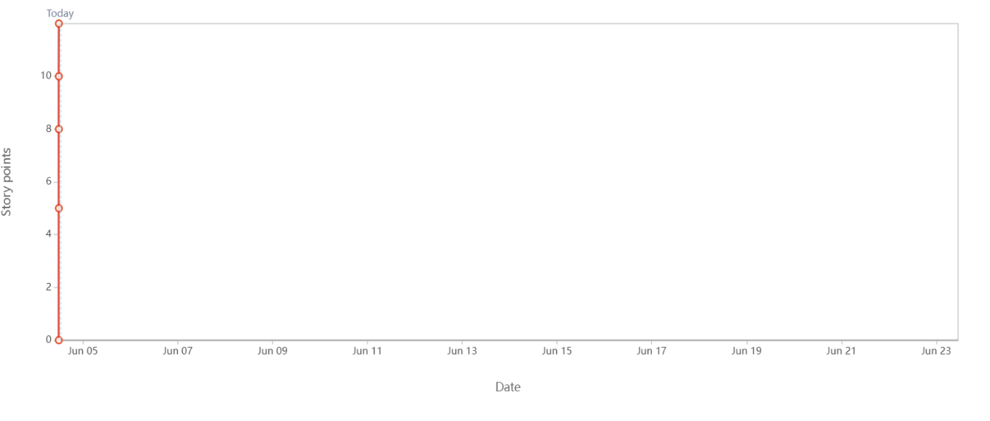
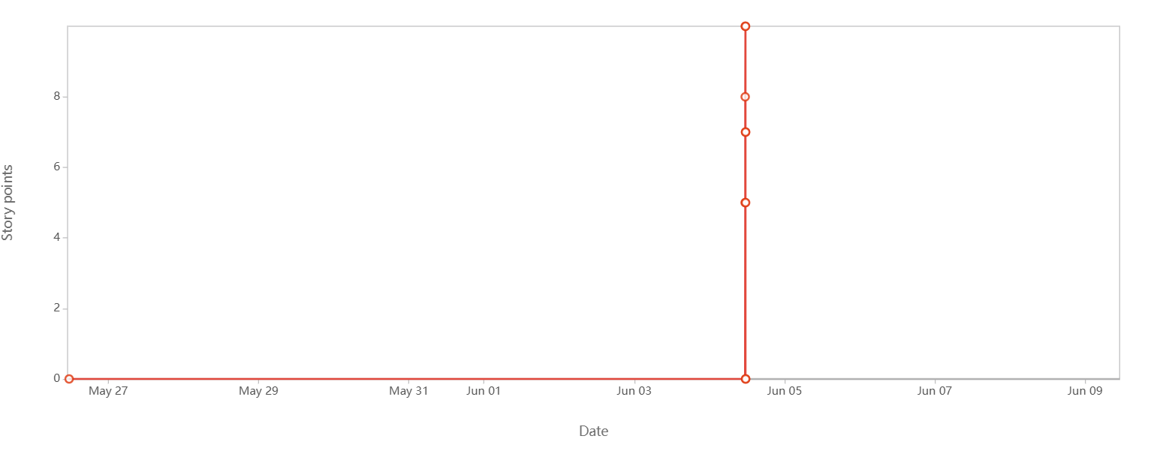

Sprint burn down charts

A Product Burndown Chart is a visual representation of the total remaining work in the product backlog over time, helping track overall progress toward the project or release goal across multiple Sprints.

Sprint | Total Scope | Completed Story Points | Remaining Story Points
0 (Start) | 53 | 0 | 53
1 | 53 | 18 | 35
2 | 53 | 14 | 21
3 | 53 | 21 | 0

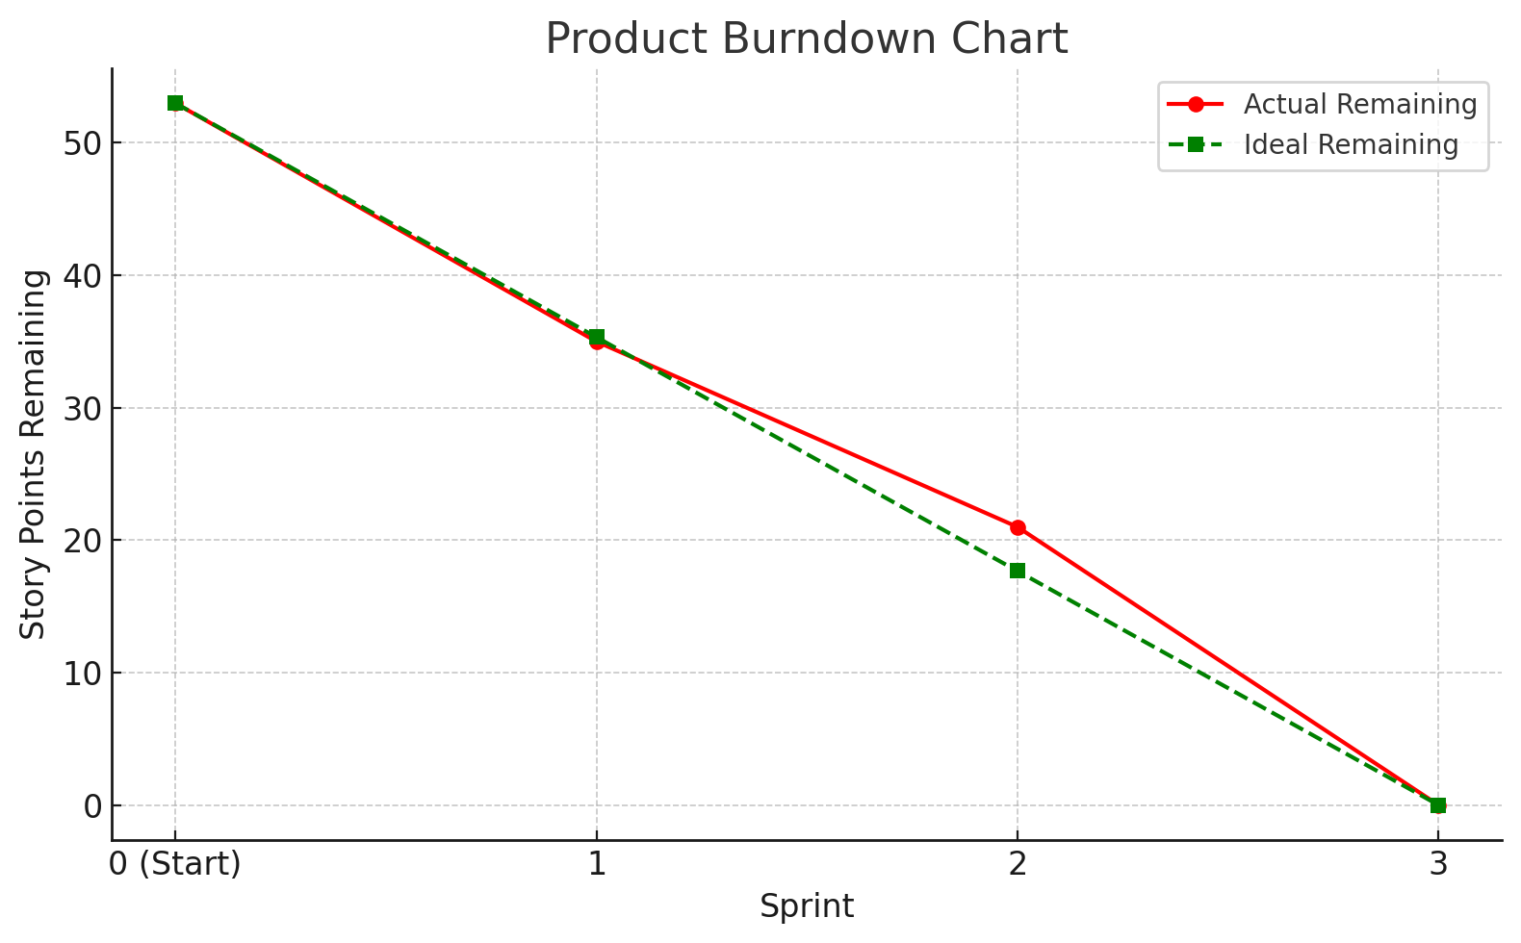

Question 10 – Explain about Product Grooming

Answer:
- Product grooming or backlog grooming is a key practice in Agile development where the Scrum team regularly meets to review, update, and prioritize items in the product backlog. The goal is to ensure the backlog remains well-organized, clearly defined, and aligned with current priorities.

- The team breaks down large user stories (epics) into smaller, manageable ones with clear acceptance criteria. The estimates (like story points) are added or updated, and priorities are adjusted based on business needs and feedback.

- It helps ensure that the backlog is ready for upcoming sprints, so the team can plan and execute efficiently.
Question 11 – Explain the roles of Scrum Master and Product Owner

Answer:
Criteria | Product Owner | Scrum Master
Nature of work | Manages the product vision, focuses on delivering value to customers and stakeholders. | Facilitates the Scrum process, focuses on the team’s efficiency and removing obstacles.
Responsibilities | Define and prioritize product backlog items:  Create and organize product backlog items based on importance and business value. Collaborate and maintain regular communication with stakeholders. Make sure all requirements are well-defined and easily understood by the team. Review completed work and decided whether it meets the acceptance criteria. | Ensure Scrum is followed properly:  Lead and support Scrum ceremonies such as daily stand-ups and retrospectives. Identify and eliminate any obstacles that hinder the team’s progress. Guide and mentor the team to improve their performance and collaboration
Accountability | Accountable for the product value delivered by the team | Accountable for the Scrum process and team’s continuous improvement
Reporting | Reports to stakeholders or product management about product progress and value | Reports to the team and sometimes to Agile Coach.
Qualities | Visionary, Decisive, Good communicator, Business- and customer-focused | Good facilitator, Empathetic and supportive  Problem-solver

Question 12 – Explain all Meetings Conducted in Scrum Project

Answer:
- Sprint Planning:
Sprint Planning meeting is conducted at the beginning of each sprint to plan the work that will be completed during the sprint. It involves key participants including the Product Owner, Scrum Master, and the Development Team. During this meeting, the team selects high-priority items from the Product Backlog, defines a clear Sprint Goal, and breaks down the selected user stories into smaller, manageable tasks. The outcome of Sprint Planning is a well-defined Sprint Backlog, which outlines the team's work plan for the sprint.

- Daily Scrum (Stand-up)
Daily Stand-up (Daily Scrum) is a short, focused meeting conducted to inspect the team's daily progress and synchronize efforts among team members. The meeting is primarily attended by the Development Team, while the Scrum Master and Product Owner may attend as optional participants. It is time-boxed to 15 minutes to 30 minutes to ensure efficiency. During the stand-up, each team member answers three key questions:
- What did I do yesterday?
- What will I do today?
- Are there any impediments or blockers? This helps identify any challenges early and promotes continuous alignment within the team.

- Sprint Review
Sprint Review is a meeting held at the end of each sprint with the purpose of demonstrating the completed product increment to the stakeholders. It is attended by the Scrum Team and stakeholders. During this session, the team showcases what has been “Done” according to the Definition of Done, gathers feedback from stakeholders, and engages in a discussion about what to do next. This collaborative review helps ensure the product is evolving in the right direction and aligns with stakeholder expectations.

- Sprint Retrospective
Sprint Retrospective is conducted after the Sprint Review and before the next Sprint Planning, with the purpose of inspecting and improving the team's process and collaboration. It is attended by the Scrum Master, Product Owner, and Development Team. During this meeting, the team reflects on the sprint by discussing key questions such as:
- What went well?
- What didn’t go well?
- What can we improve. The outcome is a set of actionable improvements to be implemented in the upcoming sprint to enhance team performance and efficiency.

- Backlog Refinement (Grooming)

Backlog Refinement also known as backlog grooming is conducted mid-sprint or on an ongoing basis with the purpose of keeping the Product Backlog updated, clear, and prioritized. It is attended by the Product Owner, Scrum Master, and Development Team.

During this session, the team:

- Breaks down large backlog items into smaller, manageable user stories,
- Adds acceptance criteria to ensure clarity,
- Estimates effort using story points, and
- Prioritizes items based on business value.
This process ensures that the backlog remains ready and well-defined for upcoming sprints.

Question 13 – Explain Sprint Size and Scrum Size.

Answer:
Sprint Size

The sprint size is defined as the time-boxed duration of a single sprint cycle in the Scrum framework. It typically ranges from 2 to 4 weeks, with a 2-week sprint being the most widely adopted by Scrum teams. The duration of sprints should remain consistent throughout the project to maintain a steady development rhythm and predictable delivery. A fixed sprint size enables the team to plan, develop, test, and deliver a potentially shippable product increment within that defined period.

Example: If your team follows a 2-week sprint, they will plan, execute, and deliver part of the product every two weeks, ensuring regular progress and feedback.

Scrum Team Size

The Scrum team size refers to the total number of individuals involved in a Scrum team, including all core roles. The ideal team size is generally between 5 to 11 members, ensuring a balance between efficiency and capability.

The team is composed of three key roles:

- Product Owner – Responsible for defining and prioritizing the product backlog based on business value.
- Scrum Master – Facilitates Scrum practices, ensures team adherence to Agile principles, and removes obstacles.
- Development Team – A cross-functional group including developers, testers, designers, and other technical experts.

The team should be small enough to remain agile and make quick decisions, yet large enough to deliver meaningful product increments within each sprint.

Example: A typical Scrum team might include 1 Product Owner, 1 Scrum Master, and 5 Developers, forming a 7-member team.

Question 14 – Explain DOR and DOD
Answer:
Definition of Ready (DoR):
(DoR) is a checklist that ensures a user story or backlog item is fully prepared before it is accepted into a Sprint. It serves as a shared understanding between the Product Owner and the development team, answering the crucial question: "Is this item ready to be worked on?"

To be considered "ready," A user story typically meets the following criteria:

- The user story is clearly written and well-understood by the team, with no ambiguity about its purpose or requirements.
- Acceptance criteria are defined, outlining the specific conditions under which the story will be considered complete.
- All dependencies are identified and addressed, ensuring there are no blockers to starting the work.
- The story is appropriately sized—small enough to be completed within a single Sprint.
- The business value is clear, so the team understands why the work is important and how it contributes to the overall goals.
- The necessary resources, tools, or skills are available, confirming that the team is equipped to take on the work.

The primary purpose of the Definition of Ready is to prevent unprepared or unclear work from entering the Sprint, which helps improve Sprint planning accuracy, reduces uncertainty, and increases the likelihood of successful delivery.

Definition of Done (DoD):
DoD is a checklist that clearly defines what it means for a product backlog item to be considered complete. It answers the important question: "Is this item truly done?"

To meet the Definition of Done, a backlog item typically satisfies the following criteria:

- Code has been written and peer-reviewed, ensuring quality and adherence to coding standards.
- The functionality has been thoroughly tested, including unit tests, integration tests, and user acceptance testing.
- All necessary documentation is updated, such as user guides or technical notes, if required.
- The code is successfully deployed to a staging or production environment, confirming its readiness for release.
- The Product Owner has reviewed and accepted the feature, validating that it meets the expected requirements.

The purpose of the Definition of Done is to ensure a consistent level of quality, avoid incomplete or half-finished work, and align the entire team on what “done” truly means, helping to deliver reliable and releasable increments of the product.
Question 15 – Explain Prioritization Techniques and MVP

Answer:

a) Prioritization techniques help Product Owners and teams decide what features, user stories, or tasks should be worked on first, based on business value, customer need, and technical feasibility. It helps manage stakeholder expectations and focus on essentials.

MoSCoW Method: The MoSCoW Method is a popular technique used in Agile and project management to prioritize features, requirements, or tasks based on their importance and urgency

This method categorizes requirements into four groups:
- Must Have – Critical to the product’s success.
- Should Have – Important but not vital.
- Could Have – Nice to have if time permits.
- Won’t Have (Now) – Out of scope for current release.

b) Minimum Viable Product (MVP): Minimum Viable Product (MVP) is the simplest version of a product that delivers essential core value to early users while requiring minimal development effort. The primary goal of an MVP is to launch quickly with just enough features to satisfy initial user needs and gather meaningful feedback. By releasing an MVP, teams can validate key product assumptions with real users in a cost-effective and time-efficient manner. This approach helps minimize risk, avoid building unnecessary features, and ensures that future development is guided by actual user behaviour and feedback rather than assumptions.

For example: A food delivery app like "Scrum Foods." Instead of developing every possible feature from the start, you launch a Minimum Viable Product (MVP) with only the core features that deliver value and solve the main user problem.

MVP Features:
- User registration and login
- Browse nearby restaurants
- Place a food order
- Real-time order tracking
- Basic payment integration

Features not in MVP (Can be added later):
- Ratings and reviews
- Loyalty or referral programs
- Advanced filters (e.g., by cuisine, price)
- In-app chat with delivery personnel
- Scheduled deliveries

Question 16 – Difference between Business Analyst and Product Owner

Answer:

Criteria | Business Analyst | Product Owner
Role Definition | A Business Analyst is responsible for gathering, analysing, and documenting business requirements. | A Product Owner is responsible for defining the product vision and managing the product backlog.
Main Objective | The main objective of a Business Analyst is to ensure that the development team fully understands business needs. | The main objective of a Product Owner is to deliver a product that provides maximum value to the customer.
Decision making power | A Business Analyst typically provides recommendations but does not have final decision-making authority. | A Product Owner has the authority to make final decisions on product features and priorities.
Stakeholder Interaction | A Business Analyst interacts with stakeholders to elicit requirements and clarify business problems. | A Product Owner works closely with stakeholders to align the product roadmap with business goals.
In Agile Teams | In Agile, a Business Analyst supports the Product Owner by helping to refine and document backlog items. | In Agile, the Product Owner leads the product vision and prioritizes user stories for the development team.
Focus Area | A Business Analyst focuses on bridging the gap between business needs and technical implementation. | A Product Owner focuses on ensuring that the product delivers value and meets user expectations.
Deliverables | A Business Analyst produces requirement documents, use cases, process models, and detailed analysis. | A Product Owner produces user stories, acceptance criteria, and maintains a prioritized backlog.

Question 17 – Prepare a sample Resume of 3yrs exp Product Owner

Answer:

SAMPLE RESUME – PRODUCT OWNER (3 Years Experience)
Name: Apeksha Nilak
Email: nilakapeksha@gmail.com
Phone: +91-9702584291
Location: Pune India
LinkedIn: linkedin.com/in/nilakapeksha
PROFESSIONAL SUMMARY
Certified and results-driven Product Owner with 3 years of experience in Agile environments, specializing in product development for web and mobile platforms. Adept at creating and managing product backlogs, writing detailed user stories, and collaborating with cross-functional teams to deliver high-value features. Proven ability to align product goals with business needs, increase customer satisfaction, and deliver successful product increments.
KEY SKILLS
- Agile & Scrum Methodologies
- Product Backlog Management
- User Story Creation & Prioritization
- Stakeholder Collaboration
- Sprint Planning & Reviews
- Definition of Done/Ready
- Jira, Trello, Confluence
- Wireframing and Prototypes (Axure, Balsamiq)
- Basic Data Analysis (Excel, Power BI, Tableau, SQL)

- PROFESSIONAL EXPERIENCE
Product Owner – Scrum Foods (Online Food Delivery App)
ABC Technologies (Capstone Project) | Pune | Jan 2022 – Present
Project Overview:
Scrum Foods is a web and mobile-based food delivery application that connects users with restaurants and delivery personnel in real time.
Responsibilities:
- Defined and maintained a product roadmap based on stakeholder goals.
- Managed a product backlog with 40+ user stories, including acceptance criteria, business value, and complexity points.
- Worked with UI/UX designers to finalize mock-ups and improve user flows.
- Led Sprint Planning, Daily Stand-ups, Reviews, and Retrospectives in a Scrum team.
- Ensured backlog items met the Definition of Ready before sprints.
- Verified completed work met the Definition of Done before acceptance.
- Used Jira and Confluence to track sprints and document requirements.
- Collected feedback from stakeholders and users to refine features.
- Prioritized backlog items based on business value and user impact.
- Coordinated with QA to ensure test coverage and successful UAT.

Key Achievements:
- Reduced product backlog churn by 40% through improved DoR enforcement.
- Delivered MVP with core ordering and tracking functionality in under 4 Sprints.
- Helped improve team velocity by 25% by clearly defining acceptance criteria and removing blockers.

EDUCATION
Bachelor of Technology (B. Tech) – Computer Science
XYZ University, Pune

CERTIFICATIONS
- Certified Scrum Product Owner (CSPO) – Scrum Alliance
- Agile Product Management – Coursera

