AGILE DOCUMENTS

Agile Model answers part 2
Document 1: Definition of Done Document 2- Product Vision Document 3: User stories Document 4: Agile PO Experience
Document 5: Product and sprint backlog and product and sprint burndown charts Document 6: Sprint meetings

Document 1: Definition of Done

Definition of Done (DoD) is a comprehensive checklist of criteria all completed work, or a product increment, must meet to be considered truly finished, ensuring quality and transparency.
The Definition of Done creates transparency by providing everyone a shared understanding of what work was completed and what standards were met as part of the Increment. If a Product Backlog Item does not meet the Definition of Done, it cannot be released yet. Think of the Definition of Done as the standards set for the products delivered.
Sometimes the Definition of Done for an Increment includes the standards of the organization. In that case, all Scrum Teams must follow these standards as a minimum. They can elaborate on it with any other standards or characteristics that need to be met for the product. If there are not specific organizational standards, the Scrum Team must create a Definition of Done appropriate for the product.

That is the team has to create a well-defined, unambiguous, measurable, agreed-upon, and shared Definition of Done between all team members.

The best form of Definition of Done representation is a checklist of activities that has to demonstrate the agreed value and quality of a user story. So, this checklist should include:
- acceptance criteria (to satisfy customer requirements for a product)
- quality criteria (to satisfy quality requirements for a product)
Definition of Done may be defined for different levels of project work. For example, in Agile
/ Scrum framework these levels of work could be user story, sprint, and release.
Checklist for DOD:

- Produced code for presumed functionalities
- Assumptions of User Story met
- Project builds without errors
- Unit tests written and passing
- Project deployed on the test environment identical to production platform
- Tests on devices/browsers listed in the project assumptions passed
- Feature ok-ed by UX designer
- QA performed & issues resolved
- Feature is tested against acceptance criteria
- Feature ok-ed by Product Owner
- Refactoring completed
- Any configuration or build changes documented
- Documentation updated
- Peer Code Review performed

Document 2- Product Vision

Scrum Project  Name: | Online Ticketing system
Venue: | Pune
Date:16/10/25 | Start time:10am | End time:12pm | Duration:2hrs
Client: | VOLVO
Stakeholder list: | Tech support managers | Project Lead | Project Manager
Scrum Team
Scrum Master: | Mr Govind
Product owner: | Mr murli
Scrum Developer 1: | Mr roy
Scrum Developer 2: | Mr mohit
Scrum Developer 3: | Mr shonik
Scrum Developer 4: | Mr rashul
Scrum Developer 5: | Mr Mangesh

Vision: To Implement a online ticketing system and provide technical support of VOLVO users
Target group  The product addresses the market of our client VOLVO.  The volvo designers benefits from it and volvo client business needs are fulfilled. | Needs  The product solves the problem of providing technical support to volvo designers.  The product provides help to volvo designers while designing volvo trucks. | Product  The product is an online ticketing system  Yes the product is feasible. | Value  The product will help generate more business  To implement the ticketing system and achieve 100 SLA and efficiency.  It is an Agile model.

Document 3: User stories

User story No:1 | Tasks:1 |  | Priority:1
Value statement:
As a user… I want to…
so that I can...
BV: |  | CP:
Acceptance criteria:

User story no 1 | Task 1 |  | Priority 1
Steps:-
As a customer, I want to Register and login to the online ticketing system.

BV | 100 | CP | 3
ACCEPTANCE CRITERIA
Registration Screen
Input :-
Name,email address,phone number
Notification sent to user for registration

User story no 2 | Task 1 |  | Priority 1
Steps:-  As a customer, I want to raise a ticket in the online ticketing system . | 1 |  | 1
BV | 50 | CP | 5
ACCEPTANCE CRITERIA
Registration Screen
Input :-
Name,email address,phone number
Notification sent to user for registration
Query to be mentioned in the ticket

User story no 3 | Task 3 |  | Priority 2
Steps:-  As a User,  I need access  to KNOX  application |  |  | 8
BV | 80 | CP | 8
ACCEPTANCE CRITERIA
Registration Screen
Input :-
Name,email address,phone number
Notification sent to user for registration
Details to be provided for knox application

User story no 4 | Task 4 |  | Priority 1
Steps:-  As a User,  I need access to  RFAS application | 4 |  | 1
BV | 100 | CP | 13
ACCEPTANCE CRITERIA
Registration Screen
Input :-
Name,email address,phone number
Notification sent to user for registration
Need to provide details of user for RFAS application

User story no 5 | Task 4 |  | Priority 4
Steps:-  As a User,  I need access to KOLA application | 1 |  | 1
BV | 100 | CP | 21
ACCEPTANCE CRITERIA
Registration Screen
Input :-
Name,email address,phone number
Notification sent to user for registration
Input name,email id for KOLA application

User story no 6 | Task 1 |  | Priority 1
Steps:-  As a User,  I need access to kola citrix application | 5 |  | 4
BV | 90 | CP | 3
ACCEPTANCE CRITERIA
Registration Screen
Input :-
Name,email address,phone number
Notification sent to user for registration
Name,email required to access
Kola citrix

User story no 7 | Task 1 |  | Priority 1
Steps:-  As a customer, create and account and save my information | 7 |  | 4
BV | 100 | CP | 5
ACCEPTANCE CRITERIA
Registration Screen
Input :-
Name,email address,phone number
Notification sent to user for registration

User story no 8 | Task 8 |  | Priority 4
Steps:-  As a customer, I want to visualize DCN | 1 |  | 4
BV | 100 | CP | 85
ACCEPTANCE CRITERIA
Registration Screen
Input :-
Name,email address,phone number
Notification sent to user for registration
Need DCN as input in kola application

User story no 9 | Task 1 |  | Priority 1
Steps:-  As a User I want to request mail box | 9
BV | 60 | CP | 8
ACCEPTANCE CRITERIA
Registration Screen
Input :-
Name,email address,phone number
Notification sent to user for registration
Email address to be input

User story no 10 | Task 10 |  | Priority 1
Steps:-  As a User I want to launch the KOLA application | 1 |  | 4
BV | 70 | CP | 8
ACCEPTANCE CRITERIA
Registration Screen
Input :-
Name,email address,phone number
Notification sent to user for registration
Name,email address to be provided for kola

Document 4: Agile PO Experience

An Agile Product Owner (PO) experiences a dynamic role focused on maximizing the value of a product by leading the product vision and managing the product backlog. Key responsibilities include prioritizing user stories, coordinating with the development team, and acting as the liaison between customers and developers. Effective Agile POs are strategic, possess strong communication and leadership skills, are readily available to the team, and thrive on accountability and negotiation.

The Product Owner has a vision of the product keeping the domain/industry experience and the market need.
- Following are the responsibilities of PO in a project
- Market Analysis ▫ Analysis of market need/demand ▫ Availability of similar products in the market
- Enterprise Analysis ▫ Due diligence on the market opportunity
- Product Vision and Roadmap ▫ Product vision keeping the need analysis in mind ▫ Product roadmap with high-level features and timeline
- Managing Product Features ▫ Managing stakeholder expectations and prioritizing needs ▫ Prioritization of the epics, stories, and features based on criticality and ROI involved
- Managing Product Backlog ▫ Prioritization of user stories ▫ Reprioritization based on stakeholders' needs ▫ Epics planning
- Managing Overall Iteration Progress ▫ Sprint progress review ▫ Reprioritization of sprints and epics if needed ▫ Sprint retrospectives with Business Analyst
- From this project I have learned how to handle sprint meetings such as
- Sprint planning meeting

- Daily scrum meeting
- Sprint review meeting
- Sprint retrospective meeting
- Backlog refinement meeting
- Also, User stories creation and what things will be included in user stories such as
- Story no
- Tasks
- Priority
- Acceptance criteria
- BV & CP value
- In Scrum, a product owner serves as the liaison between multiple areas of an organization. This person communicates with business stakeholders and collaborates closely with Scrum teams to keep all areas of the business informed on a project's development.
- The product owner develops a vision of a product's function and operation, which in turn allows this Scrum team member to define product features and break those features into product backlog items.

Document 5: Product and sprint backlog and product and sprint burndown charts
Product backlog:

User story ID | User story | Tasks | Priority | BV | CP | Sprint
US001 | User wants to launch the kola application | 1 | 2 | 80 | 5 | 1
US004 | User wants to access the RFAS application | 4 | 3 | 70 | 8 | 1

Sprint backlog:

User story ID | User story | Tasks | Owner | Status | Estimated effort
US002 | User wants to access knox | 2 | RITIKA PANDEY | successful | 2
US003 | User wants to visualize DCN | 3 | RITIKA PANDEY | successful | 3

Product burndown

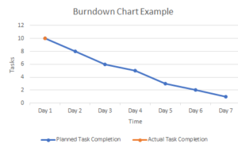
Sprint burndown

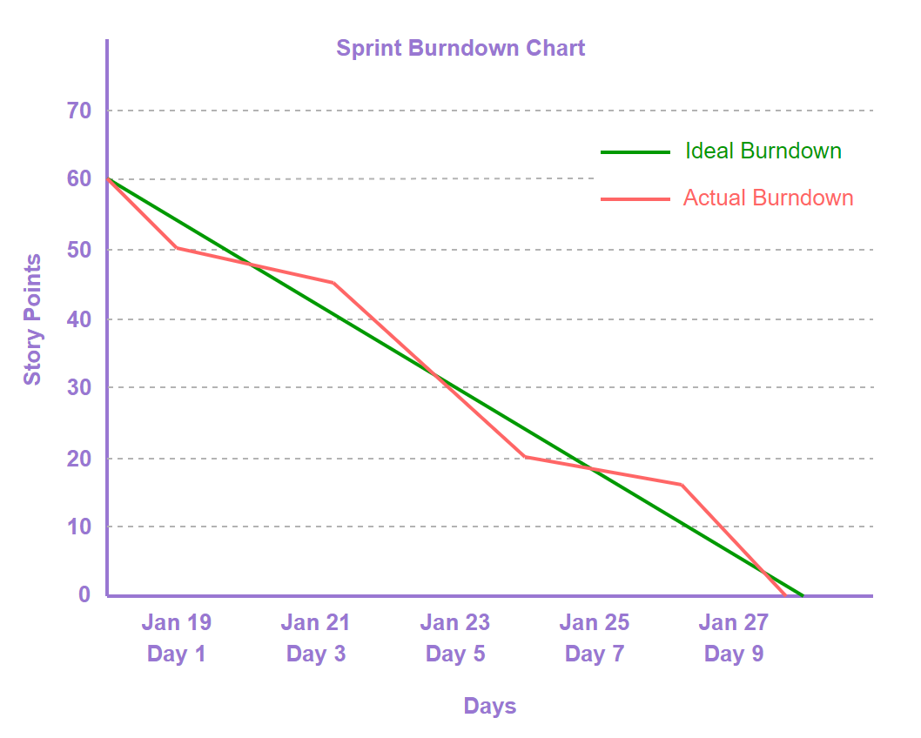

Document 6: Sprint meetings
Meeting Type 1: Sprint Planning meeting

Date | 14th oct 2025
Time | 9am
Location | Pune office
Prepared By | Ritika Pandey
Attendees | Scrum master,PO,BA developers,Testers

Agenda Topics

Topic | Presenter | Time allotted
Need to plant the sprint effectively | Ritika Pandey | 8am to 9am
Decide on inputs user stories and product backlog | Ritika Pandey | 9am to 10am

Other Information

Observers | PO,Scrum master,BA ,developers
Resources | BA,Developers,Testers
Special Notes | BA and PO,Scrum master should work together effectively.

Meeting Type 2: Sprint review meeting

Date | 15 th oct 2025
Time | 10 am
Location | Pune office
Prepared By | Ritika Pandey
Attendees | Scrum master,PO,developers ,BA

Sprint status | Things to demo | Quick updates | What’s next
Successful | Sprint 1 product backlog sprint backlog | Sprint 1 successful,  Add access,Knox ,RFAS access working properly | Detailed review with client  And sprint restrospective meeting

Meeting Type 3: Sprint retrospective meeting

Date | 16th oct 2025
Time | 10 am
Location | Pune office
Prepared By | Ritika Pandey
Attendees | Scrum master ,PO,developers,BA

Agenda | What went well | What didn’t go well | Questions | Reference
To find the flaws in the sprint | User stories were good  Sprint was successful | Some functions were not documented properly | Add users function not documented well | Sprint 1
To implement KNOX function | Sprint was successful | Some users access details were not proper | Why details were not taken from user? | User story 2

Meeting Type 4: Daily Stand-up meeting

Question | Name/Role |  |  | Week “X” (from 10/10/2025 to 16/10/2025)
Question |  |  |  | Monday | Tuesday | Wednesday | Thursday | Friday | Saturday | Sunday
What did you do yesterday? |  | Developer 1 |  | Identify stakeholder needs  Meeting with BA,PO,  sponsor | Meeting with team  Inhouse developers | Starting working on features | Starting to build prototype | Meeting with client | One on one meeting with BA,PO | Started working towards code
What did you do yesterday? |  | Developer 2
What did you do yesterday? |  | Developer 3
What will you do today? |  | Developer 1 |  | Refine requirements | Meeting with team | Design documents | Wrote the code | Performed unit testing | Performed UAT | Final review of product
What will you do today? |  | Developer 2
What will you do today? |  | Developer 3
What (if any) is blocking your progress? |  | Developer 1 |  | Will refine the requirements | Meeting with Team | Build prototype and take a meeting about what is blocking progress | Meeting with stakeholders | Writing the code | Unit testing | Final review of product
What (if any) is blocking your progress? |  | Developer 2
What (if any) is blocking your progress? |  | Developer  3

