Business Requirement Document (BRD)
Project Title: COEPD Ice Cream
Smart Inventory & Delivery Optimization System for Ice-Cream and Dairy Manufacturer

1. Executive Summary:
The client is a leading manufacturer of ice-cream and milk products with multiple manufacturing plants and warehouses across the country. They want to build an integrated software system to manage inventory levels in real-time and enable quickest delivery to customers, reducing product spoilage and improving customer satisfaction.

2. Business Objectives:
- Real-time inventory tracking at plants and warehouses
- Enable automatic stock reordering and stock transfers
- Implement smart delivery routing to minimize delivery times
- Provide dashboard and reports for supply chain performance
- Ensure traceability of product batches (for compliance and recalls)

3. Scope of Work:
In-Scope:
- Inventory management system for raw materials and finished goods
- Delivery route optimization tool with customer order tracking
- Integration with existing ERP (if any)
- Web & mobile dashboards for supply chain stakeholders
Out-of-Scope:
- Cold storage hardware integration
- External delivery vendor tracking (unless API provided)

4. Functional Requirements:
Module | Requirement
Inventory Management | Track stock at plant & warehouse level, batch-level tracking, expiry alerts
Auto Reorder | Trigger stock reorder when reaching threshold levels
Inter-Warehouse Transfer | Route-based transfer requests and approvals
Order Management | Capture customer orders from app/portal
Delivery Optimization | Auto-assign orders to routes based on location, traffic, stock availability
Alerts & Notifications | Email/SMS for low stock, delayed delivery, and order status
Reporting Dashboard | Real-time data for stock, sales, spoilage, route KPIs

5. Non-Functional Requirements:
- Performance: System should support 1000+ concurrent users
- Scalability: Should scale as business expands to more locations
- Security: Role-based access, secure API integration
- Availability: 99.9% uptime with cloud hosting

6. Stakeholders:
Role | Responsibility
Plant Managers | Update production and inventory levels
Warehouse Supervisors | Monitor stock and trigger reorders
Logistics Coordinators | Manage routing and delivery scheduling
IT Admin | Manage user access, system performance
Customers | Place and track orders

7. Assumptions & Constraints:
- Internet availability at all plants and warehouses
- GPS data available for delivery routing
- Customer order data available via portal or mobile app

8. Development Plan:
Phase | Deliverables | Timeline
Requirement Analysis | BRD, Use Cases, Workflow Diagrams | Week 1–2
Design & Prototyping | UI Mockups, Architecture Design | Week 3–4
Development – Phase I | Inventory Module | Week 5–7
Development – Phase II | Delivery Module, Routing Logic | Week 8–10
Testing & QA | UAT, Performance Testing | Week 11–12
Deployment | Go-live on cloud infrastructure | Week 13

9. Resource Plan:
Role | Count | Duration
Business Analyst | 1 | Full Project
Project Manager | 1 | Full Project
UI/UX Designer | 1 | 2 Weeks
Frontend Dev | 2 | 8 Weeks
Backend Dev | 2 | 8 Weeks
QA Engineer | 1 | 3 Weeks
DevOps Engineer | 1 | 2 Weeks

2. Process Flow Diagram (Descriptive)
Here’s a step-by-step flow that you can visualize in a diagram using standard flowchart symbols:

  - Inventory Management Flow
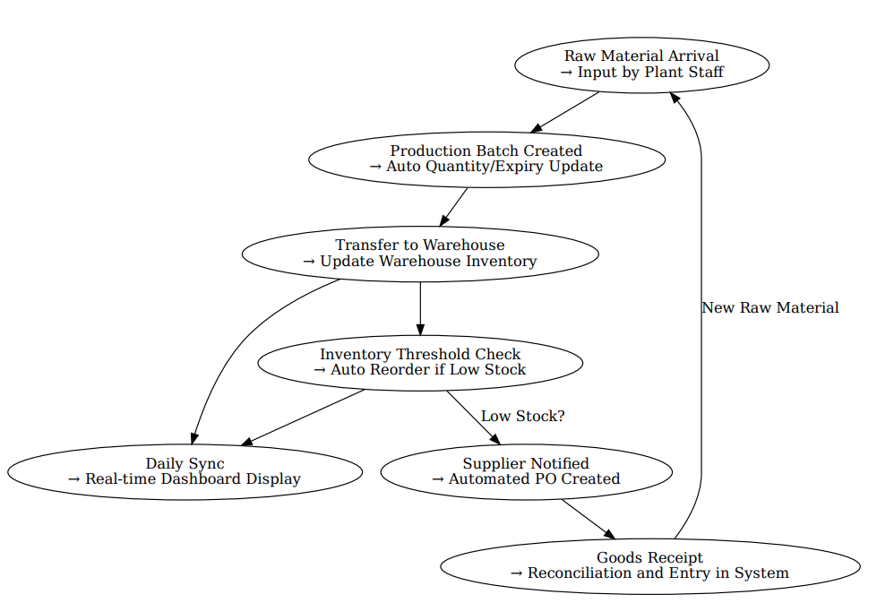

1. Introduction Letter to Client (as a Business Analyst)
Subject: Business Analyst Introduction – Project Kickoff & Collaboration
Dear [Client Name],
I hope this message finds you well.
My name is Aamir, and I will be serving as the Business Analyst for your upcoming project. I am excited to collaborate closely with you and your team to understand your business objectives, gather requirements, and ensure that the final solution aligns perfectly with your vision.
Over the next few days, I will initiate discovery sessions to capture your expectations, analyze current workflows, identify pain points, and translate them into clear, actionable requirements. I will serve as the communication bridge between your business stakeholders and our technical team to ensure clarity, alignment, and traceability throughout the project.
I look forward to a productive partnership and am confident that, together, we will deliver a solution that drives real value.
Warm regards,
Aamir
Axia Womens health
Email: aamir@axia.com | Phone: 9966577563

2. Brief BRD and SRS – (Project: Online Store)
Business Requirement Document (BRD) – Online Store
Project Title: Digital Retail Storefront for Fashion & Electronics
Objective:
To develop an online store that allows users to browse products, place orders, track deliveries, and manage returns seamlessly through a web and mobile interface.
Stakeholders:
- Product Manager
- Marketing Team
- IT & Development Team
- End Users (Customers)
Business Requirements:
- Users should be able to browse products by category and filter them.
- The system should allow secure user registration/login.
- Customers can add products to cart and complete checkout.
- Support multiple payment options (credit card, UPI, COD).
- Admins can add/update/delete products.
- Users can track orders, manage returns, and give feedback.

Software Requirement Specification (SRS)
Functional Requirements:
- User Authentication (Sign Up/Login with email & OTP)
- Product Listing with search and filters (brand, price, size)
- Shopping Cart management (add/edit/delete items)
- Checkout system (with payment gateway integration)
- Order Management: View status, history, cancel/return
- Admin Panel: Inventory control, price update, view orders
- Notification: Email/SMS updates on orders and offers
Non-Functional Requirements:
- System uptime: 99.9%
- Response time: < 3 seconds
- Mobile responsive design
- Data privacy and security (HTTPS, encrypted payments)

3. ERD – Support Ticket Lifecycle (Ticketing System)
Here’s the Entity Relationship Diagram (ERD) conceptually described:
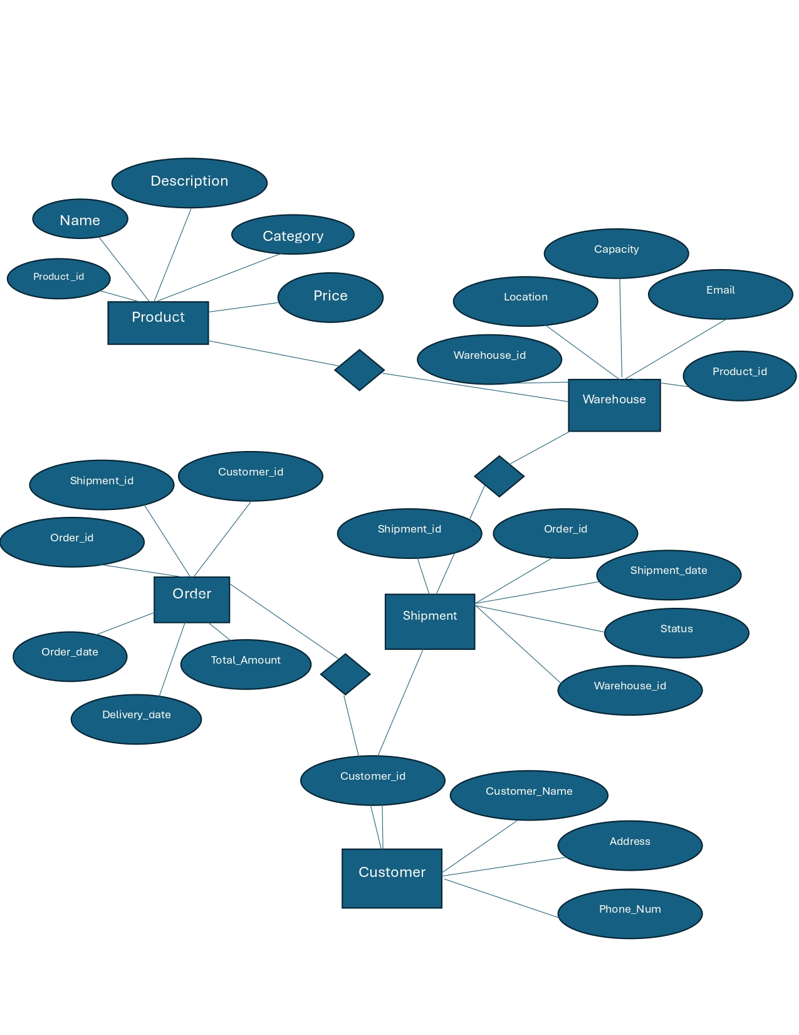
4. User Story – Shopping from E-commerce Site

ID | User Role | User Story | Tasks | Acceptance Criteria | BV ($) | CP (Fibonacci)
IceCream-001 | Inventory Clerk | As an inventory clerk, I want to verify stock at plant and warehouse locations so that discrepancies can be identified early. | Manual stock count screen, discrepancy logging feature | Discrepancy report exports in CSV, updates inventory count | 50 | 5
IceCream-002 | Plant Operator | As a plant operator, I want to input raw material arrival into the system so that inventory updates in real time. | Create material input form, integrate with inventory module | Inventory count increases, date/time of entry saved | 50 | 3
IceCream-003 | QA Inspector | As a QA inspector, I want to flag expired raw materials so they don’t enter production. | Expiry check automation, warning notification to QA | Expired items marked red, excluded from available stock | 50 | 5
IceCream-004 | Production Supervisor | As a production supervisor, I want to generate daily production reports so I can track output per line. | Auto-generate daily reports, include batch and machine data | Reports sent by 6 PM, data accurate and complete | 50 | 5
IceCream-005 | Warehouse Staff | As warehouse staff, I want to scan finished goods into warehouse so that stock is updated automatically. | Barcode scanning, transfer inventory logic | Inventory reflects scan-in, duplicates blocked | 20 | 3
IceCream-006 | Sales Manager | As a sales manager, I want to view current stock availability across regions so I can promise delivery timelines. | Regional stock dashboard, filters by location | Dashboard loads under 3s, region filter works | 100 | 8
IceCream-007 | Procurement Officer | As a procurement officer, I want to receive alerts for reorder thresholds so I can prevent stockouts. | Configure thresholds, set up email alerts | Alert sent when stock falls below 20%, PO triggered if automated | 100 | 5
IceCream-008 | IT Admin | As an IT admin, I want to manage user access by role so that sensitive features are restricted. | Role management screen, permissions module | Access control enforced, test with 3 roles | 50 | 3
IceCream-009 | Finance Analyst | As a finance analyst, I want to track cost per product batch so that I can analyze profitability. | Link costs to production entries, generate cost-per-unit field | Cost visible on report, export to Excel | 50 | 8
IceCream-010 | Distributor | As a distributor, I want to place orders via mobile so that I can restock faster. | Mobile ordering interface, order validation, SMS confirmation | Orders must be submitted, confirmed, and logged | 100 | 13
IceCream-011 | Inventory Auditor | As an auditor, I want to view stock adjustment logs so I can track anomalies. | Create audit log table, display user/date/reason | Log shows all edits, deletions, reasons | 50 | 5
IceCream-012 | QA Lead | As QA, I want to view batch test history so that I can review trends in quality. | Test history UI, link to batches | Batch history sortable by date and result | 20 | 5
IceCream-013 | Plant Manager | As plant manager, I want to view machine-wise productivity so that I can balance workload. | Collect output data by machine, chart trend lines | Report shows last 7 days per machine | 50 | 5
IceCream-014 | Logistics Manager | As logistics, I want to see order delivery statuses so I can track delays. | Display dispatch info, track delivery timestamps | Orders marked delivered only upon confirmation | 50 | 5
IceCream-015 | Support Agent | As support, I want to respond to distributor complaints within 24 hours so that satisfaction improves. | Complaint form, SLA tracking module | SLA reminder if 20 hours pass without update | 20 | 3
IceCream-016 | Executive | As an executive, I want a consolidated view of plant production and sales so I can assess performance. | Merge production + sales reports, summary graphs | Dashboard loads in under 5s, PDF export enabled | 100 | 8
IceCream-017 | Maintenance Technician | As technician, I want to log machine issues quickly so that downtime is minimized. | Fault logging screen, priority field, notify plant manager | Logged issue must alert within 2 minutes | 20 | 5
IceCream-018 | Dispatch Staff | As dispatch, I want truck loading schedules to avoid clashes between regions. | Schedule planner, assign truck capacity | Conflicts flagged in red, real-time updates | 20 | 5
IceCream-019 | Production Analyst | As an analyst, I want a daily loss report (spoilage/damage) to identify inefficiencies. | Daily auto-report of loss, link to reason | Report shows all damaged/expired items | 50 | 8
IceCream-020 | HR Manager | As HR, I want to track shift attendance so that I can analyze absenteeism. | Attendance module, shift check-in/out logic | Report available daily, alerts on no-shows | 20 | 5
IceCream-021 | Procurement Analyst | As analyst, I want to compare vendor rates over time to find better deals. | Vendor pricing table, chart module | Graph available with price per unit per month | 20 | 3
IceCream-022 | Warehouse Lead | As lead, I want incoming delivery schedules so I can assign unloading staff. | Delivery ETA screen, assign staff UI | Arrival list shows expected time, labor assigned | 20 | 3
IceCream-023 | QA Auditor | As auditor, I want to randomly select batches for extra tests to ensure standards. | Randomization logic, batch flag | Flagged batch shows up in test queue | 10 | 3
IceCream-024 | Supplier | As a supplier, I want to receive automatic PO requests with order details. | PO auto-generation, email trigger | Email includes PO ID, quantity, item | 50 | 5
IceCream-025 | Driver | As a driver, I want to confirm delivery with OTP so that records are verified. | OTP generation, verification page | OTP must match on mobile before submission | 50 | 5
IceCream-026 | Finance Lead | As finance, I want to forecast monthly spend per location so that budgeting improves. | Budget forecast logic, region filter | Report shows projected spend and variance | 50 | 8
IceCream-027 | Operations Lead | As ops lead, I want real-time line performance data so I can act fast on downtime. | Machine integration, real-time chart | Data refresh every minute, line alerts flash | 100 | 8
IceCream-028 | QA Supervisor | As QA, I want to set test frequency rules by product type to ensure compliance. | Frequency settings screen, schedule tests | Products follow rule, missed alerts show | 20 | 5
IceCream-029 | Customer Support Head | As support head, I want to view common complaints across regions to identify root causes. | Complaint categorization, region tagging | Chart shows top complaint types monthly | 50 | 5
IceCream-030 | Supplier Manager | As manager, I want vendor performance reports to track on-time delivery and rejections. | Add delivery timeline fields, rejection reasons | Monthly report with ranking and scores | 50 | 5
IceCream-031 | Dispatch Planner | As planner, I want to auto-optimize truck loads by order weight and distance. | Auto-load optimization algorithm | Optimization saves ≥15% route time | 100 | 8
IceCream-032 | Inventory Clerk | As clerk, I want an easier UI to adjust inventory counts during audits. | Simplified UI for manual adjustment | Audit logs track changes with comments | 20 | 3
IceCream-033 | Plant Director | As director, I want to approve large purchase orders over $10,000 to control spending. | Approval workflow, email to director | PO blocks until director approves | 50 | 5
IceCream-034 | Health & Safety Officer | As officer, I want accident logs per site so I can monitor plant safety. | Log UI, type/severity tracking | Reportable incidents auto-escalated | 20 | 3
IceCream-035 | IT Support | As IT, I want error logs from all modules so I can troubleshoot quickly. | Centralized error logging, filter by module | Logs show timestamp, error type, resolution status | 20 | 5
IceCream-036 | Marketing Manager | As marketing, I want sales heatmaps by product to focus promotions. | Sales map chart, filter by date/product | Map shows color-coded zones of high/low sales | 50 | 8
IceCream-037 | Finance Reviewer | As finance, I want to auto-flag any mismatch between PO and invoice amounts. | PO vs. invoice validator tool | Mismatches flagged, require manual resolution | 50 | 5
IceCream-038 | Training Lead | As training lead, I want to assign onboarding modules to new hires. | Learning module selector, tracking completion | Training dashboard shows status per user | 20 | 3
IceCream-039 | Procurement Lead | As procurement, I want auto-reminders for contract renewals. | Contract expiry tracker, alert system | Reminder email 30/15/1 days before expiry | 20 | 3
IceCream-040 | Regional Supervisor | As regional supervisor, I want to compare daily performance across sites. | Site-wise comparison dashboard | Sites sorted by KPIs; charts auto-update daily | 50 | 5

