Question 1 – Functional Requirements.
Answer – 20 Functional Requirements.
Req ID | Req Name | Req Description | Priority
FR001 | Farmer Registration | Farmers should be able to register with the application. | 8
FR002 | Farmer Search for Products | Farmers should be able to search for available products in fertilizers, seeds, pesticides. | 8
FR003 | Product Catalogue | Display all Products in a friendly format and with detailed specification. | 8
FR004 | Shopping Cart | Allow Farmers to add product to Shopping Cart. | 7
FR005 | Payment Processing | Provide secure payment processing options to farmers using Payment gateways. | 7
FR006 | Order Management | Allow Farmers to view their order history and track the status of their order. | 5
FR007 | Product Review and Ratings | Allow Farmers to Rate and Write Review for the product they have purchased to help other customers make informed decisions. | 5
FR008 | Wishlist | Allow Farmers to save product in Wishlist. | 4
FR009 | Shipping and Delivery | Provide Customers with shipping option and estimated delivery time. | 4
FR010 | Return and Refund Policy | Outline the return and refund policy for customers to ensure a positive customer experience and minimize customer complaints. | 5
FR011 | Add to buy later | Allow farmers to add products to “buy later.” | 4
FR012 | Order ID | Provide farmers with Order ID after completion of order. | 6
FR013 | Product Offers | Allow Farmers to view offers on their product. | 3
FR014 | Customer Support | Allow Farmers to contact manufacturers or support team for solving their issues using Customer Support. | 6
FR015 | Email Confirmation | Provide Farmers with email confirmation after an order is successfully placed. | 6
FR016 | Invoice | After Completion of order Invoice should be generated | 5
FR017 | Print Invoice | Allow Farmers and Manufacturers to Print Invoice. | 4
FR018 | Cancellation | Allow Farmers to Cancel Product. | 4
FR019 | Customer Profile | Allow Farmers to update their Customer Profile. | 3
FR020 | Payment Options | Allow Farmers to Pay using UPI or Credit Card. | 8

Question 2 – Minimum 5 Page Designs
Answer – Page Designs
- Log In
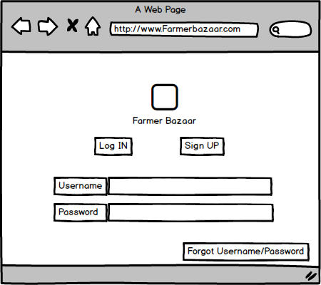

- Search
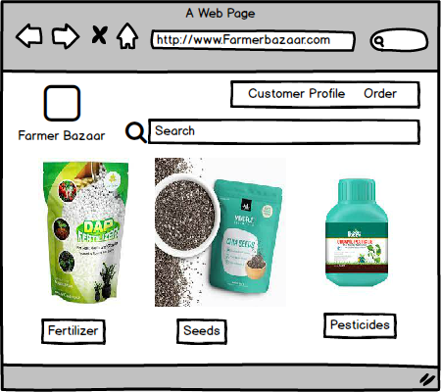

- Add to Cart
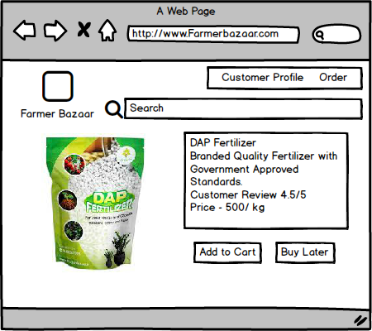

- Payment
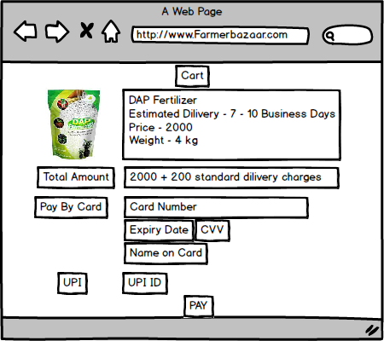

- Log out
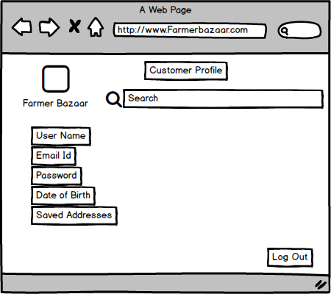

Question 3 – Tools
Answer – Tools
- MS Visio is software for drawing a variety of diagrams which includes flow charts, flow diagrams, swim lane diagrams and more. It is used for creating enterprise process diagrams and helps to organize complex ideas visually.
- Balsamiq is a graphical user interface website wireframe builder application. It allows the designer to arrange pre-built widgets using a drag and drop editor.

Question 4 – RTM
Answer – Requirements Traceability Matrix (RTM)
Req ID | Req Name | Req Description | Design | D1 | T1 | D2 | T2 | D3 | T3 | D4 | T4 | UAT
FR001 | Farmer Registration | Farmers should be able to register with the application. | Pass | Pass | Pass | Pass | Pass | Pass | Pass | Pass | Pass | Pass
FR002 | Farmer Search for Products | Farmers should be able to search for available products in fertilizers, seeds, pesticides. | Pass | Pass | Pass | Pass | Pass | Pass | Pass | Pass | Pass | Pass
FR003 | Product Catalogue | Display all Products in user friendly format and with detailed specification. | Pass | Pass | Pass | Pass | Pass | Pass | Pass | Pass | Pass | Pass
FR004 | Shopping Cart | Allow Farmers to add product to Shopping Cart. | Pass | Pass | Pass | Pass | Pass | Pass | Pass | Pass | Pass | Pass
FR005 | Payment Processing | Provide secure payment processing options to farmers using Payment gateways. | Pass | Pass | Pass | Pass | Pass | Pass | Pass | Pass | Pass | Pass
FR006 | Order Management | Allow Farmers to view their order history and track the status of their order. | Pass | Pass | Pass | Pass | Pass | Pass | Pass | Pass | Pass | Pass
FR007 | Product Review and Ratings | Allow Farmers to Rate and Write Review for the product they have purchased to help other customers make informed decisions. | Pass | Pass | Pass | Pass | Pass | Pass | Pass | Pass | Pass | Pass
FR008 | Wishlist | Allow Farmers to save product in Wishlist. | Pass | Pass | Pass | Pass | Pass | Pass | Pass | Pass | Pass | Pass
FR009 | Shipping and Delivery | Provide Customers with shipping option and estimated delivery time. | Pass | Pass | Pass | Pass | Pass | Pass | Pass | Pass | Pass | Pass
FR010 | Return and Refund Policy | Outline the return and refund policy for customers to ensure a positive customer experience and minimize customer complaints. | Pass | Pass | Pass | Pass | Pass | Pass | Pass | Pass | Pass | Pass
FR011 | Add to buy later | Allow farmers to add products to “buy later.” | Pass | Pass | Pass | Pass | Pass | Pass | Pass | Pass | Pass | Pass
FR012 | Order ID | Provide farmers with Order ID after completion of order. | Pass | Pass | Pass | Pass | Pass | Pass | Pass | Pass | Pass | Pass
FR013 | Product Offers | Allow Farmers to view offers on their product. | Pass | Pass | Pass | Pass | Pass | Pass | Pass | Pass | Pass | Pass
FR014 | Customer Support | Allow Farmers to contact manufacturers or support team for solving their issues using Customer Support. | Pass | Pass | Pass | Pass | Pass | Pass | Pass | Pass | Pass | Pass
FR015 | Email Confirmation | Provide Farmers with email confirmation after an order is successfully placed. | Pass | Pass | Pass | Pass | Pass | Pass | Pass | Pass | Pass | Pass
FR016 | Invoice | After Completion of order Invoice should be generated | Pass | Pass | Pass | Pass | Pass | Pass | Pass | Pass | Pass | Pass
FR017 | Print Invoice | Allow Farmers and Manufacturers to Print Invoice. | Pass | Pass | Pass | Pass | Pass | Pass | Pass | Pass | Pass | Pass
FR018 | Cancellation | Allow Farmers to Cancel Product. | Pass | Pass | Pass | Pass | Pass | Pass | Pass | Pass | Pass | Pass
FR019 | Customer Profile | Allow Farmers to update their Customer Profile. | Pass | Pass | Pass | Pass | Pass | Pass | Pass | Pass | Pass | Pass
FR020 | Payment Options | Allow Farmers to Pay using UPI or Credit Card. | Pass | Pass | Pass | Pass | Pass | Pass | Pass | Pass | Pass | Pass

Question 5 – 10 Test Case Document
Answer – 10 Test Case Document
- Test Case 1
Test case ID | SG123TS001 | Test Case Name | Search Query
Project ID | SG123 | Project name | Online product booking.
PM ID | 007 | PM Name | Mr. Vandanam
Test Strategy ID | SG123TS001 | Tester ID | 001 & 009
Test Plan ID | SG123TP001 | Tester Name | Jason and Alekya
Test Schedule ID | SG123TS001 | Date of Test | 01/05/2023
Scenario | Search for Product
Link to that page
 | Set 1 | Set 2 | Set 3
Input Data | 1.Pesticides  2.01/05/2023  3.Branded  4.High Quality  5.500 gm  6.UPI/Card Payment | 1.Fertilizers  2.01/05/2023  3.Branded  4.High Quality  5.500 gm  6.UPI/Card Payment | 1.Seeds  2.01/05/2023  3.Branded  4.High Quality  5.500 gm  6.UPI/Card Payment
Expected Behavior | 10 Product Details come for above data | 10 Product Details come for above data | 10 Product Details come for above data
Actual Behavior | 9 Products are displayed | 10 Products are displayed | 10 Products are displayed
Comment | One product missing | Matching the requirements | Matching the requirements
Result Pass/Fail | Fail | Pass | Pass

- Test Case 2
Test case ID | SG123TS002 | Test Case Name | Search Query
Project ID | SG123 | Project name | Online product booking.
PM ID | 007 | PM Name | Mr. Vandanam
Test Strategy ID | SG123TS002 | Tester ID | 001 & 009
Test Plan ID | SG123TP002 | Tester Name | Jason and Alekya
Test Schedule ID | SG123TS002 | Date of Test | 07/05/2023
Scenario | Display all Product
Link to that page
 | Set 1 | Set 2 | Set 3
Input Data | 1.Pesticides  2.07/05/2023  3.Branded  4.High Quality  5.500 gm  6.UPI/Card Payment | 1.Fertilizers  2.07/05/2023  3.Branded  4.High Quality  5.500 gm  6.UPI/Card Payment | 1.Seeds  2.07/05/2023  3.Branded  4.High Quality  5.500 gm  6.UPI/Card Payment
Expected Behavior | 10 Product Details come for above data | 10 Product Details come for above data | 10 Product Details come for above data
Actual Behavior | 10 Products are displayed | 10 Products are displayed | 10 Products are displayed
Comment | Matching the requirements | Matching the requirements | Matching the requirements
Result Pass/Fail | Pass | Pass | Pass

- Test Case 3
Test case ID | SG123TS003 | Test Case Name | Search Query
Project ID | SG123 | Project name | Online product booking.
PM ID | 007 | PM Name | Mr. Vandanam
Test Strategy ID | SG123TS003 | Tester ID | 001 & 009
Test Plan ID | SG123TP003 | Tester Name | Jason and Alekya
Test Schedule ID | SG123TS003 | Date of Test | 14/05/2023
Scenario | Add Product to Cart
Link to that page
 | Set 1 | Set 2 | Set 3
Input Data | 1.Pesticides  2.14/05/2023  3.Branded  4.High Quality  5.500 gm  6.UPI/Card Payment | 1.Fertilizers  2.14/05/2023  3.Branded  4.High Quality  5.500 gm  6.UPI/Card Payment | 1.Seeds  2.14/05/2023  3.Branded  4.High Quality  5.500 gm  6.UPI/Card Payment
Expected Behavior | 03 Product Details come for above data | 03 Product Details come for above data | 03 Product Details come for above data
Actual Behavior | 02 Products are displayed | 01 Products are displayed | 03 Products are displayed
Comment | One product missing | Two Product Missing | Matching the requirements
Result Pass/Fail | Fail | Fail | Pass

- Test Case 4
Test case ID | SG123TS004 | Test Case Name | Search Query
Project ID | SG123 | Project name | Online product booking.
PM ID | 007 | PM Name | Mr. Vandanam
Test Strategy ID | SG123TS004 | Tester ID | 001 & 009
Test Plan ID | SG123TP004 | Tester Name | Jason and Alekya
Test Schedule ID | SG123TS004 | Date of Test | 21/05/2023
Scenario | View Order History
Link to that page
 | Set 1 | Set 2 | Set 3
Input Data | 1.Pesticides  2.21/05/2023  3.Branded  4.High Quality  5.500 gm  6.UPI/Card Payment | 1.Fertilizers  2.21/05/2023  3.Branded  4.High Quality  5.500 gm  6.UPI/Card Payment | 1.Seeds  2.21/05/2023  3.Branded  4.High Quality  5.500 gm  6.UPI/Card Payment
Expected Behavior | 03 Product Details come for above data | 03 Product Details come for above data | 03 Product Details come for above data
Actual Behavior | 03 Products are displayed | 03 Products are displayed | 03 Products are displayed
Comment | Matching the requirements | Matching the requirements | Matching the requirements
Result Pass/Fail | Pass | Pass | Pass

- Test Case 5
Test case ID | SG123TS005 | Test Case Name | Search Query
Project ID | SG123 | Project name | Online product booking.
PM ID | 007 | PM Name | Mr. Vandanam
Test Strategy ID | SG123TS005 | Tester ID | 001 & 009
Test Plan ID | SG123TP005 | Tester Name | Jason and Alekya
Test Schedule ID | SG123TS005 | Date of Test | 28/05/2023
Scenario | Payment for Product
Link to that page
 | Set 1 | Set 2 | Set 3
Input Data | 1.Pesticides  2.28/05/2023  3.Branded  4.High Quality  5.500 gm  6.UPI/Card Payment | 1.Fertilizers  2.28/05/2023  3.Branded  4.High Quality  5.500 gm  6.UPI/Card Payment | 1.Seeds  2.28/05/2023  3.Branded  4.High Quality  5.500 gm  6.UPI/Card Payment
Expected Behavior | 03 Product Details come for above data | 07 Product Details come for above data | 10 Product Details come for above data
Actual Behavior | 02 Products are displayed | 05 Products are displayed | 10 Products are displayed
Comment | One product missing | Two Products missing | Matching the requirements
Result Pass/Fail | Fail | Fail | Pass

- Test Case 6
Test case ID | SG123TS006 | Test Case Name | Search Query
Project ID | SG123 | Project name | Online product booking.
PM ID | 007 | PM Name | Mr. Vandanam
Test Strategy ID | SG123TS006 | Tester ID | 001 & 009
Test Plan ID | SG123TP006 | Tester Name | Jason and Alekya
Test Schedule ID | SG123TS006 | Date of Test | 01/06/2023
Scenario | Add Product to Buy later
Link to that page
 | Set 1 | Set 2 | Set 3
Input Data | 1.Pesticides  2.01/06/2023  3.Branded  4.High Quality  5.500 gm  6.UPI/Card Payment | 1.Fertilizers  2.01/06/2023  3.Branded  4.High Quality  5.500 gm  6.UPI/Card Payment | 1.Seeds  2.01/06/2023  3.Branded  4.High Quality  5.500 gm  6.UPI/Card Payment
Expected Behavior | 20 Product Details come for above data | 20 Product Details come for above data | 20 Product Details come for above data
Actual Behavior | 20 Products are displayed | 20 Products are displayed | 10 Products are displayed
Comment | Matching the Requirements | Matching the Requirements | 10 Products missing
Result Pass/Fail | Pass | Pass | Fail

- Test Case 7
Test case ID | SG123TS007 | Test Case Name | Search Query
Project ID | SG123 | Project name | Online product booking.
PM ID | 007 | PM Name | Mr. Vandanam
Test Strategy ID | SG123TS007 | Tester ID | 001 & 009
Test Plan ID | SG123TP007 | Tester Name | Jason and Alekya
Test Schedule ID | SG123TS007 | Date of Test | 07/06/2023
Scenario | Offers on Product
Link to that page
 | Set 1 | Set 2 | Set 3
Input Data | 1.Pesticides  2.07/06/2023  3.Branded  4.High Quality  5.500 gm  6.UPI/Card Payment | 1.Fertilizers  2.07/06/2023  3.Branded  4.High Quality  5.500 gm  6.UPI/Card Payment | 1.Seeds  2.07/06/2023  3.Branded  4.High Quality  5.500 gm  6.UPI/Card Payment
Expected Behavior | 03 Product Details come for above data | 07 Product Details come for above data | 10 Product Details come for above data
Actual Behavior | 02 Products are displayed | 05 Products are displayed | 10 Products are displayed
Comment | One product missing | Two Products missing | Matching the requirements
Result Pass/Fail | Fail | Fail | Pass

- Test Case 8
Test case ID | SG123TS008 | Test Case Name | Search Query
Project ID | SG123 | Project name | Online product booking.
PM ID | 007 | PM Name | Mr. Vandanam
Test Strategy ID | SG123TS008 | Tester ID | 001 & 009
Test Plan ID | SG123TP008 | Tester Name | Jason and Alekya
Test Schedule ID | SG123TS008 | Date of Test | 14/06/2023
Scenario | Manufacturer Uploads Product
Link to that page
 | Set 1 | Set 2 | Set 3
Input Data | 1.Pesticides  2.14/06/2023  3.Branded  4.High Quality  5.500 gm  6.UPI/Card Payment | 1.Fertilizers  2.14/06/2023  3.Branded  4.High Quality  5.500 gm  6.UPI/Card Payment | 1.Seeds  2.14/06/2023  3.Branded  4.High Quality  5.500 gm  6.UPI/Card Payment
Expected Behavior | 100 Product Details come for above data | 100 Product Details come for above data | 100 Product Details come for above data
Actual Behavior | 100 Products are displayed | 100 Products are displayed | 100 Products are displayed
Comment | Matching the requirements | Matching the requirements | Matching the requirements
Result Pass/Fail | Pass | Pass | Pass

- Test Case 9
Test case ID | SG123TS009 | Test Case Name | Search Query
Project ID | SG123 | Project name | Online product booking.
PM ID | 007 | PM Name | Mr. Vandanam
Test Strategy ID | SG123TS009 | Tester ID | 001 & 009
Test Plan ID | SG123TP009 | Tester Name | Jason and Alekya
Test Schedule ID | SG123TS009 | Date of Test | 21/06/2023
Scenario | Cancel Product
Link to that page
 | Set 1 | Set 2 | Set 3
Input Data | 1.Pesticides  2.21/06/2023  3.Branded  4.High Quality  5.500 gm  6.UPI/Card Payment | 1.Fertilizers  2.21/06/2023  3.Branded  4.High Quality  5.500 gm  6.UPI/Card Payment | 1.Seeds  2.21/06/2023  3.Branded  4.High Quality  5.500 gm  6.UPI/Card Payment
Expected Behavior | 03 Product Details come for above data | 03 Product Details come for above data | 03 Product Details come for above data
Actual Behavior | 03 Products are displayed | 03 Products are displayed | 03 Products are displayed
Comment | Matching the requirements | Matching the requirements | Matching the requirements
Result Pass/Fail | Pass | Pass | Pass

- Test Case 10
Test case ID | SG123TS010 | Test Case Name | Search Query
Project ID | SG123 | Project name | Online product booking.
PM ID | 007 | PM Name | Mr. Vandanam
Test Strategy ID | SG123TS010 | Tester ID | 001 & 009
Test Plan ID | SG123TP010 | Tester Name | Jason and Alekya
Test Schedule ID | SG123TS010 | Date of Test | 28/06/2023
Scenario | View Discounted Products
Link to that page
 | Set 1 | Set 2 | Set 3
Input Data | 1.Pesticides  2.28/06/2023  3.Branded  4.High Quality  5.500 gm  6.UPI/Card Payment | 1.Fertilizers  2.28/06/2023  3.Branded  4.High Quality  5.500 gm  6.UPI/Card Payment | 1.Seeds  2.28/06/2023  3.Branded  4.High Quality  5.500 gm  6.UPI/Card Payment
Expected Behavior | 13 Product Details come for above data | 13 Product Details come for above data | 13 Product Details come for above data
Actual Behavior | 13 Products are displayed | 13 Products are displayed | 13 Products are displayed
Comment | Matching the requirements | Matching the requirements | Matching the requirements
Result Pass/Fail | Pass | Pass | Pass

Question 6 – Database Design
Answer – Database Design
Time Dimension
Order ID
Order Date
Sales
Product ID
Order ID
Customer ID
Customer Dimension
Customer ID
Customer Name
Customer Address
Product Dimension
Product ID
Product Name
Product Category ID
Product Category
Pesticides
Seeds
Fertilizer
Payment Dimension
Payment ID
Payment Mode
Payment Invoice

Question 7 – Data Flow Diagram
Answer – Data Flow Diagram
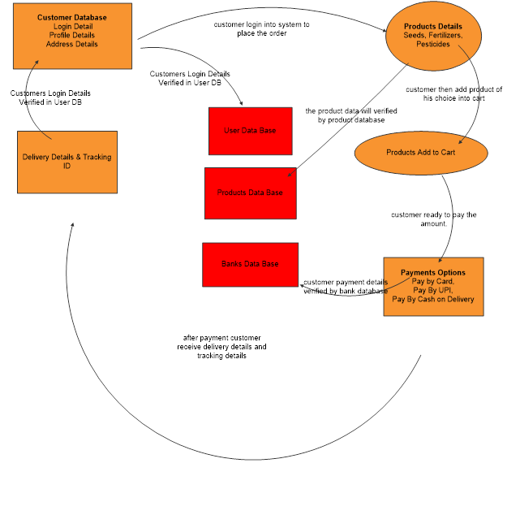

Question 8 – Change Request
Answer – How to handle Change Request
- Document the Change Request – Change in Government Taxation Structure.
- Take Approval from Project Manager or Change Manager for analyzing the change request.
- Analyse the Change Request – Perform Feasibility Study to accept the change.
- Impact analysis to measure the change I.e., how the change in government taxation structure would in scope or out scope the budget of ongoing project and how it will affect the company finances.
- Effort Estimation to implement the change in project.
- Then we will help the stakeholders to understand the impact the change request will have on the organization and to help minimize the negative impact that results from that change.
- Articulate a realistic vision of how the Change in Government Taxation Structure would help in CSR Activities or help the company save money from reduced taxes.
- Communicate a state of urgency to stakeholders and bring them to an agreement and avoid conflicts which could delay the project.

Question 9 – Change Request vs an Enhancement
Answer – In this Case adding crop yields and selling them and auction system for crop yields to the application is an enhancement as it involves adding new features to the system.
As a Business Analyst we would document the requirements, and work with the development team to determine the feasibility and impact of the new features. We would also consider the potential benefits, risks and costs associated with the enhancement before making any recommendation to the client.

Question 10 – Estimations
Answer -
Man-hour estimations: - 500-1000 Man-hours as this is a medium project.
- PM: -150 MH
- BA-150 MH
- JAVA DEVELOPER-100
- MH TESTERS-80 MH
- NW ADMIN-120 MH
- DB ADMIN- 120 MH
Total Man-hour estimation: - 720 Man-hours.

Question 11 – UAT
Answer – User Acceptance Testing Process
- Planning – In this state, Blueprints are made to implement UAT for every feature that needs to test and minimum standards for accepting the test.
- Designing – Here the Test Cases are designed to hide all the possibilities of software packages in a real-world environment.
- UAT Testers – A Testing Team consisting of end users that meet the criteria for implementing testing. The End Users must have expertise in subject matter, the ability to report the problem.
- Bug Fixing – Whatever Bugs are found in UAT Testing, the development team should work on them and make the software error free.
- Sign Off – After removing all the bugs, the testing team indicates acceptance of the completion of the bugs. In this Phase, all the stakeholders conclude that the software is ready to go live and sign it off.

Question 12 – Project Closure Documents
Answer – Project Closure Documents
The BA should keep the following into consideration during project closure: -
- Did the project achieve its goal.
- What were the planned and actual cost.
- What was the estimated time vs actual time taken to complete the project.
- Was there proper documentation and record of the same.
- Was the testing successful.
- Was the training session conducted successfully.

