Capstone project 1- Part 2

Ans 1: Audits

Business Analysts undergo quarterly audits (Q1, Q2, Q3, Q4) to check documentation quality, requirement completeness, stakeholder approvals, traceability, and process compliance. During audits, a BA presents documents such as Business Requirement Document (BRD), Functional Requirement Documents (FRD),Requirement Traceability Management (RTM), Minutes of the meeting (MOM), Change Request Log, and UAT Sign-off. Feedback received is implemented to improve BA work.

Ans 2: BA Approach Strategy

To complete a project successfully, the BA follows a structured approach that includes requirement gathering, stakeholder analysis, documentation, approvals, communication, and change management.
Key steps include:

• Identify stakeholders and conduct stakeholder analysis (RACI).
The BA identifies all project stakeholders, maps their influence and interest levels, and assigns roles using a RACI matrix to clarify responsibilities.

• Choose elicitation techniques such as Interviews, Document Analysis, and Workshops.The BA selects a mix of elicitation techniques such as Interviews, Workshops, Document Analysis, Observation, Prototyping, and Joint Application Development (JAD) sessions to gather complete business and system requirements.

• Prepare documents such as BRD, FRD, SRS, Use Case Specs, and RTM.

The BA prepares structured documents including:
BRD – Business Requirements Document
FRD/SRS – Functional Requirements Document
Use Case Diagrams & Use Case Specifications
RTM – Requirements Traceability Matrix
Process Flows, Activity Diagrams, Page Layouts

• Set up a communication plan and meeting schedule with client and team.
A communication plan is established defining meeting frequency, channels (email, Teams, Jira), escalation matrix, status reporting, and stakeholder engagement.

• Handle changes through a CR process and get approvals from the client.
Any requirement changes are documented using a Change Request form, analyzed for impact (cost, effort, timeline), shared with the client for approval, and updated in the baseline documents.

• Conduct UAT sessions and take sign-off for project closure.
The BA facilitates UAT by preparing test scenarios, coordinating with testers, clarifying requirements, recording defects, and obtaining UAT Sign-off from the client.After UAT acceptance, the BA prepares final documentation and helps transition the solution to operations/support.

Ans 3: 3-tier architechture
- Tier Architecture is a client-server architecture that divides an application into three layers:
1. Presentation Layer – User Interface
This is the topmost layer of the architecture and is responsible for all user interactions.

Key Responsibilities:
Displays the user interface (web pages, mobile screens, dashboards).
Collects inputs from the user (login credentials, search keywords, order details).
Sends user requests to the Business Layer.
Receives processed results and presents them back to the user.
This layer deals only with presentation, not logic or database operations.

- Business Layer – Application Logic
This is the core processing layer of the system. It acts as a bridge between the UI and the database.

Key Responsibilities:
Implements all business rules and functional logic.
Processes user requests received from the Presentation Layer.
Validates data (ex: check if login credentials are correct).
Communicates with the Data Layer to store or retrieve data.
Ensures security by restricting direct access to the database.
3. Data Layer – Database and Storage
This is the bottom-most layer, responsible for securely storing and managing all data.

Key Responsibilities:
Stores all system data (users, products, orders, payments, delivery tracking).
Handles data retrieval and updates based on requests from the Business Layer.
Ensures data integrity, security, and backup.
Executes SQL queries, stored procedures, and indexing.
Manages database connections and optimizes performance.
This architecture improves scalability, security, and performance.

Ans 4: BA approach strategy to framing questions

before asking questions to stakeholders, a BA should plan and keep these points in mind:

• 5W1H: What, Why, Who, When, Where, and How for every topic.
What is the requirement or problem?
Why is this needed? What business value does it provide?
Who will use this feature? Who is impacted?
When is the requirement applicable (frequency, timing, conditions)?
Where in the system will this requirement function?
How should the system support this requirement?
This helps the BA cover all dimensions of the requirement and avoid incomplete or vague questions.

• SMART: Keep questions focused on Specific, Measurable, Achievable, Relevant, Time-bound outcomes.
BA questions should be aligned with the SMART guidelines to ensure clarity and purpose.
Specific – Questions must be direct and to the point.
Measurable – Ensure the requirement can be measured or validated later.
Achievable – Confirm that the requirement is realistic within project constraints.
Relevant – Focus only on items that contribute to business objectives.
Time-Bound – Ask for timelines, frequencies, and deadlines related to the requirement.
Using SMART ensures questions lead to clear, structured, and testable requirements.

• RACI: Know who is Responsible, Accountable, Consulted, and Informed to address the right person.
The BA must identify:
Responsible – Who performs the activity
Accountable – Who approves the requirement
Consulted – Who provides input or domain knowledge
Informed – Who must be updated on decisions
This helps the BA direct each question to the right stakeholder and avoids confusion or delays.

• 3-Tier view: Clarify what belongs to UI, business rules, and database.

1. Presentation Layer – User Interface
This is the topmost layer of the architecture and is responsible for all user interactions.

Questions for UI/UX:
How should this screen look
What fields should be mandatory
What should be shown in the search results
2.Business Layer – Application Logic
This is the core processing layer of the system. It acts as a bridge between the UI and the database.
What validations need to happen before submitting the form
What conditions trigger notifications
3. Data Layer – Database and Storage
This is the bottom-most layer, responsible for securely storing and managing all data.
What data must be stored permanently
How long should data be retained
This ensures the BA covers questions for UI, processing logic, and data requirements.
• Models to think about: Use Cases, Use Case Specs, Activity Diagrams, basic page designs.
A BA should be prepared with visual modelling tools before asking questions:

a) Use Case Diagrams
Understand the actors and their interactions.

b) Use Case Specifications
Identify preconditions, post conditions, and alternate flows.

c) Activity Diagrams
Understand process steps, decision points, and workflow dependencies.

d) Page Designs / Wireframes
Use basic sketches to clarify UI expectations.
Models help the BA identify missing information and prepare targeted questions.

• Keep questions simple, one at a time, and confirm answers back to avoid confusion.
Stakeholders may come from business or non-technical backgrounds.
Thus, questions should be:
Short ,Understandable ,Free of jargon Asked one at a time
This prevents confusion and ensures accurate responses. After receiving answers, the BA should:
Repeat or summarize the stakeholder’s response
Validate the understanding
Document it immediately
Ask follow-up questions if needed.
This ensures the requirements are accurate, agreed upon, and aligned with stakeholder expectations.

Ans 5. Elicitation techniques
Elicitation techniques a BA should know:

• Brainstorming
A group discussion technique used to generate a wide range of ideas and solutions in a short time.

• Document Analysis
Reviewing existing documents to understand current processes, system behavior, and historical information.

• Research/Benchmarking
Comparing industry standards and market practices to identify best-fit solutions or validate requirements.

• Focus Groups
Gathering selected users or stakeholders together to discuss expectations, needs, and potential requirements.

• Observation/Job shadowing
Watching users perform their real work activities to understand actual workflows and pain points.

• Workshops/JAD sessions
Interactive sessions involving multiple stakeholders to gather, refine, and confirm requirements collaboratively.

• Interviews (one-to-one)
Direct one-on-one conversations with stakeholders to gather detailed and personalized requirements.

• Prototyping (wire frames/mock-ups)
Using visual screen models to help stakeholders understand the future system and clarify requirements.

• Questionnaires/Surveys
Distributing structured questions to collect information from a large number of stakeholders efficiently.

• User Story mapping (or Use cases)
Capturing user goals and interactions to understand system behavior and define end-to-end workflows.

Ans 6. This Project elicitation technique.
For the Online Agriculture Products Store project, the following elicitation techniques are the most suitable. Each technique helps in gathering clear and complete requirements from farmers, manufacturers, and the committee.

• Prototyping: To show simple screens for login, catalogue, cart, payment, and tracking.
Prototyping is useful because it allows the BA to create simple screen mock-ups of important features such as login, product catalog, cart, payment, and order tracking.
When stakeholders see the screens visually, they understand the system better and can easily suggest corrections or improvements. This reduces confusion and helps finalize UI requirements quickly.

• Use Case Specs: To describe who does what and main/alternate flows.

Use Case Specs help describe who (actor) performs what action and how the system should respond.
For example, “Farmer searches for products” or “Manufacturer uploads product details.”
Each use case explains the main flow, alternate flows, and exceptions, making it easier for both developers and testers to understand the exact system behavior.
This is very useful in this project because multiple users (farmers, manufacturers, admin) perform different actions in the system.

• Document Analysis: To review any existing order or inventory policies from SOONY/APT.

Document Analysis helps the BA review any existing policies, guidelines, inventory rules, or process documents available with SOONY or APT IT Solutions.
These documents may include order processing rules, payment guidelines, or product listing rules.
By reviewing them, the BA can ensure that the new application aligns with existing policies and avoids rework later.

• Brainstorming: With farmers and team to refine features like filters, payment types, and delivery updates.
Brainstorming sessions with farmers, the internal project team, and manufacturers help generate ideas for features such as:
Search filters (crop type, product type, brand, etc.)
Payment options (COD, UPI, cards)
Notifications and delivery updates
This technique allows all participants to openly share their thoughts, leading to better and more practical requirements.

These four techniques—Prototyping, Use Case Specs, Document Analysis, and Brainstorming—are ideal for this project because they help clarify requirements visually, document system behavior clearly, ensure alignment with existing guidelines, and gather creative ideas from real users.

Ans 7. Business Requirement

BR001 – Farmer Search for Products: Farmers should be able to search for available products in fertilizers, seeds, pesticides.
Farmers should be able to search for all types of agricultural products such as fertilizers, seeds, and pesticides using a simple and user-friendly search feature.
This helps farmers save time and directly find the products they need.

BR002 – Manufacturers Upload Products: Manufacturers should be able to upload and display their products in the application.
Manufacturers must be able to upload their product details including product name, category, description, price, available quantity, and usage instructions.
Once uploaded, these products should be visible to farmers instantly on the platform.
This eliminates middlemen and allows manufacturers to directly reach their market.

BR003 – User Registration and Login: Users (Farmers/Manufacturers) can register and login using email and password.
Both Farmers and Manufacturers should be able to create an account using their email ID and password.
The registration process should validate unique email IDs and store user details securely.
Login functionality should verify credentials and provide access to a personalized dashboard.
This ensures that only authorized users can access features related to buying or uploading products.

BR004 – Browse Catalogue: Farmers can browse product catalogue with categories and filters.
Farmers should be able to browse a well-organized catalogue that displays products grouped into categories such as fertilizers, seeds, and pesticides.
Additionally, the system should support filters like product type, brand, price range, crop type, and stock availability.
This helps farmers easily explore products and make informed purchase decisions without confusion.

BR005 – Cart and Buy Later: Farmers can add items to cart and also to a buy-later list.
Farmers should be able to add selected items to the cart for immediate purchase.
If they are not ready to buy, they should also be able to save items in a “Buy Later” or wish list section.
BR006 – Payments: Support COD, Credit/Debit Cards, and UPI payments.
The platform should support common and easy payment methods such as Cash on Delivery (COD), Credit/Debit cards, and UPI-based payments.
The payment interface should be simple, secure, and should confirm whether the transaction is successful or failed.
BR007 – Order Confirmation Notifications: Send email confirmation with order details and status updates.
The system must also send status updates (shipped, out for delivery, delivered).
This keeps farmers informed and increases trust in the platform.

BR008 – Delivery Tracking: Provide a delivery tracker to show order status and location updates.
The system should provide a delivery tracker to show the real-time status of the order, such as “packed”, “shipped”, “in transit”, and “out for delivery”.

BR009 – Manufacturer Product Management: Manufacturers can add, edit, and remove their own products.

BR010 – Security and Data Privacy: Protect user accounts, passwords, and payments using standard practices.
The system must protect all user data including passwords, personal details, payment information, and order history using secure authentication and encryption practices.
Only authorized users should have access to their data, and sensitive information should never be exposed.
This builds trust among users and ensures compliance with standard security guidelines.

Ans 8. Assumptions

• All users have basic internet access and a valid email ID.

• COD, Card, and UPI gateways are available for integration in supported regions.

• Delivery is handled by trusted courier partners with traceable IDs.

• Manufacturers provide accurate product information (price, stock, description).

• System supports English language initially; more languages can be added later.

• User passwords are stored securely and can be reset via email.

Ans 9.
Requirement Id | Requirement Name | Requirement Description | Priority
BR001 | Farmer Search for Products | Farmers should be able to search for available products in fertilizers, seeds, pesticides. | 8/10
BR002 | Manufacturers Upload Products | Manufacturers Upload Products: Manufacturers should be able to upload and display their products in the application. | 8/10
BR003 | User Registration and Login | User Registration and Login: Users (Farmers/Manufacturers) can register and login using email and password. | 10/10
BR004 | Browse Catalogue | Browse Catalogue: Farmers can browse product catalogue with categories and filters. | 9/10
BR005 | Cart and Buy Later | Cart and Buy Later: Farmers can add items to cart and also to a buy-later list. | 8/10
BR006 | Payments: Priority | Payments: Support COD, Credit/Debit Cards, and UPI payments. | 10/10
BR007 | Order Confirmation Notifications | Order Confirmation Notifications: Send email confirmation with order details and status updates. | 7/10
BR008 | Delivery Tracking: Priority | Delivery Tracking: Provide a delivery tracker to show order status and location updates. | 9/10
BR009 | Manufacturer Product Management | Manufacturer Product Management: Manufacturers can add, edit, and remove their own products. | 7/10
BR010 | Security and Data Privacy | Security and Data Privacy: Protect user accounts, passwords, and payments using standard practices | 10/10

Ans 10. Use Case Diagram

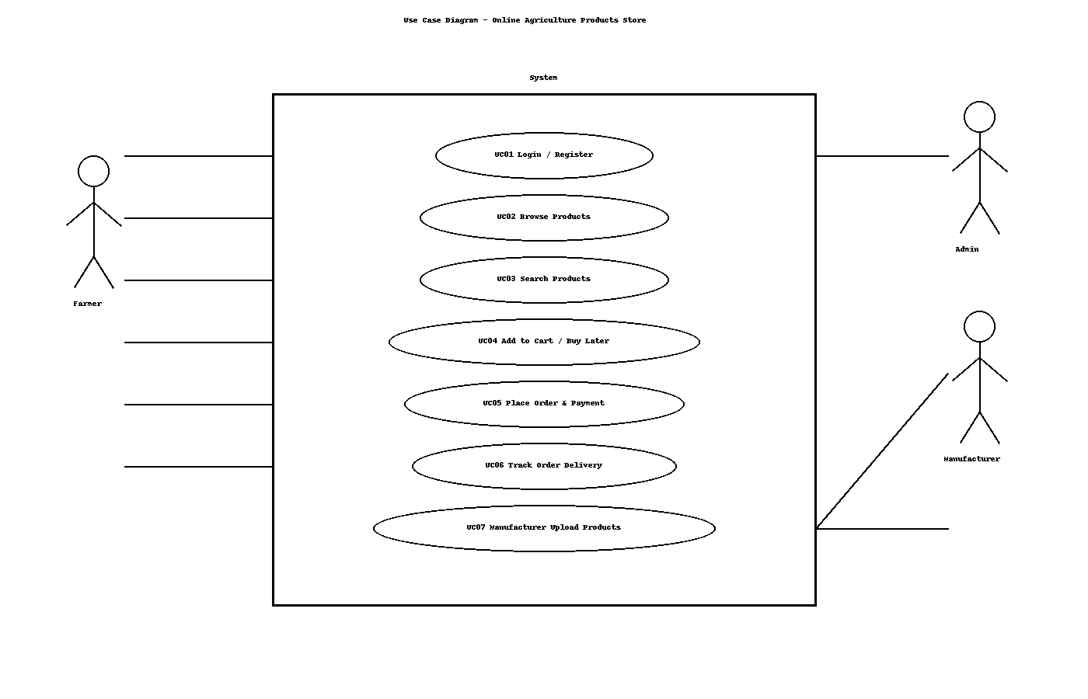

Ans 11. Use Case Specififcation

UC01: Login / Register
Primary Actor: Farmer / Manufacturer
Preconditions:
• User has app or website access.
Main Success Flow:
1. User opens Login/Register page.
2. User enters email and password.
3. If new, user selects Register and submits details.
4. System validates credentials.
5. System creates session and navigates to dashboard.
Alternate/Exception Flows:
• Invalid credentials → show error and allow retry.
• Forgot password → send reset email.
Postconditions:
• User is logged in or account created.
• User can proceed to browse or manage products.

UC02: Browse Products
Primary Actor: Farmer
Preconditions:
• User is logged in (for cart/buy later).
Main Success Flow:
1. User opens Catalogue.
2. User selects category (seeds/fertilizers/pesticides).
3. System lists products with price and rating.
4. User opens a product to view details.
Alternate/Exception Flows:
• If not logged in and tries to add to cart → prompt login.
Postconditions:
• User can see products and proceed to add to cart or buy later.

UC03: Search Products
Primary Actor: Farmer
Preconditions:
• User has access to search bar.
Main Success Flow:
1. User enters keywords.
2. System fetches and shows results.
3. User applies optional filters (brand/price).
4. User opens a product from results.
Alternate/Exception Flows:
• No results → show helpful message and suggestions.
Postconditions:
• Relevant results displayed.

UC04: Add to Cart / Buy Later
Primary Actor: Farmer
Preconditions:
• User is viewing a product detail page.
Main Success Flow:
1. User picks quantity.
2. User clicks Add to Cart or Buy Later.
3. System updates cart/list.
4. System shows confirmation.
Alternate/Exception Flows:
• Out of stock → show message and disable Add to Cart.
Postconditions:
• Cart/list updated.

UC05: Place Order & Payment
Primary Actor: Farmer
Preconditions:
• Items exist in cart.
Main Success Flow:
1. User opens cart and reviews items.
2. User enters address.
3. User selects payment method (COD/Card/UPI).
4. System processes payment/authorization.
5. System confirms order and sends email.
Alternate/Exception Flows:
• Payment failure → allow retry or change method.
• Invalid address → prompt correction.
Postconditions:
• Order created with an order ID.
• Email confirmation sent.

UC06: Track Order Delivery
Primary Actor: Farmer
Preconditions:
• Order is placed and has a tracking ID.
Main Success Flow:
1. User opens Orders page.
2. User selects an order.
3. System shows status (Packed/Shipped/Out for delivery/Delivered).
Alternate/Exception Flows:
• If courier API not available → show last known status.
Postconditions:
• User sees order progress.

Ans 12

