Preparation Exam – 3 Part – 1

Case Study 1
A customer can make a payment either by Card or by Wallet or by Cash or by Net banking.

Question 1 – Draw a Use Case Diagram
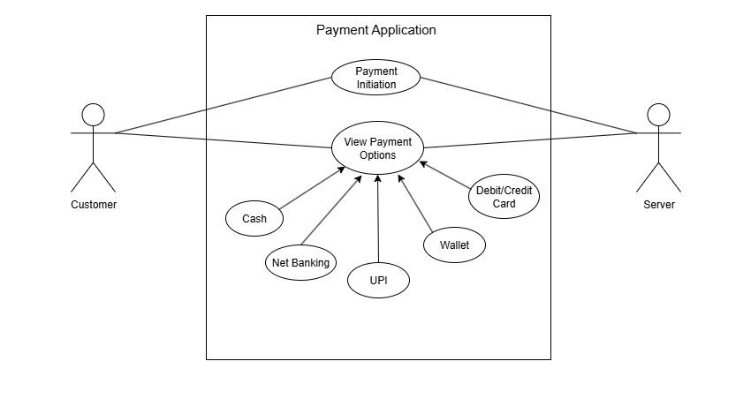
Answer:
Question 2 – Derive Boundary Classes, Controller classes, Entity Classes.
Answer:
Boundary Class: Used to handle interactions between the system and external actors.
Examples:
- Payment Option Boundary
- Card Payment Boundary
- Wallet Payment Boundary
- Cash Payment Boundary
- Net Banking Payment Boundary
Controller Class: Act as intermediaries between boundary and entity classes.
Examples:
- Payment Initiated Controller
- Card Payment Controller
- Wallet Payment Controller
- Cash Payment Controller
- Net Banking Controller
Entity Class: Represent the core data and business logic of the application.
Examples:
- Customer
- Payment
- Transaction
- Bank

Question 3 – Place these classes on a three tier Architecture.
Answer:

User Layer: Handles user interface and interactions.
Examples:
- Payment Option Boundary
- Card Payment Boundary
- Wallet Payment Boundary
- Cash Payment Boundary
- Net Banking Payment Boundary

Business Logic: Contains the application logic and coordinates between UI and data.
Examples:
- Payment Controller
- Card Payment Controller
- Wallet Payment Controller
- Cash Payment Controller
- Net Banking Controller

Data Tier: Stores and manages the core business data.
Examples:
- Customer
- Payment
- Transaction
- Bank

Question 4 – Explain Domain Model for Customer making payment through Net Banking
Answer:
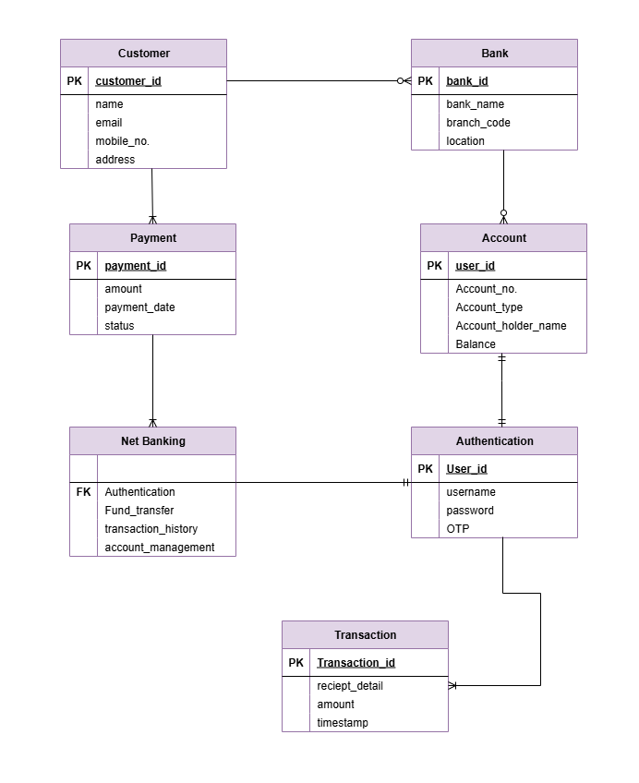

Question 5 – Draw a sequence diagram for payment done by Customer Net Banking
Answer:
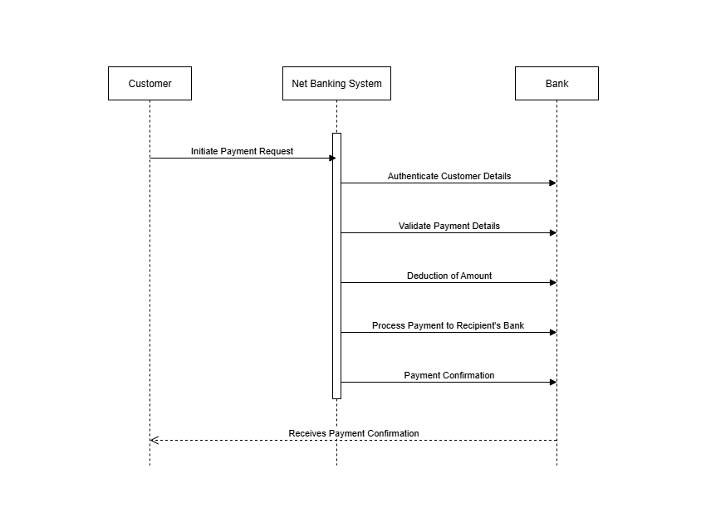

Question 6 – Explain Conceptual Model for this Case
Answer:
- A conceptual model is high level representation of a system that helps in understanding, visualizing and communicating the essential aspects of a domain.
- Its provide a clear and simplified view of the domain, making it easier to understand.
- Key elements of conceptual model
For the payment system

Entities: Customer, Payment, Bank, Transaction, Payment Method
Attributes:
Customer: customer_id, name, contact_no, email
Payment: payment_id, amount, payment_date, payment_method
Bank: bank_id, bank_name, ifsc_code
Transaction: transaction_id, status, transaction_date
PaymentMethod: method_id, method_name (Card, Wallet, Cash, Net Banking)
Relationships: Customer makes payment
Payment is processed by bank
Payment generates transaction

Question 7 – What is MVC architecture? Explain MVC rules to derive classes from use case diagram and guidelines to place classes in 3-tier architecture.
Answer: The Model-View-Controller (MVC) framework is an architectural pattern that separates an application into three main logical components Model, View and Controller.

View: Represents the presentation layer of the application.
Model: Represents the data and the business logic of the application.
Controller: Acts as an intermediary between Model and View.

MVC rules to derive classes from use case diagram:

Boundary classes in the use case diagram become View components.
Controller classes in the use case diagram become Controller components.
Entity classes in the use case diagram become Model components.

Guidelines to place classes in 3-tier architecture:

Application Layer: Contains all View (Boundary) classes such as UI forms and display pages.
Business Logic Layer: Contains all Controller classes that manage the flow of data and logic between View and Model.
Data Layer: Contains all Model (Entity) classes and handles database interactions.

Question 8 – Explain BA contributions in project (Waterfall Model – all Stages)
Answer:

Stage | Activities | Artifacts and Resources
Pre-project | Identify business problem, assess feasibility, prepare business case | Business Case, Feasibility Report
Planning | Define project scope, objectives, timelines, and resources | Project Charter, Scope Statement, Schedule
Project Initiation | Stakeholder identification | Stakeholder Register,
Requirements Gathering | Conduct interviews, workshops, surveys; document requirements | Business Requirement Document (BRD), Notes
Requirements Analysis | Analyze requirements, create models, validate with stakeholders | Use Case Diagrams, Process Flow, Requirement Spec
Design | Review system design to ensure alignment with requirements | System Design Document (SDD), Wireframes
Development | Provide clarifications to developers, ensure adherence to requirements | Requirement Specs, Change Request Forms
Testing | Review test cases, support QA team, facilitate UAT | Test Plan, Test Cases, Defect Log
UAT | Organize UAT sessions, gather user feedback, document acceptance | UAT Report, Sign-off Document

Question 9 – What is conflict management? Explain using Thomas – Kilmann technique
Answer:
Conflict Management:
Conflict management is the process of resolving conflicts or disagreements between individuals or groups in a constructive manner.

Thomas–Kilmann Technique:
The Thomas–Kilmann technique is a widely used tool for assessing conflict resolution styles and guiding individuals in selecting appropriate strategies to manage conflicts.

5 Steps of Conflict Management:
- Identify the conflict – Recognize the disagreement and its cause.
- Discuss the details – Allow all parties to share their perspectives.
- Agree with the root problem – Ensure everyone understands the core issue.
- Check for every possible solution – Explore all options collaboratively.
- Negotiate the solution to avoid future conflict – Choose the best solution acceptable to all parties.

Question 10 – List down the reasons for project failure.
Answer:
- Poor Planning – Without a proper roadmap, tasks get delayed, resources mismanaged, and project direction becomes unclear.
- Unclear Objectives and Requirements – Ambiguity in goals leads to wrong deliverables and stakeholder dissatisfaction.
- Inadequate Risk Management – Failure to predict and prepare for risks causes unexpected project issues and delays.
- Poor Communication – Misunderstanding between stakeholders and team leads to errors, delays, and rework.
- Scope Creep – Adding unplanned features increases workload, cost, and project duration.
- Lack of Stakeholder Engagement – Without active stakeholder involvement, requirements may be missed or misunderstood.
- Resource Constraints – Limited budget, staff, or tools slow down project progress and quality.
- Technical Challenges – Complex or failing technology disrupts development, testing, and deployment stages.

Question 11 – List the Challenges faced in projects for BA
Answer:
- Unclear or Changing Requirements – When business needs are unclear or keep changing frequently, it leads to misunderstandings, scope changes, increased rework, and delays in meeting project goals.
- Managing Stakeholder Expectations – Balancing diverse stakeholder priorities, resolving conflicts, and ensuring alignment with business goals can be difficult, especially when interests differ or communication is inconsistent.
- Scope Creep and Scope Management – Adding new features without proper approval increases workload, cost, and timelines, making it hard to maintain project focus and deliverables within scope.
- Time and Resource Constraints – Limited time, budget, or skilled resources cause rushed work, compromise quality, and sometimes lead to incomplete or delayed project deliverables.
- Quality Assurance and Testing – Ensuring all functional and non-functional requirements are tested thoroughly within tight schedules can be challenging for both BA and QA teams.
- Documentation and Knowledge Management – Keeping all documents up-to-date, accurate, and easily accessible is essential but often time-consuming, especially in large projects with multiple teams.
- Technology Constraints and Complexity – Integrating new solutions with out-dated or complex systems can lead to technical difficulties, performance issues, and increased project risks.

Question 12 - Write about Document Naming Standards
Answer: A document numbering standard is a systematic approach to assigning unique identifiers to various documents created and used throughout the development process.
Example:
Suppose we have a project with the ID PROJ123, and we’re working on a Requirements Specification Document.
- Project ID: PROJ123
- Document Type: REQ
- Version: 1.0
- Date: 2025-03-05
The document identifier could be:
PROJ123-REQ-1.0-2025-03-05

Question 13 - What are the Do’s and Don’ts of a Business Analyst?
Answer:

Do’s | Don’ts
Consult an SME (Subject Matter Expert) for clarifications in requirements. | Never say NO to the client.
Go to the client with a plain mind and no assumptions. Listen completely before asking questions. | There is no word as “by default.”
Try to extract maximum leads to the solution from the client himself. | Never imagine anything in terms of GUI without confirmation.
Concentrate on the important requirements. | Don’t interrupt the client when he is explaining the problem.
Question the existence of requirements. Validate if they are truly needed. | Never give solutions to the client immediately based on past assumptions.
Maintain clear and updated documentation for all discussions. | Don’t skip documenting changes or agreements.
Keep communication professional and respectful at all times. | Don’t use technical jargon that stakeholders may not understand.

Question 14 – Write the difference between packages and sub-systems
Answer: Packages: A package is a collection of components that are not reusable in nature. These components are generally created for a specific project or client requirement and are tailored to meet that particular need. Once developed, they are rarely used in other projects.
For example: application development companies often work on packages designed for one client’s application without intending to reuse them elsewhere.
Sub-Systems: Sub-system is a collection of components that are reusable in nature. They are designed with standardization and modularity in mind so that the same component can be applied across multiple projects or systems. This reusability saves time and cost in the long term and ensures consistency.
For example: product development companies often build sub-systems, such as payment modules or authentication systems that can be reused in different applications.

Question 15 – What is camel-casing and explain where it will be used
Answer: Camel-casing is a naming convention used in programming where multiple words are written together without spaces, and each word after the first starts with a capital letter. This style resembles the humps of a camel, hence the name. In lower camel-case, the first letter of the first word is in lowercase (e.g., customerName)
Camel-casing is commonly used for naming variables, methods, classes, and objects in many programming languages such as Java, C#, and JavaScript. For example, variables and method names often follow lower camel-case, while class names follow upper camel-case. This convention improves code readability, ensures consistency across the codebase, and avoids the use of spaces or underscores in names.

Question 16 - Illustrate Development server and what are the accesses does business analyst has?
Answer:
- Development Server Definition – A dedicated environment used during software development where applications are built, tested, and debugged before moving into production.
- Purpose – It provides developers and testers with a safe platform to identify and fix issues without impacting the live production system.
- Error Handling – Early testing in the development server ensures bugs and errors are caught and resolved before deployment to the real environment.
- BA Access – Business Analysts generally get limited access, enough to review features and confirm requirement implementation but not to modify technical components.
- BA Activities – A BA can use the server to perform functional checks, validate business rules, and ensure alignment of development with requirements.
- Restrictions – Unlike developers, BAs don’t have coding or administrative rights, keeping the development environment secure and preventing unintentional changes.

Question 17 – What is Data Mapping.
Answer:
- Data mapping is the process of linking data fields from a source system to equivalent fields in a target system.
- It acts like a guide or blueprint that shows how data in one place corresponds to data in another, making system communication possible.
- This is especially important when transferring data between different databases, applications, or external systems, ensuring that information remains consistent and accurate.
- Data mapping is widely used in data migration, system integration, and ETL (Extract–Transform–Load) processes where data flows across multiple platforms.
- Example: A field called CustomerName in System A can be mapped to FullName in System B, so both systems maintain identical customer records.
- For Business Analysts, data mapping helps in requirement validation, ensuring business rules are correctly applied and no important information is lost or mismatched.
- Proper data mapping reduces errors, supports reporting accuracy, and helps maintain data quality and integrity across different systems.

Question 18 - What is API. Explain how you would use API integration in the case of your application Date format is dd-mm-yyyy and it is accepting some data from Other Application from US whose Date Format is mm-dd-yyyy
Answer:
- API (Application Programming Interface):
API is a set of rules and protocols that allows two software applications to communicate and exchange data with each other.
- Purpose of API Integration:
It helps connect different systems or applications, enabling smooth data sharing and reducing manual effort in data transfer.
- Case in Application (Date Format Issue):
Our application stores dates in dd-mm-yyyy format.
The external system from the US provides dates in mm-dd-yyyy format.
Without handling, this mismatch could cause errors in reports or transactions.
- Solution using API:
While integrating, the API can include a data transformation logic that converts the date format from mm-dd-yyyy (source) into dd-mm-yyyy (target).
Example: 06-25-2025 (mm-dd-yyyy) would be automatically converted into 25-06-2025 (dd-mm-yyyy) before saving.
- BA Role in API Integration:
Identify data mismatches (like date formats, currencies, units).
Define transformation rules in the requirement specification.
Validate that API integration is tested and ensures data consistency across both systems.

