Capstone project 3.1
A customer can make a payment either by Card or by Wallet or by Cash or by Net banking.
Q1. Draw a Use Case Diagram?
A.1: The Below diagram shows that the customer interacts with the main "Make Payment" use case, which then extends to the four specific payment methods.
1. Actor (Customer and Admin):
The customer initiates the payment process and Admin Approves at back end.
2. Primary Use Case (Make Payment):
This represents the overarching functionality for processing a payment.
3. Sub Use Cases (Payment Options):
The payment process branches into four different options:
- Pay by Card: The customer selects this option to process payment using a credit/debit card.
- Pay by Wallet: The customer selects this option to process payment via a digital wallet (e.g., Paytm, PhonePe).
- Pay by Cash: The customer selects this option for cash on delivery (or in-person cash payment).
- Pay by Net Banking: The customer selects this option to process payment through net banking by redirecting to the bank’s portal.
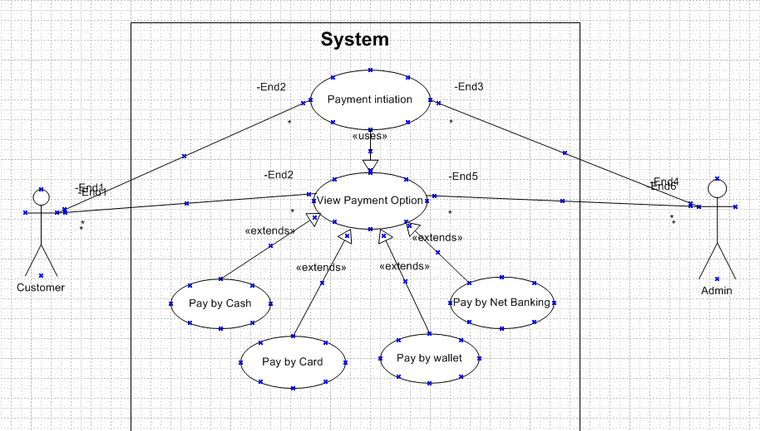
Q2. Derive Boundary Classes, Controller classes, Entity Classes. - 4 Marks

