CAPSTONE PROJECT PREP 3 PART -1

Documented by : B.Vaishnavi
Date : 05-May-2025

Case Study 1 (Q1-Q6 → 24 Marks)
A customer can make a payment either by Card or by Wallet or by Cash or by Net banking.
Q1. Draw a Use Case Diagram - 4 Marks
Answer 1 :

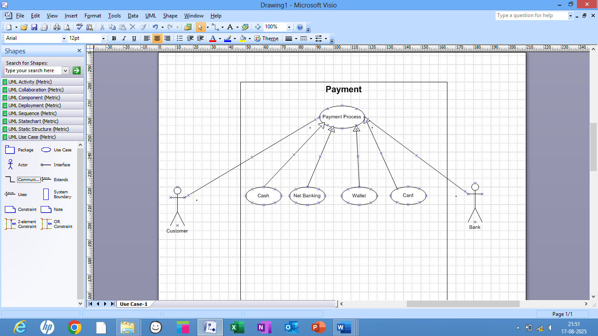

Q2. Derive Boundary Classes, Controller classes, Entity Classes. - 4 Marks
Answer 2 :
Boundary Classes :
The Boundary class is a class that is the boundary of the system and other system or user ( which is actor in the use case diagram ).
The followings are the feature of the Boundary class.
1. This class is more easy to be changed than the Entity and Control class.
2. The attribute of this class and screen layout are defined at the basic design.
3. In a class diagram , there are cases that the stereotype
(<<boundary>>) is added.
4. In a class diagram , there are cases that is shown by the following icon.
Classes:
- PaymentPageUI (Class) → Displays the payment page where customers enter their details.
- PaymentGatewayAPI (Class) → Connects the system to external payment providers (e.g., PayPal, Stripe).
- NotificationService (Class) → Sends payment confirmation via email or SMS.
- Analogy: Boundary Classes are like a hotel’s front desk. They take customer requests and pass them to the right department.
Controller classes :
The followings are the feature of the Control class.
1. This class has a few attribute.
2. In a class diagram , there are cases that the stereotype (<<control>>) is added.
3. This class is a class to achieves use cases in the Use case diagram.
4. In a class diagram , there are cases that is shown by the following icon.
Classes & Their Methods:
- PaymentController (Class) → Manages the overall payment flow.
  - initiatePayment(Order, Payment payment) → Starts the payment process.
  - handlePaymentResponse (Transaction) → Updates order status after payment is processed.
- Transaction Manager (Class) → Handles approval, money transfer, and settlement.
  - Authorize Payment(Payment) → Checks if payment details are valid.
  - process Payment(Payment) → Interacts with Payment Gateway API to complete payment.
  - record Transaction(Transaction) → Stores transaction details in the system.
- Fraud Detection Service (Class) → Monitors transactions for potential fraud.
  - Analyze Risk(Payment, Customer) → Checks for suspicious activities.
Analogy: Controller Classes are like hotel managers. They oversee the entire operation, ensuring everything runs smoothly.
Entity Classes :
The Entity class is a class that has data.
The "E" of the ER diagram means "Entity" too, if you know the ER diagram, you easily understand.
The followings are the feature of the Entity class.
1. There are many cases that this objects of this class are perpetuated 1 in the DB.
2. The extraction of the class is like ER diagram 2.
3. This class is related to the DOA (Data-oriented approach) 2.
4. The module cohesion of this class is high 3, and is not easy to be changed.
5. In a class diagram , there are cases that the stereotype (<<entity>>) is added.
6. In a class diagram , there are cases that is shown by the following icon.
Classes & Their Attributes:
- Order (Class) → Stores details of customer purchases.
  - Attributes: orderID, items, totalAmount, status.
- Payment (Class) → Stores payment details.
  - Attributes: paymentID, amount, method (credit card, PayPal, etc.), status.
- Transaction (Class) → Records individual payment transactions.
  - Attributes: transactionID, date, status, referenceNumber.
- Customer (Class) → Stores customer details.
  - Attributes: customerID, name, email, paymentHistory.
Analogy: Entity Classes are like a hotel's record books, where they keep track of guest reservations, payments, and transactions.

Final Key Points to Avoid Confusion
- Boundary Classes = Interface-related (handle user/system interaction).
- Controller Classes = Processing-related (have methods that execute business logic).
- Entity Classes = Data-related (store and manage key business information).

Q3. Place these classes on a three tier Architecture. - 4 Marks
Answer 3 :

Placing Classes in a Three-Tier Architecture
The Three-Tier Architecture divides the entire system into three layers, each serving a different purpose. The classes (code components) inside these layers contain methods that make the system work.

1. Presentation Layer (User Interface & External Communication)
This layer is responsible for user interaction and communication with external services.
Contains Boundary Classes → These classes handle inputs from users or external systems.
Class (Code Component) | Role
PaymentPageUI | Displays the payment page where customers enter their details.
Payment Gateway API | Connects with external payment providers (e.g., PayPal, Stripe).
Notification Service | Sends payment confirmation via email/SMS.
Think of this layer as a hotel’s front desk, handling customer interactions.

2. Business Logic Layer (Processing & Decision Making)
This layer processes user requests, applies business rules, and coordinates the workflow.
Contains Controller Classes → These classes define logic and control the payment process.
Class (Code Component) | Role
PaymentController | Manages the overall payment process.
TransactionManager | Handles payment authorization, processing, and transaction recording.
FraudDetectionService | Checks for fraudulent transactions before approving a payment.

Think of this layer as hotel managers ensuring smooth operations.

3. Data Layer (Database & Data Storage)
This layer is responsible for storing and retrieving all payment-related information.
Contains Entity Classes → These classes represent and store business data.
Class (Code Component) | Role
Order | Stores details of customer purchases (items, amount, status).
Payment | Stores payment details (amount, method, status).
Transaction | Records each payment transaction (date, status, transaction ID).
Customer | Stores customer details (name, email, payment history).
Think of this layer as hotel records where guest bookings, payments, and transactions are stored.

Key Takeaways to Avoid Confusion
- Three-Tier Architecture = System structure (Presentation, Business, Data Layers).
- Classes (Code Components) = Implementation inside these layers (Boundary, Controller, Entity Classes).
- Each class contains methods that make the system work (e.g., processPayment(), authorizePayment()).
Q4. Explain Domain Model for Customer making payment through Net Banking - 4 Marks
Answer 4 :
A Domain Model is a conceptual representation of business entities and their relationships, created before ER diagrams and database schemas.
- It is prepared by a Business Analyst (BA) in collaboration with stakeholders, Subject Matter Experts (SMEs), Solution Architects, and Developers.
- It is created for business teams, product owners, and technical teams to ensure a shared understanding of the payment process.

Key Entities and Relationships:
- Customer
  - Attributes: customerId, name, preferredPaymentMethod.
  - Associations: One-to-Many with Transaction (A customer can initiate multiple transactions).
- Payment
  - Attributes: paymentId, amount, method (Net Banking), status.
  - Associations: One-to-One with Transaction (Each transaction corresponds to a payment).
- Transaction
  - Attributes: transactionId, timestamp, paymentId, customerId, status.
  - Associations: Linked to Customer and Payment.
- NetBankingDetails (Optional Entity for Extended Modeling)
  - Attributes: bankName, accountNumber, IFSCCode, transactionReference.

Purpose and Use:
- Ensures Business Clarity – Defines how net banking payments work before technical design.
- Bridges the Gap – Helps both business and technical teams align on requirements.
- Prepares for Database Design – Serves as the foundation for ER diagrams and database schemas.
- Prevents Rework – Avoids misunderstandings and unnecessary changes during development.
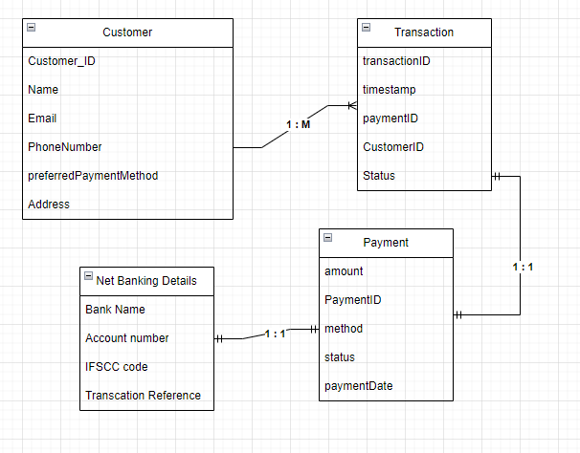

Q5. Draw a sequence diagram for payment done by Customer Net Banking - 4 Marks
Answer 5 :
A Sequence Diagram is a type of UML (Unified Modeling Language) diagram that shows how different parts of a system interact over time by exchanging messages.
Key Elements of a Sequence Diagram:
- Actors:
  - Represent external entities (e.g., users, systems) interacting with the system.
  - Depicted as stick figures.
- Objects/Classes:
  - Represent the components or participants in the interaction (e.g., system components, classes, services).
  - Depicted as rectangles at the top of the diagram.
- Lifelines:
  - Represent the life span of an object during the interaction.
  - Depicted as vertical dashed lines extending down from the objects.
- Messages:
  - Represent communication between objects.
  - Depicted as arrows between lifelines, showing the direction of the message.
    - Synchronous message: Solid arrow with a filled head.
    - Asynchronous message: Solid arrow with an open head.
- Activations:
  - Represent the time period during which an object is performing an action or task.
  - Depicted as narrow rectangles on the lifeline.
- Control Logic:
  - Includes constructs such as loops, conditionals, and alternatives.
  - Depicted using interaction frames (e.g., alt, loop).

- Return Messages:
  - Represent responses or acknowledgments.
  - Depicted as dashed arrows pointing back to the sender.

Q6. Explain Conceptual Model for this Case - 4 Marks
Answer 6:
A conceptual model provides a high-level overview of the system’s key concepts and their relationships.

Key Concepts:
- Customer:
  - Initiates payments.
  - Has attributes like customerId, name, and contactInfo.
- Payment:
  - Represents the payment instance.
  - Includes attributes like method, amount, and status.
- Transaction:
  - Logs each payment activity.
  - Tracks details like transactionId, timestamp, and status.
- NetBankingDetails (Optional in this case):
  - Captures specifics of the net banking process (e.g., account number, bank name).

Relationships:
- Customer ↔ Transaction:
  - A customer can initiate multiple transactions, but a transaction is tied to one customer.
- Transaction ↔ Payment:
  - A transaction corresponds to a single payment, defining its method and status.

Validation Rules:
- Valid Net Banking details:
  - Correct account number and IFSC.
  - Sufficient balance for the transaction.
- Unique transaction IDs.
- Secure handling of sensitive data.

Q7. What is MVC architecture? Explain MVC rules to derive classes from use case diagram and guidelines to place classes in 3-tier architecture - 8 Marks
Answer 7 :
The Model-View-Controller (MVC) is a well-known design pattern in the web development field. It is way to organize our code. It specifies that a program or application shall consist of data model, presentation information and control information. The MVC pattern needs all these components to be separated as different objects.
Model: It represents the business layer of application. It is an object to carry the data that can also contain the logic to update controller if data is changed.
View: It represents the presentation layer of application. It is used to visualize the data that the model contains.
Controller: It works on both the model and view. It is used to manage the flow of application, i.e. data flow in the model object and to update the view whenever data is changed.

MVC Rules to Derive Classes from a Use Case Diagram
To derive Model, View, and Controller classes from a use case diagram, follow these rules:
- Model Classes:
  - Identify entity classes from the use case diagram, especially nouns (e.g.,"Customer," "Payment," "Transaction").
  - Ensure these classes handle data storage and business logic, typically corresponding to database entities.
- View Classes:
  - Focus on boundary classes identified in the use case diagram (e.g., "Login Page," "Payment Form").
  - These classes represent user interfaces and are responsible for displaying data and collecting user input.
- Controller Classes:
  - Identify control classes from the use case diagram (e.g., "Payment Controller," "Order Controller").
  - These classes implement use case behaviour by orchestrating interactions between the Model and View components.

Guidelines to Place Classes in 3-Tier Architecture
In a 3-tier architecture, the application is divided into three logical layers: Presentation, Business Logic, and Data Access.
- Presentation Layer:
  - Place View Classes here.
  - Responsible for user interfaces, displaying information, and handling user inputs.
  - Examples: Login pages, payment forms, dashboards.
- Business Logic Layer:
  - Place Controller Classes and any business logic classes here.
  - Handles processing, validations, and interaction between the presentation and data layers.
  - Examples: Payment controllers, transaction processors.
- Data Access Layer:
  - Place Model Classes here.
  - Responsible for interacting with the database, performing CRUD operations, and maintaining data consistency.
  - Examples: Customer entities, payment entities.

Three-tier architecture, which separates applications into three logical and physical computing tiers, is the predominant software architecture for traditional client-server applications.
Q8. Explain BA contributions in project (Waterfall Model – all Stages) – 8 Marks
Answer 8 :
- Waterfall model is useful in the situation where the project requirements are well defined and the project goals are clear.
- Waterfall model follows sequential approach.
- In this model each phase is completed entirely and then only moved to the next phase.
- Waterfall model relies on documentation to ensure that the project is well defined and project team is working toward clear goals.
- Ones that particular phase has been completed and ones we move to the next phase , we cannot go back to the previous phase to make changes.
- This model is stable for the projects when the requirements are clear.
Requirements Gathering-
1. First, the stakeholders are identified.
2. In this phase, all the requirements are gathered from the stakeholder.
3. BA and Project Manager participates in this phase.
4. After completing this phase, BRD will be generated.

Requirements Analysis-
1. The requirements are analysed to understand the scope of the project.
2. Analysing means the BA will check all the requirements, if he founds conflicting requirements then the BA will talk to the concerned stakeholder to clear it, remove the ambiguous requirements.
3. BA will prepare functional requirement.
4. The document which contains the functional requirements is called (FRS).[Functional Requirement Specifications]
Technical team will prepare non-functional requirement. The document which contains the non-functional requirements is called (SSD).[Supplementary Support Document ] BA will combine FRS and SSD to form SRS.[ Software Requirement Specifications] BA will prepare RTM by referring SRS.

Design-
1. After the requirements are cleared, Design phase starts.
2. This has a detailed design document that outlines the software architecture, user interface, and system components.
3. HDD, ADD and solution document will be generated here. [Highlevel Design Doc.]
4. BA Collaborate with designers, architects, and developers to translate requirements into system design.
5. BA Ensure that the design aligns with the documented requirements and addresses stakeholder needs.
Development-
1. The Development phase include implementation.
2. It involves coding the software based on the design specifications.
3. Programmers or developer are involved in this phase.
4. Here BA acts as a mediator between the development team and the stakeholders.
5. BA clarifies the requirements, check if the development is going on right track or not.
6. BA also participates in scrum meetings.

Testing-
1. In the testing phase, the software is tested as a whole to ensure that it meets the requirements and is free from defects.
2. Testers are involved in this phase. Test documents are generated here.
3. BA works with the testing team to ensure that the solution meets the requirements.
4. BA facilitate UAT.
5. BA helps the users to know the functionality of the system and also helps them to use the system.
Deployment-
1. Once the software has been tested and approved, it is deployed to the production environment.
2. BA ensures that there is smooth transition from development phase to the production phase.

Implementation-
1. This is the final stage of waterfall model.
2. It involves running the code for the very first time in production phase.
3. Release manager handles this phase.
4. BA will Update documentation and requirements specifications to reflect changes in the system over time.

Maintenance-
1. Running the code for second time in the production phase is called maintenance.
2. This is done by support team.

Q9. What is conflict management? Explain using Thomas – Kilmann technique – 6 Marks
Answer 9 :
- Conflicts can occur due to various reasons, such as differences in goals, values, personalities, resources, or communication breakdowns.
- Conflict is an inevitable part of any workplace.
- So it is important to resolve it to promote learning and growth.
- Conflict management is nothing but the process of identifying and addressing conflicts in a healthy and constructive manner.
- It consists of strategies and techniques aimed at resolving disputes, disagreements, or differing perspectives among individuals or groups.
- By identifying the conflicts efficiently, it will in turn be helpful to reduce negative impact and increase positive impact.
- It is a process or skill to find creative ways to handle the disagreement.

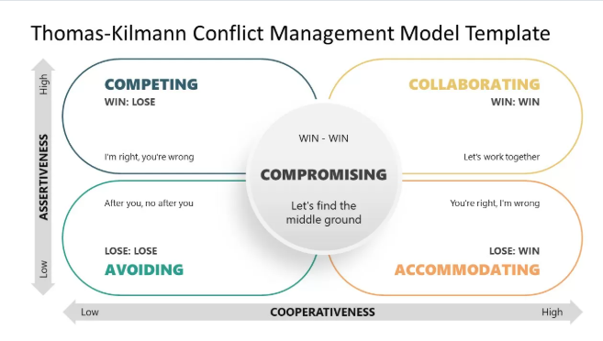

Thomas – Kilmann approach is widely used to recognize the approaches for conflict management.
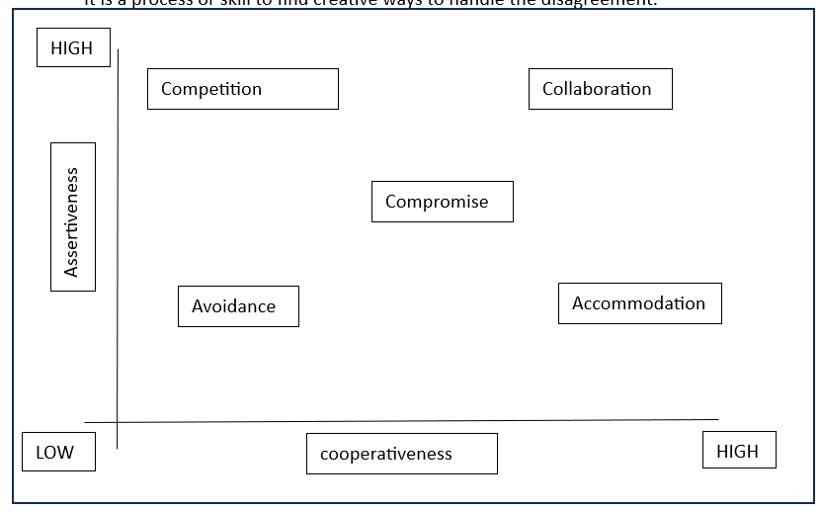
Y axis- assertiveness x axis- co-operativeness
High Assertiveness and High Cooperativeness – Collaboration- means working together to find solution
High Assertiveness and Low Cooperativeness – Competition- means defensive, that is standing for your individual beliefs and trying to win.
Low Assertiveness and High Cooperativeness – Accommodation- stakeholder will prioritize their needs over others.
Low Assertiveness and Low Cooperativeness – Avoidance- means ignoring the conflict

Assertiveness- the extent to which the person attempts to satisfy his own concerns.
Cooperativeness- the extent to which the person attempts to satisfy the other persons concerns.
Q10. List down the reasons for project failure – 6 Marks
Answer 10 :
Reasons for project failure are:
Improper requirement gathering-
If the requirements of the project are not gathered correctly, then this can lead to project failure.
Lack of stakeholder involvement-
A project can fail if the stakeholders are not participating in the process.
The stakeholders input and feedback plays very important role to meet the goals.
Ineffective or less communication-
If there are communication issues between stakeholders, team members then this can lead to misunderstandings or delays in project or even can lead to project failure.
Continuous change in the requirement-
If the requirements keep on changing frequently, this can also lead to project failure.
Because the scope of the project will also keep on changing which will lead to project failure.
Poor risk management-
Poor risk management can also lead to project failure.
The team fails to identify the risks and do the risk mitigation, which can lead to unexpected challenges or delays in project.
Lack of user involvement.
Lack of executive support.
Unrealistic expectations-
means the goals that cannot be achieved or the goals that are out of scope
Improper planning-
The project can fail if the planning is not done properly.
The milestones , goals should be discussed.
If there is no proper planning, then team may face difficulties in addressing the issues or to track the progress.
Insufficient resources-
Insufficient resources can also lead to project failure.
The project may fail due to lack of technology knowledge or lack of finances.
Q11. List the Challenges faced in projects for BA – 6 Marks
Answer 11:
Unclear Requirements: Difficulty in gathering or defining clear and complete requirements from stakeholders.
·Changing Requirements: Scope creep and evolving requirements during the project, leading to delays or rework.
·Stakeholder Conflicts: Managing differing priorities, expectations, and conflicting demands from stakeholders.
Communication Gaps: Miscommunication or lack of communication between stakeholders, team members, or clients.
·Lack of Stakeholder Engagement: Limited involvement or feedback from key stakeholders, making it difficult to understand true needs.
Time Constraints: Limited time to gather, analyze, and document requirements thoroughly due to tight project timelines.
·Managing Expectations: Balancing stakeholder expectations with project constraints (budget, scope, timelines).
·Integration with Other Teams: Difficulty in collaborating with other teams (e.g., development, testing) due to misalignment in goals or priorities.
·Technology Limitations: Dealing with outdated systems, limited technology, or tools that don't fully meet business needs.
Resistance to Change: Stakeholders or end-users resisting changes to business processes, tools, or systems.
·Ambiguous or Incomplete Documentation: Inadequate documentation can lead to misinterpretations and errors in execution.
·Scope Creep: Additional features or changes are being introduced without proper change control processes.
·Managing Multiple Stakeholders: Juggling requirements, feedback, and priorities from different stakeholders simultaneously.
·Validation and Testing: Ensuring the solution meets the business requirements and successfully handles all use cases during testing and UAT.
Q12. Write about Document Naming Standards – 4 Marks
Answer 12 :
[ProjectID][Document Type]V[x]D[y].extention
Example- [PQ777FRDV1D1.docx] or [PQ777FRD1.1.docx]
Purpose: Naming standards ensure consistency, clarity, and traceability across all project documentation, making it easier to identify, track, and manage documents.

1. Standard Naming Convention:
- Document Type: Start with the document type to clarify the content (e.g., BRD for Business Requirements Document, FRD for Functional Requirements Document, SRS for Software Requirements Specification).
- Project/Module Name: Follow with the project or module name to provide context (e.g., "BRD_OrderManagement" for a project related to order management).
- Separation: Use underscores (_) or dashes (-) to separate components for improved readability.
Example: BRD_OrderManagement

2. Version Control:
- Version Number: Include a version number to track updates (e.g., V1.0 for the initial version, V1.1 for minor updates, V2.0 for major revisions).
- Standard Format: Follow a consistent format like V1.0, V1.1, V2.0, etc.
Example: BRD_OrderManagement_V1.0

3. Author/Team Identifier (Optional):
- Optionally, include the initials of the document creator or team responsible for the document. This can be especially helpful for collaboration and tracking.
Example: BRD_OrderManagement_V1.0_JS

4. Date Inclusion:
- Add the creation or update date in YYYYMMDD format for chronological organization, making it easier to identify the most recent version.
Example: BRD_OrderManagement_20250107

5. Avoid Special Characters:
- Avoid using special characters like !, @, or spaces, which might cause issues in file systems or cloud storage.
- Stick to alphanumeric characters, underscores (_), or dashes (-) for consistency and compatibility.

6. Examples:
- BRD_InventoryManagement_V1.0_20250107.pdf
- FRD_CustomerPortal_V2.1_20250107.docx.
Q13. What are the Do’s and Don’ts of a Business analyst – 6 Marks
Answer 13:

Do’s:
- Understand Stakeholder Needs: Actively gather and validate requirements from stakeholders.
- Communicate Clearly: Keep stakeholders and the team informed with clear, concise updates.
- Document Requirements Well: Provide clear, actionable, and testable documentation.
- Prioritize Requirements: Work with stakeholders to prioritize based on value and feasibility.
- Collaborate Continuously: Engage with the team throughout the project for alignment.
- Adapt to Change: Be flexible and manage changes in scope or requirements.
- Focus on User Experience: Ensure solutions meet the needs of the end-users.
- Use Tools and Techniques: Leverage tools like JIRA, MS Visio, and analysis methods (e.g., SWOT).

Don’ts:
- Don’t Assume Requirements: Always validate, never assume stakeholder needs.
- Don’t Ignore Feedback: Incorporate stakeholder and user feedback consistently.
- Don’t Overcomplicate Solutions: Keep solutions simple and aligned with business goals.
- Don’t Work in Isolation: Collaborate with the team to ensure alignment.
- Don’t Ignore Risks: Address risks early to prevent bigger issues.
- Don’t Skip Validation: Always validate requirements and solutions with stakeholders.
- Don’t Neglect Documentation: Keep documentation clear, organized, and up-to-date.
- Don’t Forget the Big Picture: Stay focused on business goals and overall objectives.

Q14. Write the difference between packages and sub-systems – 4 Marks
Answer 14 :

Package (in UML)
A package is a logical grouping used to organize related UML elements like classes, interfaces, or use cases.

Key Points:
- No behavior of its own — it’s only used for organization.
- Helps manage large models by grouping similar components.
- Think of it like a folder that holds related files.

Example (from Payment Scenario):
A package named PaymentMethods can contain:
- CardPayment class
- WalletPayment class
- CashPayment class
- NetBankingPayment class
These classes inside the package perform actions like payWithCard(), payWithWallet() — not the package itself.

Subsystem (in UML)
A subsystem is a self-contained, functional unit within a larger system. It encapsulates behavior and has its own interfaces and responsibilities.

Key Points:
- Represents a module that performs a specific job.
- Contains methods, classes, and interfaces that work together.
- Can communicate with other subsystems or components.

Example (from Payment Scenario):
A subsystem named PaymentProcessing may:
- Contain methods like processPayment(), validatePaymentMethod(), generateReceipt()
- Internally call the right class from CardPayment, WalletPayment, etc., to complete the payment
The subsystem itself performs actions and coordinates between payment types.
Q15. What is camel-casing and explain where it will be used- 6 Marks
Answer 15 :
Camel casing is a naming convention where multiple words are written together without spaces, and each word starts with a capital letter, except the first word in some cases.

Types of Camel Casing:
- Lower Camel Case (camelCase) – The first word starts with a lowercase letter, and the following words start with uppercase letters. Example: firstName, customerOrderNumber.
- Upper Camel Case (PascalCase) – Every word starts with an uppercase letter. Example: FirstName, CustomerOrderNumber.

Where is Camel Casing Used?
- Programming (Variable & Function Names) – Used in many programming languages to improve readability.
- Class and Object Naming – Typically used to name classes in object-oriented programming.
- API & JSON Naming Conventions – Frequently used in API responses and data exchange formats.
- Database & Column Naming – Sometimes used for naming database columns and tables.

Advantages of Camel Casing:
- Improves Readability – Makes variable and function names easier to understand.
- Removes the Need for Underscores or Spaces – Ensures cleaner and more professional naming conventions.
- Widely Accepted in Industry Standards – Used across various programming languages .

Q16. Illustrate Development server and what are the accesses does business analyst has? -6 Marks
Answer 16 :
A server is a powerful computer or system that provides services, data, or resources to other computers (clients) over a network. It stores, processes, and manages data for applications and users.

Types of Servers (Common in IT & BA Work)
1️. Development Server – Used by developers to build, test, and modify applications before they are sent for testing.
- Who uses it? Developers, Testers, BAs (for review)
2️. UAT (User Acceptance Testing) Server – Used by clients and testers to validate if the system meets business requirements before going live.
- Who uses it? Clients, Testers, BAs (for UAT support)
3. Production Server – The live system where real users interact with the application.
- Who uses it? End-users, Support Teams (BAs don’t usually access it directly)
A development server is an environment where application code is written, tested, debugged, and validated before being moved to higher environments like UAT or Production. It helps identify and resolve issues early by mimicking the production setup.
Access for a Business Analyst (BA)
1️. Read-Only Access
- Can review logs, application interfaces, and data to validate requirements or assist in troubleshooting.
- No modification permissions.
2️. Testing Access
- Can review test cases and results but usually does not execute tests directly.
- Involvement in UAT (User Acceptance Testing) happens in the UAT environment, not the development server.
3️. Documentation and Reporting
- Full access to requirement documents (BRD, SRS, FRS) and project-related reports.
- May use reporting tools integrated into the server.
4️. APIs and Endpoints (Limited Access)
- May be allowed to test APIs using tools like Postman for verification.
- Usually works with developers and testers for API validation.
5️. Data Review (Limited or Indirect Access)
- Can review test datasets, data mappings, workflows, and business logic for validation.
- No direct access to production-like sensitive data due to security reasons.
6️. Role Restrictions
- No write access to code or database.
- Cannot deploy or modify application settings.
Q17. What is Data Mapping 6 Marks
Answer 17 :
- The database contains multiple tables in it.
- There may come a scenario, where we need to map the data from one table to another.
- Data mapping is necessary in cases where we want quick manner.
- Data mapping is nothing but a process to establish connection between multiple data sources.
- The purpose of data mapping is to ensure that the data is accurately transferred or converted into different format.
The main purpose of data mapping is-
Data integration-
While combining the data from different sources, it ensures that the data is properly matched.
Data Migration-
While migrating the data from legacy system(source) to the new system(destination), the data elements are mapped accurately into the new system.
Required techniques are applied to covert the data into the format that is required by the new system.
Data Transformation-
Data transformation means converting the data from one format to other.
In data mapping, data transformation plays very important role which ensures that the data of legacy system(source) is mapped correctly to the data in new system(destination).
Example on data mapping:
A bank is migrating customer data from an old system to a new system. The fields need to be mapped correctly.
Old System (Source Field) | New System (Target Field) | Transformation Required?
Customer_ID (Text) | Client_ID (Integer) | Convert Text → Integer
Full_Name (Text) | Customer_Name (Text) | No change
Phone (Text) | Mobile_Number (Text) | No change
DOB (MM/DD/YYYY) | Date_of_Birth (YYYY-MM-DD) | Date format conversion
Address (Text) | Residential_Address (Text) | No change

Q18. What is API. Explain how you would use API integration in the case of your application .Date format is dd-mm-yyyy and it is accepting some data from Other Application from US whose Date Format is mm-dd-yyyy 10 Marks
Answer 18 :
- API stands for Application Programming Interface.
- It is a software intermediary that allows the two applications to communicate with each other.
- It is the set of rules, protocols and tools that define how different software application should interact with each other.
- API allows sharing of only necessary information and keeps the internal system details hidden, which helps the system security.
For the above scenario,
Establish API communication- set up API communication between your application and other application to exchange data.
Do Data formatting- while sending the data from one application to other, convert the date format from dd-mm-yyyy to mm-dd-yyyy.
While receiving the data from other application, parse the data and extract the date, month and year and re-arrange them accordingly.
Perform Data Validation and ensure that the converted date remains in a valid format.

