Agile-Scrum Project: Scrum Foods
Question 1 – Write Agile Manifesto.
Answer:
The Agile Manifesto is a set of guiding values and principles for software development that promotes flexibility, collaboration, and customer satisfaction over rigid processes.
The 4 Core Values of the Agile Manifesto:
- Individuals and interactions over processes and tools
- Working software over comprehensive documentation
- Customer collaboration over contract negotiation
- Responding to change over following a plan
The 12 Principles of the Agile Manifesto:
- Our highest priority is to satisfy the customer through early and continuous delivery of valuable software.
- Welcome changing requirements, even in the later stages of development.
- Deliver working products frequently.
- Business people and cross-functional teams must work together daily.
- Build projects around motivated individuals and trust them to get the job done.
- The most effective and efficient method of conveying information is face-to-face conversation.
- Working products are the primary measure of progress.
- Maintain a sustainable pace indefinitely.
- Give continuous attention to technical excellence and good design.
- Simplicity—the art of maximizing the amount of work not done—is essential.
- Teams should be self-organizing.
- Teams should regularly reflect and adjust their behaviour to become more effective.
Question 2 – User Stories- Acceptance Criteria - BV - CP – Write minimum 40 User stories and their Acceptance Criteria along with their BV and CP.
Answer:
A User Story is a short, simple description of a feature told from the perspective of the end user, explaining who needs it, what they need, and why they need it.
A typical format for writing a User Story is:
- As a [type of user]
- I want [an action or goal]
- so that [benefit or reason].

User Story - 1 | Task - 2 | Priority - Highest
AS A DELIVERY BOY
I WANT TO REGISTER IN SCRUM FOODS
SO THAT I CAN DELIVER ORDERS
BV = 500 |  | CP = 5
ACCEPTANCE CRITERIA
Registration Screen
Text Boxes for User Name, Password, National ID, Mobile No, Email, Address, Phone Number.
Click on Register button.
Send successful notification to the user

User Story - 2 | Task - 2 | Priority - Highest
AS A RESTAURANT OWNER
I WANT TO VIEW ORDERS
SO THAT I CAN VIEW THE LIST OF ORDERS
BV = 500 |  | CP = 3
ACCEPTANCE CRITERIA
View Order, Display list of orders in a tabular form

User Story - 3 | Task - 2 | Priority - Highest
AS A CUSTOMER
I WANT TO ADD THE ADDRESS
SO THAT I CAN GET THE ORDER TO MY ADDRESS
BV = 500 |  | CP = 3
ACCEPTANCE CRITERIA
Text box to enter.
Business Rule: Within the radius of 5 kms

User Story - 4 | Task - 2 | Priority - Highest
AS A CUSTOMER
I WANT TO SELECT THE PAYMENT MODE
SO THAT I CAN MAKE PAYMENT OF MY CHOICE
BV = 500 |  | CP = 5
ACCEPTANCE CRITERIA
Display payment modes, radio buttons to select payment modes, payment button.
Business rule: Can select only one payment mode

User Story - 5 | Task - 1 | Priority - Highest
AS AN ADMIN
I WANT TO VIEW THE RESTAURANTS
SO THAT I CAN VIEW, APPROVE, REJECT THEIR REGISTRATION
BV = 500 |  | CP = 1
ACCEPTANCE CRITERIA
Register in the platform with the details

User Story - 6 | Task - 1 | Priority - Highest
AS A CUSTOMER
I WANT TO VIEW THE PRICE
SO THAT I CAN ORDER THE FOOD
BV = 50 |  | CP = 1
ACCEPTANCE CRITERIA
Display price in the list of menu items

User Story - 7 | Task - 2 | Priority - Low
AS A CUSTOMER
I WANT TO VIEW THE CONTACT NUMBER OF THE DELIVERY BOY
SO THAT I CAN CONTACT DELIVERY BOY FOR THE STATUS
BV = 500 |  | CP = 3
ACCEPTANCE CRITERIA
Display delivery boy number.
Display delivery boy name in tracking field
Display delivery boy picture

User Story - 8 | Task - 2 | Priority - Medium
AS A RESTAURANT OWNER
I WANT TO PROVIDE TIME SLOTS
SO THAT CUSTOMER CAN CHECK OPENING AND CLOSING HOURS
BV = 100 |  | CP = 5
ACCEPTANCE CRITERIA
Click on restaurant dashboard
Add opening time and closing time
Click on submit
Display updated successfully

User Story - 9 | Task - 2 | Priority - High
AS A BUSINESS OWNER
I WANT TO VIEW RESTAURANT REVENUE REPORT
SO THAT I CAN VIEW THE RESTAURANT'S REVENUE
BV = 200 |  | CP = 5
ACCEPTANCE CRITERIA
Select Reports
Select Revenue Reports
Select to and from date
Select Region (can select all)
Generate Report
Download report in Excel

User Story - 10 | Task - 3 | Priority - High
AS A REG ADMIN
I WANT TO MANAGE REGIONAL RESTAURANTS
SO THAT I CAN TRACK THE PERFORMANCE OF REGIONAL RESTAURANTS.
BV = 200 |  | CP = 8
ACCEPTANCE CRITERIA
Click on Performance of restaurants
Select from and to date
Click on generate report which includes Restaurants ID, Name, Revenue
Click on Download Report should be in Excel

User Story - 11 | Task - 2 | Priority - Medium
AS A ADMIN
I WANT TO SEE THE REGIONAL REVENUE REPORTS
SO THAT I CAN VIEW THE REGIONAL PERFORMANCE
BV = 100 |  | CP = 5
ACCEPTANCE CRITERIA
Select regional dropdown
View performance of each rest of that region in tabular form which includes rest name, revenue, generated Download in Excel or PDF

User Story - 12 | Task - 2 | Priority - High
AS A CUSTOMER
I WANT TO CHAT WITH REG ADMIN
SO THAT I CAN REQUEST FOR REFUND
BV = 200 |  | CP = 3
ACCEPTANCE CRITERIA
BR-All Mandatory
Text Box Fields
Display Order ID
Text Box, For Description
Submit Button
Generate Issue ID
Display Successful

User Story - 13 | Task - 2 | Priority - High
AS A HUNGRY USER
I WANT TO BROWSE NEARBY RESTAURANTS
SO THAT I CAN ORDER THE FOOD
BV = 200 |  | CP = 3
ACCEPTANCE CRITERIA
Each restaurant entry displays its name, cuisine type and rating
This list can be sorted by distance or rating

User Story - 14 | Task - 2 | Priority - High
AS A CUSTOMER
I WANT TO BROWSE DIFFERENT RESTAURANTS AND MENUS
SO THAT I CAN FIND A PLACE TO ORDER FOOD
BV = 200 |  | CP = 3
ACCEPTANCE CRITERIA
The menu includes dishes, prices and descriptions
Show the restaurant is open or closed

User Story - 15 | Task - 1 | Priority - High
AS A CUSTOMER
I WANT TO BROWSE FOR SPECIFIC DISHES AND CUISINES
SO THAT I CAN FIND A PLACE TO ORDER FOOD
BV = 200 |  | CP = 1
ACCEPTANCE CRITERIA
App displays relevant restaurant and dishes matching the query

User Story - 16 | Task - 1 | Priority - High
AS A CUSTOMER
I WANT TO FILTER THE RESTAURANTS
SO THAT I CAN FIND A PLACE TO ORDER FOOD
BV = 200 |  | CP = 1
ACCEPTANCE CRITERIA
Filter restaurants by cuisine type and dietary options (veg, non veg)

User Story - 17 | Task - 2 | Priority - High
AS A CUSTOMER
I WANT TO TRACK MY ORDER
SO THAT I KNOW THE TIME OF DELIVERY
BV = 200 |  | CP = 3
ACCEPTANCE CRITERIA
App shows real time update on the order status
Display estimate time of delivery

User Story - 18 | Task - 1 | Priority - High
AS A USER
I WANT TO RATE AND REVIEW RESTAURANTS
SO THAT I CAN RATE AND SHARE THE FEEDBACK TO THE RESTAURANTS I HAVE VISITED
BV = 200 |  | CP = 1
ACCEPTANCE CRITERIA
Can view the reviews from other users to help me make dining decisions

User Story - 19 | Task - 1 | Priority - High
AS A USER
I WANT TO SAVE FAVOURITE RESTAURANTS AND DISHES
SO THAT I CAN ORDER FROM MY FAVOURITES
BV = 200 |  | CP = 1
ACCEPTANCE CRITERIA
Access my list of favourites easily for future orders

User Story - 20 | Task - 1 | Priority - High
AS A USER
I WANT TO VIEW MY PAST ORDER ITEMS
SO THAT I CAN ORDER AGAIN
BV = 200 |  | CP = 1
ACCEPTANCE CRITERIA
Can see the details such as order items, total cost and order date

User Story - 21 | Task - 3 | Priority - High
AS A USER
I WANT TO RECEIVE NOTIFICATIONS
SO THAT I CAN RECEIVE UPDATES
BV = 200 |  | CP = 8
ACCEPTANCE CRITERIA
Notification for order confirmation
Notification for order dispatch
Notification for order delivery

User Story - 22 | Task - 1 | Priority - Medium
AS A CUSTOMER
I WANT TO CONTACT CUSTOMER SUPPORT
SO THAT I CAN SUBMIT QUERIES OR ISSUES
BV = 200 |  | CP = 1
ACCEPTANCE CRITERIA
Customer support section with contact information

User Story - 23 | Task - 2 | Priority - High
AS A RESTAURANT OWNER
I WANT TO RECEIVE AND MANAGE ORDERS
SO THAT I CAN UPDATE ORDER STATUS
BV = 200 |  | CP = 3
ACCEPTANCE CRITERIA
Manage order status
Notify restaurants about incoming orders

User Story - 24 | Task - 2 | Priority - High
AS A RESTAURANT OWNER
I WANT TO ACCESS CUSTOMER REVIEWS
SO THAT I CAN VIEW AND RESPOND TO CUSTOMER REVIEWS
BV = 200 |  | CP = 3
ACCEPTANCE CRITERIA
Owners can address feedbacks
Owners can improve their services

User Story - 25 | Task - 1 | Priority - Medium
AS A CUSTOMER
I WANT TO VIEW PROMOCODES AND DISCOUNTS
SO THAT I CAN ORDER AT LOWER PRICE
BV = 100 |  | CP = 1
ACCEPTANCE CRITERIA
Active promo codes

User Story - 26 | Task - 1 | Priority - Medium
AS A CUSTOMER
I WANT TO APPLY PROMOCODES AND DISCOUNTS
SO THAT I CAN ORDER AT LOWER PRICE
BV = 100 |  | CP = 1
ACCEPTANCE CRITERIA
Active promo codes

User Story - 27 | Task - 7 | Priority - High
AS A DELIVERY BOY
I WANT TO VIEW THE ORDERS
SO THAT I CAN ACCEPT THE ORDERS
BV = 200 |  | CP = 8
ACCEPTANCE CRITERIA
Order visibility
Real-time updates
Order details
Order filtering and sorting
Order map view
Order navigation
Order completion and confirmation

User Story - 28 | Task - 8 | Priority - High
AS A DELIVERY BOY
I WANT TO LOGIN
SO THAT I CAN ACCEPT THE ORDER
BV = 200 |  | CP = 8
ACCEPTANCE CRITERIA
User authentication
Error handling
Password security
multi-factor authentication
Compatibility and usability

User Story - 29 | Task - 5 | Priority - Medium
AS A DELIVERY BOY
I WANT TO VIEW THE FEEDBACK
SO THAT I CAN KNOW THE CUSTOMER FEEDBACKS
BV = 200 |  | CP = 5
ACCEPTANCE CRITERIA
Access to feedback system
Feedback visibility
Feedback filtering and sorting
Response mechanism
User support

User Story - 30 | Task - 5 | Priority - Medium
AS A ADMIN
I WANT TO VIEW THE FEEDBACK
SO THAT I CAN KNOW THE CUSTOMER FEEDBACKS
BV = 200 |  | CP = 5
ACCEPTANCE CRITERIA
Access to feedback system
Feedback visibility
Feedback filtering and sorting
Response mechanism
User support

User Story - 31 | Task - 5 | Priority - Medium
AS A RESTAURANT OWNER
I WANT TO VIEW THE FEEDBACK
SO THAT I CAN KNOW THE CUSTOMER FEEDBACKS
BV = 200 |  | CP = 5
ACCEPTANCE CRITERIA
Access to feedback system
Feedback visibility
Feedback filtering and sorting
Response mechanism
User support

User Story - 32 | Task - 3 | Priority - High
AS AN ADMIN
I WANT TO KNOW THE ISSUES
SO THAT I CAN RESOLVE THEM
BV = 100 |  | CP = 5
ACCEPTANCE CRITERIA
Display issue section
Sorting and filtering of issue list
Editing and modifying the issues

User Story - 33 | Task - 3 | Priority - High
AS A REGIONAL ADMIN
I WANT TO KNOW THE ISSUES
SO THAT I CAN RESOLVE THEM
BV = 200 |  | CP = 5
ACCEPTANCE CRITERIA
Display issue section
Sorting and filtering of issue list
Editing and modifying the issues

User Story - 34 | Task - 6 | Priority - High
AS A RESTAURANT OWNER
I WANT TO VIEW REVENUE GENERATED
SO THAT I CAN VIEW RESTAURANTS REVENUE
BV = 200 |  | CP = 8
ACCEPTANCE CRITERIA
Select reports
Select revenue reports
Select to and from date
Select region (can select all)
Generate report
Download report in excel

User Story - 35 | Task - 2 | Priority - High
AS A RESTAURANT OWNER
I WANT TO KNOW THE DELIVERY BOY
SO THAT I CAN VERIFY THE DELIVERY BOY
BV = 200 |  | CP = 3
ACCEPTANCE CRITERIA
ID Proof
Reliability and punctuality

User Story - 36 | Task - 2 | Priority - High
AS AN ADMIN
I WANT TO VIEW RESTAURANT PERFORMANCE REPORTS
SO THAT I CAN TRACK TOP PERFORMING AND LOW PERFORMING RESTAURANTS
BV = 500 |  | CP = 8
ACCEPTANCE CRITERIA
Dashboard displays key metrics: number of orders, average rating, total revenue.
Data should be filterable by restaurant and date range
Charts and tables should refresh automatically on data change.

User Story - 37 | Task - 2 | Priority - Medium
AS A RESTAURANT OWNER
I WANT TO PROVIDE TIME SLOTS
SO THAT CUSTOMERS CAN CHECK THE OPERATIONAL HOURS
BV = 100 |  | CP = 5
ACCEPTANCE CRITERIA
Click on restaurant dashboard
Add from time to time
Click on submit
Display updated successfully

User Story - 38 | Task - 3 | Priority - High
AS A CUSTOMER
I WANT TO CONTACT CUSTOMER SUPPORT
SO THAT I CAN SUBMIT QUERIES OR ISSUES
BV = 200 |  | CP = 5
ACCEPTANCE CRITERIA
Customer support section with contact information

User Story - 39 | Task - 4 | Priority - Medium
AS A CUSTOMER
I WANT TO VIEW THE ORDER
SO THAT I CAN CANCEL IT
BV = 100 |  | CP = 8
ACCEPTANCE CRITERIA
Order status
Method of cancellation refund
Policy
Time frame
Refund confirmation email/SMS sent to user.

User Story - 40 | Task - 4 | Priority - High
AS A REGIONAL ADMIN
I WANT TO TRACK THE DELIVERY
SO THAT I CAN VIEW THE STATUS OF THE DELIVERY
BV = 100 |  | CP = 5
ACCEPTANCE CRITERIA
Real time tracking security and data privacy
User friendly interface

Question 3 – What is epic? Write 2 epics – Business Value and Complexity Points
Answer:
An Epic is a large user story or a collection of related user stories that represents a significant feature or functionality. Epics are high-level, often spanning multiple sprints or iterations, and they provide a way to organize and prioritize work in a product backlog.
Epic No. 1 – Ratings and Reviews
As a user, I want to view ratings and reviews for restaurants on Scrum Foods, so that I can make informed decisions about where to order food from.
As a user, I also want to provide ratings and reviews for restaurants on Scrum Foods, so that I can share my experiences with other users and contribute to the community.
Acceptance Criteria:
- Users can view average ratings and reviews for each restaurant on the restaurant’s details page.
- Users can read detailed reviews and comments left by other customers.
- Users can sort and filter reviews based on criteria such as rating and relevance.
- Users can rate restaurants and leave a review after placing an order.
- Users can edit or delete their own reviews within a specified timeframe.
- Reviews are displayed in a way that provides helpful insights to other users.
- The rating and review system must maintain the integrity and authenticity of user feedback.
Business Value (BV): 500
Complexity Points (CP): 03
Epic No. 2 – Real-Time Order Tracking for Food Delivery App
The real-time order tracking epic aims to provide users with a seamless and transparent experience by allowing them to track the status and location of their food orders in real time.
This feature enhances customer satisfaction, reduces support inquiries, and improves overall user engagement.
User Stories:
As a customer, I want to see the live status of my order.
- Display the current status of the order, such as "Order Confirmed," "Preparing," "Out for Delivery," and "Delivered."
- Provide real-time updates as the order progresses through various stages.
As a customer, I want to track the location of my delivery.
- Integrate GPS or location services to show the delivery partner's real-time location on a map.
As a customer, I want to view the estimated time of arrival (ETA).
- Display the ETA based on the delivery partner’s current location and traffic conditions.
As a customer, I want to receive notifications for order updates.
- Send push notifications or SMS updates for key events (order confirmed, out for delivery, delivered).
As a customer, I want to contact the delivery partner directly.
- Enable in-app chat or masked call functionality to communicate securely with the delivery partner.
As a customer, I want to view the delivery route.
- Display the route on the map and allow real-time progress tracking.
As a customer, I want to provide feedback on the delivery experience.
- Allow users to rate the delivery partner and leave written feedback after delivery.
As a customer, I want to see estimated delivery time adjustments.
- Update ETA dynamically based on real-time traffic and route conditions.
As a customer, I want a seamless tracking experience across all platforms.
- Ensure tracking consistency across mobile app, tablet, and web versions.
As an admin, I want to monitor order tracking performance.
- Generate reports on delivery times, average delays, and customer satisfaction ratings.
Acceptance Criteria:
Real-Time Order Updates:
- The app should provide live updates on the order status such as "Order Received," "Preparing," "Out for Delivery," and "Delivered."
Order Location Tracking:
- Display the delivery driver’s live location on the map while en-route.
- Update the map regularly to reflect accurate movement.
Estimated Delivery Time:
- Provide accurate ETA based on current driver location and traffic conditions.
Delivery Notifications:
- Send push or in-app alerts for key events like dispatch and arrival.
Map Zoom and Interaction:
- Allow users to zoom in/out and interact with the delivery route.
Delivery Status History:
- Display order timeline from placement to completion for reference.
Accuracy and Reliability:
- Ensure real-time updates are accurate, fast, and minimize delays.
Privacy and Security:
- Comply with data privacy rules and ensure user location data is used only for tracking.
Compatibility:
- Ensure smooth functionality on Android, iOS, and web browsers.
Opt-Out Option:
- Allow users to disable tracking if they prefer not to share location data.
User Education:
- Provide tooltips or instructions on how to use the tracking feature effectively.
Support for Multiple Orders:
- Allow users to track multiple orders individually with separate statuses.
By meeting these acceptance criteria, the food delivery app can successfully implement real-time order tracking, providing users with a transparent and convenient way to monitor their orders from placement until delivery.
Business Value (BV): 500
Complexity Points (CP): 05
Question 4 –What is the difference between BV and CP?
Answer:
Business Value (BV):
- Business Value refers to the perceived or measurable worth or benefit that a specific task, feature, or requirement brings to the business or project.
- It is typically determined based on factors such as revenue generation, cost savings, customer satisfaction, market competitiveness, strategic alignment, and other business-related criteria.
- Business Value helps prioritize tasks or features based on their importance to the overall project goals and objectives.
- Examples of Business Value considerations: increased revenue, improved user experience, enhanced customer retention, compliance with regulations, and competitive advantage.
Techniques used: MOSCOW, Currency Notes Technique
MOSCOW Technique:
The MOSCOW technique is a prioritization and requirements management method used in Agile and Scrum. It helps teams classify and prioritize requirements based on importance and urgency.
The acronym MOSCOW stands for:
- Must Have: Critical requirements or tasks essential for project success.
- Should Have: Important requirements that add significant value but are not absolutely critical.
- Could Have: Desirable features that enhance the product but can be included only if time/resources allow.
- Won’t Have (this time): Features that are deliberately deprioritized for future iterations or versions.
The MoSCoW technique helps project teams and stakeholders make informed decisions about what should be included in a project based on the available resources, constraints, and objectives. It facilitates open communication between stakeholders, ensures that the most critical aspects are addressed first, and allows for flexibility in project scope as priorities change.
Example using MOSCOW:
- Must Have: User authentication, order placement, and payment processing.
- Should Have: User profile settings, restaurant filters, and reviews.
- Could Have: Additional language support, social media sharing features.
- Won’t Have: Integration with legacy systems, complex data visualization.
Currency Notes Technique:
In this technique, stakeholders assign currency denominations (e.g., 500, 100, 50, 20, 10) to each user story to represent its relative business value.
The Product Owner then uses these values to rank the backlog items and determine development priorities.
Complexity Points (CP):
- Complexity Points, also known as Story Points or Function Points, are a measure of the relative effort or complexity required to complete a specific user story or feature.
- They are used to estimate the time, effort, and resources needed by the development team.
- CP is typically determined based on factors such as technical difficulty, integration challenges, dependencies, or algorithmic complexity.
- Examples of CP considerations: integration with legacy systems, third-party API development, data migration, performance optimization, and system reliability.
Techniques used: Planning Poker
Planning Poker is a consensus-based technique commonly used in Agile and Scrum methodologies for estimating the effort or complexity of user stories or tasks. It helps teams collaborate and arrive at a shared understanding of the work involved in a particular item. The term "CP" in your question likely stands for "Complexity Points," which are used in Planning Poker to represent the relative effort or complexity of a task. Here's how the Planning Poker technique works:
Preparation:
The team gathers to estimate the effort or complexity of user stories or tasks that need to be completed in a sprint or iteration.
Estimation Cards:
- Estimation cards are used, each containing a number representing a predefined range of Complexity Points (e.g., 0, 1, 1, 2, 3, 5, 8, 13, 21).
- The cards are designed so that the numbers increase non-linearly, reflecting that as tasks become more complex, the uncertainty in estimates also increases.
Facilitator:
- A facilitator (usually the Scrum Master or Agile Coach) leads the session and explains the process to the team.
Estimation Process:
- For each user story or task, the team discusses the requirements, assumptions, and any relevant information.
- Each team member selects an estimation card representing their individual view of the Complexity Points required to complete the task. The card is kept face down.
Reveal and Discussion:
- After everyone has selected a card, all team members reveal their chosen cards simultaneously.
- If there is a wide variation in estimates, team members have a discussion to share their reasoning and insights. This helps clarify assumptions and leads to a shared understanding.
Re-Estimation and Consensus:
- After discussion, team members may revise their estimates by selecting a different card based on the insights gained.
- The process of discussion and re-estimation continues until a consensus is reached.
- The goal is to align the team’s understanding and arrive at a common estimate.
Repeat for Each Task:
- The process is repeated for each user story or task in the backlog.
Final Estimate:
- The final estimate for each user story or task is often determined by the mode or median of the estimates chosen by the team members.
Planning Poker helps mitigate individual biases and provides a collaborative and transparent way to estimate work.
It encourages discussion, helps identify potential challenges, and allows the team to make informed decisions about how much work can be taken in a sprint or iteration.
Summary:
In summary, Business Value (BV) focuses on the business impact and importance of tasks or features, while Complexity Points (CP) focus on the technical effort and complexity involved in implementing those tasks or features.
Both concepts are crucial in Agile project management as they help prioritize and plan work effectively based on both business goals and technical constraints.
Question 5 – Explain about Sprint.
Answer:
SPRINT:
In the context of software development and project management, a Sprint is a time-boxed, iterative development period during which a specific set of tasks and goals are worked on by a development team.
Sprint is a core concept in Agile methodologies such as Scrum, which emphasize flexibility, collaboration, and delivering value to the customer in shorter cycles.
Here are the key characteristics and components of a Sprint:
- Time Frame: A sprint typically has a fixed duration, often ranging from 2 to 4 weeks. The duration is consistent across all sprints to provide a predictable cadence for development and planning.
- Goals and Objectives: At the beginning of each sprint, the development team, along with stakeholders, selects a set of user stories, features, or tasks to work on during that sprint. These items are collectively referred to as the sprint backlog.
- Planning: During sprint planning, the development team breaks down the selected items from the product backlog into smaller tasks and estimates the effort required for each task. The team commits to completing these tasks within the sprint duration.
- Daily Stand-ups: Throughout the sprint, the team holds daily stand-up meetings (also known as daily scrums) to discuss progress, obstacles, and plans. Each team member shares what they’ve accomplished, what they’re working on, and any challenges they’re facing. These meetings foster communication and collaboration.
- Development: The development team works on the tasks identified in the sprint backlog. They collaborate closely, often using techniques such as pair programming and frequent code reviews to ensure high-quality work.
- Continuous Integration: Developers integrate their code changes into the main codebase regularly, ensuring that the software remains functional and stable throughout the sprint.
- Testing: Testing is an integral part of a sprint. Automated tests are run to validate code changes, and manual testing may be conducted to ensure software quality.
- Review and Demo: At the end of the sprint, the development team conducts a sprint review and demo. They showcase the completed work to stakeholders, gathering feedback and validation. This ensures that the delivered features align with expectations.
- Retrospective: Following the review and demo, the team holds a sprint retrospective. They reflect on what went well during the sprint, what could be improved, and actions to take in the next sprint. The retrospective encourages continuous improvement.
- Incremental Development: Each sprint results in a potentially shippable product increment, meaning that at the end of each sprint, a new version of the software is available with additional features or improvements.
- Adaptability: Agile methodologies emphasize adaptability and the ability to respond to changing requirements. If new priorities or insights emerge, adjustments can be made in subsequent sprints.
Sprints allow development teams to iteratively deliver value to customers and stakeholders in a controlled and predictable manner.
By breaking down the work into manageable chunks and continuously seeking feedback, Agile teams can enhance collaboration, reduce risk, and improve the overall quality of the software being developed.
Question 6 – Explain Product backlog and sprint back log
Answer:
Product Backlog and Sprint Backlog:
The Product Backlog is a dynamic, prioritized list of all the features, user stories, enhancements, bug fixes, and other work items that need to be addressed over the course of a project. It represents the entire scope of the product’s development and is managed by the Product Owner. The Product Backlog is continually refined and updated based on feedback, changing requirements, and new insights.
The Sprint Backlog is a subset of the Product Backlog that represents the work that the development team commits to completing during a specific time period called a Sprint. A Sprint is a fixed-duration iteration, usually lasting from two to four weeks, during which the team works on a set of selected items from the Product Backlog.
The Sprint Backlog is created during the Sprint Planning meeting, where the development team selects a set of items to work on based on their capacity and the priorities set by the Product Owner.
S. No. | Product Backlog | Sprint Backlog
1 | Anything needed to accomplish the project vision | Anything needed to fulfil the sprint goal
2 | Owned by the Product Owner | Owned by the Development Team
3 | Contains requirements, tasks, and defects | A subset of product backlog items prioritized by the Product Owner
4 | Everyone contributes to the product catalogue | Sprint Planning meeting refines the sprint backlog items
5 | The Product Backlog evolves, and changes are made by the Product Owner throughout the product life cycle | No changes are allowed to sprint backlog items once the sprint has started
6 | Product Backlog Refinement meeting is conducted to refine the backlog | Sprint Planning meeting is conducted to finalize sprint backlog items
7 | Release burndown metric is used | Sprint burndown metric is used
8 | Estimation is done at the user story level | Estimation is done at the activity or task level
9 | Daily stand-up meetings do not discuss Product Backlog items | Daily stand-up meetings discuss Sprint Backlog items in accordance with the sprint goal

Question 7 – What is impediments log? Write 2 impediments.
Answer:
Impediments Log:
An Impediment Log, also known as an Issue Log or Obstacle Log, is a document or tool used in Agile software development to track and manage obstacles, bottlenecks, or any factors that impede the progress of a project or team.
Examples of two impediments are as follows:
- Delivery partner shortage in a specific region.
- Technical issue causing intermittent order processing failure.
- Delivery Partner Shortage in a Specific Region
Login ID | 1
Description | Delivery partner shortage in a specific region
Impact | Delays in order deliveries, leading to customer dissatisfaction
Priority | High (due to its impact on customer experience)
Assigned To | Operations Team and HR Team
Status | Open
Action Taken | The Operations Team is actively recruiting new delivery partners in the region. The HR Team is fast-tracking the onboarding process.
Resolution | Recruitment efforts are ongoing, and the HR Team is streamlining onboarding to expedite new hires. Regular progress updates are being shared in team meetings.

- Technical Issue Causing Intermittent Order Processing Failure
Login ID | 2
Description | Technical issue causing intermittent order processing failures
Impact | Delays in order processing, resulting in potential revenue loss
Priority | High (due to its impact on revenue and customer experience)
Assigned To | Tech Team and QA Team
Status | In Progress
Action Taken | The Tech Team identified the root cause and is working on a fix. The QA Team is conducting extensive testing to ensure the issue is resolved.
Resolution | The Tech Team has implemented a fix and performed thorough testing. The issue has been resolved, and orders are now processing smoothly.

Question 8 – Explain Velocity of the Team
Answer:
VELOCITY OF THE TEAM:
Velocity refers to the measure of the amount of work a development team can complete during a sprint.
The calculation of velocity is performed by the development team itself, as they are responsible for estimating the effort required to complete each user story or backlog item.
Story Point Estimation:
Story point estimation is a technique used in Agile software development to estimate the effort required for a specific task or user story.
It’s a relative measure of complexity, not a fixed time unit. Team members assign story points based on factors like complexity, effort, and uncertainty.
The time a story point represents may vary between teams. For some, it might equate to hours; for others, to days. It’s important to establish a consistent baseline so story points can be used effectively for planning and prioritization.
Tracking Completed Work:
Tracking completed work in Agile development involves calculating the total story points completed by the team over a specific sprint or iteration.
Steps:
- Identify Completed Stories: At the end of the sprint, review user stories that were completed and accepted as “done.”
- Sum Story Points: Add up the story points of all completed user stories, excluding any unfinished or rejected ones.
- Calculate Total Completed Work: The total sum of completed story points represents the completed work for that sprint.
This total is then used to calculate the team’s velocity and provides insights into their capacity for future sprint planning.
Summing Story Points:
Summing story points involves adding the numerical values assigned to completed user stories or tasks.
Steps:
- List Completed User Stories: Gather all stories completed in the sprint.
- Identify Story Point Values: Each story has an assigned point value (e.g., 1, 2, 3, 5, 8, 13, etc.).
- Add Up Story Point Values: Sum the values for all completed stories (e.g., if stories = 3, 5, and 8, total = 16 CP).
This provides a quantitative measure of work completed during the sprint, used to calculate velocity for planning future work.
Average Velocity:
Average Velocity refers to the average amount of work (in story points) that a team completes across multiple sprints. It’s a key metric for forecasting and capacity planning.
Steps:
- Select a Time Frame: Choose a specific number of past sprints (e.g., last 5 sprints).
- Sum Completed Story Points: Add the total story points completed across those sprints.
- Calculate Average: Divide the total story points by the number of sprints.
Formula:
Average Velocity = Total Completed Story Points ÷ Number of Sprints
Use for Planning:
Average velocity helps the team estimate how much work they can realistically commit to in future sprints based on their historical performance.
It’s important to note that velocity may fluctuate due to changes in team size, capacity, or complexity of tasks, so adjustments should be made over time for accuracy.
Question 9 – Draw Sprint Burn Charts and Product Burn Down Charts.
Answer:
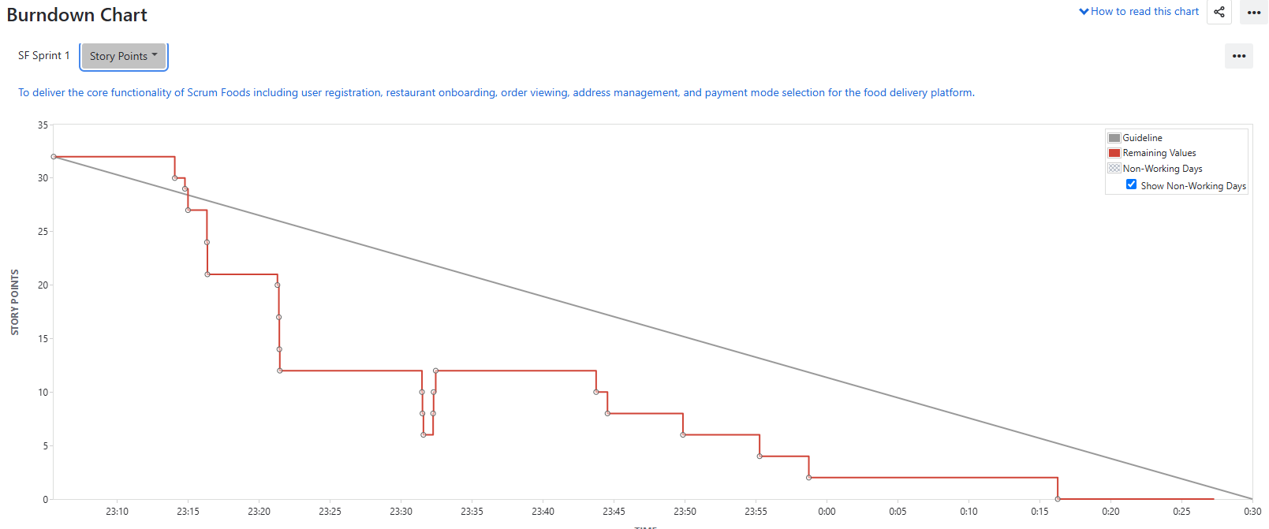
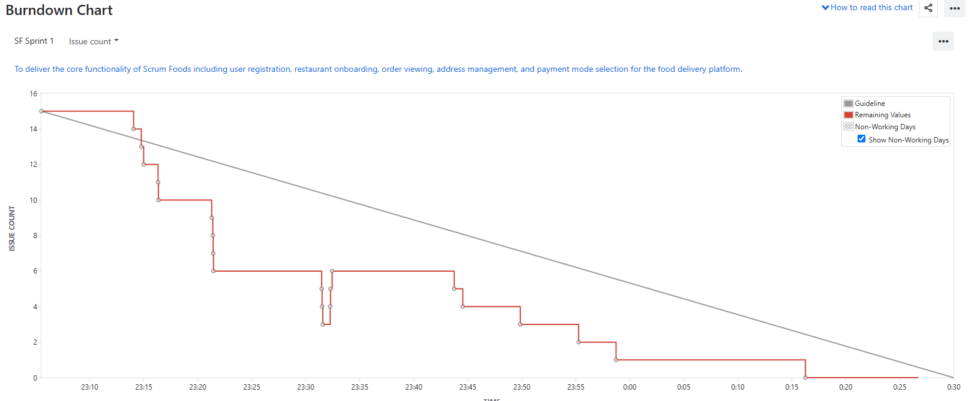
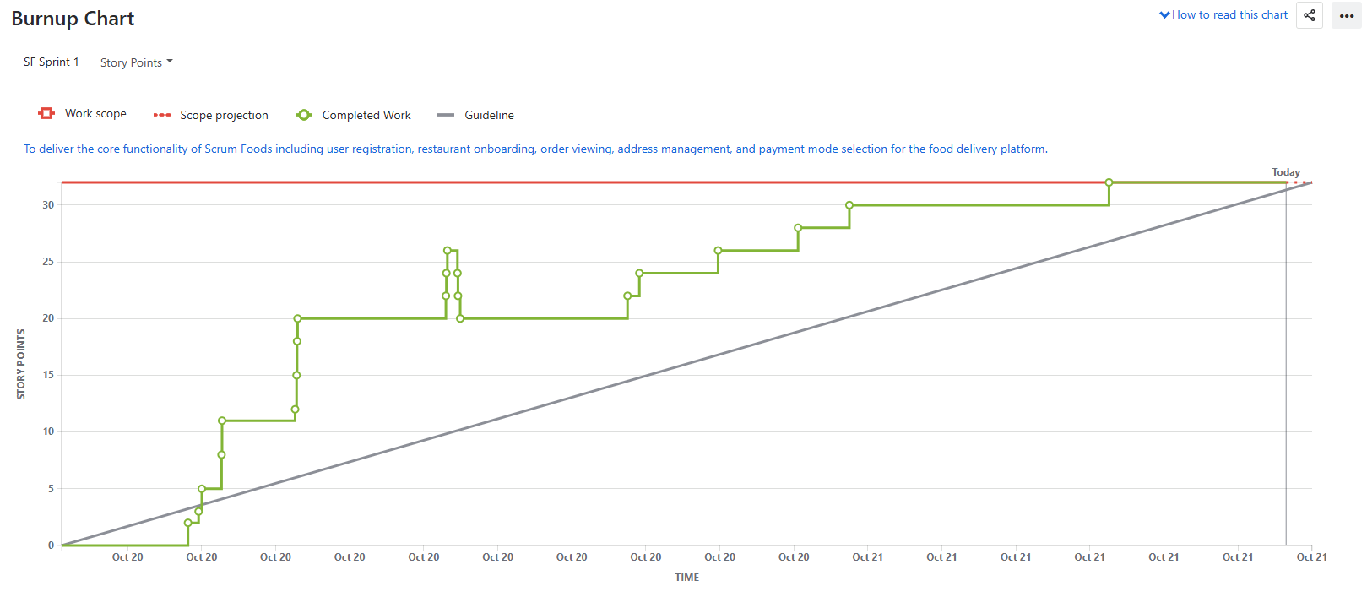
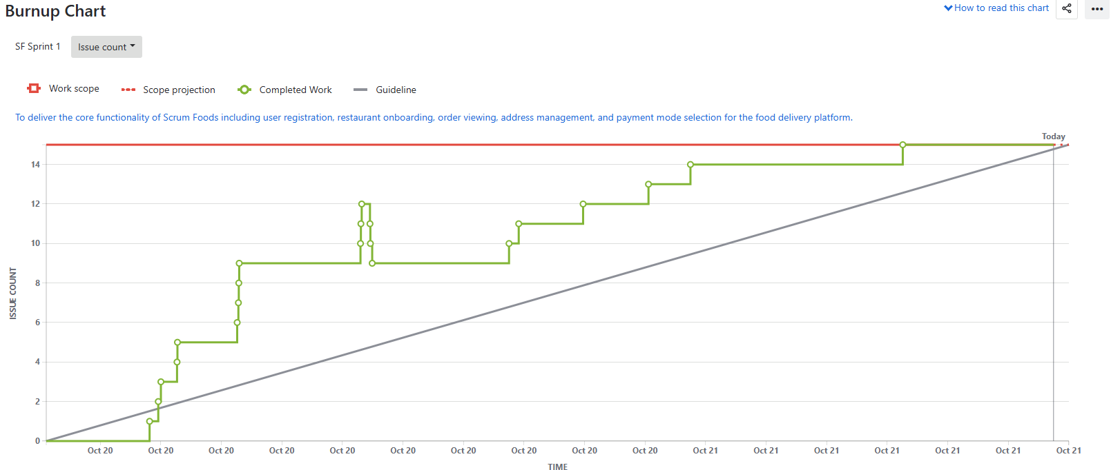
Question 10 – Explain about Product Grooming.
Answer:
Product Grooming:
Product grooming, also known as backlog grooming or refinement, is a crucial activity in Agile development that involves preparing and refining items in the product backlog to ensure they are well-understood, prioritized, and ready for development. Let's break down the process step by step:
Setting the Context: At the beginning of the backlog grooming process, the team and relevant stakeholders come together to understand the overall goals and objectives of the project. This helps set the context for the work to be done, aligns everyone’s understanding, and ensures that all team members share a clear view of the product vision and sprint goals.
Backlog Review: The product owner and the development team review the items in the product backlog. This involves assessing the user stories, tasks, and other items to ensure they are accurate, up to date, and still relevant to the project’s goals.
Prioritization: During backlog grooming, the team collaboratively prioritizes the backlog items based on their value to the product and the needs of the users or customers. This helps ensure that the most important and valuable work is addressed first.
Refinement and Estimation: In this step, the backlog items are refined to provide clear and detailed descriptions. The team breaks down user stories into smaller tasks and discusses technical requirements. Estimation involves assigning Story Points or other sizing metrics to each item, indicating the relative effort required for implementation.
Dependency Analysis: The team examines potential dependencies between backlog items. Identifying and understanding dependencies helps in planning the order of implementation and managing potential bottlenecks.
Acceptance Criteria: Well-defined acceptance criteria are established for each backlog item. These criteria outline the conditions that must be met for the item to be considered complete and ready for delivery. Clear acceptance criteria help prevent misunderstandings and ensure a shared understanding of what is expected.
Backlog Grooming Meetings: These are recurring meetings where the product owner and the development team come together to perform the activities mentioned above. These meetings often occur before sprint planning sessions to ensure that the upcoming sprint backlog is well-prepared.
Backlog grooming is an iterative process that helps maintain a healthy and well-organized product backlog. It ensures that the development team always has a prioritized list of well-defined, estimated, and ready-to-develop items. This, in turn, supports the efficient planning and execution of sprints and helps the team deliver value to customers in a more predictable and effective manner.
Question 11 – Explain the roles of Scrum Master and Product Owner.
Answer:
Criteria | Product Owner (Corrected) | Scrum Master (Corrected)
Nature of Work | Collaborates with all stakeholders to bring the product vision into the Product Backlog. | Acts as a team coach and is responsible for ensuring the Scrum process is followed and maintaining the quality of the product.
Responsibilities | Responsible for completing the project on time and acts as an intermediary between the development team and stakeholders. | Ensures that the Scrum framework is properly followed and helps the development team deliver a high-quality product.
Accountability | Accountable for the Product Backlog, timely completion of the product, and for providing updates to clients and stakeholders. | Accountable for ensuring the Scrum process runs effectively and for updating management on the progress and quality of deliverables.
Reporting | Reports to top management and clients on the progress and outcomes of the project. | Liaises with stakeholders and management to ensure smooth communication and process efficiency
Qualities | Strong communication, leadership, creativity, and critical thinking skills, along with a sharp business mindset, are key assets for any Product Owner. | Requires thorough knowledge of Scrum theory and practices. Should be able to lead and support the team with influence rather than authority.

Question 12 – Explain all Meetings Conducted in Scrum Project.
Answer:
Sprint Planning:
This meeting kicks off each sprint, which is a time-boxed iteration of work, usually spanning 2–4 weeks. During this meeting, the Scrum team — including the Product Owner, Scrum Master, and Development Team — collaborates to determine which backlog items (user stories, features, etc.) will be worked on in the upcoming sprint.
The team also breaks down these items into tasks and estimates the effort required.
Daily Stand-up (Daily Scrum):
Held daily during the sprint, this short meeting aims to facilitate quick and focused communication among team members. Each team member answers three key questions:
- What did I accomplish since the last stand-up?
- What will I work on until the next stand-up?
- Are there any obstacles or impediments in my way?
This meeting helps keep everyone aligned and informed about the progress and challenges.
Sprint Review:
At the end of each sprint, the team holds a review meeting to showcase the work completed during the sprint to stakeholders, customers, and the Product Owner.
The team demonstrates the potentially shippable product increment and gathers feedback. Based on this feedback, the Product Owner can update the backlog.
Sprint Retrospective:
Also held at the end of each sprint, the retrospective is a dedicated time for the team to reflect on their processes and practices.
The team discusses what went well, what could be improved, and any potential changes they would like to make in the next sprint to enhance their efficiency and effectiveness.
The Scrum Master facilitates this discussion and ensures action items are captured for improvement.
Backlog Refinement (Grooming):
While not officially part of the Scrum events, backlog refinement is an important ongoing activity. During these sessions, the team and the Product Owner review and refine backlog items adding details, clarifications, and estimates to make them ready for inclusion in future sprints.
This ensures that the backlog remains clear, prioritized, and ready for upcoming sprint planning.
Release Planning:
This meeting occurs at the start of the project or a major release and involves the Product Owner, Development Team, and Stakeholders.
It aims to discuss and plan the high-level scope, timeline, and goals for the project. Release planning ensures that everyone has a clear understanding of deliverables and dependencies before development begins.
Ad hoc Meetings:
These meetings may be scheduled as needed to address specific topics or issues, such as resolving impediments, discussing technical challenges, or conducting additional planning or collaboration sessions.
They are unplanned but play a vital role in maintaining communication and resolving urgent issues during the sprint.
Question 13 – Explain Sprint Size and Scrum Size.
Answer:
Sprint Size:
In Scrum, a sprint is a time-boxed iteration during which the development team works to deliver a potentially shippable product increment.
The length of a sprint is referred to as the sprint duration and is usually fixed throughout the project. Common sprint durations range from 1 to 4 weeks.
The choice of sprint duration depends on factors such as team velocity, project complexity, and business needs.
A shorter sprint encourages more frequent opportunities for feedback and adaptation, while a longer sprint provides additional time for development.
Scrum Team Size:
The Scrum team size refers to the number of individuals who collectively contribute to the development of the product.
A Scrum team consists of three key roles: the Product Owner, the Scrum Master, and the Development Team.
The Development Team, in particular, is responsible for creating the product increment.
Scrum recommends that the Development Team size be kept small typically between 3 to 9 members to facilitate effective communication, collaboration, and decision-making.
Question 14 – Explain DOR and DOD.
Answer:
Definition of Ready (DOR):
The Definition of Ready outlines the criteria that a product backlog item (user story, feature, task, etc) should meet before it is considered ready to be taken into a sprint for development.
The DOR ensures that the item is well-defined, understood, and prepared for efficient implementation.
The specific criteria in the DOR can vary from team to team but commonly include elements such as:
- Clear description and acceptance criteria: The item’s requirements are clearly stated, and the conditions for successful completion are well-defined.
- Dependencies identified: Any dependencies on external factors, teams, or resources are identified and addressed.
- Estimable: The team has sufficient information to provide a reasonable estimate of the effort required.
- Testable: It’s possible to determine whether the item has been successfully implemented through testing.
- Minimal ambiguity: The item’s details are clear, and any uncertainties are resolved.
Definition of Done (DOD):
The Definition of Done outlines the criteria that must be met for a product increment or backlog item to be considered complete and potentially shippable.
The DoD ensures that the team maintains a consistent level of quality and completeness in their work.
The specific criteria in the DoD can vary based on the team’s standards, project type, and industry, but commonly include elements such as:
- Code complete: All development work is finished, including coding, testing, and integration.
- Peer-reviewed: The code has been reviewed by other team members for quality and adherence to standards.
- Automated tests passed: Automated tests (unit tests, integration tests, etc.) have been successfully executed and passed.
- Functional requirements met: The item meets all specified acceptance criteria and functional requirements.
- Documentation updated: Any necessary documents, user guides, or technical documentation have been updated.
Question 15 – Explain Prioritization Techniques and MVP.
Answer:
Prioritization Techniques:
Prioritization techniques are methods used to determine the order in which tasks, features, or items should be addressed in a project. These techniques help teams allocate resources effectively and focus on delivering the most valuable work first. Some common prioritization techniques include:
- MoSCoW: This technique categorizes items into Must Have, Should Have, Could Have, and Won’t Have categories. It helps clarify essential features from those that are optional or lower priority.
- Weighted Shortest Job First (WSJF): WSJF assigns a priority score to each item based on factors like business value, time sensitivity, and risk. Items with higher scores are considered more important to work on.
- Kano Model: This model categorizes features into Basic Needs, Performance Needs, and Delighters. It helps prioritize based on how features impact user satisfaction.
- Value vs. Effort Matrix: Items are plotted on a matrix based on their potential value and effort required. This helps identify quick wins and high-value tasks.
- Relative Prioritization: Teams compare items pairwise to determine which is more important. This helps create a relative ranking of items.
- Buy a Feature: Stakeholders are given a budget to "buy" features, which helps prioritize features based on how much value they see in them.
Minimum Viable Product (MVP):
An MVP is the smallest version of a product that includes just enough features to provide value to early adopters and gather feedback. The MVP approach helps validate assumptions, learn from users, and iteratively build upon a product’s foundation. It involves:
- Core Functionality: Focuses on delivering the core features that address the primary needs or pain points of target users.
- Minimal Features: Omits non-essential features to avoid unnecessary complexity and expedite development.
- Testing Hypotheses: Tests assumptions and hypotheses about user behaviour, market demand, and product viability.
- Iterative Development: Based on user feedback, the product is refined and expanded in subsequent iterations, gradually adding more features.
- Early Value: Allows the product to be released faster, gaining valuable insights and attracting early adopters.
Question 16 – Difference between Business Analyst and Product Owner.
Answer:

Aspect | Business Analyst | Product Owner
Role Focus | Understands business needs, processes, and requirements. | Defines, prioritizes, and communicates requirements for the product.
Requirement Gathering | Gathers and documents detailed business requirements. | Creates user stories and defines product features.
Problem Solving | Identifies problems, inefficiencies, and suggests improvements. | Drives the product vision, strategy, and value proposition.
Communication | Acts as a liaison between business stakeholders and development teams. | Collaborates with stakeholders, customers, and the development team.
Documentation | Creates documentation of business rules, workflows, and requirements. | Manages the product backlog and maintains clear user stories.
Scope Definition | Helps define the scope of projects based on business needs. | Defines the scope of product features and enhancements.
Vision and Strategy | Focuses on specific projects or process improvements. | Has a holistic vision for the product and its strategic direction.
Backlog Management | Not typically responsible for managing a product backlog. | Manages and prioritizes the product backlog items.
Prioritization | Does not have a primary role in prioritizing features. | Prioritizes features based on business value, user needs, and market trends.
Decision Making | Provides input but is not responsible for final product decisions. | Makes final decisions on product features, enhancements, and priorities.
Iterative Development | May or may not be involved in iterative development cycles. | Actively participates in sprint planning, reviews, and retrospectives.
Collaboration | Collaborates with business stakeholders and development teams. | Collaborates closely with stakeholders, customers, and the development team.
Acceptance | Ensures business requirements are met. | Ensures user stories meet acceptance criteria and align with the product vision.
Leadership and Strategy | Focuses on tactical solutions and improvements. | Focuses on strategic leadership and product direction.
Continuous Improvement | Contributes to process improvements and business efficiency. | Incorporates user feedback for ongoing product enhancement.

Question 17 – Prepare a sample Resume of 3yrs exp Product Owner.

TUSHAR DOIBALE
Pune, Maharashtra | +91-9665359995 | tushardoibale94@gmail.com
___________________________________________________________________________
PROFESSIONAL SUMMARY
Results-driven Product Owner with 3 years of experience in Agile environments. Proven expertise in managing product backlogs, defining user stories, and collaborating with stakeholders to deliver high-quality digital solutions. Skilled at aligning business goals with product strategy to maximize customer value and team efficiency.
___________________________________________________________________________
EXPERIENCE
EXL Service Pvt. Ltd., Pune — Apr 2024 – Present
- Managed and prioritized the product backlog to ensure alignment with strategic goals.
- Worked with cross-functional Agile teams to define sprint objectives and deliver business value.
- Created clear user stories and acceptance criteria based on stakeholder input.
- Collaborated with QA and development teams for timely sprint delivery and defect resolution.
KPMG Assurance & Consulting LLP, Pune — Sep 2022 – Mar 2024
- Supported Agile project delivery by defining requirements and refining backlog items.
- Coordinated sprint planning, review, and retrospective meetings.
- Enhanced process efficiency through backlog refinement and prioritization sessions.
- Contributed to successful delivery of multiple sprint releases.
___________________________________________________________________________
EDUCATION
Bachelor of Business Administration (B.B.A.)
Sinhgad College of Commerce, Vadgaon, Pune (2013–2017)
___________________________________________________________________________
SKILLS
- Agile & Scrum Frameworks
- Product Backlog Management
- User Story Creation & Prioritization
- Stakeholder Collaboration
- Sprint Planning & Review
- Jira, Confluence, and MS Excel
- Data-driven Product Decisions
___________________________________________________________________________
ACHIEVEMENTS
Increased sprint delivery efficiency by 15% through backlog optimization.
Played a key role in improving sprint velocity and product quality.

