Question 1: Quarterly Audits for a BA?
Answer:
Audit Report
Quarter | Completed | Description | Observation
1.  (Requirement gathering phase) | 10 weeks  ( week 1 to week 10) | Identifying stakeholders  Conducting interviews with stakeholder  Reviewing existing document  Clearly define the scope  Defining all the requirement  Prioritizing requirements  Validating requirements  Obtaining sigh-off | Pass
2.  (Requirement analysis phase) | 7 weeks  (week 16 to 23) | Designing solution  Developing prototype  Developing code  Testing units | Pass
3.  (Design phase) | 7 weeks  (week 30 to week 37) | Testing multiple modules  Testing security features  Testing the system as a whole  Fixing the errors | Pass
4.  (Testing phase) | 20 weeks  (week 58 to week 78) | Regression testing  UAT Testing  Prepare test report  Obtaining sign-off | Pass

Question 2: BA approach strategy?
Answer:
Elicitation technique:
Conduct interviews with stakeholder (Mr. Henry, Mr. Pandu, Mr. Doku, Peter, Kevin and Ben), organize Focus Groups session to understand the need of the remote area farmers, Review existing system and documents to gather additional information, conduct Surveys and Questionnaire to gather a wider perspective.
Conduct RACI OR ILS (Involved, Lead, Support) analysis to identify key stakeholders, determine role and responsibility of each stakeholder and priorities their requirement. Make a effective communication channel with then to keep them informed about progress of project.
Documents:
Write Requirement Document: To outline functional and non- functional requirements.
Create BRD : to provide detailed description about projects goal, scope and deliverables.
Charter: to define goal, deliverable, timeline and budget.
Create Use cases: to describe process involved in project.
Sign Off and Approval: Obtain sign-off from stakeholders on BRD, Charter, and Use case document. Ensure that the stakeholder understand and agree with requirement, scope and objective of project. Obtain clients approval on project deliverables, budget timeline and approach. Ensure that projects objective are aligned with clients expectation.
Communication channels: Create a communication plan to outline the channels and methods of communication. Schedule regular meetings with stakeholders to discuss projects progress and address any issue concerned.
Change request: handle change request in a systematic and structured way. Obtain approval from stakeholder before implementing any change request.
Progress Updates: provide regular progress update to the stakeholders and seek their feedbacks.
UAT Sign-off: conduct user acceptance testing to validate projects deliverables. Obtain clients sign-off on UAT results and project acceptance form.
Question 3: Explain and illustrate 3-Tier architecture?
Answer:
It is a widely used software design pattern that separate an application into 3 distinct layers, each with its own responsibility. This separation improves scalability, maintainability, and flexibility.
Tier | Role and Responsibility
- Presentation Tier | It is the user interface layer. It handles all interactions with the user.  Examples: web browser, mobile apps.
- Application tier | It is the business logic layer. It processes user inputs, make decisions, and perform calculations.
3.Data Tier | It is the database layer. It stores, retrieves, and manages data.  Examples: MySQL, Oracle.

Working:
- The user interacts with the Presentation Tier (like clicking the button).
- The request is send to Application Tier, which Processes the logic.
- If the data is needed, the Application Tier queries the data tier.
- The result is passed back up to the Presentation Tier for display.

Question 4: BA approach strategy for framing question?
Answer:
- 5WH: Ask questions about Who, What, When, Where, Why, and How of the project.
- SMART: Ensure that question are Specific, Measurable, Achievable, Relevant and Time-bound.
- RACI: understands the role and responsibility of all the stakeholders involved in the project.
- Use cases: Develop a deep understanding of how the application will be used by various users.
- Use case Specs: Develop detail documentation outlining specific requirements and expected behavior of each use case.
- Activity Diagram: create visual representation of how different activities and processes will flow within the application.
- Models: Use various models to help stakeholder to better understand the system E.g.: data model, sequence diagram.
- Page designs: Create wireframes and Mock-ups of the user interface to better understand user need and preferences.

Question 5: What elicitation techniques you are aware of?
Answer: Here are some of most commonly used elicitation techniques
- Interviews: one-on one or group conversations to explore stakeholders need in depths.
- Workshops: Collaborative sessions where stakeholders and analysts brainstorm and refine requirements together.
- Surveys/Questionnaires: Useful for gathering input from large groups quickly and efficiently.
- Observations: Watching user performing tasks to understand workflows and pain points.
- Document Analysis: To review existing documentation to extract relevant information.
- Brainstorming: Generating wide range of ideas or solution in a group setting.
- Prototyping: Creating mock-ups and models to visualize requirements and get feedbacks.
- Focus Groups: Guided discussion with selected participants to explore opinions and expectations.
- Mind Mapping: Visual technique to organize and connect ideas or requirements.
- Interface Analysis: Examining how system interact with each other and user.
- JAD (Joint Application Developments): These are structured workshops that bring together stakeholders and decision makers to collaboratively define system requirements and design solutions.
- Reverse Engineering: Process of deconstructing a product, system and software to understand how it works.

Question 6: which Elicitation techniques can be used in this project and Justify your answer?

Answer: Each technique has its own strength depending on the stage of the project and the nature of requirements. Together these technique can provide a comprehensive and adaptable approach for complex projects.
Prototyping: It involves creating a working model of the system early in the project. This prototyping is continuously refined based on users feedback, allowing stakeholder to interact with system and clarify their needs.
Use case Specs: use cases describe how user will interact with the system to achieve a specific goal. Creating use cases with stakeholder used to define functional requirement in a structured way by detailing system action, user interaction and expected outcomes.
Document analysis: it involves reviewing existing document like policies, reports, business process maps to extract relevant requirement and information. This technique is useful for understanding current system, regulations or workflows that impact the project.
Brainstorming: it is a collaborative technique where a group of stakeholders come together to generate a wide range of ideas, solution, requirements in a short amount of time. The goal is to come up with as many ideas as possible without criticism.

Questions 7: Identify at least 10 Business requirement?
Answer:
- Application should be accessible via both desktop and mobile.
- Application should be user friendly so that both manufacturers and farmers can used it easily.
- Application should have multiple language so that user feel convenience.
- User should be able to search all the available options and add a filter to it.
- The manufacturers should be able to the details of available products.
- The application should be able to show the availability of the product.
- All the personal data uploaded by user should be able to protected by application.
- The application should provide a tracking system to track the order and provide delivery date/day update.
- There should be a system to provide pre-sales and post-sales support to users for effectiveness of the application.
- The application should be able to send notifications and important updates via SMS or email.

Question 8: List your Assumptions?
Answer:
Assumptions:
- The stakeholders should have all the idea around the business requirement before the first stage of project.
- The stakeholders will attend the meetings on time as scheduled.
- User should have the basic knowledge to use application.
- The targeted area should have stable network connection.
- Reliable suppliers exist to fulfil product(fertilizers, seeds and pesticides) demand
- Logistics for delivery and pickups are feasible in the target area.
- Skilled developers and designers are available.
- The Application should develop within the timeframe and decided budget.
- All the 3rd party stakeholder would cooperate positively at each stage of the development.
- The overall user will increase with time.
- Application should be maintained regularly post development.

Question 9: Project requirement priority?
Answer:
Req ID | Requirement Name | Requirement Description | Priority
BR001 | User registration | Farmers and manufacturers can register into application | 10
BR002 | Product catalogue | The app should display the catalogue if available products | 9
BR003 | Product search | User should be able to search for a product | 9
BR004 | Product filter | User should be able to search a product based on price and rating | 8
BR005 | Product detail | User should be able to see detailed description about each product | 10
BR006 | Add to cart | User should be able to add selected product to cart | 9
BR007 | Manage cart | User should be able to delete the product from cart | 8
BR008 | Checkout | User should be able to make online payment | 10
BR009 | Order tracking | User should be able to track the delivery status | 7
BR010 | Order cancellation | User should be able to cancel the order before it is shipped | 6
BR011 | Order history | User should be able to view the past order history | 10
BR012 | Payment gateway | The app should be integrated with Bharat UPI payment gateway | 8
BR013 | Feedback and complaints | User should be able to provide feedback about purchased product | 7
BR014 | Call customer care | User should be able to call the customer care team from the app | 5
BR015 | Chat support | User should be able to initiate chat from the app | 4
BR016 | Social media integration | User should integrate with various social media platform | 6
BR017 | Multi language | User should be able to choose the desired language | 8
BR018 | Security and privacy | The app should ensure high security and privacy | 10
BR019 | Product availability | The app should able to update the inventory to check product availability | 9
BR20 | Refund | The app should initiate refund to the original payment mode upon order cancellation | 7

Question 10: Use case Diagram
Answer:
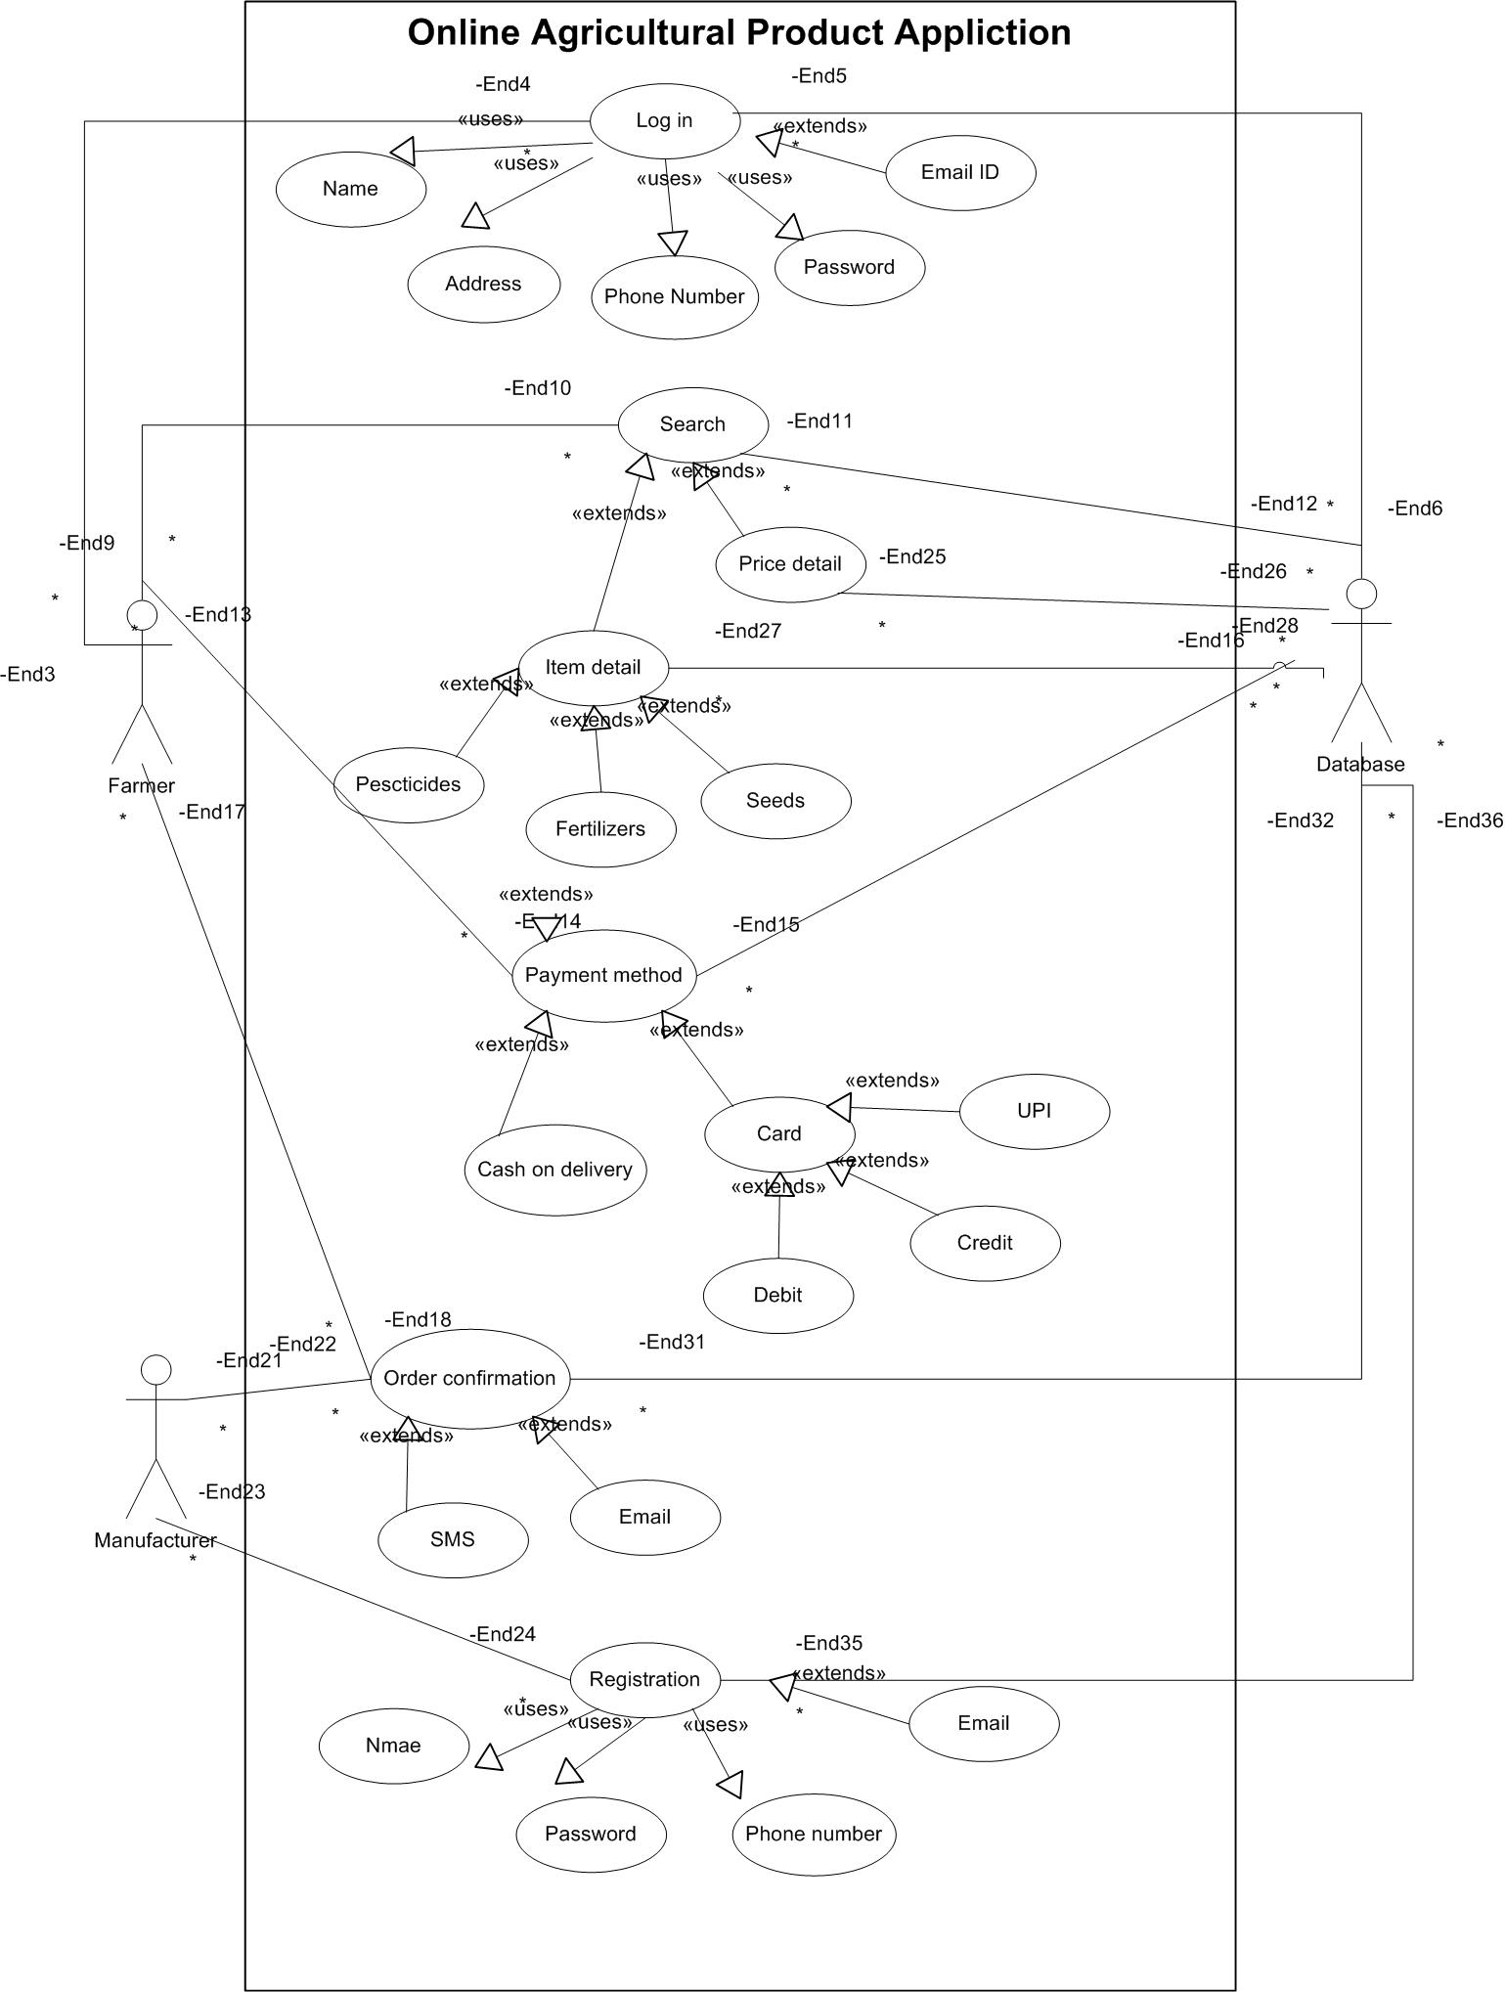
Question 11: Use case Specification

User case ID: | UC001
Case Name: | New user registration
Created By: | BA
Date Created: | 10/07/2025
Last Updated: | 10/07/2025
Actor: | Farmers
Description: | New farmers can register into the app
Pre and Post condition: | User need to have a valid phone no. and email ID to register
Flow: | User click on register  User will enter the mobile no and email ID  User will receive and enter OTP  User would be able to login and create profile
Alternate flow: | Click on forget password link
Requirement: | R001,R002
User case ID: | UC002
Case Name: | Choose from the list available
Created By: | BA
Date Created: | 10/07/2025
Last Updated: | 10/07/2025
Actor: | Farmers
Description: | Registered user would be able to select the product and add to the cart
Pre and Post condition: | User must be registered
Flow: | Registered user would be able to search for the product  Registered user would be able to select the product from the list  User would be able to add the item to the cart or wish list
Alternate flow: | None
Requirement: | R003,R004

User case ID: | UC003
Case Name: | Checkout and payment
Created By: | BA
Date Created: | 10/07/2025
Last Updated: | 10/07/2025
Actor: | Farmers
Description: | Registered user would be able to make the payment and place the order
Pre and Post condition: | User must be registered
Flow: | User will select the address for shipment  User will select the payment mode  User will enter debit/credit card detail, CVV and pin or UPI  User will enter the OTP received from bank
Alternate flow: | None
Requirement: | R005,R006

User case ID: | Uc004
Case Name: | Cancel the order
Created By: | BA
Date Created: | 10/07/2025
Last Updated: | 10/07/2025
Actor: | Farmers
Description: | Registered user would be able to cancel the order
Pre and Post condition: | User must be registered
Flow: | User will click on ‘My Account’  User will click on order history  User will select the order to be cancelled  Selected order will show as cancelled  Refund will be initiated
Alternate flow: | None
Requirement: | R007, R008

Question 12 : Activity Diagram
Answer: New user registration

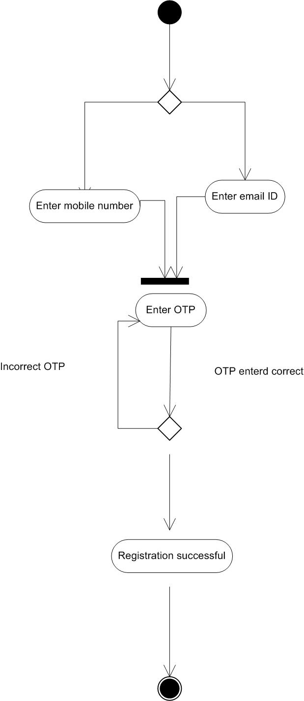
Placing order:
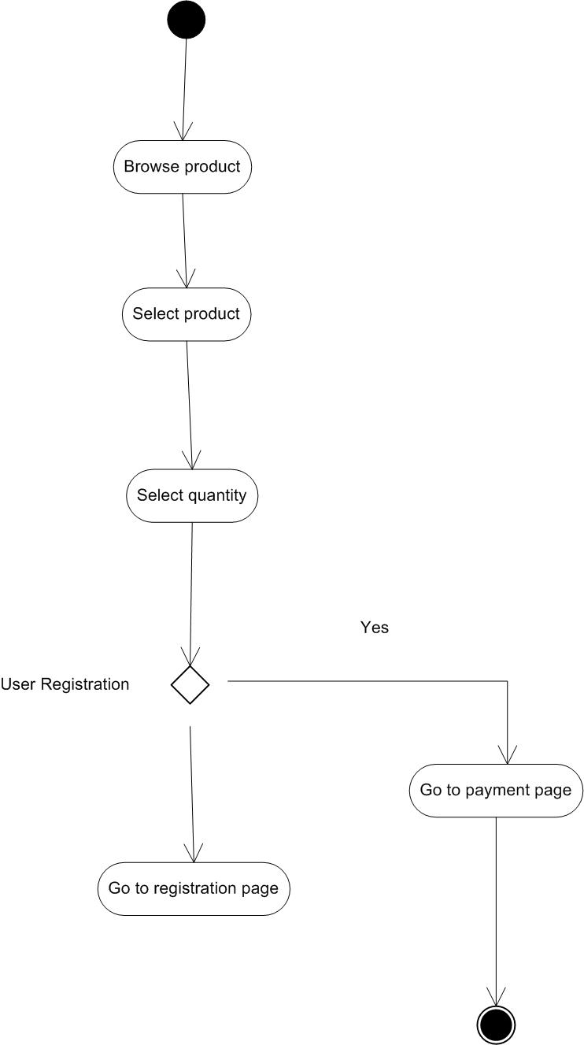

Order cancellation:

