Question 1: Identify Minimum 20 Functional Requirements.
Answer 1:
Functional requirements define specific behavior, functions or operations of a system. It describes what system should do such as tasks, activities or actions to achieve its objectives. (Functionalities which we are developing in our system).

Req ID | Requirement Name | Requirement Description
FR001 | Users Registration | Users should be able to register with the application with email id and password
FR002 | User Login | User should be able to login with email id and password
FR003 | Forgot Password | System should able to recover the password through email in case if the user forgot the password
FR004 | User Account | User should be able to update their profile information
FR005 | Add the Products Information | Manufacturers should be able to add/upload their products information in the application.
FR006 | Update or Delete the Products Details | Manufacturers should be able to update or delete their products details (price, description, stock) in the application.
FR007 | View Product Catalogue | User should be able to view the Product Catalogue for variety of seeds, fertilizers, pesticides.
FR008 | Product Search | Farmers should be able to search for available products in fertilizers, seeds, pesticides with or without login by using keywords and filters.
FR009 | Adding the Products to the Wishlist | Farmer should be able to add the products to the wish list after login.
FR010 | Adding the Products to the Cart | Farmers should be able to add the products to the cart after login.
FR011 | Removing the products from the cart | Farmers should be able to remove the products from the cart after login.
FR012 | Update the Products Quantity | Farmers should be able to update their product quantity.
FR013 | Place an Order in the Cart | System should be able to place an order for the items in the cart
FR014 | Delivery Details | System should have a provision to enter delivery details at checkout
FR015 | Easy Payment Gateway | User should be able to make Payments in three modes i.e.) Cash, Cards, UPI
FR016 | Order Confirmation | System should be able to generate order confirmation after payment is successful
FR017 | Order Status | System should be able to send order confirmation through email.
FR018 | Delivery Tracker | System should have a provision for delivery tracking system integration to track the orders
FR019 | View the Past Orders | Farmers should be able to see their past orders
FR020 | Misc. Information | System should be able to display return policy, privacy policy, contact information

Non-Functional Requirements: Non-Functional Requirements describes the qualities & attributes (properties) of a system, focusing on how system performs rather than specific behavior or functions. It’s also known as quality or supplementary requirements.

Req ID | Requirement Name | Requirement Description
NFR001 | Usability | The application should be user friendly
NFR002 | Performance | The application must load pages within 3 seconds
NFR003 | Performance | The application must do the order process within 3 seconds
NFR004 | Security | The application must ensure secure user authentication. System should be able to session timeout and automatic logout after inactivity.
NFR005 | Scalability | The system must be able to scale horizontally and vertically to handle future increases in users and products.
NFR006 | Compatibility | The application should be compatible with major web browsers & mobile responsiveness for smart phones
NFR007 | Response Time | The application should respond to user inputs within 2 seconds
NFR008 | Multiple Languages | The application should support multiple languages
NFR009 | Integrations | Application should support integrations
NFR010 | Data Encryption | The application must use SSL encryption for all kind of communications and it should comply with privacy standards

Question 2: Make Wireframe and Prototypes.

Answer 2:
Wireframes: It’s a high level sketch which gives the idea about the new product functionality. A wireframe is the blueprint of the future without any colour.It can be designed on paper with pen or pencil. It can be designed very quickly. It is developed by BA and it is developed in almost every project. It is used in Requirement Gathering Phase if necessary. In wireframe, it shows the placeholders like where login button will be placed.

Registration:
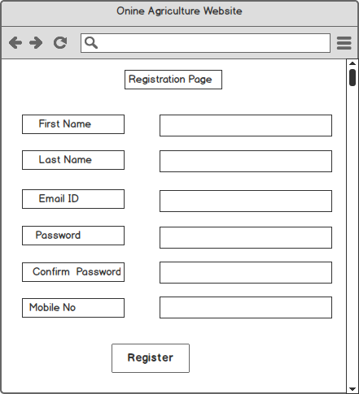
Login:
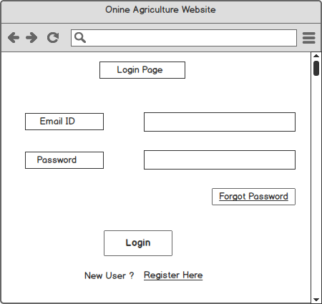
Prototyping: A prototype goes in detail creating an interactive simulation that users can test out and provide feedback on. It’s a replica of the future system. The prototype of a product is developed by developer and business analyst to understand the system. It takes more time to develop. It is used in Design Phase. Prototypes may not be required for all the projects. We use Axure tool.
Prototyping means showing the sample of the working model. It generally starts when client give references and based on the references we will prepare working model we will showcase the client how the functionality will be achieved.
My Cart:

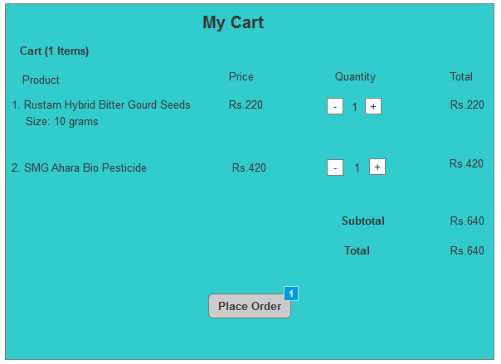

Delivery Address:

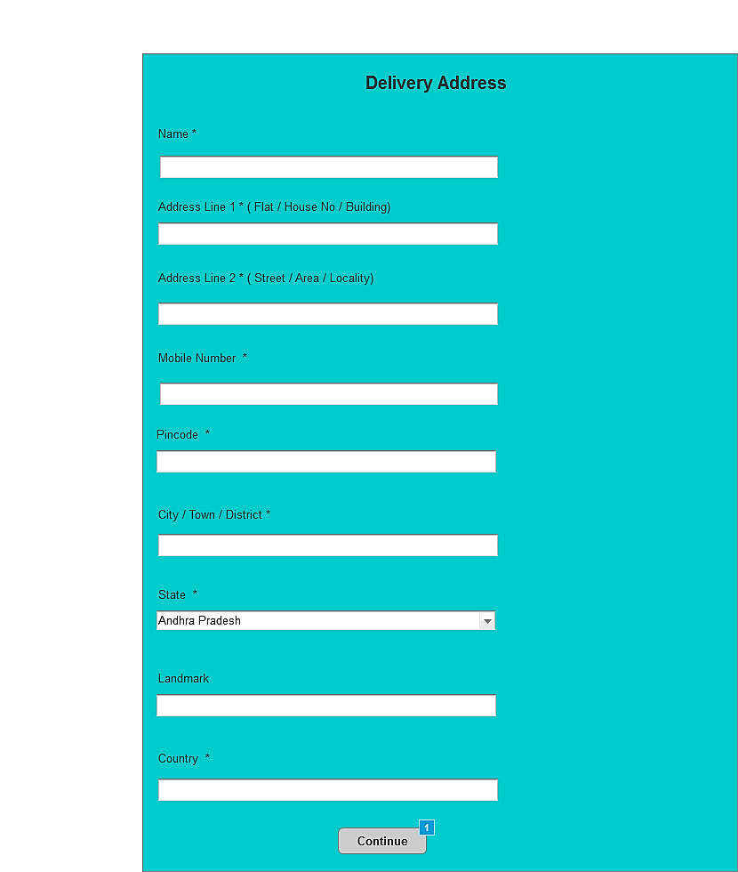

Payment:

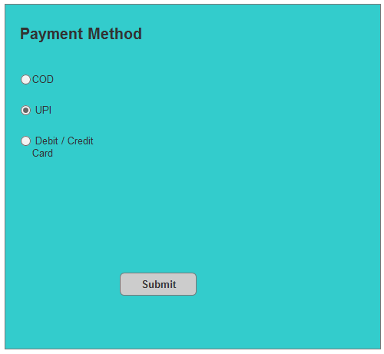

Question 3: Make a note of tools which you are using for above concepts:
Answer 3:
Balsamiq: This tool is used to create web and mobile application user interface design tool and it helps in creating wireframes/mockups. It is widely used in requirement gathering and design discussions because it helps visualize how a product will look and behave before actual development starts. Balsamiq is a low-fidelity wire framing and prototyping tool that helps teams brainstorm, visualize, and validate ideas quickly.
It is less advanced tool and it is simple to learn and use. It is more focused on creating static wireframes and mock-ups. It is more affordable and one-time fee. It is more focused on creating static images and exporting them in formats such as PNG & PDF.

Balsamiq helps in below areas:
- Changes can be done easily, rather than changing the entire code.
- Avoids Miscommunications, everyone can visualize how the product might look like.
- It can capture the ideas quickly by preparing the screens in few minutes.
- It helps the developers in understanding screen flows and UI elements
- It helps the BA’s to show the stakeholders the proposed UI system and confirm the requirements visually before development.
Axure RP (Rapid Prototyping): Axure RP is an advanced prototyping tool for creating high fidelity, interactive prototypes for web, mobile and desktop applications with screen navigations. It has clickable buttons. It allows the business stakeholders to get the feel of the future system and you can capture their feedback during the session. The Axure RP is used in starting of the project during both the research and design phases of a project.
It is more advanced tool and it requires more time to master it. It has advanced prototyping features. It is a subscription based pricing model. It supports wide range of output formats including Java Script, HTML.
Ex: In Axure RP, you can actually make the Login Form interactive i.e.) user types username & password.

MS Visio is a diagramming vector graphics application used to create visual diagrams, charts and flow charts. It helps to represent information in an organised way.

Question 4: A business analyst’s key responsibilities are to keep track of the requirements and make sure that no requirement is missed. Mr. Henry and peter have approached you regarding the current status of the project. How will you tackle this situation?

Answer 4 :
RTM is a document that maps the requirements with test cases and make sure that no requirement is missed during development and testing phases.
BA will take sign-off from the client on SRS Document. Once the sign-off is given by the client, BA will prepare Requirement Traceability Matrix (RTM) by referring SRS document in Requirement Analysis Phase.
Types of Testing:
a. Unit Testing: It’s testing the small pieces of code it is usually done by developers.
Ex: Calculating the total prices in the cart.
3 items* Rs. 50 = Rs. 150
b. Component Testing: Testing a complete component/module of the system independently, which may consist of multiple units working together. It’s done by testers.
Ex: Testing the Shopping Cart module:
- Add item to cart.
- Remove item from cart.
- Update item quantity.
- Check total price calculation.
Multiple unit functions (add, delete, calculate) are tested together as one component.
c. System Testing: Testing the entire system/application as a whole (end-to-end).It verifies that the system meets all functional and non-functional requirements. It’s done by testers. Testing includes functionality, usability, performance, and security.
Example (Online Agriculture Store):
A farmer logs in → browses catalogue → add product → makes payment → receives confirmation email.
This testing verifies if the whole application works properly for real-world use.
d. System Integration Testing: Testing the interaction between different systems or external interfaces to ensure they work together correctly.
Ex: After order placement, the system triggers email/SMS service.
When a farmer pays using UPI/Credit Card, the app must connect to the third-party payment gateway.
Req ID | Req Name | Req Description | Category | Design | Code | Unit Testing(UT) | Component Testing(CT) | System Testing (ST) | System Integration Testing (SIT) | User Acceptance Testing (UAT)
FR001 | Users Registration | Users should be able to register with the application with email id and password | Functional | Completed | Completed | Completed | Completed | Completed | In Progress | Not Started Yet
FR002 | User Login | User should be able to login with email id and password | Functional | Completed | Completed | Completed | Completed | Completed | In Progress | Not Started Yet
FR003 | Forgot Password | System should able to recover the password through email. | Functional | Completed | Completed | Completed | Completed | Completed | In Progress | Not Started Yet
FR004 | User Account | User should be able to update their profile information | Functional | Completed | Completed | Completed | Completed | Completed | In Progress | Not Started Yet
FR005 | Add the Products Information | Manufacturers should be able to add their products information in the application. | Functional | Completed | Completed | Completed | Completed | Completed | In Progress | Not Started Yet
FR006 | Update or Delete the Products Details | Manufacturers should be able to update or delete their products details (price, description, stock) in the application. | Functional | Completed | Completed | Completed | Completed | Completed | In Progress | Not Started Yet
FR007 | View Product Catalogue | User should be able to view the Product Catalogue for variety of seeds, fertilizers, pesticides. | Functional | Completed | Completed | Completed | Completed | Completed | In Progress | Not Started Yet
FR008 | Product Search | Farmers should be able to search for available products in fertilizers, seeds, pesticides with or without login by using keywords and filters. | Functional | Completed | Completed | Completed | Completed | Completed | In Progress | Not Started Yet
FR009 | Adding the Products to the Wishlist | Farmer should be able to add the products to the wishlist after login. | Functional | Completed | Completed | Completed | Completed | Completed | In Progress | Not Started Yet
FR010 | Adding the Products to the Cart | Farmers should be able to add the products to the cart after login. | Functional | Completed | Completed | Completed | Completed | Completed | In Progress | Not Started Yet
FR015 | Easy Payment Gateway | User should be able to make Payments in three modes i.e.) Cash, Cards, UPI | Functional | Completed | Completed | Completed | Completed | Completed | In Progress | Not Yet Done
FR016 | Order Confirmation | System should be able to generate order confirmation after payment is successful | Functional | Completed | Completed | Completed | Completed | Completed | In Progress | Not Yet Done
FR017 | Order Status | System should be able to send order confirmation through email. | Functional | Completed | Completed | Completed | Completed | Completed | In Progress | Not Yet Done
FR018 | Delivery Tracker | System should have a provision for delivery tracking system integration to track the orders | Functional | Completed | Completed | Completed | Completed | Completed | In Progress | Not Yet Done
NFR001 | Usability | The application should be user friendly | Non- Functional | Completed | Completed | Completed | Completed | Completed | In Progress | Not Yet Done
NFR002 | Performance | The application must load pages within 3 seconds | Non- Functional | Completed | Completed | Completed | Completed | Completed | In Progress | Not Yet Done
NFR003 | Performance | The application must do the order process within 3 seconds | Non- Functional | Completed | Completed | Completed | Completed | Completed | In Progress | Not Yet Done
NFR004 | Security | The application must ensure secure user authentication | Non- Functional | Completed | Completed | Completed | Completed | Completed | In Progress | Not Yet Done
NFR005 | Scalability | The system must be able to scale horizontally and vertically to handle future increases in users and products. | Non- Functional | Completed | Completed | Completed | Completed | Completed | In Progress | Not Yet Done
NFR006 | Compatibility | The application should be compatible with major web browsers & mobile responsiveness for smart phones | Non- Functional | Completed | Completed | Completed | Completed | Completed | In Progress | Not Yet Done

Question 5: Prepare 10 Test Case Documents
Answer 5:
A test case document is a detailed file that contains a set of test cases created by Test Managers to validate whether a particular feature, function, or module of the software works as expected.
It serves as a step-by-step guide for how testing should be carried out.
Test Strategy ID: It defines the overall testing approach for the project, like Component Testing, System Testing, and System Integration Testing. Tools used such as Selenium (Automation Testing Tool), J Meter (Performance & Load Testing Tool)
Test Plan ID: The test plan is more detailed and project-specific than the strategy. It describes what will be tested, by whom, no. of resources.
Ex: Testing Shopping Cart Module (Add To Cart, Checkout, and Payment)
Test Schedule ID: The test schedule defines the timeline and sequence of testing activities (test case design, environment setup, Test execution, defect fixing, etc.).
Test Case ID | TC_01 | Test Case Name | User Registration
Project ID | OAS_001 | Project Name | Online Agriculture Store
PM ID | 7157 | PM Name | Mr.Vandanam
Test Strategy ID | TS_001 | Tester ID | 7210
Test Plan ID | TP_01 | Tester Name | Mr. Jason
Test Schedule ID | TS_01 | Date of Test | 30-08-2025
Scenario | New User Registration
Link To That Page | https://oas.com/registration
Input Data | a. First Name: Ramu, Last Name: Kotipi, Email ID : ramu789@gmail.com  Password: Ramu7891$, Mobile Number : 9000456090 ;  b. First Name : Sandhya, Last Name : Aluri  Email : sandhya@gmail.com,  Password:Sandhya@91, Mobile No: 9111890211
Expected Behaviour | Successful User Registration should lead to account creation.  If it's not created, message should be shown.  Data should be saved in the database.
Actual Behaviour | Working as Expected
Comments | This scenario followed all the business rules and validations given.
Result (Pass/Fail) | Pass

Test Case ID | TC_02 | Test Case Name | User Login
Project ID | OAS_001 | Project Name | Online Agriculture Store
PM ID | 7157 | PM Name | Mr.Vandanam
Test Stratergy ID | TS_001 | Tester ID | 7210
Test Plan ID | TP_02 | Tester Name | Mr.Jason
Test Schedule ID | TS_02 | Date of Test | 30-08-2025
Scenario | Login with valid credentials
Link To That Page | https://oas.com/login
Input Data | Set1 : Email : ramu789@gmail.com  Password: Ramu7891$.  Set2: Email : sandhya@gmail.com,  Password:Sandhya@91
Expected Behaviour | User should log in successfully.  Alert should be shown, if they are unable to login, ''Please enter valid credentials''.
Actual Behaviour | Working as Expected
Comments | This scenario followed all the business rules and validations given.
Result (Pass/Fail) | Pass

Test Case ID | TC_03 | Test Case Name | Search by Category Name& Product Name
Project ID | OAS_001 | Project Name | Online Agriculture Store
PM ID | 7157 | PM Name | Mr.Vandanam
Test Strategy ID | TS_001 | Tester ID | 7211
Test Plan ID | TP_03 | Tester Name | Ms.Alekhya
Test Schedule ID | TS_03 | Date of Test | 30-08-2025
Scenario | Search by Category Name & Product Name
Link To That Page | https://oas.com/search
Input Data | Set1 : Category Names: Seeds,Fertlizers, Pesticides;  Set 2: Searching with Product Names.  Set 3: Search with Price Range
Expected Behaviour | While selecting seeds category, products related to seeds should be shown, same thing is applied for other categories too and If we are searching through Product Names then respective product name should be displayed.  If no results are found, it should display the alert saying ''No Products are Found''.
Actual Behaviour | When searching with category, fertilizers products are not displaying.
Comments | Except Fertilizer Category, Rest all working fine.
Result (Pass/Fail) | Fail

Test Case ID | TC_04 | Test Case Name | Add to the Cart
Project ID | OAS_001 | Project Name | Online Agriculture Store
PM ID | 7157 | PM Name | Mr.Vandanam
Test Strategy ID | TS_001 | Tester ID | 7211
Test Plan ID | TP_04 | Tester Name | Ms.Alekhya
Test Schedule ID | TS_04 | Date of Test | 30-08-2025
Scenario | Add Products to the Cart
Link To That Page | https://oas.com/addproduct
Input Data | Add few products from each category
Expected Behaviour | To validate whether the system is adding the required quantities of the products to the cart and it's calculating the total amount and If the product is out of stock, system should not allow to add the products.
Actual Behaviour | Working as Expected
Comments | This scenario followed all the business rules and validations given.
Result (Pass/Fail) | Pass

Test Case ID | TC_05 | Test Case Name | Removing the products from the cart
Project ID | OAS_001 | Project Name | Online Agriculture Store
PM ID | 7157 | PM Name | Mr.Vandanam
Test Strategy ID | TS_001 | Tester ID | 7211
Test Plan ID | TP_05 | Tester Name | Ms.Alekhya
Test Schedule ID | TS_05 | Date of Test | 30-08-2025
Scenario | Removing the products from the cart
Link To That Page | https://oas.com/removeproduct
Input Data | Remove the products which are added to the cart
Expected Behaviour | To check whether system is allowing to remove the products from the cart and total amount is getting updated according to that.
Actual Behaviour | Working as Expected
Comments | This scenario followed all the business rules and validations given.
Result (Pass/Fail) | Pass

Test Case ID | TC_06 | Test Case Name | Payments
Project ID | OAS_001 | Project Name | Online Agriculture Store
PM ID | 7157 | PM Name | Mr.Vandanam
Test Strategy ID | TS_001 | Tester ID | 7210
Test Plan ID | TP_06 | Tester Name | Mr.Jason
Test Schedule ID | TS_06 | Date of Test | 31-08-2025
Scenario | Making the Payment
Link To That Page | https://oas.com/payments
Input Data | Set1:Payment through COD  Set2:Payment through UPI (UPI ID : ramu @icici ; sandhya1992@hdfcbank)  Set3:Payment through Cards (Card No: 456 780 1234, Exp: 12/30 , CVV : 301 ;  Card No : 789 213 0981,Exp: 12/29 , CVV : 780)
Expected Behaviour | Set1: Payment through COD  a. Order should be placed successfully and confirmation message should be shown.  b. Email Confirmation need to be sent to consumer.  Set2 : Payment through UPI  a. Payment redirects to UPI Gateway then Payment successful message should be displayed and Order confirmation page should be displayed then Email confirmation need to be sent to the consumer.  b. If there is insufficient funds, alert should be displayed and order cannot be proceed. User need to select another payment method.  Set3:Payment through Cards  a. Need to enter card details, if the card details are correct payment will be done, and Order confirmation page should be displayed then Email confirmation need to be sent to the consumer.  b. If the card details are wrong, alert will be shown and payment will not be done.
Actual Behaviour | Working as Expected
Comments | This scenario followed all the business rules and validations given.
Result (Pass/Fail) | Pass

Test Case ID | TC_07 | Test Case Name | Order Status
Project ID | OAS_001 | Project Name | Online Agriculture Store
PM ID | 7157 | PM Name | Mr.Vandanam
Test Strategy ID | TS_001 | Tester ID | 7211
Test Plan ID | TP_07 | Tester Name | Ms.Alekhya
Test Schedule ID | TS_07 | Date of Test | 31-08-2025
Scenario | After order is placed, email confirmation should be sent to the consumer
Link To That Page | https://oas.com/orderstatus
Input Data | Set1 : ramu789@gmail.com and Order ID : OI9001  Set 2 : dummy908@gmail.com and Order ID : OI8091
Expected Behaviour | Set1: Email should be sent to the consumer with the proper order details which includes (quantity, price, delivery estimate, payment method). It should be sent within 1 minute after placing the order and Status in DB should be updated as Email Sent.  Set 2: While entering the wrong email id, it should alert the consumer when giving delivery details, '' Not a registered email id''. in order confirmation page
Actual Behaviour | It’s taking more than 1 minute to send an email and it's sending the email two times
Comments | -
Result (Pass/Fail) | Fail

Test Case ID | TC_08 | Test Case Name | Uploading the Products
Project ID | OAS_001 | Project Name | Online Agriculture Store
PM ID | 7157 | PM Name | Mr.Vandanam
Test Strategy ID | TS_001 | Tester ID | 7211
Test Plan ID | TP_08 | Tester Name | Ms.Alekhya
Test Schedule ID | TS_08 | Date of Test | 01-09-2025
Scenario | After registration, manufacturer uploading the products.
Link To That Page | https://oas.com/manufacturer/update product
Input Data | Product Name: Hybrid Seeds, Category: Seeds, Quantity: 50, Price per quantity: Rs.50, Expiry Date: 31-08-2026, Product Image: It should be less than 2mb and png format is accepted.
Expected Behaviour | Data should be accepted for mandatory fields, and product should be uploaded and product should be visible.  If mandatory fields are not filled, alert should be shown.  If invalid image is uploaded, alert should be shown.
Actual Behaviour | Working as Expected
Comments | It is working according to the business rules.
Result (Pass/Fail) | Pass

Test Case ID | TC_09 | Test Case Name | Tracking the Order Status
Project ID | OAS_001 | Project Name | Online Agriculture Store
PM ID | 7157 | PM Name | Mr.Vandanam
Test Stratergy ID | TS_001 | Tester ID | 7211
Test Plan ID | TP_09 | Tester Name | Mr.Jason
Test Schedule ID | TS_09 | Date of Test | 01-09-2025
Scenario | After placing the order, user should be able to track the order status
Link To That Page | https://oas.com/order/track
Input Data | Set1 : Order ID : OI9001  Set2 : Order ID : OI9
Expected Behaviour | Set1 : System need to fetch real time status from logistics API.  It need to display Estimated Delivery Date & Order Status (Order Placed, Packed, Shipped, Out for Delivery, Delivery).  Set2 : If it's a invalid order id, alert need to be displayed, ‘Order not Found''
Actual Behaviour | Working as Expected
Comments | No comments
Result (Pass/Fail) | Pass

Test Case ID | TC_10 | Test Case Name | Updating or Deleting Product Details
Project ID | OAS_001 | Project Name | Online Agriculture Store
PM ID | 7157 | PM Name | Mr.Vandanam
Test Strategy ID | TS_001 | Tester ID | 7211
Test Plan ID | TP_10 | Tester Name | Mr.Jason
Test Schedule ID | TS_10 | Date of Test | 01-09-2025
Scenario | Manufacturer updating or deleting the product details after adding it
Link To That Page | https://oas.com/manufacturer/update product
Input Data | Set1 : Updating the Product :  Product Name : Hybrid Seeds, New Price Rs.70/Quantity  Set2 : Delete Bone Meal Fertilizer (Dummy Data)
Expected Behaviour | Set 1: Able to update the details and the changes should reflect in Product Catalogue, DB and Confirmation message should be shown '' Product Details Updated Successfully''.  Set 2 : Able to remove the product and it should be reflected in catalogue too. It should display ''Product Deleted Successfully'' after removing it.
Actual Behaviour | Working as Expected
Comments
Result (Pass/Fail) | Pass

Question 6. DB Design: After the requirements are thoroughly explained to the entire project team by business analyst, the Database architects have decided to do the database design and also to represent the in-flow and out-flow of data.
Draw database schema and ER diagram.
Answer 6:
Database means collection of tables. In a table, column names are called as entities. When we insert a record is called a data record. So table will have table name, entities and data records.
Database Example: Bank Database.
- Services of Banks are called as Products.
Table Name: Products
Product ID | Product Name | Category | Date of Inception | Remarks
SAV001 | Savings | SAV | 01-09-2010
SAV002 | Salary Savings | SSAV | 02-09-2010
LOA003 | Personal Loan | LOAN | 03-09-2010
LOA004 | 2 Wheeler Loan | LOAN | 04-09-2010

Once banks have their services, they need to have customers to whom they will offer these products.

Table Name: Customer
Customer ID | Customer Name | DOB | PAN | Contact
0332124-1754 | Ajay.Ch | 09-09-1993 | BBNPC6501H | 8374677729
0332124-1755 | Sri Ram.Ch | 10-08-1995 | BBNPC6502V | 8374677629

After customer table is created, we need to check which customer is taking which product, so we will have customer-product table. So whenever customer takes a product that will be saved in below table.
Table Name: Customer - Product Table
Account Number | Customer ID | Product ID | Date of Start | Remarks
31211000376 | 0332124-1754 | SAV001 | 04-12-2010
31211000442 | 0332124-1755 | LOA004 | 05-12-2010

Once the customer took the product, they will do few transactions in savings account or repaying their loans, then these details will be saved in transaction table.
Table Name: Transaction Table
Transaction ID | Account Number | Customer ID | Amount | Debit/Credit | Balance
900111 | 31211000376 | 0332124-1754 | 5000 | Cr | 5000

Here Bank Database (DB) have four tables, in these tables few columns are interlinked with other tables which is called Entity Relationship.
ER (Entity Relationship) Diagram: It’s a logical model of data. It focuses on what data need to be stored and how entities relate. It shows entities, attributes, relationships. The things you store in the table (entities), what details you keep in the table (attributes), and how those things are connected (relationships).
ER diagram means it’s a high level representation of how data is structured and related in a system. It helps in planning and structuring a database before it is built. It does not talk about implementation in a database. It acts as a base for DB Schema where it focus on implementation in a database.
ER Diagram is drawn first then followed by DB Schema. ER Diagram is drawn by BA. It’s used in requirements analysis and database design phases to make sure everyone agrees on what will be stored and how it relates-before you build tables.
Ex:
Entities: Farmer, Manufacturer, Product, Order, Payments
Attributes: Farmer Entity: Name, Email ID, Password, Contact Number

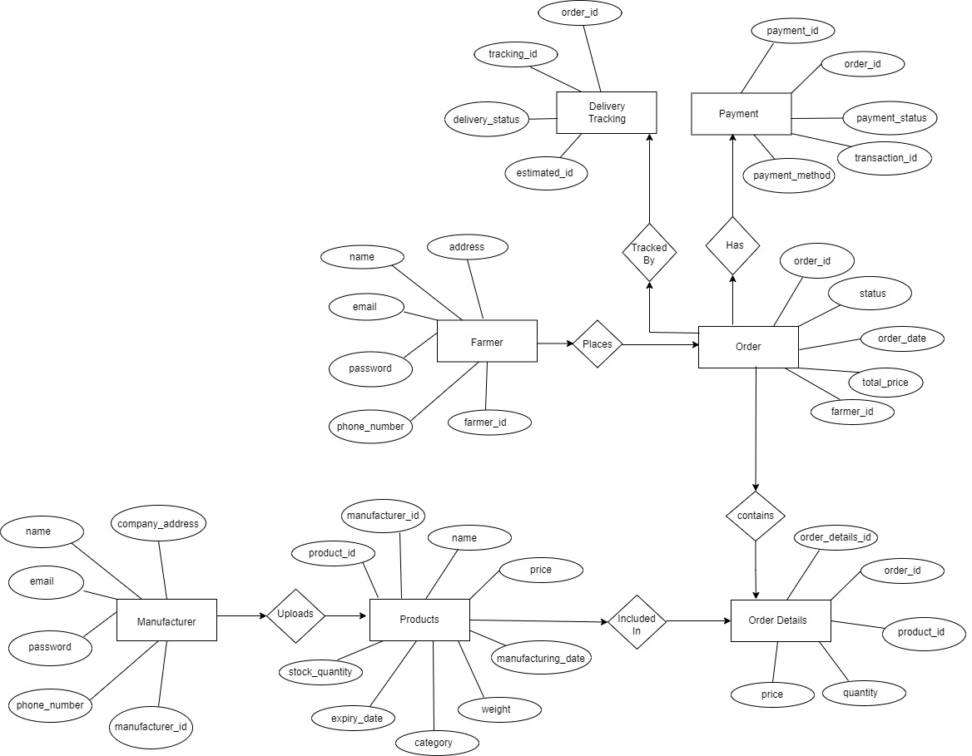

DB Schema: It’s a blueprint that outlines the structure of a database including its tables, columns, relationships, constraints and other characteristics. It defines how the data will be stored, organized, and related inside the database. It focuses on implementation in Database. DB Administrators, Developers will be included while designing DB Schema and it is drawn by using MS Visio tool. It is the last diagram in the database.
Key Features of DB Schema:
It describes tables, columns, data types, and constraints.
It also defines relationships between tables (one-to-one, one-to-many, many-to-many).
It ensures data integrity and makes sure the data is stored in a logical way.
Without a schema, data would be unorganized and hard to manage.
In a DB Schema, relationships define how tables are connected to each other using primary keys (PK) and foreign keys (FK).
Constraints:
Primary Key: A primary key is a column or set of columns that uniquely identifies each record in the table. Each table will have only one primary key. A primary key must contain unique values for each row and it cannot contain NULL Values.
Foreign Key: A foreign key is a column or a set of columns in one table that refers to the primary key of another table. It is used to link two tables. The values in foreign key column must match existing values in primary key column of the other table. A table can have multiple foreign keys, each referring a different primary key in another table, or even the same primary key in the same table.
DB Design is the process of structuring and organizing data into a database so that it can be stored, retrieved, and managed efficiently.
It defines:
- What data needs to be stored?
- How data will be organized into tables.
- How tables are related to each other (relationships).
DB Design: DB Schema + ER Diagram together is called DB Design.

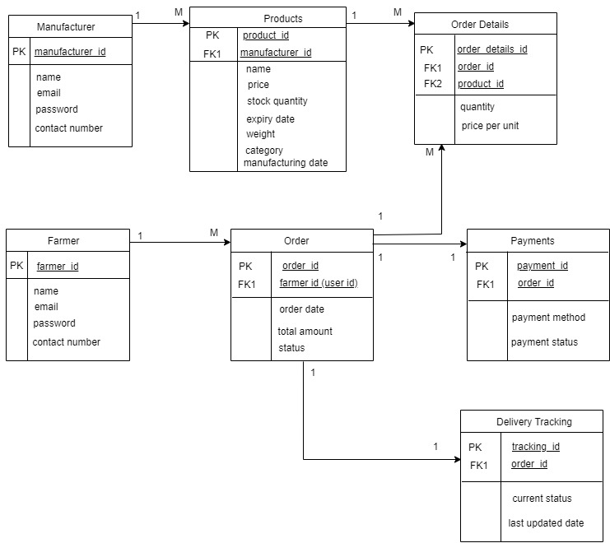

Here are the main types of relationships:
Farmer - Order (1: M) (One to Many Relationship): A farmer can place many orders, but each order belongs to a single farmer.
Product - Order Details (1: M): One product can appear in many order details, whereas one order detail belongs to one product.
Order - Order Details (1: M): One Order can have many Order Details. Each Order Detail belongs to one Order.
Manufacturer - Products (1: M): One manufacturer can supply many products, each product belongs to only one manufacturer.
Order - Payments: (1:1): One order can be done by one payment method.
Order - Delivery tracking (1: 1) (One to One Relationship): One order will have one delivery tracking.

Question 7: What is a data flow diagram? Draw a data flow diagram to represent the in-flow and out-flow of data when a Farmer is placing an order for the product.
Data Flow Diagram:
A data flow diagram is the graphical representation of the flow of data within a system. It visually shows how data moves from one process to another, how it’s stored and where it ends up. Data which is being flowing from one class to another class is called data flow diagram.
It helps analysts and designers understand the flow of data within a system, identify potential bottlenecks or inefficiencies and communicate system requirements to stakeholders.
- Actors will be as Entity Classes (Each Actor will be One Entity Class)
- Use Cases will be Controller Class (Each Use Case will be One Controller Class)
- One Actor & 1 Use Case will as One Boundary Class. Two Actors & 1 Use Case will be as Two Boundary Classes and so on.
Suppose we have 2 Entity Classes, 2 Controller Classes, and 2 Boundary Classes that means we have 6 Classes.
Process:
The Farmer selects products and places an order.
The system process the order.
The order details are saved in the Orders Database.
Notifications are sent to the Manufacturer & Farmer.

Inflow of data (Input Data): Data that enters the system, process or database. It is the input information provided by a user.
Ex: Farmer enters login details (email, password).
Farmer searches for a product (search keywords).
Farmer enters payment details.
Outflow of data (Output Data):
It is the output that is generated after processing the input. This means the data that leaves a system, process, or database.
Ex:
System shows search results (list of fertilizers/seeds).
System gives order confirmation message.
System sends delivery tracking updates to the farmer’s email.

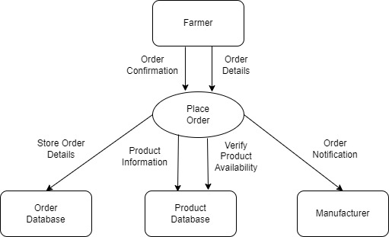

Question 8: Due to change in the Government Taxation structure. We should change the Tax structure. How do you handle change requests in a project?
Answer 8:
Whenever change request arises from the client, As a BA, First I need to document the change requests given.
I need to do, Impact Analysis to measure the change to the project. Impact Analysis means evaluating the effect of a proposed change on the entire project before approving or rejecting it in terms of,
Timelines: Whether it requires more time?
Budget: Whether it increases the budget?
Resource: Does it require more manpower?
Risk: Does it bring any new risks or reduce it?
Quality Impact: Does it affect the quality of the final product?
Then as a BA, I need to analyse whether it’s really a change request or defect discovered from previous communications.
Project Manager need to give approval for a BA for proceeding further
Project Manager & BA need to analyse whether the change requested is minor or complex one. If it’s a complex one which is effecting the organisation and the delivery timelines, BA need to convince the stakeholders and make them understand its negative effects.
Successful change management need to bring all the stakeholders to one agreement without any conflicts.

Question 9: As the project is in process, Ben and Kevin have contacted you. The reason is to inform you that they want the Farmers to sell their crop yields through this application i.e. Farmers should be able to add their crop yields or products and display to general public and should be able to sell them. They also want to introduce Auction system for their Crop yields. As a BA, what will be your response? Is this a change request or an enhancement???
Answer 9: As a BA, I feel it’s an enhancement. Because it’s not mentioned earlier in the given scope (System should able to add the products from the farmers and able to sell them and keep them in Auction)
A change request means modifying which is already in scope. Enhancement means adding new functionality which is not part of the scope.
Ex: Adding Crop Selling Feature, Add Auction System

S.No | Aspect | Change Request | Enhancement
1 | Definition | Making changes to the existing agreed functionality | Adding the new functionality which is not there in scope
2 | Impact | Changes Current Features/Process | Expands System Capabilities
3 | Timeline Impact | Usually smaller adjustments | Future Phase
4 | Budget Impact | May or may not require extra budget | Almost always requires extra budget
5 | Example | Change Delivery Charges | Adding Auction System

Question 10: How many Man - hours required?
Answer 10:
Man Hours: The total time spent by a person (or multiple people) in completing a task.
18 Months = 548 Days.
Working Days Calculation: Total Weeks * No. Of Working Days in a Week.
= 78.29 *5 = 391 days
Hours Per Day: 8 Hours per day.
Project Manager & BA Man Hours = No. of people * Hours per Day * Working Days
= 2*8* 391 = 6256 Man Hours
Development Team, Network Admin, DB Admin Team Man Hours = No. of people * Hours per Day * Working Days
= 7* 8 * 351 = 19,656 Man hours

The man hours might be varying for Testing Team as they will be involved in later phase of the project.
Testing Team Man Hours = No. of people * Hours per Day * Working Days
= 2 * 8 * 263 = 4208 Man Hours

Question 11: Project has finally completed all the stages i.e., design, development, testing etc. Now, it is the role of a business analyst to contact the client for testing of the final product and have to successfully complete it. How are you going to handle this situation? And once it is done, what will be the process to close the project? Explain UAT Acceptance process.

Answer 11:
Planning:
- Separate UAT Environment should be provided with pre-loaded test data.
- Inform the client through formal communication that development & testing is done and ask for their availability for UAT.
- Share the UAT Test Plan (What Features/Modules can be tested i.e.) Login, Catalogue, Payments etc.)
Designing:
- Create Test Cases for presenting.
- Execute the UAT
Bug Fixing:
- Record the Feedback/Bugs if any and communicate to respective developers.
- Developers will fix the bugs and they should make sure that software is error-free.
- Testing Team will re-test the process and they will give the result. Then it will be presented for UAT, until the client is satisfied this process will be repeated.
Sign-Off:
- Once the client is satisfied, all the stakeholders come to a conclusion that software is ready to Go-Live & Sign it off. UAT Sign-Off document is signed by Mr. Henry / SOONY committee.

Question 12: Explain Project closure document.
Answer 12:
A project closure document is also known as project closure report. It is the formal document that summarizes the key outcomes, lessons learned, and final details of a completed project.
It serves as a comprehensive record of the project’s accomplishments, challenges and overall performance providing valuable insights for stakeholders and for future projects.

S.No | Points To Include | Details | Reference Link
1 | Did the client sign-off on UAT Testing |  | Businessscope document.docx
 | Date of the sign-off | 01-09-2025 | Businessscope document.docx
 | Name of the Resource | Mr.Henry | Businessscope document.docx
2 | Objectives of the project |  | Businessscope document.docx
 | Facilitate Online Access for Agricultural Products by creating web and mobile application | Achieved
 | Enable Direct Communication Between Farmers and Manufacturers | Achieved
 | Provide a User-Friendly Application | Achieved
 | Easy Payment Gateway | Achieved
3 | Functionalities Worked On
 | Manufacturers should be able to upload the products | Achieved
 | Farmers should be able to search for the products | Achieved
 | Farmers should be able to add to cart | Achieved
 | Farmers should able to place the order & pay the amount | Achieved
 | Farmers should be able to Order Tracking & Notifications | Achieved
4 | Infrastructure
 | Sofwares Installed | Achieved
 | Laptops Purchased (12) | Achieved
5 | Funding
 | Amount Approved | Rs. 2,00,00,000 | FinanceBreakdown.docx
 | Amount Used | Rs. 1,80,00,000
6 | Overall Project Information
 | Escalations | 15
 | Customer Staisfaction | High
7 | Value To The Company
 |  | Company has gained an edge over the competitors.
 |  | Client Satisfaction
 |  | Trained Employees
 |  | New Projects In Pipeline
8 | Achievements | Key Deliverables completed
9 | Challenges | Many farmers in rural areas are not aware of online shopping, mitigated by using simple UI Design, Tutorial Videos in local languages.
10 | Quality Assurance | All modules underwent UAT, 95% test cases passed in first round and minimal post-release defects.

