Q1) Quarterly Audits are planned Q1 , Q2, Q3, Q4 for this Project What is your knowledge on how these Audits will happen for a BAx

Stage | Q1: Audit Report (Requirement Gathering Phase)
Completed | 10 weeks (Week 1 to Week 10)
Check list | BRD (Business Requirement Document) template completion
 | Elicitation results documented from stakeholder interviews and JAD sessions
 | Duplicate requirements identified and removed
 | Features grouped into modules and sent for client sign-off
 | Email communication tracked (To, CC, BCC)

Stage | Q2: Audit Report (Requirement Analysis Phase)
Completed | 7 weeks (Week 16 to Week 22)
Check list | UML diagrams
 | Business to functional requirements mapping
 | Client sign off – documents
 | RTM document version control
 | Email communication – To, CC, BCC

Stage | Q3: Audit Report  (Prototyping/Pre-Design Phase Validation phase)
Completed | Prototyping and design- 15 weeks (Week 22to Week 37)
Check list | Wireframes/UI prototypes
 | User feedback& approvals
 | Change request tracking log
 | Utilization of design tools
 | Documented evidence on client communication
 | Stake holder meeting MOM
 | Email Communication – To, CC, BCC

Stage | Q4: Audit Report (Development Phase)
Completed | 22 Weeks (Week 38 to 60)
Check list | JAD Session report
 | End user manual preparation document
 | BA and developer MOM
 | Email communication tracked (To, CC, BCC)

Q2) Before the Project is going to Kick Start, The Committee asked Mr Karthik to submit BA Approach.Write BA Approach strategy (As a business analyst, what are the steps that you would need to follow to complete a project – What Elicitation Techniques to apply, how to do Stakeholder Analysis RACI/ILS, What Documents to Write, What process to follow to Sign off on the Documents, How to take Approvals from the Client, What Communication Channels to establish n implement, How to Handle Change Requests, How to update the progress of the project to the Stakeholders, How to take signoff on the UAT- Client Project Acceptance Form )
Ans:
What Elicitation Techniques to apply:
Conduct interviews, workshops, document analysis, observations, and surveys to gather requirements.

How to do Stakeholder Analysis RACI/ILS:
Identify key stakeholders. Use RACI matrix:
Responsible: BA, Developers
Accountable: Project Manager
Consulted: Admins
Informed: Testers, Clients
What Documents to Write:
BRD, FRS, Use Cases, Change Request Document, UAT Plan, Sign-off Forms, Meeting Minutes.

What process to follow to Sign off on the Documents:
Share draft documents, conduct review meetings, incorporate feedback, and collect formal approval via email or form.

How to take Approvals from the Client:
Submit documents for review, follow up through communication channels, and get sign-off on official client approval forms.

What Communication Channels to establish n implement:
Use email (To, CC, BCC), Zoom/Teams for meetings, project management tools like Trello/Google Sheets for task tracking.

How to Handle Change Requests:
Maintain a change request log, analyse impacts, conduct review meetings, and obtain approvals before changes are implemented.

How to update the progress of the project to the Stakeholders:
Share weekly status reports, use dashboards for visibility, and conduct regular update meetings.

How to take signoff on the UAT – Client Project Acceptance Form:
Coordinate UAT execution, document test results, resolve issues, and obtain final sign-off using the Client Project Acceptance Form.

Q3) Explain and illustrate 3-tier architecture?
Ans:
1. Client Tier (Presentation Layer):
This is the topmost layer where users interact with the system through client devices like computers or mobile phones. It displays data and sends user inputs to the business logic layer.

2. Business Logic Tier (Application Layer):
This middle layer processes user inputs, performs business operations, and handles the logic of the application. It connects the client tier to the database tier and manages communication between them.

3. Database Tier (Data Layer):
This bottom layer contains the database server where all data is stored, retrieved, and managed. It responds to queries from the application layer and sends back the required data.

Q4) Business Analyst should keep What points in his/her mind before he frames a Question to ask to the Stakeholder (5W 1H – SMART – RACI – 3 Tier Architecture – Use Cases, Use case Specs, Activity, Diagrams, Models, Page designs) As a Business Analyst, What Elicitation Techniques you are aware of?
Ans:
Before framing questions to stakeholders, a Business Analyst should consider the following key frameworks and techniques:

1. 5W 1H (Who, What, When, Where, why, How):
Ensure questions cover all aspects of the requirement.
Example: Who will use the system? What features are needed? How will it be used?

2. SMART Criteria (Specific, Measurable, Achievable, Relevant, Time-bound):
Frame questions to gather requirements that meet SMART goals.
This ensures clarity and practical feasibility of stakeholder expectations.

3. RACI Matrix (Responsible, Accountable, Consulted, Informed):
Understand stakeholder roles to direct questions appropriately.
Helps clarify responsibilities and decision-making authority.

4. 3-Tier Architecture Understanding:
Ask questions considering client, business logic, and data layers.
Helps gather technical and non-technical requirements effectively.

5. Use Cases and Use Case Specifications:
Prepare to explore different user interactions and system behaviour.
Questions should lead to complete scenarios and conditions.

6. Activity Diagrams, Models, and Page Designs:
Visualize workflows and screen designs to identify gaps.
Frame questions to validate or refine visual models with stakeholders.

These techniques ensure that the questions are comprehensive, aligned with the project's goals, and tailored to stakeholder expectations.

Q5) As a Business Analyst, What Elicitation Techniques you are aware of? ( BDRFOWJIPQU)
Ans:
As a Business Analyst, I am aware of several elicitation techniques used to gather requirements from stakeholders and other sources.
The acronym BDRFOWJIPQU can help remember them:

1. B – Brainstorming: Used to generate a large number of ideas quickly from a group of stakeholders.

2. D – Document Analysis: Reviewing existing documentation to understand current systems or processes.

3. R – Requirements Workshops: Structured meetings with stakeholders to define, prioritize, and review requirements.

4. F – Focus Groups: A guided discussion with a selected group of participants to gain their opinions and attitudes.

5. O – Observation: Watching users perform tasks to understand how a system is used in real-world conditions.

6. W – Walkthroughs: Step-by-step reviews of processes or documents with stakeholders to validate requirements.

7. J – Job Shadowing: Closely observing a user while they perform their daily tasks to understand their workflow and challenges.

8. I – Interviews: One-on-one or group discussions to gather detailed information from stakeholders.

9. P – Prototyping: Creating early models of a solution to gather feedback and refine requirements.

10. Q – Questionnaires/Surveys: Distributing structured questions to a wide audience to gather data efficiently.
11. U – User Stories/Use Cases: Capturing requirements in a narrative form to understand user interactions with the system.
These techniques are often used in combination, depending on the project context, stakeholder availability, and the nature of the requirements.
Q6) Which Elicitation Techniques can be used in this Project and Justify your selection of Elicitation Techniques?
Prototyping
Use case Specs
Document Analysis
Brainstorming
Ans: In this agriculture-based project where stakeholders include manufacturers (of fertilizers, seeds, pesticides) and farmers, the following elicitation techniques are suitable
1. Document Analysis
Justification:
Document analysis helps understand existing systems, workflows, and content. In this case, the Business Analyst (BA) would examine documents such as:
Existing product catalogs from manufacturers,
Company SOPs (Standard Operating Procedures),
Prior project documentation or reports (if available).
The BA performs this analysis to extract relevant data and understand the current process. The BA may also consult SMEs or stakeholders to clarify ambiguous content. This helps in identifying gaps and defining initial requirements effectively.

2. Prototyping
Justification:
Prototyping is used to present visual mock-ups of key screens like:
Login/registration page,
Product catalog and search functionality,
Payment gateway interface,
Order tracking system.

By sharing early visual designs with stakeholders like Mr. Henry, Peter, Kevin, and Ben, the BA can gather feedback on layout, usability, and required changes. This reduces miscommunication and ensures the system aligns with their expectations.

3. Use Case Specifications
Justification:
Use case specifications are used to describe the system behaviour from a user’s perspective. For this project, key use cases would include:
"User registration and login"
"Search and browse products"
"Add to cart and checkout"
"Track order"

These detailed descriptions help developers and testers understand what users (farmers/manufacturers) need to do within the system and ensure alignment between business needs and technical solutions.

4. Brainstorming
Justification:
Brainstorming sessions with stakeholders like Peter, Kevin, and Ben allow the BA to collect a wide range of ideas quickly. It encourages open discussion about features such as:

Types of products to include,
Various payment options,
Search filters,
Order tracking preferences.
Brainstorming helps in identifying innovative features and understanding expectations from multiple viewpoints in one collaborative session.
These techniques, when used together, provide a comprehensive understanding of business needs and user expectations, ensuring successful requirement gathering for the project

Q7) Make suitable Assumptions and identify at least 10 Business Requirements.
Ans:
Assumptions

1. All users (farmers and manufacturers) will have internet access and basic digital literacy.
2. Farmers will access the platform primarily via mobile devices.
3. Manufacturers will manage their product listings through a secure login.
4. The platform will support multiple payment methods and order tracking.
5. Email confirmation is an acceptable mode of communication for all users.
6. Product categories are limited to fertilizers, seeds, and pesticides for now.
7. Only verified users can post or purchase products.
8. Delivery logistics will be handled by third-party services.
9. Product availability will be updated in real time.
10. The platform will follow standard data protection and privacy regulations.
Business Requirements:
BR001: Farmers should be able to search for available products in categories like fertilizers, seeds, and pesticides using keywords or filters.
BR002: Manufacturers should be able to securely log in and upload, update, and manage their product listings on the platform.
BR003: All users, including farmers and manufacturers, must be able to register and log in using a valid email ID and password.
BR004: New users should be able to create an account by entering their email ID and setting a strong password.
BR005: Farmers should be able to browse through a comprehensive product catalog with detailed product information and availability.
BR006: Farmers should have the option to add products to a shopping cart or a “buy later” Wishlist for future consideration.
BR007: The platform should offer a secure payment gateway with options like Cash on Delivery (COD), credit/debit cards, and UPI.
BR008: Users should receive an email confirmation with full order details after placing an order successfully.
BR009: Farmers should be able to track the real-time delivery status of their orders through a delivery tracking feature.
BR010: The system should provide an admin interface to manage user roles, monitor transactions, and maintain platform security.

Q8) List your assumptions.
Ans: Here are some assumptions made while identifying the business requirements for the Online Agriculture Portal project:

1. All users will have access to smartphones or computers with internet connectivity to access the application or website.
2. Farmers and manufacturers are familiar with basic digital operations, such as logging in, browsing, and online purchasing.
3. A centralized admin system exists to manage user access, product approvals, and order tracking.
4. Manufacturers have digital product catalogs and are willing to upload their product information to the system.
5. Delivery logistics are handled by a partnered or third-party courier service which supports tracking integration.
6. Payment gateway integration is technically feasible and complies with local financial and data privacy regulations.
7. The platform will support multilingual functionality to accommodate farmers across different regions.
8. Email IDs are used as the primary unique identifiers for login and account management.
9. Security measures are in place to protect user data and ensure secure transactions.
10. The product categories (fertilizers, seeds, pesticides) are clearly defined and structured to ensure easy catalog browsing and search functionality.

Q9) Give Priority 1 to 10 numbers ( 1 being low priority – 10 being high priority) to these Requirements after discussions with the stakeholders Req ID Req Name Req Description Priority
BR001 Farmer Search for Products Farmers should be able to search for available products in fertilizers, seeds, pesticides 8
BR002 Manufacturers upload their Products Manufacturers should be able to upload and display their products in the application 8
Once the requirements are finalized, as a business analyst, one of the major roles is to act as a liaison between the client and the project team. To gather the requirements correctly from the client side and then to deliver those requirements to the project team in a way they understand.
To make the project team understand the requirements, you need to convert those requirements into UML diagrams and screen mock-ups.
Ans: Here’s a clear justification of how I assigned priority scores (from 1 to 10) to each business requirement (BR001 to BR010), considering stakeholder input, importance to project goals, user impact, and logical dependencies:

Req ID | Req Name | Req Description | Priority
BR001 | Farmer Search for Products | Farmers should be able to search for available products in fertilizers, seeds, and pesticides. | 8
BR002 | Manufacturers Upload Their Products | Manufacturers should be able to upload and display their products in the application. | 8
BR003 | User Login & Registration | Users (farmers and manufacturers) should be able to log in or register using their email and password to access application features. | 10
BR004 | Product Catalog Browsing | Farmers should be able to browse through the available products without logging in. | 9
BR005 | Add to Wishlist (Buy Later) | Users should be able to save products to a Wishlist or buy-later list after logging in. | 6
BR006 | Secure Payment Gateway | The platform should provide payment options including COD, UPI, and Credit/Debit card for secure transactions. | 9
BR007 | Order Email Confirmation | The system should send an order confirmation email to the user after placing the order. | 5
BR008 | Delivery Tracking | The platform should allow users to track the status of their product deliveries. | 7
BR009 | Admin Panel for Product Approvals | Admin should have access to approve and manage the products uploaded by manufacturers. | 4
BR010 | System Scalability | The system should be scalable to support future enhancements and feature integrations. | 3

10, Draw use case diagram.
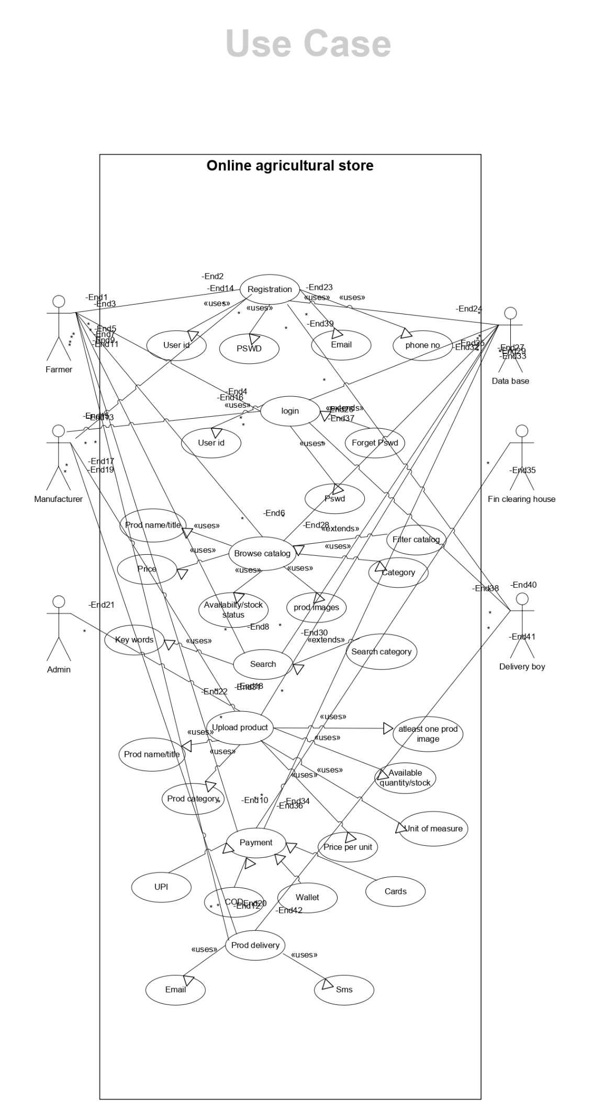

Q11) Prepare use case specs for all use cases.
Ans:
Total Primary Actors Identified:
1. Farmer
2. Manufacturer
3. Admin
4. Database (System/Service Actor)
5. Financial Clearing House (Payment Gateway)
6. Delivery Boy

Communication Summary Between Actors and Use Cases:

Farmer:
Registers, logs in
Browses catalog
Searches products
Makes payments
Tracks delivery (Product delivery)

Manufacturer:
Uploads products with details (price, stock, etc.)
Browses catalog for their listing verification

Admin:
Can view, verify or manage product listings
Manages system data (not shown explicitly but inferred)

Database:
Interacts with all major use cases like login, product upload, and catalog search

Financial Clearing House:
Engaged during the payment process (UPI, COD, Wallet, Cards)

Delivery Boy:
Connected to product delivery and status update

Use Case: User Registration
Use Case ID: UCD_REG_001
Use Case Name: Register User
Description: This use case allows a new farmer or manufacturer to create an account by providing required credentials.
Primary Actor: Farmer / Manufacturer
Secondary Actor: Database
Preconditions: Internet connectivity, valid email/phone
Basic Flow:
Open registration page
Enter email, phone, user ID, password
Submit form
System stores data in database and confirms registration
Postconditions:
Successful: User account created
Unsuccessful: Error message if data is invalid
Inputs: User ID, Password, Email, Phone
Outputs: Registration confirmation message
Business Rules: Email ID must be unique, strong password required
Assumptions: User has valid contact info
Exceptions: Network failure, duplicate email

2. Use Case: Product Search
Use Case ID: UCD_SEARCH_002
Use Case Name: Search Product
Description: Enables farmers to search products using keywords, price, or category.
Primary Actor: Farmer
Secondary Actor: Database
Preconditions: User must be logged in
Basic Flow:
Navigate to product search page
Enter keyword or filter by price/category
System displays matching results
Postconditions:
Successful: Results shown
Unsuccessful: “No product found” message
Inputs: Keywords, filters
Outputs: List of products
Business Rules: Search only on active listings
Assumptions: Products are already uploaded
Exceptions: Empty result, slow network

3. Use Case: Upload Product
Use Case ID: UCD_UPLOAD_003
Use Case Name: Upload Product Details
Description: Allows manufacturers to upload new products with price, stock, and images.
Primary Actor: Manufacturer
Secondary Actor: Admin (optional approval), Database
Preconditions: Manufacturer is logged in
Basic Flow:
Navigate to upload page
Enter product name, price, stock, category
Upload image and click submit
System stores data
Postconditions: Product listed in catalog
Inputs: Product details
Outputs: Confirmation of upload
Business Rules: Image is mandatory, price should be valid
Assumptions: Admin may review
Exceptions: Incomplete form, invalid data

4. Use Case: Make Payment
Use Case ID: UCD_PAY_004
Use Case Name: Process Payment
Description: Allows farmer to pay using UPI, cards, wallet, or COD.
Primary Actor: Farmer
Secondary Actor: Payment Gateway
Preconditions: Cart has products, total bill calculated
Basic Flow:
Choose payment method
Enter details (UPI/card/etc.)
Payment processed via gateway
Confirmation received
Postconditions:
Successful: Order confirmed
Unsuccessful: Payment failed
Inputs: Payment credentials
Outputs: Transaction ID, email/SMS
Business Rules: Secure gateway use, mandatory transaction ID
Assumptions: Gateway is active
Exceptions: API down, transaction declined

5. Use Case: Track Delivery
Use Case ID: UCD_TRACK_005
Use Case Name: Track Product Delivery
Description: Allows farmers to track order using delivery status updates.
Primary Actor: Farmer
Secondary Actor: Delivery Boy, System
Preconditions: Order is placed
Basic Flow:
Go to “My Orders”
Click on “Track Delivery”
System displays ETA and location status
Postconditions: Delivery status shown
Inputs: Order ID
Outputs: Delivery updates
Business Rules: Only for placed orders
Assumptions: Delivery system synced
Exceptions: Status delay, tracking system offline

Q12) Activity diagram

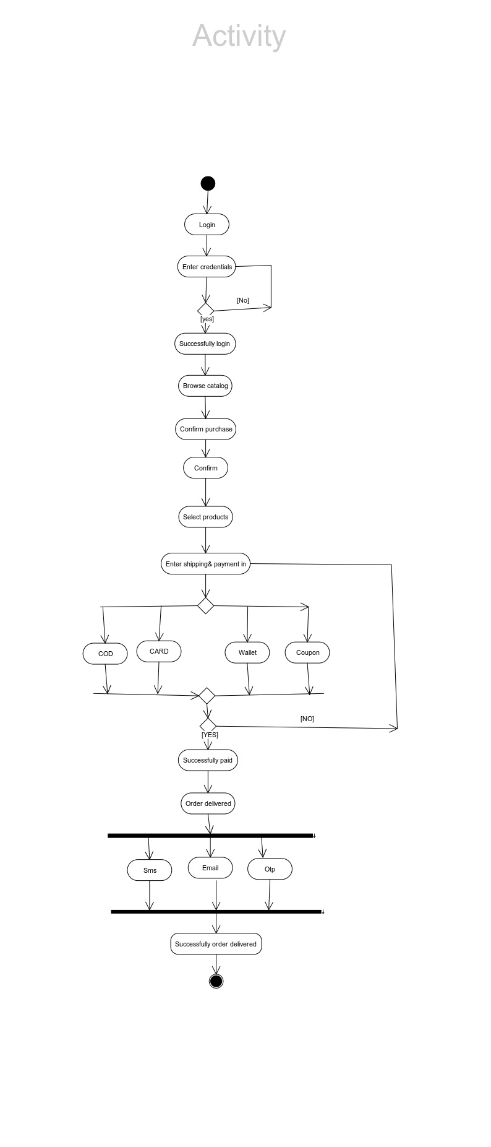Z

