Nurturing Process – Capstone Project 1 – Part - 2/3 V2D2 – August 2024

COEPD – Traditional Development
Capstone Project 1 – Part - 2/3 – 100 Marks - Pass 60%
12 Questions
Instructions to follow:
- Copy paste (either image, diagram or text) is not entertained. If done, the document will not be evaluated.
- After submission of the answers of this prep exam, you should be prepared to attend Viva and justify your answers in the prep exams. If in Viva, participant is NOT justifying the answers, Viva will be repeated until Candidates justify 60% correctness.
- Mentor calls are scheduled only if the participant have submitted their task at least for one time. (should apply their knowledge in this task first).
- For attempting prep exams participating should be thorough on the topics using their references.
- Please format the document properly (Always have a question no., question and answer).
- Have a consistent format (Font Name: Arial/Calibri; Font Size: 12; Font Colour: Black).
- Few Questions are related to the case study, check Questions thoroughly before you answer.
- Answers should be elaborated in detail (*not as per the allotted marks).
- Please focus on learning and applying the knowledge as this knowledge will be helpful in contributing at your Business Analyst job.
- In the evaluation, students must answer all questions and should be able to justify at least 60% content and correctness of each answer.

Online Agriculture Products Store

Mr. Henry, after being successful as a businessman and has become one of the wealthiest persons in the city. Now, Mr. Henry wants to help others to fulfil their dreams. One day, Mr. Henry went to meet his childhood friends Peter, Kevin and Ben. They live in a remote village and do farming. Mr. Henry asked his friends if they are facing any difficulties in their day-to-day work.

Peter told Mr. Henry that he is facing difficulties in procuring fertilizers which are very important for farm. Kevin said that he is also facing the same problem in case of buying seeds for farming certain crops. Ben raised his concern on lack of pesticides which could help in greatly reducing pests in crops.

After listening to all his friends’ problems, Mr. Henry thought that this is a crucial problem faced not only by his friends, but also by so many other farmers. So, Mr. Henry decided to make an online agriculture product store to facilitate remote area farmers to buy agriculture products. Through this Online Web / Mobile Application, Farmers and Companies (Fertilizers, Seeds and Pesticides manufacturing Companies) can communicate directly with each other.

The main purpose to build this online store is to facilitate farmers to buy seeds, pesticides, and fertilizers from anywhere through internet connectivity. Since new users are involved, Application should be user friendly.

This new application should be able to accept the product (fertilizers, seeds, pesticides) details from the manufacturers and should be able to display them to the Farmers. Farmers will browse through these products and select the products what they need and request to buy them and deliver them to farmers’ location.

Mr. Henry has given this project through his Company SOONY. In SOONY Company, Mr. Pandu is Financial Head and Mr. Dooku is Project Coordinator. Mr. Henry, Mr. Pandu and Mr. Dooku formed one Committee and gave this project to APT IT SOLUTIONS company for Budget INR 2 Crores and Duration 18 months under CSR initiative. Peter, Kevin and Ben are helping the Committee and can be considered as Stakeholders share requirements for the Project.

Mr. Karthik is the Delivery Head in APT IT SOLUTIONS company and he reached out to Mr. Henry through his connects and Bagged this Project. APT IT SOLUTIONS company have Talent pool available for this Project. Mr. Vandanam is Project Manager, Ms. Juhi is Senior Java Developer, Mr. Teyson, Ms. Lucie, Mr. Tucker, Mr. Bravo are Java Developers. Network Admin is Mr. Mike and DB Admin is Mr. John. Mr. Jason and Ms. Alekya are the Testers. And you joined this team as a Business Analyst.

Decode the case study:
Project Idea: To build a web and mobile application that enables farmers, especially in remote areas, to purchase agricultural products (seeds, fertilizers, pesticides) directly from manufacturing companies.
This platform will act as an online store and communication bridge between farmers and agricultural products companies, and in turn helps improve the access to essential farming inputs.

Current Needs:
- To provide Farmers easy access to agricultural products (seeds, fertilizers, pesticides).
- A user-friendly platform for farmers who may not be tech-savvy.
- A system where manufacturing companies can list their products and farmers can browse, compare and buy directly without any mediators.
- It’s an initiative under Corporate Social Responsibility (CSR) to empower rural communities.

Overview of the Project:
Objective: Build a user-friendly online platform for agricultural products (Agricultural Inputs: Seeds, Fertilizers, Pesticides).
Project’s Name: Online Agricultural Products Store
Initiated by: Mr. Henry under CSR initiative through his company – SOONY
Development Partner: APT IT SOLUTIONS
Budget: INR 2 Crores
Duration: 18 Months
Technology: Java-based Web and Mobile Application
End Users: Farmers and Agricultural Products Manufacturing Companies

Current Problems:
Procurement Issues: Farmers don’t have easy access to seeds, fertilizers, and pesticides due to remote location.
Middlemen Involvement: Increases cost and reduces quality.
Lack of Platform: No existing system to connect farmers directly with companies.
Digital system: Farmers need a system that’s simple and user-friendly.

Know the Team:
Name | Role | Company/Background
Mr. Henry | Sponsor, Visionary and  Initiator of the Project | SOONY
Mr. Pandu | Financial Head | SOONY
Mr. Dooku | Project Coordinator | SOONY
Mr. Peter, Mr. Kevin and Mr. Ben | Farmers & Stakeholders (End Users) | Rural Farmers
Mr. Karthik | Delivery Head | APT IT SOLUTIONS
Mr. Vandanam | Project Manager | APT IT SOLUTIONS
Ms. Juhi | Senior Java Developer | APT IT SOLUTIONS
Mr. Teyson, Ms. Lucie, Mr. Tucker, Mr. Bravo | Java Developers | APT IT SOLUTIONS
Mr. Mike | Network Admin | APT IT SOLUTIONS
Mr. John | DB Admin | APT IT SOLUTIONS
Mr. Jason, Ms. Alekya | Testers | APT IT SOLUTIONS
Myself | Business Analyst |  | APT IT SOLUTIONS

Question 1 – Audits (5 Marks)
Q: 4 Quarterly Audits are planned (Q1, Q2, Q3, Q4) for this Project. What is your knowledge on how these Audits will happen for a BA?

Solution:

Audits are checkpoints to ensure requirements and BA deliverables align with project goals. For a BA, audits focus on requirements documentation, stakeholder sign-offs, and traceability.

- Q1 Audit (Initiation & Planning):

- Verify stakeholder analysis is complete.
- Confirm elicitation techniques chosen and applied.
- Ensure BA approach document and initial BRD draft exist.

- Q2 Audit (Analysis Stage):

- Validate finalized Business Requirements Document (BRD).
- Confirm Requirements Traceability Matrix (RTM) is created.
- Ensure use cases and diagrams are consistent with BRD.

- Q3 Audit (Design & Development Stage):

- Check requirements are mapped to functional designs.
- Ensure prototyping and mock-ups align with requirements.
- Confirm change requests are tracked and baselined.

- Q4 Audit (Testing & Closure):

- Verify requirements coverage in test cases.
- Ensure UAT is planned and executed.
- Confirm client sign-off and closure of all requirements.

BA Role: Provide updated BRD, SRS, RTM, participate in walkthroughs, justify requirements, and ensure alignment with client expectations.

Question 2 – BA Approach Strategy (6 Marks)
Q: Write BA Approach strategy.

Solution: As a BA, my approach includes:

- Elicitation Techniques:

- Interviews (with Mr. Henry, Farmers, Manufacturers).
- Workshops (with key stakeholders).
- Prototyping (for login, catalogue, payment).
- Document Analysis (CSR reports, procurement process).
- Brainstorming.
- Reverse Engineering.
- Focus Groups.

- Stakeholder Analysis (RACI):
- Responsible: BA, Developers, Testers.
- Accountable: Project Manager.
- Consulted: Farmers, Manufacturers, Committee.
- Informed: Sponsor, Finance Head.

- Documents to Write:
- Business Requirements Document (BRD).
- Functional Requirements Document (FRD).
- System Requirements Specification (SRS).
- Use Case Specs.
- UML Diagrams (Use Case, Activity).
- RTM, Change Request Log.

- Process for Sign-off:
- Draft Internal Review Stakeholder walkthrough Final approval Baseline.
- Sign Off to be taken on SRS as this the primary and important document. Sign off can be taken by using email confirmation from Client.

- Approvals from Client:
- Through committee sign-off (Mr. Henry, Pandu, Dooku).
- Establish formal meetings with clients to keep them informed and get continuous feedback.

- Communication Channels:
- Weekly reports, Steering Committee meetings, Teams/Slack.
- Regular Meetings – Weekly status meetings, bi-weekly sprint reviews, and monthly stakeholder updates.

- Change Requests:
- Logged in CR register (Includes Change Request Form) Impact analysis CCB approval Documentation.

- Project Progress Updates:
- Weekly status reports, monthly review meetings.

- UAT & Client Acceptance:
- UAT Preparation Conduct UAT Fix Issues Acceptance Form Final Review Meeting Obtain Sign-off.

Question 3 – 3-Tier Architecture (5 Marks)
Q: Explain and illustrate 3-tier architecture.

Solution: -

3-Tier Architecture separates the system into:
- Application Layer (UI): It handles user interface (UI) components such as Web/Mobile screens for login, product catalogue, cart, payment.
Ex: E-Commerce Website
- Business Logic Layer (Application Server): Handles rules like authentication, product search, payments, order management.
Ex: Payment gateways.
- Database Layer (Database): Stores data of Farmers, Manufacturers, Products, and Orders.
Ex: MySQL, Oracle database.

Example:
A farmer logs in (UI) Request validated (Logic) User details retrieved (DB).

Benefits: Scalability, Security, Maintainability, Modularity.

Question 4 – BA Approach Strategy for Framing Questions (10 Marks)
Q: What should a BA keep in mind before framing questions?

Solution: -

When framing questions, a BA should consider:

- 5W1H: Who, What, When, Where, Why and How.
- Ex: “How should delivery status updates be provided?”

- SMART: Questions should be Specific, Measurable, Attainable, Relevant, & Time-bound.

- RACI charts help define and clarify roles and responsibilities within a team by outlining who is responsible, accountable, consulted and informed for each task. Ask only role-relevant questions (farmers = usability, finance = payment rules).

- 3-Tier Awareness:
- (UI) Application questions Farmers.
- Business logic questions Development Team.
- Database questions DB Admin.

- UML Model-based: Use case diagrams, activity flows, page mock-ups as aids.
It is a standardized way of diagramming and modelling software systems to aid in design, development, and communication between members.

Example: Instead of vague “Do you want tracking?”, ask:
- “Should farmers see real-time GPS delivery tracking, or just estimated delivery date?”

Question 5 – Elicitation Techniques (6 Marks)
Q: What elicitation techniques are you aware of?

Solution: -

Using mnemonic BDRFOWJIPQU:
- Brainstorming
- Document Analysis
- Reverse Engineering
- Focus Groups
- Observations
- Workshops
- JAD (Joint Application Development)
- Interviews
- Prototypes
- Questionnaire
- Use Case Specs

Question 6 – Elicitation Techniques for this Project (5 Marks)
Q: Which elicitation techniques apply here and why?

Solution: -

Best-fit for Online Agriculture Products Store:

Prototyping: Farmers are new to digital platforms, so mock-ups for login, search, add to cart, checkout (Proceed to Buy) and payment will help them visualize.

Use Case Specs: Define interactions like product upload, order tracking clearly.

Document Analysis: Review CSR reports and existing systems.

Brainstorming: With farmers & manufacturers to refine product catalogue and payment features.

Question 7 – Business Requirements (10 Marks)
Q: Identify at least 10 business requirements.

Solution: -

- BR001 – Farmers can search products.
- BR002 – Manufacturers can upload/display products.
- BR003 – Farmers/manufacturers can register new accounts.
- BR004 – Secure login/logout.
- BR005 – Multiple payment options (COD, UPI, Cards).
- BR006 – Farmers can track order status.
- BR007 – System sends email/SMS confirmations.
- BR008 – Manufacturers can edit/delete products.
- BR009 – Farmers can create a Wishlist/Buy later list.
- BR010 – System supports mobile-friendly interface.

Question 8 – Assumptions (5 Marks)
Q: List assumptions.

Solution: -
- Farmers have access to smartphones and internet.
- Payment gateways (UPI, Cards) are available in rural areas.
- Online sale of seeds/fertilizers/pesticides is legally permitted.
- Logistics partners can deliver to remote villages.
- Regional language support is feasible.

Question 9 – Requirements Prioritization (8 Marks)
Q: Assign priority (1 = low, 10 = high).

Solution: -

Req ID Requirement Priority
BR001 Farmers Search for Products 9
BR002 Manufacturers Upload Products 8
BR003 Account Registration 10
BR004 Login/Logout 9
BR005 Payment Gateway 10
BR006 Delivery Tracking 8
BR007 Notifications (Email/SMS) 7
BR008 Manage Products/Inventory 7
BR009 Wishlist/Buy Later 6
BR010 Mobile-friendly UI 8

Question 10 – Use Case Diagram (10 Marks)
Q: Draw use case diagram.

Solution: -

Actors: Farmer, Manufacturer, Admin.
Use Cases: Register, Login, Search Products, View Catalogue, Add to Cart, Wishlist, Checkout, Payment, Track Order, Upload Products, Manage Products.

Rework: Draw the below mentioned diagram using MS – Visio and include – Includes, Extends, Generalizations, and Associations. Move Manufacturer to the left-hand side. Move Admin in place of Manufacturer and connect to all use cases.

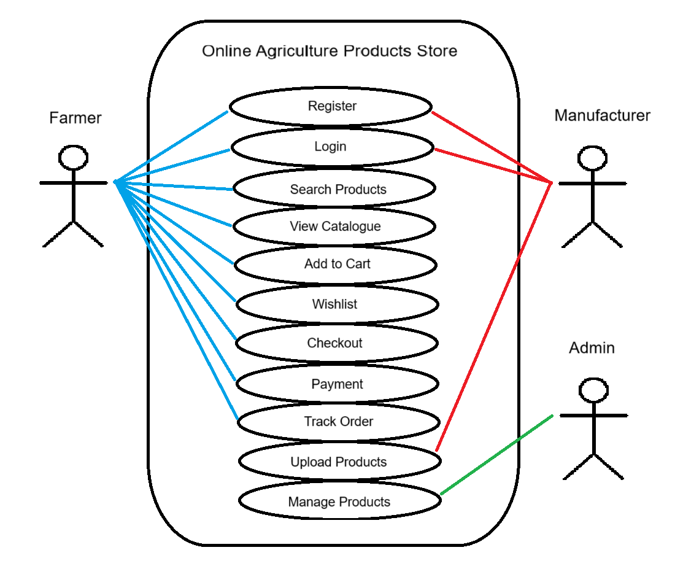

Question 11 – Use Case Specs (15 Marks)
Q: Prepare use case specs (minimum 5).

Solution: -

Use Case Spec – 1: Register Account

- Actors: Farmer, Manufacturer
- Preconditions: User is on registration page.
- Main Flow: Enter details Validate OTP SMS/Email Verify Account active.
- Alternate Flows: Duplicate email, OTP expired.
- Postcondition: Active account created.

Use Case Spec – 2: Login/Logout

- Actors: Farmer, Manufacturer, Admin
- Preconditions: User account exists.
- Main Flow: Enter credentials Validate Access dashboard Logout.
- Alternate Flows: Invalid credentials, locked account.
- Postcondition: Session created/ended.

Use Case Spec – 3: Search Products

- Actors: Farmer
- Preconditions: User logged in.
- Main Flow: Enter keyword System fetches results Display.
- Alternate Flows: No results found Suggestions.
- Postcondition: Products displayed.

Use Case Spec – 4: Upload Products

- Actors: Manufacturer.
- Preconditions: Manufacturer logged in.
- Main Flow: Enter product details System validates Save.
- Alternate Flows: Invalid data, failed upload.
- Postcondition: Product visible in catalogue.

Use Case Spec – 5: Checkout & Payment

- Actors: Farmer.
- Preconditions: Items in cart.
- Main Flow: Confirm order Select payment Process payment Confirm order.
- Alternate Flows: Out-of-stock, payment failed.
- Postcondition: Order created with ID.

Question 12 – Activity Diagrams (15 Marks)
Q: Draw activity diagrams (minimum 5)

Solution: -
- Registration:

- Login Flow:

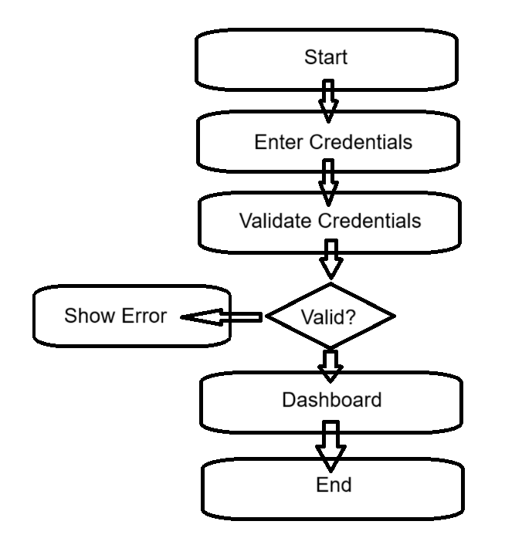

- Product Search:
Rework: Include Branch & Merge and draw using MS – Visio.
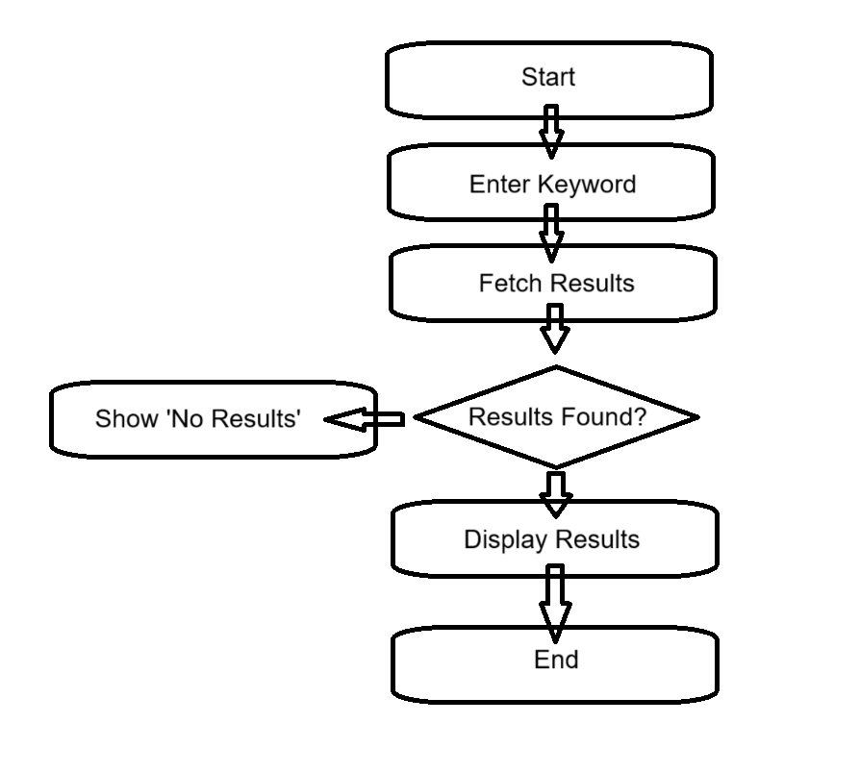

- Payment:

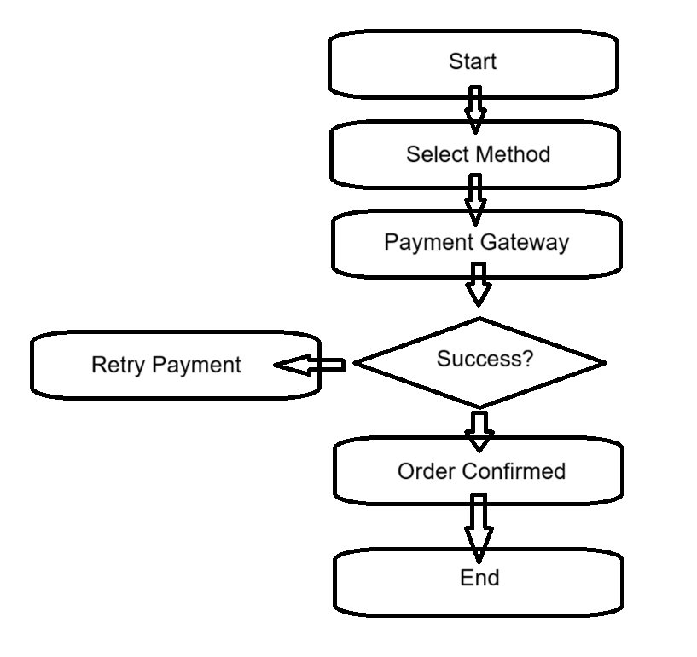

- Order Details:

