Assignment 1: Business Requirements Document (BRD)
Project Title: The country side Inventory & Delivery Management System
Client: Everyday Dairy Enterprises Ltd.

1. Background
Everyday Dairy operates manufacturing plants and warehouses across India. With rising demand and delivery areas, they aim to digitize inventory tracking and optimize deliveries.

2. Project Objective
To build a centralized software system that enables:
- Real-time inventory visibility
- Automated order routing based on proximity
- Delivery route optimization
- Tracking and reporting for supply chain decisions

3. Goals & Objectives
- Maintain accurate, real-time inventory data across all locations
- Automate order assignment to the nearest warehouse
- Optimize delivery routes for speed and cost-efficiency
- Provide analytics dashboards for logistics decisions

4. Key Stakeholders
- Supply Chain Manager
- Inventory Supervisors
- Dispatch & Delivery Team
- IT Department
- End Customers

5. In-Scope Functionalities
- Centralized inventory visibility
- Intelligent delivery planner
- Geo-based stock lookup
- Real-time delivery tracking
- Alerts and system-generated reports
Out-of-Scope (Phase 1):
- Raw material procurement
- Integration with retail POS

6. Functional Requirements Summary
ID | Requirement Description | Priority
INV01 | Auto-update inventory after manufacturing/dispatch | High
INV02 | Multi-warehouse inventory synchronization | High
DEL01 | Map-based delivery planner using pincode/location | High
DEL02 | Notify customer on order status | Medium
ADM01 | Dashboard with filters by region/product/stock levels | Medium

7. Development Plan
Phase | Duration | Deliverables
Requirements & UI | 2 weeks | BRD, Wireframes
Inventory Module | 3 weeks | APIs, Sync Functionality
Delivery Engine | 4 weeks | Route Optimizer, Tracking Module
Admin Interface | 2 weeks | Dashboard, Reports
QA & UAT | 2 weeks | Testing, Bug Fixes

8. Resource Plan
Role | Count | Time Allocation
Business Analyst | 1 | Full project
Backend Developer | 2 | 10 weeks
Frontend Developer | 1 | 6 weeks
QA Engineer | 1 | 4 weeks
Scrum Master | 1 | Full project

9. Constraints
- Integration must work with existing warehouse systems
- System must support both mobile and web access
- Delivery tracking depends on third-party APIs/GPS tools
- Limited development time: 13 weeks total

10. Assumptions
- All warehouses have basic internet and IT infrastructure
- Each warehouse maintains correct input of inventory data
- Delivery staff have smartphones for real-time tracking
- Users will access the system via authenticated login only

11. Risks
- Inaccurate inventory data entry by warehouse staff may lead to wrong order assignments.
- Delivery delays could occur due to GPS tracking failure or incorrect route data.
- Third-party API failures (e.g., map or notification services) may affect delivery tracking and updates.
- Insufficient training of staff may lead to improper system usage or delays in processing.
- Limited network connectivity in rural warehouse areas could disrupt real-time updates.
- Resistance to change from warehouse or delivery staff may slow adoption of the new system.

Process Flow: From Order to Delivery
- Customer places order (mobile app/website)
- System verifies stock availability across all warehouses
- Nearest warehouse with availability identified
- Order routed to selected warehouse
- Packing & dispatch by warehouse team
- Delivery agent assigned with optimized route
- Live tracking enabled for customer
- Delivery confirmed, system updates inventory

Process Flow: From Order to Delivery
Start
↓
Customer Places Order (App/Website)
↓
System Verifies Stock Availability
↓
Nearest Warehouse with Stock Identified
↓
Order Routed to Selected Warehouse
↓
Packing & Dispatch by Warehouse Team
↓
Delivery Agent Assigned with Optimized Route
↓
Live Tracking Enabled for Customer
↓
Delivery Confirmed
↓
Inventory Updated in System
↓
End

Assignment 2
1. Introduction Letter
Dear Sir,
I hope you are doing well.
My name is Garima Sharma, and I’ll be working with you as the Business Analyst assigned to this project. My role is to closely collaborate with you and your team to define requirements, streamline business processes, and ensure we build a solution that adds real value to your operations.
Looking forward to engaging conversations and a productive partnership.

Warm regards,
Garima Sharma
Business Analyst

Project Title: Online Store Management System
Business Requirements Document (BRD)
1. Project Objective:
To develop a user-friendly and secure online store that allows customers to browse products, place orders, and make payments online. The system should also enable administrators to manage inventory, users, and orders.
2. Scope of the Project:
- Product catalog with categories and filters
- User registration and login
- Shopping cart and checkout process
- Online payment integration
- Admin panel for product and order management
3. Stakeholders:
- Customers (End Users)
- Store Admin
- Delivery Staff
- IT Team
4. Business Requirements:
- BR1: Users should be able to register and log in securely.
- BR2: Customers should browse/search for products and see details.
- BR3: Customers can add products to the cart and checkout.
- BR4: System should support digital payment gateways (UPI, Net Banking, Cards).
- BR5: Admin should be able to manage products, orders, and users.
5. Assumptions:
- The store will operate within India.
- All users will have internet access.
- Delivery logistics are handled externally.
6. Constraints:
- Application must be mobile-responsive.
- Payment must be completed within 15 minutes of checkout.
- Max cart size: 20 items.
7. Risks:
- Technical failures during payment process.
- Cybersecurity threats.
- Delay in product delivery affecting customer satisfaction.
8. Success Criteria:
- User adoption rate after 1 month.
- Average order processing time < 5 mins.
- Less than 1% payment failures.

Process flow diagram for online store:

Start
Customer browse products
/
Add items to cart
/
Proceeds to checkout
/
Enter shipping details
/
Make payment
/
Order delivered to customer
/
Items packed and delivered
/
Warehouse process order
/
Order confirmation sent
/
End

Software Requirements Specification (SRS)
1. Introduction:
The Online Store Management System is a web-based solution to simplify product ordering and delivery. It ensures a smooth user experience and streamlined admin operations.
2. Functional Requirements:
- FR1: User Registration/Login (with OTP or email verification)
- FR2: Browse/Search products with filters
- FR3: View product details (price, description, reviews)
- FR4: Add/Remove items in shopping cart
- FR5: Checkout and process payment
- FR6: Order confirmation via email/SMS
- FR7: Admin dashboard for managing products, users, and orders
- FR8: View order status and history
3. Non-Functional Requirements:
- NFR1: System should support 100+ concurrent users
- NFR2: Uptime of 99.9%
- NFR3: Payment integration with SSL security
- NFR4: Page load time < 3 seconds
4. System Interface Requirements:
- Web interface (responsive design)
- Database (MySQL/PostgreSQL)
- Integration with Razorpay/Paytm for payments
- Email/SMS APIs for notifications

Entities & Attributes
- User
  - UserID (PK)
  - Name
  - Email
  - Phone
  - Role (Customer / Agent / Admin)
- Ticket
  - TicketID (PK)
  - Title
  - Description
  - Status (Open, In Progress, Resolved, Closed)
  - Priority (Low, Medium, High)
  - CreatedAt
  - UpdatedAt
  - CategoryID (FK)
  - CreatedBy (FK → UserID)
  - AssignedTo (FK → UserID)
- Category
  - CategoryID (PK)
  - Name
  - Description
- Comment
  - CommentID (PK)
  - TicketID (FK)
  - CommentText
  - CommentedBy (FK → UserID)
  - CommentedAt
- Attachment
  - AttachmentID (PK)
  - TicketID (FK)
  - FileName
  - FileType
  - UploadedBy (FK → UserID)
  - UploadedAt
- Ticket_History
  - HistoryID (PK)
  - TicketID (FK)
  - ChangedBy (FK → UserID)
  - ChangeDescription
  - ChangedAt

Relationships
- A User can create multiple Tickets.
- A User (Agent) can be assigned to multiple Tickets.
- A Ticket can belong to one Category.
- A Ticket can have multiple Comments and Attachments.
- A Ticket can have multiple History records tracking changes.

ERD - Support Ticket / Ticketing Lifecycle

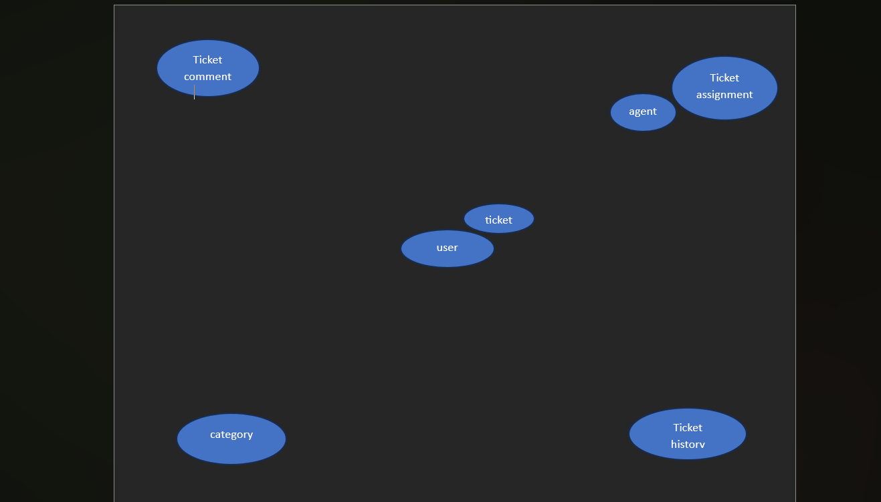

User story 1
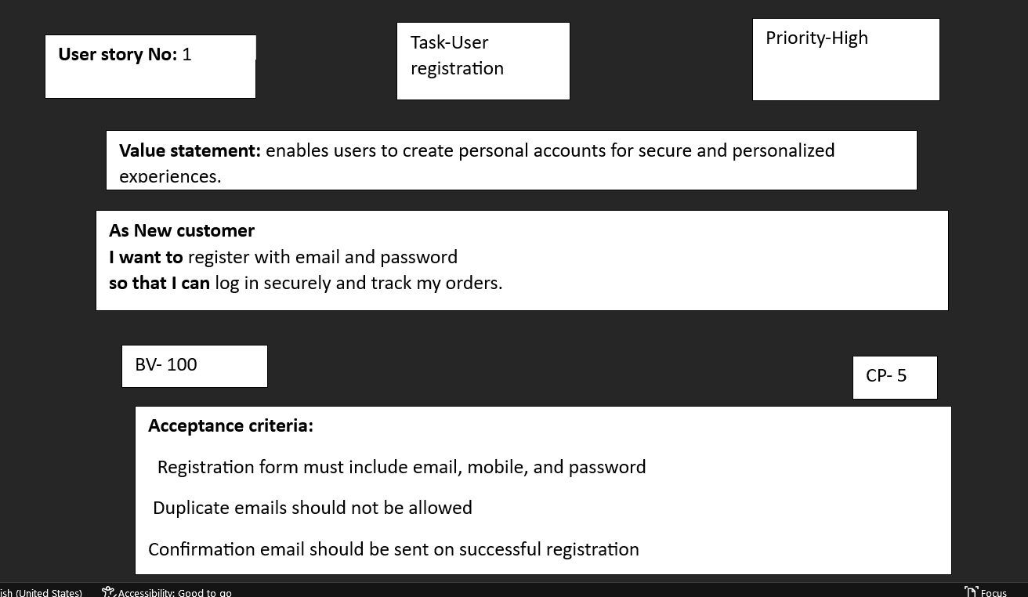

User story 2
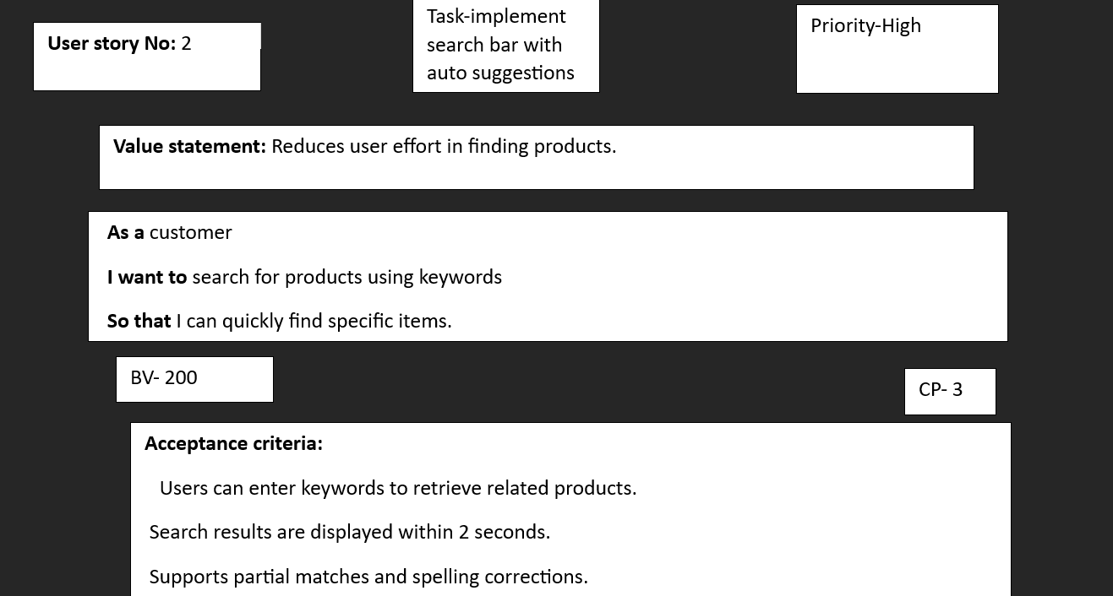
User story 3
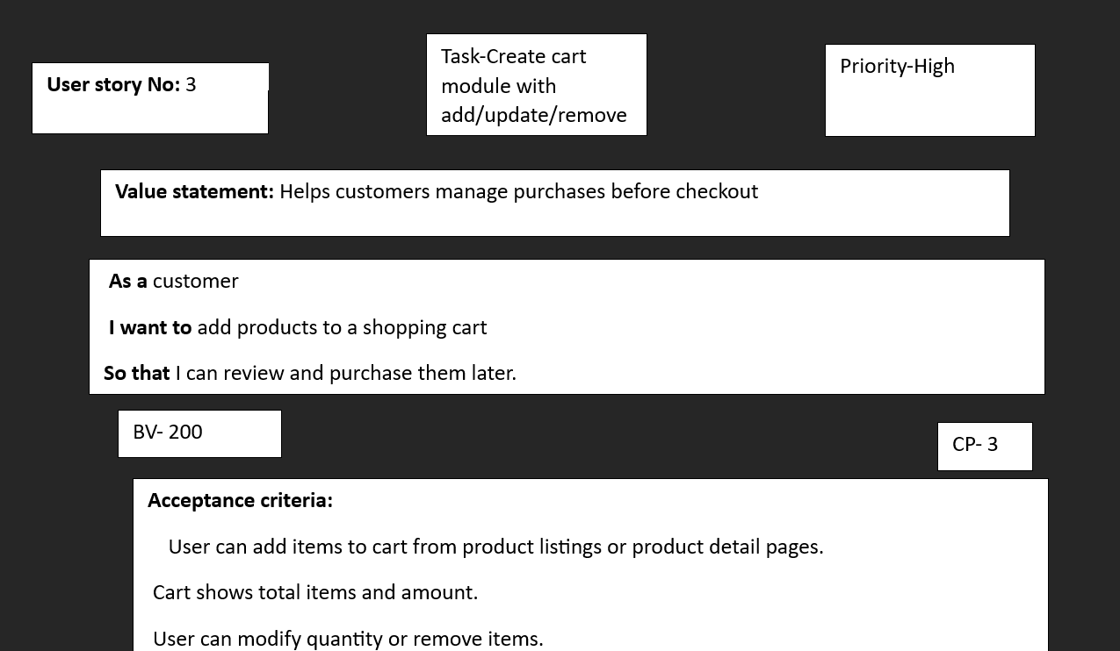
User story 4
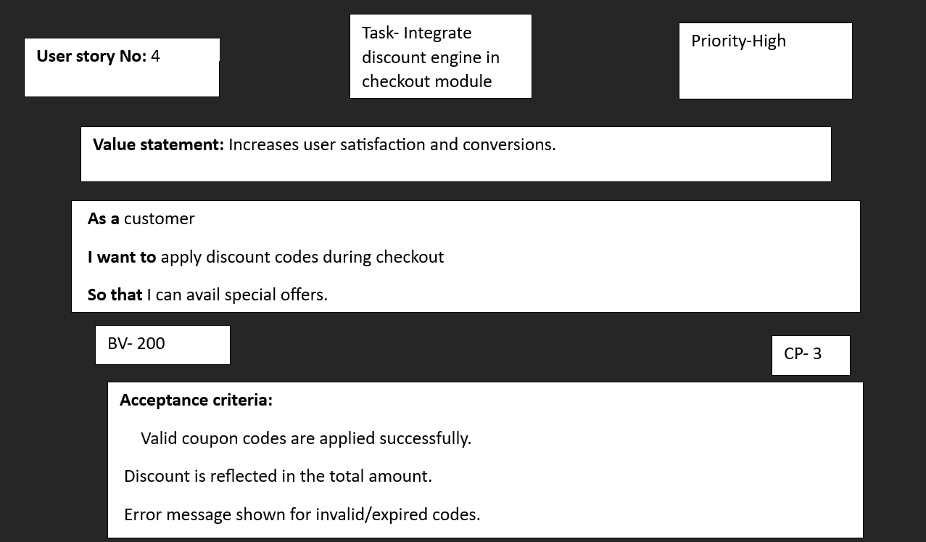
User story 5
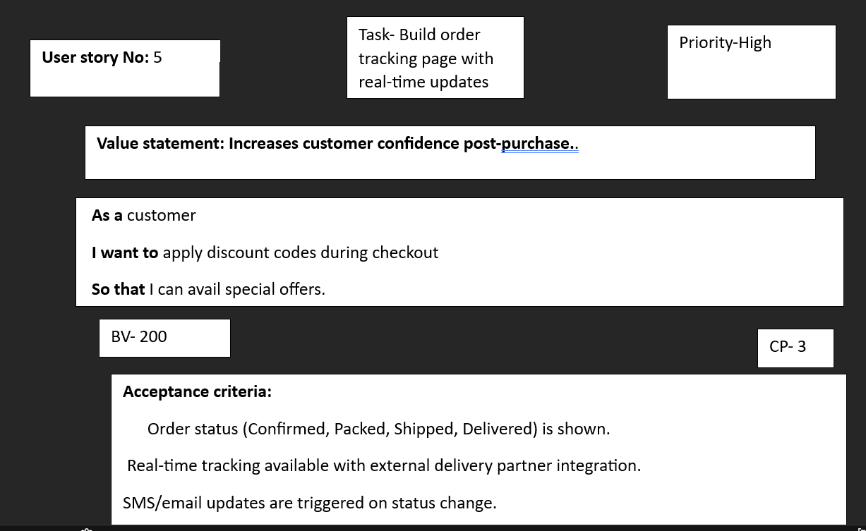
User story 6
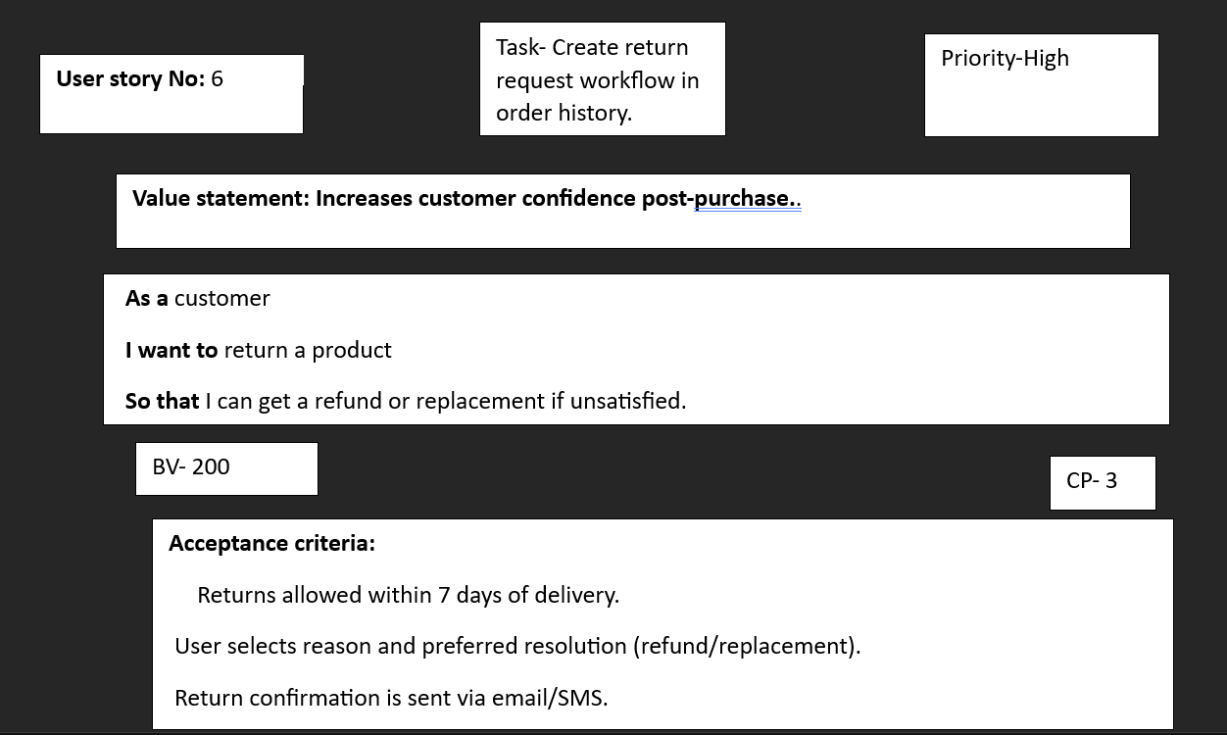
User story 7
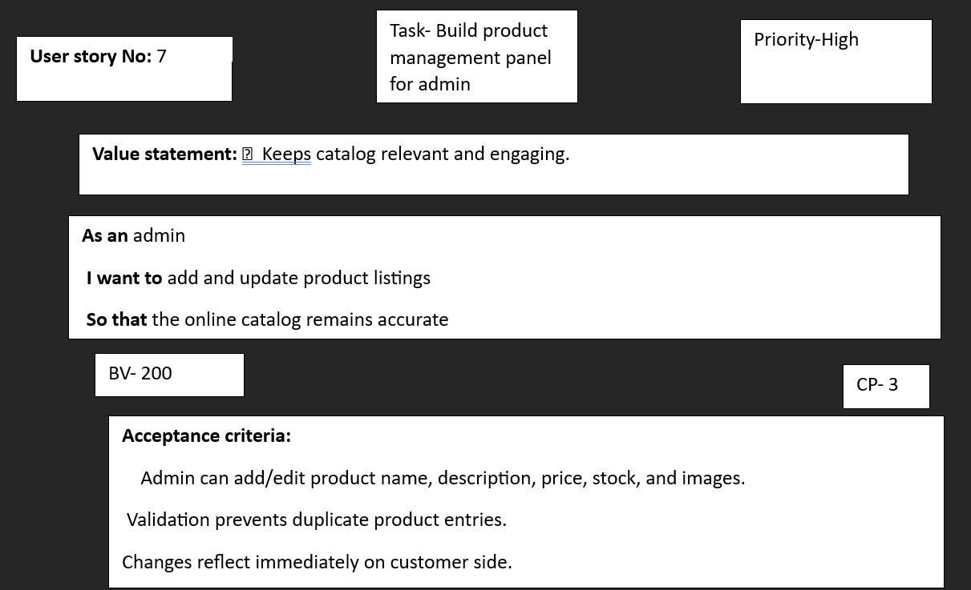

User story 8

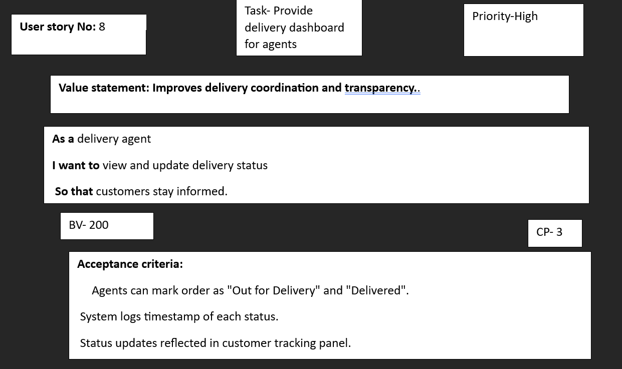
User story 9
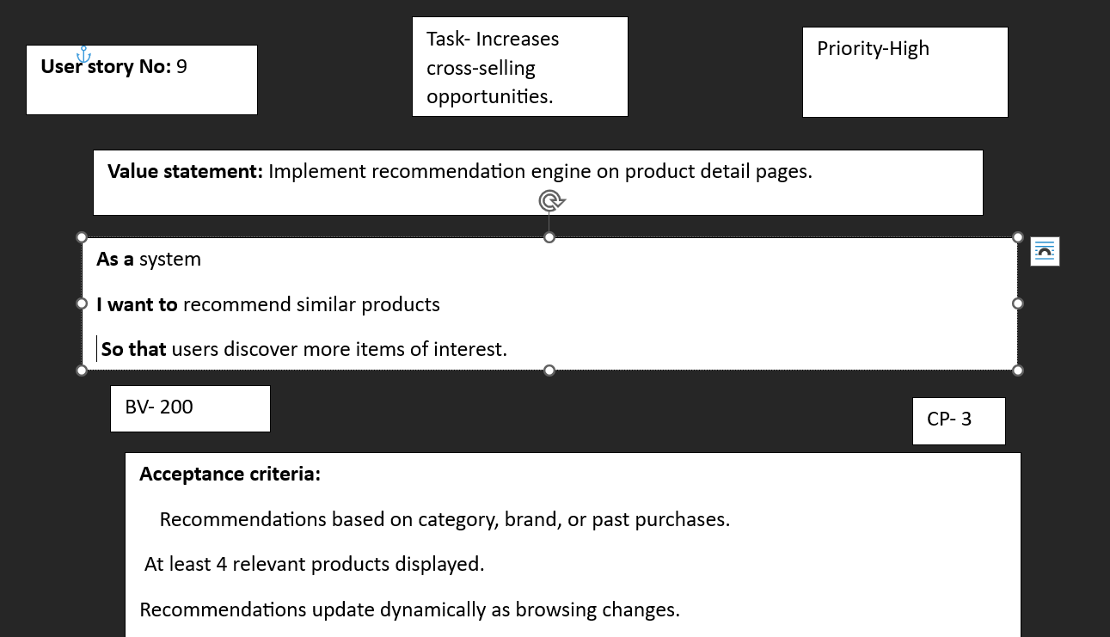
User story 10
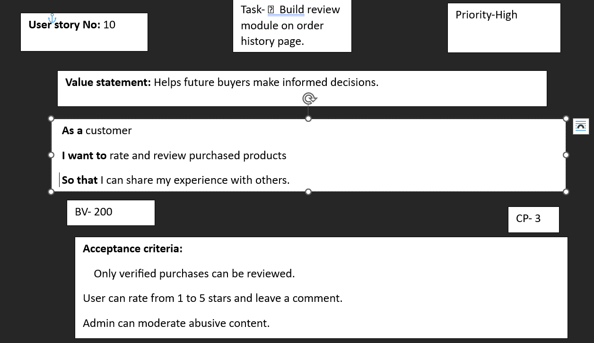
User story 11
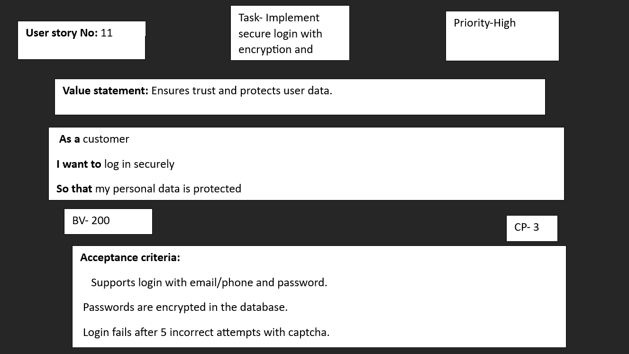
User story 12

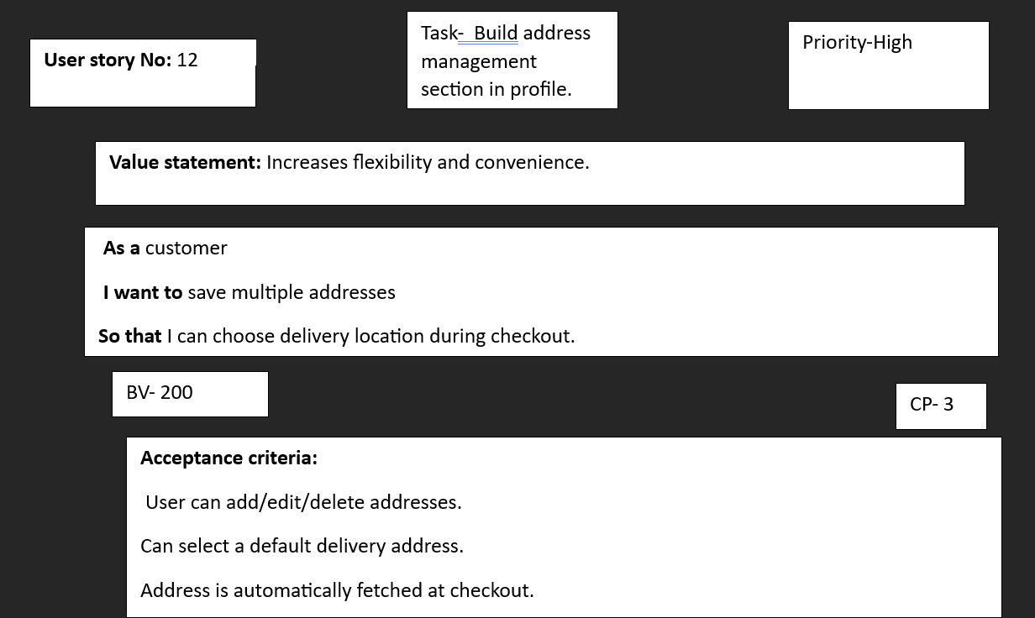
User story 13
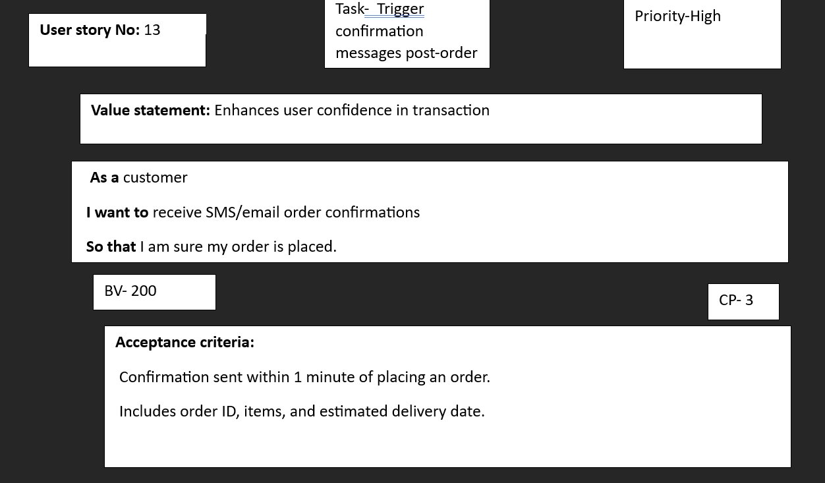
User story 14
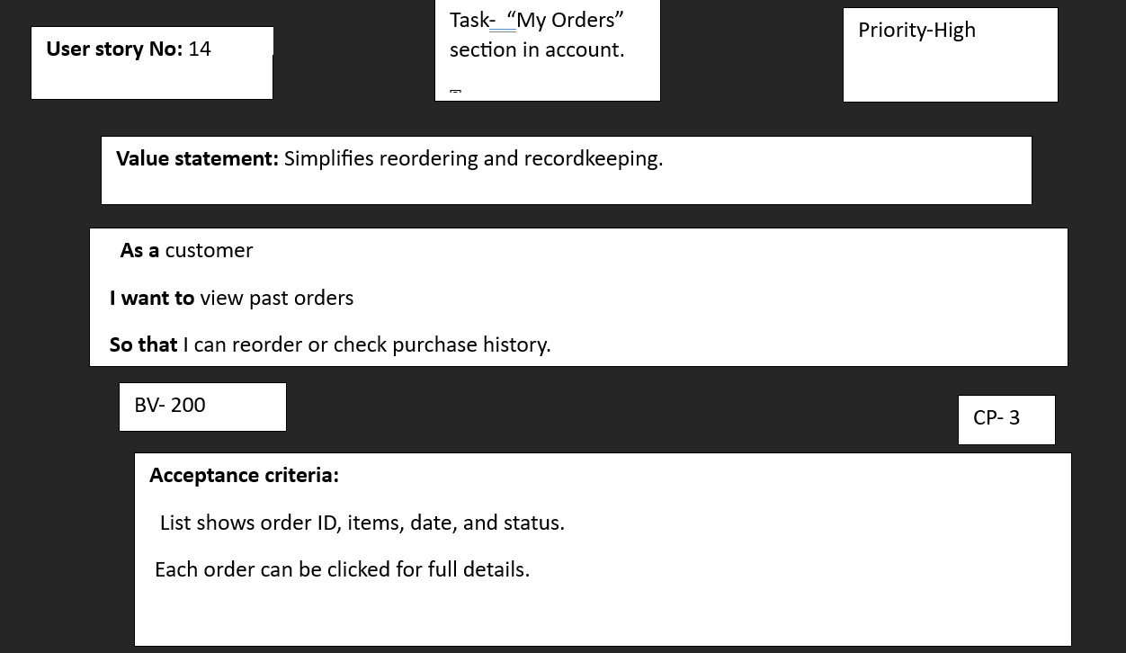
User story 15
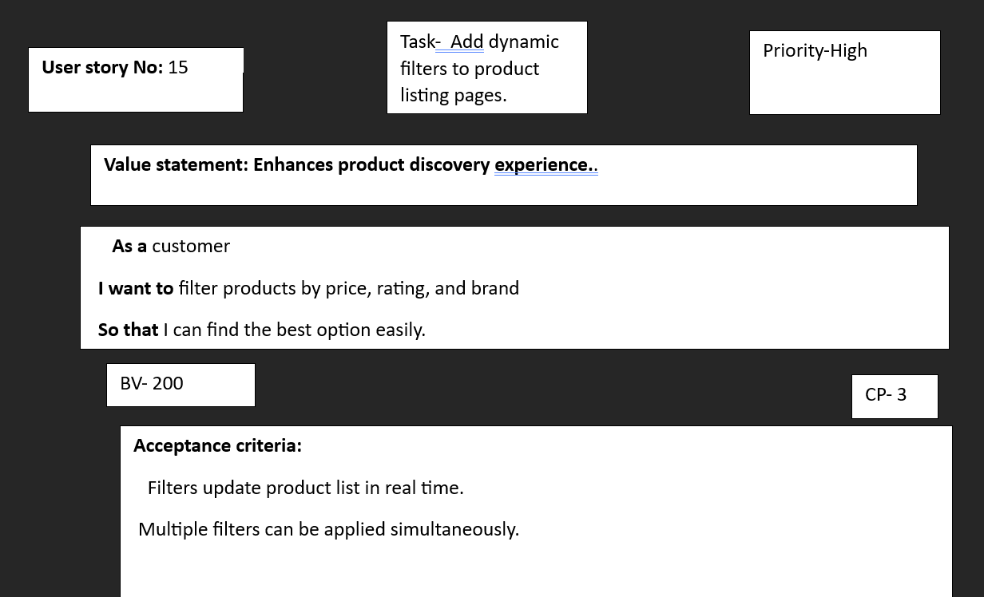
User story 16
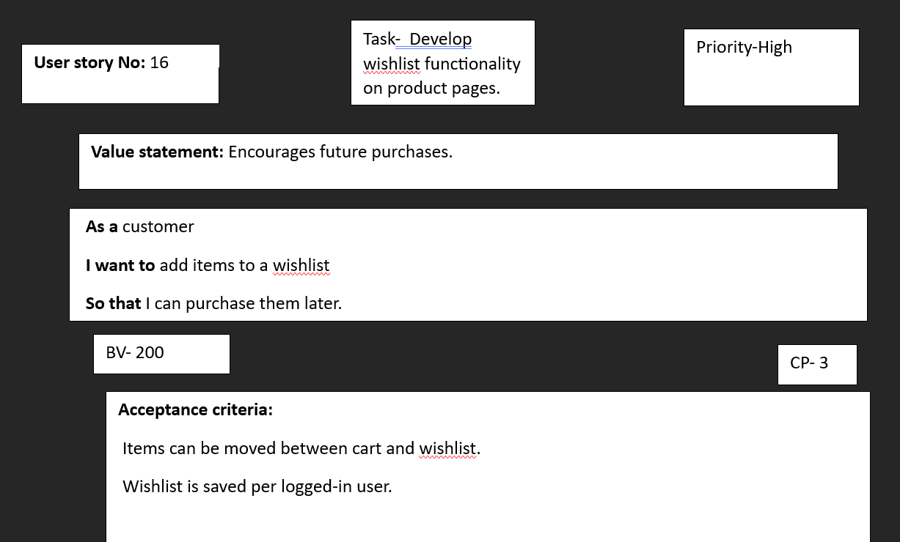
User story 17
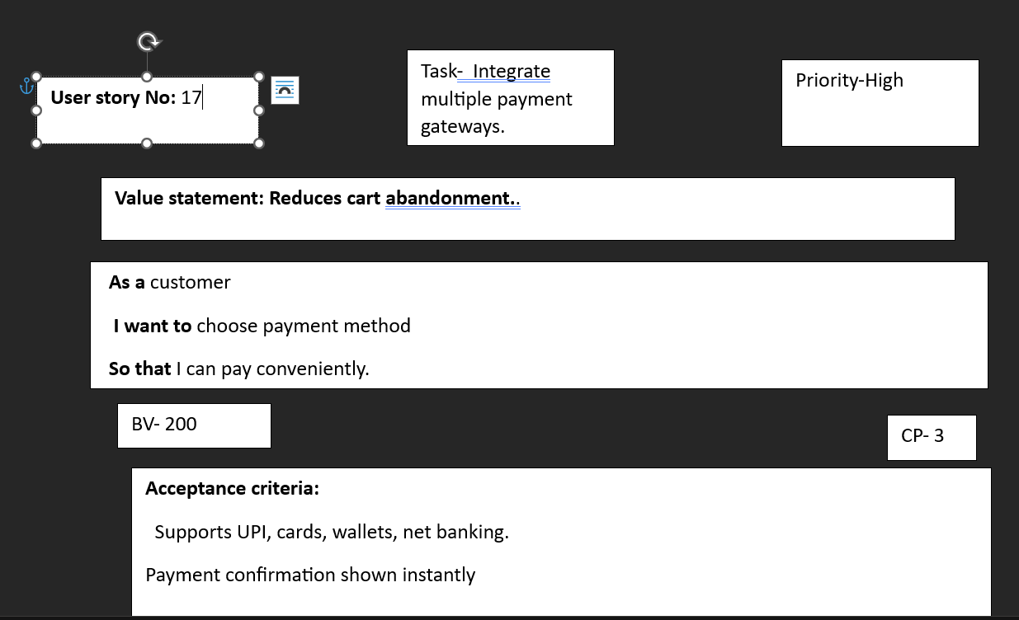
User story 18
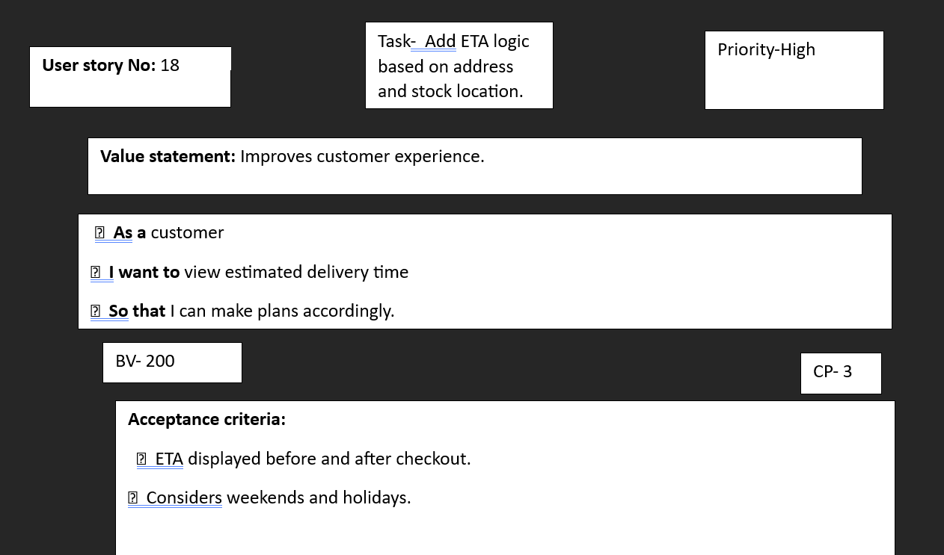
User story 19
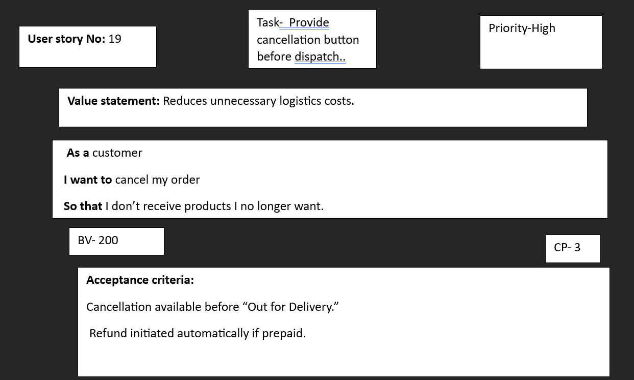
User story 20

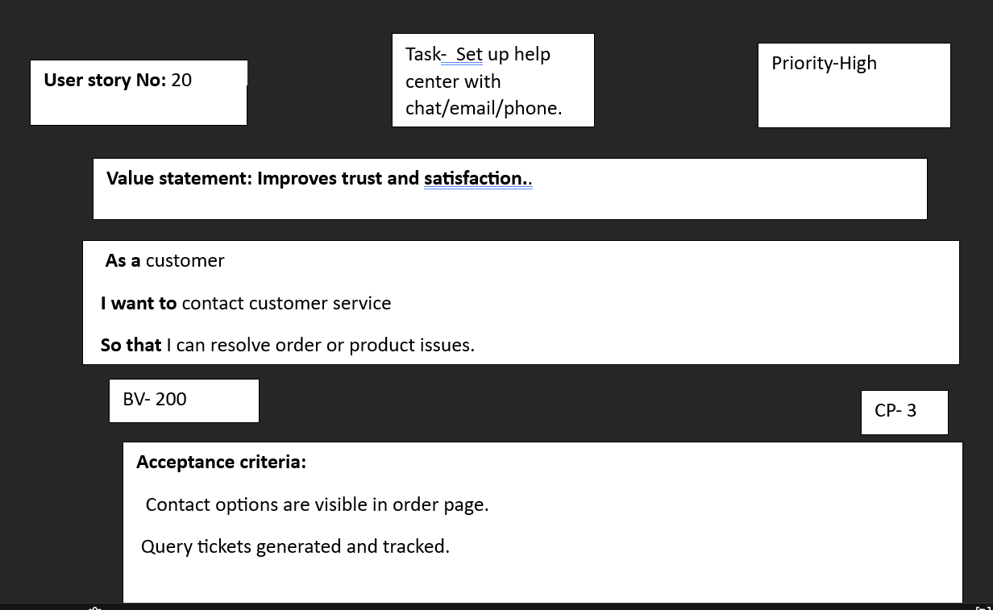
User story 21
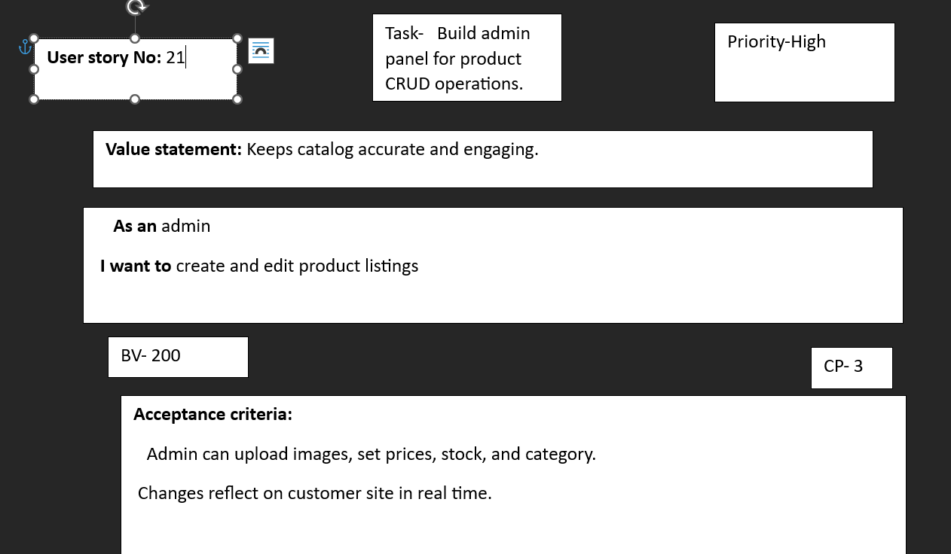
User story 22
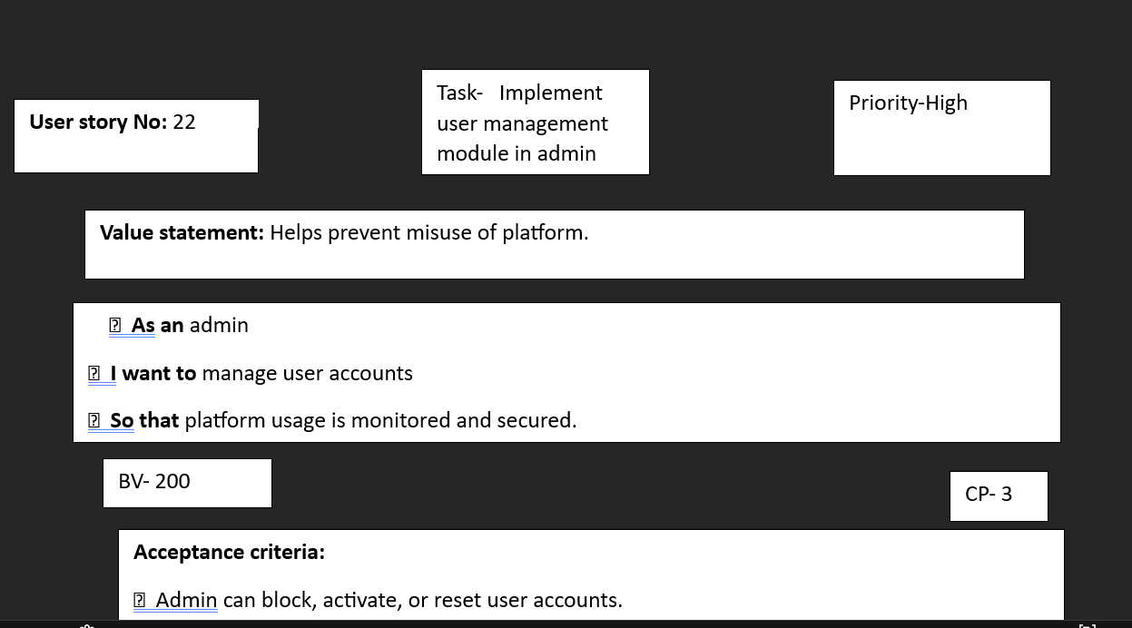

User story 23
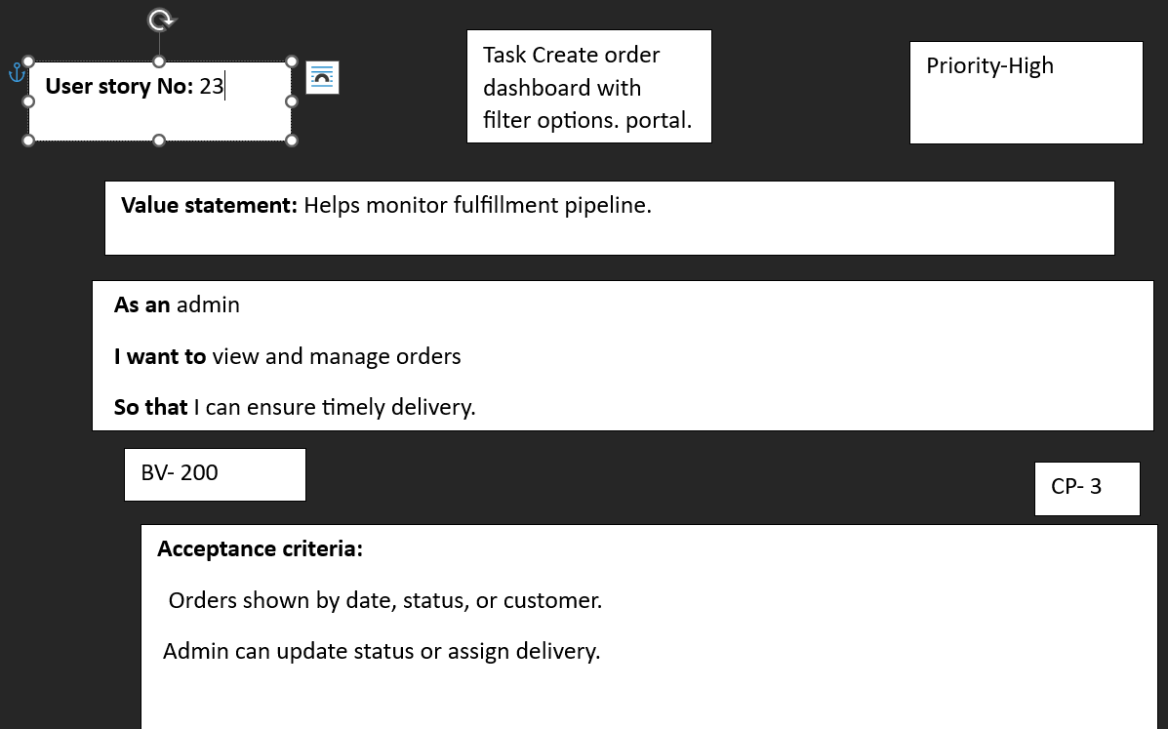
User story 24
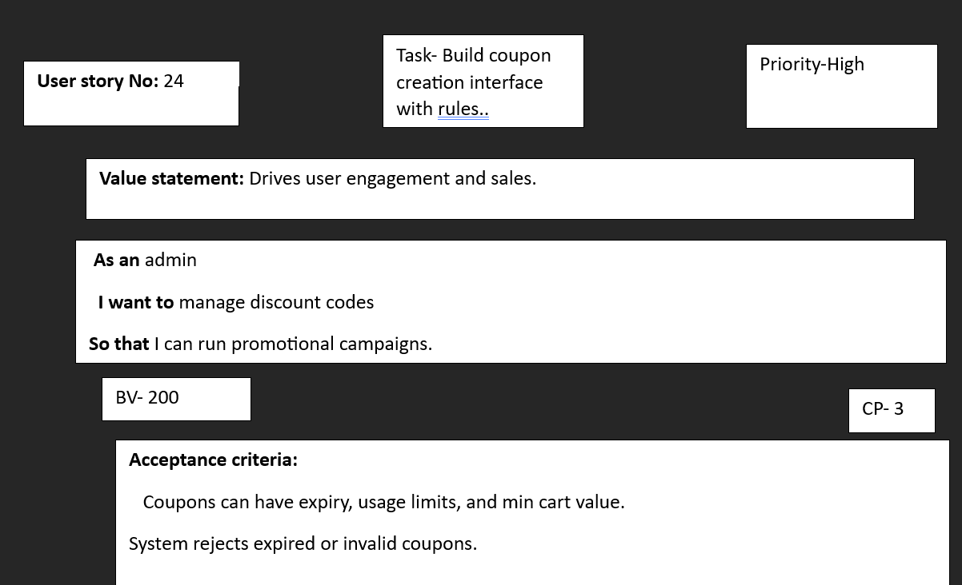
User story 25
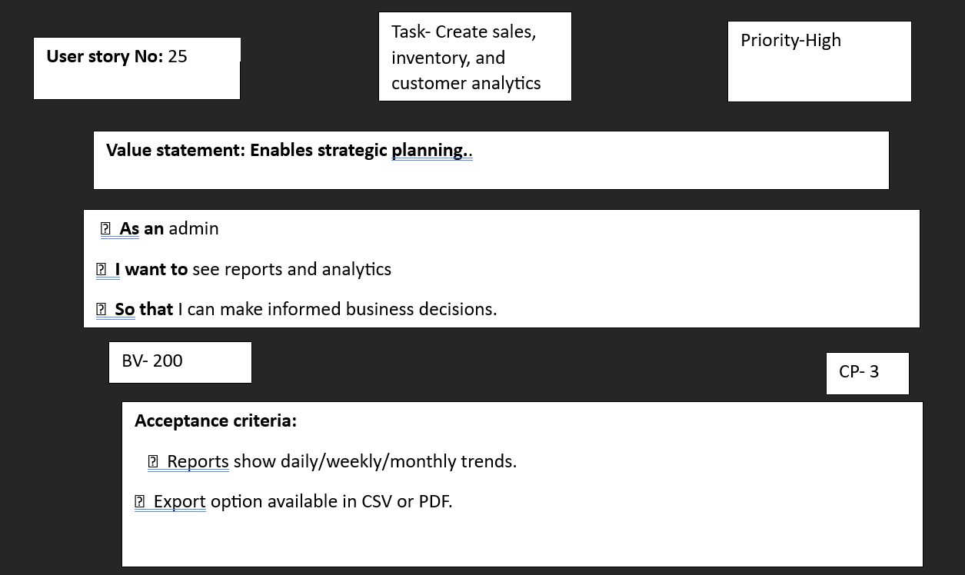
User story 26
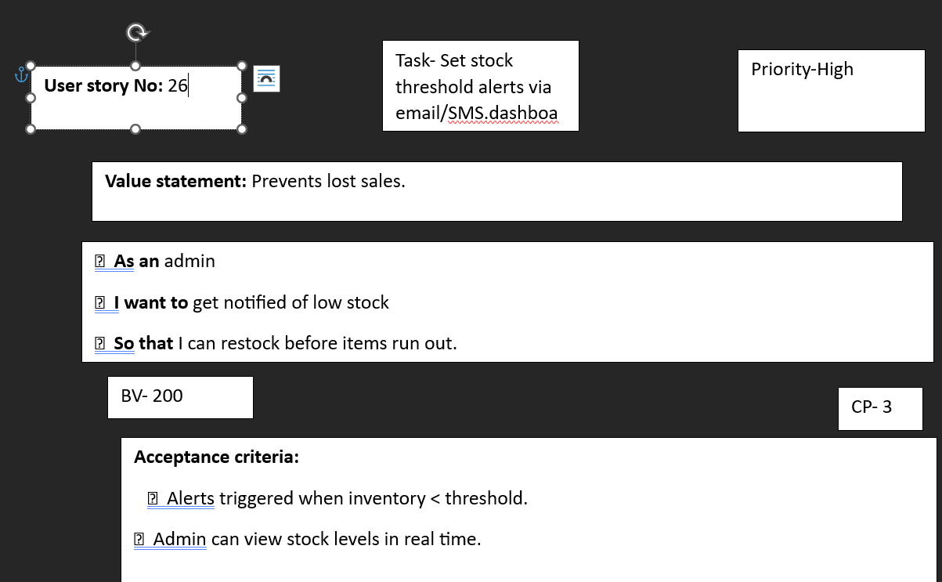
User story 27
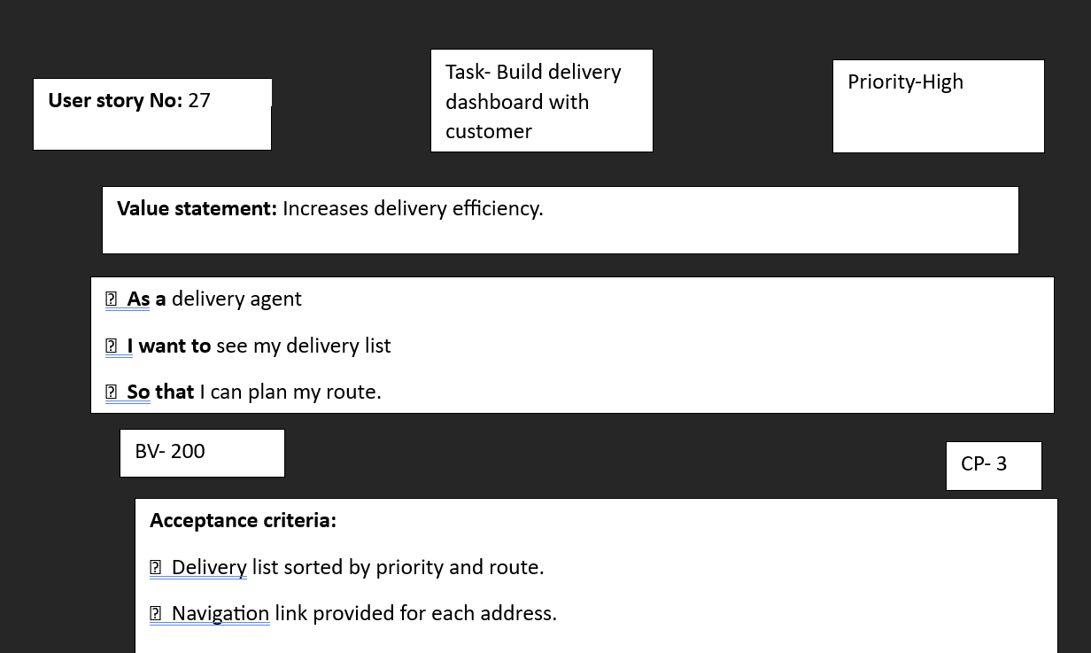
User story 28
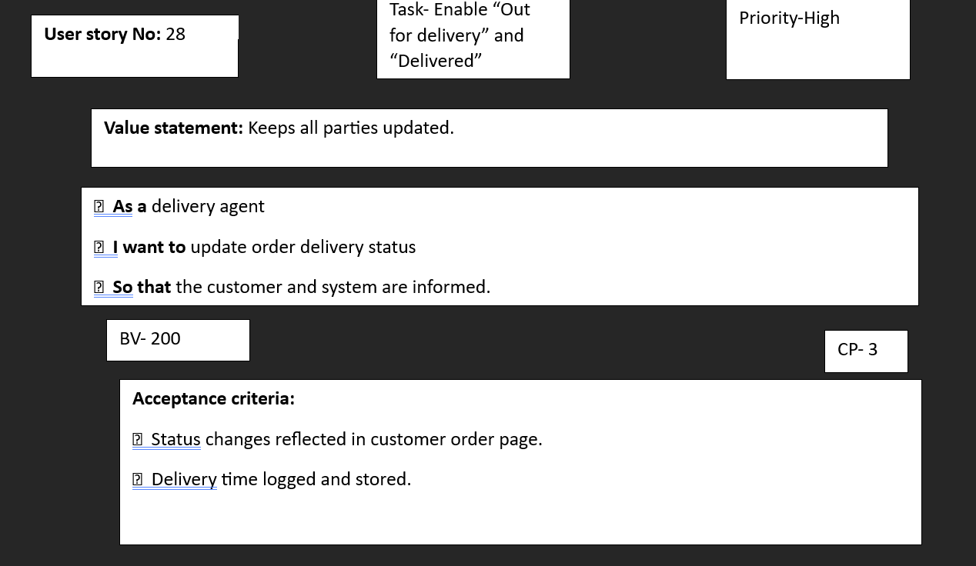
User story 29
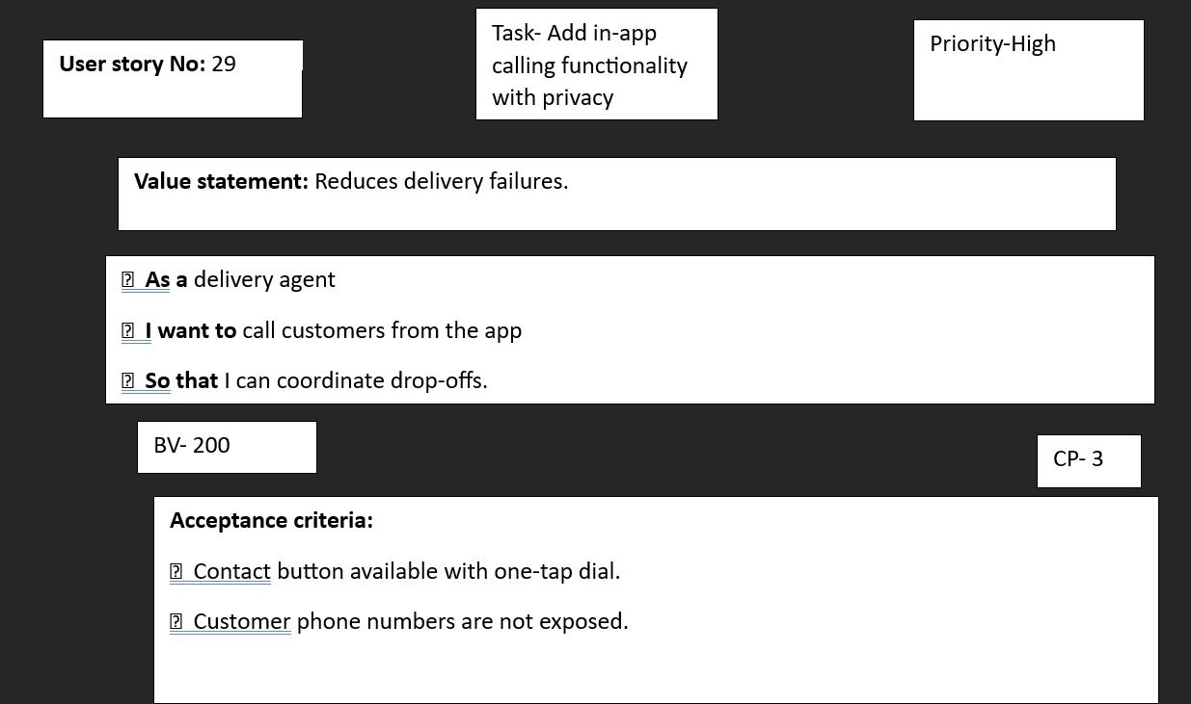
User story 30
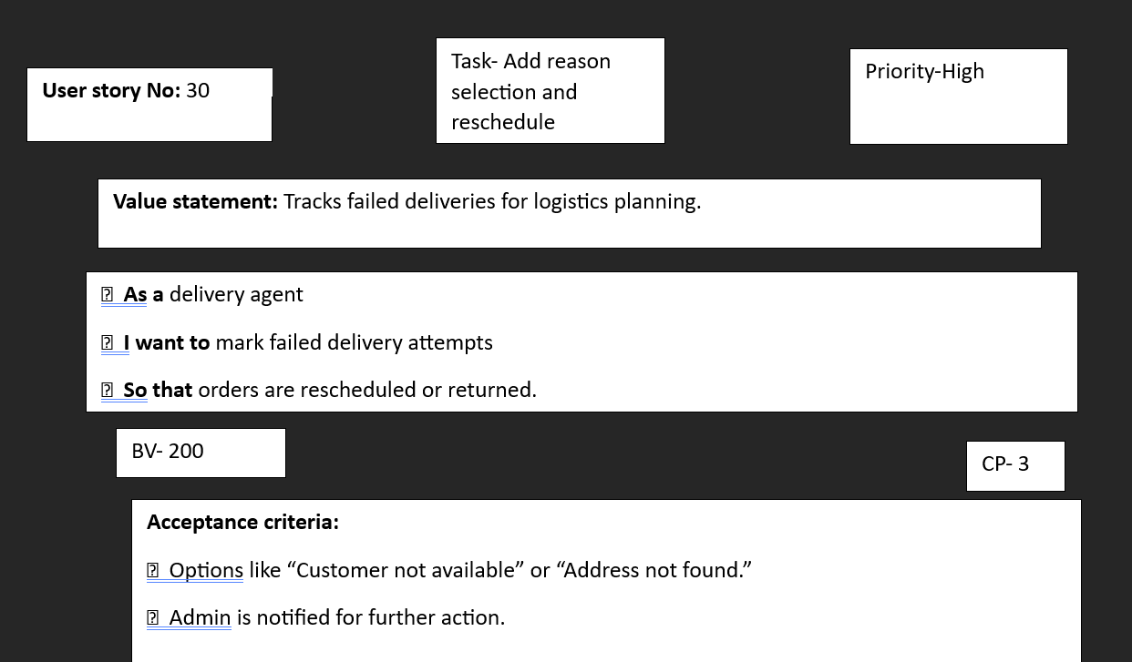
User story 31
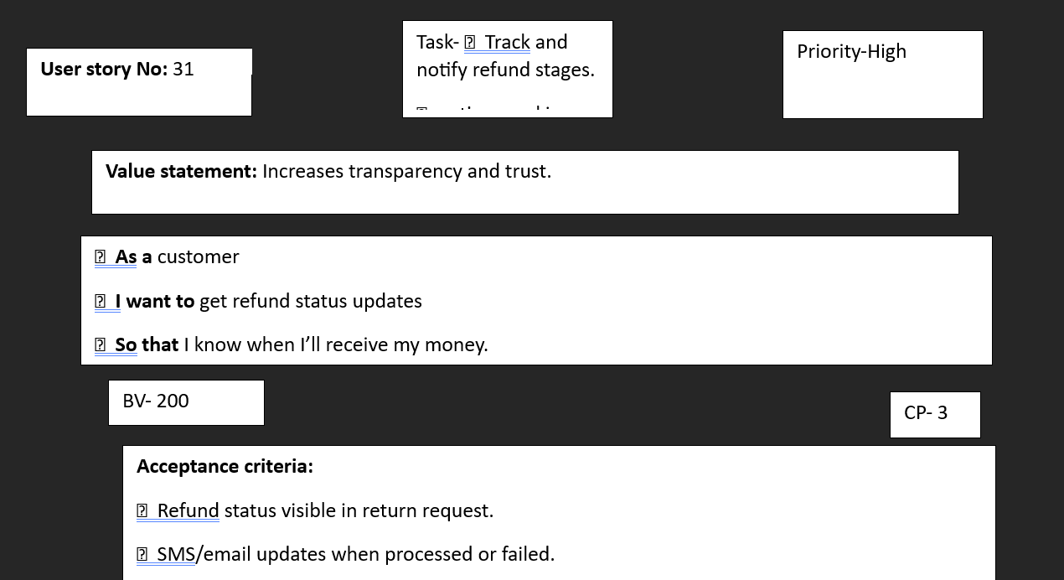
User story 32

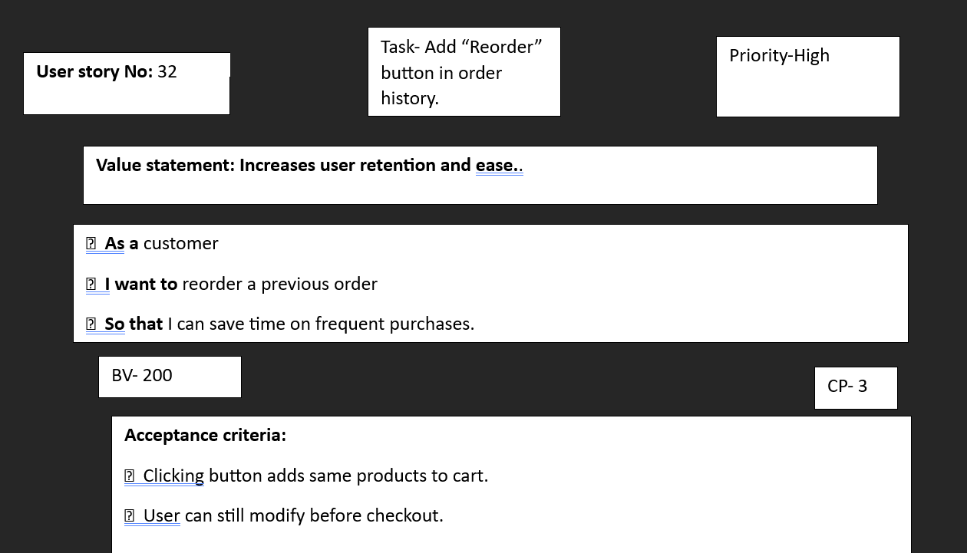
User story 33
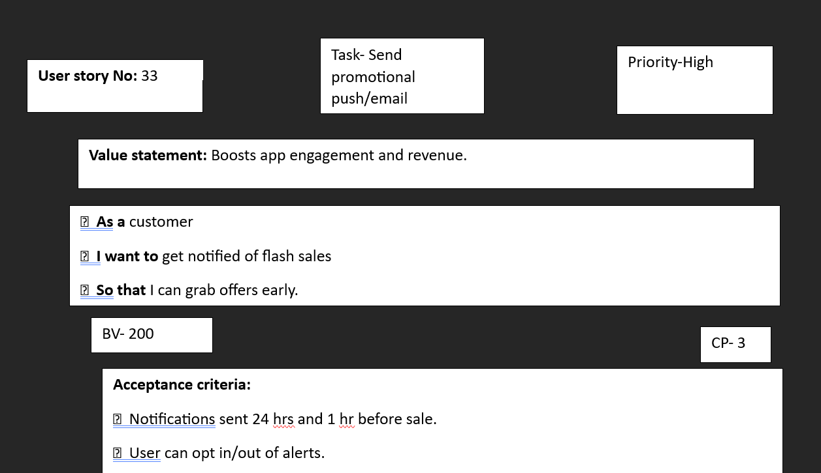
User story 34
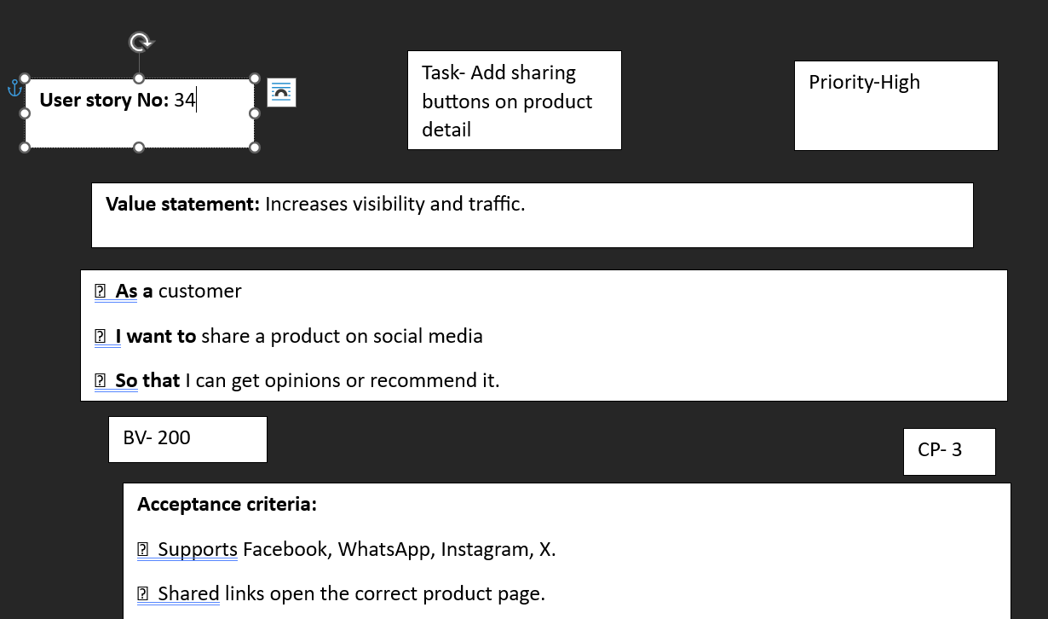

User story 35
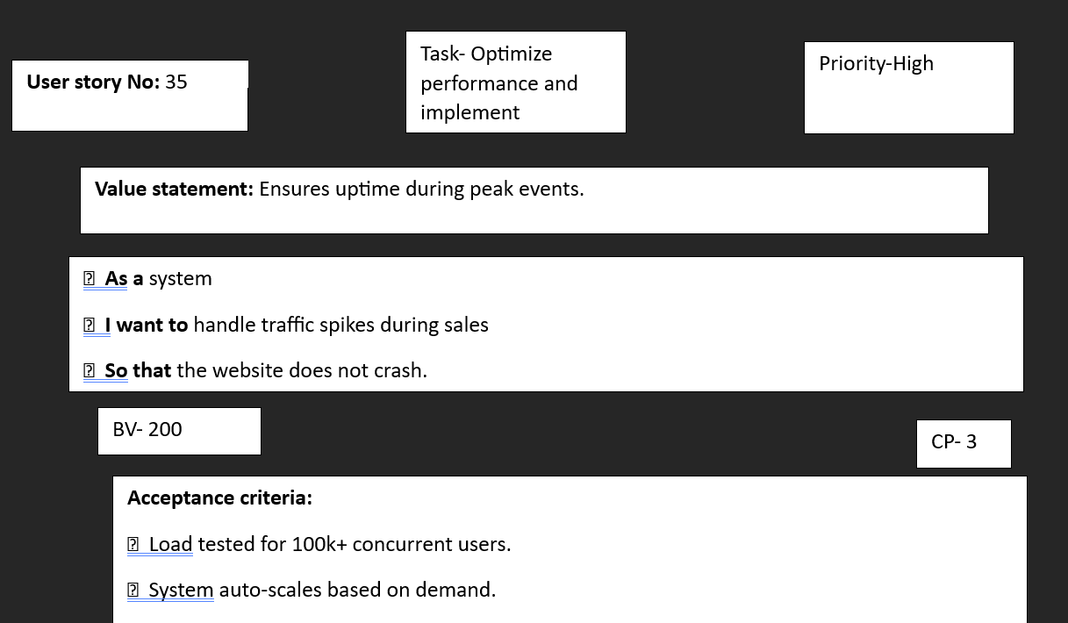
User story 36
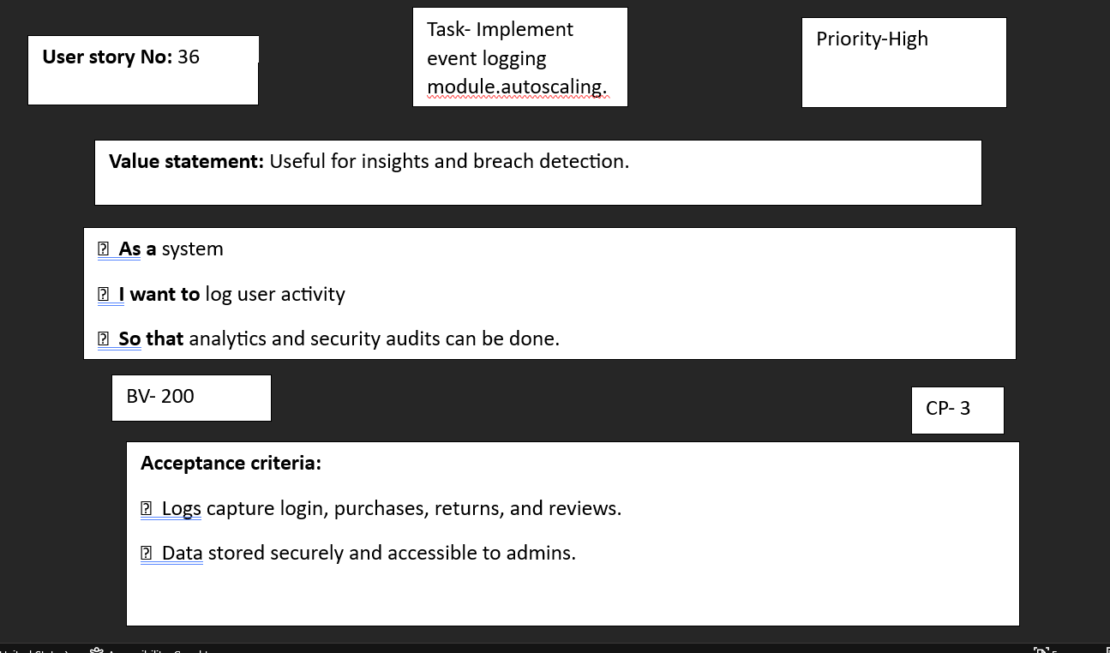
User story 37
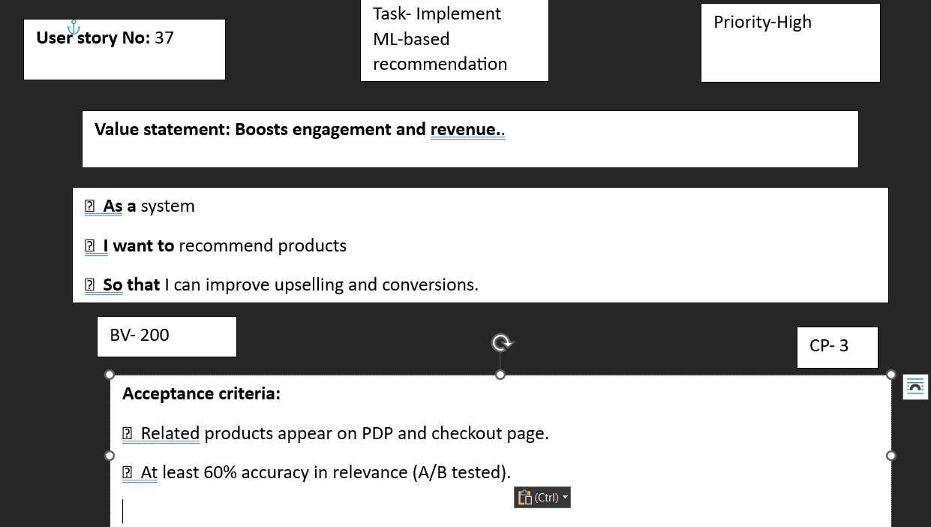
User story 38
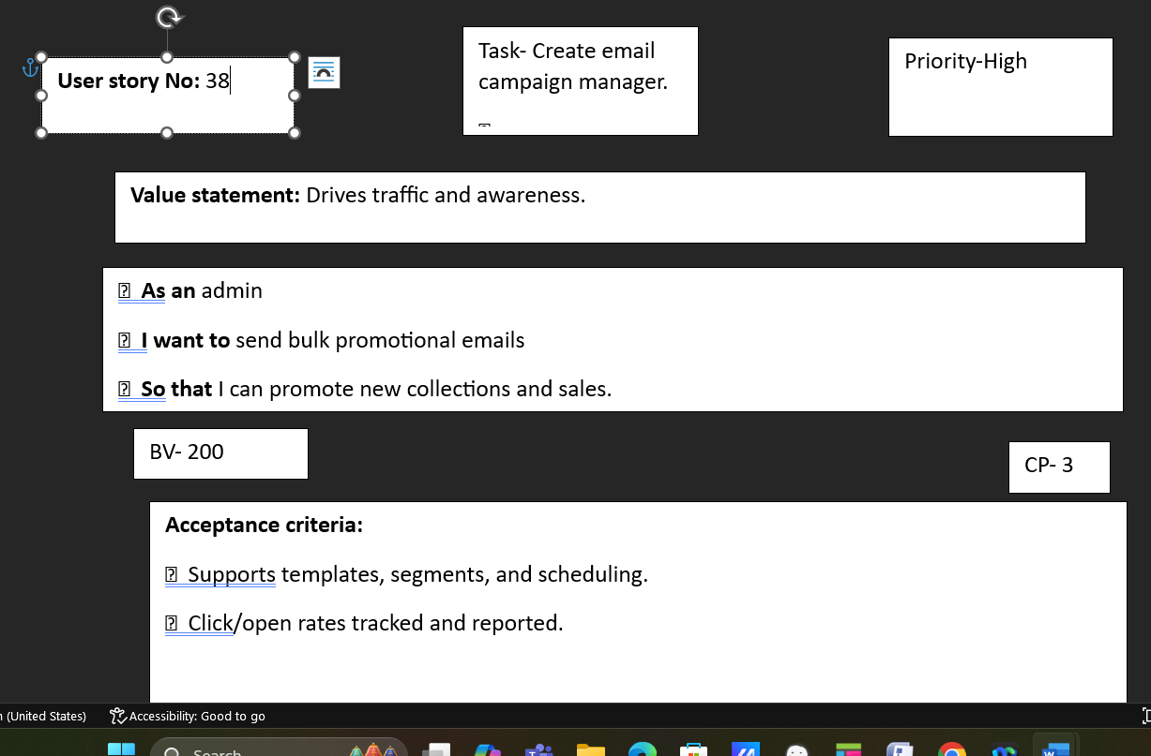
User story 39
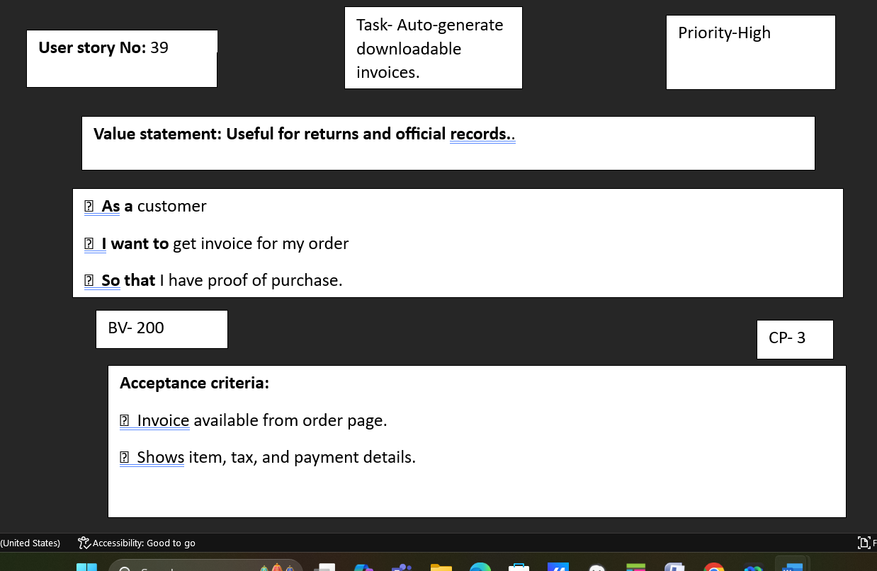
User story 40

