AGILE DOCUMENTS
Document 1: Definition of Done – Data Recovery Automation Enhancement Project (INTACT Platform)
Overview: As per the Agile Extension to the BABOK® Guide v2, the Definition of Done (DoD) is a shared understanding among the team members of the conditions that must be true for any backlog item (e.g., user story) to be considered complete. This ensures consistent quality and alignment with customer expectations.
The DoD is prominently displayed and used across all levels of Agile work – including user story, sprint, and release levels. In our enhancement project for the INTACT Platform (Data Recovery Automation Feature), the following Definition of Done checklist will be used:

Definition of Done Checklist (Applicable for User Story, Sprint, and Release):
- Produced Code for Presumed Functionalities:
  - All intended features related to automated data recovery are coded and functioning.
- Assumptions of User Story Met:
  - All business and technical assumptions listed in the user story have been validated.
- Project Builds Without Errors:
  - The code compiles and builds successfully in the development environment.
- Unit Tests Written and Passing:
  - Relevant unit tests are created and have passed successfully.
- Project Deployed on Test Environment Identical to Production:
  - The feature has been deployed in a staging/testing environment that mirrors production.
- Tests on Devices/Browsers Listed in Project Assumptions Passed:
  - The application works as expected on all specified platforms and browsers.
- Feature Ok-ed by UX Designer:
  - The feature design is reviewed and approved by the UX designer to ensure a seamless user experience.
- QA Performed & Issues Resolved:
  - QA testing is completed and all reported issues are resolved or deferred with approval.
- Feature is Tested Against Acceptance Criteria:
  - All acceptance criteria defined in the user story are verified and met.
- Feature Ok-ed by Product Owner:
- The Product Owner signs off the feature as "done" and fit for release.
- Refactoring Completed:
- The code is optimized and refactored to maintain performance and readability.
- Any Configuration or Build Changes Documented:
- All environment-specific changes are clearly documented and shared with the deployment team.
- Documentation Updated:
- End-user, technical, and process documentation are updated as per the feature.
- Peer Code Review Performed:
- Code is reviewed by at least one peer developer and approved before merging into the main branch.

Document 2- Product Vision:

Scrum Project:
Name: INTACT – Data Recovery Automation Enhancement
Venue: Infosys Project Collaboration Room / Microsoft Teams
Date: Start Date: 01 June 2025 – End Date: 31 August 2025
Start Time: 10:00 AM
End Time: 5:00 PM
Duration: 3 Months (June to August 2025)
Client: Infosys Internal IT Department (INTACT Platform Enhancement)

Stakeholder List:
- IT Operations Head
- Disaster Recovery Lead
- Security & Compliance Officer
- Infrastructure Manager
- End Users (L1/L2 support staff)
- Product Owner
- Scrum Master

Scrum Team
- Scrum Master: Rahul Nair
- Product Owner: Kalyani Bhavsar
- Scrum Developer 1: Aakash Mehta (Backend Developer)
- Scrum Developer 2: Priya Sinha (Frontend Developer)
- Scrum Developer 3: Sanjay Rawat (QA Tester)
- Scrum Developer 4: Nisha Kulkarni (Automation Engineer)
- Scrum Developer 5: Ravi Patil (DevOps & Deployment)

Vision
The vision of this project is to enhance the INTACT platform by integrating Data Recovery Automation features, minimizing downtime, improving resilience, and ensuring faster recovery during outages or disasters. This automation aims to boost operational efficiency while maintaining compliance with internal SLAs and business continuity objectives.

Target Group
Criteria | Details
Market Segment | IT Infrastructure Management and Enterprise Service Management Tools
Target Users | System Admins, L1/L2 Support Engineers, Recovery Officers
Target Customers | Infosys Internal IT Teams & Business Units relying on INTACT

Needs
Problem | Solution/Benefit
Manual recovery is time-consuming and error-prone. | Automated workflows reduce manual errors and time.
No single-click recovery options. | Integrate predefined scripts for auto-recovery of services.
Delays in detecting and resolving outages. | Real-time dashboards and alerting integrated with recovery steps.
Limited visibility into historical recovery actions. | Enhanced audit and logging module for all recovery events.

Product
Aspect | Details
What is the product? | A recovery automation module integrated within the INTACT platform.
Special Features | Auto-recovery triggers, customizable workflows, multi-tier fallback system, audit trails.
Feasibility | Yes – Feasible with existing tech stack (Java, Oracle, Jenkins, Bash scripting) and skilled team in place.

Value
Aspect | Details
Benefit to Company | Reduces MTTR, improves SLA adherence, reduces manual effort, enhances service reliability.
Business Goals | 30% faster recovery, improved operational stability, increased user confidence in INTACT.
Business Model | Internal IT support efficiency → reduced downtime → lower indirect operational costs.

3. USER STORIES

User story No: 1 | Tasks: Design UI, Develop recovery trigger, Test recovery job | Priority: High
Value statement:As a system admin,I want to trigger automatic data recovery,so that I can restore lost incident records without manual intervention.
BV: 8 | CP: 5
Acceptance criteria:✔ A “Recover Data” button is available on the incident management screen.✔ Clicking the button initiates data recovery from the last available backup.✔ Recovery status and logs are displayed post action.✔ Admin is notified if the recovery fails.

User story No: 2 | Tasks: Integrate backup verification logic, UI error messages | Priority: Medium
Value statement:As a user,I want to be notified if recovery data is corrupted,so that I can take alternate action manually.
BV: 6 | CP: 4
Acceptance criteria:✔ System checks the integrity of backup before initiating recovery.✔ Clear error messages shown for corrupted or incomplete backups.✔ Incident flagged for manual intervention if corruption is found.

User story No: 3 | Tasks: Create dashboard view, link recovery logs | Priority: High
Value statement:As a team lead,I want to view past recovery attempts,so that I can analyze issues and improve future automation.
BV: 7 | CP: 3
Acceptance criteria:✔ Dashboard displays timestamped log of recovery attempts.✔ Success/failure status is shown with reason if failed.✔ Search and filter options are available for logs.

User story No: 4 | Tasks: Setup user roles, Validate access control | Priority: High
Value statement:As a system admin,I want to restrict data recovery feature to authorized users only,so that I can ensure security and control access.
BV: 8 | CP: 2
Acceptance criteria:✔ Only users with "Recovery Manager" role can trigger recovery.✔ Unauthorized users are shown an access denied message.✔ All actions are logged with user details for audit.

User story No: 5 | Tasks: Test multi-platform compatibility, optimize recovery logic | Priority: Medium
Value statement:As a QA tester,I want to test data recovery across different browsers,so that I can ensure consistent behavior of the feature.
BV: 5 | CP: 4
Acceptance criteria:✔ Recovery works smoothly on Chrome, Firefox, and Edge.✔ UI elements align properly across devices.✔ Performance time remains under defined limit on each platform.

Document 4: Agile Product Owner Experience
As the Product Owner for the Data Recovery Automation enhancement project under the INTACT platform, my role centered around delivering high-value features in a timely and collaborative Agile environment. With a clear vision grounded in domain understanding and stakeholder needs, I ensured smooth coordination between technical teams and business units.

Responsibilities as a Product Owner
1. Market Analysis
- Conducted analysis to validate the need for a Data Recovery Automation enhancement.
- Compared existing tools like ServiceNow (SNOW) to identify differentiators and improvement opportunities.
2. Enterprise Analysis
- Evaluated ROI, feasibility, and benefits of adding automation to the current INTACT platform.
- Understood operational pain points from previous manual recovery processes.
3. Product Vision and Roadmap
- Defined a clear product vision focusing on reducing downtime and improving system resilience.
- Created a high-level roadmap outlining epics and major features across 3 months of development.
4. Managing Product Features
- Prioritized features based on business criticality, value addition, and risk reduction.
- Balanced both technical and non-technical stakeholder expectations.
5. Managing Product Backlog
- Created and prioritized user stories in JIRA with clear value statements and acceptance criteria.
- Maintained the backlog actively, incorporating stakeholder feedback after each sprint review.
6. Managing Iteration Progress
- Monitored sprint burn-down and tracked velocity to ensure progress matched commitments.
- Participated in retrospectives and supported continuous improvement by analyzing team feedback.

Agile Events Participated As Product Owner
- Sprint Planning Meetings: Defined sprint goals and selected backlog items with the team.
- Daily Scrum Meetings: Addressed blockers and helped team realign priorities.
- Sprint Review Meetings: Demonstrated completed stories and gathered business feedback.
- Sprint Retrospective Meetings: Contributed inputs for better planning and delivery processes.
- Backlog Refinement Sessions: Reprioritized items and improved user story detailing.

User Story Detailing
Each user story created as part of the Data Recovery Automation project followed a structured format:
- Story No
- Value Statement (As a user… I want to… So that I can…)
- Tasks
- Priority
- BV (Business Value) & CP (Complexity Points)
- Acceptance Criteria

Key Learnings and Contributions
- Learned how to break down epics into actionable stories and align them with sprint goals.
- Developed strong collaboration skills with developers, testers, and stakeholders.
- Improved estimation accuracy by participating in story pointing sessions.
- Contributed to Agile maturity by fostering a culture of continuous feedback and iteration.

Document 5: Product and sprint backlog and product and sprint burndown charts

Product Backlog
User Story ID | User Story | Tasks | Priority | BV | CP | Sprint
US001 | As a user, I want to auto-detect system failures so that I can prevent downtime. | Design failure detection logic, build module, test | High | 8 | 3 | Sprint 1
US002 | As a user, I want automatic backup initiation so that I don’t lose data. | Integrate auto-backup scheduler, testing | High | 7 | 2 | Sprint 2
US003 | As an admin, I want to receive alerts for failures so I can act immediately. | Setup alert rules, integrate SMS/Email notifications | Medium | 6 | 2 | Sprint 2
US004 | As a user, I want to view recovery logs so I can track recovery operations. | Create log UI, backend for data fetching | Medium | 5 | 2 | Sprint 3
US005 | As a manager, I want a report of downtime incidents so I can audit performance. | Design report templates, export functionality | Low | 4 | 2 | Sprint 3

Sprint Backlog

User Story ID | User Story | Tasks | Owner | Status | Estimated Effort (hrs)
US002 | Enable real-time recovery status dashboard | UI design, wireframe approval | Dev 3 | Completed | 8
 | Backend data binding & chart integration | Dev 4 | In Progress | 10
 | Test data refresh rate & responsiveness | QA Tester | To Do | 5

User Story ID | User Story | Tasks | Owner | Status | Estimated Effort (hrs)
US004 | Implement Audit Log for Recovery Events | Requirement validation, stakeholder sign-off | BA | Completed | 4
 | Design and develop audit trail module | Dev 1 | In Progress | 9
 | Integrate logs with reporting dashboard | Dev 2 | To Do | 6
 | Functional & security testing of audit logs | QA Tester | To Do | 5

User Story ID | User Story | Tasks | Owner | Status | Estimated Effort (hrs)
US001 | Auto-detect system failures | Requirement review, design logic, unit testing | Dev 1 | In Progress | 12
 |  | Backend API creation, Integration | Dev 2 | To Do | 10
 |  | QA & Debugging | QA Tester | To Do | 6

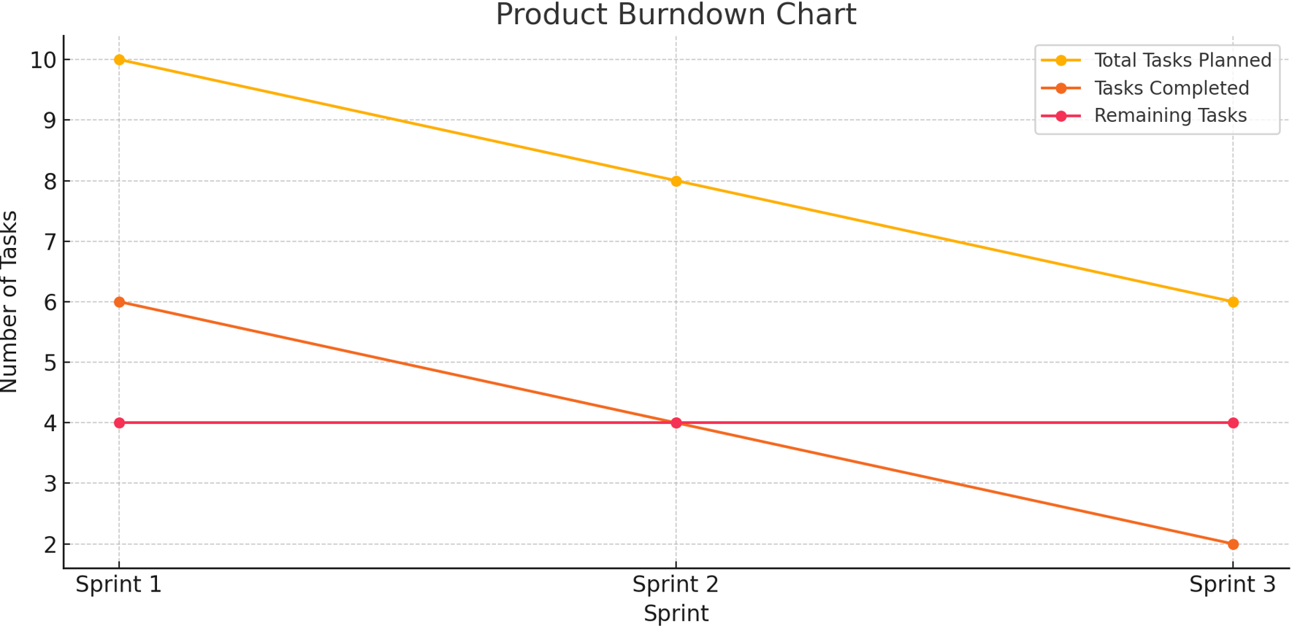

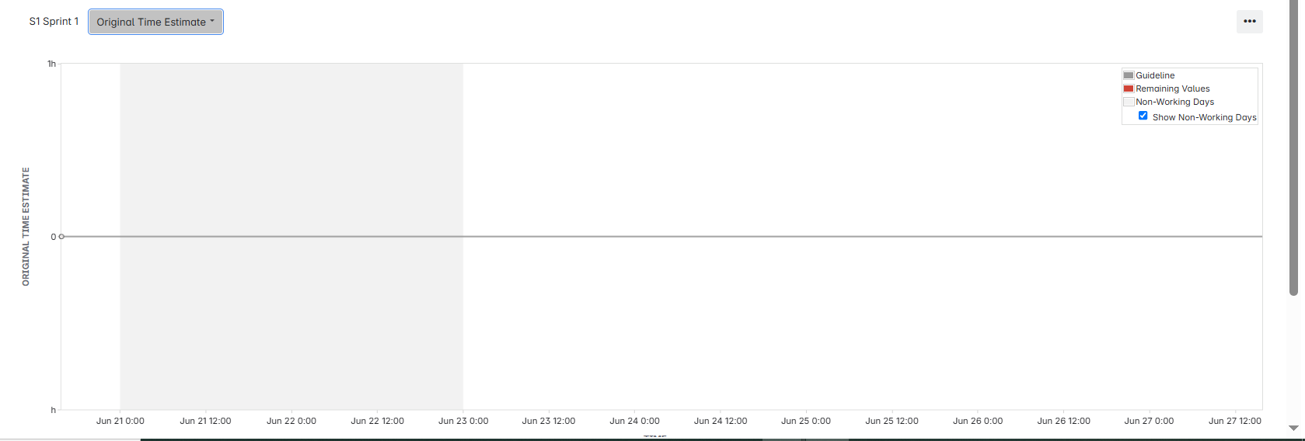

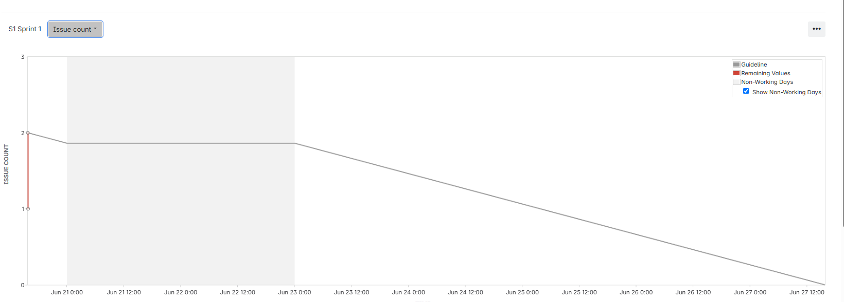

Document 6: Sprint meetings

Field | Details
Date | 01-Jun-25
Time | 10:00 AM
Location | Microsoft Teams / Project Room A
Prepared By | Product Owner – Kalyani Bhavsar
Attendees | Scrum Master, Developers, QA, Product Owner

Agenda Topics
Topic | Presenter | Time allotted
Project Overview | Scrum Master | 10 mins
Review Product Backlog | Product Owner | 20 mins
Select Stories for Sprint | Scrum Team | 15 mins
Define Sprint Goal & Tasks | All Developers | 15 mins
Other Information
Observers | QA Team Lead
Resources | JIRA Board, Confluence, Visio
Special Notes | Follow-up for story clarification in next call

Meeting Type 2: Sprint Review Meeting
Field | Details
Date | 14-Jun-25
Time | 4:00 PM
Location | Microsoft Teams / Intact Demo Room
Prepared By | Scrum Master
Attendees | Scrum Team, Stakeholders, Business Head
Sprint status | Things to demo | Quick updates | What’s next
Completed | Auto incident detection | Minor bug fixes done | Begin enhancement on Data Reports

Meeting Type 3: Sprint Retrospective Meeting
Field | Details
Date | 15-Jun-25
Time | 2:30 PM
Location | Microsoft Teams
Prepared By | Scrum Master
Attendees | Scrum Team
Agenda | What went well | What didn’t go well | Questions | Reference
Retrospective | Collaboration was effective | Delay in integration | Better testing plan? | Jira Sprint board, Confluence

Meeting Type 4: Daily Stand-up Meeting
Question | Name/Role | Monday | Tuesday | Wednesday | Thursday | Friday | Saturday | Sunday
What did you do yesterday? | Priya Sinha (Frontend Developer) | Design | Review | Coding | Testing | Fixes | - | -
 | Aakash Mehta (Backend Developer) | Setup | Backend | API Dev | Test | Fix | - | -
 | Sanjay Rawat (QA Tester) | QA Plan | Test | Report | Verify | - | - | -
What will you do today? | Priya Sinha (Frontend Developer) | Review | Coding | Testing | Fix | Deploy | - | -
 | Aakash Mehta (Backend Developer) | API Dev | Test | Fix | QA | Review | - | -
 | Sanjay Rawat (QA Tester) | Execute | Report | Bug log | Feedback | - | - | -
What (if any) is blocking you? | Aakash Mehta (Backend Developer) | None | None | API delay | None | None | - | -
 | Nisha Kulkarni (Automation Engineer) | Setup | None | None | Integration | None | - | -
 | Ravi Patil (DevOps & Deployment) | Env | None | Delay | None | - | - | -

