Capstone Project 1 – Part 3/3

Question 1 – Functional Requirements
Identify minimum 20 functional requirements

Answer 1 –
Functional Requirements specify the behaviour, functions and operations of a system based on user needs.
Req. ID | Req. Name | Req. Description | Priority
FR0001 | Farmer Registration | Farmers should be able to register with the application using email ID and password | 9
FR0002 | Manufacturer upload products | Manufacturer should be able to upload product details including images and prices | 9
FR0003 | Farmer Search for Products | Farmers should be able to search for available products in fertilizers, seeds, pesticides | 8
FR0004 | Manufacturer Registration & Login | Manufacturer should be able to register and access the application | 8
FR0005 | Product Catalog | A product catalog/list of fertilizers, seeds and pesticides should be displayed | 8
FR0006 | View Product details | Farmers should be able to view detailed product information | 8
FR0007 | Add to Wishlist/cart | Farmers should be able to add products to Wishlist or cart | 8
FR0008 | Place Order | Farmers should be able to place product orders | 8
FR0009 | Multiple Payment Methods | The application should be able to support payment through COD, debit/credit card and UPI | 8
FR0010 | Admin User Management | Admin should be able to manage user accounts for farmers and manufacturers | 8
FR0011 | Password Reset | Famers and Manufacturers should be able to reset forgotten passwords | 8
FR0012 | Product management for Sellers | Manufacturers should be able to add, update and delete product listings | 8
FR0013 | Product browsing by category | Farmers should be able to browse products by categories | 7
FR0014 | Search filter for products | Farmers should be able to apply filter to products by price, type, etc. | 7
FR0015 | Location Based Product Availability | Product availability should be shown based on farmer's location | 7
FR0016 | Order Notification to Manufacturer | Manufacturers should be notified when an order is placed | 7
FR0017 | Generate Reports | Admin should be able to generate reports on orders, users and product performance | 7
FR0018 | Order confirmation email | The application should be able to send email confirmation after order placement | 6
FR0019 | View Order History | Farmers should be able to see past placed orders | 6
FR0020 | Track order | Farmers should be able to track delivery status of the orders | 6
FR0021 | Product Ratings & Reviews | Farmers should be able to rate and review purchased products | 6

Non-functional Requirements specify how a system should work focusing on usability, scalability, security, performance, etc
Req. ID | Req. Name | Req. Description | Priority
NFR001 | Performance | Each Page should load within 2 seconds time | 9
NFR002 | Availability | The system should be available for 99.9% of the time excluding the scheduled maintenance | 9
NFR003 | Security | All the sensitive data (passwords, payments) should be encrypted using industry standards | 9
NFR004 | WCAG 2.1. | The system must meet Web Content Accessibility Guidelines WCAG 2.1. | 8
NFR005 | Scalability | The system should support at least 10,000 concurrent users without impacting performance | 8
NFR006 | Usability | The UI should be user friendly and easy to navigate | 8
NFR007 | Compatability | The system should be able to work across all the browsers | 8
NFR008 | Legal Compliance | The system must meet Indian e-commerce and data protection regulations | 8
NFR009 | Response Time | Actions like login, search, checkout, etc should respond within 2 seconds time | 8
NFR010 | Data integrity | The system should ensure that the user data, product listings, etc are not lost or corrupted | 8
NFR011 | Operating System | The system should be compatible with both Linux and windows server environments | 8
NFR012 | Maintainability | The code should be able to easily update and maintain by developers | 7
NFR013 | Backup & Recovery | Backup should be automatically maintained and restored in case of system failure | 7
NFR014 | Auditability | All the system activities should be recorded for auditing purpose | 7
NFR015 | Session Management | The users should be automatically logged out after 15 minutes of inactivity | 7
NFR016 | Testability | The system architecture should support unit, integration and end-to-end testing | 7
NFR017 | Localization | The system should support multiple languages | 6
NFR018 | Browser compatability | The system must function on latest web browsers like Chrome, Firefox, Safari, Edge | 6
NFR019 | Error messages | The system should display clear error messages | 6

Question 2–Minimum 5-page designs
Make wireframe and prototypes

Answer – Wireframes

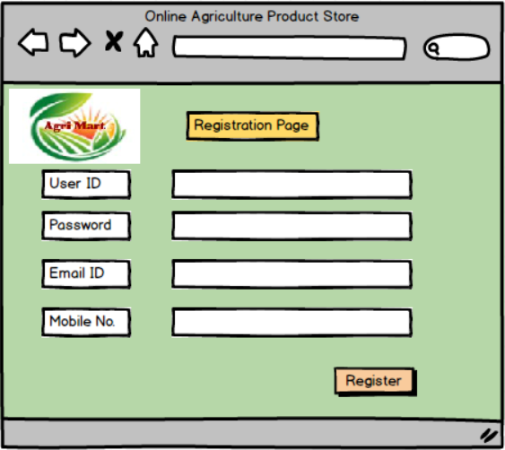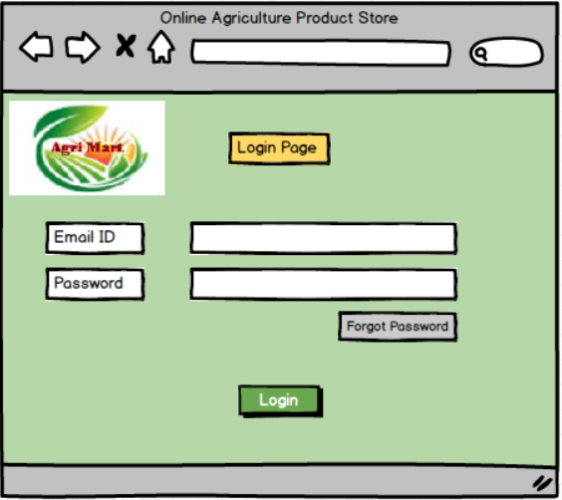
Login Page
Registration Page

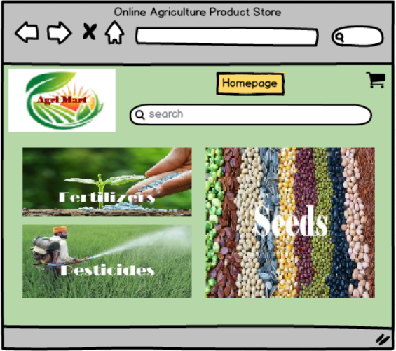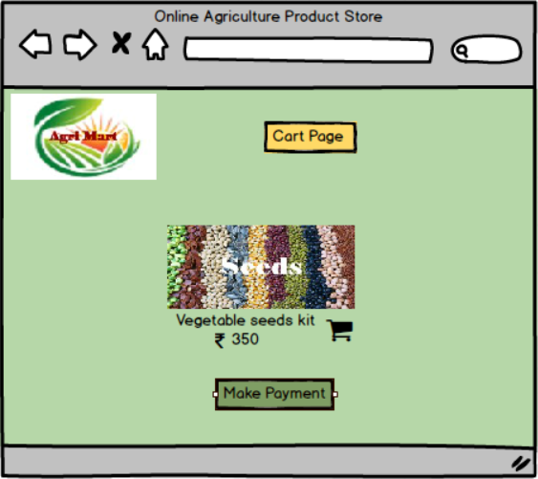
Cart Page
Homepage

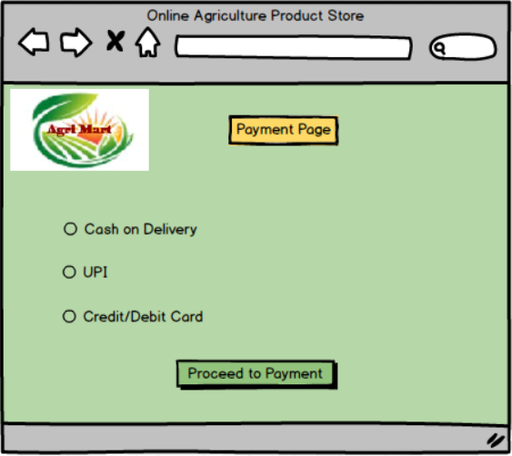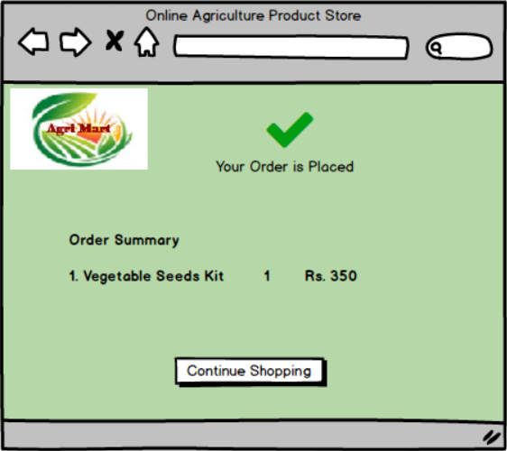
Payment Page
Order Success Page

Question 3 – Tools (Visio, Balsamiq)
Make a note of the Tools, which you are using for above concepts.

Answer 3 -
- MS Visio:
- Microsoft Visio is a diagramming tool used to create flowcharts, UML diagrams and other visual representation on complex information.
- It visually explains how different parts of your system work together.
- Visio is useful to design Data flow diagrams, use case diagrams, activity diagrams and architectural diagrams.
- These visuals help developers, stakeholders and testers understand how information flows through the system.
- It also helps in identifying weak areas or improvements in design early on.

- Balsamiq:
- Balsamiq studio is founded in March 2008 by Peldi Guilizzoni, a former adobe senior software engineer.
- Balsamiq is a rapid wireframing tool used to create mock-ups. It is used to create web and mobile application.
- A wireframe is a blueprint of how the future application will look.
- It lets you create rough sketches of your application’s interface.
- It used to create wireframes of screens like login page, product listing, cart, and checkout.
- It helps in planning the user interface and getting quick feedback before actual UI development starts.
Question 4 – RTM
A business analyst’s key responsibilities are to keep track of the requirements and make sure that no requirement is missed.
Mr. Henry and peter have approached you regarding the current status of the project. How will you tackle this situation?
Prepare RTM
Answer 4 –
- RTM is a document to track the requirements throughout the project lifecycle, ensuring that they are met and that no requirements are overlooked.
Functional Requirements – RTM:
Non-Functional Requirements – RTM:

Question 5 – 10 Test Case Documents
Prepare 10 Test Case Documents

Answer 5 –

Question 6 – DB Design
After the requirements are thoroughly explained to the entire project team by business analyst, the Database architects have decided to do the database design and also to represent the in-flow and out-flow of data.
Draw database schema and ER diagram
Answer 6 –

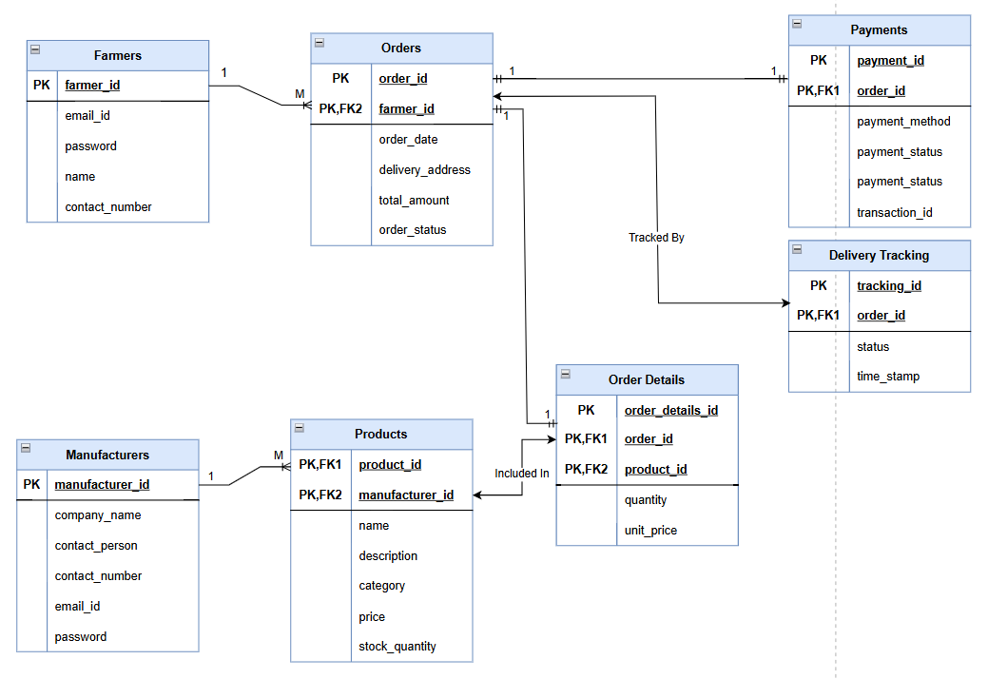

Question 7 – Data Flow Diagram
What is a data flow diagram? Draw a data flow diagram to represent the in-flow and out-flow of data when a Farmer is placing an order for the product
Answer 7 –

1st Level Data Flow Diagram of Online Agriculture Product Store

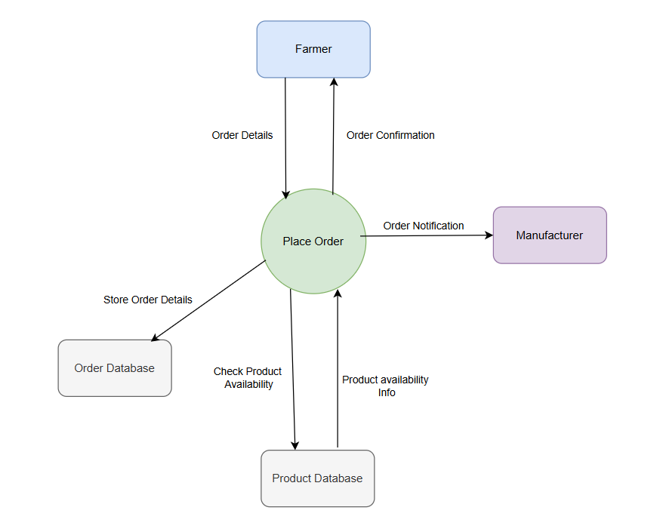

Question 8 – Change Request
Due to change in the Government Taxation structure. we should change the Tax structure How do you handle change requests in a project?
Answer 8 –

As a BA I will handle this change request as follows:
- Understand and Document the Change Request – Collect information about new taxation rules and document what needs to be changed in the system like tax calculation, invoices, product prices.

- Do impact analysis – Asses how this change will affect the project work, time, cost and people involved. Check if this change will impact the project scope (tax calculations, database structure, UI changes on invoices)

- Prioritize Change Requests – Since taxation changes are legal changes, prioritize it as urgent and high importance.

- Seek approval form project sponsor – Present the change request and impact analysis to project sponsor (Mr. Henry) and committee for formal approval

- Communicate to Stakeholders – Inform all relevant stakeholders including the developers, testers, DB admin, project manager, farmers, manufacturers, if necessary, about the change and its urgency.

- Implementation and Testing – Update the tax calculation in the system. Perform testing to ensure the new tax rates are applied correctly.

- Deployment – Deploy changes to the live system. Monitor transactions to ensure everything is working fine with new taxation structure.

Question 9 – Change Request Vs an Enhancement
As the project is in process, Ben and Kevin have contacted you. The reason is to inform you that they want the Farmers to sell their crop yields through this application i.e. Farmers should be able to add their crop yields or products and display to general public and should be able to sell them. They also want to introduce Auction system for their Crop yields. As a BA, what will be your response?
Is this a change request or an enhancement???

Answer 9 –
This is an enhancement, as initially the application was only for farmers to buy seeds, fertilizers and pesticides from the manufacturers.
Now as Ben and Kevin want farmers to sell crop yields and have an auction system so this is a new business requirement and feature addition.
As a BA, I would –
- Understand the details of change requirement (adding crop selling and auction feature) and document them.
- Do impact analysis on cost, timeline, resources and risks.
- Share the analysis report with the project sponsor to decide if this should be added in current project by increasing the budget and timeline.

Question 10 – Estimations
Come up with estimations – How many Manhours required
Answer 10 –
As per the case study, the duration of the project is 18 months and the current team size is 11 team members.
Man-hours = team size x weekly hours x total weeks
= 11 x 40 x 78
= 34,320 man-hours required
Hence this will come under large project.
Role | No. of members | Weekly Hours per member | Project duration in weeks | Total man-hours
Project Manager | 1 | 40 | 78 | 3,120
Sr. Java Developer | 1 | 40 | 78 | 3,120
Java Developers | 4 | 40 | 78 | 12,480
Network Admin | 1 | 40 | 78 | 3,120
DB Admin | 1 | 40 | 78 | 3,120
Testers | 2 | 40 | 78 | 6,240
Business Analyst | 1 | 40 | 78 | 3,120
Total | 11 |  |  | 34,320

Question 11 – UAT
Project has finally completed all the stages i.e., design, development, testing etc. Now, it is the role of a business analyst to contact the client for testing of the final product and have to successfully complete it. How are you going to handle this situation? And once it is done, what will be the process to close the project?
Explain UAT Acceptance process

Answer 11 –
As a BA, I will ensure smooth communication between the client and technical team during UAT.
I will handle the situation as follows-
- Planning – In this step, I will prepare a UAT plan listing all the features that will be tested, how they will be tested and what standards must be met. Share this plan with Mr. Henry and stakeholders and agree on testing timelines.
- Designing – Create UAT test cases that cover all the real-life scenarios that the system will face. Example – logging in, searching products, making payments, tracking deliveries.
- UAT Testers – Identify UAT testers who understand the system (farmers and manufacturer representatives). Provide them with the test cases and guide them on how to perform the tests. Ensure testers understand how to execute and record results.
- Bug fixing – Record all the issues and bugs found during UAT in a defect log. Co-ordinate with the development team to fix the bugs. Re-test the fixed features to confirm the issues are resolved.
- Sign-Off – Once all critical bugs are fixed, the client and key stakeholders review the final product. Get a formal sign-off from the client, confirming the system is ready for Go-Live.

Process to close the project –
- Confirm all the deliverables are met with the agreed scope of the project.
- Get formal written approval from the client
- Handover the manuals, user guides and technical documents to the client.
- Release project team members from the project.
- Record lessons learned for future projects and officially mark the project as closed.

Question 12 – Project Closure Document
Explain Project closure document
Answer 12 –
A project closure document is a formal report that confirms the completion of the project, summarizes achievements, lessons learned, challenges and provides final approval from the client.
It serves as a record for future reference and officially closes the project.

