CAPSTONE PROJECT 2
Scrum Food Delivery Application Project

Q1 Agile Manifesto

Agile Manifesto consist of 4 Basic Values and 12 Principal
The 4 Main Values Agile
- Individual and Interaction over processes and tools
- Working software over comprehensive documentation
- Customer Collaboration over contract Negotiation
- Responding to Change over following a Plan

The 12 Principles of Agile
- Our Highest priority is to satisfy the customer through early and continue delivery of valuable software.
- Welcome Changing requirement even late in development. Agile processes change for the customer’s competitive advantages
- Deliver Working software frequently from a couple of weeks to a couple of month with a preference to the shorter timescale
- Business people and developers must work together daily throught the project.
- Build Project around motivated individuals give them the envirometn and support they need and trust them to get the job done
- The most efficient and effective method of conveying information to and with in a development team is face to face conversation
- Working software is the primary measure of progress
- Agile processers promote sustainable development. The Sponsors developers and users should be able to maintain a constant pace indefinitely
- Continuous attention to technical excellence and good design enhances agility
- Simplicity the art of maximizing the amount of the work not done is essential .
- The best Architecture requirements and design emerge from self organizing teams
- At regular intervals this team reflects on how to become ore effective then and adjust its behaviors accordingly

Q.2 Write Minimum 40 Users Story and their acceptance criteria along with their BV and CP
User Story No 1 | Tasks 2 |  | Priority Highest
AS A DELIVERY BOY
I WANT TO REGISTER IN SCRUM FOODS
SO THAT I CAN DELIVER ORDERS
BV 500 |  | CP :02
ACCEPTANCE CRITERIA
Registration screen
Text Box for User Name , Password, Mobile no , Email id , Phone No
Click on registration button
Send Successful Notification to User

User Story No 2 | Tasks 2 |  | Priority Highest
AS A CUSTOMER
I WANT TO VIEW MY ORDER
SO THAT I CAN GIVE MY FEEDBACK
BV 500 |  | CP :02
ACCEPTANCE CRITERIA
View Order and rate according to quality

User Story No 3 | Tasks 02 |  | Priority Highest
AS A RESTAURANT ONWER
I WANT TO VIEW ORDER
SO THAT I CAN VIEW THE LIST OF ORDERS
BV 500 |  | CP :02
ACCEPTANCE CRITERIA
View Order
Display list of Order

User Story No 4 | Tasks 02 |  | Priority Highest
AS A CUSTOMER
I WANT TO ADD MY CONTACT NO
SO THAT I CAN GET DETAILS ON MY NUMBER
BV 500 |  | CP :02
ACCEPTANCE CRITERIA
Notification on number

User Story No 5 | Tasks 02 |  | Priority Highest
AS A CUSTOMER
I WANT TO ADD MY ADDRESS
SO THAT I CAN GET ORDER TO MY ADDRESS
BV 500 |  | CP :02
ACCEPTANCE CRITERIA
With in Business Radius of 5 Km

User Story No 6 | Tasks |  | Priority Highest
AS A CUSTOMER
I WANT TO VIEW PRICE LIST
SO THAT I CAN PLACE THE ORDER
BV 500 |  | CP :02
ACCEPTANCE CRITERIA
Display Price List in Menu Card

User Story No 7 | Tasks |  | Priority Highest
AS A CUSTOMER
I WANT TO VIEW MY ORDER
SO THAT I CAN GIVE FEEDBACK
BV 500 |  | CP :02
ACCEPTANCE CRITERIA
Customer Experience

User Story No 8 | Tasks |  | Priority Highest
AS A CUSTOMER
I WANT TO VIEW REVIEW AND RATING FOR RESTAURANTS
SO THAT I CAN MAKE DECISION FROM WHERE TO ORDER FOOD FROM
BV 500 |  | CP :02
ACCEPTANCE CRITERIA
User can view rating

User Story No 9 | Tasks |  | Priority Highest
AS A CUSTOMER
I WANT TO SCHEDULE FOOD ORDER IN ADVANCE
SO THAT I CAN PLAN A MEALS ON TIME
BV 500 |  | CP :02
ACCEPTANCE CRITERIA
User can select future date and time for order

User Story No 10 | Tasks 2 |  | Priority Highest
AS A HUNGRY CUSTOMER
I WANT TO ORDER FOOD
SO THAT I CAN ENJOY DELICIOUS FOOD
BV 500 |  | CP :02
ACCEPTANCE CRITERIA
I Search for Specific Restaurant

User Story No 11 | Tasks 2 |  | Priority Medium
AS A RESTAURANT ONWER
I WANT TO PROVIDE TIME SLOTS
SO THAT CUSTOMER CAN CHECK OPENING CLOSING HOURS
BV 100 |  | CP :02
ACCEPTANCE CRITERIA
Add Timing from to Too
Display Successfully

User Story No 12 | Tasks 2 |  | Priority low
AS A CUSTOMER
I WANT CONTACT NUMBER OF DELIVERY BOY
SO THAT I CAN CONTACT HIM
BV 50 |  | CP :01
ACCEPTANCE CRITERIA
Delivery boy Mobile Number and Name

User Story No 13 | Tasks 2 |  | Priority Highest
AS AN ADMIN
I WANT TO VIEW THE RESTAURANT
SO THAT I CAN APPROVE THEIR REGISTRATION
BV 500 |  | CP :02
ACCEPTANCE CRITERIA
List of Restaurant ,select restaurant , verify details

User Story No 14 | Tasks 2 |  | Priority Highest
AS A BUSIENSS ONWER
I WANT TO VIEW RESTAURANT REVENUE REPORT
SO THAT I CAN VIEW RESTAURANT REVENUE
BV 500 |  | CP :02
ACCEPTANCE CRITERIA
Select Revenue Report , revenue report , select date and time

User Story No 15 | Tasks 2 |  | Priority HigH
AS A REG ADMIN
I WANT TO MANAGE CLUSTER RESTAURANT
SO THAT I CAN TRACK THE PERFORMANCE
BV 100 |  | CP :01
ACCEPTANCE CRITERIA
Click on performance report of restaurant date by date

User Story No 16 | Tasks 2 |  | Priority High
AS AN RESTAURANT ONWER
I WANT TO ADD DISCOUNT OFFER
SO THAT I CAN OFFER DISCOUNT ON FOODS
BV 200 |  | CP :01
ACCEPTANCE CRITERIA
View Discount offer as per festive season , weekends , holidays

User Story No 17 | Tasks 2 |  | Priority High
AS A RESTAURANT ONWER
I WANT TO ADD SPECIAL DAYS ITEMS
SO THAT I CAN OFFER SPECIAL FOOD
BV 200 |  | CP :01
ACCEPTANCE CRITERIA
Special day different foods offer

User Story No 18 | Tasks 2 |  | Priority High
AS A DELIVERY BOY
I WANT TO ACTIVE GPS TRACKER
SO THAT I CAN TRACK THE LOCATION
BV 200 |  | CP :01
ACCEPTANCE CRITERIA
Gps location should be on and reach on time

User Story No 19 | Tasks 2 |  | Priority Medium
AS A RESTAURANT ONWER
I WANT TO INTEGRATE RAILWAY BOOKING
SO THAT I CAN GET ORDERS
BV 200 |  | CP :01
ACCEPTANCE CRITERIA
Activate online delivery for railway station and trains

User Story No 20 | Tasks 2 |  | Priority High
AS A DELIVERY BOY
I WANT TO MAINTAIN TIME
SO THAT I CAN DELEVER ON TIME
BV 200 |  | CP :01
ACCEPTANCE CRITERIA
Timer should be on and same should be reflecting in Application

User Story No 21 | Tasks 2 |  | Priority High
AS A DELIVERY BOY
I WANT TO MAINTAIN TIP
SO THAT I CAN RECEIVE FROM CUSTOMER
BV 200 |  | CP :01
ACCEPTANCE CRITERIA
Depends on Customer experience they will provide tips

User Story No 22 | Tasks 2 |  | Priority High
AS A CUSTOMER
I WANT TO ONBOARD APPLICATION
SO THAT I CAN PLACE ORDER
BV 200 |  | CP :01
ACCEPTANCE CRITERIA
Onboarding screen , User Name , Password , Mobile no , Email Id

User Story No 23 | Tasks 2 |  | Priority Mefium
AS A RESTAURANT ONWER
I WANT TO SET BRANDING FOR DELIVERY BOY
SO THAT I CAN IDENTIFY DELIVERY BOY SEPRATELY
BV 200 |  | CP :01
ACCEPTANCE CRITERIA
Set a different branding for delivery boy ,which help to differentiate him

User Story No 24 | Tasks 2 |  | Priority High
AS A RESTAURANT ONWER
I WANT TO MAINTAIN COMPLAIN SYSTEM
SO THAT I CAN SEE CUSTOMER COMPLAIN
BV 200 |  | CP :01
ACCEPTANCE CRITERIA
Separate path for customer complain to be set

User Story No 25 | Tasks 2 |  | Priority High
AS A CUSTOMER
I WANT TO ENSURE AND ACTIVATE GPS
SO THAT I CAN GET UPDATE AND DELIVERY ON TIME
BV 200 |  | CP :01
ACCEPTANCE CRITERIA
Active Mobile GPS for Location tracking

User Story No 26 | Tasks 2 |  | Priority High
AS A ADMIN
I WANT TO ACTIVATE BULK ORDER FACILITY
SO THAT I CAN TAKE BULK ORDER
BV 200 |  | CP :01
ACCEPTANCE CRITERIA
Separate Application for bulk delivery

User Story No 27 | Tasks 2 |  | Priority High
AS A CUSTOMER
I WANT TO ACTIVATE MY EMAIL ID
SO THAT I CAN GET STATUS OF MY ORDER
BV 200 |  | CP :01
ACCEPTANCE CRITERIA
During on boarding update email for Notification

User Story No 28 | Tasks 2 |  | Priority High
AS A CUSTOMER
I WANT TO VIEW FEEDBACK
SO THAT I CAN KNOW THE QUALITY
BV 200 |  | CP :01
ACCEPTANCE CRITERIA
Select views , feedbacks and submit report

User Story No 29 | Tasks 2 |  | Priority High
AS A CUSTOMER
I WANT TO CHECK ORDER CANCELLATION POLICY
SO THAT I CAN CANCEL ORDER IF REQUIRE
BV 200 |  | CP :01
ACCEPTANCE CRITERIA
Condition of cancelation , return policy , charges will be checked

User Story No 30 | Tasks 2 |  | Priority High
AS A CUSTOMER
I WANT TO ORDER ON TIME
SO THAT I CAN TAKE MEAL ON TIME
BV 200 |  | CP :01
ACCEPTANCE CRITERIA
All Mandatory field , specific time , delivery time , expected delivery

User Story No 31 | Tasks 2 |  | Priority High
AS A CUSTOMER
I WANT TO ORDER ON TIME
SO THAT I CAN TAKE MEAL ON TIME
BV 200 |  | CP :01
ACCEPTANCE CRITERIA
All Mandatory field , specific time , delivery time , expected delivery

User Story No 32 | Tasks 2 |  | Priority High
AS A ADMIN
I WANT TO ADD REFUND AND NON REFUND POLICY
SO THAT I CAN
BV 200 |  | CP :01
ACCEPTANCE CRITERIA
Admin declare all refund policy with conditions if any it should be clear to user

User Story No 34 | Tasks 2 |  | Priority High
AS A CUSTOMER
I WANT TO KNOW FOOD RESQUE POLICY
SO THAT I CAN PURCHASE FOOD IN LESS RATE
BV 200 |  | CP :01
ACCEPTANCE CRITERIA
List of item , details , price , and additional condition if any

User Story No 34 | Tasks 2 |  | Priority High
AS A CUSTOMER
I WANT TO CHECK REFUND POLICY
SO THAT I CAN PROCESS FOR CANCELATION INCASE OF DELAY
BV 200 |  | CP :01
ACCEPTANCE CRITERIA
Acceptable , Policy should be clear, and contain all details

User Story No 35 | Tasks 2 |  | Priority High
AS A RESTAURANT ONWER
I WANT TO SET DELIVERY CHARGES SCHEDULE
SO THAT I CAN KNOW THE ACTUAL CHARGES
BV 200 |  | CP :01
ACCEPTANCE CRITERIA
List of charges should be mentioned as per radius

User Story No 36 | Tasks 2 |  | Priority High
AS A PRIVILAGE CUSTOMER
I WANT TO SET PRIORITIZATION
SO THAT I CAN GIVE PRIVILAGE TO PRIME MEMBER
BV 200 |  | CP :01
ACCEPTANCE CRITERIA
Privilege category , Exclusive category , Condition for these facility

User Story No 37 | Tasks 2 |  | Priority Medium
AS A REASTAURANT ONWER
I WANT TO SET PACKAGE POLICY
SO THAT I CAN TRACK THE FEEDBACK AND RESPONSE
BV 200 |  | CP :01
ACCEPTANCE CRITERIA
Google review rating , online feedback submission should be their

User Story No 38 | Tasks 2 |  | Priority Medium
AS A RESTAURANT ONWER
I WANT TO SET GIFT CARDS
SO THAT I CAN OFFER TO CUSTOMER
BV 200 |  | CP :01
ACCEPTANCE CRITERIA
Exclusive offer with cards should be separately mentioned

User Story No 39 | Tasks 2 |  | Priority Medium
AS A ADMIN
I WANT TO SEE THE REGIONAL REVEUE REPORT
SO THAT I CAN VIEW THE REGIONAL PERFORMANCE
BV 200 |  | CP :01
ACCEPTANCE CRITERIA
Select Region , View report , generate report , download report

User Story No 40 | Tasks 2 |  | Priority Low
AS A CUSTOMER
I WANT TO CHAT WITH ADMIN
SO THAT I CAN REQUEST FOR REFUND
BV 200 |  | CP :02
ACCEPTANCE CRITERIA
All Mandatory field, Text box id , display order , submit button

Q 3 What is EPIC ? Write 2 EPIC
EPIC is a large or bigger User Story or Collection of related User Story that represent significant features or functionality . Epic is a high Level , Multiple Sprints and they provide a way to organize and prioritize the work in a product backlog.
EPIC 1 :- Restaurant Ratings and Review
AS A USER
I WANT TO REVIEW AND RATING FOR RESTAURANT ON SCRUM FOOD
SO THAT I CAN TAKE DECISION ABOUT WHERE TO ORDER FOOD
AS A USER
I WANT TO PROVIDE RATINGS AND REVIEW TO RESTAURANTS ON SCRUM FOODS
SO THAT I CAN SHARE MY EXPERIENCE WITH OTHER USER AND CONTRIBUTE TO THE COMMUNITY

EPIC 2 :- Schedule Order
AS A USER
I WANT TO SCHEDULE FOOD ORDER IN ADVANCE
SO THAT I CAN PLAN MEALS AHEAD OF TIME

AS A USER
I WANT TO HAVE FLESIBILITY TO CHOOSE TIME SLOTS
SO THAT I CAN SCHEDULE ORDER IN SURUM FOOD

EPIC 3 :- Payment
AS A USER
I WANT TO CHOOSE COD OPTION
SO THAT I CAN MAKE PAYMENT ONCE I RECEIVE THE ORDER

AS A USER
I WANT TO CHOOSE DIFFERENT OPTION OF PAYMENT
SO THAT FLEXIBIY SHOULD BE THEIR FOR PAYMENT

Q.4 what is difference between BV and CP

BV Means Business Value It means how important is this feature to the business . BV is estimated by SCRUM Currency Notes . The value we provide in BV is Rs 10Rs ,20Rs ,50Rs ,100Rs ,500Rs ,1000Rs Denomination . This estimation is done by Stakeholders . IF different values are selected then discussion happen and they agree to one BV Value for user story
Technique Used :- MOSCOW , Currency Notes
MOSCOW :- It is a prioritization technique used in Business Analysis
MOSCOW Stands for MUST SHOULD COULD WOULD
Must :- Must have the requirement to meet the business needs
Should :-Should have this requirement if Possible but Project success does not rely on it
Could :-Could have this requirement if it does not affect anything else in the project
Would :- Would like to have this requirement later , but it won’t be delivered this time
MVP :- Minimum Viable product
CP means Complexity Points , CP is also known as Story Points it is the efforts required by Scrum development to develop this features using technology . Efforts include time taken to solve the complexity. CP is estimated by scrum developers by using Poker Cards . Poker Cards value is in series that is 1,2,3,5,8,13,20,40,60,100 and so on. Scrum Developers will give CP to the user Story
Technique Used :- Planning Pocker

Q.5 Explain About Sprint
Sprint is a period that team decide to deliver their objective . Normally a sprint period will be for 2 weeks but may extend to 4 weeks
Sprint planning Meeting :- This meeting occurs at the beginning of each sprint and involves the entire Scrum Team . The product owner shares the prioritized product back log item and the development team collaborates to select the item they will work on during the sprint . The team also defines the sprint goal and create sprint backlog which outlines the specific tasks require to complete the selected backlog item .
Daily Stand Up Meeting :- The Short daily meeting typically lasting 15 Min involves the development team . Each team member shares their progress sinc the last stand up progress since to the last stand ups . discuss any impediments or challenges they are facing and communicates their plan for the day . There are only 3 question in this meeting this meeting held for only 15 meeting in the morning .
There are only three question in Daily Stand ups meeting
- What we have done yesterday
- what we will do today
- what we will do tomorrow
Sprint Review Meeting :- At the end of each sprint the sprint review takes place . Development team present the work complete during the sprint to the stake holders including the product owner and possibly customer and users . The purpose of the meeting is to access progress gather input and determine potential adjustment to the product backlog.
Sprint Retrospective :- After Sprint Review Sprint Retrospective occurs . It is a dedicated session for the scrum team to reflect on the sprint . Identify what went well and identify the area of improvement and discuss potential adjustment to their process . The focus is on Continuous Learning , Adaption and enhancing team effectiveness .
These meeting are conducterd at the end of the sprint . here we discuss about what happen in the sprint what went wrong did we able to complete users story what lesson we havelearn . we are trying to understand good and bad

Q. 6 Explain Product Backlog and Sprint Backlog

S.No | Product Backlog | Sprint Backlog
1 | Product Backlog means anything needed to accomplish the project vision | Sprint Backlog means any thing needed to fulfill sprint goal
2 | Product Team Owns | Development Team Owns
3 | Contain requirement defects tasks | A Subset of product backlog item defined as a priority by the product owner
4 | Every One Contribute to the product backlog | Only the development team contribution to the sprint backlog
5 | Product Backlog refinement meeting is to refer the product backlog | Sprint Planning meeting is to refine the sprint backlog item
6 | Product backlog the product evolves and changes will be done by PO through the product lifecycle | No changes are allowed to the sprint backlog item once the sprint has started
7 | Release Burndown metric is used | Sprint Burndown metric is used
8 | Estimation if done at a user story level | Estimation is done at the activity or task level
9 | Daily Stand up meeting does not dscuss product backlog items | Daily stand up meetings discuss the sprint backlog in accordance with sprint goal
Q.7 What is impediments log ? Write 2 Impediments ?
An Impediments Log are also known as an issue log or obstacle log is a document or tool used in Agile Software development to track and manage obstacle or any factor that impede the progress of a Project or Team .
Log Id | 1
Description | Delivery staff shortage in a specifiec location
Impact | Delay in customer order delivery increase customer dis –satisfaction
Priority | High ( Customer Satisfation is invole )
Assigned to | Operation Team and Hr Team
Status | Open
Action Taken | Operation team actively increase network and Hr team appoint more staff for easy delivery Services
Resolution | Recruitment process is going on , Hr team will work on onboarding process . Regular Updates are shared on daily meeting
Log Id | 2
Description | Technical issue causing in Order processing failure
Impact | Delay in order processing and potential revenue loss
Priority | High ( customer experinece and revenue loss)
Assigned to | Technical Team
Status | In progress
Action Taken | The Technical team has identified the root cause and start wprking on it
Resolution | The Technical team implemented a fix and conduct testing . The issue has been resolved and order are now processing smoothly . The team has also implemented
Log Id | 3
Description | Technical issue causing in Order Searching failure
Impact | Customer use different website it impact our revenue and income
Priority | High ( customer experinece and revenue loss)
Assigned to | Technical Team
Status | In progress
Action Taken | The Technical team has identified the root cause and start wprking on it
Resolution | The Technical team implemented a fix and conduct testing . The issue has been resolved and order are now processing smoothly . The team has also implemented

Q 8 Explain Velocity of the Team
Velocity Refer to the measure of the amount of work a development team can complete during a sprint . How many complexity
The calculation of velocity is performed by development team itself as they are responsible for estimating the effort required to complete each user story or back log item
How it is calculated
- Story Point Estimation
- Tracking Completed Work
- Summing Story Points
- Average Velocity calculated by scrum master

Q. 9 Draw Sprint burn down chart and Product burn down chart .
SPRINT BURNUP CHART
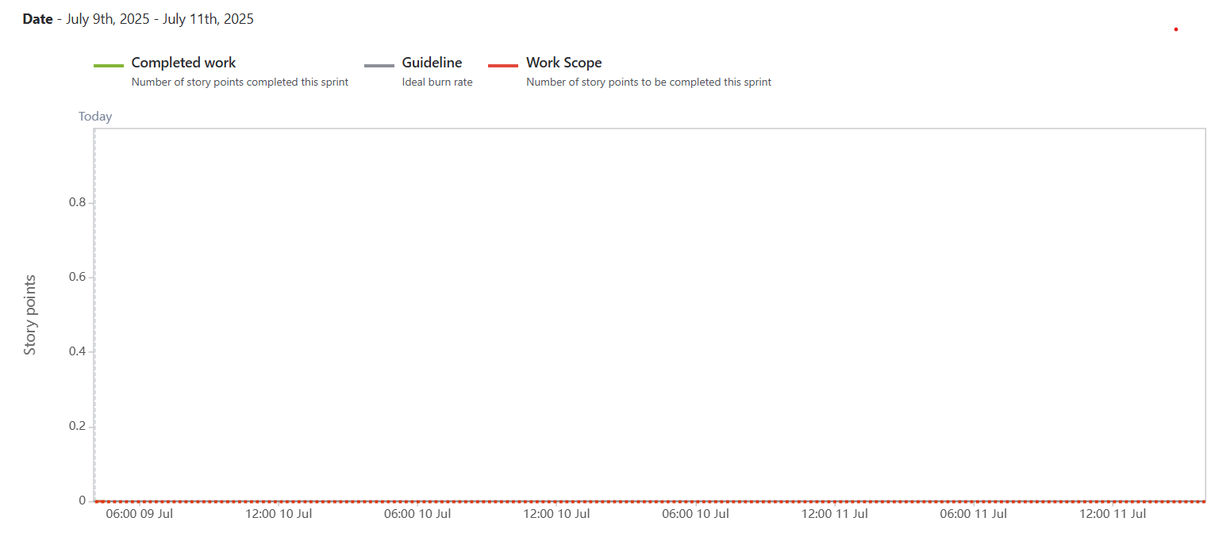

SPRINT BURN DOWN CHART

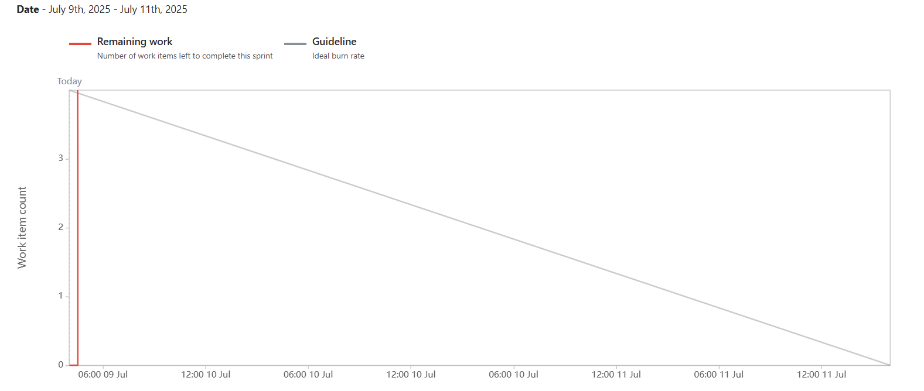

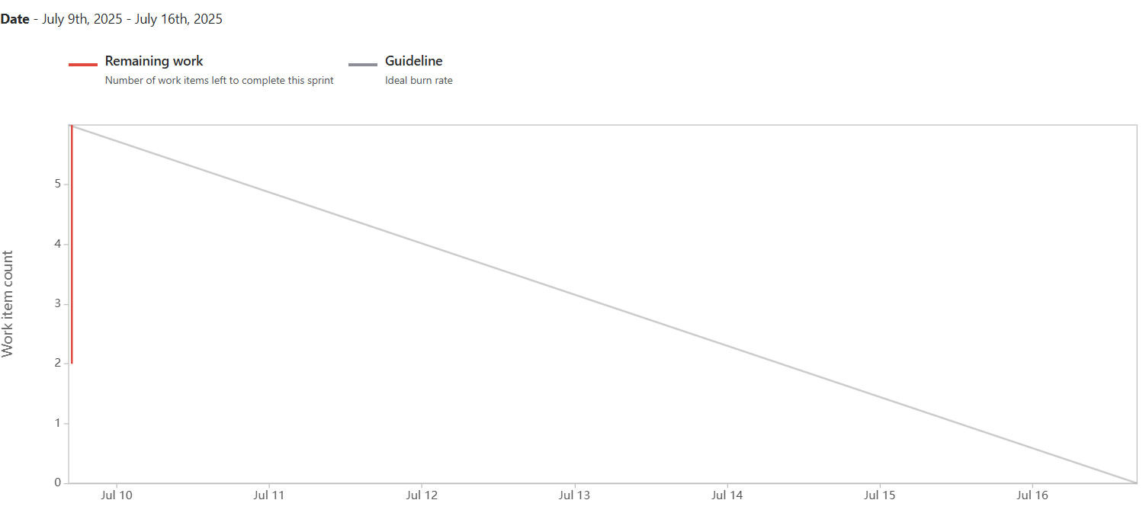

Q.10 Explain about product Grooming
“Scrum Team will sit Together and Refine Product Back log “
Product Grooming is also called backlog grooming or refinement it is an important activity in Agile software development that involves reviewing prioritizing and refining item in the product backlog . Product backlog will be cleaned up in product Grooming .
The Goal of product grooming is to ensure that the backlog is well prepared organized and ready for implementation in upcoming sprints.
It is typically a collaborative efforts involving the product owner development team and other relevant stakeholders . Meeting includes
- Backlog review
- Prioritization
- Refinement and Estimation
- Dependency Analysis
- Acceptance Criteria
- Backlog Grooming Meetings
Q.11 Explain the Role of Scrum Master and Product Owner.
Criteria | PRODUCT OWNER | SCRUM MASTER
Nature of Work | Collaborates with all stakeholders and bring the vision of a product into the product backlog | Act as a team coach and is responsible for maintaining the quality of the product
Responsibilities | Responsible for completing project on time . Act as an intermediary between development team and the customers | Ensures the scrum framework is followed and helps the development team create a quality product
Accountability | Responsible for the Project backlog , the timely completing of the product and for providing updates to the client and stakeholders | Accountable for the quality f the entire project and for giving updates to management about completion of the product
Reporting | Reports to top management and the client | Reports to the top management about efficiency of the team and the quality of the product
Qualities | Communication an leardership skills cretivity critical thinking ad a sharp mind are key aspect for any product owner | Through Knowledge of the scrum theory and practice being able to lead but without a sense of authority

Q 12 Explain All meetings conducted in Scrum Project .
Sprint planning Meeting :- This meeting occurs at the beginning of each sprint and involves the entire Scrum Team . The product owner shares the prioritized product back log item and the development team collaborates to select the item they will work on during the sprint . The team also defines the sprint goal and create sprint backlog which outlines the specific tasks require to complete the selected backlog item .
Daily Stand Up Meeting :- The Short daily meeting typically lasting 15 Min involves the development team . Each team member shares their progress sinc the last stand up progress since to the last stand ups . discuss any impediments or challenges they are facing and communicates their plan for the day . There are only 3 question in this meeting this meeting held for only 15 meeting in the morning .
There are only three question in Daily Stand ups meeting
- What we have done yesterday
- what we will do today
- what we will do tomorrow
Sprint Review Meeting :- At the end of each sprint the sprint review takes place . Development team present the work complete during the sprint to the stake holders including the product owner and possibly customer and users . The purpose of the meeting is to access progress gather input and determine potential adjustment to the product backlog.
Sprint Retrospective :- After Sprint Review Sprint Retrospective occurs . It is a dedicated session for the scrum team to reflect on the sprint . Identify what went well and identify the area of improvement and discuss potential adjustment to their process . The focus is on Continuous Learning , Adaption and enhancing team effectiveness .
These meeting are conducterd at the end of the sprint . here we discuss about what happen in the sprint what went wrong did we able to complete users story what lesson we have learn . we are trying to understand good and bad

Q.13. Explain Sprint Size and Scrum Size
Sprint Size :- The Sprint Size refers to the length or duration of the sprint in scrum A Sprint is a time boxed period during which the development team works to deliver a potentially shippable product increment , the range is from 1 week to 4 week . the most common sprint duration is 2 weeks depends upon project needs complexity and team dynamics .
Scrum Team Size :- The Scrum Team Size refers to the number of individuals who collaborates together to deliver the product increment in scrum Team must have developer , and product owner
Q14 Defination of DOR and DOR

Checklist that decide users story is ready now

- The definition of Ready defines the criteria that user story should must meet before it is considered ready to be included in a sprint . It ensure that the team has sufficient information and clarity about the user story , reducing the delay during the sprint .
- The user story should has a clear and concise description including expected behavior or functions .
- The acceptance criteria for the user story are well define and agreed upon by the product owner and the development team .
- Any necessary design and wireframes related to the user story are available
- The User story is Appropriately sized or estimated in story points or relevant units
- Any dependency or external resourses needed for the user atory are identified and accessible .

Definition of Done

The definition of Done is the out line the criteria that av user story or any other backlog item must to be considered complete and ready to release . It ensure that all necessary aspects such as quality , testing and documentation are addressed
- The code for the user story is implemented reviewed and merged into the main code base .
- Automated test are created and passing ensuring that the functionality function correctly and does not introduce regression.
- The User Story is thoroughly tested and validated agaist the defined acceptance criteria
- The Use interface and User Experience aspects related to the user story are implemented and reviewed .
- The user story is documented including any relevant instruction guides or release notes
- The product owner has reviewed and accepted the user story as meeting the expected Requirement .
- Definition of Done is more technical

Q. 15 Explain Prioritization Technique and MVP

MOSCOW :- It is a prioritization technique used in Business Analysis
MOSCOW Stands for MUST SHOULD COULD WOULD
Must :- Must have the requirement to meet the business needs
Should :-Should have this requirement if Possible but Project success does not rely on it
Could :-Could have this requirement if it does not effect anything else in the project
Would :- Would like to have this requirement later , but it won’t be delivered this time

MVP :- Minimum Viable Product

Minimum viable product means a piece of work or a small part introduce in market for
Publicity and feedback at intial level

Q16 Difference between Busniess Analysist and Project Owner
Product Onwer | Business Analysist
Work on Market Strategy | Work on Requirement Stategy
Enterprise Analysis | Needs Analysis
Product Vision | Non Functional Requirement
Go to Market Strategy | User Story
Project roadmap | Modeling
Customer Focus | Project Focus
Competitive Analysis | Conflict Resolution
Product Backlog | Prioritization of stories
Release Planning | Facilitaion for smooth project execution

Q.17 Prepare a sample Resume of 3 Yr Exp Product Owner

AJAY YASHWANT DEO
Product Owner

CONTACT WORK EXPERIENCE
Ajaydeo1212@gmail.com Agile Product Owner
8512254578 Apple
Linkedin May 2022 to Till Date / Bangalore

EDUCATION Acted as a liaison between product IT and Sales Team to
BS understand Customer demand for New Features and prioritize
Computer Science the roadmap.
Barkatullah University Owned the Product Road Map and Met 96 % of all feature
Bhopal deadlines by identifying and mitigating any engineer roadblocks
Sep 2010 to April 2014 Led a team of 1 Full – Time Employee and 3 Contractors

SKILLS
Agile Development PRODUCT OWNER
Scrum Project Management Pune
Excel/Google Sheets/Power Aug 2021 to May 2022
Point UserStories , Product Created User Stories , Acceptance Criteria to get buy in from roadmap JIRA stakeholders and refined those stories with Scrum Teams .
Certification Owned the Planning and Schedule of Two weeks Sprint and articulated the project vision to engineering resulting in hitting 98 % of the product goals defined at the beginning of the Year Managed and re prioritize the product backlog , Resulting in coming under budget by an average of $45000 on projects
Directed Vendor Relationship and 30 % of contract including execution and financial Payments

CERTIFICATION
SCRUM PRODUCT OWNER INTERN
Professional Scrum Product Mumbai
Owner II Certification May 2020 to May 2022
Developed a data driven Project Management Culture by building KPI Dashboards for executives around feature development and product life cycles.
Worked Cross functionality with executive leadership and marketing teams to understand customer pain points and translate them into actionable users story .
Created and Improved 33% of Systems and protocols to share work and information related to matrix measurement , business operation and operation management

