Nurturing Process - Capstone Project1 – Part -3/3 V2D2 Aug 2024
Question 1 – Functional Requirements - 15 Marks
Identify minimum 20 functional requirements
Ans: Functional requirements define the specific behaviours, functions, or operations of a system. They describe what the system should do, outline the necessary tasks, actions or activities it must performs to achieve its objectives.
Req ID | Req Name | Req Description | Priority
FR001 | Farmer Registration | Farmer should be able to register with the application | 8
FR002 | Farmer Search for Products | Farmers should be able to search for available products in fertilizers, seeds, pesticides | 8
FR003 | Farmers adding product to cart | Farmers should be able to add product to cart | 9
FR004 | Farmers adding product to Wishlist | Farmers should be able to add the product to Wishlist | 7
FR005 | Product Filter/Sorting | Farmers should filters(price, rating, availability)and sort options | 8
FR006 | Payment with different modes | Farmers should be able to make payment with different modes | 9
FR007 | Farmer tracking order | Farmers shall be able to track their order stats in real-time | 6
FR008 | Payment Gateway Integration | The system shall support secure online payment via UPI Credit/debit card, or net banking | 8
FR009 | Admin Dashboard | The admins shall view reports on users, sales,inventory,and system usage. | 7
FR010 | Complaint/Feedback System | Farmers should able to submit feedback or raise complains | 7

Non-Functional Requirement:(Performance of system) will describe the qualities and attributes of a system, focusing on how the system performs rather than specific behaviours or functions.
Req ID | Req Name | Req Description | Priority
NR001 | Page Loading Time | Each Page should load within 2 seconds time | 9
NR002 | Scalability | Platform shall support upto 50,000 concurrent users without performance degradation | 9
NR003 | WCAG 2.1. | The system must meet Web Content Accessibility Guidelines WCAG 2.1. | 8
NR004 | Mobile Responsiveness | The UI shall adapt and work efficiently on all mobile devices | 8
NR005 | Legal Compliance | The application shall adhere to data protection regulations (e.g GDPR,Indian IT Act) | 9
NR006 | Compatibility | The application shall run on all modern browsers(Chrome,firebox,Safari,Edge) | 8
NR007 | Security | All user data shall be encrypted | 9
NR008 | Availability | The system shall maintain 99.9% uptime monthly | 9
NR009 | Reliability | The application shall process all transactions accurately and consistently | 8
NR010 | Error Handling | The application shall display user-friendly error messages and log technical details for admin use. | 7

Question 2–Minimum 5-page designs - 15 Marks
Make wireframe and prototypes
Ans: Wireframe: Blueprint of Screens and Pages –Prepare by BA
Mockup : Advanced of Wireframe ---Colours and shapes –UIUX, BA
Prototypes: Complete Application with help developers –Front end and Back end
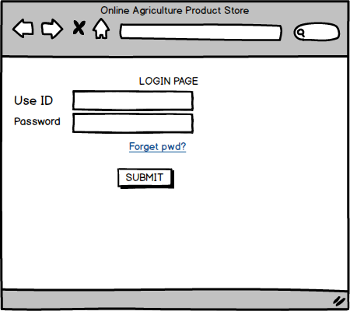
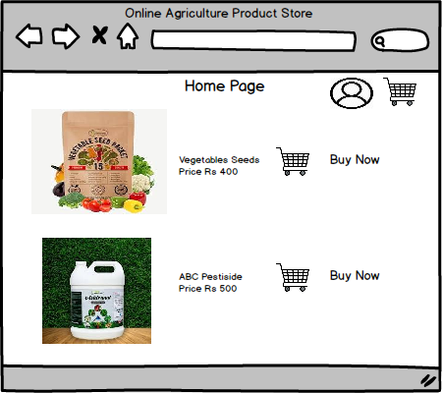

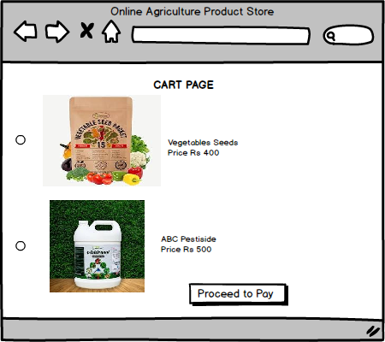
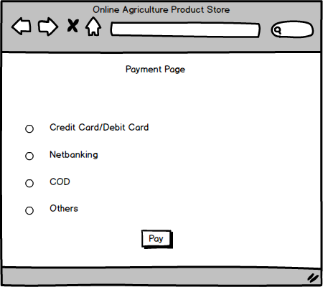

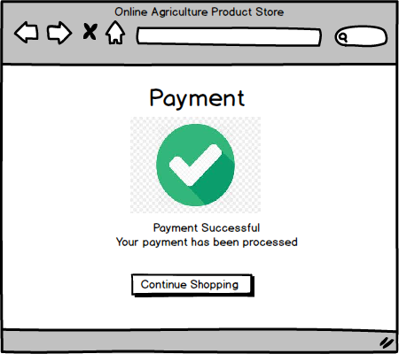
Question 3 – Tools (Visio, Balsamiq) - 15 Marks
Make a note of the Tools, which you are using for above concepts.
Ans: Microsoft Visio is a diagramming and vector graphics application used to create diagrams, flowcharts, and other visual reorientations of complex information.
Developed by Microsoft
It is widely used for creating a variety of professional diagrams that help visualize complex information, system and processes.
Advantage Of MS Visio
1.Easy Diagram Creation: Allows users to create flowcharts, organizational charts, network diagrams Diagrams, and more using drag-and-drop tools.
2.Intergration with Microsoft : Seamlessly integrates with other Office tools like Excel,Word,Powerpoint for importing/exporting data.
3.Real Time Collaboration: Support multiple users working on the same diagrams simultaneously with cloud-based sharing and comments.
4.Improved Communication: Helps teams and stakeholders clearly understand complex systems or processes through visual representation.
Balsamiq: is a rapid wireframing tool used to create mock-ups and prototypes of user interfaces(UI) for websites, mobile apps,and software applications. It is designed to mimic the experience of sketching on a whiteboard, making it ideal for brainstorming and early-stage UI/UX design
Key Features: Low -Fidelity Design: Purposefully simple, hand-drawn look to keep the focus on functionality and structure rather than detailed visual design.
- Helps teams focus on layout, content placement, and user flow, avoiding pixel-level distractions.
- Pre build UI Components: offers a wide variety of ready-made components: buttons, input fields, dropdowns, tabs,modals etc.
- Drag-and drop interface for building wireframes quickly.
Benefits : Fast ideation and iteration, Encourage feedback early in the design process,
Keeps stakeholders focused on structure over aesthetics.
Limitation: Not intended for high-fidelity or pixel perfect design, Lacks advanced animation or interaction support.
Axure RP (Rapid Prototyping): is a more advanced prototyping tool used to create high-fidelity, interactive wireframes and prototypes for web and mobile applications.
Key Features: 1. Interarive Prototypes
2.No coding Required: Build logic-driven prototypes (with conditions, variables and actions) without writing code.
3.Advanced Interactions: support dynamic content, conditional logic, and animations, enabling realistic user flow simulations.
4.Responsive Design: Supports responsive prototypes for different screen sizes (Desktop, tablet, mobile)

Question 4 – RTM( Requiremnet Traceability Matrix) - 6 Marks
Ans: It is a document to track the requirements throughout the project lifecycle ensuring that they are met and that no requirements are overlooked
Purpose of RTM : To ensure that all requirements are covered by test cases.
To track requirements status across phases: Design, Development, and Testing.
To avoid missing functionalities during testing.

Req ID | Req Name | Req Description | Design | Code | UT(Unit Testing) | CT(Component Testing) | ST(System Testing) | SIT | UAT
FR001 | Farmer Registration | Farmer should be able to register with the application | Complete | Completed | Complete | Complete | Complete | Complete | Incomplete
FR002 | Farmer Search for Products | Farmers should be able to search for available products in fertilizers, seeds, pesticides | Complete | Complete | Complete | Complete | Complete | Incomplete | Incomplete
FR003 | Farmers adding product to cart | Farmers should be able to add product to cart | Complete | Complete | Complete | Complete | Complete | Incomplete | Incomplete
FR004 | Farmers adding product to Wishlist | Farmers should be able to add the product to Wishlist | Complete | Complete | Complete | Complete | Complete | incomplete | Complete
FR005 | Product Filter/Sorting | Farmers should filters(price, rating, availability)and sort options | Complete | Complete | Complete | Complete | Complete | Complete | Complete
FR006 | Payment with different modes | Farmers should be able to make payment with different modes | Complete | Complete | Complete | Complete | Complete | Complete | Complete
FR007 | Farmer tracking order | Farmers shall be able to track their order stats in real-time | Complete | Incomplete | Incomplete | Incomplete | Incomplete | Incomplete | Incomplete
FR008 | Payment Gateway Integration | The system shall support secure online payment via UPI Credit/debit card, or net banking | Complete | Complete | Complete | Complete | Complete | Complete | Complete

Question 5 – 10 Test Case Documents - 10 Marks
Ans: A test case documents is a detailed outline used by testers to ensure that a software application or system is working as expected.
Test Case ID | TC001 | Test Case Name | User Registration
Project ID | AP678 | Project Name | Online Agriculture Product Store
PM ID | 4896 | PM Name | Mr.Wandanam
Test Strategy ID | AP678TS001 | Tester ID
Test plan ID | AP678TP001 | Tester Name | Jason & Alekya
Test schedule ID | AP678TS001 | Date of Test
Scenario | User Registration
Link to that page:
Input Data | Set 1 Name | Set 2 Email id | Set 3 Password
Expected behaviour | User Account Created
Actual behaviour | User Account Created
Comments
Result ( Pass/Fail)

Test Case ID | TC002 | Test Case Name
Project ID | AP678 | Project Name | Online Agriculture Product Store
PM ID | 4896 | PM Name | Mr.Wandanam
Test Strategy ID | AP678TS002 | Tester ID
Test plan ID | AP678TP002 | Tester Name | Jason & Alekya
Test schedule ID | AP678TS002 | Date of Test
Scenario | Login
Link to that page:
Input Data | Set 1 Email ID | Set 2 Password
Expected behaviour | Login Successful
Actual behaviour | Login Successful
Comments
Result ( Pass/Fail)

Test Case ID | TC003 | Test Case Name
Project ID | AP678 | Project Name | Online Agriculture Product Store
PM ID | 4896 | PM Name | Mr.Wandanam
Test Strategy ID | AP678TS003 | Tester ID
Test plan ID | AP678TP003 | Tester Name | Jason & Alekya
Test schedule ID | AP678TS003 | Date of Test
Scenario
Link to that page:
Input Data | Set 1: Seeds | Set 2: Pesticides | Set 3 Fertiliser
Expected behaviour | Search Product
Actual behaviour | Show 15 options
Comments | Show 15 options
Result ( Pass/Fail)

Test Case ID | TC004 | Test Case Name
Project ID | AP678 | Project Name | Online Agriculture Product Store
PM ID | 4896 | PM Name | Mr.Wandanam
Test Strategy ID | AP678TS004 | Tester ID
Test plan ID | AP678TP004 | Tester Name | Jason & Alekya
Test schedule ID | AP678TS004 | Date of Test
Scenario | Add to Card
Link to that page:
Input Data | Set 1 Product Id | Set 2 Quantity
Expected behaviour | Product added to Card
Actual behaviour | Product added
Comments
Result ( Pass/Fail)

Test Case ID | TC005 | Test Case Name
Project ID | AP678 | Project Name | Online Agriculture Product Store
PM ID | 4896 | PM Name | Mr.Wandanam
Test Strategy ID | AP678TS005 | Tester ID
Test plan ID | AP678TP005 | Tester Name | Jason & Alekya
Test schedule ID | AP678TS005 | Date of Test
Scenario | Make Payment -Credit card
Link to that page:
Input Data | Set 1: Card Number | Set 2: Expiry | Set 3: CVV
Expected behaviour | Payment Successful
Actual behaviour | Payment done
Comments
Result ( Pass/Fail)
 | TC006 | Test Case Name
Project ID | AP678 | Project Name
PM ID | 4896 | PM Name | Mr.Wandanam
Test Strategy ID | AP678TS006 | Tester ID
Test plan ID | AP678TP006 | Tester Name | Jason & Alekya
Test schedule ID | AP678TS006 | Date of Test
Scenario | Search product –seeds
Link to that page:
Input Data | Set 1 product | Set 2 Price | Set 3 Brand | Set 4 | Set 5
Expected behaviour | Show seeds
Actual behaviour | Showed Seeds
Comments
Result ( Pass/Fail)
Test Case ID | TC007 | Test Case Name
Project ID | AP678 | Project Name | Online Agriculture Product Store
PM ID | 4896 | PM Name | Mr.Wandanam
Test Strategy ID | AP678TS007 | Tester ID
Test plan ID | AP678TP007 | Tester Name | Jason & Alekya
Test schedule ID | AP678TS007 | Date of Test
Scenario
Link to that page:
Input Data | Set 1 | Set 2 | Set 3 | Set 4 | Set 5
Expected behaviour
Actual behaviour
Comments
Result ( Pass/Fail)

Test Case ID | TC009 | Test Case Name | Apply Coupon
Project ID | AP678 | Project Name | Online Agriculture Product Store
PM ID | 4896 | PM Name | Mr.Wandanam
Test Strategy ID | AP678TS009 | Tester ID
Test plan ID | AP678TP009 | Tester Name | Jason & Alekya
Test schedule ID | AP678TS009 | Date of Test
Scenario | Apply Coupon
Link to that page:
Input Data | Set 1 :Coupon code SAVE20 | Set 2 | Set 3 | Set 4 | Set 5
Expected behaviour | 20% Discount applied
Actual behaviour | Discount applied
Comments
Result ( Pass/Fail)

Test Case ID | TC0010 | Test Case Name | Track Order
Project ID | AP678 | Project Name | Online Agriculture Product Store
PM ID | 4896 | PM Name | Mr.Wandanam
Test Strategy ID | AP678TS0010 | Tester ID
Test plan ID | AP678TP0010 | Tester Name | Jason & Alekya
Test schedule ID | AP678TS0010 | Date of Test
Scenario | Track Order
Link to that page:
Input Data | Set 1:Order ID | Set 2 | Set 3 | Set 4 | Set 5
Expected behaviour | Tracking into displayed
Actual behaviour | Info displayed
Comments
Result ( Pass/Fail)

Question 6 – DB Design – 8 Marks
After the requirements are thoroughly explained to the entire project team by business analyst, the Database architects have decided to do the database design and also to represent the in-flow and out-flow of data. Draw database schema and ER diagram
Ans: DB Schema is a blueprint that outlines the structure of a database, including its tables, fields, relationships, constraints, Primary &Foreign keys, Relationships between tables.
An Entity-Relationship Diagram (ERD) is a visual representation of the relationships between entries in a database. It depicts the entities (such as tables), attributes (properties or fields), and relationships between them.
Entities: Customer (PK: Customer ID), Order (PK: Order ID, FK: Customer ID) Product & Order Detail
Relationships: A customer places many orders
An order can include multiple Products

Question 7 – Data Flow Diagram - 3 Marks What is a data flow diagram? Draw a data flow diagram to represent the in-flow and out-flow of data when a Farmer is placing an order for the product
Ans: A Data Flow Diagram is a graphical representation of the flow of data within a system. It visually shows how data moves from one process to another, how it’s stored, and where it ends up.
It helps analysts and designers understand the flow of data within a system, identify potential bottlenecks or inefficiencies and communicated system requirements to stakeholders

Question 8 – Change Request- - 10 Marks
Due to change in the Government Taxation structure. we should change the Tax structure How do you handle change requests in a project?
Ans: A change request is a formal proposal to alter s system, product, or project.
BAs always will be prepared for Change Request and their management. Whenever a Change request comes from the client The BA will analyse this Change request. Initially, he performs Feasibility Study to accept the change and then the Impact Analysis to measure change to project and finally Estimation to implement the change in the project.
Change Management will impact project scope. That ,means that any requirement which was not scoped as a part of the initial business requirement documents, must be managed under a proper change management /control technique and the business Analyst along with the PM has to carefully review and follow a rigorous change control process.

1.Understand the scope of change request and document the change request
2. Do this impact analysis- project scope, schedule, budget, resources and risks
3. Prioritize change requests based on its urgency, importance, impact on project
4.Seek approval from the project sponsor for the change request.
5. Communicate the change request and its potential impacts to all relevant stakeholders, including the project team.

Question 9 – Change Request Vs an Enhancement - 5 Marks
As the project is in process, Ben and Kevin have contacted you. The reason is to inform you that they want the Farmers to sell their crop yields through this application i.e. Farmers should be able to add their crop yields or products and display to general public and should be able to sell them. They also want to introduce Auction system for their Crop yields. As a BA, what will be your response? Is this a change request or an enhancement???
Ans: Change Request: is a formal proposal to modify any document, deliverables or baseline of a project. Raise during the project lifecycle. Involves significant changes to scope, requirements, timeline, or cost.
Often triggered by new business needs, regulatory changes, or user demands.
This requirement qualifies as a change request, not just an enhancement.
Reason: 1. The request introduces a new business flow (Farmer selling and auction system,) which was not part of the original project scope. 2.It require new user roles (Farmers), new modules (Product upload, Auction Setup), and changes in the data model, UI, and system integration. 3.It impacts project timeline, budget, testing effort and user training.
As a BA this is a Change request since it introduces a significant functional shift from the original scop. I will document the Chang, assess its impact on scope, schedule and cost, and initiate the change control process with project stakeholders for further approval and prioritization.
An Enhancement is a planned improvement or refinement of s system’s functionality, sally after deployment. Typically occurs post go-live. Focuses on improving user experience or system performance
Question 10 – Estimations - 6 Marks Come up with estimations – How many Manhours required
Ans: Man, Hours are the required effort of the resources to complete a project. There are 3 types of Projects
Small: up to 500 Hours
Medium: Upton 1000 Hours
Large: up to 1500 Hours
Analysis: As per the case study, the duration of the project is 18 Months and the current size is around 15. This will come under medium project.
As the trained resources are available, trainers are not required.

Question 11 – UAT – 6 Marks Project has finally completed all the stages i.e., design, development, testing etc. Now, it is the role of a business analyst to contact the client for testing of the final product and have to successfully complete it. How are you going to handle this situation? And once it is done, what will be the process to close the project? Explain UAT Acceptance process
Ans: Once the project has completed the stages of design, development, and internet testing its is responsibility of BA to coordinate with the client for UAT (e.g. farmers and admin)
Planning: In this step, blue prints are made to implement UAT testing for every feature that needs to test and Minium standards for accepting the test. Prepare UAT test cases/scenarios that reflect real-world agricultural workflows---e.g. product, search, order placement, auction participation. Rules validation
Designing: Here the Test cases are designed to hide all the possibilities of software package in a real-world environment.
UAT Testers: A testing team consists of a end users that meet the criteria for implementing testing. They should know the test cases to run and understand the functionalities
Bug Fixing: Whatever Bugs are found in the UAT Testing, the development team should work on them and make it software error free. If any defect is reported it is logged, assigned to the development team, and then re-tested.
Sign Off: After removing all the bugs, the testing team indicates acceptance of the completion of the bugs. In this phase, all the stakeholders come to a conclusion that the software is ready to GO LIVE ad sign it off
Project Closure Process after UAT: 1. Confirm all UAT criteria are met.
2.Get UAT sign-off from the client.
3. Prepare closure documents (UAT report, release notes, know issues)

Question 12 – Project Closure Document - 6 Marks Explain Project closure document
Ans: A project closure documents also known as a project report—is a formal document that summarizes the key outcomes. Lessons Larned, and final details of a complete project.
It serves as a comprehensive record of the project’s accomplishment, challenges and overall performance, providing valuable insights for stakeholders and future projects.
Point to be included in the Project close documents are:
1Project Overview
2. Achievements
3. Lessons learned
4. Quality Assurance
5 Resource Utilization
6.Risk Management
7.Challenges

Sr No. | Points to include | Details | Reference Link
1 | Did the client signed off on the UAT testing
 | Date of the signoff: | 06-May-25
2 | Objective of the project | Mr. Henry
 | User friendlines | Achieved
 | Customer satisfaction | ROI in 6 months
 | More categaries | Achieved
3 | Functionalities worked on
 | Secured paymnet processing | Achieved
 | Categories | Achieved
4 | Indrastructure
 | Software installed | Achieved
 | Laptop purchased | Achieved
5 | Funding
 | Amount approved | 2 CR
 | Amount Used | Rs 2 cr
6 | Overall Project Information
 | Escalations /Customer Satisfaction | 25/Low
7 | Value of Company
 | Positive/Negative | Positive
 |  | Increased Clients
 |  | Trained Eployees

