Waterfall Project 2 – Part -2/2 Evaluation

Document 6- Please prepare a use case diagram, activity diagram and a use case specification document.
Answer:
Use case diagrams
- Customer Inquiry Phase
Customer initiates contact via chat, email, or call.
The system automatically logs the interaction and identifies the customer using account details.

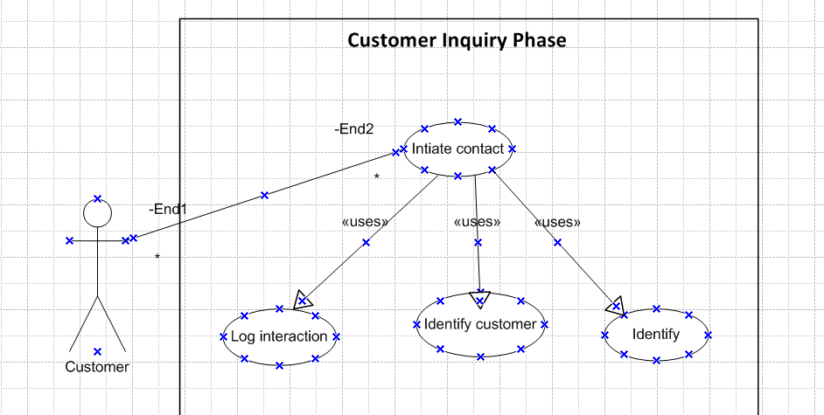

- Case Creation Phase
A support ticket is automatically created in the system.
The agent receives the ticket with all customer context and previous interaction history.
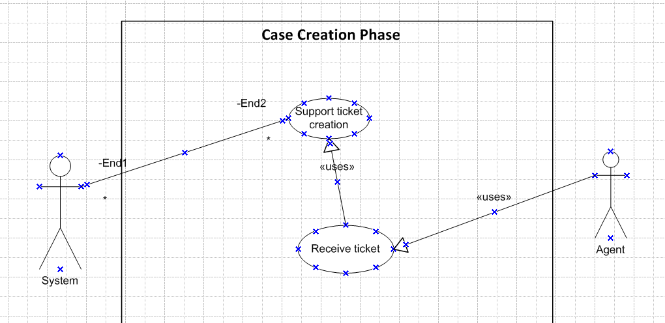

- Response & Resolution Phase
Agent uses the built-in knowledge base and customer account access to resolve the issue.
Agent communicates with the customer through the same channel or switches channel (if needed) seamlessly.
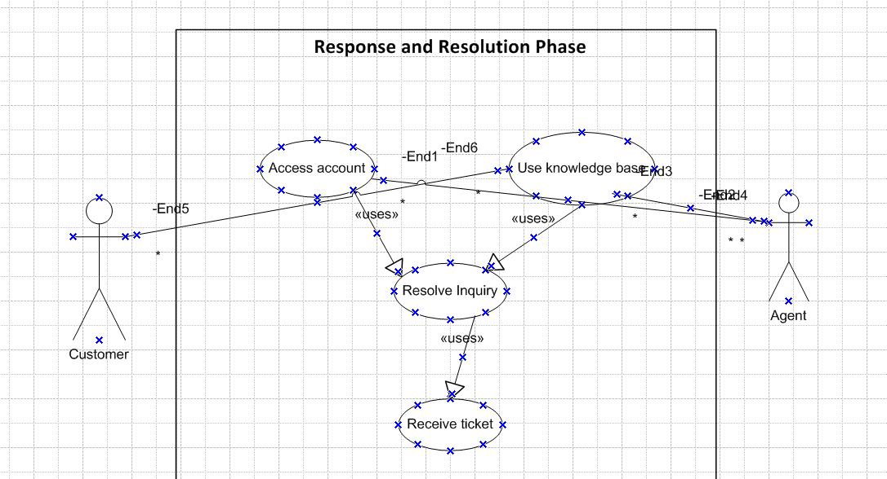

4. Follow-Up Phase
Once the issue is resolved, a customer feedback survey is sent automatically.
Survey results are stored in the system for analysis and reporting.
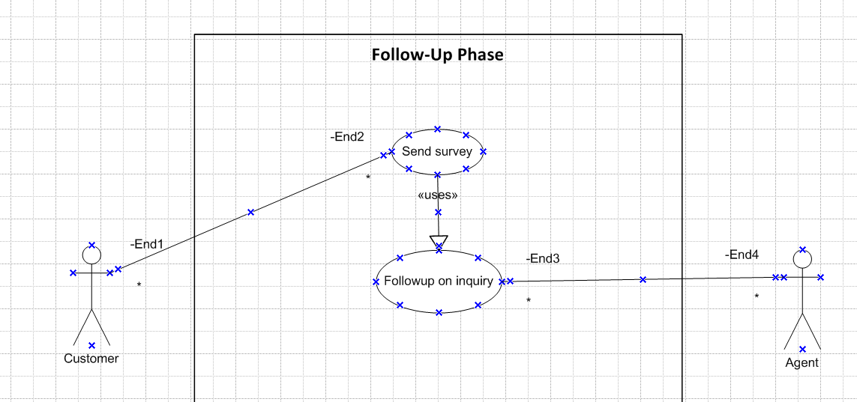

5. Escalation Phase (If Needed)
If the issue cannot be resolved at Level 1 support, it is escalated to Level 2/3.
The system notifies the relevant support level and carries forward all case details.
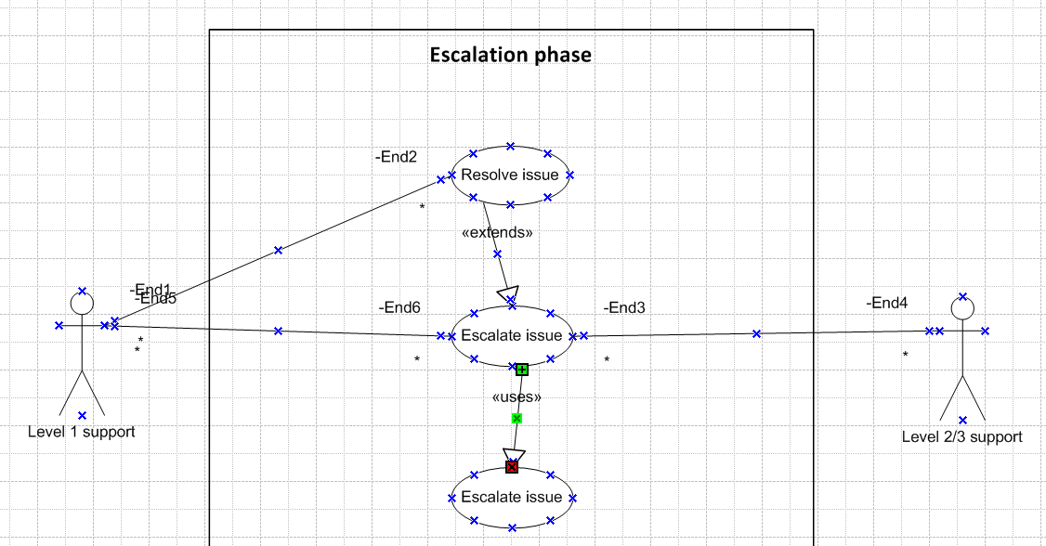

6. Reporting & Analytics Phase
Managers generate reports on resolution time, customer satisfaction, and agent performance.
Data from all support channels is unified for strategic decision-making.
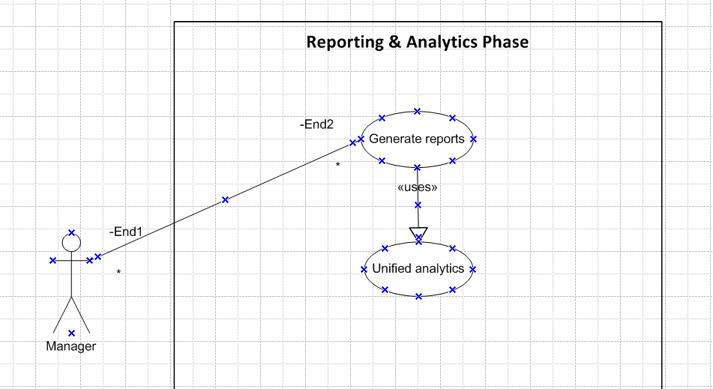

Activity diagrams

- Customer Inquiry Phase
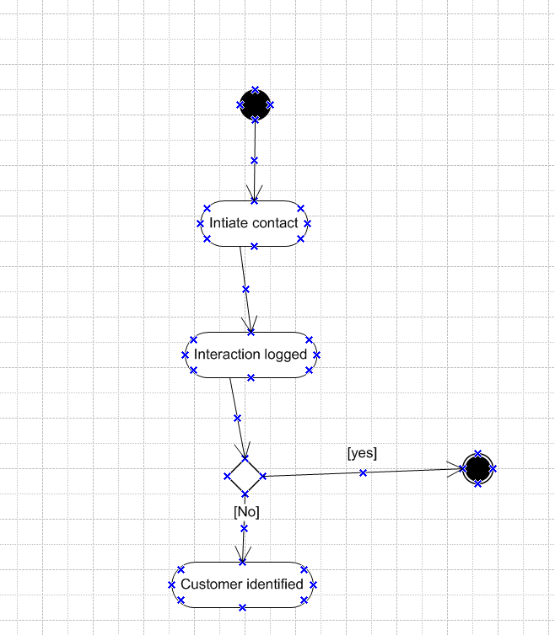

- Case Creation Phase
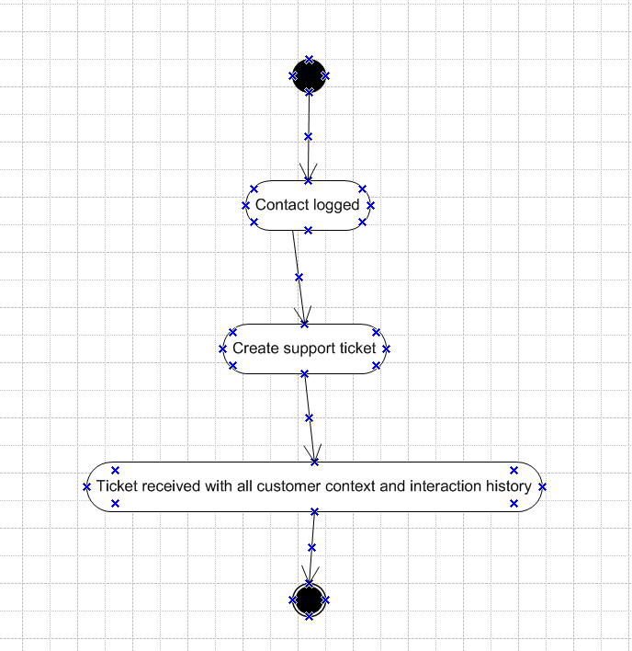

3. Response & Resolution Phase

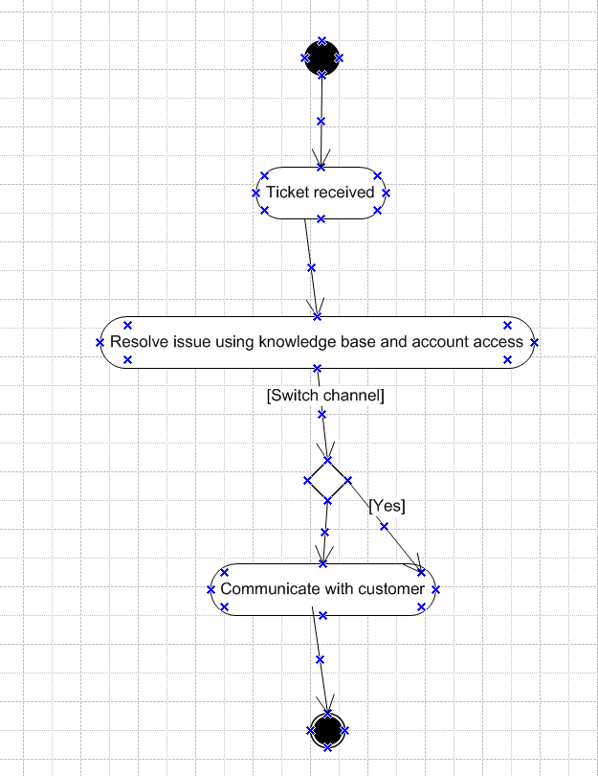

4. Follow-Up Phase
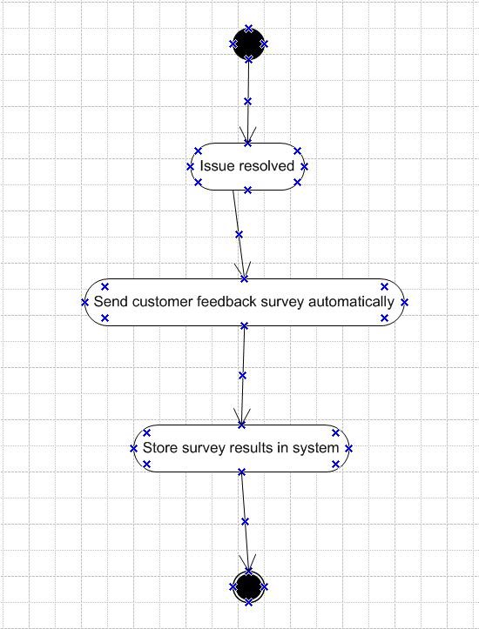

5. Escalation Phase (If Needed)
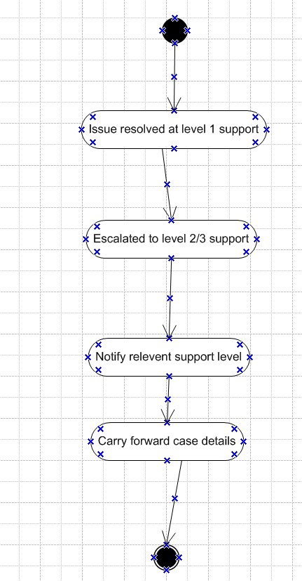

6. Reporting & Analytics Phase
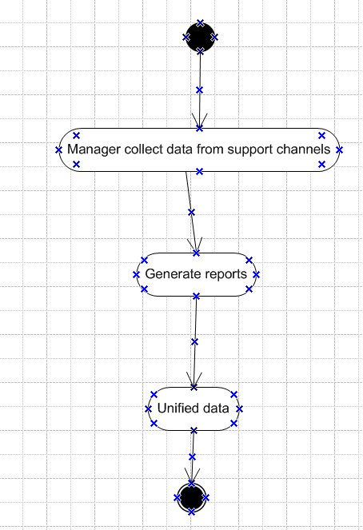

Use Case Specification Document
1. Use Case Name:
Customer Support Interaction Management
2. Use Case Description:
This use case describes how a customer service agent interacts with the core application to manage customer communications via chat, email, and voice call, access customer details, consult knowledge articles, and collect post-interaction feedback.
3. Actors:
Primary Actors:
Customer Support Agent
Customer
Secondary Actors:
System (Core Application)
Knowledge Base
CRM System
Email Server / Telephony System
4. Basic Flow:
- Customer initiates contact via chat, email, or call.
- The system identifies the customer using provided details.
- The system logs the interaction automatically.
- Agent views the customer's profile and interaction history.
- Agent responds to query using system tools and knowledge base.
- Once resolved, the agent closes the interaction.
- System sends a feedback survey to the customer.
- Feedback is logged and visible in reports.
5. Alternate Flow:
If the customer is not identified:
System prompts agent to create a new customer profile.
Agent manually enters customer information and proceeds.

6. Exceptional Flows:
Communication service failure (chat/email/call):
System shows an error message.
Logs issue and suggests retry.
CRM system down:
Basic interaction continues.
Profile data access is temporarily unavailable.
7. Pre-Conditions:
Agent is logged into the system.
Communication channels (chat, email, call) are active.
8. Post-Conditions:
Interaction is logged.
Resolution status is updated.
Feedback (if submitted) is stored.
9. Assumptions:
Agents are trained on the system.
Customers use registered communication channels.
10. Constraints:
System uptime must meet SLA (99.9%).
Real-time updates are limited by network latency.
11. Dependencies:
Third-party systems (CRM, Telephony, Email).
Availability of knowledge base content.
12. Inputs and Outputs:
Inputs: Customer message, customer details
Outputs: Resolution message, survey link, interaction log
13. Business Rules:
Only authenticated agents can access customer profiles.
All interactions must be logged.
Feedback is optional but encouraged.
14. Miscellaneous Information:
The system is accessible via web and mobile interface.
Each interaction is tagged with a unique case ID.
Audit logs are maintained for compliance.

Document 7- Screens and pages
Answer:
1. Customer Inquiry Phase
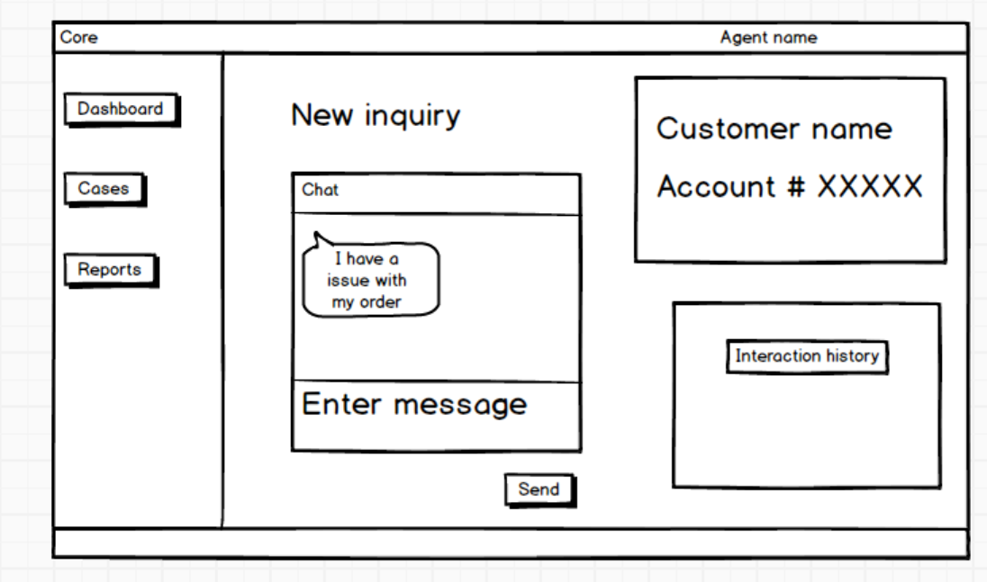
2. Case Creation Phase
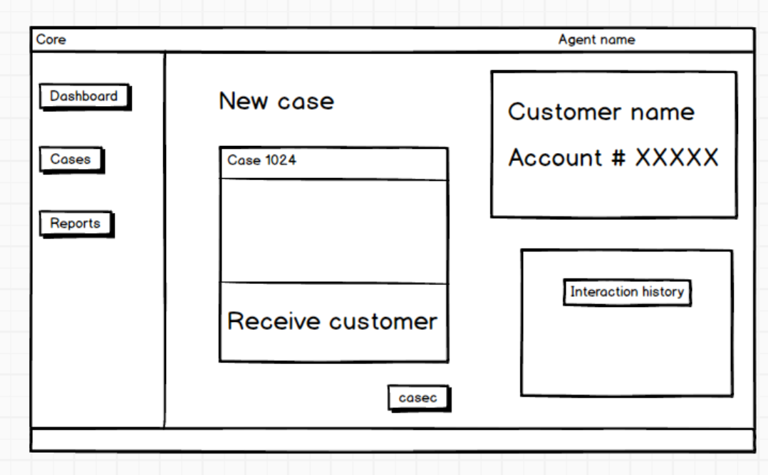
3. Response & Resolution Phase
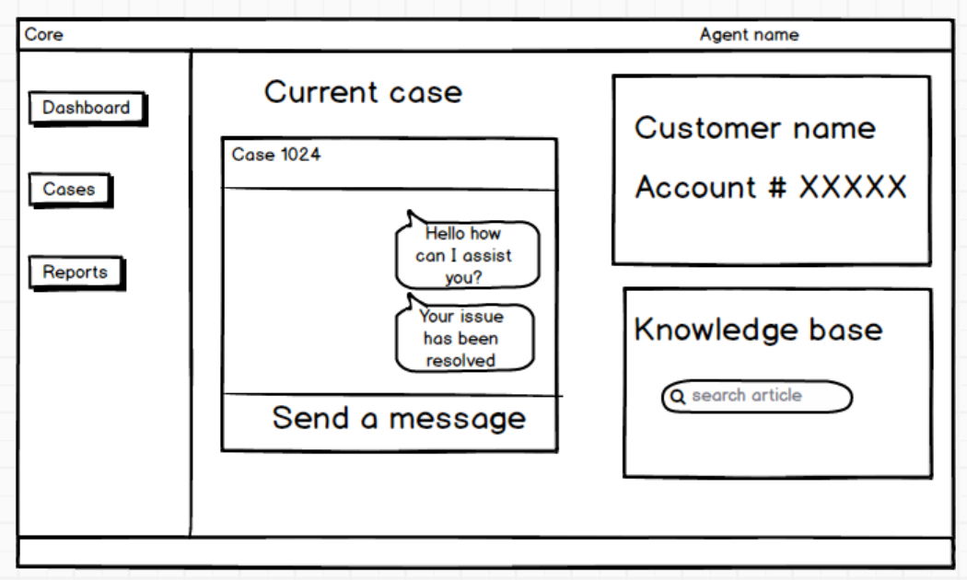
4. Follow-Up Phase
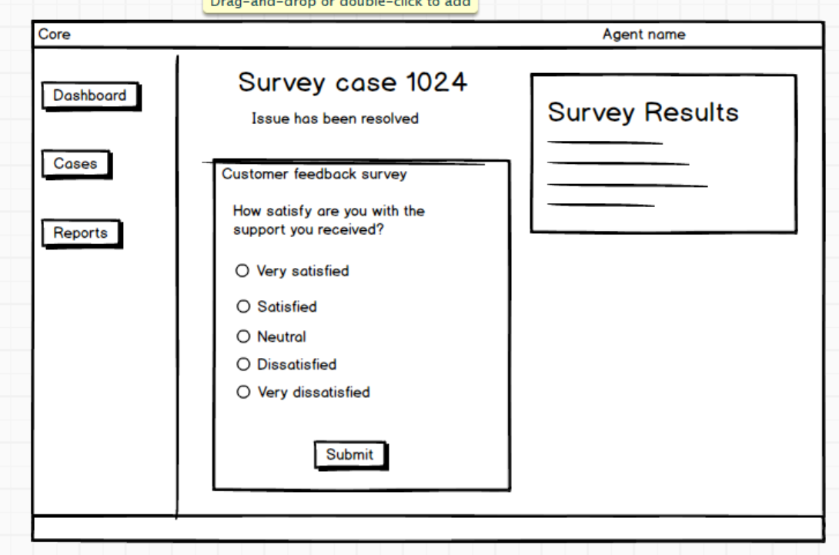
5. Escalation Phase (If Needed)
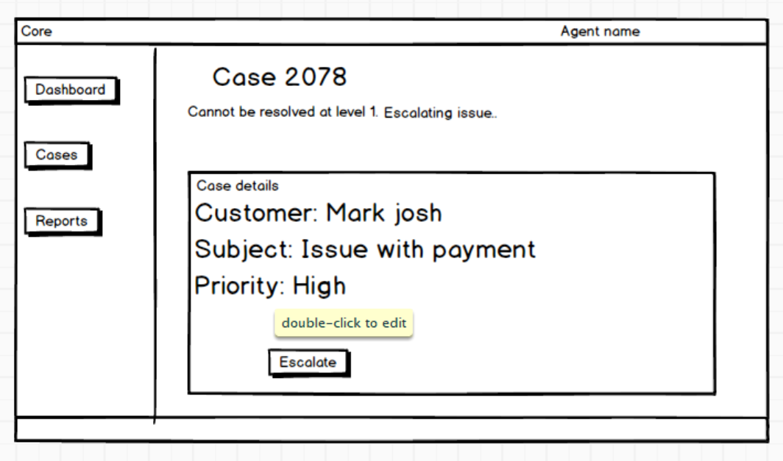
6. Reporting & Analytics Phase
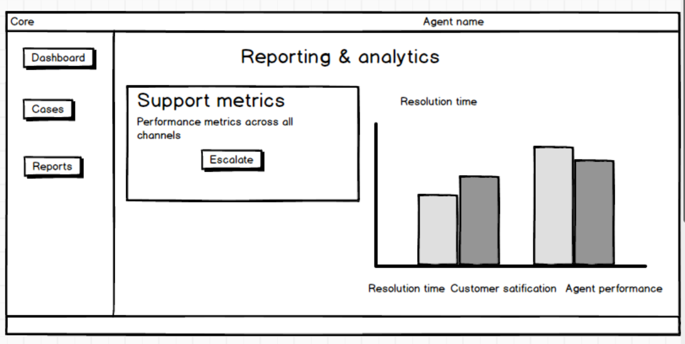

Document 8
Tools-Visio and Axure Write a paragraph on your experience using Visio and Axure for the project.
Answer:
Using Microsoft Visio for the core customer support application project was a valuable experience, especially for creating detailed and structured visual models. Visio enabled us to design comprehensive use case diagrams and activity diagrams for each phase of the customer support process, such as Customer Inquiry, Case Creation, Response & Resolution, and Reporting. The tool’s intuitive interface and wide range of diagramming templates helped in clearly representing workflows, system interactions, and actor relationships. These visuals were instrumental during stakeholder discussions, helping to ensure a shared understanding of the system’s functionality and processes. Overall, Visio contributed significantly to the clarity and quality of the project’s documentation, making it easier to align business requirements with technical implementation.
Axure, on the other hand, will be used for designing interactive wireframes and mockups, providing a realistic preview of user interface screens across different stages of the application. Its drag-and-drop functionality and ability to simulate user interactions enhanced our ability to gather early feedback, validate requirements, and align design expectations with development goals. Together, these tools contributed significantly to efficient communication, improved documentation, and reduced design ambiguity.

Document 9- BA experience
My experience as BA in following phases:
Answer:
- Requirement gathering:
As a Business Analyst (BA) during the Requirement Gathering phase of the core customer support application project, my approach focused on structured elicitation and validation methods to ensure clarity and completeness. I began by applying the MoSCoW technique to prioritize requirements into Must Have, Should Have, Could Have, and Won’t Have categories, which helped manage stakeholder expectations and scope definition effectively. One challenge faced was the limited availability of the client, which required me to proactively identify alternate points of contact from the client side to avoid delays and gather key inputs on time.
To validate the collected requirements, I utilized the FURPS model (Functionality, Usability, Reliability, Performance, and Supportability), ensuring all aspects of the system were considered. During this process, I identified duplicate or redundant requirements, which were promptly reviewed and eliminated to maintain a clean and actionable requirement set. Additionally, I introduced prototyping techniques, including early wireframes and mock-ups, to help stakeholders visualize the application features. This method led to more precise and refined requirements, as visual representation enabled better feedback and engagement. Overall, the phase required strong coordination, analytical thinking, and effective communication to gather high-quality requirements despite constraints.
- Requirement Analysis:

As a Business Analyst (BA) during the Requirement Analysis phase of the core customer support application project, my role was to interpret and structure the gathered requirements into clear, actionable artifacts for the development team. I began by preparing UML diagrams, such as use case diagrams to represent system interactions and activity diagrams to illustrate detailed process flows like Customer Inquiry, Case Creation, and Escalation phases. These visual representations helped in conveying complex requirements in a more understandable format.

Once the diagrams were prepared, I presented them to the development and QA teams. During discussions, some team members raised valid concerns or offered improvements based on their technical perspectives. As a BA, I facilitated collaborative reviews, ensured all feedback was documented, and made necessary modifications to reflect a shared understanding of the system.

Simultaneously, I was responsible for drafting both the Business Requirements Specification (BRS) and the System Requirements Specification (SRS) documents. The BRS outlined the high-level goals and needs from the business perspective, while the SRS translated these into detailed functional and non-functional system specifications. This phase was critical in bridging the gap between business intent and technical implementation, requiring clear documentation, effective communication, and iterative refinement.

- Design:
As a Business Analyst during the Design phase of the core customer support application project, my primary responsibility was to ensure that the transition from requirements to solution design was both accurate and comprehensive. Starting with the finalized use case diagrams, I collaborated with the QA team to derive detailed test cases, covering both positive and negative scenarios. I was particularly meticulous about not missing any edge cases, as even a small oversight could lead to major issues during development or UAT.
In parallel, I regularly communicated with the client to review and validate the design and solution documents, ensuring that what was being proposed aligned with their expectations. I also played an active role in preparing test data that could be used during the testing phase to simulate real-world scenarios, helping testers verify the system’s robustness and accuracy.
Additionally, I updated the Requirements Traceability Matrix (RTM) consistently to ensure each requirement from the BRS and SRS was mapped to its corresponding test cases and design components. This was crucial for maintaining end-to-end traceability and ensuring complete coverage. My involvement in this phase was instrumental in laying a strong foundation for testing and eventual implementation.
- Development:
As a Business Analyst during the Development phase of the core customer support application project, my role was centered around facilitating smooth communication between the technical team and the client, and ensuring that the development progressed in alignment with the defined requirements. I organized JAD (Joint Application Development) sessions to bring together stakeholders and developers for collaborative discussions, which proved essential for addressing ambiguities in implementation.
During development, I actively clarified queries from the technical team regarding business logic, functional expectations, and data flow. There were instances where certain team members either disagreed with the proposed design or showed reluctance during JAD sessions. I handled such situations tactfully by having one-on-one discussions, explaining the potential impact of their disengagement on project outcomes, and fostering a healthy team environment based on mutual understanding and respect.
To support the developers, I regularly referred to use case and activity diagrams, helping them visualize the workflow and code each module correctly. I also conducted regular meetings with both the technical team and the client to ensure consistent progress and feedback. When some team members couldn’t attend, I ensured the sessions were recorded and followed up with individual discussions to keep everyone on the same page. These efforts helped maintain transparency, accountability, and steady development momentum throughout the phase.
- Testing:
As a Business Analyst during the Testing phase of the core customer support application project, my primary responsibility was to ensure that the developed application aligned with the documented requirements and delivered the expected functionality. I began by preparing detailed test cases derived directly from the use cases and user stories created earlier. These test cases covered both positive and negative scenarios, ensuring thorough validation of each feature.
I was actively involved in performing high-level testing alongside the QA team to verify end-to-end workflows, including chat, email, voice call handling, knowledge base access, and feedback mechanisms. To facilitate effective testing, I coordinated with the client to request and obtain realistic test data, which was essential for simulating actual user interactions and edge cases.
As part of traceability and compliance, I regularly updated the RTM (Requirements Traceability Matrix) to track the coverage of each requirement against test cases. Once the testing was complete and all issues were addressed, I worked on obtaining a formal sign-off from the client, confirming that the application met their expectations.
In preparation for User Acceptance Testing (UAT), I collaborated closely with the client team, helping them understand the scope of UAT, walk through the test scenarios, and ensure they were equipped to validate the application independently. This proactive involvement helped minimize UAT defects and enabled a smooth transition toward deployment.
- Deployment:
As a Business Analyst in the Deployment phase of the core customer support application project, my role focused on ensuring a seamless transition from development to production and preparing end users for adoption. I forwarded the finalized Requirements Traceability Matrix (RTM) to the client, ensuring it was properly attached to the project closure documentation for formal recordkeeping and audit purposes.
I also coordinated the creation and distribution of end user manuals, collaborating with the documentation and product teams to ensure the guides were clear, user-friendly, and aligned with the final functionality. To support successful onboarding, I planned and organized comprehensive training sessions for end users, tailoring the content to different user roles such as customer service agents, team leads, and managers.
Additionally, I worked diligently to track attendance and follow up individually with users who missed the training to ensure full coverage. By making sure all relevant users attended the sessions, I helped reduce future support queries and ensured the application was used effectively from day one. This proactive engagement during deployment was crucial for achieving a smooth go-live and ensuring client satisfaction.

